Additional information

Additional File1: Figure S1

Peripheral Vδ1 T cells remained unchanged in 22 PK patients compared with NCs. The representative flow cytometry data (a), and scatterplot graph (b) showing the frequencies of total Vδ1, Vδ1⁺Vγ9⁺ and Vδ1⁺Vγ9⁻ T cells in CD3⁺ T cells subsets.
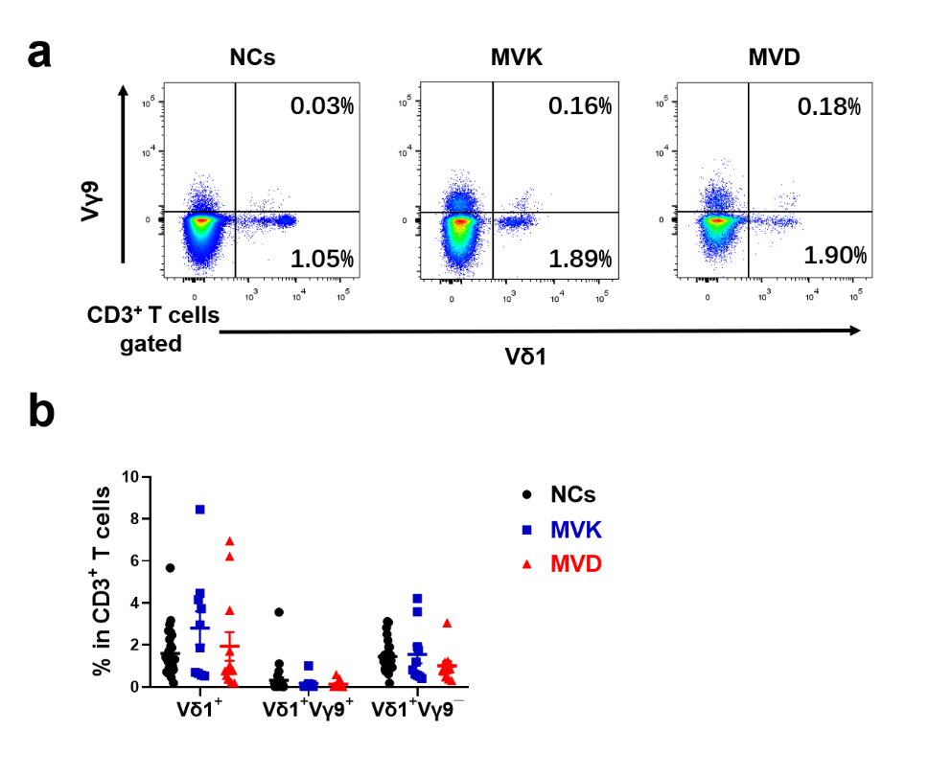
Notes: MVK: the PK patients with MVK variants (n = 10); MVD: PK patients with MVD variants (n = 12); NCs: normal controls (n = 27).

