Supplementary Information Guide
Supplementary Information
This file provides a supplementary discussion to complement the main text.
Supplementary tables 1, 2, 4, 5 and 6. This Excel file contains multiple sheets with the results of the analyses conducted on the samples examined in this study. The first sheet provides information on the necropsy samples collected from the three mangabeys that died during the mpox outbreak (Supplementary Table 1). The second sheet includes the results from the mangabey faecal samples collected from the Audrenisrou group during the study period (Supplementary Table 2). The results presented include information on Monkeypox virus (MPXV) qPCR, whole genome sequencing, virus isolation, and metabarcoding analysis. The fifth and sixth sheets contain the orthopoxvirus (OPV) qPCR results obtained from the rodents and shrews that were trapped (i) on a transect leading from the primary forest in Tai National Park (TNP) through agricultural land into neighbouring villages in 2021 and 2022 and (ii) in the mangabey territory in 2021 and 2023 (Supplementary Table 4). The seventh sheet provides information on the other necropsy samples that were collected in TNP and analysed in this study (Supplementary Table 5). The data presented include details on the species and tissues examined as well as the results on OPV qPCR, MPXV qPCR, whole genome sequencing, and virus isolation. The last sheets provides the results of the re-analyses of the mammal metabarcoding performed on flies collected around TNP (Supplementary Table 6).
Supplementary table 3. This table (two sheets) provides detailed information on each mangabey in the Audrenisrou group during the study period. The first sheet contains data on the age, sex, and absence/presence and severity of clinical signs associated with MPXV for each mangabey. It also includes information on individuals who were asymptomatic but MPXV-positive, as well as on the mothers of symptomatic infants. The second sheet documents all observations of the Audrenisrou individuals made by the two field veterinarians from January 27th until August 6th, 2023. The MPXV outbreak was considered to have occurred from the first day clinical signs were observed in the mangabey group (January 27th, 2023) until the day the MPXV-related lesions disappeared (April 26th, 2023). The lesions that are described after this day were attributed to secondary complications.
Supplementary Video 1. Hannibal capturing and eating a squirrel (species not identifiable). The video was recorded on January 12th 2025.
Supplementary Video 2. Tanjung eating a fire-footed rope squirrel. This video captures Tanjung, an adult female mangabey from the Audrenisrou group, eating a fire-footed rope squirrel on December 9th, 2014. This mangabey went missing in January 2016, and the cause of her disappearance remains unknown.

Supplementary Information
Supplementary Discussion
Necropsies of three MPXV-infected infant mangabeys (Cercocebus atys)
During the MPXV outbreak in the mangabey group, four mangabeys died. The deaths occurred on January 29th (BB-Amboseli), February 7th (BB-Atacama) and 11th (BB-Gishwati) and March 1st (BB-Cavally) 2023. Their mothers carried and groomed the bodies for approximately two days before leaving them on the forest ground. Once the bodies were dropped and the group had moved away, two field veterinarians (Carme Riutord-Fe and Ane López-Morales) promptly conducted necropsies and collected samples at the site where the body was left, approximately 48h after death in all three cases. The three carcasses presented multiple brownish circular lesions of approximately 0.5 cm of diameter, covering most of the skin. Organ examination revealed that BB-Atacama's liver was likely enlarged, while BB-Gishwati's liver, kidneys, and heart were also suspected to be enlarged. All three necropsies were classified as being in the early decomposition stage. Supplementary Table 1 shows all samples that were collected from the mangabeys and results of laboratory analyses.
Necropsy report of a fire-footed rope squirrel (Funisciurus pyrropus)
An adult male of fire-footed rope squirrel was found dead in TNP on November 3rd, 2022. The necropsy was performed by a field veterinarian (Carme Riutord-Fe) on the same day, from 14:30 to 16:30.
Location: South territory, at around 700m South-East from South Camp on a human-made trail.
GPS coordinates: 29 N 0686351 0645073
History: The carcass was spotted at 13:30 on November 3rd, 2022 by a research assistant on his way from South to East Camp. The field veterinarian was immediately informed by a satellite message about the location and species of the carcass, and promptly proceeded to perform the necropsy.
External examination: The carcass was found lying on its right side with hundreds of ants and fly eggs distributed across the skin (Extended Data Fig. 4). The ants were predominantly found around the limbs, muzzle, and genital area while the fly eggs were mostly observed on the ventral side of the body. Fly larvae (~20) were also present around the genital area.
The skin covering the muzzle and left part of the mandible was reddish and rugged (Supplementary Figure 1) and the scrotum was diffusely red (Supplementary Figure 2). Sero-hemorrhagic content was collected from the urethra and once a genital swab was taken, semen could also be collected.
Internal examination: A reddish area of ~2cm was noted in the subcutaneous tissue and underlying muscle around the right axillary area (Supplementary Figure 3). Regarding the abdominal cavity, the liver and spleen presented round edges (Supplementary Figure 4 and Supplementary Figure 5) and white multifocal nodules were found on the cross section of the spleen. The small intestine was diffusely red and the blood vessels around the large intestine were increased in size (Supplementary Figure 6). Yellowish mucus content was found in the urinary bladder (Supplementary Figure 7) and formed faeces were found in the rectum. The stomach was filled with a yellowish dry content and the intestinal content was brownish. In the thorax, the heart was augmented in size and the lungs were diffusely red and presented multifocal non-delineated dark-reddish areas ranging from 0.5cm to 1.5cm (Supplementary Figure 8). Coagulated blood was collected from the heart.
Comments: The reactive lesions observed on the animal’s skin, specifically on the muzzle, mandible, and scrotum, along with the hematoma in the right axillary region, suggest that the animal may have been restrained and dragged prior to death. The individual responsible for this may have been the cause of death, potentially inflicting the haemorrhagic lesions in the lungs and intestines. It is plausible that the animal abandoned the carcass afterwards, possibly due to the approach of a larger predator or humans. The round edges of the spleen and liver indicate an increase of its size and the white multifocal nodules that were found on the cross section of the spleen may indicate a hyperplasia of the lymphoid tissue (potentially indicating a reactive state). These findings, together with the cardiomegaly (heart augmented in size), and haemorrhagic lesions on the lungs and intestines (if not caused by a predator) suggest that the animal could have been weakened by an underlying systemic disease that affected most of its vital organs. The yellowish mucus content found in the urinary bladder may be refluxed seminal coagula which often occurs during the perimortem in rodents¹. Based on the presence of fly eggs and some fly larvae, rigor mortis in the mandible and intact hair and lack of bloat, the carcass was classified as fresh and the time of death was estimated to be around 6-8 hours in advance of the necropsy.
Sample collection: Samples from all the inner organs were collected with clean surgical tools and were stored in 2-ml cryotubes, both empty and filled with NAP buffer. Samples from most of the vital organs were also collected in 10% Neutral-buffered formalin. A complete sample list is available in Supplementary table 3.
Diet analysis
To investigate the presence of prey DNA in mangabey faeces, we used a mammal-generic metabarcoding system. Unsurprisingly, all samples contained many reads in replicates assigned to Cercocebus atys. No additional taxa were detected using the obitools pipeline. To ensure that we were not missing taxa not in EMBL at the time of downloading, or those for which a close relative was not available in EMBL, we proceeded to use a discontiguous megablast of all aligned sequences detected in more than two replicates with at least 156 reads. This approach revealed a sequence that was present in all three replicates in two samples (F00842 and NA_01000; gaacaaaataacctccgaatgatattaaccaagacacactcgtccaagttcatattcataaattgacccaaactttaattgaccaacggaaca) that was most similar to Funisciurus sp. LIK280 (MN597823.1; 96.7% identity) and then Funisciurus pyrropus (AY227469.1; 90.1%). To further confirm that this detection was of the species of Funisciurus in which we detected MPXV, we mapped the aligned reads (with their primers removed) to the 20x mitogenome we generated from the squirrel spleen, as well as a human (NC_012920), chimpanzee (KU308547), and mangabey (NC_028592) mitogenomes. Reads from both positive samples mapped to the Funisciurus pyrropus mitogenome from Taï, with the 95% consensus sequence being a 100% match to this reference mitogenome.

Supplementary Figures mentioned in the necropsy report of the fire-footed rope squirrel
Supplementary Figure 1. Ventral view of the fire-footed rope squirrel’s head.
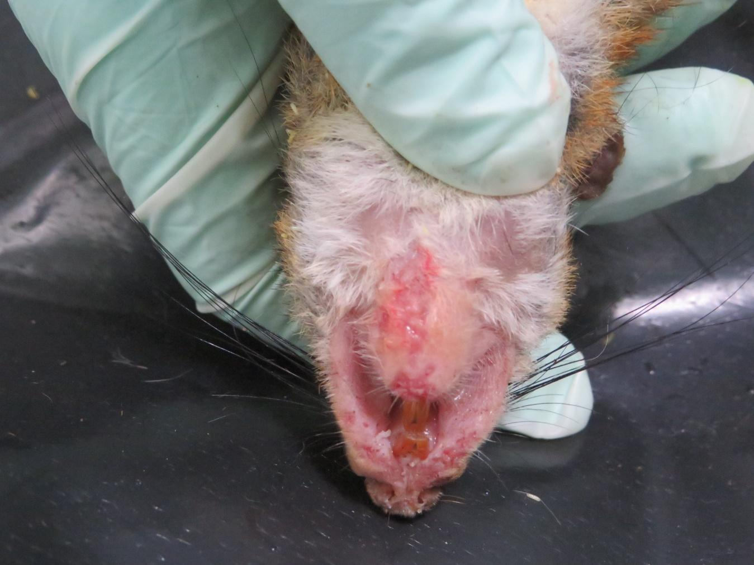
Supplementary Figure 2. Scrotum of the fire-footed rope squirrel.
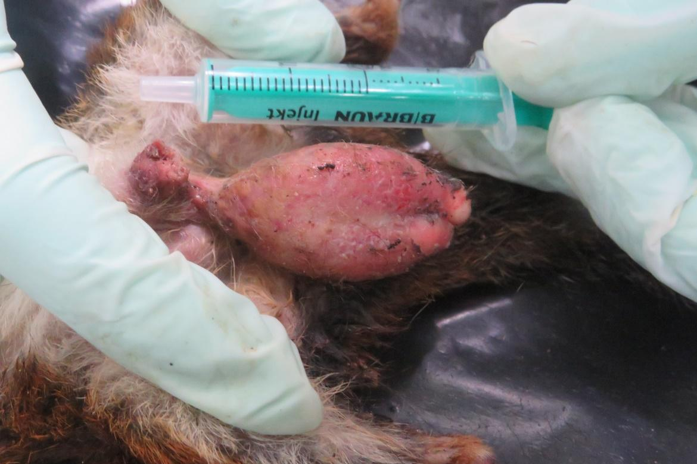
Supplementary Figure 3. Ventral view of the fire-footed rope squirrel carcass, with the abdominal cavity opened.

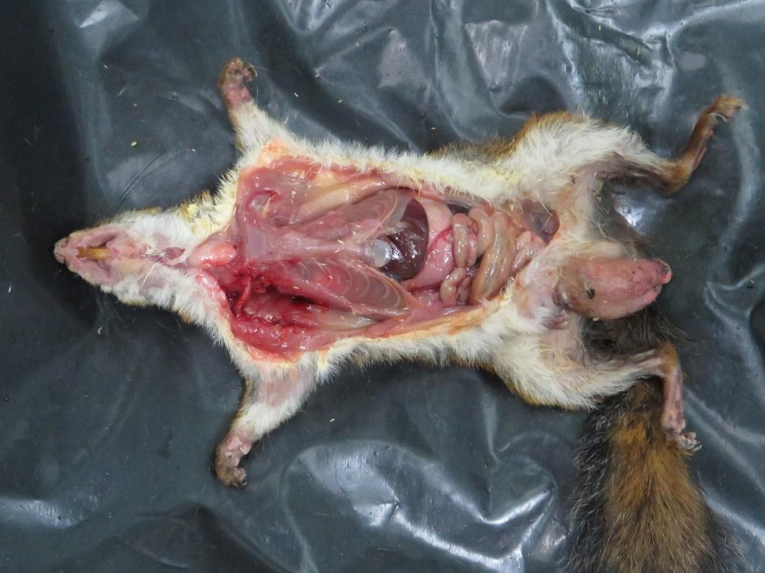
Supplementary Figure 5. Spleen of the fire-footed rope squirrel.

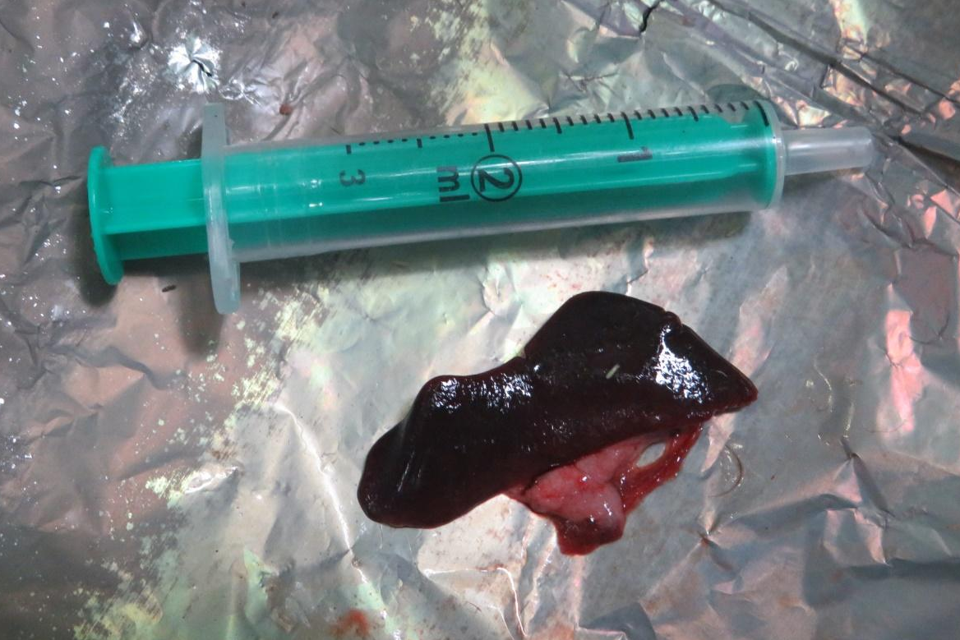
Supplementary Figure 6. Liver of the fire-footed rope squirrel.
b
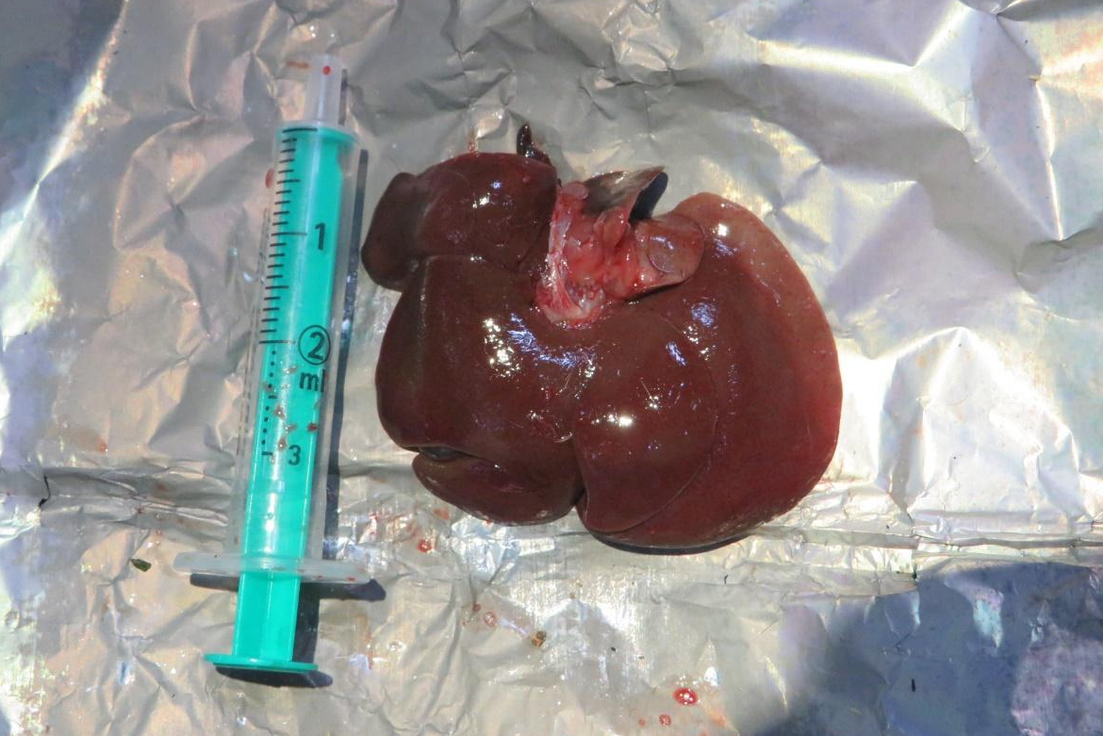

Supplementary Figure 7. Intestines of the fire-footed rope squirrel.
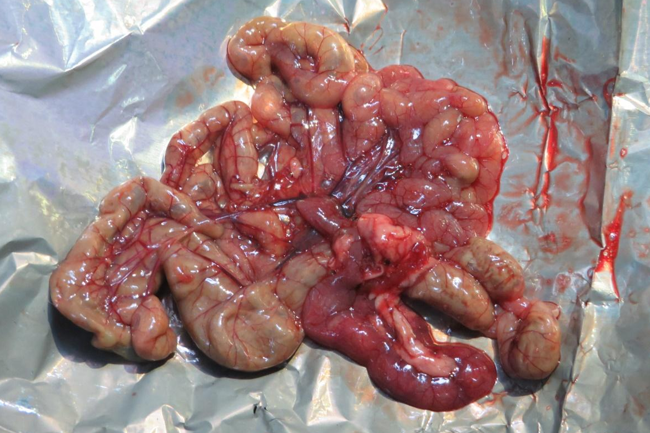
Supplementary Figure 8. Urinary bladder of the fire-footed rope squirrel and its content on the side.

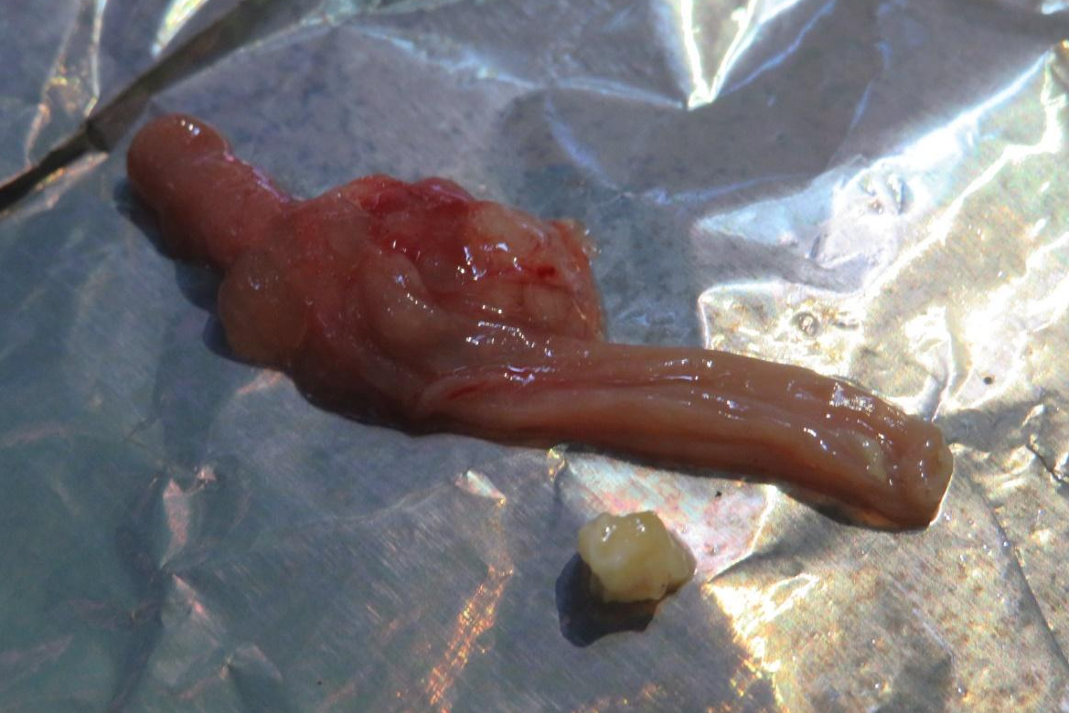
Supplementary Figure 9. Lungs and heart of the fire-footed rope squirrel.

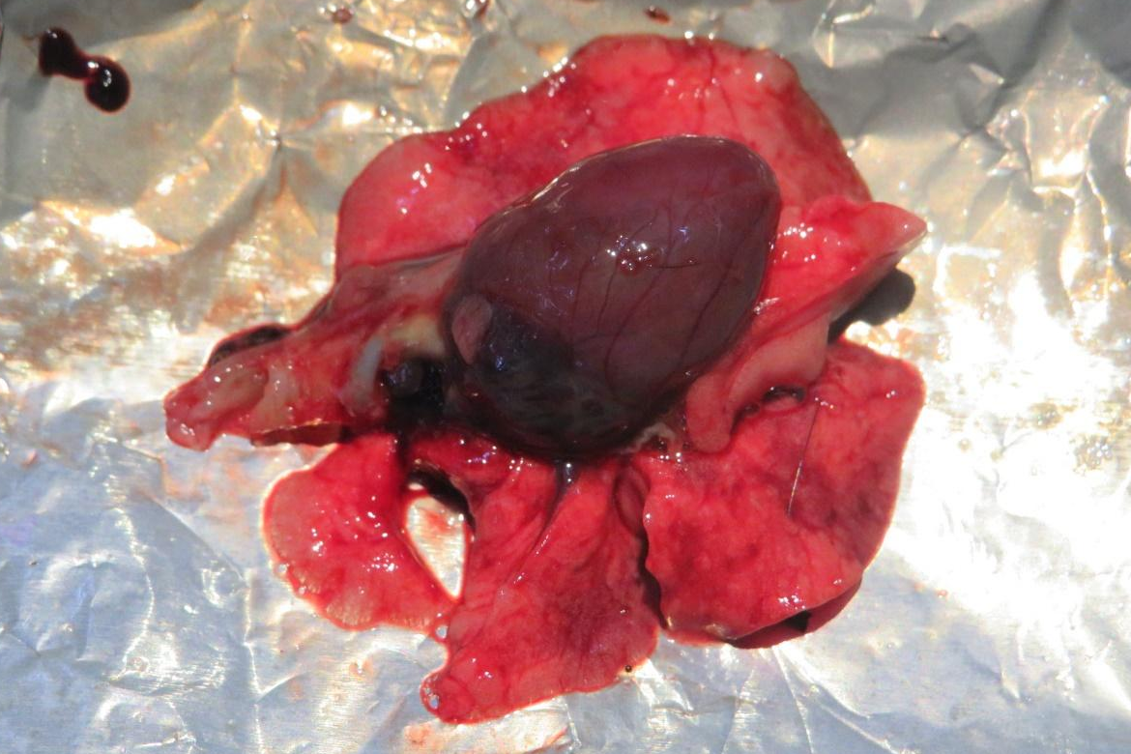

References
- Delaney, M.A., Treuting, P.M., Rothenburger, J.L. Rodentia. In Pathology of Wildlife and Zoo Animals (eds. Terio, K.A., McAloose, D., St Leger, J.) pp. 499–515 (Epub, 2018)

