Supplementary Material

Supplementary Tables and Figures

Molecular Neurobiology

The Effect of Fibulin-5 on Hydrocephalus After Subarachnoid Hemorrhage in Mice

Yume Suzuki, Mai Nampei, Fumihiro Kawakita, Hiroki Oinaka, Hideki Nakajima,
and Hidenori Suzuki

Address correspondence to: Yume Suzuki, M.D., Ph.D.
Department of Neurosurgery, Mie University Graduate School of Medicine, 2-174 Edobashi, Tsu, Mie 514-8507, Japan
E-mail: box_308044@yahoo.co.jp
ORCID: 0000-0003-4853-395X

Supplementary Table S1 The number of animals and mortality in experiment 1

Modeling | Treatment | Mortality | Mild SAH | Total mortality | p value
Sham | PBS | 0/12 (0.0%) | 0 | 0/12 (0.0%)
SAH | PBS | 1/16 (6.3%) | 3 | 6/47 (12.8%) | 0.485
SAH | Short rFBLN5 0.01μg | 2/8 (25.0%) | 0 | 6/47 (12.8%) | 0.485
SAH | Short rFBLN5 0.1μg | 0/7 (0.0%) | 1 | 6/47 (12.8%) | 0.485
SAH | Long rFBLN5 0.01μg | 2/9 (22.2%) | 1 | 6/47 (12.8%) | 0.485
SAH | Long rFBLN5 0.1μg | 1/7 (14.3%) | 0 | 6/47 (12.8%) | 0.485

Data, the number of dead mice / total number of mice (mortality). Mild subarachnoid hemorrhage (SAH) is defined as SAH grading score ≤7. PBS, phosphate-buffered saline; rFBLN5, recombinant fibulin-5. Fisher’s exact test was used to compare the mortality of each SAH group

Supplementary Table S2 The number of animals and mortality in experiment 2

Modeling | Treatment | Mortality | Mild SAH | Total mortality | p value
Sham | PBS | 0/16 (0.0%) | 0 | 0/16 (0.0%)
SAH | PBS | 19/39 (48.7%) | 4 | 27/84 (32.1%) | 0.028
SAH | Short rFBLN5 0.01μg | 3/15 (20.0%) | 4 | 27/84 (32.1%) | 0.028
SAH | Short rFBLN5 0.1μg | 4/14 (28.6%) | 1 | 27/84 (32.1%) | 0.028
SAH | Long rFBLN5 0.01μg | 0/7 (0.0%) | 1 | 27/84 (32.1%) | 0.028
SAH | Long rFBLN5 0.1μg | 1/9 (11.1%) | 1 | 27/84 (32.1%) | 0.028

Data, the number of dead mice / total number of mice (mortality). Mild subarachnoid hemorrhage (SAH) is defined as SAH grading score ≤4. PBS, phosphate-buffered saline; rFBLN5, recombinant fibulin-5. Fisher’s exact test was used to compare the mortality of each SAH group

Supplementary Table S3 The number of animals and mortality in experiment 3

Modeling | Treatment | Mortality | Mild SAH | Total mortality | p value
Sham | PBS | 0/6 (0.0%) | 0 | 0/6 (0.0%)
SAH | PBS | 2/8 (25.0%) | 0 | 5/23 (21.7%) | 0.370
SAH | Long rFBLN5 0.01μg | 0/6 (0.0%) | 0 | 5/23 (21.7%) | 0.370
SAH | Long rFBLN5 0.1μg | 3/9 (33.3%) | 0 | 5/23 (21.7%) | 0.370

Data, the number of dead mice / total number of mice (mortality). Mild subarachnoid hemorrhage (SAH) is defined as SAH grading score ≤4. PBS, phosphate-buffered saline; rFBLN5, recombinant fibulin-5. Fisher’s exact test was used to compare the mortality of each SAH group

Supplementary Table S4 The number of animals and mortality in experiment 4

Modeling | Treatment | Mortality | Mild SAH | Total mortality | p value
Sham | PBS | 0/6 (0.0%) | 0 | 0/6 (0.0%)
SAH | PBS | 5/15 (33.3%) | 3 | 6/31 (19.4%) | 0.217
SAH | Long rFBLN5 0.01μg | 0/7 (0.0%) | 1 | 6/31 (19.4%) | 0.217
SAH | Long rFBLN5 0.1μg | 1/9 (11.1%) | 1 | 6/31 (19.4%) | 0.217

Data, the number of dead mice / total number of mice (mortality). Mild subarachnoid hemorrhage (SAH) is defined as SAH grading score ≤4. PBS, phosphate-buffered saline; rFBLN5, recombinant fibulin-5. Fisher’s exact test was used to compare the mortality of each SAH group

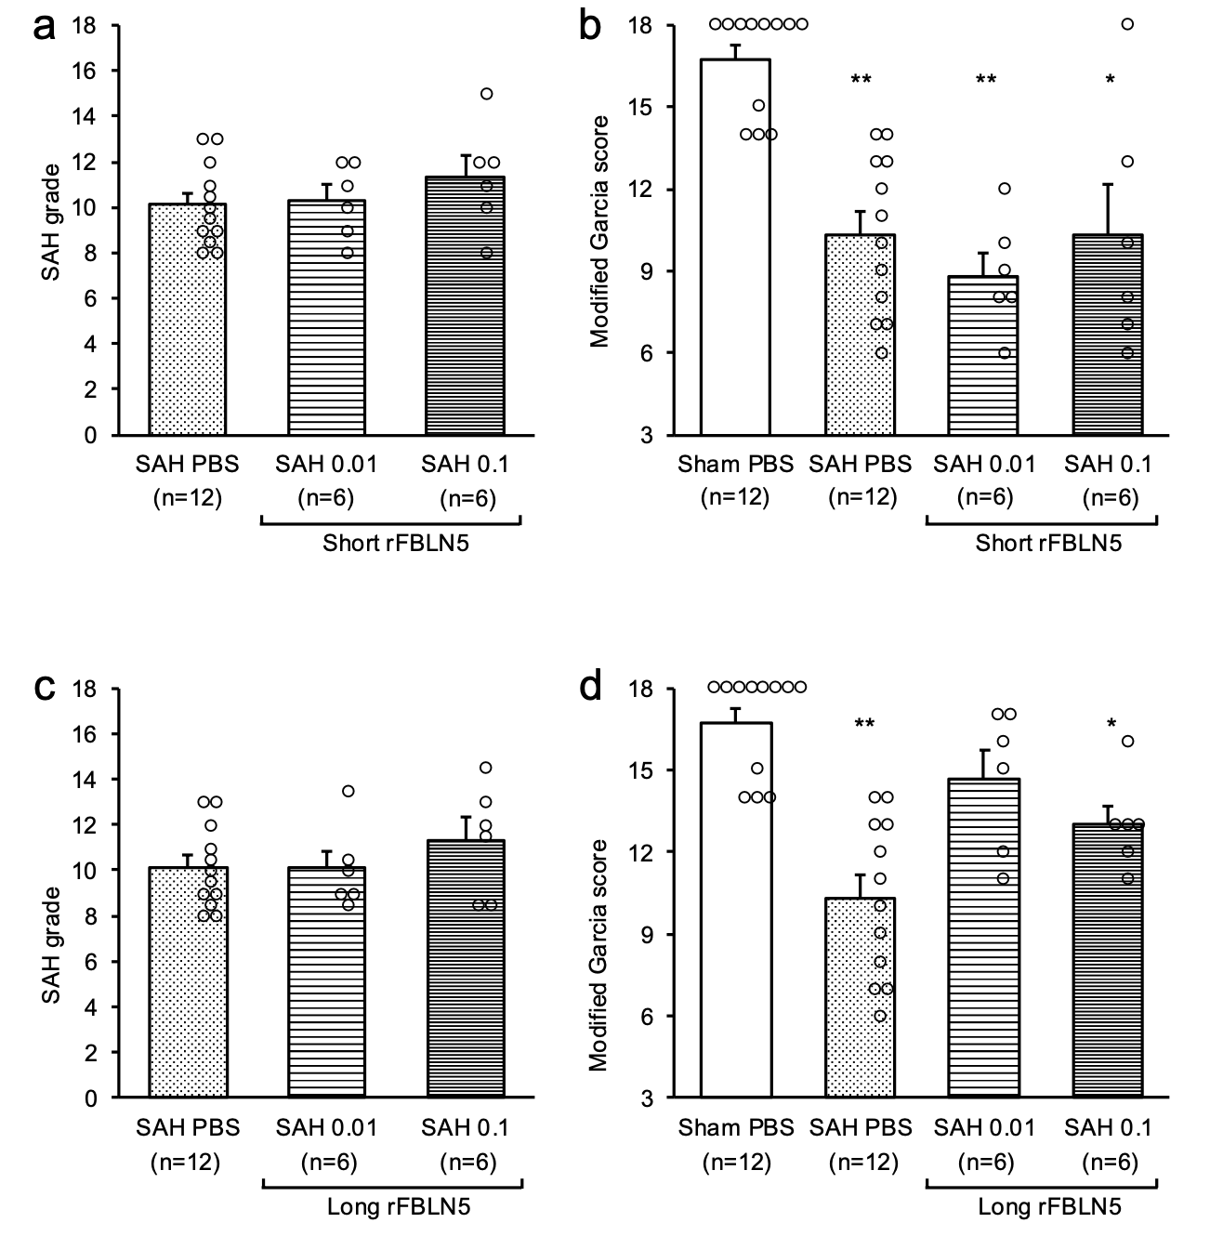

Supplementary Fig. S1 The effects of 2 dosages (0.01 or 0.1μg) of recombinant fibulin-5 (rFBLN5) administration on subarachnoid hemorrhage (SAH) grade (a, c) and neurological score (b, d) at 24 hours after SAH. To reduce the number of mice sacrificed, sham phosphate-buffered saline (PBS) mice and SAH PBS mice are duplicated in both analyses. *p<0.05 vs Sham PBS group, and **p<0.01 vs Sham PBS group; one-way ANOVA (a, c) or Kruskal-Wallis test (b, d)

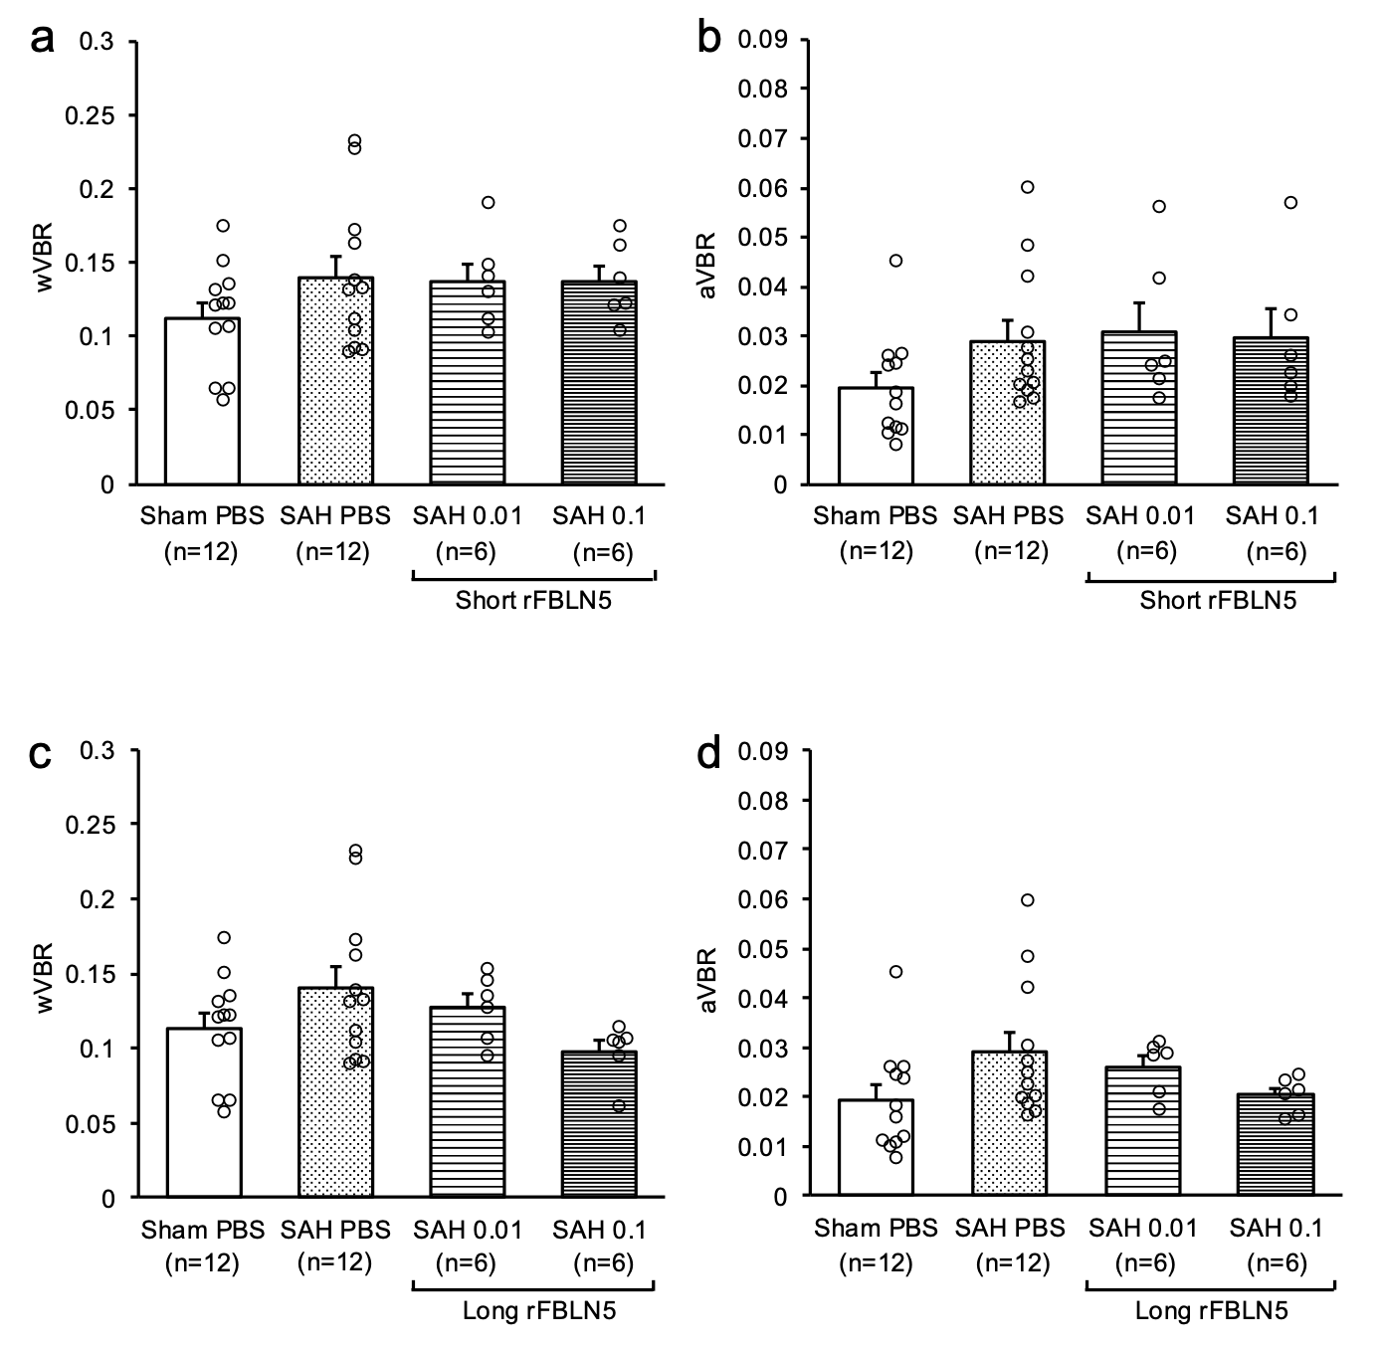

Supplementary Fig. S2 The effects of two dosages (0.01 or 0.1μg) of administered short or long recombinant fibulin-5 (rFBLN5) on ventricle-to-brain ratio at 24 hours after subarachnoid hemorrhage (SAH). There are no significant differences among the groups (a, one-way ANOVA; b–d, Kruskal-Wallis test). aVBR, area of ventricle-to-brain ratio; wVBR, width of ventricle-to-brain ratio; PBS, phosphate-buffered saline

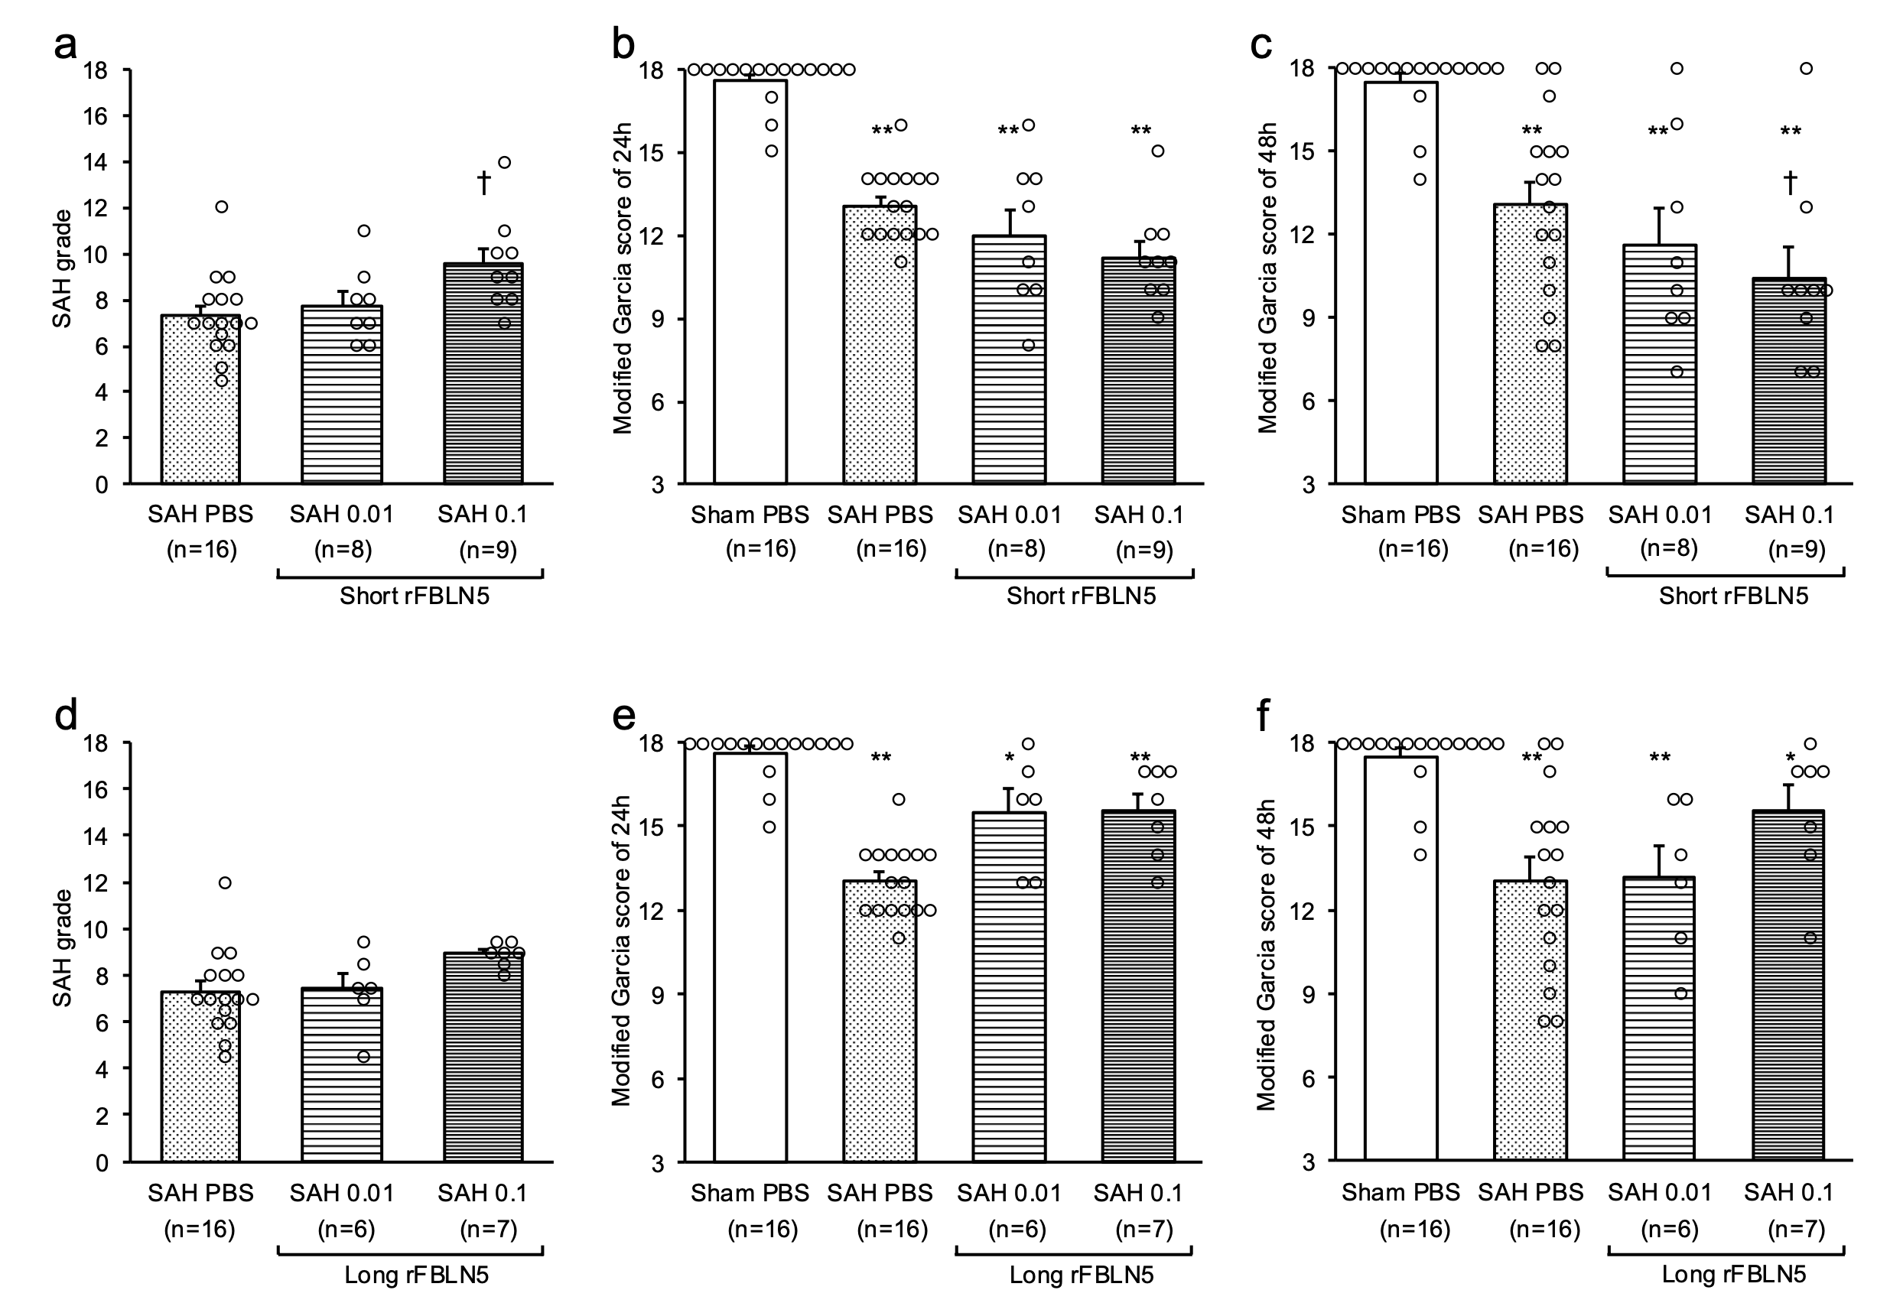

Supplementary Fig. S3 The effects of 2 dosages (0.01 or 0.1μg) of recombinant fibulin-5 (rFBLN5) administration on subarachnoid hemorrhage (SAH) grade (a, d) and neurological score at 24 hours (b, e) and at 48 hours (c, f) after SAH. To reduce the number of mice sacrificed, sham phosphate-buffered saline (PBS) mice and SAH PBS mice are duplicated in both analyses. *p<0.05 vs Sham PBS group, **p<0.01 vs Sham PBS group, and †p<0.05 vs SAH PBS group; one-way ANOVA (a, d) or Kruskal-Wallis test (b, c, e, f)

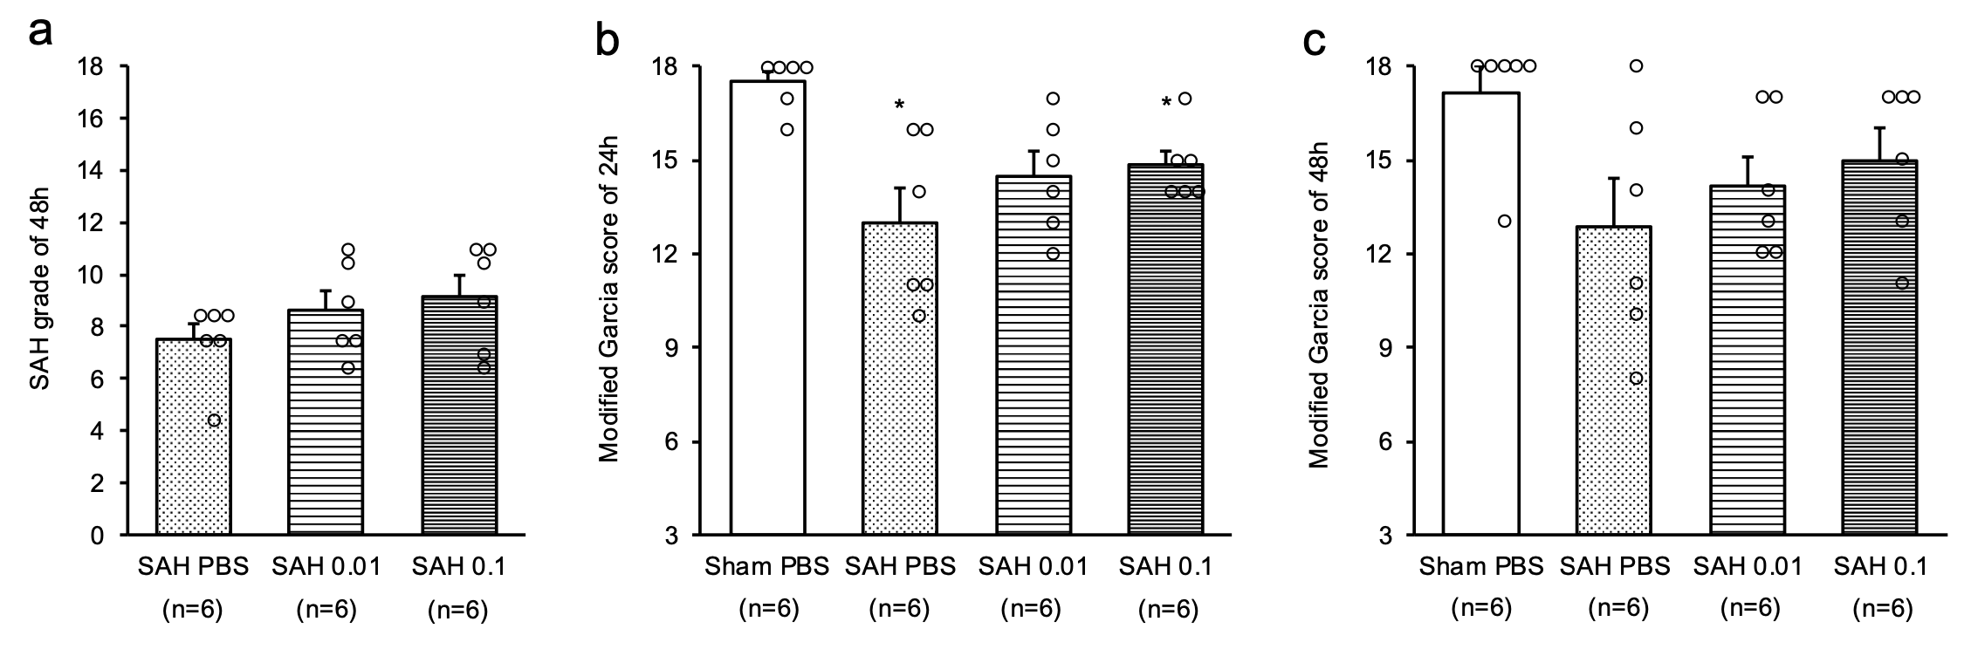

Supplementary Fig. S4 The effects of 2 dosages (0.01 or 0.1μg) of long recombinant fibulin-5 administration on subarachnoid hemorrhage (SAH) grade (a) and neurological score at 24 hours (b) and at 48 hours (c) after SAH. *p<0.05 vs Sham phosphate-buffered saline (PBS) group; Kruskal-Wallis test

