Supporting Information
A Self-Cleaning Hierarchical Thermal Cloak
Hetao Guo^{1,2}, Wenzhuo Li^{1,2}, Liran Jing^{1,2}, Xiaolong Yang^{1,2,a*}, Di Zhu^{1,2,b*}
¹College of Mechanical & Electrical Engineering, Nanjing University of Aeronautics and Astronautics, Nanjing 210016, China
²Jiangsu Key Laboratory of Precision and Micro-Manufacturing Technology, Nanjing University of Aeronautics and Astronautics, Nanjing 210016, PR China

E-mail: ªxlyang@nuaa.edu.cn, ^{b}dzhu@nuaa.edu.cn
The PDF file includes:
Supplementary Text S1 to S3
Figs. S1 to S11
Table S1 to S2
Legend for movies S1 to S8
References
Other Supplementary Material for this manuscript includes the following:
Movies S1 to S8
Source Data file

Supplementary Text

S1. Design strategy of Co-A
It is essential to consider how to achieve perfect compatibility between hydrophobic microcolumn structures and antenna elements. Our initial design for the hydrophobic microcolumns prioritizes the wettability control. The wettability of microcolumn arrays can typically be explained using either the Wenzel or Cassie-Baxter models. We favor the Cassie-Baxter model, as it minimizes the solid-liquid contact area and the resulted adhesion force, thereby enabling the rolling-off of impact droplets and the sweeping of contaminants. In this analysis, we assume that the microcolumns are sufficiently tall to suspend the droplet for stable Cassie-Baxter wetting state. Thus, the how the microcolumn width and period affect the expected contact angle can be potted (Fig. S1b and S1c) using Cassie-Baxter model, given by
(1)
f is the area fraction of the liquid-air interface, θ* is the contact angle of the liquid in the air (θ*=180°); θ_{Y} represents the intrinsic contact angle of liquid on smooth solid surface, which was measured at ~120°. As anticipated, narrower microcolumns and larger periods yield higher contact angles, as they reduce the contact area between the microcolumn and the droplet.
The antenna configured on top of the microcolumns has a thickness of 100 nm, a width of 1.1 μm, and a periodicity of 2.2 μm. From a microscopic point of view, the contact state between the liquid of droplet and top surface of the columns (including the patched antennas) aligns with the interactions described by the Wenzel model, as shown in Fig. S1a.
(2)
r represents the ratio of the real rough surface area to the projected perfectly smooth surface. It is thus clear that the contact between the deposited droplet and the Co-A structure is in the Cassie-Wenzel hybrid wetting state. However, it should be noted that the droplet pinning force is rather small that favorably ensures the droplet rolling off the surface and self-cleaning of contaminants.
A thermal system model of the microcolumn array in an air environment was developed to analyze how microcolumn height impacts the structure's cooling performance. In our model, the microcolumn array is positioned within a larger air domain to simulate the cooling effect of air on the structure. The boundary surrounding the air domain features heat convection with a heat transfer coefficient of 4 W/(m²·K). To simulate radiative cooling enhanced by the antenna, the average emissivity of the top surface of each microcolumn is set to 0.4, while the emissivity of the remaining surfaces is reduced to 0.1 to limit excess heat radiation (Fig. S1f). The bottom of the microcolumn array is subjected to varying thermal power densities, and the average surface temperature is analyzed as a function of microcolumn width and height (Fig. S1g and S1h). The increase of the width directly increases the proportion of the high emissivity of the whole surface of the microcolumn, which shows the dependence on radiation cooling. The decrease in temperature due to increased altitude can be attributed to increased air convection. Considering the effect of the microcolumn on antenna and radiative cooling and the difficulty of manufacturing, we set the width, period and height of the microcolumn to be 100 μm, 200 μm and 250 μm, respectively. The fluent model was used to preliminarily estimate the contact angle, as shown in Fig. S1d and S1e, in accordance with the Cassie-Baxter model.
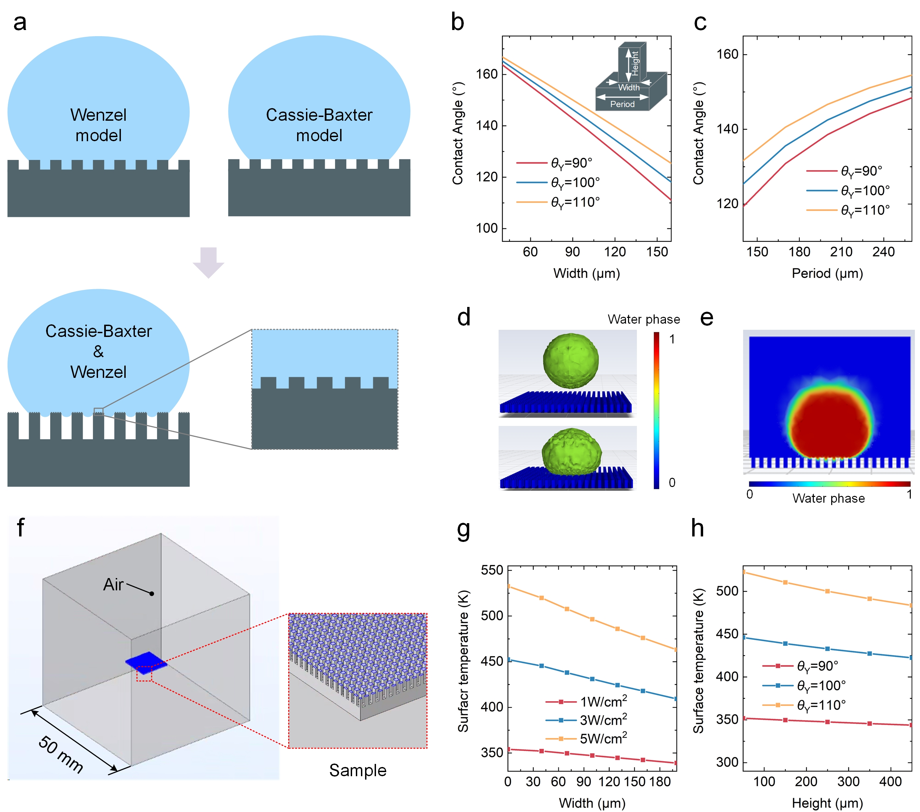
Fig. S1. Self-cleaning microcolumn design: (a) Wenzel and Cassie-Baxter model wetting behavior; influence of microcolumn width (b) and period (c) on the contact angle; (d) 3D view of the fluent simulation of contact angle prediction after droplet dropping; (e) cross-sectional profile of droplet in (d); (f) thermal system model of microcolumn array; effect of width (g) and height (h) of microcolumn on average surface temperature.
The limited area of the top surface of the microcolumn may restrict the antenna placement. To address this, we used Lumerical FDTD simulation software to investigate the dependence of the number of antennas on the emissivity (Fig. S2). Our findings indicate that the width of microcolumn should be more than 10 times larger than the antenna period to achieve the desired radiation performance.
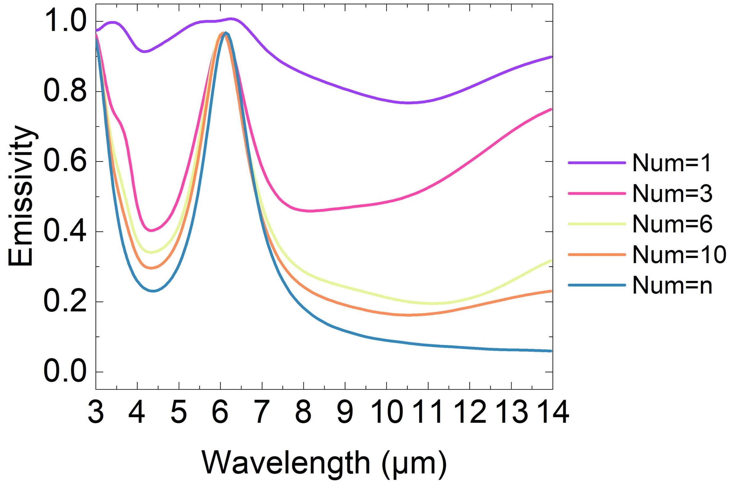
Fig. S2. Effect of the period number of antennas on emissivity.

S2. Manufacturing the antenna and Co-A via femtosecond laser direct writing system
First step of manufacturing the f Co-A is creating the microcolumn arrays using deep silicon etching (Fig. S3). During the etching, lithography was first employed to pattern the mask. A magnetron sputtering system (DM400, China) was then used to deposit layers of Pt and ZrO₂ onto the surface of the microcolumn array. Finally, a femtosecond laser direct writing system was utilized to precisely tailor the top layer of Pt on the microcolumn surface, completing the fabrication of the nano antennas on top of the microcolumns.
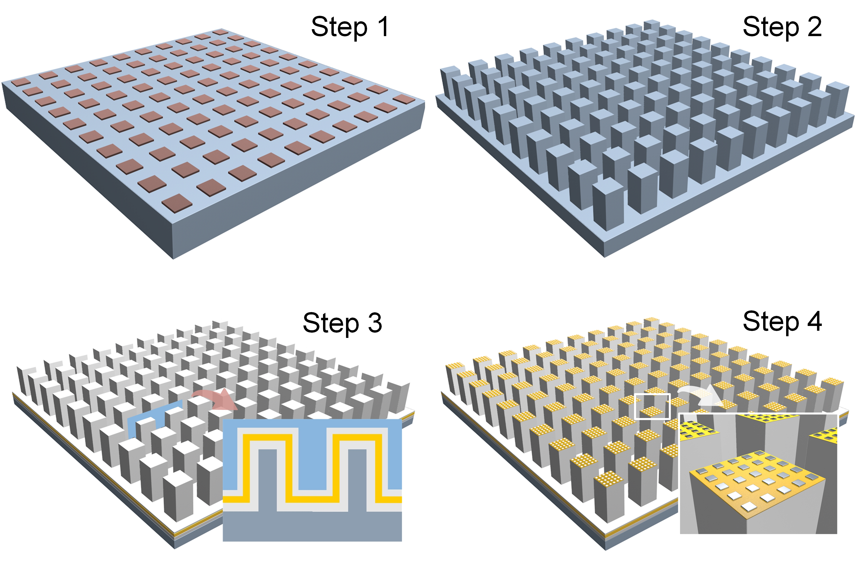
Fig. S3. Fabrication routing of Co-A manufacturing.
A self-developed femtosecond laser direct writing system was employed to fabricate the nano antennas. This system was composed of several key components, including a nano-precision moving platform (Aerotech, USA), objective lens (Mitotoyo, Japan), laser light source (Pharos, LTU), observation light source, observation camera (DAHENG, China), and mirrors. Large samples, spanning tens of millimeters, were successfully manufactured, as depicted in the illustration in Fig. S4.
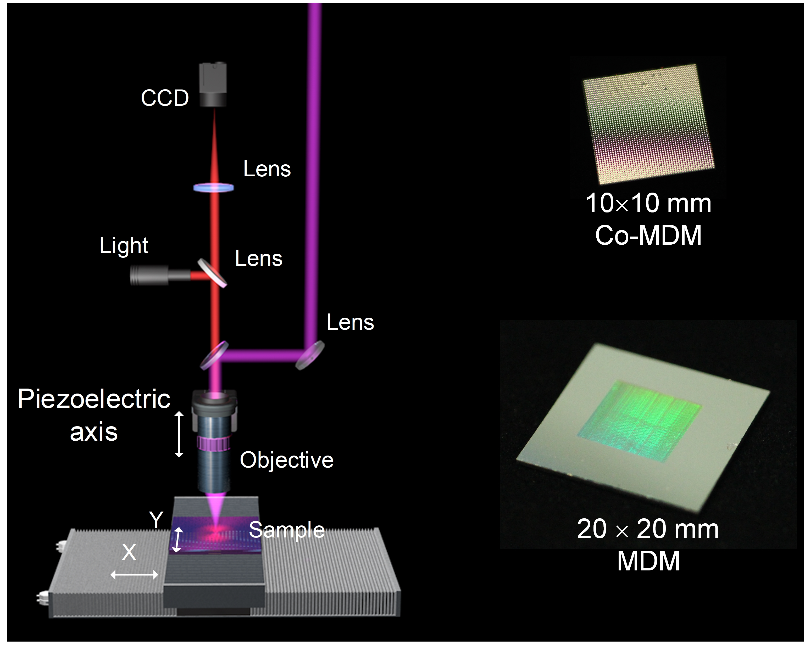
Fig. S4. Femtosecond laser direct writing system. Inserts are the optical images of
Co-A and antennas.
Two fabrication strategies, single-pulse and multi-pulse processing at the same position, were compared (Fig. S5). The single-pulse method can produce sharp edges, but width inaccuracies remain an issue. As the spot overlap rate increased, subsequent nano film layer risked being damaged. In the multi-pulse approach, when the spot overlap rate was below 0.7, the coupling effect between pulses was limited, resulting in more residue within the laser ablation zone. Optimal fabrication quality was achieved when the overlap rate reached 0.7. However, further increase of the overlap rate resulted in obvious damages of the subsequent film layers, and the nano particle deposition on the surface, significantly degrading the fabrication quality.
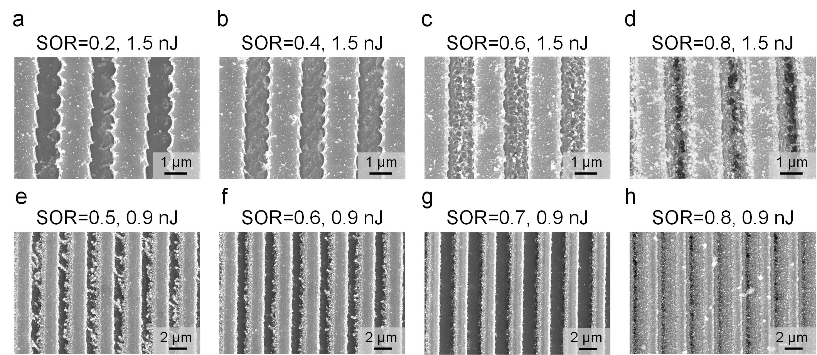
Fig. S5. Micro-morphology of the Pt nano films that were tailored with different spot overlap rates: morphologies obtained using single-pulse (a-d) and multi-pulse (e-h) fabrication strategies at different spot overlap rates.
When the film was subjected to multiple tailoring, the enhancement effect of the precursor structure on subsequent laser energy absorption was simulated, as shown in Fig. S6. The primary source of this absorption enhancement is the scattering absorption of nano particles or nano holes. The absorption of laser energy is significantly enhanced.
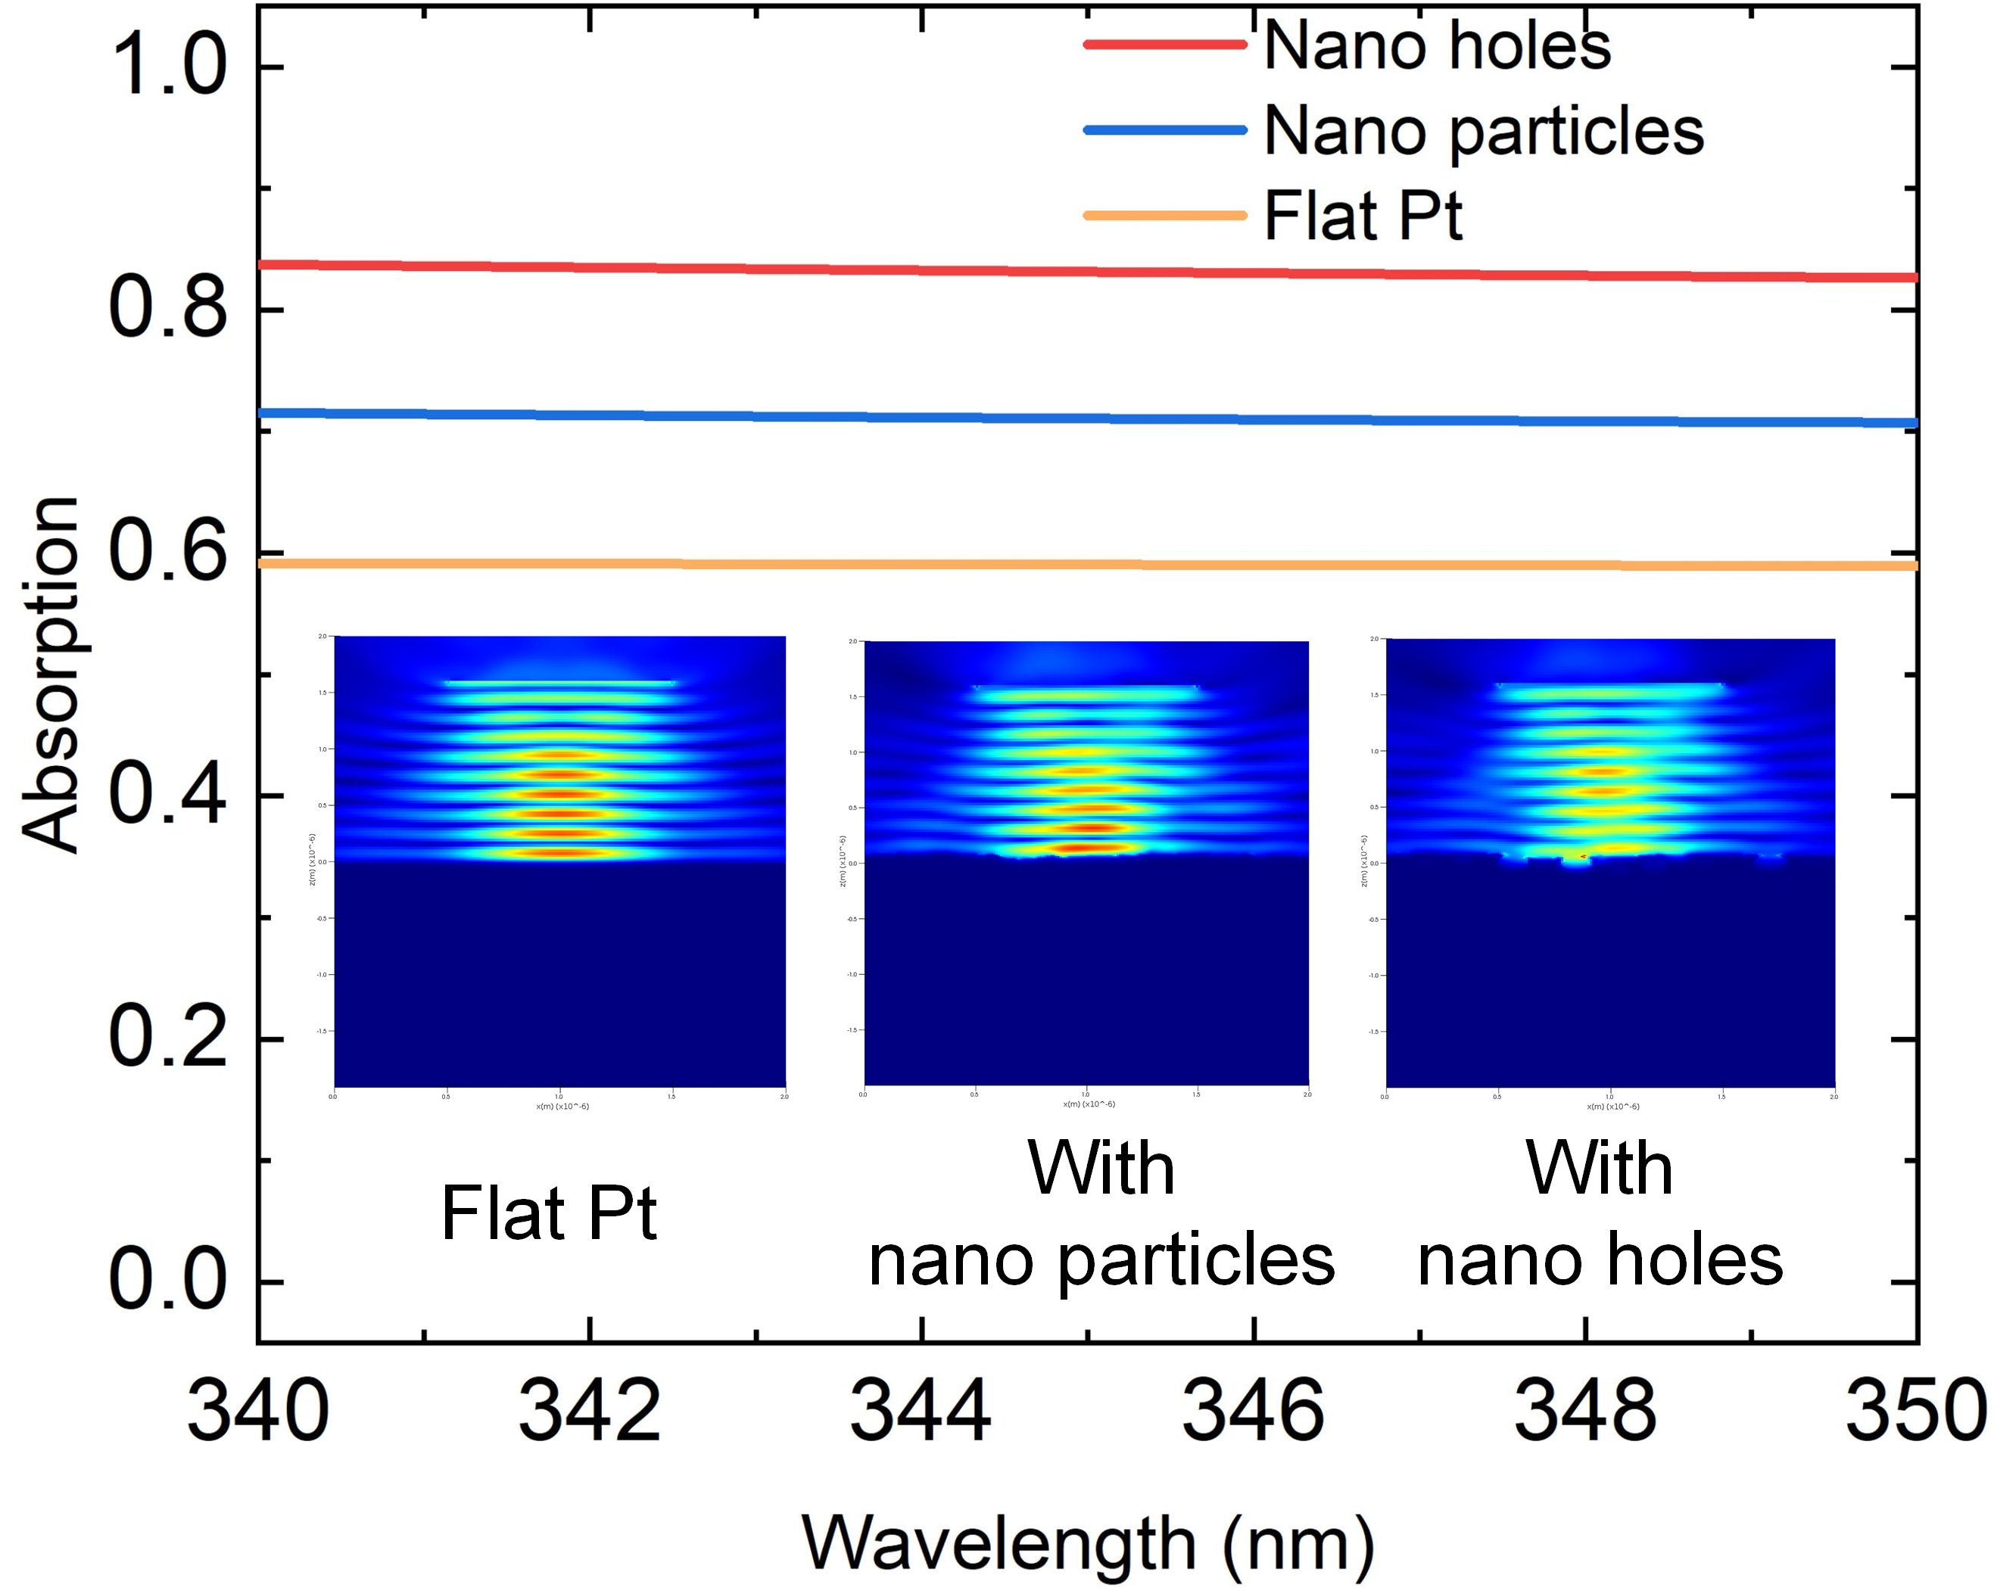
Fig. S6. Enhancement effect of precursor structure on laser energy absorption.
How the deflection distances affect the microscopic morphology during the multiple tailoring was illustrated in Fig. S7. At an offset of 0, multiple tailoring did not affect the morphology, which was quite encouraging. This indicated that the crossed tracks during the tailoring process remained intact; although the film at the top of the crossed area was removed, the underlying layer was undamaged. A limited offset enables the machining of high-quality profiles. Compared to single tailoring, subsequent tailoring can clean the ablation area and improve overall fabrication quality. However, excessive trajectory offsets lead to significant residue in the ablation area.
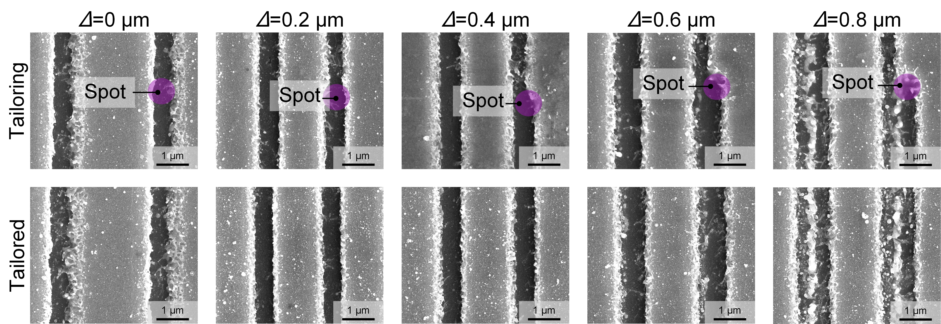
Fig. S7. Multiple tailoring of antenna spacing.

S3. Various properties of Co-A
SEM (FEI Scios2 - ThermoFisher, USA) was utilized to characterize the antennas on top of the microcolumns in detail, as shown in Fig. S8. The images revealed that high-quality antennas were obtained by optimizing the spot overlap rate and single pulse energy, demonstrating the significant potential of femtosecond laser direct writing for nano film tailoring. Notably, after understanding the rules of nanofilm tailoring, we successfully created the antennas with side length of ~700 nm (Fig. S9), which closed to the diffraction limit of the used laser.
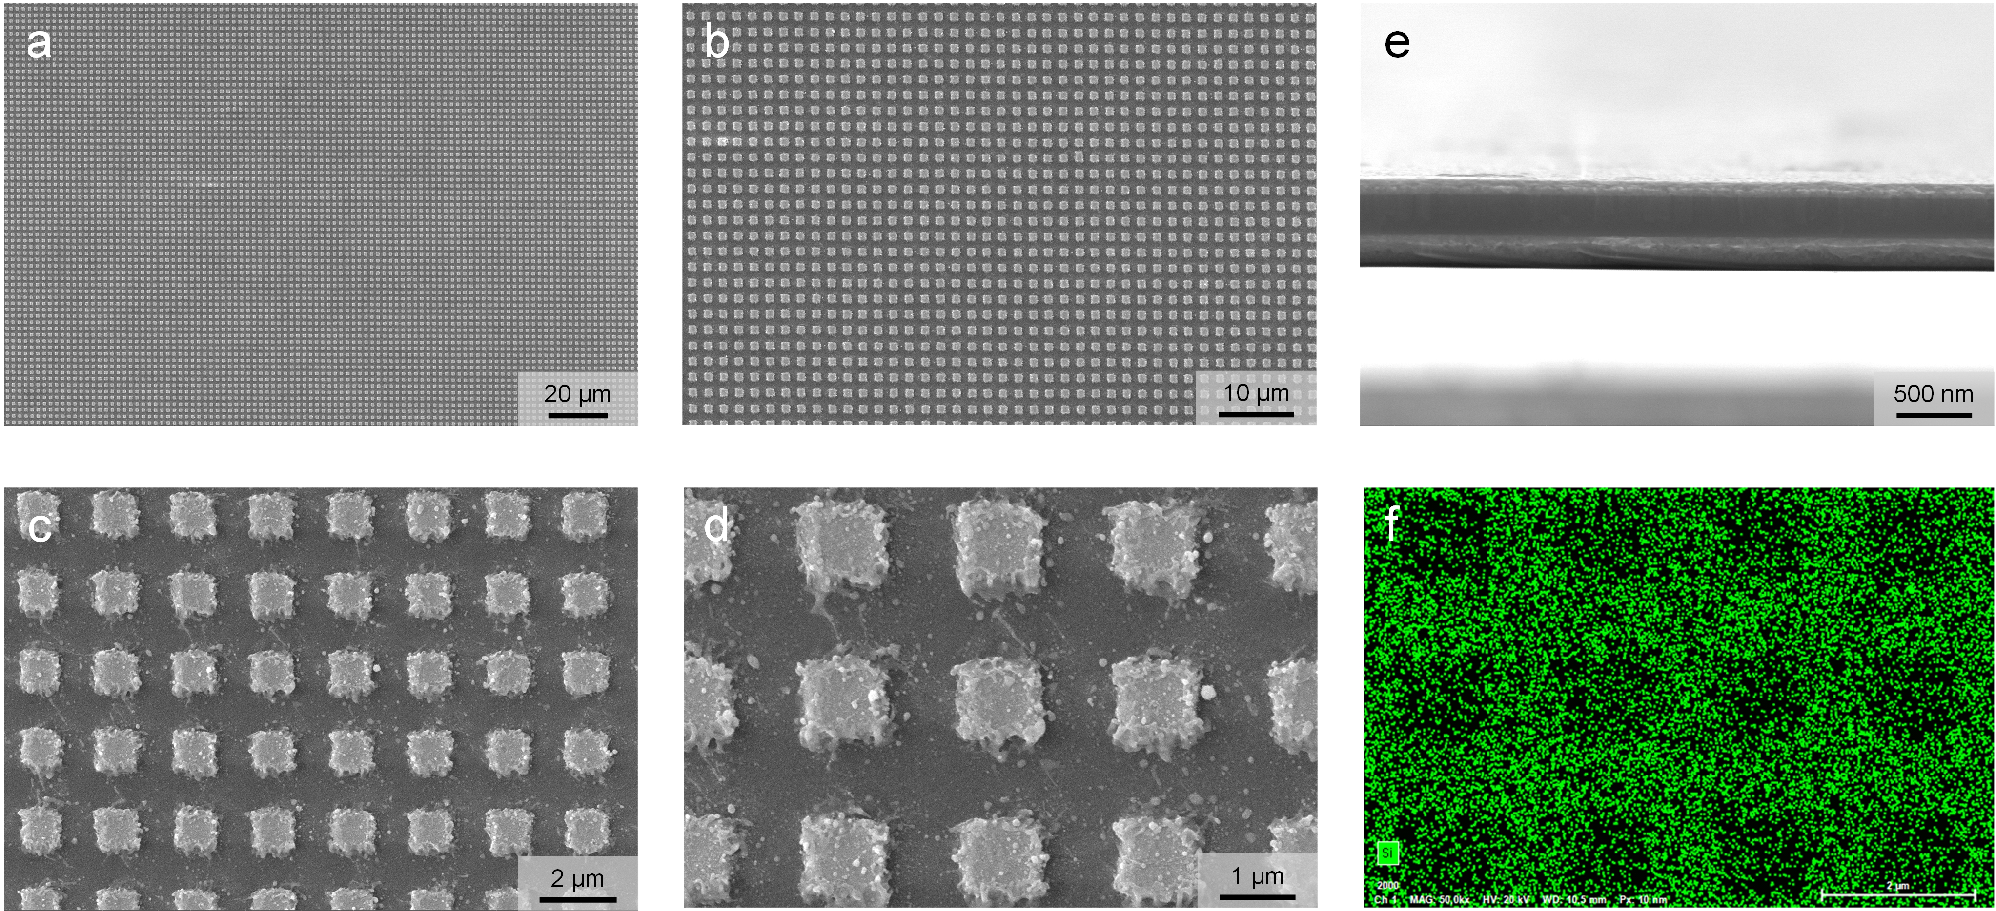
Fig. S8. Micro-morphology of large-area antennas: (a-d) SEM images of the antennas with different magnification; (e) SEM image of the cross section of the multi-layer films, which displays the Pt, ZrO₂, Pt, and Si from top to bottom; (f) EDS images of the Si substrate that was patched with the Pt antenna.
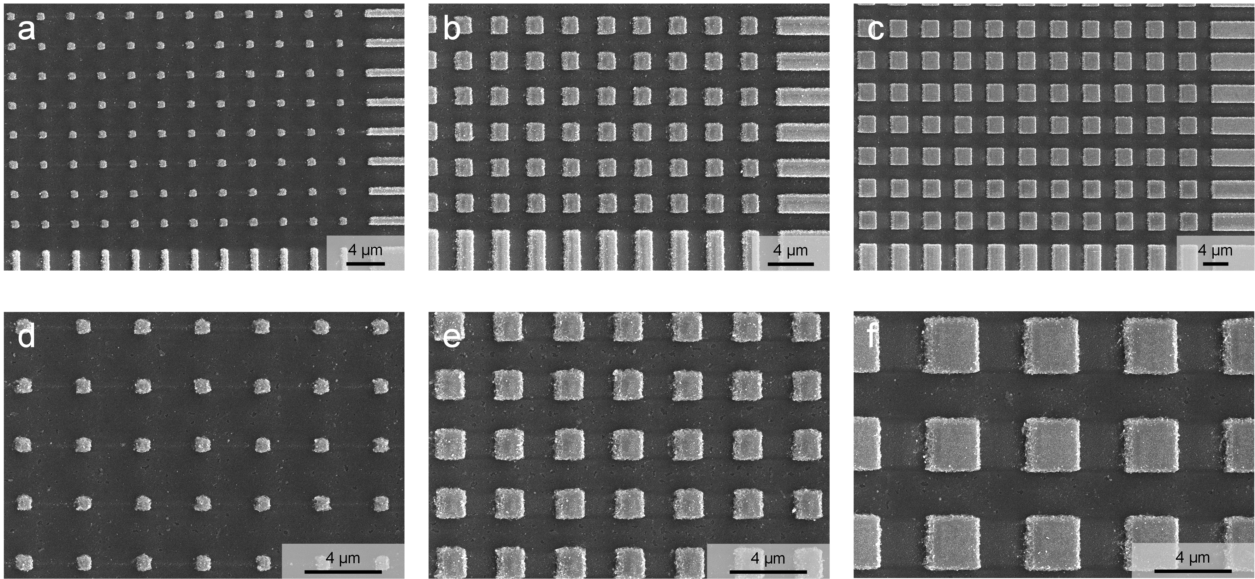
Fig. S9. Antennas with different sizes manufactured by femtosecond laser direct writing: (a-c) the nano-antennas of different sizes were partially manufactured; (d-f) local close-up of nano antennas of different sizes.
A closed temperature test system was designed to test the thermal performance of the fabricated thermal cloak, as illustrated in Fig. S10. The sample and ceramic heater were housed within a closed box featuring a black flannel interior to prevent interference from external airflow. An infrared camera was positioned on top of the box to record the apparent radiation temperature of the sample.
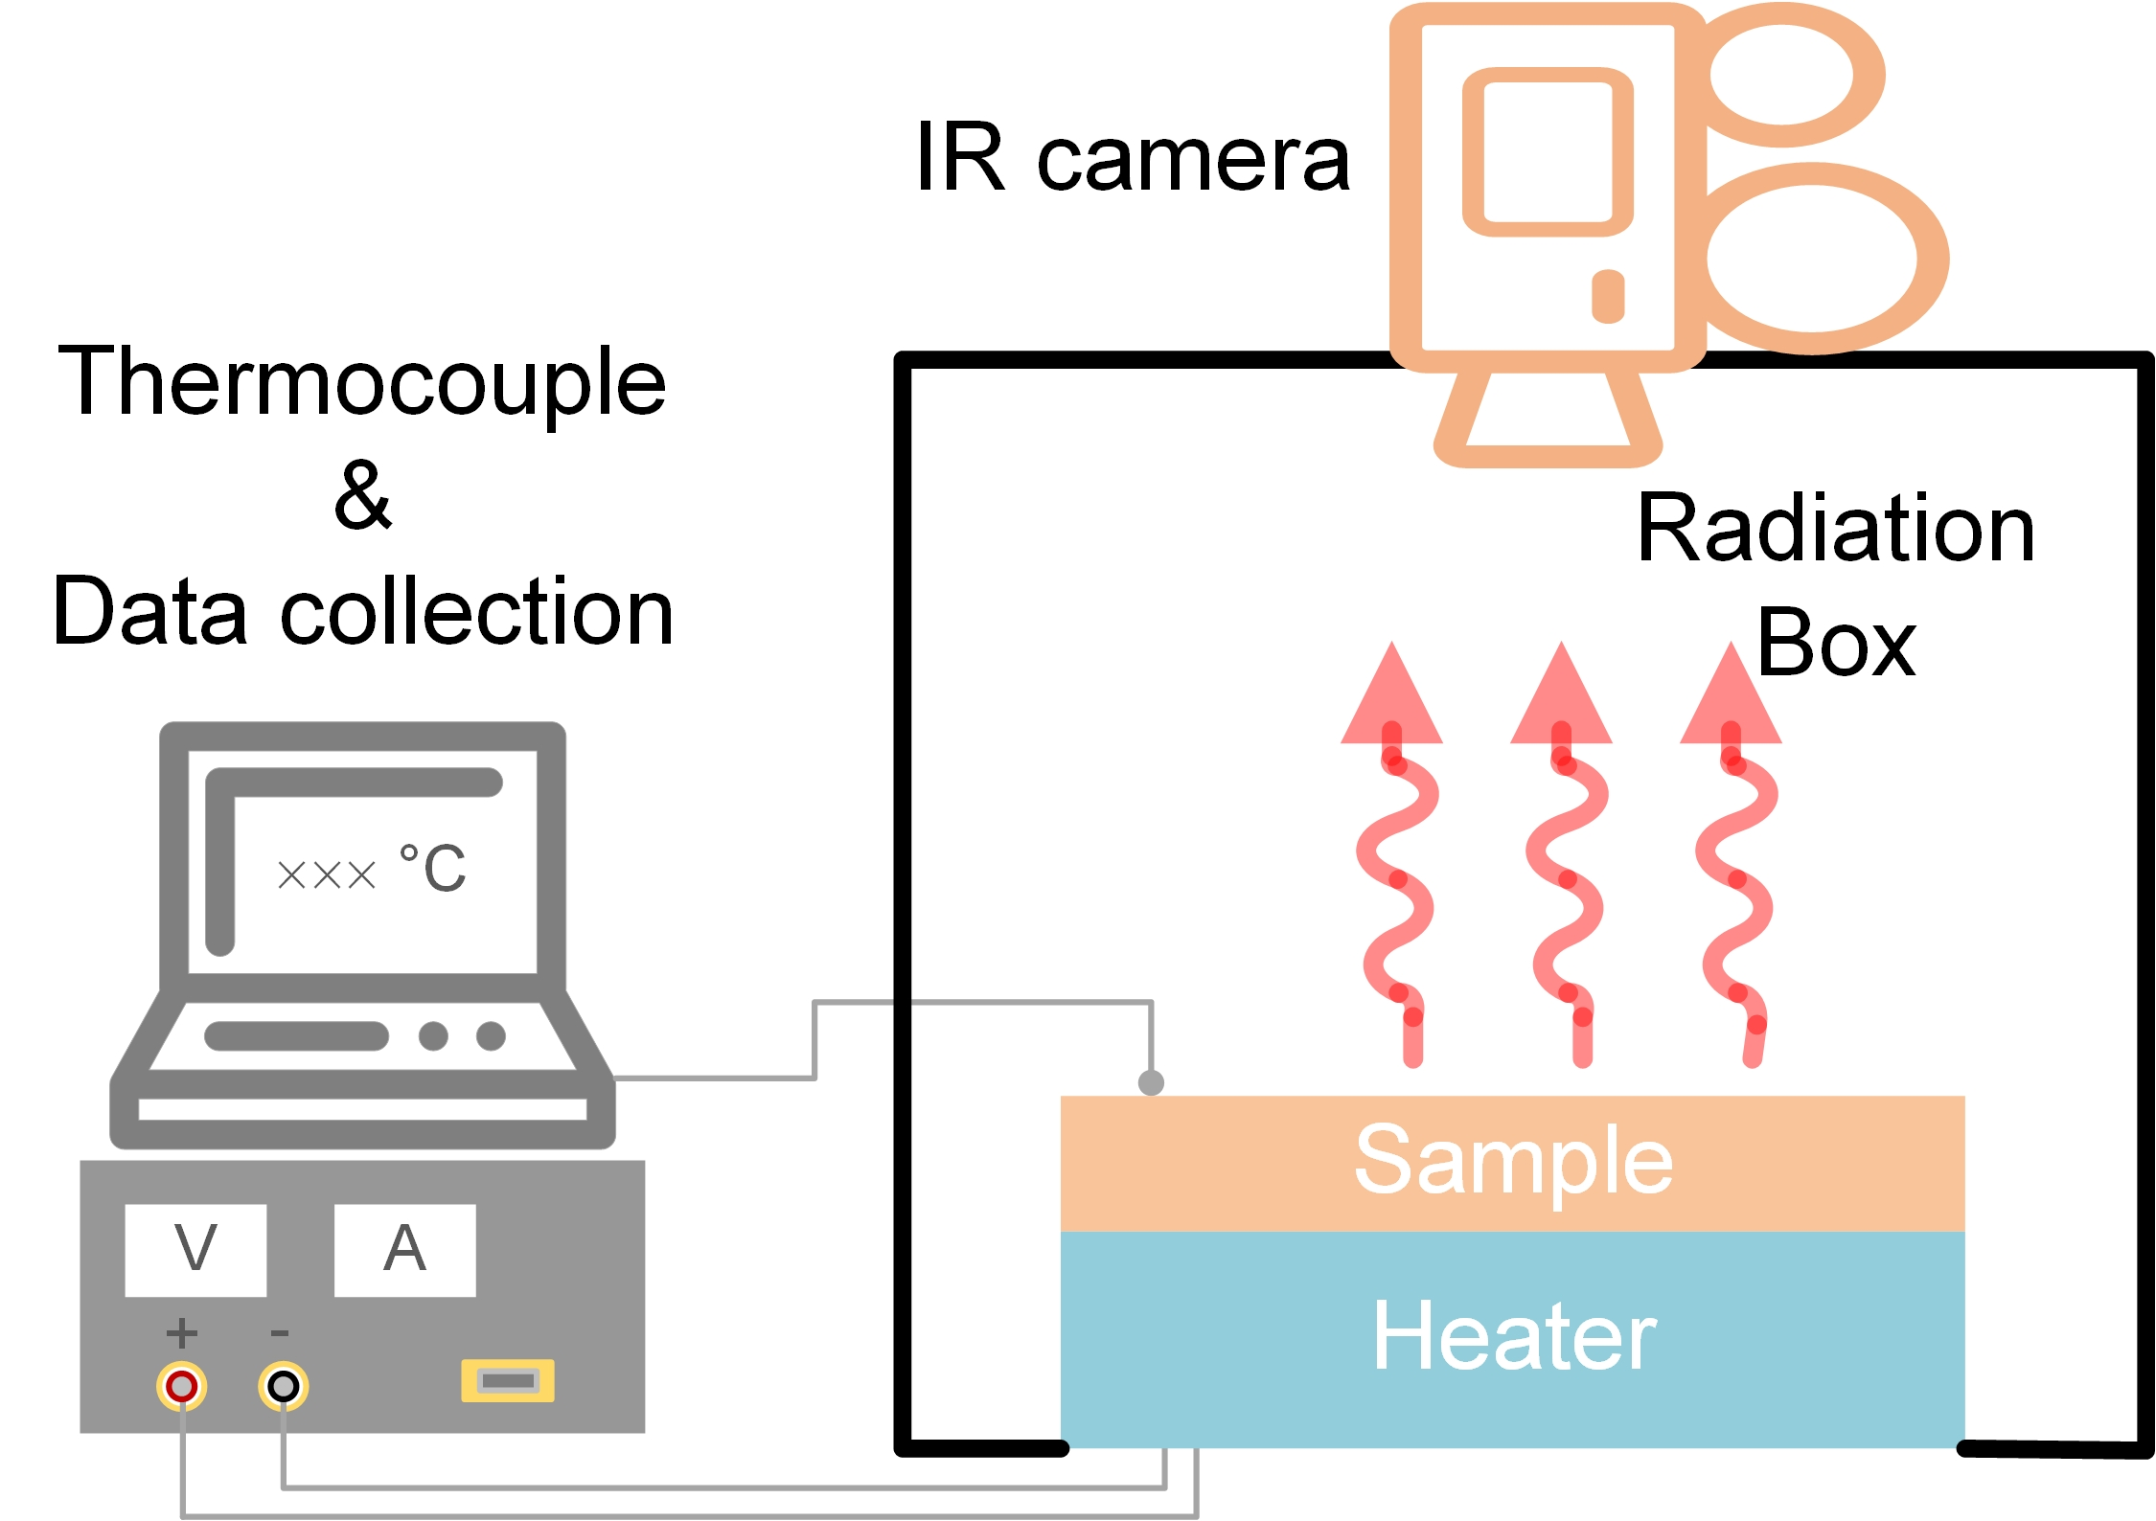
Fig. S10. Schematic diagram of a surface temperature measuring system.
What’s more, the robustness of the antennas in practical applications is a critical consideration. To address this, we constructed a thermal load system, as shown in Fig. S11. This system subjects the antennas to horizontal high-speed thermal airflow. Various test conditions were applied, and the results are promising. Even after being exposed to 340 km/h, 200°C thermal airflow for 1 hour, the infrared radiation characteristics of the nano antennas remained unchanged.
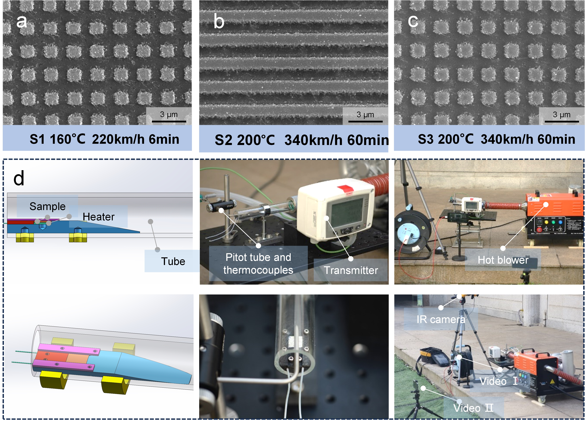
Fig. S11. Horizontal high-speed thermal load test of antennas; (a-c) different antenna structures and test conditions; (d) thermal load system composition.
The thermal expansion behavior of Pt and ZrO₂ is shown in Table S1.
Table S1. The size change of different materials in high temperature.
Material | Coefficient of linear expansion (900K) | Melt point | Original size |  | Δ
Material | Coefficient of linear expansion (900K) | Melt point | Width | Thickness | Width | Thickness
Pt¹ | 10.7╳10⁻⁶ /K | 2045 K | 1100 nm | 100 nm | 7.4 nm | 0.7 nm
ZrO₂² | 22╳10⁻⁶ /K | 2988 K | / | 255 nm | / | 3.5 nm
To provide a more comprehensive evaluation of the proposed thermal cloak, we conducted a comparative analysis with recently reported designs, as summarized in Table S2. The relevant calculations have been described in detail in our previous work³. Beyond achieving radiation cooling and infrared invisibility, our structure exhibited superior performance in multiple aspects, including temperature load, robustness, and self-cleaning capabilities.
Table S2. Comparison of comprehensive performance of different thermal cloaks.
Structure | Non-atmospheric window (200 ℃) |  | Atmospheric window (200 ℃) |  | Temperature load  (℃) | Anti-erosion | Self-  cleaning
Structure |  | Radiation cooling Power (W/m²) |  | Detectable  IR radiation Power (W/m²) | Temperature load  (℃) | Anti-erosion | Self-  cleaning
Ge/ZnS⁴ | 0.615 | 1574.9 | 0.127 | 338.9 | 180 | No | No
Al₂O₃/Ge/ZnS/GST/Ni⁵ | 0.446 | 988.9 | 0.239 | 464.8 | 180 | No | No
Ge/ZnS/Pt/Ag/Au/SiO₂⁶ | 0.745 | 1723.9 | 0.264 | 563.2 | 227 | No | No
ITO/ZnS⁷ | 0.637 | 1444.2 | 0.272 | 551.1 | 427 | No | No
Au-Si₃N₄-Au⁸ | 0.354 | 820.9 | 0.205 | 449.4 | 37 | No | No
Si/GST/Au⁹ | 0.734 | 1588.1 | 0.356 | 664.4 | 160 | No | No
Au- Si₃N₄-ITO¹⁰ | 0.522 | 1167.8 | 0.298 | 544.1 | 40 | No | No
VO₂/SiO₂/ITO¹¹ | 0.523 | 1130.9 | 0.308 | 575.4 | 130 | No | No
Ge/SiO₂/Pt/ZnS/Au¹² | 0.504 | 1165.4 | 0.236 | 490.1 | 160 | No | No
OPA/Cu¹³ | 0.248 | 565.6 | 0.191 | 436.7 | 130 | No | No
Cu foil¹⁴ | 0.224 | 495.7 | 0.224 | 434.4 | 100 | No | Yes
Pt-ZrO₂-Pt  (This work) | 0.487 | 1198.1 | 0.215 | 395.1 | 600 | Yes | Yes

Legend for movies
Movie S1. The wetting behavior of the micro-column hydrophobic array was investigated through simulations conducted using ANSYS Fluent. The model employed an open boundary condition, with a 2 mm diameter droplet released freely from a height of 1.3 mm directly above the surface.
Movie S2. A real-time laser focus control scheme, based on visual feedback, is employed to assist in femtosecond laser direct writing of antenna arrays. Using an optical camera coaxial with the femtosecond laser, real-time images are captured and processed in MATLAB into analog signals, as represented by the red curve in the top-left corner of the video. The black curve indicates the real-time Z-axis coordinate of the objective. Notably, image processing operates continuously, while control of the Z-axis can be independently managed through numerical control instructions.
Movie S3. The arrayed antennas were tailored by femtosecond laser. The metal film has already been tailored into a regular grating array along the X-direction, and the tailoring along the Y-direction is currently in progress, with a speed of 10 mm/s.
Movie S4. The manufacturing process of Co-A was showed here. The array of microcolumns was clearly visible, and the femtosecond laser was precisely tailoring the tops of the microcolumns. Currently, the tailoring of the grating along the X-direction was in process.
Movie S5. The wetting behavior of Co-A and Cr were recorded using high-speed photography. Manganese dioxide particles were employed to simulate pollutants like dust, which disrupt the carefully designed emission behavior. After droplets falling onto various surfaces, the distinct cleaning behavior on each surface was clearly demonstrated.
Movie S6. In the infrared view, the surfaces of Co-A and Cr gradually become covered with manganese oxide particles, leading to a sharp increase in infrared radiation and disrupting the infrared camouflage properties of both surfaces. Interestingly, the manganese oxide particles on the Co-A surface were trapped and eventually removed by the droplets, restoring Co-A’ s infrared camouflage ability. In contrast, the Cr surface exhibited a lower contact angle, causing the droplet to adhere to the surface along with the manganese oxide particles, rendering its infrared camouflage capability permanently ineffective.
Movie S7. A horizontal high-speed thermal load test system was constructed and used to evaluate the samples. The test conditions and real-time view of the test were shown in detail here. The pitot tube test data was displayed in the upper left corner of the screen. The test position was 4 mm above the sample surface, and the pitot tube has a diameter of 6 mm.
Movie S8. High-speed photography was adopted to capture the droplet bounce behavior of Co-A sample before and after thermal load. The results demonstrated that the structure exhibited strong robustness.

Reference
1. Hahn, T., Kirby, R. Thermal expansion of platinum from 293 to 1900 K. In: AIP Conference Proceedings). American Institute of Physics (1972).
2. Jin, L., et al. Theoretical calculations of thermodynamic properties of tetragonal ZrO2. Comput. Mater. Sci. 65, 170-174 (2012).
3. Guo, H., et al. Easy-to-Manufacture In-Line 2D Nano Antenna for Enhanced Radiation-Cooled IR Camouflage. ACS Photonics 10, 1405-1415 (2023).
4. Zhu, H., et al. Multispectral camouflage for infrared, visible, lasers and microwave with radiative cooling. Nat. Commun. 12, 1805 (2021).
5. Qin, B., et al. Whole-infrared-band camouflage with dual-band radiative heat dissipation. Light Sci. Appl. 12, 246 (2023).
6. Li, X., et al. Multispectral camouflage nanostructure design based on a particle swarm optimization algorithm for color camouflage, infrared camouflage, laser stealth, and heat dissipation. Opt. Express 31, 44811-44822 (2023).
7. Zhang, L., et al. A thermally robust and optically transparent infrared selective emitter for compatible camouflage. J. Mater. Chem. C 9, 15018-15025 (2021).
8. Lee, N., et al. Flexible assembled metamaterials for infrared and microwave camouflage. Adv. Opt. Mater. 10, 2200448 (2022).
9. Pan, M., et al. Multi-band middle-infrared-compatible camouflage with thermal management via simple photonic structures. Nano Energy 69, 104449 (2020).
10. Lee, N., et al. Transparent metamaterials for multispectral camouflage with thermal management. Int. J. Heat Mass Transf. 173, 121173 (2021).
11. Gui, B., et al. Spectrally-switchable infrared selective emitters for adaptive camouflage. Infrared Phys. Techn. 126, 104363 (2022).
12. Jiang, X., et al. Implementing of infrared camouflage with thermal management based on inverse design and hierarchical metamaterial. Nanophotonics 12, 1891-1902 (2023).
13. Ding, D., et al. Porous Nanostructured Composite Film for Visible-to-Infrared Camouflage with Thermal Management. ACS Appl. Mater. Interfaces 14, 24690-24696 (2022).
14. Yang, J.-H., et al. Flexible Superhydrophobic Infrared Invisibility Cloak for Hiding Objects From Both Thermal and Laser Detections. J. Lightwave Technol. 42, 5974-5980 (2024).

