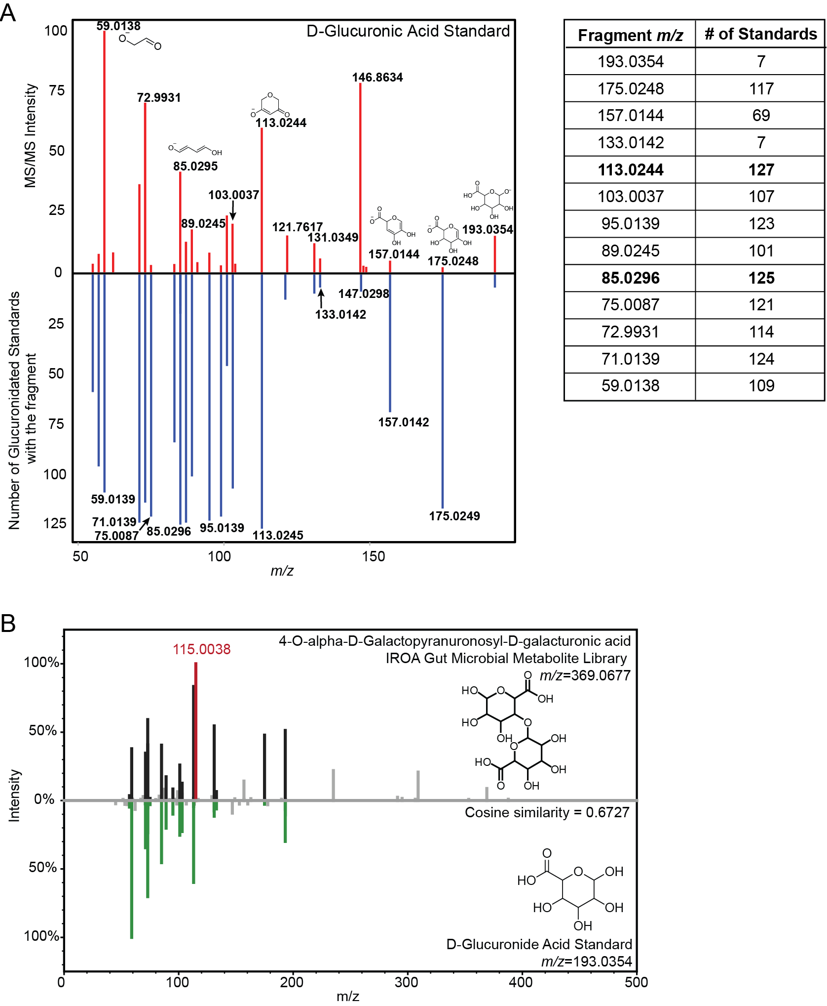
Supplemental Figure S1. Negative ESI Glucuronidated Fragmentation. (A) Negative ESI plot of MS/MS fragmentation spectra from the D-glucuronic acid standard (top) compared to the number of standards each fragment was detected in, calculated from all glucuronidated standards detected in negative ESI (bottom). The count values for key fragments are listed in the table to the right of the plot. (B) Example MS/MS mirror plot of a galacturonic acid metabolite (top) compared to glucuronic acid (bottom), showing the characteristic galacturonic fragment (m/z 115.0038) in red.

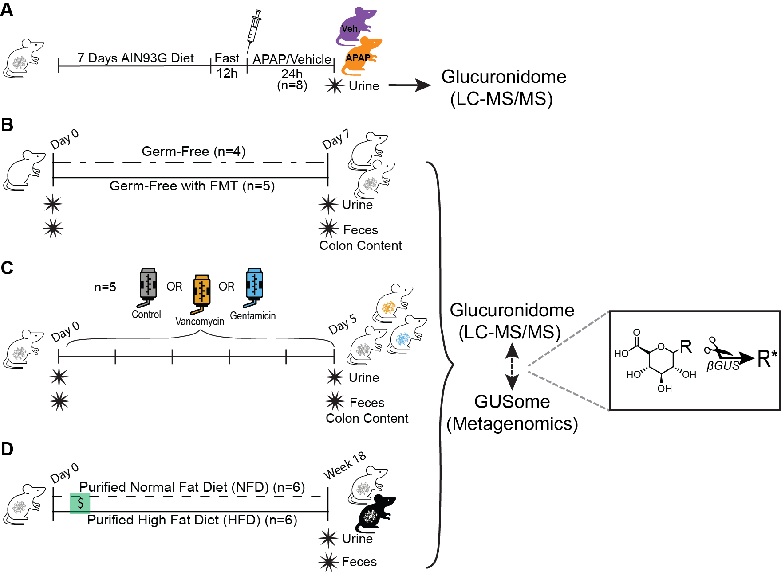
Supplementary Figure S2. Mouse Experiment Designs. (A) Conventional C57BL/6J mice were fed pelleted AIN93G diet for 7 days before being fasted for 12 h and then receiving intraperitoneal injections of vehicle or APAP (300 mg/kg) (n=8/group). Urine was collected 24 h post injection. AIN93G feeding was resumed post injection. (B) Germ-free C57BL/6J mice received an oral gavage with vehicle (BHI-CHV w/ 20% glycerol) or FMT (BHI-CHV w/ 20% glycerol + 10% weight/volume conventional mouse feces) and were allowed to colonize for 7 days. Urine and feces were collected on day 0 (baseline). Urine, feces, serum, and colon contents were collected on day 7. (C) Conventional C57BL/6J mice were administered low dose vancomycin (45 mg/L) or gentamicin (35 mg/L) in drinking water for 5 days. Control was untreated water. Urine and feces were collected at baseline (day 0) and urine, feces, serum, and colon contents were collected at termination on day 5. (D) Conventional C57BL/6J mice were fed either purified normal fat diet (NFD, control) or purified high fat diet (HFD, treatment) for 18-weeks. $ indicates 5 continuous days, in the second week of diet, of consuming vehicle (acetone) dough pills. Urine and feces were collected after 18 weeks of diet (16 weeks post dough pills).

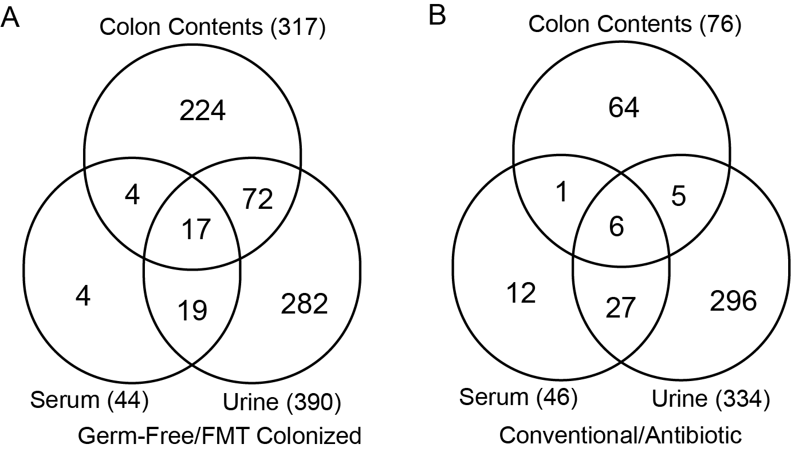

Supplemental Figure S3: Matrix glucuronidome comparisons between FMT and ABX experiments. (A) Number of glucuronidated features detected in colonic contents, serum and urine for GF and FMT colonized mice. (B) Number of glucuronidated features detected in colonic contents, serum and urine of conventional and antibiotic treated mice. The total number of glucuronidated features for each sample type is in parentheses.

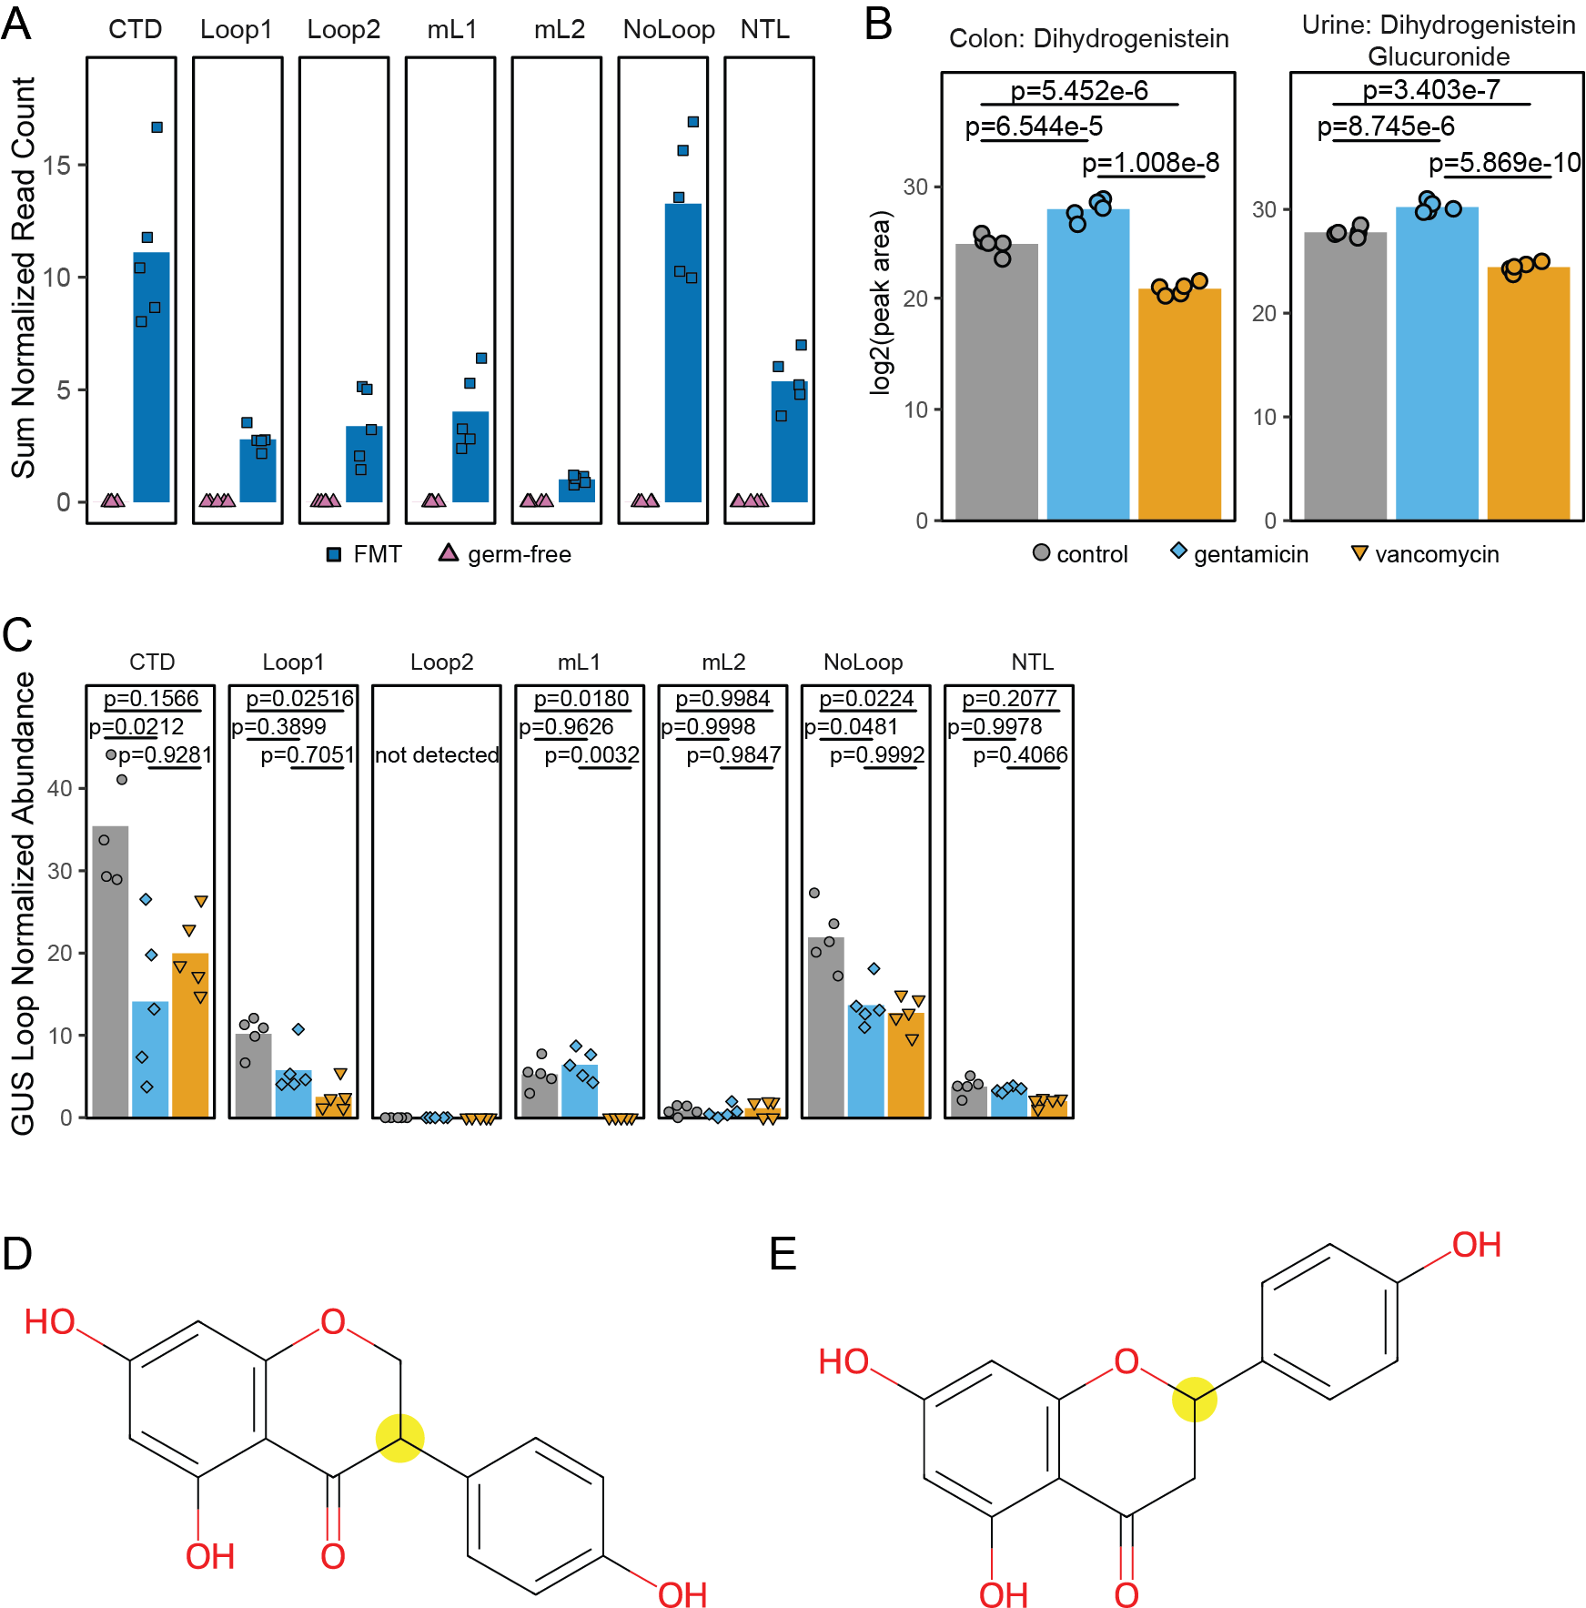
Supplemental Figure S4. Supporting figure for GUSome:Glucuronidome analysis. (A) Summed normalized GUS gene counts by loop type for germ-free (GF) and 7 days post fecal microbiota transfer (FMT) mice. GF mice are presumed zeros, based on null colony formation during anaerobic fecal drop plate culturing. No hypothesis testing was performed. (B) Log2 transformed peak areas for colonic dihydrogenistein (aglycone) and urine dihydrogenistein glucuronide. Hypothesis testing was performed with Dunnett’s Test and p-values were Benjamini & Hochberg FDR corrected for multiple hypothesis testing. (C) Summed normalized GUS gene counts by loop type for day 5 control, gentamicin and vancomycin treated mice. Hypothesis testing was performed with linear mixed effects models in R, using lmer for the main model and emmeans for pairwise comparisons between groups. (D-E) Dihydrogenistein (aglycone) and naringenin (aglycone) chemical structures, respectively. Yellow circle highlights the C3 and C2 positions, respectively, where the two chemicals differ in localization of the phenol group.

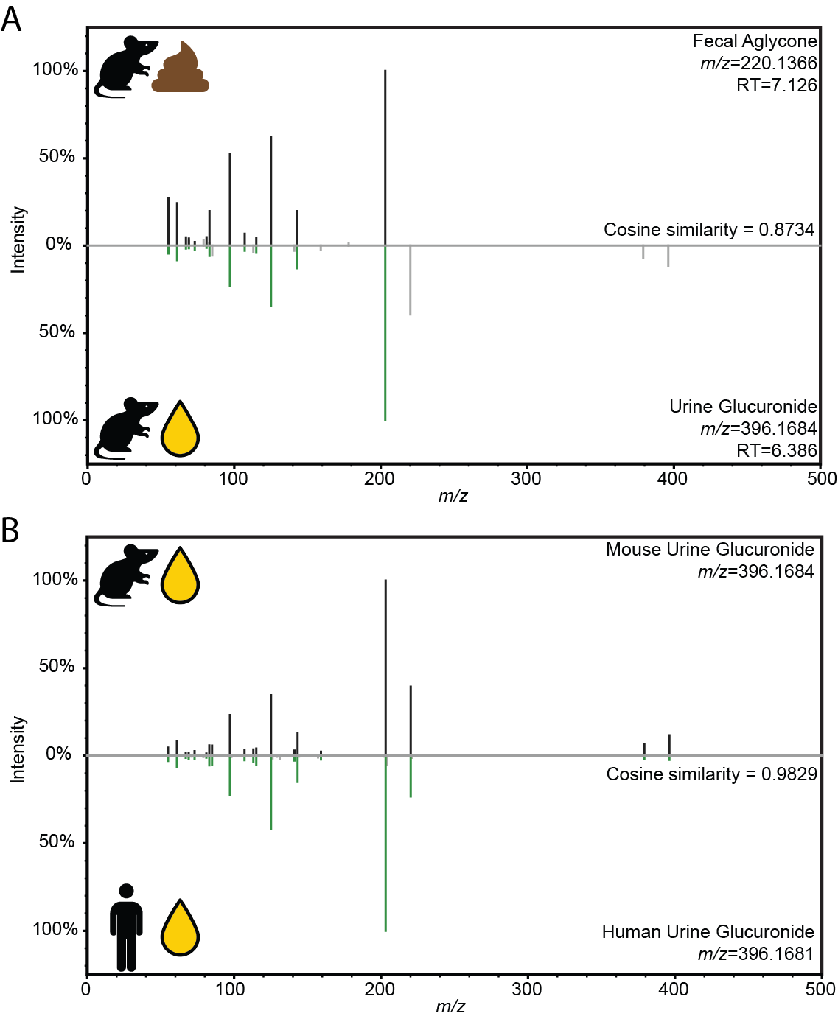
Supplemental Figure S5. Common urine glucuronide to obese mice and humans. (A) MS/MS mirror plot comparing the fecal aglycone MS/MS fragmentation (top) and urine glucuronide MS/MS fragmentation (bottom). (B) MS/MS mirror plot of the MS/MS fragmentation of the 396.168 glucuronide from mouse urine (top) and human urine (bottom).

