EXTENDED DATA

Online Appendix 1. Map of the spatial units used in Tallinn and its urban region.
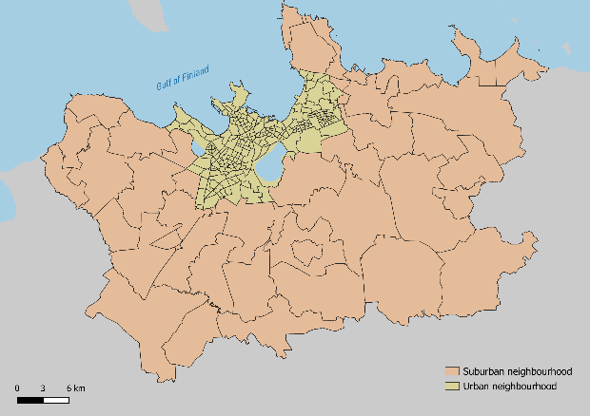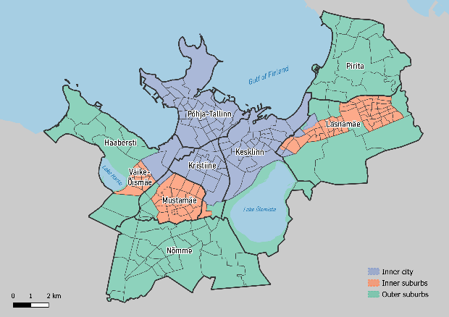
(a) Neighborhoods in Tallinn (b) Districts and residential zones of Tallinn
urban region

Online Appendix 2. A neighborhood typology based on the concentrations of Estonian majority and Russian minority tech workers, location quotients (LQ).

Majority LQ | Minority LQ | Neighborhood typology
>1.2 | >1.2 | High majority - High minority
>1.2 | <0.85 | High majority - Low minority
<0.85 | >1.2 | Low majority - High minority
<0.85 | <0.85 | Low majority - Low minority
Other combinations |  | Mixed-ethnic neighborhood

Online Appendix 3. Dissimilarity indices of Estonian and Russian tech workers across municipalities of Estonia in 2011 and 2021.

2011: | Tech minority | High minority | Middle minority | Low minority
Tech majority | 34 | 33 | 36 | 41
High majority | 49 | 46 | 47 | 44
Middle majority | 50 | 47 | 48 | 45
Low majority | 68 | 64 | 65 | 60
Tech minority |  | 26 | 29 | 35
High minority | 26 |  | 5 | 11
Middle minority | 29 | 5 |  | 8
Low minority | 35 | 11 | 8
2021: | Tech minority | High minority | Middle minority | Low minority
Tech majority | 39 | 35 | 37 | 38
High majority | 51 | 46 | 47 | 46
Middle majority | 53 | 37 | 48 | 46
Low majority | 70 | 63 | 64 | 60
Tech minority |  | 29 | 26 | 39
High minority | 29 |  | 6 | 12
Middle minority | 26 | 6 |  | 14
Low minority | 39 | 12 | 14

Online Appendix 4. Dissimilarity indices of Estonian and Russian tech workers living in Tallinn urban region in 2011 and 2021.

2011: | Tech minority | High minority | Middle minority | Low minority
Tech majority | 49 | 46 | 51 | 60
High majority | 52 | 46 | 53 | 61
Middle majority | 46 | 41 | 46 | 53
Low majority | 44 | 37 | 40 | 46
Tech minority |  | 22 | 24 | 33
High minority | 22 |  | 11 | 22
Middle minority | 24 | 11 |  | 14
Low minority | 33 | 22 | 14
2021: | Tech minority | High minority | Middle minority | Low minority
Tech majority | 36 | 43 | 49 | 57
High majority | 39 | 45 | 51 | 59
Middle majority | 37 | 39 | 44 | 52
Low majority | 37 | 36 | 39 | 45
Tech majority |  | 23 | 28 | 39
High majority | 23 |  | 10 | 21
Middle majority | 28 | 10 |  | 14
Low majority | 39 | 21 | 14

Online Appendix 5. Mean share of ethnic Estonians in the neighborhood of residence for different ‘eth-class’ groups in Tallinn in 2021.

‘Eth-class’ group and year of arrival | Mean share (%)
Tech majority | 63,8
High majority | 65,0
Middle majority | 61,3
Low majority | 57,8
Tech minority, <1990 | 46,4
Tech minority, 1990-2014 | 50,8
Tech minority, >2014 | 56,9
Tech minority, native-born | 47,9
High minority | 45,5
Middle minority | 42,8
Low minority | 40,7

