Supplementary Information for
Constraining the structure and composition of the Moon-forming impactor and the proto-Earth
Zixian Shi et al.

Corresponding author
Correspondence to: Zhensheng Wang & Renguang Zuo
Zhensheng Wang, jasonwang@cug.edu.cn; Renguang Zuo, zrguang@cug.edu.cn

Contents
Supplementary Figures 1 to 3
Supplementary Tables 1 to 2

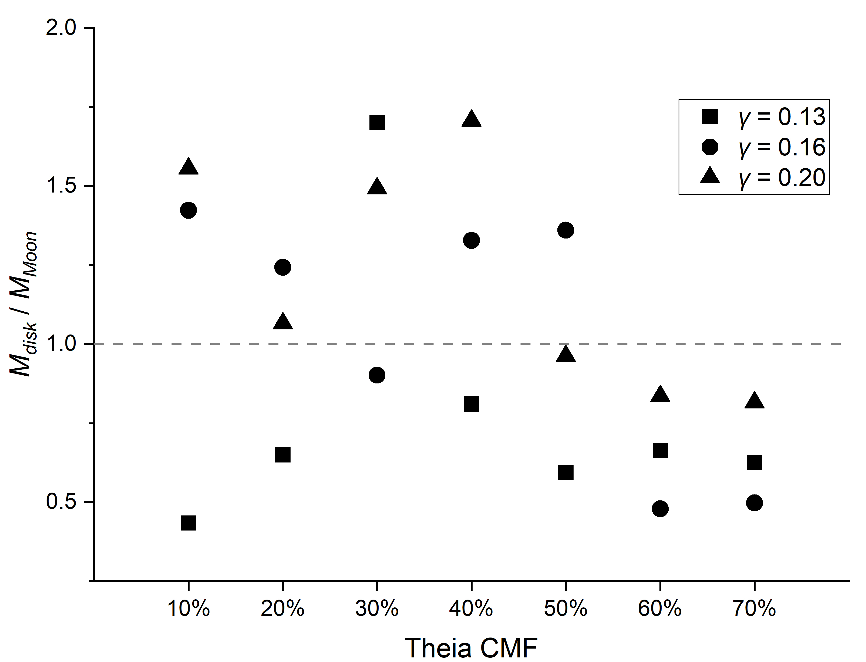
Supplementary Figure 1. Mass of the protolunar disk beyond the Roche limit. The vertical axis is the ratio of the iron content in the disk beyond the Roche limit (M_{disk iron}) to the disk’s mass beyond the Roche limit (M_{disk}). The division of particles beyond the Roche limit is based on their circularised orbits (Methods).

Supplementary Figure 2. Theia CMF versus material fraction for the post-impact proto-Earth mantle and protolunar disk beyond the Roche limit. The material within the Roche limit is added to the post-impact proto-Earth because this material would have eventually fallen back to the Earth with cooling. For f, the vertical axis is the ratio of the iron content in the disk beyond the Roche limit (M_{disk iron}) to the disk’s mass beyond the Roche limit (M_{disk}). The white points are the results obtained from the numerical model and the red ones are the mean values. The grey dashed line is the polynomial of the fitted mean data, whose mathematical expression is written next to the dashed line.

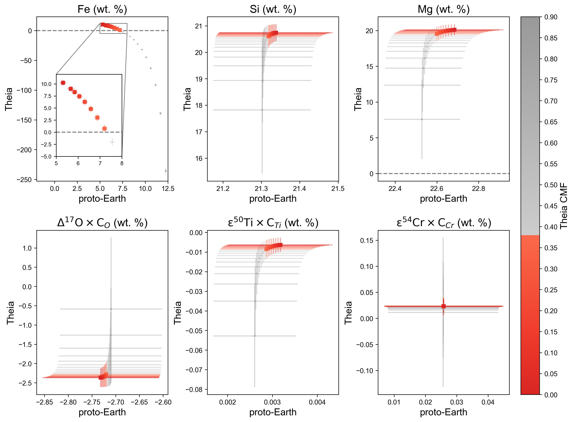

Supplementary Figure 3. Predicted Theia and proto-Earth mantle composition changing with CMF to fit the Earth and Moon. The data of the Earth and the Moon are from Supplementary Table 2. This scenario is an unmixing of iron and silicates. The points and error bars represent the mean and standard deviation, respectively.

Supplementary Table 1. The outputs from a numerical model.
Model | Theia CMF | γ | L_{final}  /L_{EM} | M_{pE}  /M_{Earth} | f_{iron}  (pE) | β  (pE) | f_{iron}  (pEm) | M_{D}  /M_{Moon} | f_{iron}  (D) | β  (D) | M_{inner}  /M_{Moon} | M_{i iron}  /M_{Moon} | β  (inner) | M_{outer}  /M_{Moon} | β  (outer) | M_{o iron}  /M_{Moon}
Run1 | 0.1 | 0.13 | 1.12 | 1.001 | 0.28 | 0.85 | 0.0025 | 0.87 | 0.06 | 0.28 | 0.43 | 0.03 | 0.30 | 0.43 | 0.26 | 0.02
Run2 | 0.2 | 0.13 | 1.15 | 1.000 | 0.29 | 0.87 | 0.0021 | 1.09 | 0.03 | 0.25 | 0.44 | 0.02 | 0.31 | 0.65 | 0.21 | 0.01
Run3 | 0.3 | 0.13 | 1.28 | 0.996 | 0.31 | 0.89 | 0.0017 | 1.81 | 0.02 | 0.22 | 0.11 | 0.00 | 0.41 | 1.70 | 0.21 | 0.03
Run4 | 0.4 | 0.13 | 1.21 | 0.999 | 0.32 | 0.90 | 0.0029 | 1.36 | 0.06 | 0.32 | 0.54 | 0.02 | 0.26 | 0.81 | 0.36 | 0.05
Run5 | 0.5 | 0.13 | 1.17 | 0.998 | 0.33 | 0.92 | 0.0036 | 1.11 | 0.11 | 0.42 | 0.52 | 0.04 | 0.33 | 0.59 | 0.50 | 0.09
Run6 | 0.6 | 0.13 | 1.14 | 0.997 | 0.34 | 0.94 | 0.0049 | 1.03 | 0.17 | 0.56 | 0.36 | 0.06 | 0.60 | 0.66 | 0.54 | 0.12
Run7 | 0.7 | 0.13 | 1.15 | 0.999 | 0.36 | 0.95 | 0.0065 | 0.94 | 0.21 | 0.63 | 0.31 | 0.06 | 0.66 | 0.63 | 0.61 | 0.13
Run8 | 0.1 | 0.16 | 1.54 | 0.994 | 0.27 | 0.82 | 0.0018 | 1.94 | 0.02 | 0.21 | 0.52 | 0.02 | 0.32 | 1.42 | 0.17 | 0.02
Run9 | 0.2 | 0.16 | 1.50 | 0.993 | 0.29 | 0.84 | 0.0029 | 1.89 | 0.04 | 0.26 | 0.65 | 0.04 | 0.34 | 1.24 | 0.22 | 0.03
Run10 | 0.3 | 0.16 | 1.38 | 0.995 | 0.31 | 0.86 | 0.0035 | 1.35 | 0.10 | 0.33 | 0.45 | 0.04 | 0.42 | 0.90 | 0.28 | 0.10
Run11 | 0.4 | 0.16 | 1.51 | 0.996 | 0.32 | 0.88 | 0.0032 | 1.77 | 0.05 | 0.41 | 0.44 | 0.04 | 0.48 | 1.33 | 0.39 | 0.06
Run12 | 0.5 | 0.16 | 1.47 | 0.992 | 0.34 | 0.90 | 0.0048 | 1.93 | 0.12 | 0.45 | 0.57 | 0.08 | 0.49 | 1.36 | 0.43 | 0.15
Run13 | 0.6 | 0.16 | 1.42 | 0.998 | 0.35 | 0.91 | 0.0053 | 1.19 | 0.12 | 0.56 | 0.71 | 0.08 | 0.53 | 0.48 | 0.60 | 0.06
Run14 | 0.7 | 0.16 | 1.39 | 0.998 | 0.37 | 0.94 | 0.0074 | 1.05 | 0.16 | 0.60 | 0.55 | 0.09 | 0.59 | 0.50 | 0.62 | 0.08
Run15 | 0.1 | 0.20 | 1.82 | 0.985 | 0.27 | 0.78 | 0.0015 | 2.62 | 0.02 | 0.27 | 1.07 | 0.04 | 0.34 | 1.56 | 0.23 | 0.03
Run16 | 0.2 | 0.20 | 1.72 | 0.989 | 0.29 | 0.80 | 0.0024 | 1.89 | 0.05 | 0.34 | 0.83 | 0.06 | 0.45 | 1.07 | 0.26 | 0.03
Run17 | 0.3 | 0.20 | 1.85 | 0.981 | 0.31 | 0.83 | 0.0035 | 3.11 | 0.04 | 0.33 | 1.62 | 0.08 | 0.34 | 1.49 | 0.33 | 0.05
Run18 | 0.4 | 0.20 | 1.74 | 0.986 | 0.33 | 0.84 | 0.0044 | 2.26 | 0.12 | 0.36 | 0.56 | 0.07 | 0.49 | 1.71 | 0.32 | 0.20
Run19 | 0.5 | 0.20 | 1.83 | 0.989 | 0.35 | 0.86 | 0.0038 | 2.50 | 0.06 | 0.50 | 1.54 | 0.09 | 0.51 | 0.96 | 0.49 | 0.06
Run20 | 0.6 | 0.20 | 1.75 | 0.991 | 0.37 | 0.89 | 0.0076 | 2.05 | 0.13 | 0.54 | 1.21 | 0.16 | 0.55 | 0.84 | 0.53 | 0.10
Run21 | 0.7 | 0.20 | 1.70 | 0.989 | 0.39 | 0.92 | 0.0106 | 1.99 | 0.21 | 0.62 | 1.17 | 0.24 | 0.62 | 0.82 | 0.61 | 0.17
Note: M and L are mass and angular momentum, respectively. β is the proportion of proto-Earth in the silicate materials. f_{iron} is the iron proportion. The subscripts represent the abbreviations of the respective reservoirs (pE = post-impact proto-Earth, pEm = post-impact proto-Earth mantle, D = protolunar disk, inner = protolunar disk within Roche limit, i iron = protolunar disk iron within Roche limit, outer = protolunar disk beyond Roche limit, o iron = protolunar disk iron beyond Roche limit).

Supplementary Table 2. Elemental isotope and abundance data for meteorites, the Earth, and the Moon.
 | Δ¹⁷O | ± | O (wt. %) | ± | ε⁵⁰Ti | ± | Ti (ppm) | ± | ε⁵⁴Cr | ± | Cr (ppm) | ±
CI | 0.39 | 0.10 | 45.85 | 0.00 | 1.83 | 0.09 | 451.00 | 0.00 | 1.57 | 0.03 | 2650.00 | 0.00
CM | -2.92 | 0.44 | 43.20 | 0.00 | 3.01 | 0.09 | 550.00 | 0.00 | 1.10 | 0.18 | 3050.00 | 0.00
CO | -4.32 | 0.26 | 37.00 | 0.00 | 3.76 | 0.66 | 730.00 | 0.00 | 0.75 | 0.21 | 3520.00 | 0.00
CV | -3.62 | 0.48 | 37.00 | 0.00 | 3.64 | 0.29 | 870.00 | 0.00 | 0.87 | 0.04 | 3480.00 | 0.00
CK | -4.46 | 0.21 |  |  | 3.60 | 1.10 | 940.00 | 0.00 | 0.49 | 0.46 | 3530.00 | 0.00
CR | -1.48 | 0.55 |  |  | 2.35 | 0.04 | 750.00 | 0.00 | 1.32 | 0.08 | 3590.00 | 0.00
CH | -1.55 | 0.27 |  |  |  |  |  |  | 1.37 | 0.29 | 3100.00 | 0.00
H | 0.72 | 0.05 | 33.86 | 0.00 | -0.61 | 0.17 | 630.00 | 0.00 | -0.38 | 0.03 | 3500.00 | 0.00
L | 1.03 | 0.04 | 36.93 | 0.00 | -0.63 | 0.03 | 670.00 | 0.00 | -0.39 | 0.07 | 3690.00 | 0.00
LL | 1.19 | 0.06 | 38.37 | 0.00 | -0.65 | 0.04 | 680.00 | 0.00 | -0.43 | 0.04 | 3680.00 | 0.00
EH | -0.03 | 0.10 | 31.00 | 0.00 | -0.10 | 0.02 | 460.00 | 0.00 | 0.04 | 0.08 | 3320.00 | 0.00
EL | -0.01 | 0.07 | 31.00 | 0.00 | -0.28 | 0.06 | 550.00 | 0.00 | 0.06 | 0.04 | 3030.00 | 0.00
Acapulcoites | -0.99 | 0.09 | 41.58 | 2.20 | -1.30 | 0.05 | 837.19 | 206.81 | -0.57 | 0.61 | 4305.95 | 531.82
Lodranites | -1.11 | 0.11 | 41.03 | 3.15
Brachinites | -0.26 | 0.08 | 31.85 | 9.54
Winonaites | -0.49 | 0.07 | 45.99 | 1.24
Angrites | -0.11 | 0.11 | 41.30 | 0.51 | -1.15 | 0.02 | 7860.54 | 1700.56 | -0.41 | 0.09 | 914.90 | 163.43
Aubrites | 0.04 | 0.09 | 46.72 | 1.24 | -0.06 | 0.04 | 315.56 | 91.77 | 0.02 | 0.07 | 723.18 | 228.67
HED | -0.29 | 0.08 | 43.69 | 0.13 | -1.23 | 0.04 | 3211.08 | 173.26 | -0.67 | 0.07 | 3760.02 | 209.96
Ureilites | -1.16 | 0.15 | 43.59 | 0.82 | -1.85 | 0.20 | 446.73 | 91.69 | -0.88 | 0.03 | 4787.39 | 208.39
Mesosiderites | -0.24 | 0.06 | 39.39 | 2.95 | -1.26 | 0.10 | 2314.40 | 552.95 | -0.70 | 0.06 | 3669.90 | 879.53
MG pal | -0.28 | 0.03 | 28.56 | 1.76 | -1.37 | 0.08 |  |  | -0.40 | 1.00 | 1984.22 | 617.71
ESPAL | -4.69 | 0.10 | 33.05 | 1.20 |  |  |  |  | 0.71 | 0.18 | 820.00 | 480.83
IAB irons | -0.50 | 0.06 | 44.54 | 18.39
Mars’s mantle | 0.27 | 0.03 | 42.21 | 0.17 | -0.54 | 0.17 | 739.20 | 124.76 | -0.19 | 0.04 | 4971.91 | 439.88
Earth’s mantle | -0.06 | 0.004 | 44.33 | 0.89 | 0.01 | 0.01 | 1265 | 126.5 | 0.1 | 0.13 | 2520 | 252
Moon’s mantle | -0.056 | 0.01 | 43.34 | 0.25 | -0.03 | 0.04 | 1576.92 | 370.70 | 0.09 | 0.08 | 2645.63 | 555.95

 | Fe (wt. %) | ± | Si (wt. %) | ± | Mg (wt. %) | ±
CI | 18.50 | 0.00 | 10.70 | 0.00 | 9.58 | 0.00
CM | 21.30 | 0.00 | 12.70 | 0.00 | 11.50 | 0.00
CO | 25.00 | 0.00 | 15.80 | 0.00 | 14.50 | 0.00
CV | 23.50 | 0.00 | 15.70 | 0.00 | 14.30 | 0.00
CK | 23.00 | 0.00 | 15.80 | 0.00 | 14.70 | 0.00
CR | 23.80 | 0.00 | 15.10 | 0.00 | 13.80 | 0.00
CH | 38.00 | 0.00 | 13.50 | 0.00 | 11.30 | 0.00
H | 27.20 | 0.00 | 17.10 | 0.00 | 14.10 | 0.00
L | 21.75 | 0.00 | 18.60 | 0.00 | 14.90 | 0.00
LL | 19.80 | 0.00 | 18.90 | 0.00 | 15.30 | 0.00
EH | 30.40 | 0.00 | 16.59 | 0.00 | 10.73 | 0.00
EL | 24.80 | 0.00 | 18.80 | 0.00 | 13.75 | 0.00
Acapulcoites | 21.64 | 1.68 | 21.01 | 2.37 | 14.52 | 0.54
Lodranites | 20.25 | 6.23 | 18.64 | 2.40 | 18.34 | 2.19
Brachinites | 15.32 | 6.29 | 17.54 | 0.31 | 17.12 | 1.02
Winonaites | 18.02 | 3.34 | 18.47 | 1.08 | 14.90 | 3.30
Angrites | 13.36 | 2.21 | 19.11 | 0.66 | 7.26 | 0.97
Aubrites | 5.16 | 2.18 | 25.73 | 1.18 | 19.71 | 2.97
HED | 13.90 | 0.14 | 23.14 | 0.12 | 7.38 | 0.39
Ureilites | 13.74 | 0.84 | 18.35 | 0.59 | 20.57 | 0.60
Mesosiderites | 22.88 | 4.44 | 19.19 | 2.19 | 6.96 | 0.90
MG pal | 47.16 | 5.64 | 8.84 | 0.92 | 13.43 | 1.39
ESPAL | 40.74 | 4.52 | 14.29 | 1.76 | 11.92 | 5.25
IAB irons | 28.98 | 20.03 | 15.52 | 12.47 | 16.01 | 3.47
Mars’s mantle | 13.68 | 0.28 | 21.40 | 0.74 | 17.51 | 0.91
Earth’s mantle | 6.3 | 0.063 | 21.22 | 0.2122 | 22.17 | 0.2217
Moon’s mantle | 9.39 | 1.07 | 20.84 | 0.57 | 20.55 | 1.39
Note: All isotope data form a compilation by ref. ¹ except for the Earth, the Moon, and the Δ¹⁷O and ε⁵⁴Cr of Aubrites. The Δ¹⁷O and ε⁵⁴Cr of Aubrites are added to ref. ¹ with ref. ^{2,3}. The Δ¹⁷O, ε⁵⁰Ti, and ε⁵⁴Cr of Earth and Moon from ref. ^{4–6}. The abundance of chondrites from ref. ^{7,8}. The abundance of Earth from ref. ⁹. The abundance of Moon from a compilation by ref. ¹⁰ with the addition of ref. ¹¹. The abundance of the Mars from ref. ¹². The rest of the abundances are made up from the database (https://metbase.org) and the t-distribution is used to estimate the possible margin of error for the sample mean at a given confidence level (95%). The O abundances that are not directly given are calculated from the rest known major elements (Si, Ti, Al, Fe, Mn, Mg, Ca, Na, K, P), assuming they sum to 100%. Abbreviation: MG pal is Main group Pallasites, ESPAL is Eagle Station Pallasites.

References
1. Dauphas, N. The isotopic nature of the Earth’s accreting material through time. Nature 541, 521–524 (2017).
2. Barrat, J. A. et al. The origin of aubrites: Evidence from lithophile trace element abundances and oxygen isotope compositions. Geochim. Cosmochim. Acta 192, 29–48 (2016).
3. Zhu, K. et al. Tracing the origin and core formation of the enstatite achondrite parent bodies using Cr isotopes. Geochim. Cosmochim. Acta 308, 256–272 (2021).
4. Zhang, J., Dauphas, N., Davis, A. M., Leya, I. & Fedkin, A. The proto-Earth as a significant source of lunar material. Nat. Geosci. 5, 251–255 (2012).
5. Mougel, B., Moynier, F. & Göpel, C. Chromium isotopic homogeneity between the Moon, the Earth, and enstatite chondrites. Earth Planet. Sci. Lett. 481, 1–8 (2018).
6. Cano, E. J., Sharp, Z. D. & Shearer, C. K. Distinct oxygen isotope compositions of the Earth and Moon. Nat. Geosci. 13, 270–274 (2020).
7. Lodders, K. & Fegley Jr, B. Eds. The Planetary Scientist’s Companion. (Oxford University Press, 1998).
8. Lodders, K. & Fegley Jr, B. Eds. Chemistry of the Solar System. (Royal Society of Chemistry, 2010).
9. Palme, H. & O’Neill, H. St. C. in Treatise on Geochemistry 2nd (eds Turekian, K. K., & Holland, H. D.). Ch. 3.1 (Elsevier, Oxford, 2014).
10. Warren, P. H. “New” lunar meteorites: Implications for composition of the global lunar surface, lunar crust, and the bulk Moon. Meteorit. Planet. Sci. 40, 477–506 (2005).
11. Hauri, E. H., Saal, A. E., Rutherford, M. J. & Van Orman, J. A. Water in the Moon’s interior: Truth and consequences. Earth Planet. Sci. Lett. 409, 252–264 (2015).
12. McSween Jr, H. Y. & McLennan, S. M. in Treatise on Geochemistry 2nd (eds Turekian, K. K., & Holland, H. D.) Ch. 2.10 (Elsevier, Oxford, 2014).

