Appendix
Stepwise approach to get organizational interoperability in a federated infrastructure

In the implementation of a research query, we do recommend building semantic interoperability by following these 8 activities - some of them recursive. In the client-server approach, the coordination node has to orchestrate all the activities across nodes, aiming to reduce human interaction as much as possible.
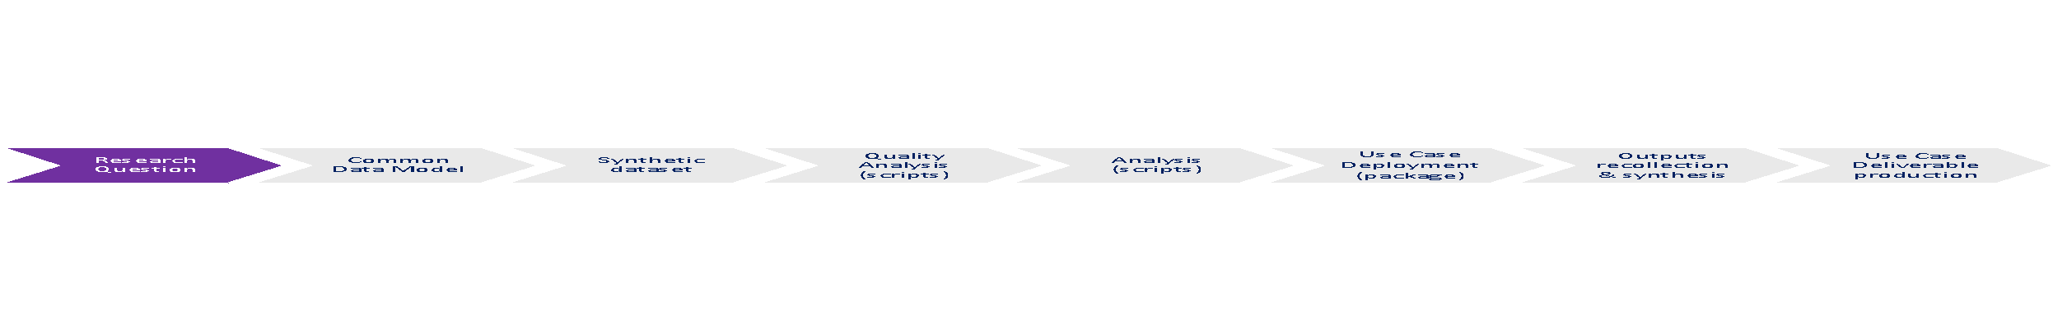
Step 1 Any member of the user community could broadcast a research question to the federated research infrastructure.

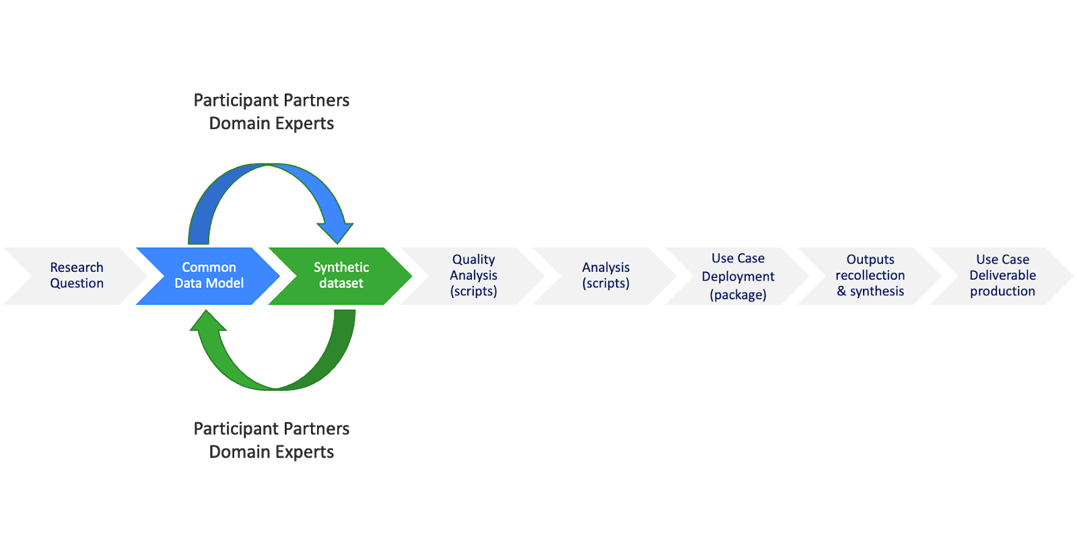
Step 2 Once a research question (RQ) has been sent out to the federation of nodes, the coordination hub will start a process to define the key components of the RQ, so to get a detailed operational definition (i.e. unit of analysis, period of study, target population, inclusion and exclusion criteria, etc.)
Once the research question is clear, the promoter of the query will draft the data schema of the use case defining in detail; so, the data schema will require: the entity, the attribute of interest (variable) with a label and a normative description, the encoding system of the variables, the unit and values in which it is stored, the validation rules, whether the variable is required of optional, and finally the data source from which the variable has been extracted. In addition, the data model will specify the mapping of the variables to different encoding systems.
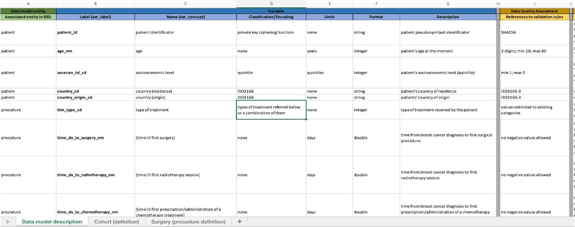
Step 3 As a continuation a synthetic dataset based on these data requirements will be produced to document the data model and formalize the analytical pipeline (see next steps) in a transparent and auditable way. The idea is to anticipate and program all the critical elements in the pipelines and solve any potential problem before real data are used.
When it comes to the formalization of the data model there are multiple options; for example, the minimum metadata schema provided by the `dataspice` implementation (both in R, and Python) complying with the Schema.org international standard (see the example below).
Note: Steps 2 and 3 are recursive and end once the data model is finally approved in the federation. The participation of domain experts and data scientists is key at this point.
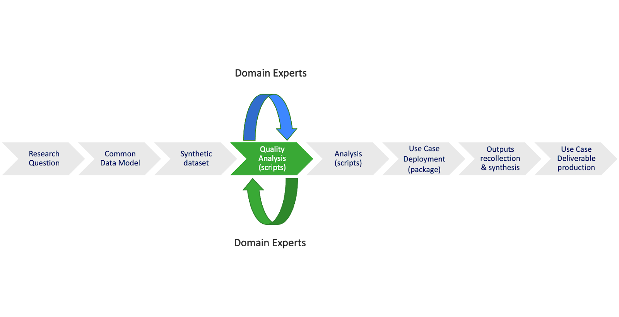
Step 4 Data quality assessment. Using the synthetic dataset and open sources libraries, the coordination hub will prepare a quality analysis in those key variables looking for incompleteness, missingness, outlier values, anomalous distribution, flaw associations, etc. There are open source libraries (e.g., ‘dlookr’, ‘DataExplorer’, etc.) that provide you with standard scripts for data quality evaluation.
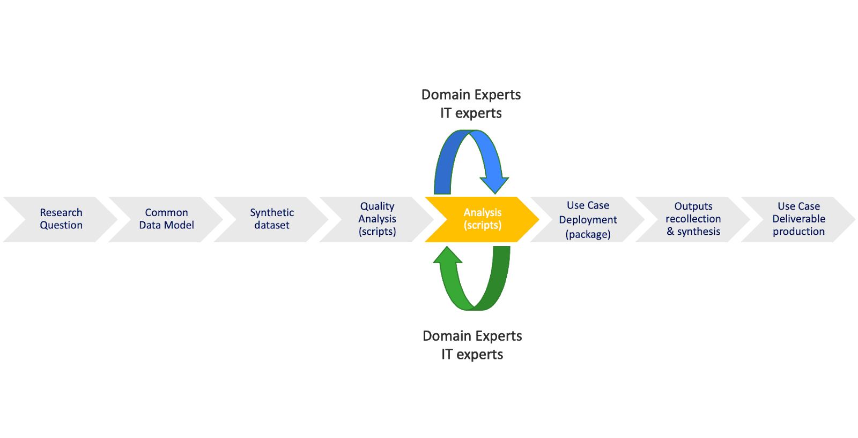
Step 5. Configuration of a preliminary analytical script according to the objectives of the study. Iteration will be critical which will help to update and improve the scripts. For that purpose, the exchange between domain experts, data scientists and IT is key, particularly if the distribution implies models assemblement.
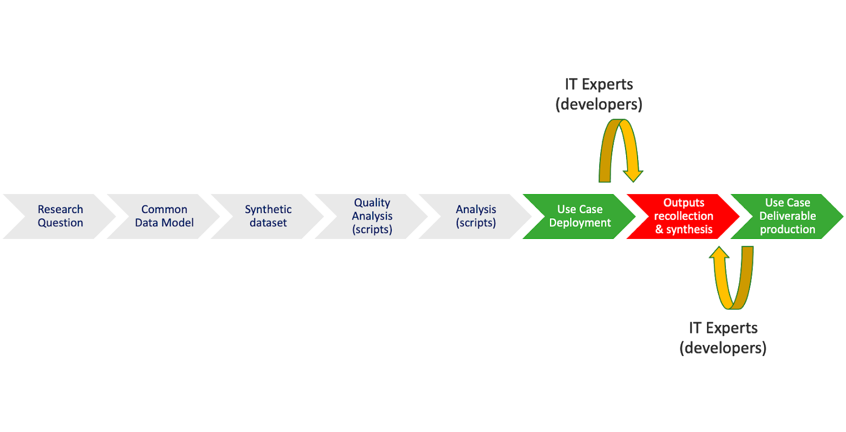
Step 6. Once steps 3 to 5 are over, the coordination hub will package the whole pipeline distributing the solution (for example, providing a containerized solution using Docker or Podman) to the different nodes. They, then, will transform their data to the common data schema, and will run the different parts - data quality assessment and analyses.
Step 7 In this step the results of the analysis are collected and if the research question requires meta-analysis it will get back to the coordination Hub, who will run the meta-analyses. Depending on the type of meta-analysis, there could be the need for some recursive interaction between the coordination hub and the nodes.
Step 8 All the pipeline is published in a repertoire as ZENODO. It is worth to highlight the need having all these pipeline findable, accesibles, interoperable and reusable in the OPENAIRE community (https://www.openaire.eu) At this very moment the federation has to decide the level of access given to the pipeline (https://guidelines.openaire.eu/en/latest/literature/index_guidelines-lit_v3.html).

