1. A 59-year-old male patient presents to the emergency department with newly onset chest pain radiating to his left arm. The patient has a history of hypertension, hypercholesterolemia, and a 20 pack-year smoking history. On ECG, T-wave inversions are observed in the lateral leads. Which of the following management approaches is the most appropriate?
A. Administer two sublingual nitroglycerin tablets and observe whether the chest pain resolves.
B. Connect the patient to cardiac monitoring, provide oxygen, and administer aspirin.
C. Call the cardiac catheterization laboratory and request an urgent percutaneous coronary intervention (PCI).
D. Obtain a chest X-ray and administer aspirin, clopidogrel, and heparin.
E. Immediately start a beta-blocker.
2. In a patient with suspected pulmonary embolism, which of the following is the most commonly observed ECG finding?
A. S1Q3T3 pattern
B. Atrial fibrillation
C. Right axis deviation
D. Right atrial enlargement
E. Tachycardia or non-specific ST-T wave changes
3. A 35-year-old male is brought to the emergency department after a traffic accident. He is unconscious and experiencing respiratory distress. On physical examination, breath sounds are significantly diminished on the left hemithorax, and the trachea is not in the midline. His blood pressure is 70/40 mmHg.
Which procedure should be performed first?
A. Initiate isotonic fluid therapy
B. Perform thoracotomy
C. Perform emergency thoracentesis
D. Initiate mechanical ventilation
E. Obtain a brain CT scan
4. A patient presents with severe pelvic trauma, hypotension, and positive FAST (Focused Assessment with Sonography for Trauma) findings. Which method is recommended before surgical intervention?
A. Perform laparoscopy
B. Direct laparotomy
C. Repeat ultrasound evaluation
D. Perform CT scan
E. Administer isotonic fluids
5. In a patient with traumatic shock, what is the targeted range for systolic blood pressure to correct hypotension?
A) <60 mmHg
B) 60-70 mmHg
C) 70-90 mmHg
D) 90-110 mmHg
E) >120 mmHg
6. What is the earliest sign of hypovolemic shock?
A) Decrease in blood pressure
B) Change in mental status
C) Oliguria
D) Tachycardia
E) Cold skin
7. A 60-year-old female patient presents to the emergency department three days after receiving an anterior nasal tamponade for epistaxis (nosebleed). She currently complains of fever, chills, muscle aches, and widespread abdominal pain.
Vital Signs:
● Temperature: 39.2°C
● Blood Pressure (BP): 82/44 mmHg
● Heart Rate (HR): 132 bpm
On examination, a widespread, swollen, erythematous rash resembling severe sunburn, which blanches with pressure, is observed.
What is the most beneficial approach to treatment for this patient?
A) Establish an intravenous (IV) line, perform a blood transfusion, leave the nasal tampon in place due to the possibility of disseminated intravascular coagulation (DIC), and admit the patient to the hospital.
B) Establish an intravenous (IV) line, perform fluid resuscitation, administer intravenous antibiotics, remove the nasal tampon, and admit the patient to the hospital.
C) Establish an intravenous (IV) line, perform fluid resuscitation, administer epinephrine for anaphylaxis, and admit the patient to the hospital.
D) Perform an abdominal CT scan to evaluate for an intra-abdominal abscess.
E) Discharge the patient with a diagnosis of sinusitis and viral exanthem (rash)
8. Which of the following statements about pulse oximetry monitoring is correct?
I. It shows heart rate and hemoglobin oxygen saturation.
II. In cases of carbon monoxide poisoning, pulse oximetry gives falsely lower readings.
III. It works on the principle that oxyhemoglobin and deoxyhemoglobin absorb different wavelengths of light.
IV. Changes in saturation are detected earlier with a finger probe compared to an ear probe.
A. I and II
B. I and III
C. II and III
D. II and IV
E. III and IV
9. Which of the following statements about anion gap is incorrect?
A. It is used to determine the cause of metabolic acidosis.
B. It is calculated using sodium chloride and bicarbonate measurements.
C. Serum albumin level is an important determinant.
D. It is elevated in diabetic ketoacidosis.
E. It is higher when metabolic acidosis is associated with hyperchloremia.
10. A 50-year-old male patient presents to the emergency department with complaints of shortness of breath. His arterial blood gas analysis shows the following:
PaCO₂ = 58 mmHg, PaO₂ = 62 mmHg, HCO₃⁻ = 18 mEq/L, pH = 7.25, SaO₂ = 86%.
What is the most likely diagnosis for this patient?
A) Compensated respiratory acidosis
B) Compensated metabolic acidosis
C) Respiratory acidosis + Metabolic acidosis
D) Decompensated respiratory acidosis
E) Decompensated metabolic acidosis
11. A 30-year-old female patient with a diagnosis of asthma is intubated and placed on mechanical ventilation due to respiratory failure. The patient's initial ventilator settings are as follows:
- Ventilator rate: 16 breaths/min
- Tidal volume: 650 ml
- FiO₂: 60%
- Inspiratory flow rate: 70 L/min
- Low PEEP
- Assist-control mode
After approximately 20 minutes, the patient's blood pressure drops from 120/60 mm Hg to 70/50 mm Hg. On physical examination, bilateral decreased breath sounds are noted.
What should the next intervention be?
A) Add PEEP
B) Administer 1L normal saline bolus
C) Decrease inspiratory flow rate
D) Decrease ventilator rate
E) Perform bilateral needle decompression
12. A 65-year-old male patient with a 40 pack-year smoking history presents with progressively worsening shortness of breath over the past two days. He has tried using his "orange" inhaler and increasing the oxygen flow at home but has not found relief. On physical examination, the patient appears anxious, and significant intercostal retractions are observed.
Vital signs are as follows:
- Temperature: 37.4°C
- Respiratory rate: 16 breaths/min
- Heart rate: 110 bpm
- Blood pressure: 110/60 mmHg
- Pulse oximetry: 92% on 2L nasal cannula
Which of the following interventions would most improve respiratory effort acutely?
A) Albuterol 2.5 mg nebulizer treatment
B) Ipratropium 0.5 mg nebulizer treatment
C) Non-invasive positive pressure ventilation
D) 100% non-rebreather mask oxygen
E) Methylprednisolone 60 mg IV bolus
13. A 65-year-old male patient presents to the emergency department with complaints of palpitations and chest pain. At the time of presentation, his vital signs are:
- Blood pressure: 115/75 mmHg
- Heart rate: 155 bpm
- Respiratory rate: 26 breaths/min
- Temperature: 36.5°C
- SpO₂: 93% (room air)
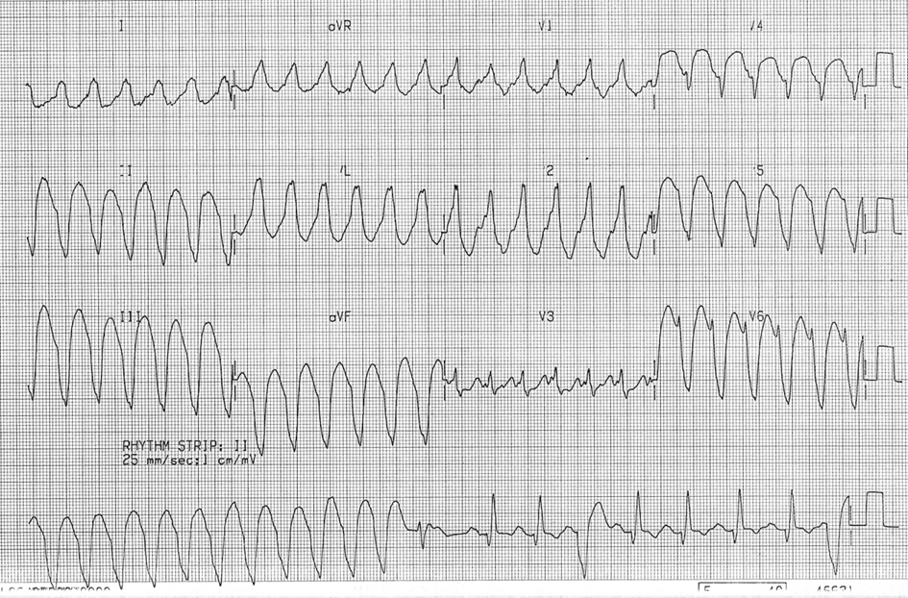
The patient has a history of coronary artery disease. Based on the ECG findings, what is the most appropriate diagnosis and treatment?
A) AVNRT + RBBB, IV diltiazem 25 mg
B) RBBB + sinus tachycardia, investigate the underlying cause
C) Wolff-Parkinson-White syndrome, IV adenosine 6 mg
D) Atrial flutter with 2:1 block + RBBB, IV propafenone 150 mg
E) Ventricular tachycardia, IV amiodarone 150 mg
14. A 51-year-old male patient presents to the emergency department with a complaint of intermittent palpitations lasting for the past week. He does not have chest pain, shortness of breath, nausea, or vomiting. His blood pressure is 130/75 mmHg, heart rate is 130 bpm, respiratory rate is 16 breaths/min, and oxygen saturation is 99%. An ECG is performed.
Which of the following treatment approaches is most appropriate?
A) Perform 100 J synchronized cardioversion after sedation
B) Prepare the patient for cardiac catheterization
C) Initiate warfarin therapy
D) Administer amiodarone
E) Administer diltiazem
15. A 64-year-old male patient presents with loss of consciousness and pulseless ventricular tachycardia. What is the first intervention to be performed?
A) Electrical defibrillation
B) Initiate mechanical ventilation
C) Amiodarone infusion
D) Administer lidocaine
E) Start CPR and then defibrillation
16. What is the recommended energy level during electrical cardioversion in a patient with atrial fibrillation?
A) 50 J
B) 100 J
C) 120-200 J
D) 300 J
E) 360 J
17. A patient is brought to the emergency department after a house fire, and carbon monoxide poisoning is suspected. Which of the following laboratory findings most strongly indicates a poor prognosis for the patient?
A) Carboxyhemoglobin level >25%
B) Lactate level >10 mmol/L
C) Metabolic alkalosis
D) Mild respiratory failure
E) Normal brain imaging findings
18. Which of the following statements is correct regarding the indication for hyperbaric oxygen therapy in patients with carbon monoxide poisoning?
A) It should only be administered if the COHb level is above 50%
B) It is recommended for pregnant women if the carboxyhemoglobin level is above 15%
C) It should be routinely applied to all patients
D) Reassessment after 48 hours is required in terms of treatment effectiveness
E) It is contraindicated in patients without loss of consciousness
19. In a patient who develops cardiac arrest and has no breathing or pulse 4 minutes after the arrest, and asystole is detected on the electrocardiogram, what should be done first at this stage?
A) Administer 1 mg intravenous adrenaline
B) Administer 100 J shock
C) Administer 50 mmol intravenous bolus of bicarbonate
D) Administer 5 ml of 10% calcium chloride intravenously
E) Intubate the patient
20. Which of the following is not included in the chain of survival for resuscitating patients with sudden cardiac arrest?
A) Early recognition and calling for help
B) Early cardiopulmonary resuscitation to gain time
C) Early defibrillation
D) Post-resuscitation care to improve quality of life
E) Early thermoregulation
21. Which of the following statements about defibrillation treatment during advanced life support is incorrect?
A) Automatic external defibrillators for adults in out-of-hospital arrests are also suitable for children over 8 years old.
B) The success of defibrillation depends on thoracic impedance and electrode positioning.
C) There is no significant relationship between the energy requirement for defibrillation and body size.
D) During advanced life support, chest compressions should be paused while pads are applied and the defibrillator is charging.
E) Biphasic waveform defibrillators are more effective than monophasic ones.
22. Which drug is commonly used to sedate the patient and provide analgesia during awake intubation?
A) Midazolam
B) Ketamine
C) Etomidate
D) Fentanyl
E) Propofol
23. In which of the following patient groups is performing a surgical cricothyroidotomy after a failed intubation procedure least appropriate?
A) Geriatric patient over 85 years old
B) Trauma patient with facial integrity compromised
C) Pediatric patient under 6 years old
D) Patient with a Mallampati score of 3 or higher
E) Patient with no neck mobilization
24. A 36-week pregnant woman is brought to the emergency department after an out-of-vehicle traffic accident. The ambulance team reports that the patient had at least 45 seconds of apnea at the scene. The patient's general condition is moderate, and her consciousness is clear, cooperative, and oriented. The patient appears obese, with a blood pressure of 105/65 mmHg, a heart rate of 106 beats per minute, and an oxygen saturation of 86%. The patient reports difficulty breathing and pain on the right side of her chest. Which of the following statements regarding airway management for this patient is incorrect?
A) Emergency physicians are recommended to follow difficult airway algorithms for airway management in pregnant patients.
B) Due to the weight gain and obesity during pregnancy, the balloon mask ventilation will be quite difficult for the pregnant patient.
C) Oxygen saturation should be rapidly increased because maternal hypoxia can lead to fetal hypoxia and distress.
D) Since Mallampati score is lower in pregnant women, intubation in this case will be easier.
E) Due to the developed apnea, oxygen saturation has decreased more than it would in a non-pregnant woman.
25. How should the mechanical ventilator settings be adjusted to provide adequate minute ventilation in a patient with severe metabolic acidosis (e.g., diabetic ketoacidosis)?
A) Increase tidal volume to 10-12 mL/kg
B) Increase respiratory rate in response to acidosis
C) Decrease positive end-expiratory pressure (PEEP)
D) Increase fractional inspired oxygen (FiO₂) to 100%
E) Apply pressure-controlled ventilation instead of volume-controlled ventilation
26. In patients on mechanical ventilation, hyperoxia is associated with which of the following?
A) Better mortality
B) Reduced oxidative stress
C) Dose-dependent increased mortality
D) No clinically significant effect
E) Increased lung compliance
27. Which of the following methods is most commonly used in cardiac output assessment?
A) Central venous pressure
B) Pulmonary capillary wedge pressure
C) Echocardiography
D) Cardiac output
E) Arterial blood gas analysis
28. What is the best initial intervention for a patient in cardiogenic shock?
A) Establishing an intravenous line and administering fluids
B) Performing an arterial blood gas analysis
C) Ensuring airway management
D) Inserting a catheter to measure cardiac output
E) Starting high-dose vasopressor therapy
29. What is the most common mechanical complication seen during central venous catheter placement?
A) Infection
B) Pneumothorax
C) Arterial puncture
D) Air embolism
E) Catheter occlusion
30. Which of the following complications is the least common in subclavian vein catheterization?
A) Pneumothorax
B) Catheter infection
C) Arterial puncture
D) Thrombosis
E) Air embolism
31 . A 60-year-old male patient is brought to the emergency department with complaints of sweating and crushing chest pain radiating to his left arm. His pulse is 55 bpm and his blood pressure is 140/90 mm Hg. The ECG is as shown. Troponin levels are normal. Write the diagnosis and emergency treatment for this patient.
………………………….
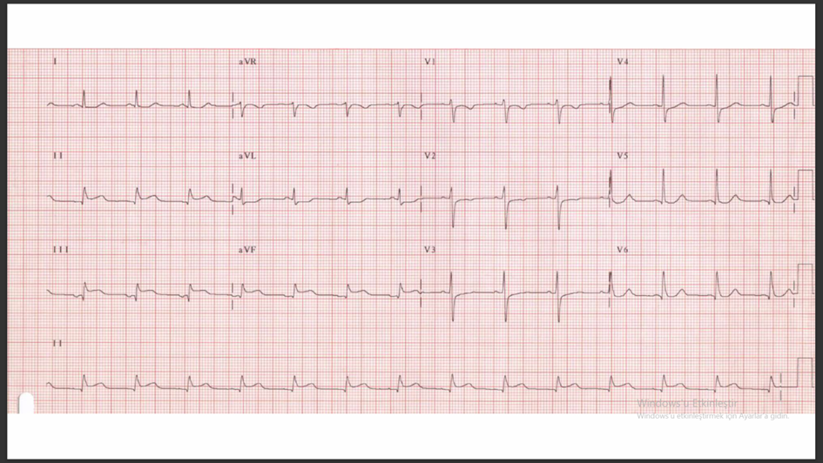
32. A 70-year-old male patient presents with progressively worsening fatigue, weakness, and swelling in his legs and abdomen. It is learned from his history that he had coronary bypass surgery 7 years ago. The ECG shows atrial fibrillation. The echocardiogram shows biatrial dilation, normal left ventricle dimensions and systolic function, and thickened and bright pericardium. Which of the following findings would not be observed in the physical examination of this patient?
A) Kussmaul sign
B) Hepatomegaly and ascites
C) Prominence in apical impulse
D) Pulsus paradoxus
E) Widespread rales

33. A 70-year-old female patient with a known history of hypertension presents to the emergency department with occasional complaints of headaches. The EKG of the patient is shown below. Despite taking medication, the patient's blood pressure is measured at 180/100. She reports no active complaints other than the headache. What is your diagnosis based on the EKG? What tests would you request for this patient? 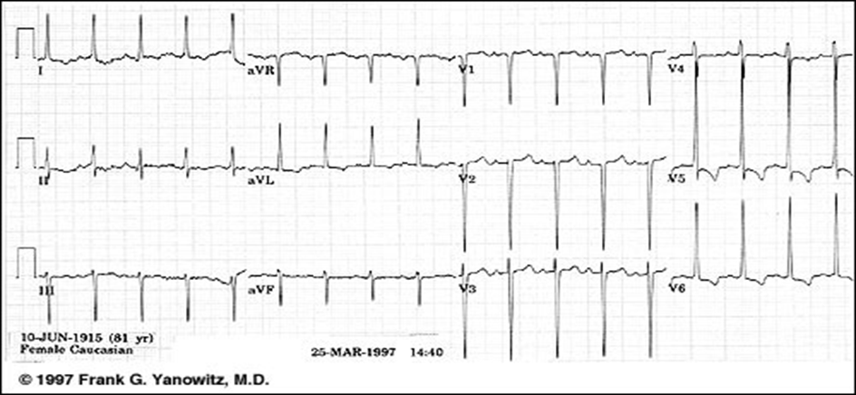
34. A 40-year-old female patient presents with dizziness that started suddenly a few hours ago when getting out of bed. She feels severe dizziness, especially when turning her head to the right, as if the room is spinning, and experiences nausea; she has vomited several times. The symptoms completely disappear when she keeps her head still. She reports no hearing loss or tinnitus. She has no medical issues, does not smoke, and does not use illicit drugs. Her neurological examination, including coordination, is normal. When the Dix-Hallpike maneuver is performed and her head is tilted to the right, her symptoms and rotational nystagmus (eye movement) start with a 3-second delay and last for 30 seconds before resolving.
What is the most likely diagnosis?
A) Benign paroxysmal positional vertigo (BPPV)
B) Cerebellar infarct
C) Meniere's disease
D) Vertebral artery dissection
E) Vertebrobasilar insufficiency
35. A 22-year-old male patient, who has no medical history, develops fainting while accompanying a patient with an open tibia fracture transferred from another hospital. He feels dizzy, appears pale and sweaty, and slowly collapses to the ground. Fortunately, a careful nurse prevents him from hitting his head. He does not respond for 10 seconds, has a brief tonic-clonic movement, but wakes up spontaneously and says, "That was strange." His neurological examination appears normal. What is the most likely cause of his condition?
A) Dysrhythmia
B) Grand mal seizure
C) Hypoglycemia
D) Orthostatic hypotension
E) Vasovagal syncope
36. A 30-year-old pregnant woman, 25 weeks into her pregnancy, presents with a complaint of palpitations lasting for 1 hour. She does not report any history of syncope or presyncope. On physical examination, her blood pressure is 100/70 mmHg. An ECG shows a heart rate of 170 bpm with narrow QRS complex supraventricular tachycardia. No response is obtained with vagal maneuvers. Which of the following medications should be the first choice for medical rhythm correction in this patient?
A) Verapamil
B) Atenolol
C) Adenosine
D) Amiodarone
E) Propafenone
37. A 61-year-old female patient with congestive heart failure (CHF) presents to the emergency department with complaints of shortness of breath. Her oxygen saturation is 85%, blood pressure is 185/90 mmHg, and her heart rate is 101 bpm. A chest X-ray shows bilateral pulmonary edema.
What is the first drug of choice to reduce this patient's preload?
A) Metoprolol
B) Morphine sulfate
C) Nitroprusside
D) Nitroglycerin
E) Oxygen
38. Which of the following cardiac biomarkers begins to rise 3-6 hours after the onset of chest pain, peaks at 12-24 hours, and returns to normal within 7-10 days?
A) Myoglobin
B) Creatine kinase (CK)
C) Creatine kinase-MB (CK-MB)
D) Troponin I
E) Lactate dehydrogenase (LDH)
39. A 68-year-old male patient presents to the emergency department with sudden onset of shortness of breath and chest pain. The patient has smoked for 40 years and has recently complained of swelling in the left lower extremity. Vital signs: Blood pressure 110/70 mmHg, heart rate 115 bpm, respiratory rate 24 breaths/min, oxygen saturation 89% on room air. The ECG shows sinus tachycardia. Arterial blood gas analysis reveals hypoxemia and mild hypocapnia. Pulmonary embolism is suspected in this patient. Which diagnostic method should be prioritized?
A) D-dimer test
B) Ventilation/perfusion (V/Q) scintigraphy
C) Pulmonary CT angiography
D) Doppler ultrasonography
E) Arterial blood gas analysis
40. If all the PERC criteria are negative in a patient, how much does the risk of pulmonary embolism decrease?
A) 2%
B) 5%
C) 10%
D) 20%
E) 50%
41. A 60-year-old male patient presents to the emergency department with severe headache, blurred vision, and nosebleeds. The patient has a known history of hypertension and reports not regularly taking his antihypertensive medications. On physical examination, his blood pressure is 240/130 mmHg, heart rate is 90 bpm, and his consciousness is mildly confused. Papilledema is observed. What is the most appropriate first step in the management of this patient?
A) Administer sublingual nifedipine to rapidly lower blood pressure
B) The patient's clinical condition is a hypertensive emergency, and blood pressure should be quickly lowered to normal with nitroglycerin
C) Use IV labetalol or nicardipine to achieve controlled blood pressure reduction
D) Start aggressive IV therapy to reduce blood pressure to normal levels within 6 hours
E) Immediately perform an MRI of the brain to rule out hypertensive encephalopathy
42. What is the most appropriate first-line treatment for acute decompensation in a patient with pulmonary hypertension?
A) Start IV beta-blockers
B) Administer intravenous fluid loading
C) Start high-dose diuretics
D) Provide oxygen support and administer pulmonary vasodilators
E) Rapidly decrease blood pressure
43. What is the most appropriate intervention for a patient with suspected pulmonary hypertension who is receiving continuous positive airway pressure (CPAP) and has worsening consciousness?
A) Provide oxygen support via Hi-flow due to impaired cooperation
B) Endotracheal intubation
C) Start IV furosemide
D) Increase the CPAP pressure from 5 to 10 cm H2O and adjust the mask
E) Start IV nitroglycerin
44. Which classification is used specifically for the description of descending aortic dissection?
A) DeBakey type I
B) DeBakey type II
C) Stanford type A
D) Stanford type A and DeBakey type III
E) Stanford type B and DeBakey type III
45. Which of the following statements about abdominal aortic aneurysms (AAA) is incorrect?
A) AAA is the most common type of true aneurysm, and in elective cases, the surgical mortality rate is less than 5%.
B) The term "juxtarenal AAA" means that the renal arteries are not involved in the lesion.
C) AAA is rare in children, but it most commonly occurs due to hereditary connective tissue diseases.
D) In adults, an aneurysm is defined when the transverse diameter of the infrarenal abdominal aorta is 3 cm or more, and the common iliac artery is 1.8 cm or more.
E) AAA is seen with iliac artery aneurysm in 25% of cases, but isolated iliac artery aneurysm is rare.
46. What is the main reason for the decrease in the PaO2/FiO2 ratio in Acute Respiratory Distress Syndrome (ARDS)?
A) Hypoventilation resulting from insufficient stimulation to the respiratory center
B) Shunt formation due to alveoli being filled with exudate
C) Alveolar hypoventilation due to widespread bronchoconstriction
D) Pneumothoraxes developing due to high airway pressures
E) Pulmonary embolism associated with systemic inflammatory response syndrome
47. A 45-year-old male patient, a smoker with a history of hypertension, presents to the emergency department with two days of rapidly worsening shortness of breath, cough, and fever. The patient reports that two days ago, he developed mild cold symptoms (sore throat, nasal congestion, low-grade fever), and his shortness of breath quickly worsened. In the last 24 hours, he has had severe difficulty breathing, with increased cough and sputum production. His fever rose to 39°C last night and worsened by the morning.
Physical Examination:
- General Condition: The patient is struggling to breathe, restless, and has limited responses.
- Vital Signs: Blood pressure: 95/60 mmHg, Pulse: 120 bpm, rapid and weak, Respirations: 28/min, deep, labored with intercostal muscle use, Saturation: 80% (on 6 L/min oxygen mask), Temperature: 38.8°C.
- Lung Auscultation: Bilateral widespread crackles and rales.
The patient's condition suggests ARDS. Which of the following is NOT part of the Berlin criteria frequently used in ARDS diagnosis?
A) Respiratory symptoms must occur within 1 week after a known clinical event or existing symptoms must worsen.
B) SpO2 levels should be 80% or below.
C) Bilateral opacities must be present on chest X-ray or CT scan.
D) Respiratory distress should not be explained by CHF or hypervolemia.
E) A moderate-severe oxygenation impairment defined by the PaO2/FiO2 ratio must be present.
48. A 24-year-old woman, 20 weeks pregnant, presents to the emergency department with acute respiratory distress. The patient's medical history includes asthma, which is controlled with a dose-adjusted inhaler used only when necessary. She states that she used her inhaler at least eight times before coming to the emergency department but did not experience any relief. On physical examination, the patient is in acute respiratory distress, and widespread wheezing is heard in both lungs. Pulse oximetry performed in room air shows an oxygen saturation of 92%. Arterial blood gas analysis reveals the following values:
- pH: 7.34
- PCO₂: 40
- HCO₃⁻: 30
- PAO₂: 68
- SAO₂: 91%
How should this patient be evaluated and managed?
A) The patient has moderate asthma exacerbation and should be given oxygen support along with a dose-adjusted inhaler albuterol.
B) The patient has moderate asthma exacerbation and should be given oxygen support along with a dose-adjusted inhaler albuterol and oral steroids.
C) The patient has moderate asthma exacerbation and should be given oxygen support, nebulized albuterol and ipratropium, along with steroid therapy.
D) The patient has a severe asthma exacerbation and shows signs of respiratory failure. Oxygen support should be provided, nebulized albuterol should be administered, and steroid therapy should be started quickly.
E) The patient has a severe asthma exacerbation and respiratory failure. Oxygen support, nebulized albuterol and ipratropium should be given, steroid therapy should be started, and fetal monitoring should be initiated.
49. What is the most appropriate anatomical entry site for needle decompression in the emergency treatment of tension pneumothorax?
A) 2nd intercostal space, midclavicular line
B) 4th intercostal space, midclavicular line
C) 4th intercostal space, midaxillary line
D) 6th intercostal space, midaxillary line
E) 2nd intercostal space, anterior axillary line
50. Which of the following is a contraindication for paracentesis?
A) INR >2.5 or platelet count <50,000/µL
B) Presence of ascites
C) History of hypertension
D) Abdominal pain
E) Mild peritoneal irritation

