SUPPLEMENTARY

Table 1. Hypothetical target trial and the emulated trial using observational data.

Table 2. Clinical diagnoses included into the major adverse cardiovascular events (MACE) components.

Table 3. Pre-COVID-19 comorbidities identified for every study participant till five years before inclusion in the study. Comorbidities were identified using ICD-10 codes, as any primary or secondary diagnosis code in the claim or diagnosis of any type on hospital or outpatient health care claims.

Figure 1. Unadjusted cumulative incidence of death (A) and major adverse cardiovascular events (MACE) (B) over 365 days after COVID-19 diagnosis plotted for the vaccinated (green) and the non-vaccinated status (red), stratified by age and sex.

Figure 2. Directed acyclic graph, representing graphically the directions of possible causal connections between the treatment (vaccination) and the outcomes (MACE or death).

Figure 3. Standardized mean differences (SMD) in the covariates of the vaccinated and unvaccinated study participants before (circles) and after (triangles) correction with IP weights.

Figure 4. MACE and all-cause mortality weighted incidence rates (wIR) for the vaccinated and the unvaccinated over the study follow-up period among those with non-severe COVID-19.

Table 4. Effect of COVID-19 vaccination on incidence rate ratios (IRRs) for major adverse cardiovascular events (MACE) and all-cause mortality after COVID-19, stratified by age and gender (full cohort, and the non-severe COVID-19 cohort).

Supplementary discussion: Causal study design

Table 1. Hypothetical target trial and the emulated trial using observational data.

Protocol component | Hypothetical target trial | Observational study
Causal question | To assess if anti-COVID-19 vaccination had a protective effect on incidence of major adverse cardiovascular events (MACE) and all-cause mortality in COVID-19 survivors. | Same
Eligibility criteria | Age 40 – 85 years  No history of SARS-CoV-2 infection.  Not vaccinated against COVID-19. | Same
Treatment strategies | Full COVID-19 vaccination vs no vaccination. | Same
Treatment assignment | Subjects randomly assigned upon  enrolment to full COVID-19 vaccination course or placebo. | We classified individuals as vaccinated and not-vaccinated according to the observational data at time zero (at the time of COVID-19 infection).
Blinding of the exposure | Yes | No  Non-blinded pragmatic trial.
Main outcomes | New-onset myocardial infarction or stroke (MACE) after COVID-19 infection; All-cause death after COVID-19 infection. | Same
Follow-up period | Starts at T0 = at the time of acquiring the COVID-19 (defined by the first positive SARS-CoV-2 test) and ends 365 days after time zero. | Same
Causal contrast | Intention-to-treat and per protocol effect | Observational analogy of  per-protocol effect

Table 2. Clinical diagnoses included into the major adverse cardiovascular events (MACE) components.

International Classification of Disease, 10th Revision (ICD-10) codes
- I21, including I21.0 - I21.9
- I22, including I22.0 - I22.9
- I23, including I23.0 - I23.9
- I24, including I24.0 - I24.9
- I46, including I46.0 - I46.9
- I60, including I60.0 - I60.9
- I61, including I61.0 - I61.9
- I62, including I62.0 - I62.9
- I63, including I63.0 - I63.9
- I64, including I64.0 - I64.9
- I65, including I65.0 - I65.9
- I66, including I66.0 - I66.9
- G45, including G45.0 - G45.9
- G46, including G46.0 - G46.9

Table 3. Pre-COVID-19 comorbidities identified for every study participant till five years before inclusion in the study. Comorbidities were identified using ICD-10 codes, as any primary or secondary diagnosis code in the claim or diagnosis of any type on hospital or outpatient health care claims.

Diabetes | Type 1 diabetes  E10, including E10.0 - E10.9  Type 2 diabetes  E11, E11.0 - E11.9
Lung diseases | Chronic lower respiratory diseases  J41, J41.0, J41.1, J41.8; J42; J43, J43.0, J43.1, J43.2, J43.8, J43.9  J44, J44.0, J44.1, J44.8, J44.9; J45, J45.0, J45.1, J45.8, J45.9; J46  J47
Cardiovascular diseases | Chronic rheumatic heart diseases  I05, I05.0, I05.1, I05.2, I05.8, I05.9; I06, I06.0, I06.1, I06.2, I06.8, I06.9; I07, I07.0, I07.1, I07.2, I07.8, I07.9; I08, I08.0, I08.1, I08.2, I08.3, I08.8, I08.9; I09, I09.0, I09.1, I09.2, I09.8, I09.9  Primary and secondary hypertension  I10; I11, I11.0, I11.9; I12, I12.0, I12.9; I13, I13.0, I13.1, I13.2, I13.9  I15, I15.0, I15.1, I15.2, I15.8, I15.9  Non-acute ischemic heart diseases  I20.0, I20.1, I20.8, I20.9; I25, I25.0, I25.1, I25.3, I25.4, I25.5, I25.6, I25.8, I25.9  Heart valve disorders  I34, I34.0, I34.1, I34.2, I34.8, I34.9; I35, I35.0, I35.1, I35.2, I35.8, I35.9; I36, I36.0, I36.1, I36.2, I36.8, I36.9; I37, I37.0, I37.1, I37.2, I37.8, I37.9  Cardiomyopathy  I42, I42.0, I42.1, I42.2, I42.3, I42.4, I42.5, I42.6, I42.7, I42.8, I42.9  I43, I43.0, I43.1, I43.2, I43.8  Atrial fibrillation and flutter  I48  Heart failure  I50, I50.0, I50.1, I50.9  Diseases of heart, other central and peripheral arteries  I70, I70.0, I70.1, I70.2, I70.8, I70.9; I71, I71.0, I71.2, I71.4, I71.6, I71.9  I73, I73.8, I73.9  I74, I74.0, I74.1, I74.2, I74.3, I74.4, I74.5, I74.8, I74.9

Table 4. Clinical diagnoses related to severe COVID-19. In order to be classified as severe COVId-19 there had to be an ICD-10-based COVID-19 diagnosis (U07.1, U07.2) and at least one additional diagnosis from the table below.

Acute upper respiratory infections | J00; J01, J01.0 - J01.4, J01.8, J01.9; J02, J02.0, J02.8, J02.9; J03, J03.0, J03.8, J03.9; J04, J04.0, J04.1, J04.2; J05, J05.0, J05.1; J06, J06.0, J06.8, J06.9
Severe complications of lower respiratory tract infections | J80; J81; J82; J83; J84, J84.0, J84.1, J84.8, J84.9; J85, J85.0, J85.1, J85.2, J85.3; J86, J86.0, J86.9
Viral pneumonia (not influenza) | J12.0, J12.1, J12.2, J12.8, J12.9
Bacterial pneumonia | J15, J15.0-15.9; J16, J16.0, J16.8; J17.0, J17, J17.1 - J17.3, J17.8; J18, J18.0, J18.1, J18.2, J18.8, J18.9
Other acute lower respiratory infections | J20, J20.0-J20.9; J21, J21.0, J21.8, J21.9; J22
Status asthmaticus | J46
Respiratory failure | J96, J96.0, J96.1, J96.9

Figure 1 Unadjusted cumulative incidence of death (A) and MACE (B) over 365 days after COVID-19 diagnosis plotted for the vaccinated (green) and the non-vaccinated status (red), stratified by age and sex.

A.
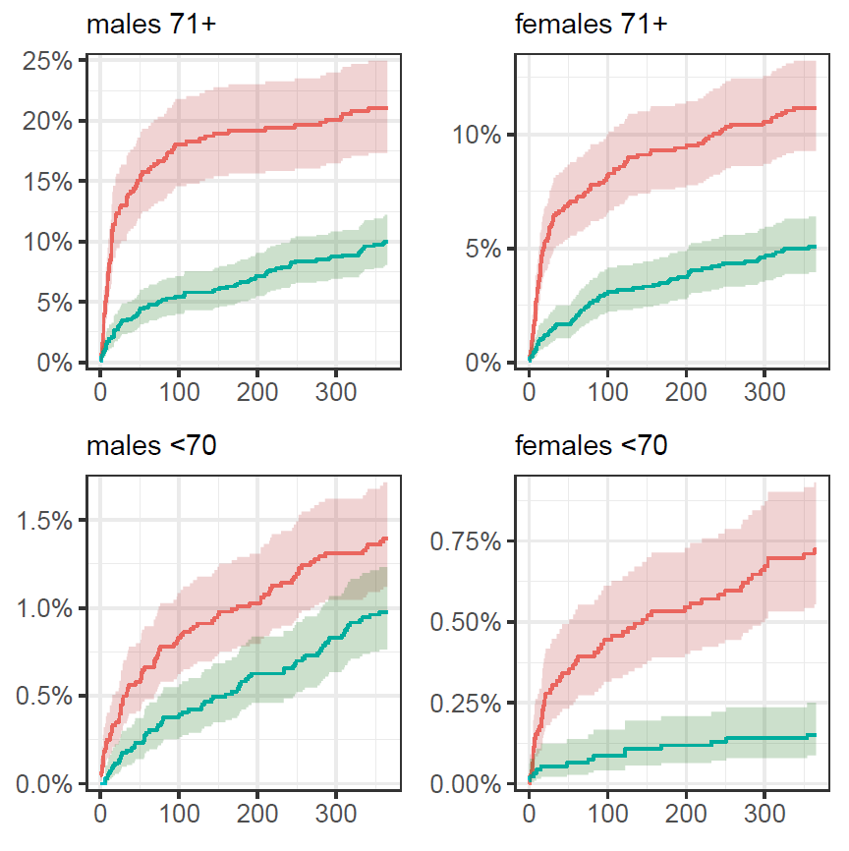

B.
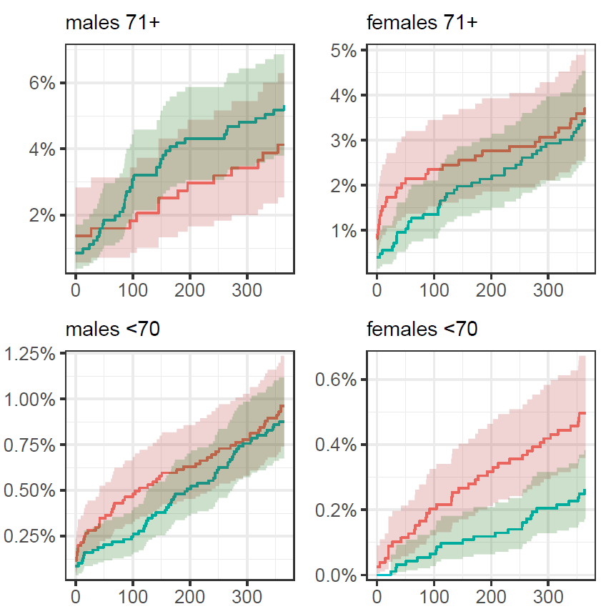

Figure 2. Directed acyclic graph, representing graphically the directions of possible causal connections between the treatment (vaccination) and the outcomes (MACE or death).

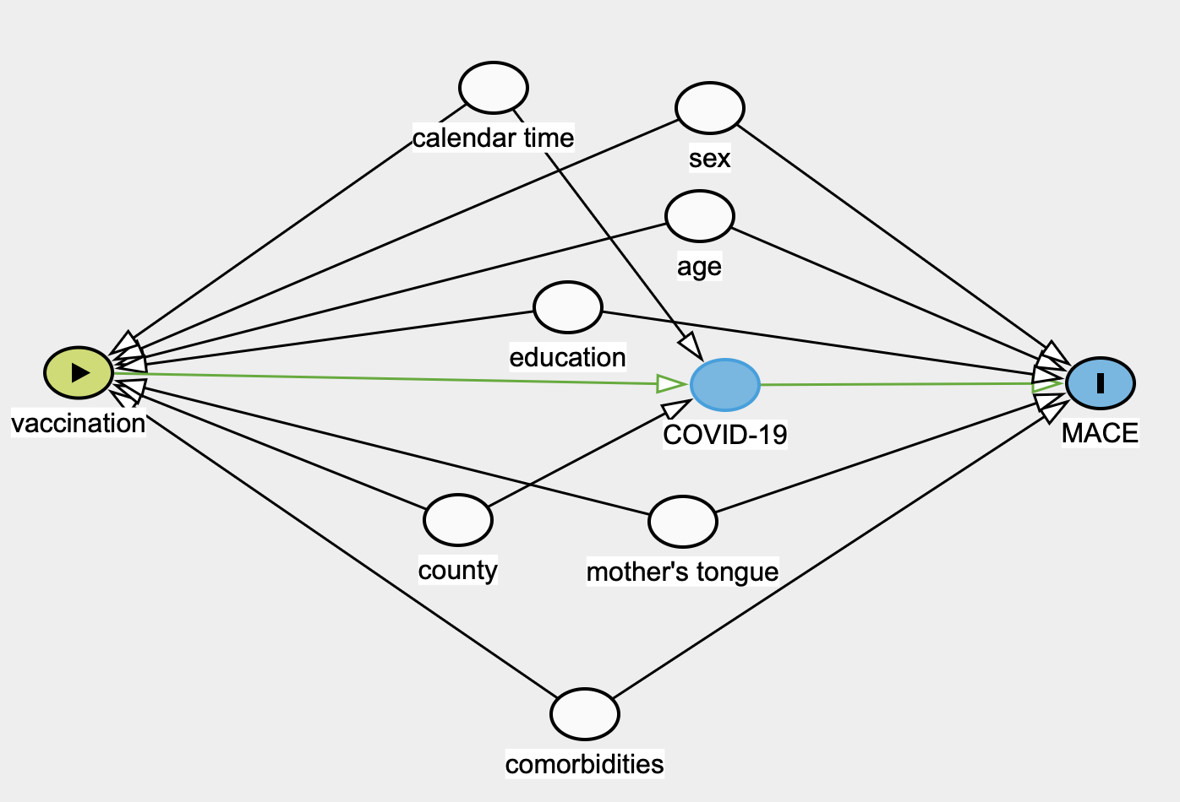

Figure 3. Standardized mean differences (SMD) in the covariates of the vaccinated and unvaccinated study participants before (circles) and after (triangles) correction with IP weights. SMD values between -0.1 and 0.1, shown as dotted lines, indicate good balance. The upper panel is calculated from the full data, the middle panel from the males’ data and the lower panel from the females’ data.
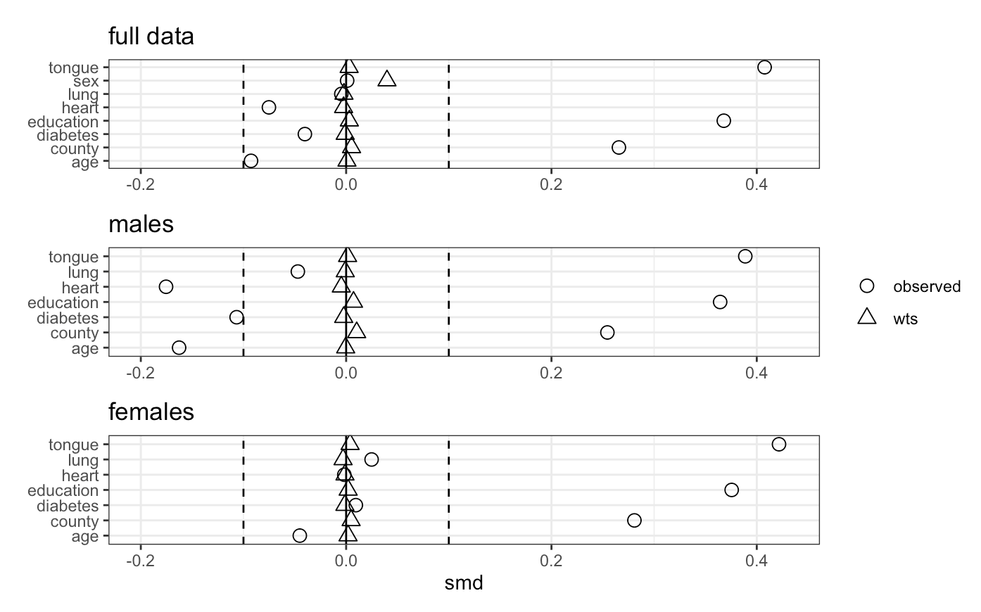

Figure 4. MACE and all-cause mortality weighted incidence rates (wIR) for the vaccinated and the unvaccinated over the study follow-up period among those with non-severe COVID-19.

Table 4. Effect of COVID-19 vaccination on incidence rate ratios (IRRs) for Major adverse cardiovascular events (MACE) and all-cause mortality after COVID-19, stratified by age and gender (full cohort, and the non-severe COVID-19 cohort).

Population | Gender | MACE  (wIRR, 95%CI) | MACE  (cIRR, 95%CI) | All-cause death  (wIRR, 95%CI) | All-cause death (cIRR, 95%CI
Full cohort

 | All | 0.71  (0.58; 0.84) | 0.95  (0.71 - 1.18) | 0.32  (0.28; 0.36) | 0.38  (0.31 - 0.45)
 | Females | 0.56  (0.41; 0.71) | 0.62  (0.38; 0.85) | 0.36  (0.30; 0.43) | 0.39  (0.29; 0.49)
 | Male | 1.03  (0.78; 1.27) | 0.99  (0.63; 1.35) | 0.44  (0.38; 0.5) | 0.71  (0.56; 0.85)
≤ 70 years | Males | 0.70  (0.50; 0.91) | 0.73  (0.42, 1.04) | 0.48  (0.36; 0.60) | 0.57  (0.36; 0.78)
≤ 70 years | Females | 0.46  (0.27; 0.64) | 0.52  (0.23; 0.81) | 0.18  (0.09; 0.27) | 0.17  (0.05; 0.29)
>70 years | Males | 1.66  (0.95; 2.37) | 1.66  (0.56; 2.75) | 0.31  (0.24; 0.39) | 0.34  (0.23; 0.45)
>70 years | Females | 0.60  (0.39; 0.82) | 0.62  (0.30; 0.95) | 0.33  (0.25; 0.42) | 0.33  (0.22; 0.44)
Non-severe COVID-19 cohort

 | All | 0.73  (0.59; 0.87) | 1.07  (0.83; 1.31) | 0.35  (0.31; 0.39) | 0.45  (0.36; 0.53)
 | Females | 0.55  (0.40; 0.70) | 0.86  (0.57; 1.15) | 0.35  (0.27; 0.43) | 0.41  (0.28; 0.54)
 | Males | 1.09  (0.84; 1.35) | 1.28  (0.87; 1.68) | 0.45  (0.37; 0.53) | 0.85  (0.61; 1.1)

Supplementary discussion: Causal study design

Formal epidemiological causal inference is based on the concept of counterfactual outcomes, whereby to get an average causal effect of a treatment vis-a-vis control (or exposure vs. non-exposure), one compares the average outcomes under conditions where everybody would have gotten the treatment and, at the same time, everybody would have gotten the control. To map the highly abstract counterfactual outcomes onto a real-world observational study, one needs to ensure that the actual effect under study is precisely the same effect that is being modelled in the abstract counterfactual situation -- i.e. consistency of the treatment and the outcome between the factual and the counterfactual situation. The other major condition of causal inference, exchangeability, is that the results of the study should not depend on which group gets the treatment, and which group gets the control.
In practice, the consistency condition can be approached via target trial emulation (TTE) procedure and the exchangeability by modelling the causal process that generated the data by a directed acyclic graph (DAG). This typically leads to statistical modelling of the observational data that adjusts the effect of treatment/exposure on the outcome by a set of variables identified from the DAG. Such an adjusted effect can be interpreted as a causal effect of the treatment on the outcome.

Our causal inference strategy is based on a TTE that poses the causal question of the influence of anti-COVID-19 vaccination on major adverse cardiovascular events (MACE) and all-cause mortality in COVID-19 survivors, e.g. in people who have suffered their first episode of SARS-CoV-2 infection, including asymptomatic infections, after their first full vaccination course (see Table S1). The TTE is a two-step procedure where the first step involves constructing a protocol for a hypothetical randomized controlled trial (RCT), which should (i) pose a well-defined question which is answerable through a realistic, even if ethically challenged, study protocol and (ii) lead to unbiased causal estimates that answer that question. In the second step, we set our observational study protocol to emulate, as closely as possible, the hypothetical randomized target study.
The major practical reasons behind the TTE approach are 1) to de-bias the observational study by setting its protocol as close as possible to an unbiased hypothetical RCT; 2) to make explicit the remaining sources of bias, as indicated by the remaining differences between the target trial and the observational trial protocols; and 3) to make explicit the target population toward which the results of the observational study are generalized.¹

From our TTE table two potential sources of bias can be inferred. The first is related to the fact that because a tightly controlled RCT would include purposefully and successfully infecting all participants with SARS-CoV-2, it could neither be conducted in the real world nor emulated in an observational study. Instead, we are hypothesizing a pragmatic randomized trial where infections are acquired naturally. This means that people who do not get infected with SARS-CoV-2, for instance, due to the protective effect of vaccination, are not in the population towards which our causal inference is directed. Thus, there is a systematic difference between the vaccinated and the unvaccinated populations, whereby a subset of the vaccinated population is selectively removed from the study. As people thus lost to follow-up are likely to be, on average, younger and fitter, we expect this to potentially reduce the effect of vaccination on MACE and death in our study population versus the starting population that had an opportunity to be vaccinated. To counter this potential bias, we successfully balanced the vaccinated and the unvaccinated groups for the known confounders, using IPT weighting (Figure S3). Nevertheless, we cannot guarantee that these groups are also balanced for the unknown and unmeasured confounders, which are not present in our DAG (Figure S1). This potential source of bias, and its remedy, applies equally to the target trial and its observational analogue.
Secondly, we have a discrepancy between the target study and its observational analogue in that the observational study cannot be blinded. This could lead to unvaccinated persons to be more vigilant in avoiding the infection and/or the vaccinated to be less vigilant. Again, IPTW performed at baseline de-biases the resulting inference in respect to known confounders, but not the unknown ones.

In summary, we conclude that TTE did not suggest to us any major biases emanating from violating the consistency criterion of causal inference. In order to meet the exchangeability criterion, we built a directed acyclic graph (DAG), by binding patient-level socio-economic factors (approximated in our data by education level, county of residence and mother’s native tongue) with biological factors (age and sex) and comorbidities (heart disease, pulmonary disease and diabetes diagnosed during the 3 years prior to T₀) into a single causal scheme (Figure S2). This allowed us to calculate a minimal sufficient adjustment set that would lead to meeting of the exchangeability criterion, if modelled correctly. Here we must note that, due to lack of sufficient quality data, our adjustment set does not include obesity, which is an important risk factor for our study outcomes and may have been also influencing people’s decisions to vaccinate, through its effect on the severity of COVID-19. This is a shortcoming that could bias our results and should be addressed in later studies.

Hernán MA, Robins JM. Using Big Data to Emulate a Target Trial When a Randomized Trial Is Not Available. Am J Epidemiol. 2016;183(8):758-64. doi: 10.1093/aje/kwv254.

