SUPPLEMENTAL INFORMATION
Supplemental Table 1 Antibodies Used for Experimental Procedures
Antibody | Dilution | Reference | Distributor
HIF-1α | 1:1000 | #ab179483 | Abcam
β-actin | 1:5000 | #A5316 | Merk
B55α | 1:1000 | #5689S | Cell Signaling
phospho-AMPK | 1:1000 | #2535S | Cell Signaling
total-AMPK | 1:1000 | #ab80039 | Abcam
Sirtuin 1 | 1:1000 | #8469 | Cell Signaling
p21 Waf1/Cip1 (p21) | 1:1000 | #2947 | Cell Signaling
HSP 90 | 1:1000 | #4874 | Cell Signaling
α-SMA | 1:500 | #53-9760-80 | Invitrogen
CD31 | 1:100 | #ab28364  #14-0311-85 | Abcam  Invitrogen
CAV1 | 1:1000 | #3267 | Cell Signaling
CD34 | 1:100 | 553731 | BD Biosciences
peNOS | 1:1000 | ab215717 | Abcam
eNOS | 1:1000 | 32027S | Cell signaling
MPO | 1:200 | #ab208670 | Abcam
F4/80 | 1:50 | #MCA497 | Bio-Rad
Ki67 | 1:100 | #ab15580 | Abcam
Gapdh | 1:10000 | #ab1816002 | Abcam
PARP1 | 1:1000 | 9542S | Cell Signaling
Biotinylated anti-mouse goat | R.T.U. | #BP-9200 | Vector Lab
Goat anti mouse Alexa 488 | 1:500 | #A11029 | Thermo Fisher
Goat anti mouse Alexa 647 | 1:500 | #A21235 | Thermo Fisher

qRT-PCR.
cDNA was then subjected to quantitative real-time PCR (qPCR) using the iQ™ SYBR Green Supermix (Bio-Rad) and a CFX96 Real-Time PCR Detection System (Bio-Rad).PCR amplification efficiency was normalized to the expression of the PPIA gene for each sample, and the relative fold change in gene expression was calculated using the -ΔΔCt method. The primers used for amplification were synthesized by Eurofins (Luxembourg) and are detailed in the table below:

Supplemental Table S2 qRT-PCR Primers and Their Sequences
Genes | Forward (5’ 3’) | Reverse (3’5’)
B55α | GAGACAAAAGACCAGAAGGCTATA | ATTCTCCGTGGACTGGCTTCCA
CAV1 | CACACCAAGGAGATTGACCTGG | CCTTCCAGATGCCGTCGAAACT
Epo | GACAAAGCCATCAGTGGTCTACG | GCAGAAAGTATCCACTGTGAGTG
Hgf | GTCCTGAAGGCTCAGACTTGGT | CCAGCCGTAAATACTGCAAGTGG
PPIA | CATACAGGTCCTGGCATCTTGTC | AGACCACATGCTTGCCATCCAG
Sirt1 | GGAGCAGATTAGTAAGCGGCTTG | GTTACTGCCACAGGAACTAGAGG
Vegfa | CTGCTGTAACGATGAAGCCCTG | GCTGTAGGAAGCTCATCTCTCC
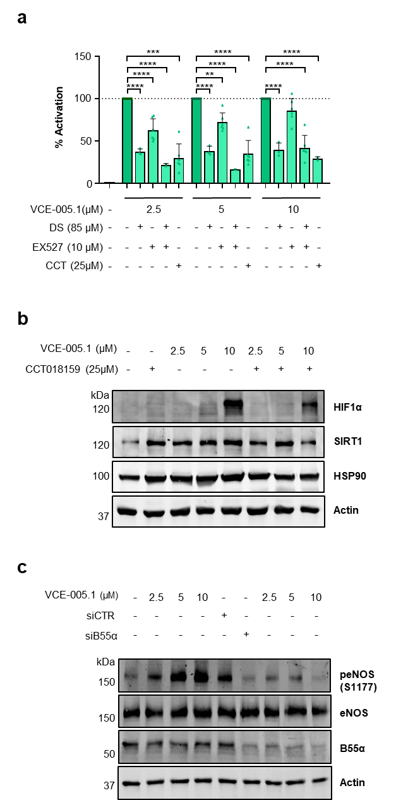

Supplemental Fig. 1 Inhibition of HSP90 by CCT018159 decreases HIF-1α expression induced by VCE-005.1. (a) In the presence or absence of AMPK, SIRT1 and HSP90 inhibitors, NIH-3T3-EPO-luc cells were treated with VCE-005.1 for 6 h. After this, luciferase activity was measured and expressed as a percentage of activation, considering the value of VCE-005.1 as 100% activation. Data represent the mean ± SD (n= 3-6) and the significance was determined using non-parametric followed by a Kruskal-Wallis test; **p < 0.01, ****p < 0.0001. (b) EA.hy926 cell line was pre-incubated with CTT018159 and subsequently treated with different concentrations of VCE-005.1 for a period of three hours. Western blot analysis was then performed in order to measure the levels of HIF1α, Sirt1, HSP90, and Actin (n=3). (c) EA.hy926 cells were subjected to transfection with siSIRT1 or scrambled control siRNAs, followed by exposure to VCE-005.1 for a duration of 5h. Then, the expression levels of peNOS (s1177), eNOS, B55α and Actin were analysed using Western Blot analysis (n=3).
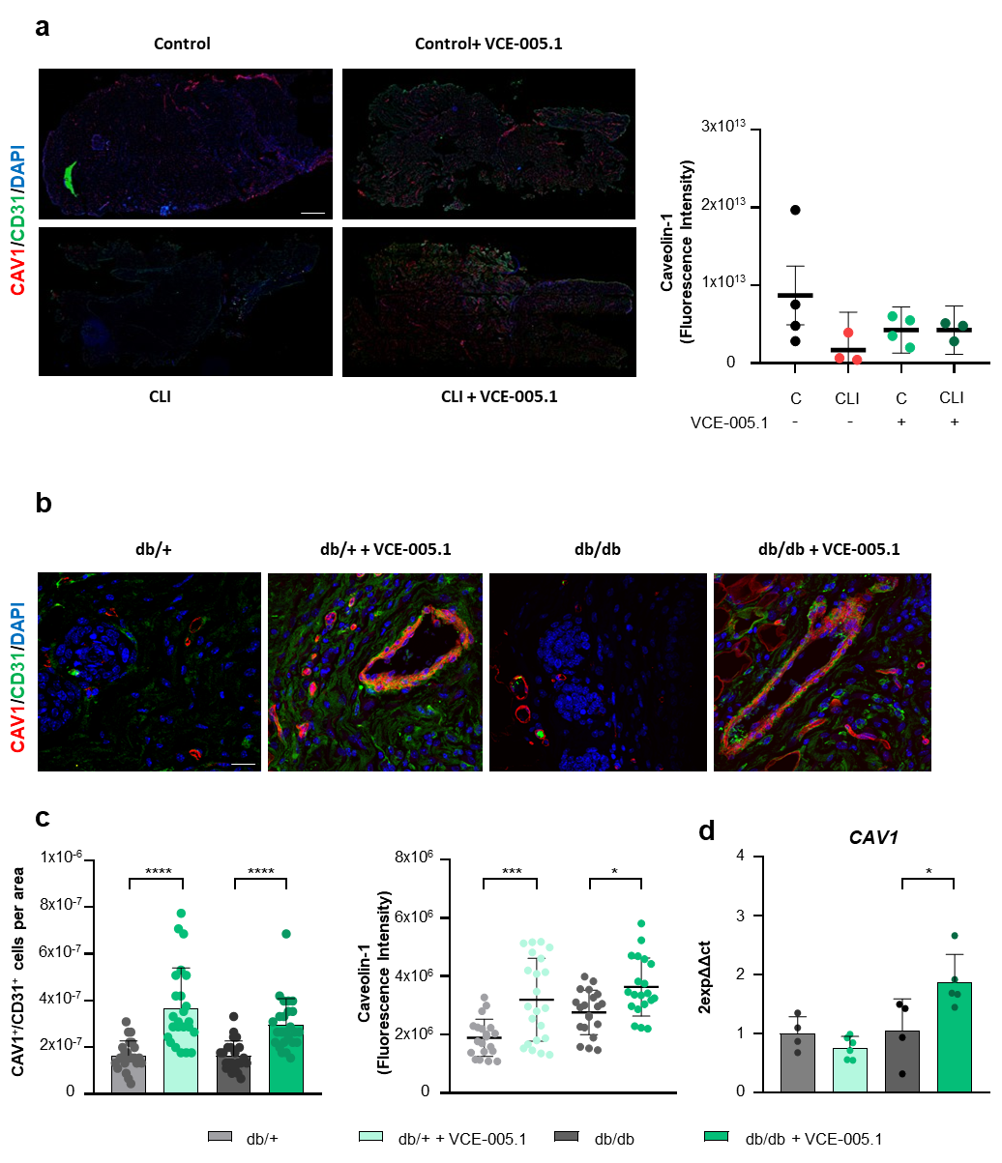
Supplemental Fig. 2 VCE-005.1 induces Cav1 in vivo. (a) Representative double immunofluorescence confocal staining of CAV1(red)/CD31 (green) and its quantification in gastrocnemius muscles 10 days after ischemia. Scale bar corresponds to 100 μm. (b) Representative double immunofluorescence confocal staining of CAV1(red)/CD31 (green) in Wound Healing. Scale bars equivalent to 50 μm for confocal images. (c) Quantification of CAV1 (red)/CD31 (green) immunofluorescence. Data did not pass the normality test, and significance was determined using non-parametric methods, followed by a Kruskal–Wallis test. (d) The mRNA expression of CAV1 in the skin after 10 days of wounding. Data passed the Shapiro-Wilk normality test and statistical analysis was performed using one-way ANOVA, followed by Tukey’s post hoc test to compare differences among the groups (n =4–6 animals per group). The results are presented as mean ± SEM. Statistical significance is indicated in the panel, with *p < 0.05, ***p < 0.001 and ****p < 0.0001.
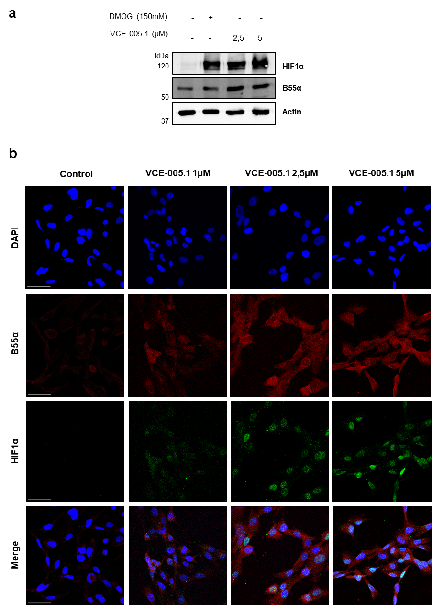

Supplemental Fig. 3 VCE-005.1 induce HIF1α and B55α in papillary follicular cell line. (a) The IHDPC cell line was stimulated with increasing concentrations of VCE-005.1 for 3 hours, and the compound DMOG was used as a positive control for HIF1α. The expression levels of HIF1α, B55α, and Actin were assessed by Western blot analysis (n=3). (b) Representative confocal image of HIF1α (green) and B55α (red) expression in IHDPC cells untreated and treated with increasing concentrations of VCE-005.1 for 3h (scale bars=50 μm; n=3).

