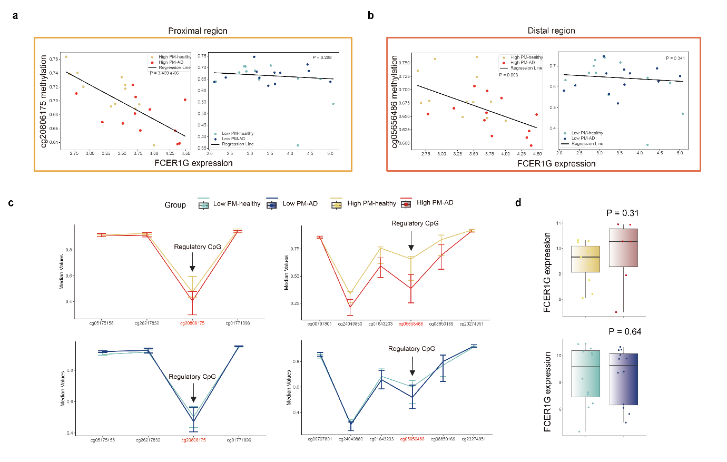
Extended Data Fig. 1 FCER1G expression and regulatory CpGs in cord blood. a, Correlation plots between proximal CpG methylation (cg20806175) and FCER1G expression in cord blood. Each dot represents the High PM exposure-AD group (n = 6), High PM exposure-healthy group (n = 11), Low PM exposure-healthy group (n = 12), and Low PM exposure-AD group (n = 12). b, Correlation plots between distal CpG methylation (cg05656486) and FCER1G expression in cord blood. Each dot represents the same groups as in (a). c, Line plots with error bars represent the median DNA methylation levels of CpGs located within ±200 bp of the regulatory CpG (indicated by the arrow) in the proximal (left) and distal (middle) regions, from cord blood samples. The CpG IDs (x-axis) are ordered based on chromosomal position. d, Box plots illustrate FCER1G expression levels across the four groups in cord blood. Error bars indicate the mean ± s.e.m (c). Each box and whisker plot displays the median as the central line, the interquartile range (25th–75th percentiles) is shown by the edges of the box, and the whiskers represent minimum–maximum values (d). Statistical analyses include Huber regression (a and b) and Wilcoxon rank-sum test (c and d). All cord blood samples were collected from individuals with matched placental samples.

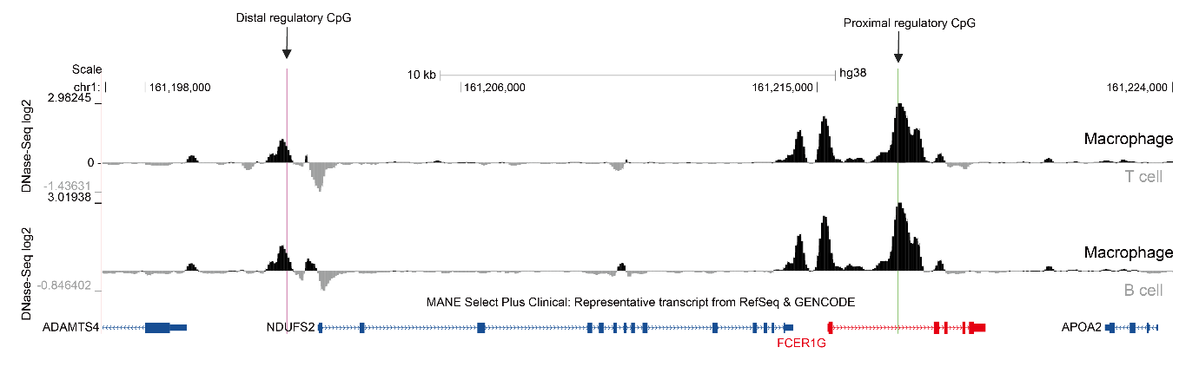
Extended Data Fig. 2| Comparison of the epigenetic landscape between macrophages and other immune cells. DNase-seq log₂-transformed ratios comparing macrophages to immune cells (T cells, B cells). Green marks indicate the proximal regulatory CpG site, while purple marks indicate the distal regulatory CpG site. All data were obtained from ENCODE.
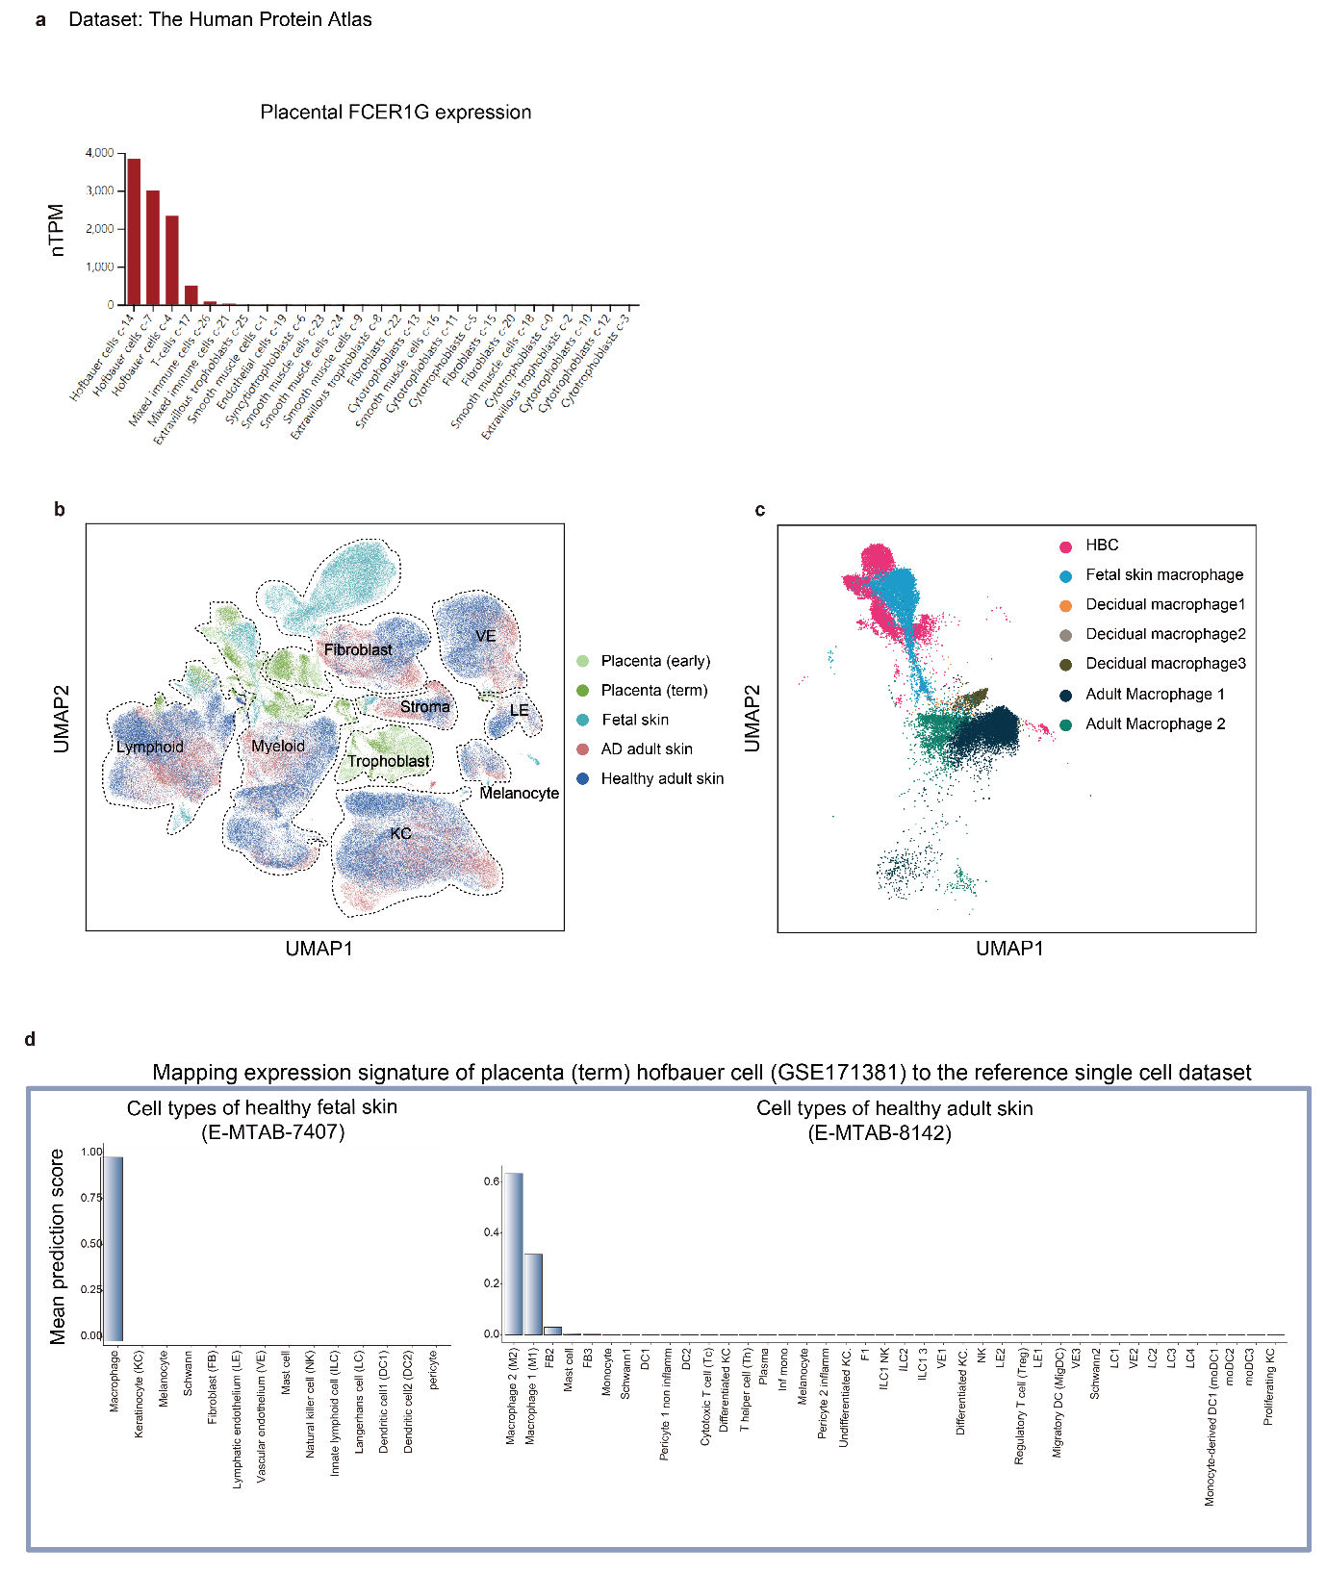
Extended Data Fig. 3| FCER1G expression and placental Hofbauer cell state prediction across developmental stages. a, Bar plots represent FCER1G expression across various placental cell types (n = 25,615 cells) from scRNA-seq data. Data accessed from Human Protein Atlas (proteinatlas.org). b, Uniform manifold approximation and projection (UMAP) plots of scRNA-seq data from different developmental stages (placenta early, n = 18,547 cells; placenta term, n = 33,173 cells; fetal skin, n = 44,295 cells; healthy adult skin, n = 192,347 cells; AD adult skin, n = 115,807 cells) from the E-MTAB-6701, GSE171381, E-MTAB-7407, and E-MTAB-8142 datasets. VE, vascular endothelial cell; LE, lymphatic endothelium; KC, keratinocyte. c, UMAP plot of Hofbauer cells, fetal skin macrophages, decidual macrophages (maternal side), and adult macrophages. d, Bar plots displaying the mean prediction score of term placental Hofbauer cell states, using healthy fetal skin (left) and healthy adult skin (right) as references, derived from the TransferAnchors function in Seurat.

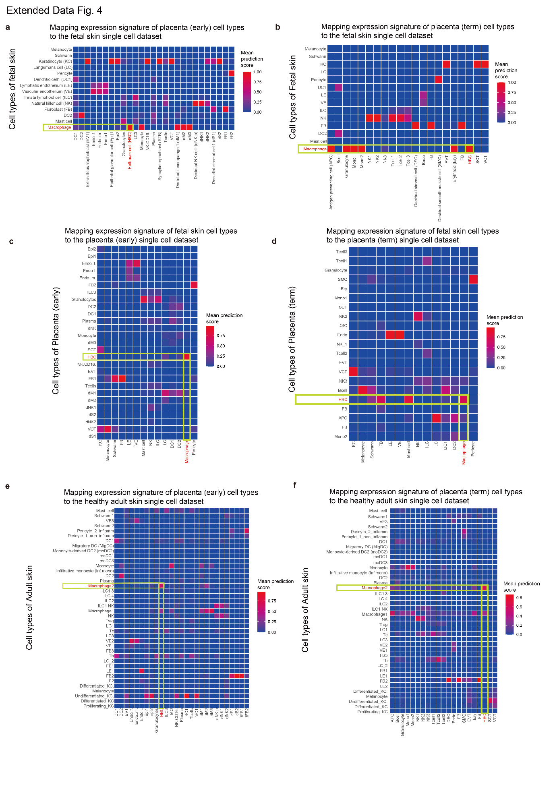
Extended Data Fig. 4| Phenotypic similarity across cells from different developmental stages. a, Heatmaps showing the median prediction score of early-stage placental cell states using healthy fetal skin as a reference, derived from the TransferAnchors function in Seurat. b, Heatmaps showing the median prediction score of term-stage placental cell states using healthy fetal skin as a reference, derived from the TransferAnchors function in Seurat. c, Heatmaps showing the median prediction score of healthy fetal skin cell types using early-stage placenta as a reference, derived from the TransferAnchors function in Seurat. Hofbauer cells showed high prediction scores across multiple cell types. This analysis was conducted to identify which fetal cell types are most closely related to Hofbauer cells. d, Heatmaps showing the median prediction score of healthy fetal skin cell types using term-stage placenta as a reference, derived from the TransferAnchors function in Seurat. Hofbauer cells showed high prediction scores across multiple cell types. This analysis was conducted to identify which fetal cell types are most closely related to Hofbauer cells. e, Heatmaps showing the median prediction score of early-stage placental cell states using healthy adult skin as a reference, derived from the TransferAnchors function in Seurat. f, Heatmaps showing the median prediction score of term-stage placental cell states using healthy adult skin as a reference, derived from the TransferAnchors function in Seurat.
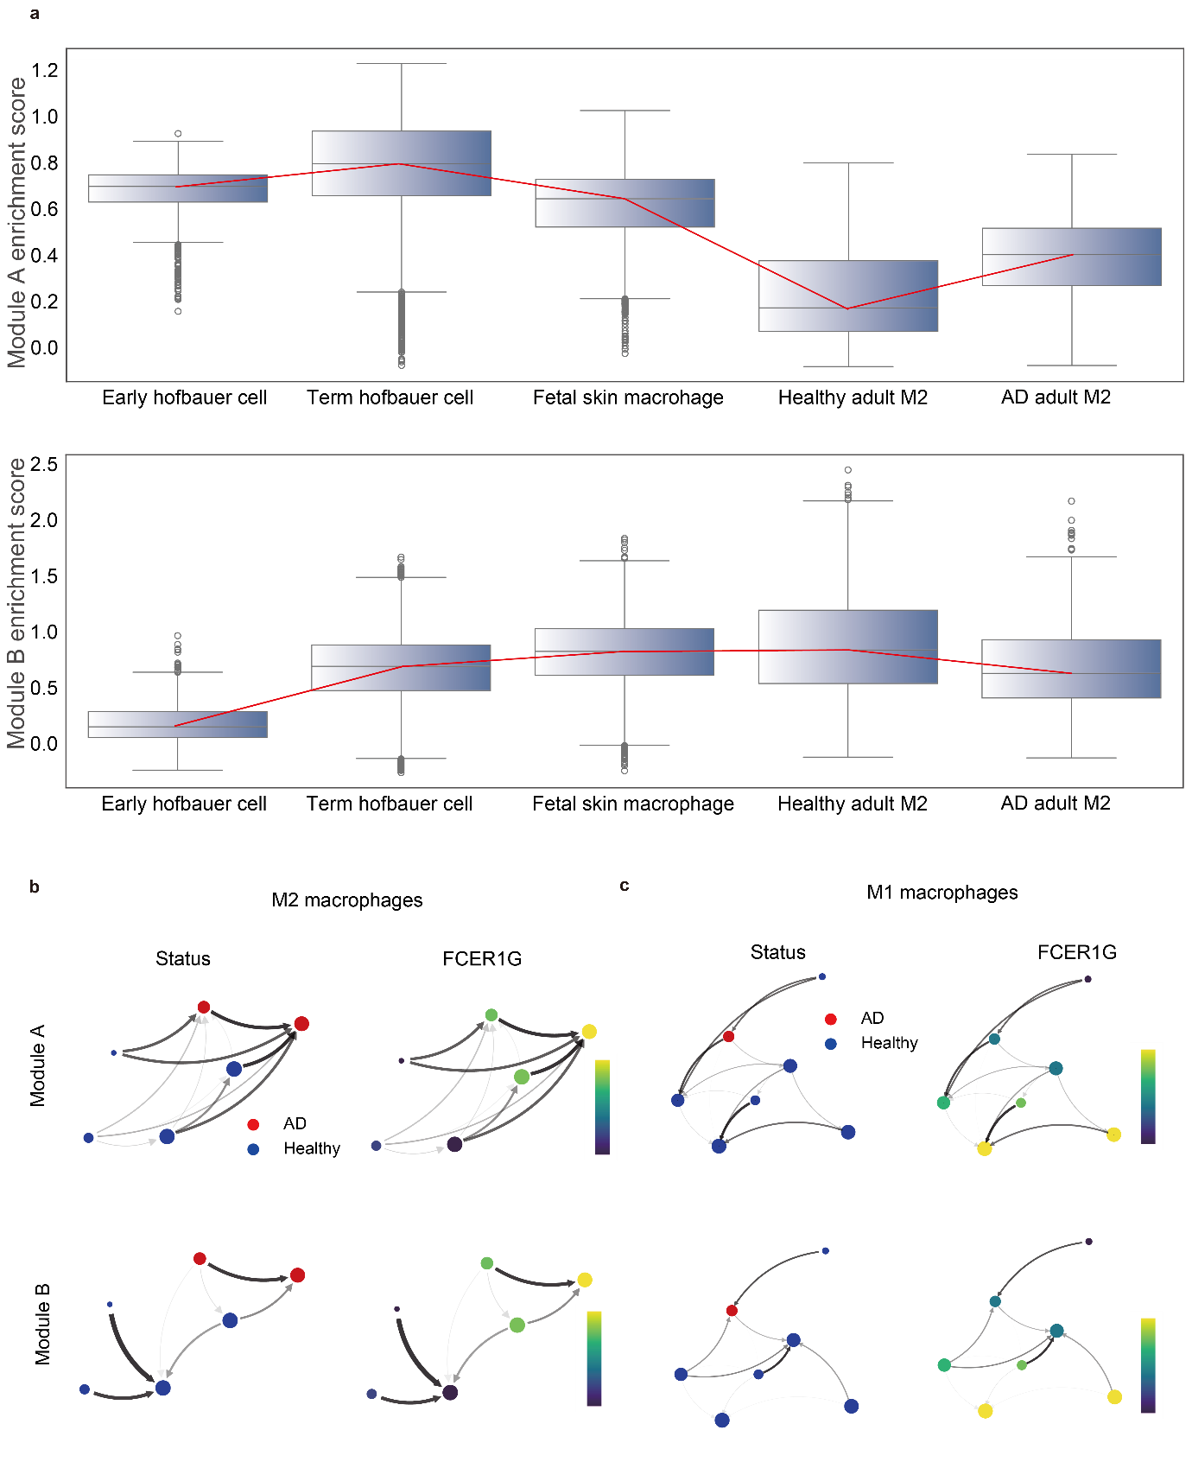
Extended Data Fig. 5| Module scores across developmental stages and cell state transitions in adult macrophages. a, Box plots showing module scores calculated using scanpy.tl.score_genes across developmental stages, including Hofbauer cells, fetal skin macrophages, and adult M2 macrophages. Each box-and-whisker plot displays the median as the central line, the interquartile range (25th–75th percentiles) is shown by the edges of the box, and the whiskers represent minimum–maximum values. b, The cell state transition graph, based on modules A (top) and B (bottom), displays the AD and healthy status (left) and the FCER1G gene expression (right) in Macrophage 2. The size of each node is proportional to the cluster size, while the thickness of the edges indicates the strength of the connections. Arrows represent the direction of the transitions. Cell state transitions were analyzed using dynamo.pl.state_graph. c, The cell state transition graph, based on modules A (top) and B (bottom), displays the AD and healthy status (left) and the FCER1G gene expression (right) in Macrophage 1. The size of each node is proportional to the cluster size, while the thickness of the edges indicates the strength of the connections. Arrows represent the direction of the transitions. Cell state transitions were analyzed using dynamo.pl.state_graph.
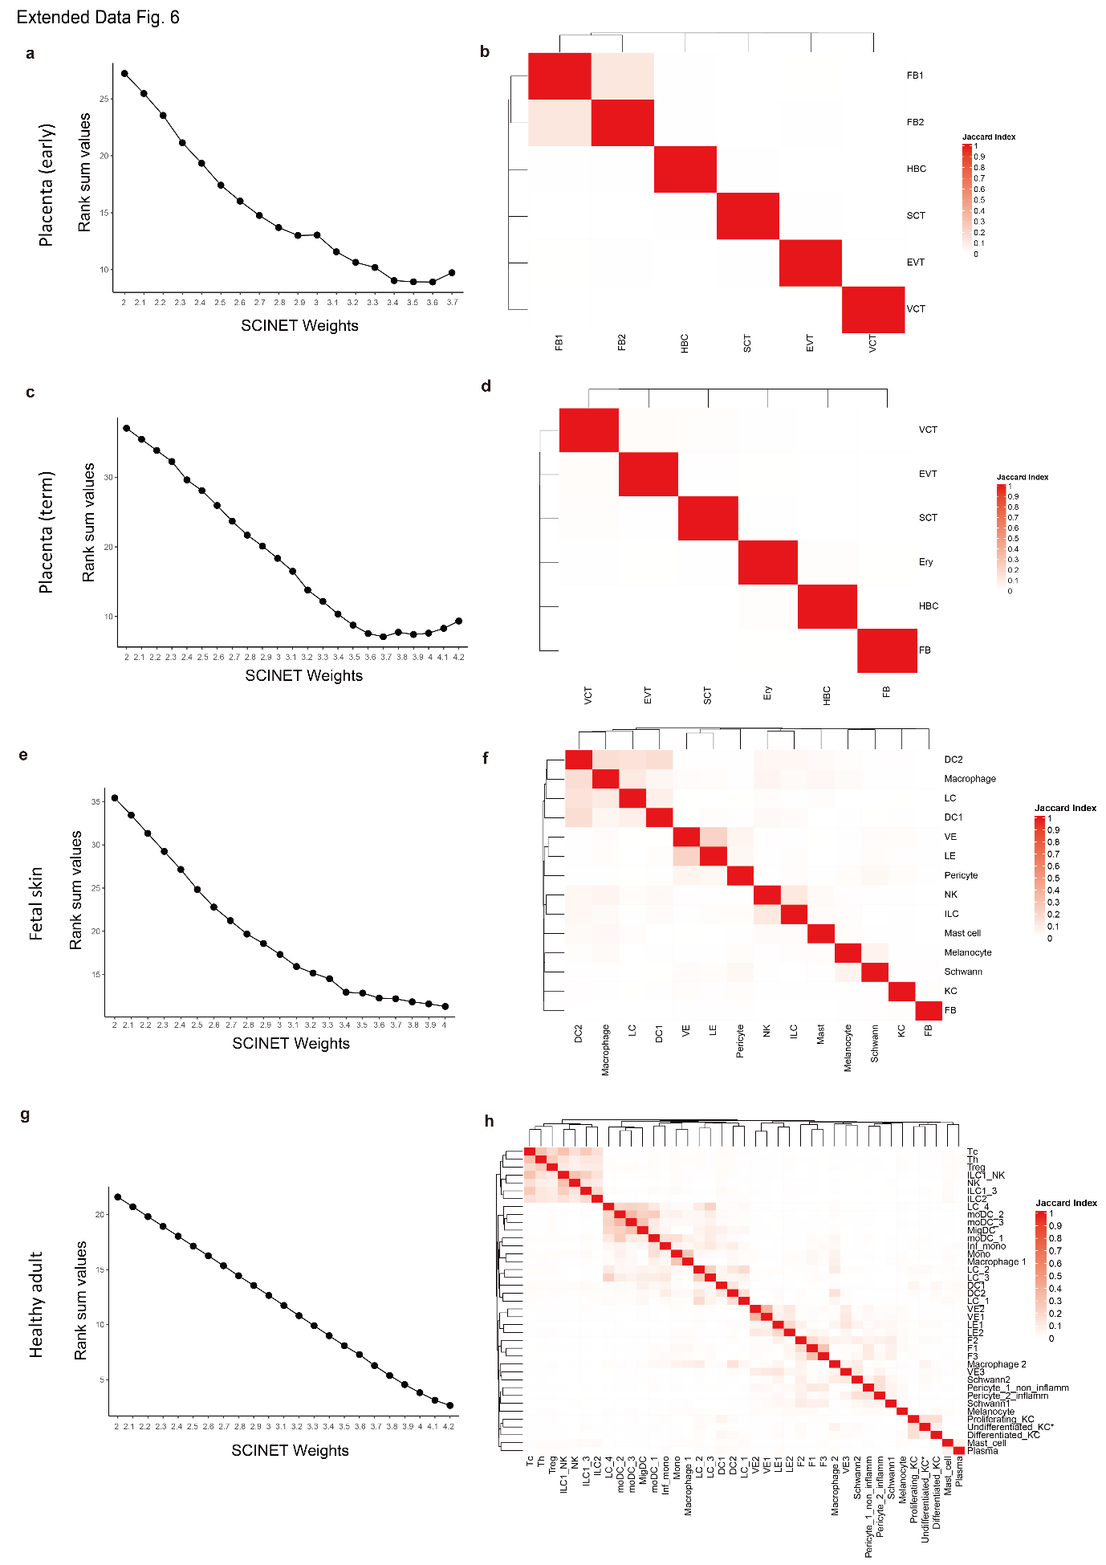
Extended Data Fig. 6| Optimal weight calculation and cell type-specific network construction. a, The optimal weights for constructing an early placenta cell-type-specific network were determined by calculating the rank sum values based on SCINET weights. The rank sum values consider two factors: (1) the higher the number of marker genes included, the lower the rank, and (2) the more cell type-specific genes present without overlap, the lower the rank. See Methods for more details. b, The heatmap represents the Jaccard index, which measures the degree of overlap between the genes of each cell type-specific network (weight = 3.6). c, The optimal weights for constructing a term placenta cell type-specific network were determined by calculating the rank sum values based on SCINET weights. The rank sum values consider two factors: (1) the higher the number of marker genes included, the lower the rank, and (2) the more cell type-specific genes present without overlap, the lower the rank. See Methods for more details. d, The heatmap represents the Jaccard index, which measures the degree of overlap between the genes of each term placenta cell-type-specific network (weight = 3.7). e, The optimal weights for constructing a healthy fetal skin cell-type-specific network were determined by calculating the rank sum values based on SCINET weights. The rank sum values consider two factors: (1) the higher the number of marker genes included, the lower the rank, and (2) the more cell type-specific genes present without overlap, the lower the rank. See Methods for more details. f, The heatmap represents the Jaccard index, which measures the degree of overlap between the genes of each healthy fetal skin cell-type-specific network (weight = 4.0). g, The optimal weights for constructing a healthy adult skin cell-type-specific network were determined by calculating the rank sum values based on SCINET weights. The rank sum values consider two factors: (1) the higher the number of marker genes included, the lower the rank, and (2) the more cell type-specific genes present without overlap, the lower the rank. See Methods for more details. h, The heatmap represents the Jaccard index, which measures the degree of overlap between the genes of each healthy adult skin cell-type-specific network (weight = 4.2).

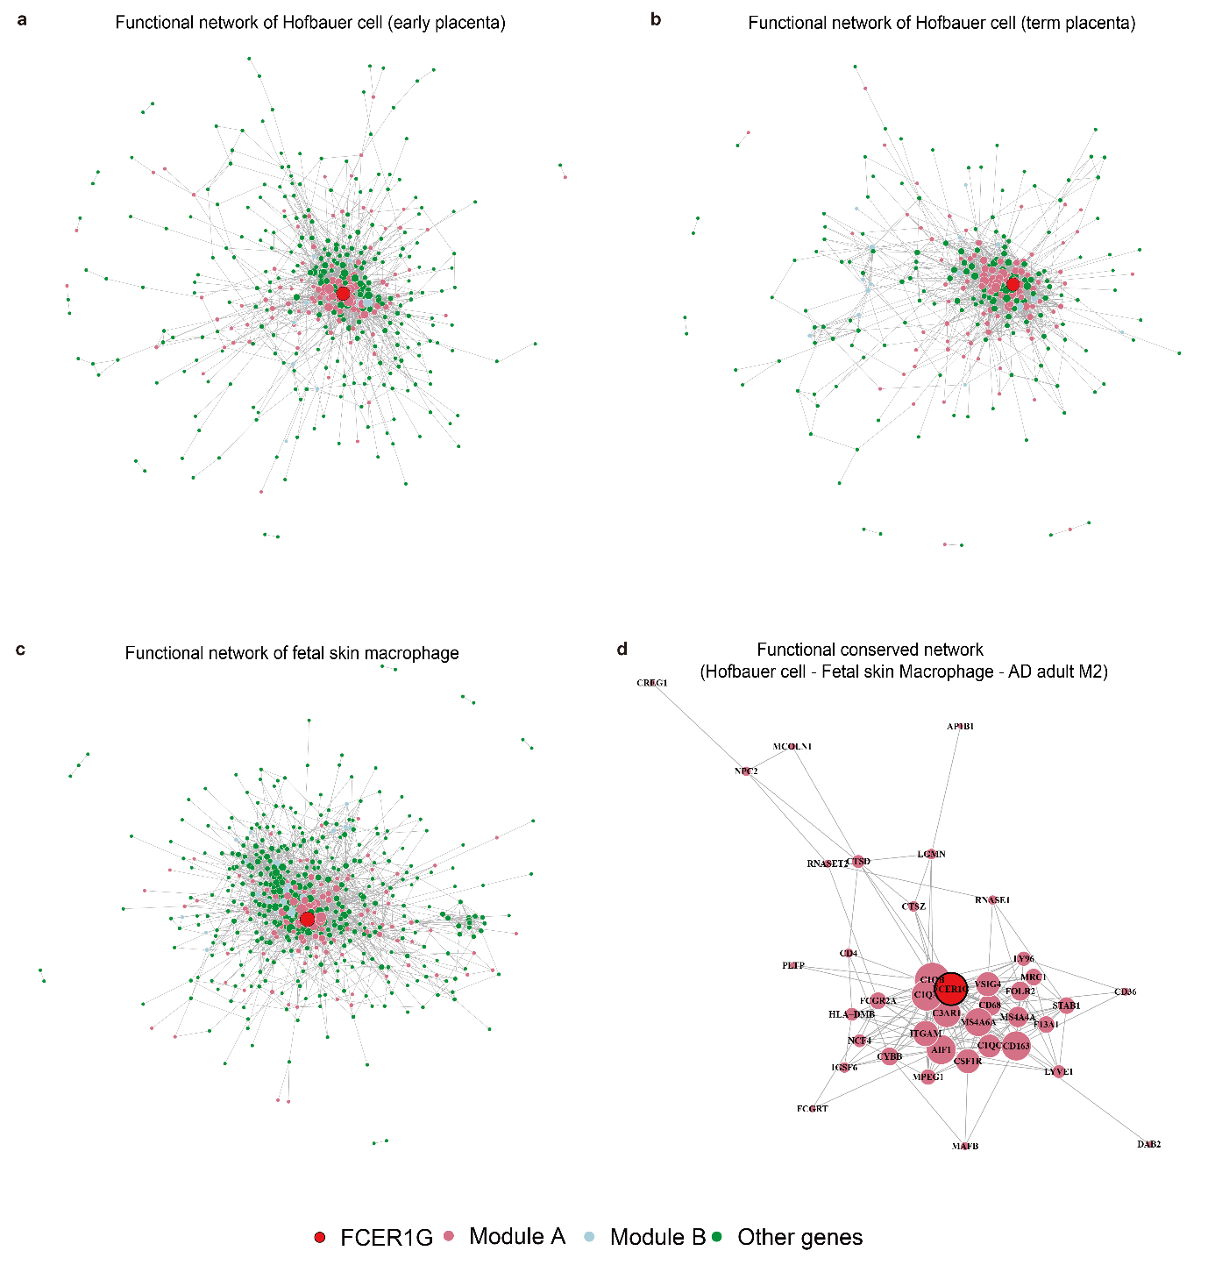
Extended Data Fig. 7| Functional network visualizations of early and term placental Hofbauer cells, fetal skin macrophages, and conserved networks. a, Network visualization of early-stage placental Hofbauer cells. Node colors represent specific genes or modules: red indicates FCER1G, pink represents Module A, green represents Module B, and light blue denotes other genes. Node size corresponds to the number of interactions for each gene. b, Network visualization of term-stage placental Hofbauer cells, using the same color and node size scheme as in (a). Node size corresponds to the number of interactions for each node. c, Network visualization of fetal skin macrophages, using the same color and node size scheme as in (a). d, Network visualization of conserved networks for Hofbauer cells, fetal skin macrophages, and AD adult M2 macrophages. This network contains only Module A and FCER1G. Node size corresponds to the number of interactions for each gene.

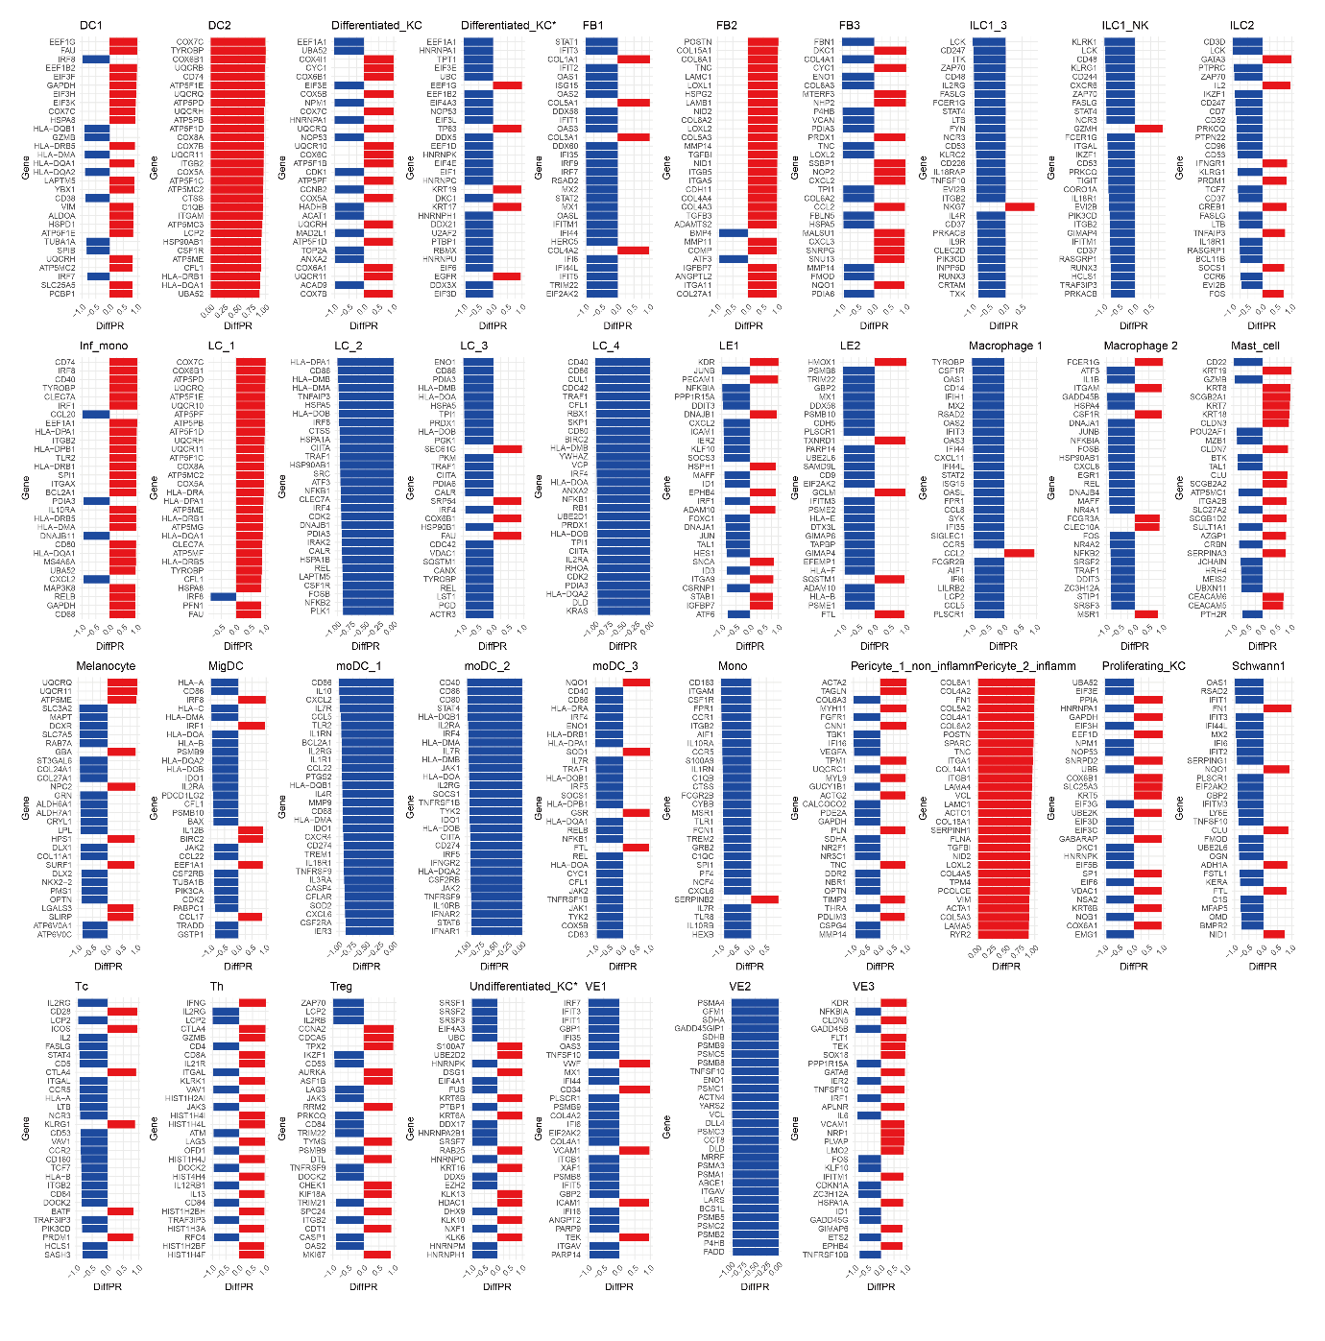
Extended Data Fig. 8| Differential percentile rank (diffPR) of genes in healthy and AD adult cell types. Top 30 genes ranked by differential percentile rank (diffPR) values, comparing healthy and AD adult cell types. Red bars indicate AD-specific central genes in these cell types. The gene list is sorted by P values. Statistics were calculated using the FindDiffHub function from scHumanNet.

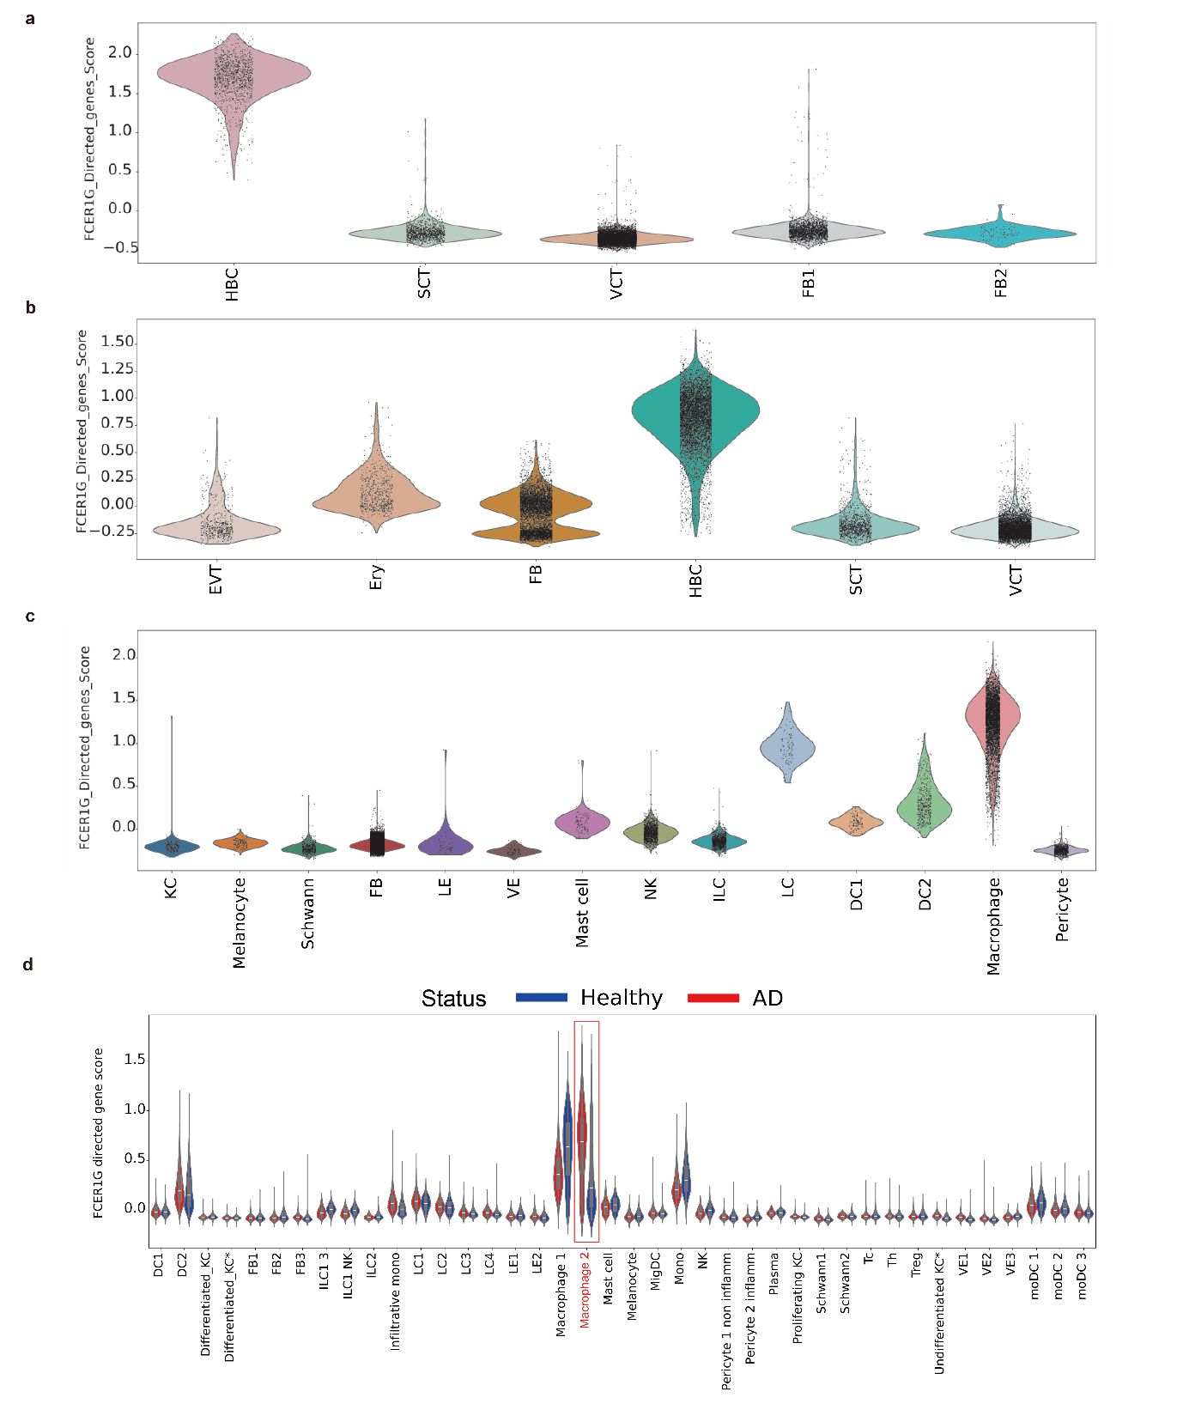
Extended Data Fig. 9| FCER1G-directed neighbor gene scores across developmental stages. a, Violin plots showing FCER1G-directed neighbor gene scores calculated using scanpy.tl.score_genes across early-stage placental cell types. Each dot represents an individual cell. b, Violin plots showing FCER1G-directed neighbor gene scores calculated using scanpy.tl.score_genes across term-stage placental cell types. Each dot represents an individual cell. c, Violin plots showing FCER1G-directed neighbor gene scores calculated using scanpy.tl.score_genes across fetal skin cell types. Each dot represents an individual cell. d, Violin plots showing FCER1G-directed neighbor gene scores calculated using scanpy.tl.score_genes in healthy and AD adult skin cell types. Each dot represents an individual cell. The gene set used for this analysis was derived from Fig. 6f. (a–d)

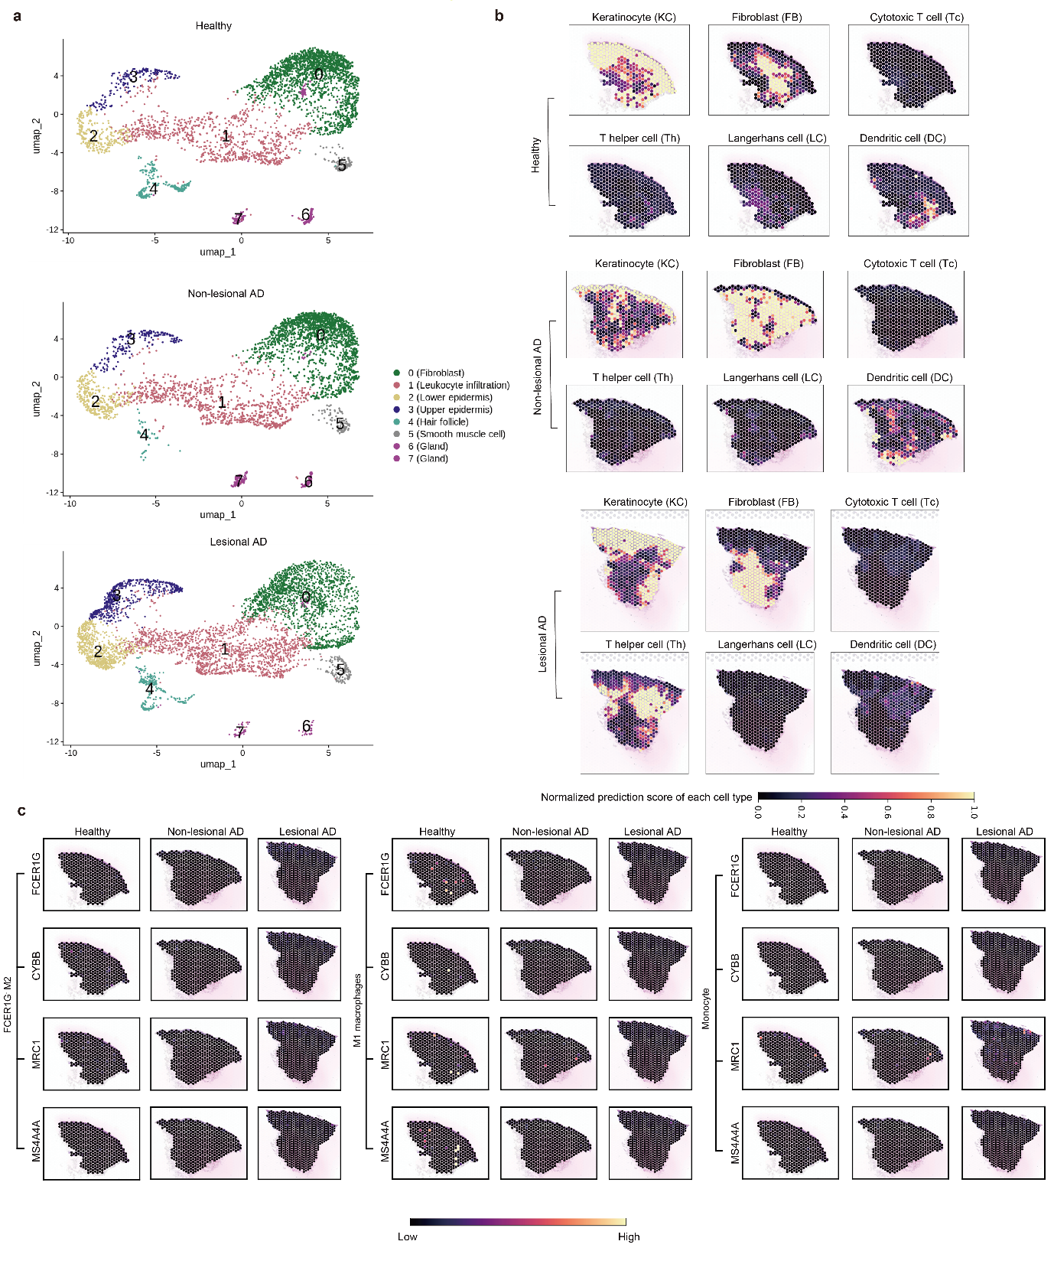
Extended Data Fig. 10| Spatial transcriptome analysis and cell type-specific prediction scores across healthy, non-lesional, and lesional AD. a, UMAP plots of total spatial transcriptome spots (healthy, n = 6; non-lesional AD, n = 5; lesional AD, n = 7) from the GSE197023 dataset. b, Normalized prediction scores of each cell type (Keratinocyte, Fibroblast, Cytotoxic T cell, T helper cell, Langerhans cell, Dendritic cell), estimated using cell2location, across healthy, non-lesional and lesional AD sections. c, Gene expression levels of FCER1G, CYBB, MRC1, and MS4A4A in FCER1G⁻ M2 macrophages, M1 macrophages, and monocytes across healthy, non-lesional, and lesional AD sections.

