Extended data Figures
Extended data Fig. 1 Global mining-induced forest loss from 2000 to 2020 at the continent scale.
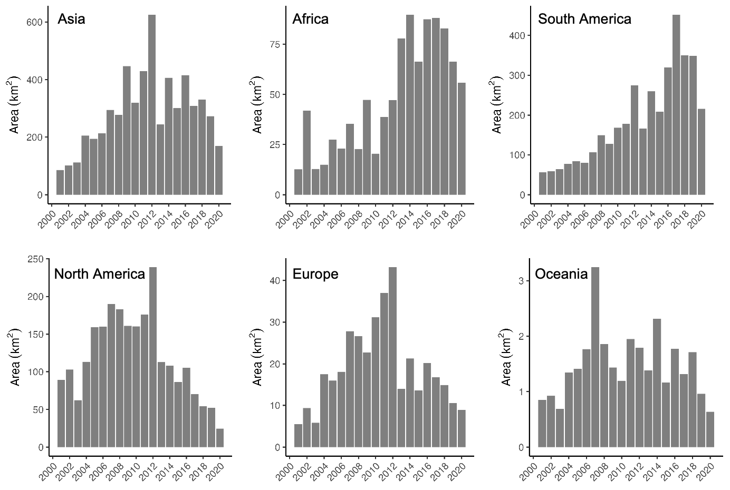
Extended data Fig. 2 Global mining-induced forest loss within the PA boundaries from 2000 to 2020 at the continent scale.
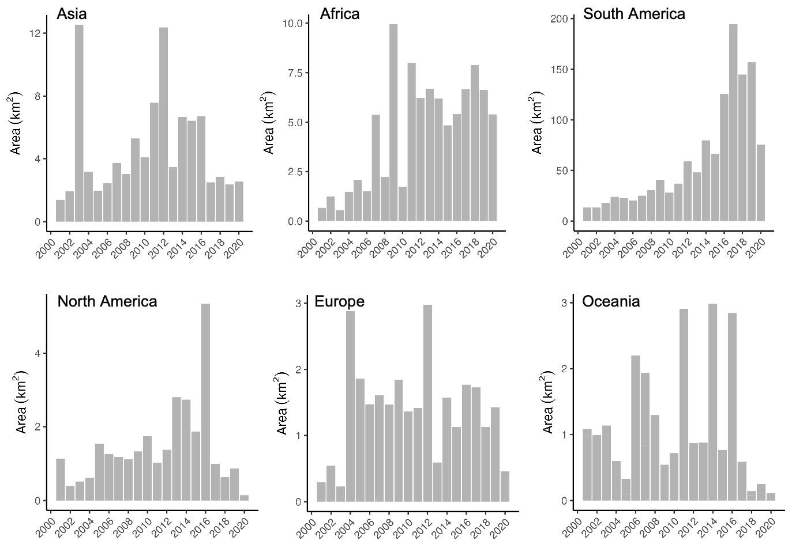
Extended data Fig. 3 Proportion of forest loss within PAs to global forest loss from 2000 to 2020 at the continent scale.
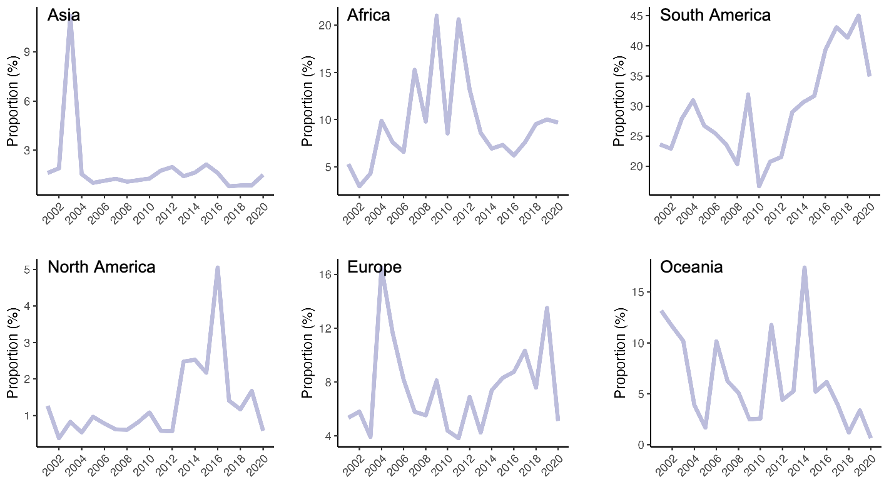
Extended data Fig. 4 Forest loss within the PAs in different strict levels.
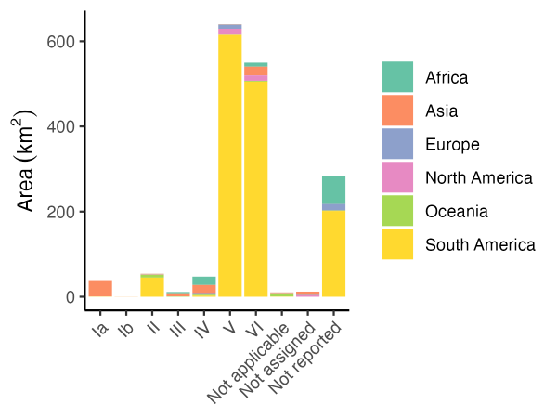

Extended data Fig. 5 Forest loss outside PA boundaries at the continental scale. Solid circle represents forest loss within the PA boundaries, while the line represents cumulative forest loss within the 1-10 km buffer zones outside the PAs.
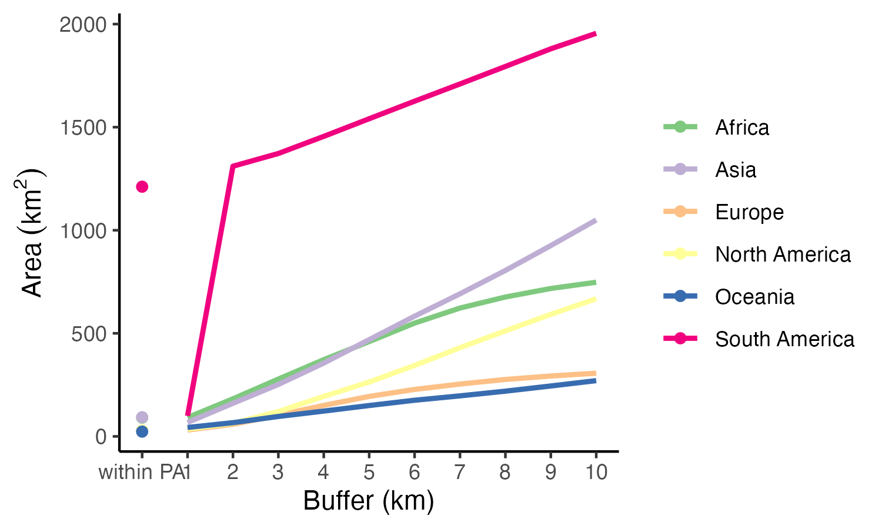
Extended data Fig. 6 Ratio (Times) of forest loss within the 5 km- and 10 km-buffer zones outside the PAs to forest loss within the PA boundaries during the period of 2001-2020.
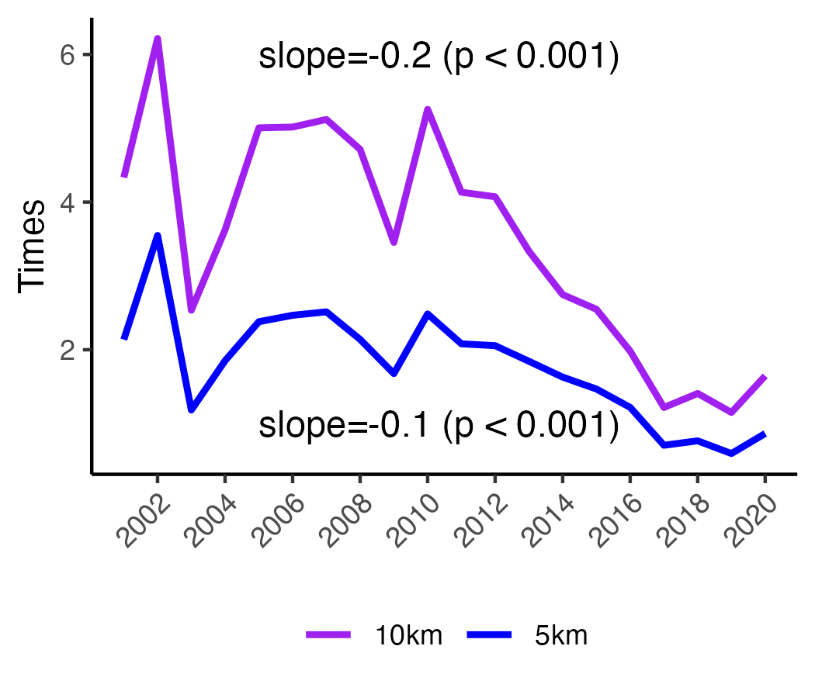
Extended data Fig. 7 Visualization of the temporal dynamics of forest loss within the 10 km-buffer outside the PA boundaries, using Borneo, Indonesia, as a case study.
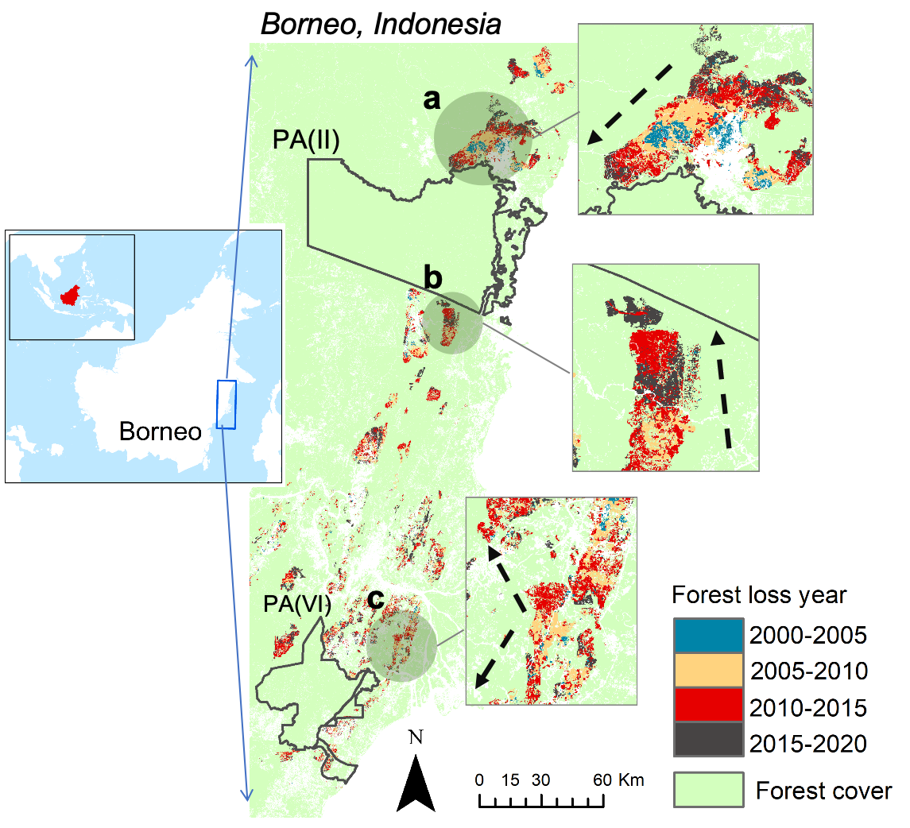

Extended data Fig. 8 Temporal changes of average AGB density of forest loss within the PA boundaries and the 10 km-buffer zone outside the PAs.
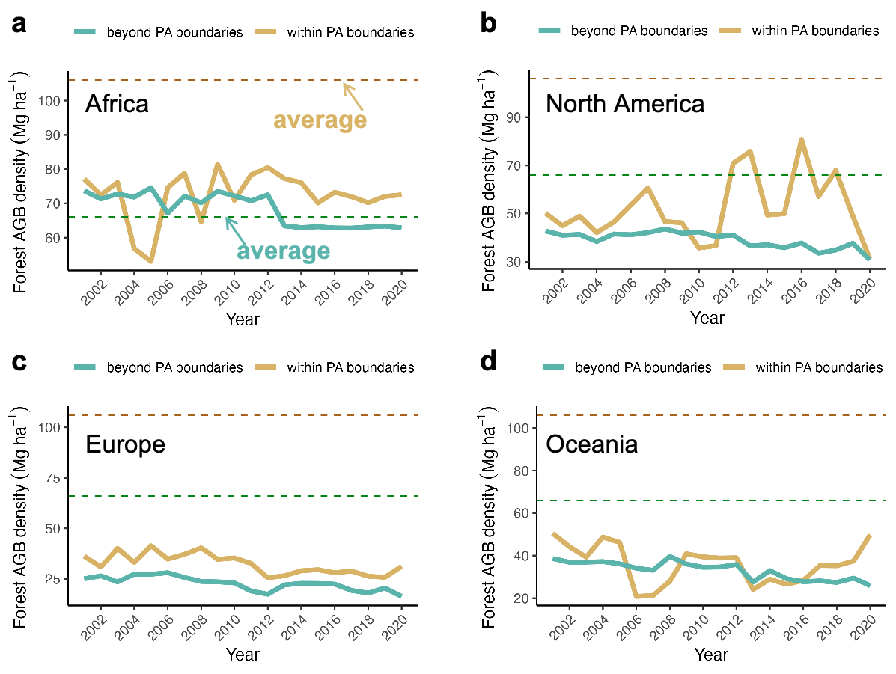
Extended data Fig. 9 Methods for identifying the mine sites in Borneo, Indonesia.
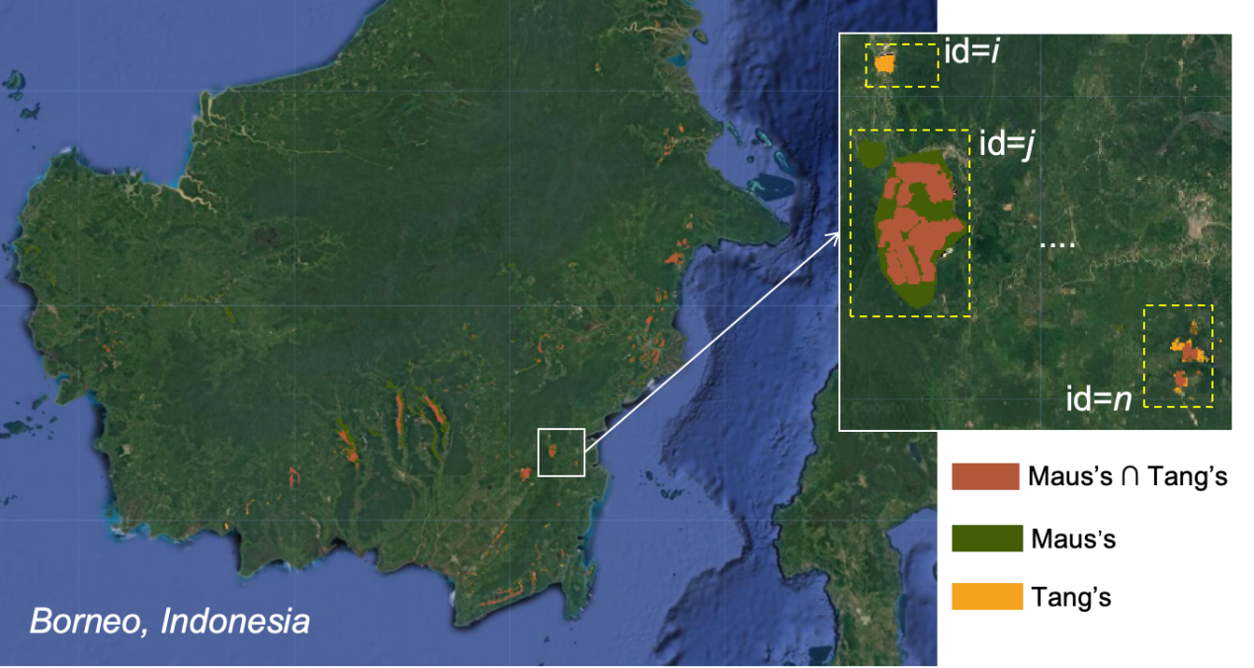

Extended data Fig. 10 Conceptual diagram of active mining identification.
