Future flood risk exacerbated by the dynamic impacts of sea level rise
Matthew V. Bilskie¹, Diana Del Angel², David Yoskowitz² & Scott C. Hagen^{3,4}
Supplemental Materials
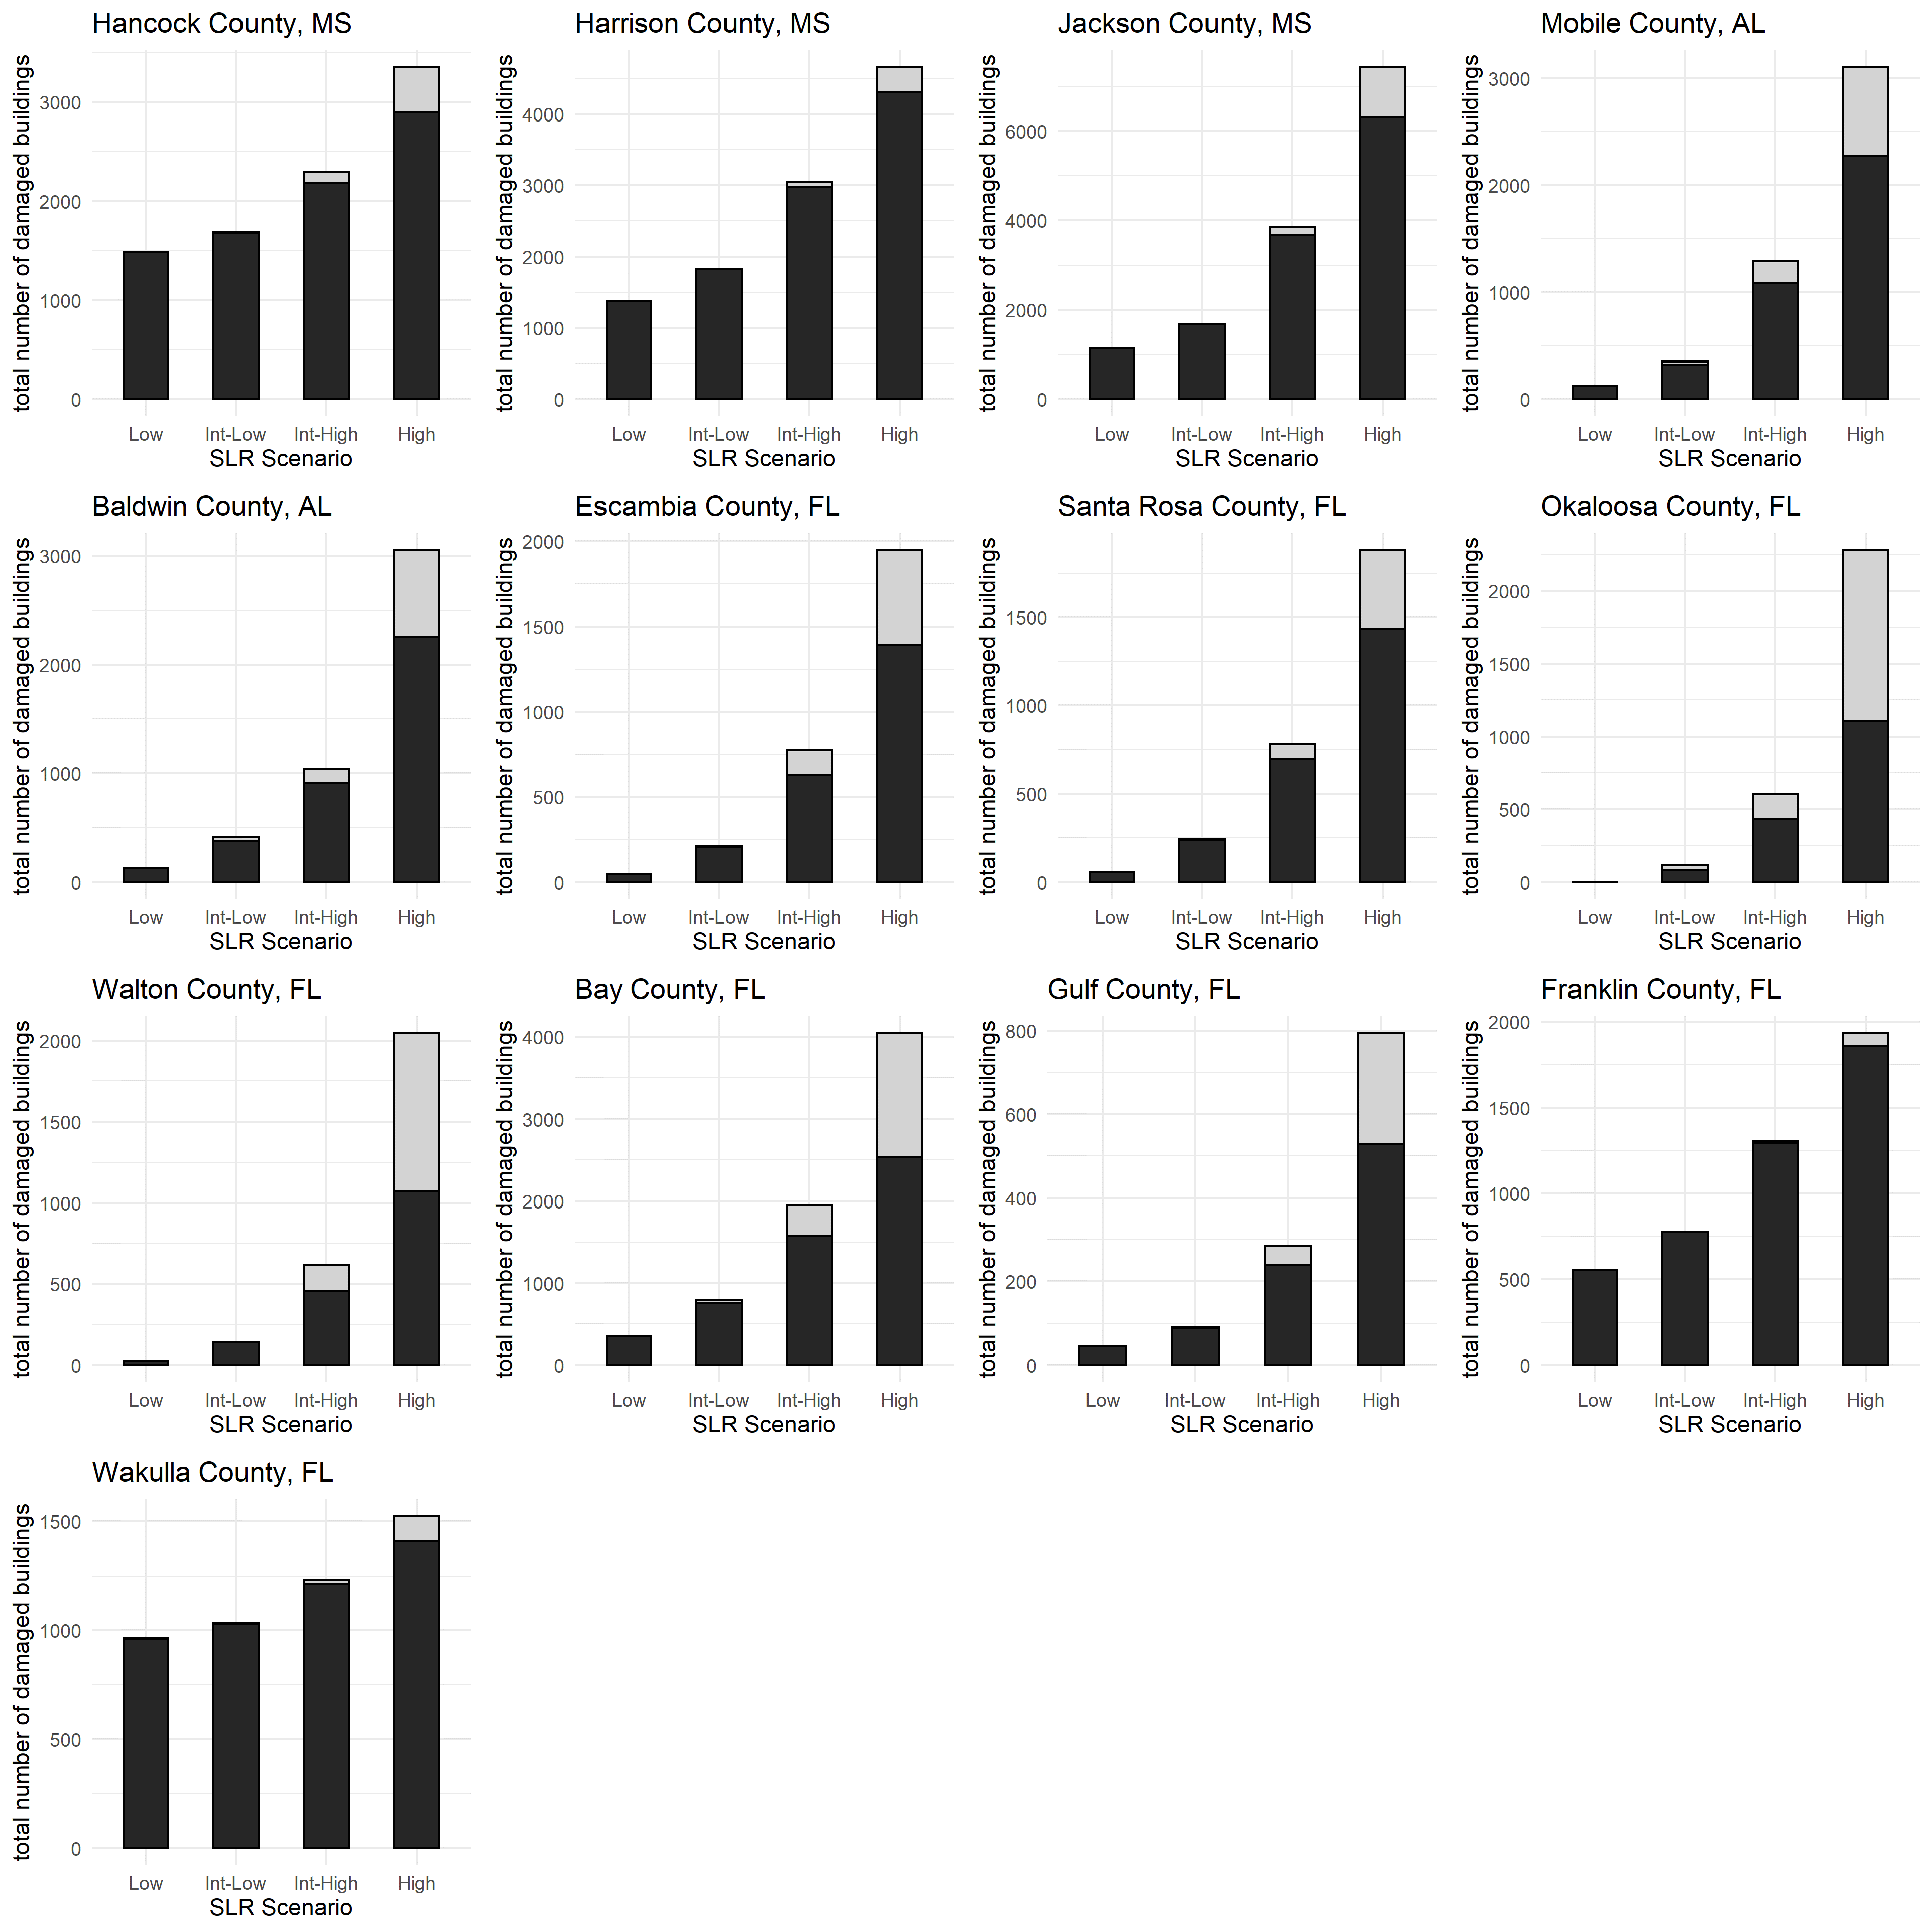
Figure S1. Total number of substantially damaged residential buildings for each SLR scenario categorized by increasing damages for buildings in the present 1% annual chance floodplain and new buildings exposed under SLR. Black bars represent building exposed to the present-day 1% AEP flood and gray bars represent new buildings exposed to the 1% AEP under SLR. Substantially damaged buildings are classified as greater than 50% damaged. Damages are summed by county.
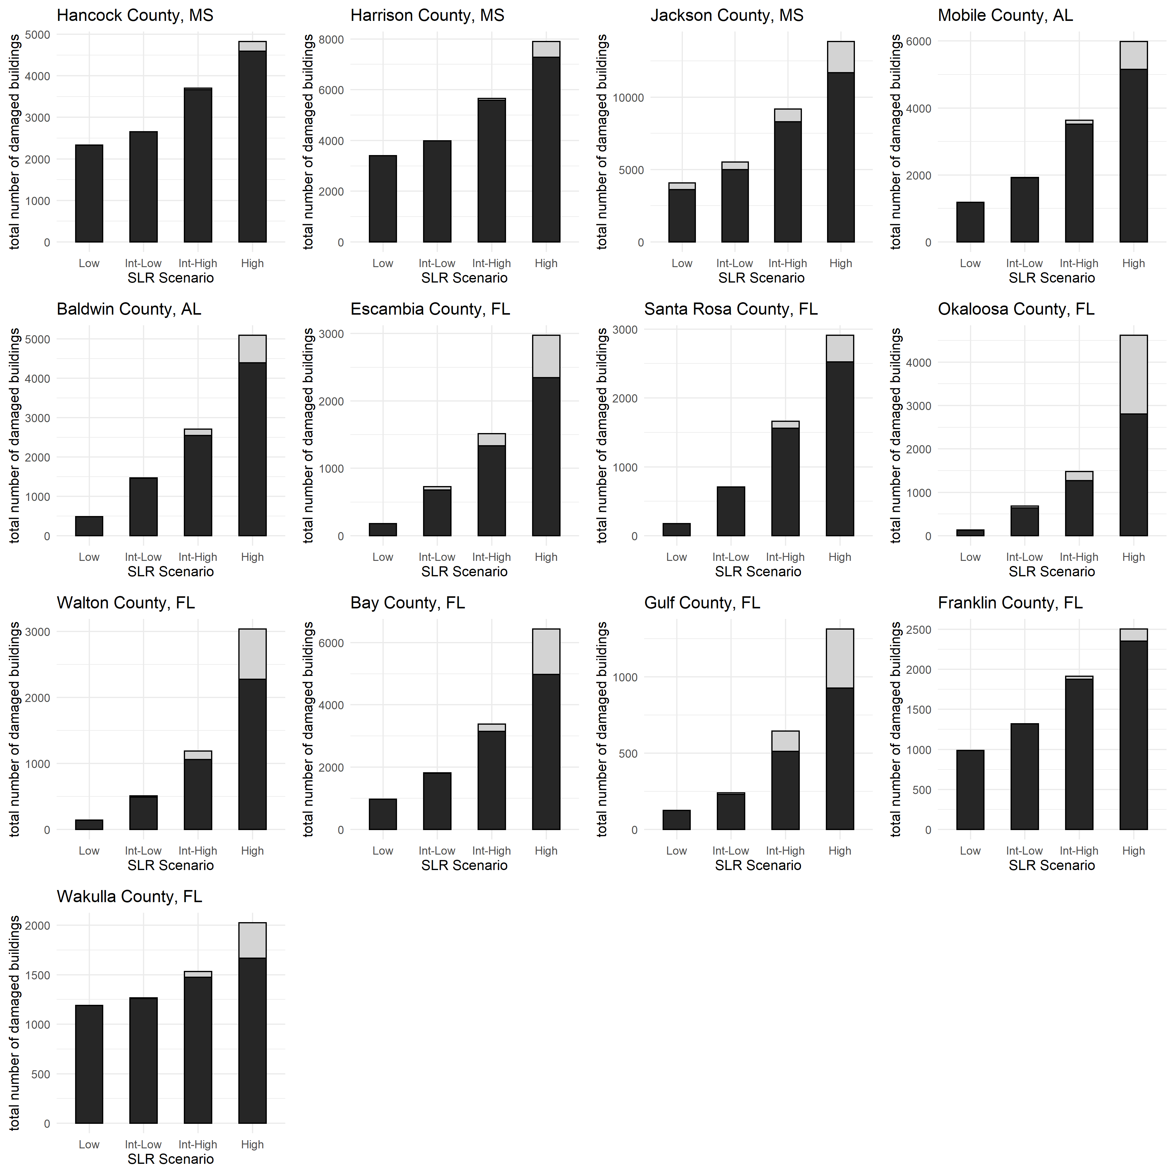
Figure S2. Total number of substantially damaged residential buildings for each SLR scenario categorized by increasing damages for buildings in the present 0.2% annual chance floodplain and new buildings exposed under SLR. Black bars represent building exposed to the present-day 0.2% AEP flood and gray bars represent new buildings exposed to the 0.2% AEP under SLR. Substantially damaged buildings are classified as greater than 50% damaged. Damages are summed by county.

