6-ethoxy-4-N-(2-morpholin-4-ylethyl)-2-N-propan-2-yl-1,3,5-triazine-2,4-diamine endows herbicidal activity against Phalaris minor a weed of wheat crop field: An in-silico and experimental approaches of herbicide discovery
Nandan Kumarª, Priyanka Raniª, Shikha Agarwal^{b} and Durg Vijay Singh^{a*}
ªDepartment of Bioinformatics, School of Earth Biological and Environmental Sciences, Central University of South Bihar, Gaya.
^{b}Department of Computer Science, Central University of South Bihar, Gaya.
*Corresponding Author: Durg Vijay Singh
E-mail address: dvsbiotech@gmail.com

Supplementary material

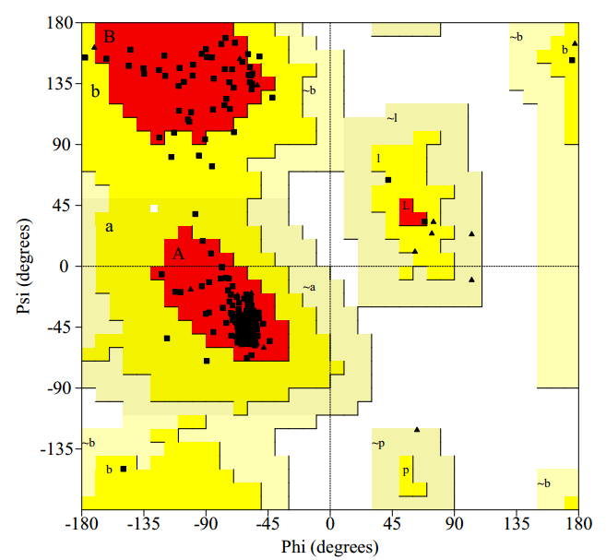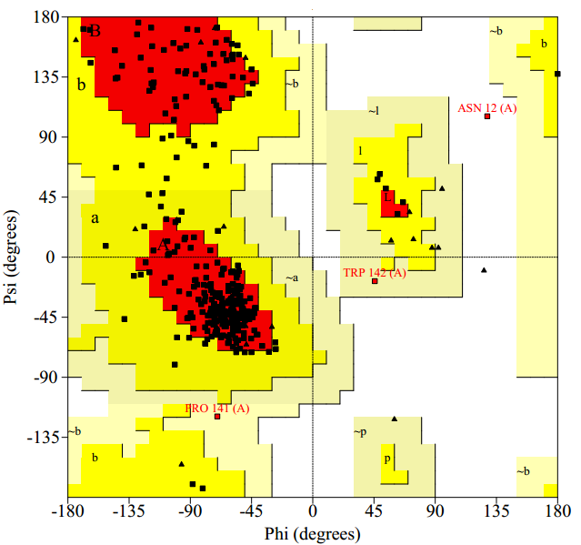
(A) D1 modelled protein (B) Template strand (pdb|3PRQ|A)

Figure S1: (A) Ramachandran plot of modelled D1 protein and (B) Ramachandran plot of template structure (pdb|3PRQ|A).

Table S1: Validation score

Ramachandran scores | D1 protein R-Biotype | Template strand
Core region | 93.6 | 82.3
Allowed region | 6.4 | 17.0
Disallowed  Quality factor | 0.0  93.254 | 0.3  92.879

Table S2: List of retrieved ligands from PubChem and ZINC database.

C1 (Photo system II inhibitors) |  |  | C2 (PSII inhibitor (Urea’s and amides))
Serial No. | Herbicide Name | Number of chemical molecules | Serial No. | Herbicide Name |  | Number of chemical molecules
Phenyl-carbamates |  |  | Amides
1. | Desmedipham | 289 | 1. |  | Propanil |  | 1505
2. | Phenmedipham | 410 | 2. |  | solen |  | 1153
Pyridazinones |  |  | Ureas
1. | chloridazon = pyrazon | 688 | 1. |  | Chlorobromuron |  | 1127
Triazines |  |  | 2. |  | Chlorotoluron |  | 1128
1. | Ametryne | 88 | 3. |  | chloroxuron |  | 210
2. | Atrazine | 1183 | 4. |  | Dimefuron |  | 4
3. | Cyanazine | 364 | 5. |  | Diuron |  | 787
4. | Desmetryne | 853 | 6. |  | Ethidimuron |  | 32
5. | Dimethametryn | 62 | 7. |  | Fenuron |  | 339
6. | Eglinazine-ethyl | 479 | 8. |  | Fluometuron |  | 937
7. | Proglinazine-ethyl | 1 | 9. |  | Isoproturon |  | 1558
8. | Prometon | 983 | 10. |  | Isouron |  | 591
9. | Prometryne | 87 | 11. |  | Linuron |  | 71
10. | Propazine | 1182 | 12. |  | Methabenzthiazuron |  | 1284
11. | Simazine | 885 | 13. |  | Metobromuron |  | 120
12. | Simetryn | 564 | 14. |  | Metoxuron |  | 593
13. | Terbumeton | 969 | 15. |  | Monilinuron |  | 1
14. | Terbuthylazine | 1240 | 16. |  | Neburon |  | 3550
15. | Terbutryne | 164 | 17. |  | Siduron |  | 3955
16. | Trietazine | 1964 | 18. |  | Tebuthiuron |  | 695
Triazinones |  |  | C3 (PSII inhibitors (Nitriles))
1. | Hexazinone | 33 | Benzothiadiazinones
2. | Metamitron | 34 | 1. |  | Bentazone |  | 61
3. | Metribuzin | 87 | Nitriles
Triazolinone |  |  | 1. |  | Bromofenoxim |  | 1
1. | Amicarbazone | 14 | 2. |  | Bromoxynil |  | 86
Uracils |  |  | 3. |  | Ioxynil |  | 32
1. | Bromacil | 257 | Phenyl-pyridazines
2. | Lenacil | 297 | 1. |  | Pyridafol |  | 1
3. | Terbacil | 17 | 2. |  | Pyridate |  | 1
Total = 33016

Table S3: Number of Clusters of vHTS ligands and de novo synthesized ligands and selected best ligands from each cluster.

vHTS Cluster |  |  |  | De novo Synthesized ligands
Cluster | No of ligands in cluster |  | Selected  best ligands |  | Cluster | No of ligands in cluster | Selected  best ligands
Cluster1 | 19 |  | 5 | Cluster1 |  | 66 | 8
Cluster2 | 21 |  | 6 | Cluster2 |  | 11 | 5
Cluster3 | 16 |  | 6 | Cluster3 |  | 15 | 6
Cluster4 | 20 |  | 5 | Cluster4 |  | 40 | 3
Cluster5 | 22 |  | 7 | Cluster5 |  | 29 | 10
Cluster6 | 30 |  | 5 | Cluster6 |  | 13 | 5
Cluster7 | 10 |  | 4 | Cluster7 |  | 7 | 3
Cluster8 | 21 |  | 4 | Cluster8 |  | 16 | 4
Cluster9 | 15 |  | 9 | Cluster9 |  | 58 | 5
Cluster10 | 20 |  | 7 | Cluster10 |  | 20 | 2
Cluster11 | 18 |  | 5 | Cluster11 |  | 07 | 2
Cluster12 | 10 |  | 4 | Total |  | 282 | 53
Cluster13 | 8 | 3
Total | 230 | 70

Table S4: Docking energy and interacting residues of terbutryn (reference molecule) molecule with template (pdb|3PRQ|A).

 | AutoDock score |  |  | Molegro Score
Name | Binding energy | Ligand efficiency | Inhibition  Constant | H-bond | ReRank score | MolDock Score | H-bond interaction | Interacting residues close to 3Å of ligand
Terbutryn | -4.05 | -0.25 | 1.08 mM | -9.027 | -88.791 | -101.4 | Ala225 O8......N7, Ser226 O8......N7, Ser226 O8......N7 Phe227 N7....N7 | Ala213,HIS214, Phe217,Leu218,Leu233,Ala225, Phe227,Leu233, Leu237

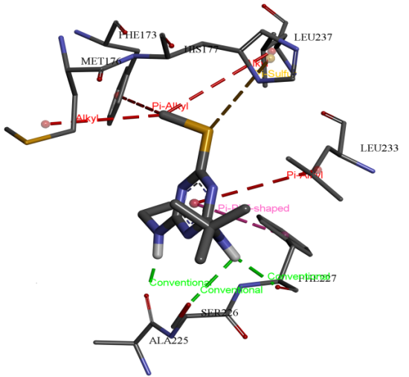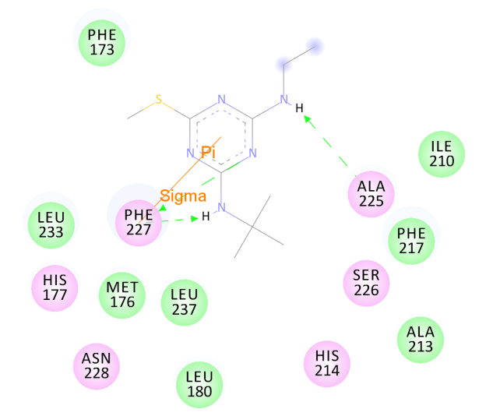
Figure S2: (a) 3D Representation of docked complex of terbutryn and (b) its representation in 2D

Table S5 (a) Binding energy, Ligand efficiency and inhibition Constant of vHTS ligands

 |  | AutoDock Score |  |  | Molegro Score
Cluster | Name of the ligands | Binding energy | Ligand efficiency | Inhibition  Constant | H-bond  Score | Rerank Score | MolDock  Score
Cluster1 | 4-Chloro-2-(4 chlorophenyl)-5-(2 methyl propyl amino pyridazin-3-one (ZINC48544133) | -6.96 | -0.35 | 7.97 µM | -3.2652 | -71.0743 | -112.085
Cluster2 | N-(tert-Butyl)-3-isopropyl-4-methyl-5-oxo-4,5-dihydro-1H-1,2,4-triazole-1-carboxamide  (ZINC38530142) | -5.12 | -0.3 | 177.43 µM | -6.2964 | -93.9601 | -98.3165
Cluster3 | 2-[5(ethylcarbamoylamino) 1,3,4-thiadiazol-2yl] sulfanyl acetic acid (ZINC41018306) | -4.03 | -0.25 | 1.12 mM | -9.1776 | -90.7511 | -119.998
Cluster4 | N,N'.bis(2,4,5trichlorophenyl) pentanediamide  (ZINC02132543) | -9.11 | -0.34 | 208.4 nM | -2.4322 | -99.2876 | -137.324
Cluster5 | 6-Ethoxy-N-isopropyl-N'-(2-morpholin-4-yl-ethyl)-[1,3,5]triazine-2,4-diamine  ( Pubchem: 767097) | -5.84 | -0.31 | 9.62 µM | -10.610 | -77.3127 | -119.432
Cluster6 | 1-[2(dimethyl sulfamoyl amino)-3-methyl-benzoyl] pyrrolidine  (ZINC71916551) | -2.55 | -0.12 | 13.48 µM | -2.3977 | -76.1552 | -105.732
Cluster7 | 7R-3-cyclohexyl-7-[(imino-l [5-azanylidene)amino]-1,5,6,7 tetra hydrocyclopenta pyrimidine-2,4  (ZINC32603999) | -5.07 | -0.25 | 191.65 µM | -3.8743 | -97.3008 | -111.857
Cluster8 | 1-benzyl-3-(5-tert butyl isoxazol-3-yl)-1-methyl-urea  (ZINC59961084) | -6.46 | -0.31 | 18.24 µM | -8.6253 | -91.3906 | -107.258
Cluster9 | 2-{[4-(tert-butylamino)-6-(ethylamino)-1,3,5-triazin-2-yl]thio}acetamide  (ZINC00619845) | -2.87 | -0.15 | 7.86 µM | -9.3693 | -98.4489 | -114.495
Cluster10 | 2-[[4,6-bis(propan-2-ylamino)-1,3,5-triazin-2-yl sulfanyl ethyl-tri methylazanium  (Pubchem: 3639081)  (ZINC03153038) | -5.0 | -0.38 | 8.37 µM | -7.8143 | -94.4882 | -117.682
Cluster11 | 4-chloro-2,6-bis[(5-chloro-2-hydroxyphenyl)methyl]phenol  (Pubchem: 62616) | -2.94 | -0.46 | 114.78 µM | -8.5862 | -167.993 | -104.751
Cluster12 | 2-[[4-chloro-6-(2 hydroxy ethyl  amino)-1,3,5-triazin-2-yl amino- 2 methyl propan-1-ol  (Pubchem: 22333149) | -6.63 | -0.39 | 13.78 µM | -10.800 | -64.1474 | -192.168
Cluster13 | 4-amino-3-ethylsulfanyl-6-[(3-hydroxyphenyl)methyl]-1,2,4-triazin-5-one  (Pubchem: 46398566) | -3.81 | -0.46 | - µM | -7.3020 | -67.5387 | -102.461

Table S5 (b) Hydrogen bond interaction and interacting residues close to 3Å of vHTS ligands

Name of the ligands | Hydrogen bond interaction | Interacting residues close to 3 Å of ligand
N-tert-butyl-4-methyl-5-oxo-3-propan-2-yl-1,2,4-triazole-1 carboxamide | Phe227….N7, Ala225 O….O8 | Met176, His177, Leu180, Val181, Ala213, Phe217, Ala225, Phe227, Leu233, Leu237
N-(tert-Butyl)-3-isopropyl-4-methyl-5-oxo-4,5-dihydro-1H-1,2,4-triazole-1-carboxamide | Ser226 O….O8, Phe227 N….O8, Phe227 O….N7 | His177, Ala213, His214, Phe217, Ser226, Phe227, Leu233, Phe236, Leu237
2-[[5(ethylcarbamoylamino) 1,3,4-thiadiazol-2yl] sulfanyl acetic acid | Ser226 O….N2, Ser226 O….N6, Phe227 O….O8, Phe227 N….N6, Phe227 N….N7 | His177, Ile210, Ala213, His214, Phe217, Ser226, Phe227, Leu233, Leu237,
N,N'.bis(2,4,5trichlorophenyl) pentanediamide | His177 N….O15 | Phe173, Met176, His177, Leu180, Ile210, Ala213, His214, Phe217, Ala225, Phe227, Phe236, Leu237
6-Ethoxy-N-isopropyl-N'-(2-morpholin-4-yl-ethyl)-[1,3,5]triazine-2,4-diamine | Ser226 O….N6, Ser226 O….N7, Phe227 O….N7, Phe227 H….N6, Ala250….N15 | Met170, Phe173, Ile210, Ala213, His214, Phe217, Ile221,Ala225, Ser226, Phe227
1-[2(dimethyl sulfamoyl amino)-3-methyl-benzoyl] pyrrolidine | Ala225 O….N15, Ser226 O….O9, ser226 O….O25, Phe227 N….O25 | Met176, Leu180, Ile210, Phe217, Ala225, Ser226, Phe227, Leu233, Leu237
7R-3-cyclohexyl-7-[(imino-l [5-azanylidene) amino]-1, 5, 6, 7 tetra hydrocyclopenta pyrimidine-2, 4 | His177 N….O13, Ile210 O….N10, Ser226 O….N3, Ser226 O….N10, Phe227 N….O1, Phe227 O….N11, Phe227 O….N12 | Phe173, Met176, His177, Leu180, Ile210, Ala213, His214, Phe217, Ser226, Phe227, Leu233, Leu237
1-benzyl-3-(5-tert butyl isoxazol-3-yl)-1-methyl-urea | Ser226 O….N18, Ser226 O….O19, Phe227 N….N18, Phe227 N….O19 | Phe173, His177, Leu180, Phe217, Ala225, Ser226, Phe227, Leu233, Leu237
2-{[4-(tert-butylamino)-6-(ethylamino)-1, 3, 5-triazin-2-yl]thio}acetamide | Ala225 O….N20, Ser226 O….N6, Ser226 O….N7, Phe227 O….N7, Phe227 N….N6 | Phe173, Met176, Ala213, His214, Phe217, Ala225, Ser226, Phe227, Leu233
2-[[4,6-bis(propan-2-ylamino)-1,3,5-triazin-2-yl sulfanyl ethyl-tri methylazanium | Ser226 O….N4, Ser226 O….N7, Phe227 O….N7, Phe227 N….N4 | Phe173, Met176, His177, Ile210, Ala213, His214, Phe217, Ala225, Ser226, Phe227, Phe236,Leu237
4-chloro-2,6-bis[(5-chloro-2-hydroxyphenyl)methyl]phenol | Ala225 O….O8, Ala225 O….O17, Ser226 O….O27, Phe227 N….O8, Phe227 O….O27 | Met176, His177, Leu180, Val181, Ala213, His214, Phe217, Ala225, Ser226, Phe227 ,Leu233
2-[[4-chloro-6-(2 hydroxy ethyl  amino)-1,3,5-triazin-2-yl]amino]-2 methyl propan-1-ol | Ala225 O….N16, Ser226 O….N8, Phe227 N….N7, Phe227 O….N8, Phe227 O….O14 | Ile210, Ala213, Phe217, His214, Ala225, Ser226, Phe227 ,Leu233, Leu237
4-amino-3-ethylsulfanyl-6-[(3-hydroxyphenyl)methyl]-1,2,4-triazin-5-one | Phe170 O….O21, Phe173 O….O21, His177 N….O21, Ser226 O….O7, Ser226 O….N5, Ser226 O….N8 | Phe173, Met176, His177, Leu180, Val181, Ile210, Ala213, Phe217, Ser226, Phe236, Leu237, Phe271

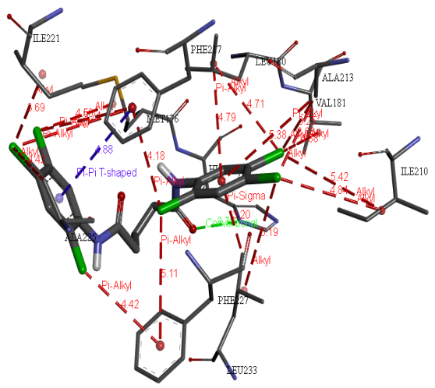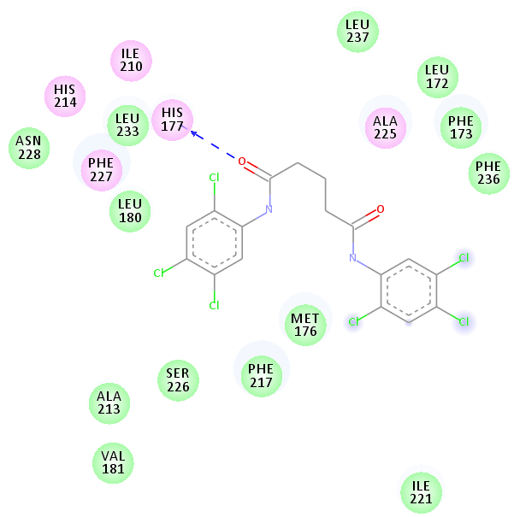

- (b)
Figure S3: Cluster-4 (a) 3D Representation of docked complex of cluster-4 Ligand and (b) its representation in 2D

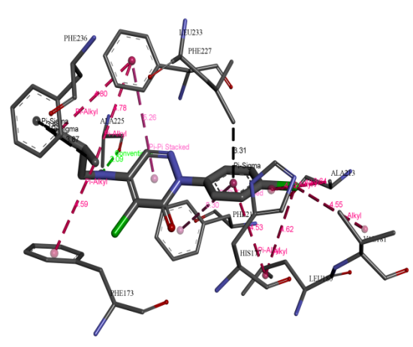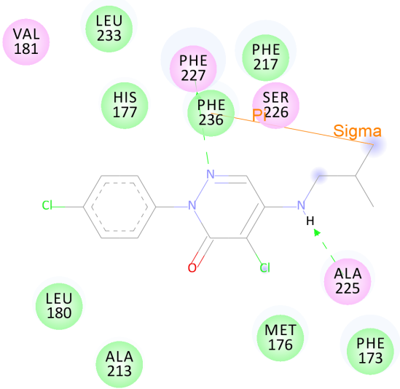

Figure S4: Cluster-1 (a) 3D Representation of docked complex of cluster-1 Ligand and (b) its representation in 2D

Table S6 (a) Binding energy, Ligand efficiency and inhibition constant of de novo synthesized ligands.

Cluster | Smile notation | Binding energy | Ligand efficiency | Inhibition  Constant | H-bond  Score | Rerank Score | MolDock  Score
Cluster1 | O=c1n(ncc(c1=[Cl])N([H])C[C@](C)([H])C[C@](C)([H])O[H])c2ccc(=[Cl])cc2 | -6.87 | -0.34 | 9.24 µM | -4.7238 | -87.49 | -105.372
Cluster2 | O=C(n1nc(C)n(c1=O)=N([H])[H])N([H])C(C)(C)CCC | -3.65 | -0.21 | 2.11 µM | -8.6617 | -87.38 | -94.1911
Cluster3 | OC(O)C[S]c1nnc([s]1)N([H])C(=O)N(=C)CC | -3.85 | -0.23 | 1.52 mM | -9.6978 | -97.21 | -116.525
Cluster4 | [H]O\N=C(\CCCCN([H])C(=O)N([H])c1ccc(C)c(Cl)c1)N([H])[H] | -8.6 | -0.43 | 499.07nM | -6.7639 | -51.37 | -118.01
Cluster5 | [H]N(c1nc(nc(n1)N([H])CCN2CCOCC2)OCC)C(C)(C)[H] | -4.3 | -0.2 | 701.35µM | -8.4610 | -100.37 | -130.281
Cluster6 | O=[S](=O)(Nc1ccccc1C(=O)N([H])Cc2ccc(C)cc2)N(C)C | -2.56 | -0.12 | 13.33 mM | -3.6619 | -82.239 | -99.8606
Cluster7 | [H]n2c1c(CC[C@]1([H])NN([H])([H])N[H])c(=O)n(c2=O)[C@@]3([H])CCCCC3 | -5.1 | -0.26 | 182.74µM | -9.3462 | -87.323 | -108.685
Cluster8 | N=CCC/N(=C/CC(C)(C)[H])C(=O)N([H])c1noc(c1)C(C)(C)C | -6.15 | -0.32 | 31.02 µM | -6.3872 | -79.565 | -105.04
Cluster9 | [H]N(c1nc(nc(n1)[S]CC(=O)N([H])[H])N([H])CC)C(C)(C)C | -1.58 | -0.08 | 69.95 µM | -8.6442 | -99.791 | -126.58
Cluster10 | [H]c1nc(nc(n1)C(=O)O[H])C([H])([H])C([H])([H])N([H])C([H])([H])[H] | -5.64 | -0.43 | 73.6 µM | -6.9706 | -72.033 | -80.2828
Cluster11 | [H]c1nc(nc(n1)C(=O)O[H])C([H])([H])C([H])([H])O[H] | -4.66 | -0.39 | 386.63µM | -6.5193 | -68.011 | -95.2105

Table S6 (b) Smile notation of ligands, H-bond interaction and interacting residues close to 3 Å of de novo synthesized ligands.

Ligand smile notation | Hydrogen bond interaction | Interacting residues close to 3 Å of ligand
O=c1n(ncc(c1=[Cl])N([H])C[C@](C)([H])C[C@](C)([H])O[H])c2ccc(=[Cl])cc2 | His 177….O8, Ala225 O….O8 | Met176, His177, Leu180, Val181, Ala213, Phe217, Ala225, Phe227, Leu233, Leu237
[H]N(C(=O)n1nc(n(C)c1=O)C(C)(C)[H])C(C)(C)C | Ser226 O….O8, Phe227 N….O8, Phe227 O….N7 | His177, Ala213, His214, Phe217, Ser226, Phe227, Leu233, Phe236, Leu237
OC(O)C[S]c1nnc([s]1)N([H])C(=O)N(=C)CC | Ser226 O….N2, Ser226 O….N6, Phe227 O….O8, Phe227 N….N6, Phe227 N….N7 | His177, Ile210, Ala213, His214, Phe217, Ser226, Phe227, Leu233, Leu237,
[H]O\N=C(\CCCCN([H])C(=O)N([H])c1ccc(C)c(Cl)c1)N([H])[H] | His177 N….O15 | Met176, His177, Leu180, Ile210, Ala213, His214, Phe217, Ala225, Phe227, Phe236, Leu237
[H]N(c1nc(nc(n1)N([H])CCN2CCOCC2)OCC)C(C)(C)[H] | Ser226 O….N6, Ser226 O….N7, Phe227 O….N7, Phe227 H….N6, Ala250….N15 | Met170, Phe173, Ile210, Ala213, His214, Phe217, Ile221,Ala225, Ser226, Phe227
O=[S](=O)(Nc1ccccc1C(=O)N([H])Cc2ccc(C)cc2)N(C)C | Ala225 O….N15, Ser226 O….O9, ser226 O….O25, Phe227 N….O25 | Met176, Leu180, Ile210, Phe217, Ala225, Ser226, Phe227, Leu233, Leu237
O=c2nc1c(CC[C@]1([H])NNN)c(=O)n2[C@@]3([H])CCCCC3.[H].[H].[H].[H] | His177 N….O13, Ile210 O….N10, Ser226 O….N3, Ser226 O….N10, Phe227 N….O1, Phe227 O….N11, Phe227 O….N12 | Phe173, Met176, His177, Leu180, Ile210, Ala213, His214, Phe217, Ser226, Phe227, Leu233, Leu237
[H]N(C(=O)N(CCOC)Cc1ccccc1)c2noc(c2)C(C)(C)C | Ser226 O….N18, Ser226 O….O19, Phe227 N….N18, Phe227 N….O19 | Phe173, His177, Leu180, Phe217, Ala225, Ser226, Phe227, Leu233, Leu237
[H]N(c1nc(nc(n1)[S]CC(=O)N([H])[H])N([H])CC)C(C)(C)C | Ala225 O….N20, Ser226 O….N6, Ser226 O….N7, Phe227 O….N7, Phe227 N….N6 | Phe173, Met176, Ala213, His214, Phe217, Ala225, Ser226, Phe227, Leu233
[H]N(c1nc(nc(n1)N([H])C(C)(C)[H])[S]CCN(C)(C)C)C(C)(C)[H] | Ser226 O….N4, Ser226 O….N7, Phe227 O….N7, Phe227 N….N4 | Phe173, Met176, His177, Ile210, Ala213, His214, Phe217, Ala225, Ser226, Phe227, Phe236,Leu237
[Cl]=c2cc(Cc1cc(=[Cl])ccc1O[H])c(O[H])c(c2)Cc3cc(=[Cl])ccc3O[H] | Ala225 O….O8, Ala225 O….O17, Ser226 O….O27, Phe227 N….O8, Phe227 O….O27 | Met176, His177, Leu180, Val181, Ala213, His214, Phe217, Ala225, Ser226, Phe227 ,Leu233
[Cl]=c1nc(nc(n1)N([H])C(C)(C)CO[H])N([H])CCO[H] | Ala225 O….N16, Ser226 O….N8, Phe227 N….N7, Phe227 O….N8, Phe227 O….O14 | Ile210, Ala213, Phe217, His214, Ala225, Ser226, Phe227 ,Leu233, Leu237
O=c1c(nnc([S]CC)n1=N([H])[H])Cc2cccc(c2)O[H] | Phe170 O….O21, Phe173 O….O21, His177 N….O21, Ser226 O….O7, Ser226 O….N5, Ser226 O….N8 | Phe173, Met176, His177, Leu180, Val181, Ile210, Ala213, Phe217, Ser226, Phe236, Leu237, Phe271

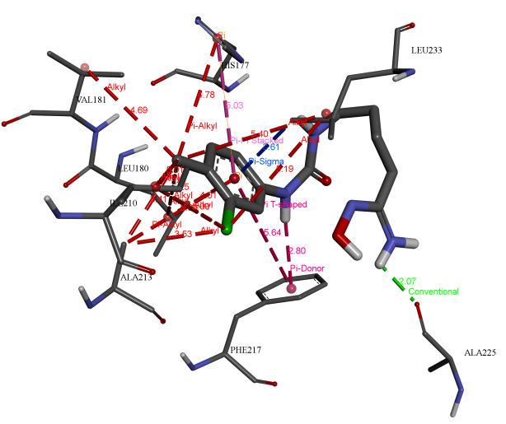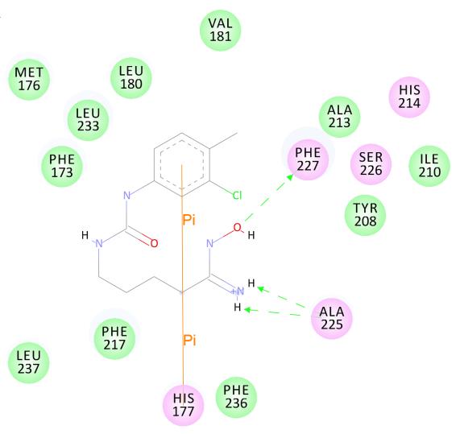
- (b)

Figure S5: Cluster-4 (a) 3D Representation of docked complex of cluster-4 Ligand and (b) its representation in 2D
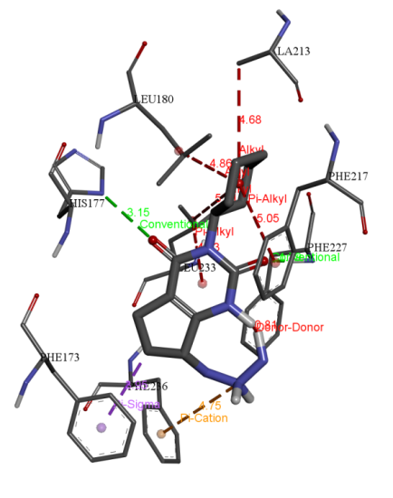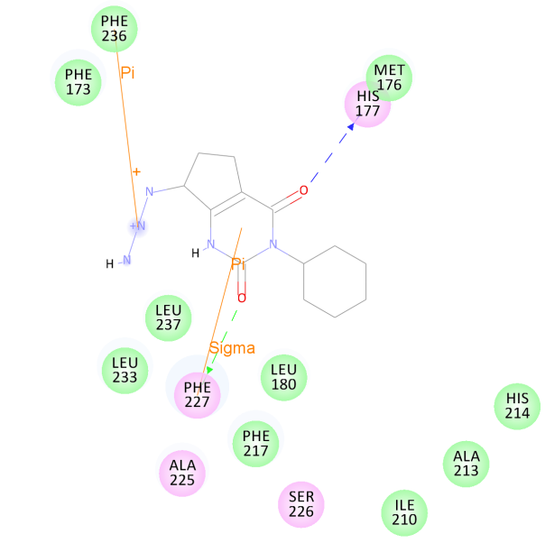
(a) (b)

Figure S6: Cluster-7 (a) 3D Representation of docked complex of cluster-7 Ligand and (b) its representation in 2D.

Table S7: Physiochemical properties of proposed molecules and known herbicides of PS-II.

Molecules | MW | logp | Alogp | HBA | HBD | TPSA | nRB | nAcidicGroup | nRigidB | nAromRing | nHB
Known herbicides for PS-II
ZINC00392884 | 206.14 | 1.748 | 0.911 | 3 | 1 | 32.34 | 4 | 0 | 11 | 1 | 4
ZINC00187408 | 300.11 | 1.635 | 1.651 | 6 | 2 | 76.66 | 8 | 0 | 15 | 2 | 8
ZINC00390960 | 300.11 | 1.604 | 1.847 | 6 | 2 | 76.66 | 7 | 0 | 16 | 2 | 8
ZINC00035807 | 221.04 | 1.179 | -0.073 | 4 | 1 | 58.69 | 1 | 0 | 15 | 1 | 5
ZINC00085378 | 227.12 | 0.875 | -0.204 | 5 | 2 | 86.44 | 5 | 0 | 10 | 1 | 7
ZINC03078958 | 215.09 | 0.755 | -0.411 | 5 | 2 | 61.14 | 4 | 0 | 10 | 1 | 7
ZINC02016088 | 240.09 | 0.001 | 0.165 | 6 | 2 | 84.93 | 4 | 0 | 12 | 1 | 8
ZINC02015372 | 255.15 | 1.53 | 0.318 | 5 | 2 | 86.44 | 6 | 0 | 11 | 1 | 7
ZINC02382774 | 258.08 | -0.241 | -1.23 | 7 | 1 | 92.48 | 6 | 0 | 11 | 1 | 8
ZINC00246221 | 225.16 | 0.667 | -1.063 | 6 | 2 | 70.37 | 5 | 0 | 11 | 1 | 8
ZINC01635499 | 241.14 | 1.335 | -0.505 | 5 | 2 | 86.44 | 5 | 0 | 11 | 1 | 7
ZINC00246137 | 229.11 | 1.215 | -0.712 | 5 | 2 | 61.14 | 4 | 0 | 11 | 1 | 7
ZINC00121575 | 201.08 | 0.295 | -0.111 | 5 | 2 | 61.14 | 4 | 0 | 9 | 1 | 7
ZINC01635501 | 213.1 | 0.415 | 0.096 | 5 | 2 | 86.44 | 5 | 0 | 9 | 1 | 7
ZINC00163706 | 229.11 | 1.172 | 0.57 | 5 | 2 | 61.14 | 4 | 0 | 11 | 1 | 7
ZINC02008092 | 241.14 | 1.292 | 0.777 | 5 | 2 | 86.44 | 5 | 0 | 11 | 1 | 7
ZINC01592069 | 229.11 | 1.281 | 0.242 | 5 | 1 | 52.35 | 5 | 0 | 10 | 1 | 6
ZINC37858993 | 253.17 | 1.418 | -2.357 | 6 | 1 | 52.65 | 2 | 0 | 17 | 0 | 7
ZINC00404228 | 202.09 | 0.881 | -0.083 | 5 | 1 | 71.05 | 1 | 0 | 15 | 1 | 6
ZINC00039744 | 214.09 | 1.122 | 1.466 | 5 | 1 | 96.35 | 2 | 0 | 12 | 0 | 6
ZINC05761691 | 241.15 | 1.073 | 0.463 | 7 | 2 | 91.03 | 4 | 0 | 13 | 0 | 9
ZINC00178090 | 260.02 | 1.497 | -0.074 | 4 | 1 | 49.41 | 2 | 0 | 12 | 0 | 5
ZINC08952422 | 234.14 | 1.32 | -2.386 | 4 | 1 | 49.41 | 1 | 0 | 18 | 0 | 5
ZINC00362579 | 217.01 | 1.802 | 1.145 | 2 | 1 | 29.1 | 3 | 0 | 10 | 1 | 3
ZINC02516873 | 338.11 | 1.864 | 1.962 | 7 | 1 | 74.24 | 5 | 0 | 19 | 1 | 8
ZINC00057287 | 232.02 | 1.331 | 1.271 | 3 | 1 | 32.34 | 3 | 0 | 11 | 1 | 4
ZINC02555387 | 264.04 | 0.221 | 1.201 | 7 | 1 | 124.88 | 5 | 0 | 11 | 1 | 8
ZINC00097471 | 164.09 | 0.388 | 0.533 | 3 | 1 | 32.34 | 3 | 0 | 9 | 1 | 4
ZINC02038834 | 232.08 | 1.057 | 1.436 | 3 | 1 | 32.34 | 4 | 0 | 12 | 1 | 4
ZINC00392884 | 206.14 | 1.748 | 0.911 | 3 | 1 | 32.34 | 4 | 0 | 11 | 1 | 4
ZINC02002600 | 211.13 | 1.088 | 0.928 | 3 | 1 | 53.93 | 4 | 0 | 11 | 1 | 4
ZINC00900693 | 248.01 | 1.24 | 1.117 | 2 | 1 | 41.57 | 4 | 0 | 11 | 1 | 3
ZINC00900532 | 221.06 | 0.041 | 1.23 | 4 | 1 | 70 | 3 | 0 | 13 | 2 | 5
ZINC00260866 | 258 | 0.839 | 0.832 | 2 | 1 | 41.57 | 4 | 0 | 10 | 1 | 3
ZINC00900697 | 228.07 | 0.994 | 0.404 | 4 | 1 | 41.57 | 4 | 0 | 11 | 1 | 5
ZINC01532184 | 274.06 | 2.681 | 0.656 | 3 | 1 | 32.34 | 6 | 0 | 11 | 1 | 4
ZINC00043452 | 228.1 | 1.315 | 2.312 | 5 | 1 | 82.36 | 4 | 0 | 11 | 1 | 6
ZINC05442053 | 239.05 | 0.278 | -0.758 | 5 | 0 | 62.83 | 1 | 0 | 16 | 1 | 5
ZINC00334873 | 273.85 | 1.882 | 0.907 | 2 | 0 | 46.85 | 0 | 0 | 11 | 1 | 2
ZINC04262023 | 369.82 | 2.422 | 0.567 | 2 | 0 | 46.85 | 0 | 0 | 11 | 1 | 2
Proposed molecules
ELC2 | 240.16 | 1.89 | 1.161 | 6 | 1 | 65.01 | 4 | 0 | 13 | 0 | 7
ELC4 | 266.08 | 2.744 | 0.336 | 6 | 2 | 89.9 | 2 | 0 | 20 | 3 | 8
ELC5 | 310.21 | -0.34 | -0.936 | 8 | 2 | 82.84 | 8 | 0 | 15 | 1 | 10
ELC8 | 287.16 | 2.18 | 2.045 | 3 | 1 | 53.93 | 6 | 0 | 16 | 2 | 4
ELC11 | 408.01 | 3.222 | 3.757 | 3 | 3 | 60.69 | 4 | 0 | 24 | 3 | 6
ELC12 | 261.1 | -1.092 | -1.108 | 7 | 4 | 101.6 | 6 | 0 | 11 | 1 | 11
DLC4 | 298.12 | 0.881 | 0.021 | 4 | 4 | 99.74 | 8 | 0 | 12 | 1 | 8
DLC6 | 347.13 | 1.395 | 0.549 | 6 | 2 | 86.89 | 7 | 0 | 18 | 2 | 8

Table S8: Proposed molecule as an inhibitor of D1 protein by this study with their database chemical id and IUPAC name. IUPAC name is taken from chemicalize database (http://www.chemicalize.org/).

System | Chemical Id | IUPAC Name
ELC2 | ZINC38530142 | N-tert-butyl-4-methyl-5-oxo-3-(propan-2-yl)-4,5-dihydro-1H-1,2,4-triazole-1-carboxamide
ELC4 | ZINC0213254 | 4-[6-(4-hydroxyphenyl)-1,2,4,5-tetrazin-3-yl]phenol
ELC5 | PubChem 767097 | 6-ethoxy-N2-[2-(morpholin-4-yl)ethyl]-N4-(propan-2-yl)-1,3,5-triazine-2,4-diamine
ELC8 | ZINC59961084 | 1-benzyl-3-(5-tert-butyl-1,2-oxazol-3-yl)-1-methylurea
ELC11 | PubChem 62616 | 4-chloro-2,6-bis[(5-chloro-2-hydroxyphenyl)methyl]phenol
ELC12 | PubChem 22333149 | 2-({4-chloro-6-[(2-hydroxyethyl)amino]-1,3,5-triazin-2-yl}amino)-2-methylpropan-1-ol
DLC4 | ----- | 1-(3-chloro-4-methylphenyl)-3-{4-[(Z)-N'-hydroxycarbamimidoyl]butyl}urea
DLC6 | ----- | 2-[(dimethylsulfamoyl)amino]-N-[(4-methylphenyl)methyl]benzamide

Table S9: Effect on the biomass reduction of P. minor and wheat plantlet upon treatment with new potential herbicidal molecules at the concentration of 600 μM.
Condition | Control |  | Isoproturon |  | ELC11 |  | ELC8 |  | ELC5 |  | ELC12
Condition | Weed | Wheat | Weed | Wheat | Weed | Wheat | Weed | Wheat | Weed | Wheat | Weed | Wheat
Wet weight (mg) | 40.4 | 397.8 | 17 | 398.4 | 20.9 | 398.2 | 16.6 | 396.7 | 10.4 | 397.5 | 16.6 | 396.3
Dry weight (mg) | 11.6 | 26.8 | 0.9 | 26.7 | 2.2 | 28.4 | 1.1 | 28.3 | 0.8 | 27.2 | 1.1 | 27.8
Table S10: Effect of ECL5 on the biomass reduction of P. minor plantlet at different concentrations under laboratory controlled conditions.
Conc. of ECL5 | Wet Weight (mg) |  |  |  | Dry Weight (mg)
Conc. of ECL5 | Expt. 1 | Expt. 2 | Expt. 3 | AV±SD (mg) | Expt. 1 | Expt. 2 | Expt. 3 | AV±SD (mg)
0 μM | 40.4 | 40.2 | 36.3 | 40.57±2.51 | 11.6 | 11.9 | 10.2 | 11.23±0.91
40 μM | 22.4 | 22.6 | 22.3 | 21.77±0.74 | 2.8 | 2.6 | 2.57 | 4.31±0.20
80 μM | 18.5 | 18.6 | 18.6 | 19.4±0.1 | 1.1 | 1.3 | 1.3 | 3.67±0.15
120 μM | 18.4 | 18.3 | 18.5 | 19.07±0.11 | 1.1 | 1.2 | 1.1 | 3.28±0.07
160 μM | 18.1 | 18.2 | 18.0 | 18.77±0.06 | 1.0 | 1.12 | 1.1 | 2.71±0.19
200 μM | 17.9 | 17.8 | 17.9 | 18.37±0.12 | 0.89 | 0.92 | 0.88 | 2.38±0.07
240 μM | 17.8 | 17.8 | 17.1 | 18.03±0.06 | 0.88 | 0.87 | 0.87 | 2.05±0.06
280 μM | 17.6 | 17.6 | 17.6 | 17.82±0.08 | 0.86 | 0.87 | 0.86 | 1.87±0.06
320 μM | 17.5 | 17.4 | 17.4 | 17.53±0.06 | 0.85 | 0.85 | 0.85 | 1.59±0.09
360 μM | 17.5 | 17.3 | 17.4 | 17.34±0.05 | 0.85 | 0.78 | 0.84 | 1.18±0.04
400 μM | 17.1 | 17.0 | 17.0 | 17.03±0.06 | 0.83 | 0.76 | 0.83 | 1.03±0.04
440 μM | 16.9 | 16.9 | 16.7 | 16.87±0.06 | 0.82 | 0.76 | 0.82 | 0.92±0.01
480 μM | 16.8 | 16.9 | 16.7 | 16.77±0.12 | 0.74 | 0.82 | 0.81 | 0.87±0.01
520 μM | 16.5 | 16.6 | 16.6 | 16.57±0.06 | 0.82 | 0.73 | 0.81 | 0.83±0.01
560 μM | 16.5 | 16.4 | 16.5 | 16.25±0.05 | 0.81 | 0.72 | 0.81 | 0.82±0.01
600 μM | 16.18 | 16.3 | 16.2 | 15.87±0.15 | 0.8 | 0.8 | 0.7 | 0.73±0.03

