Supplementary material
Supplementary Figures
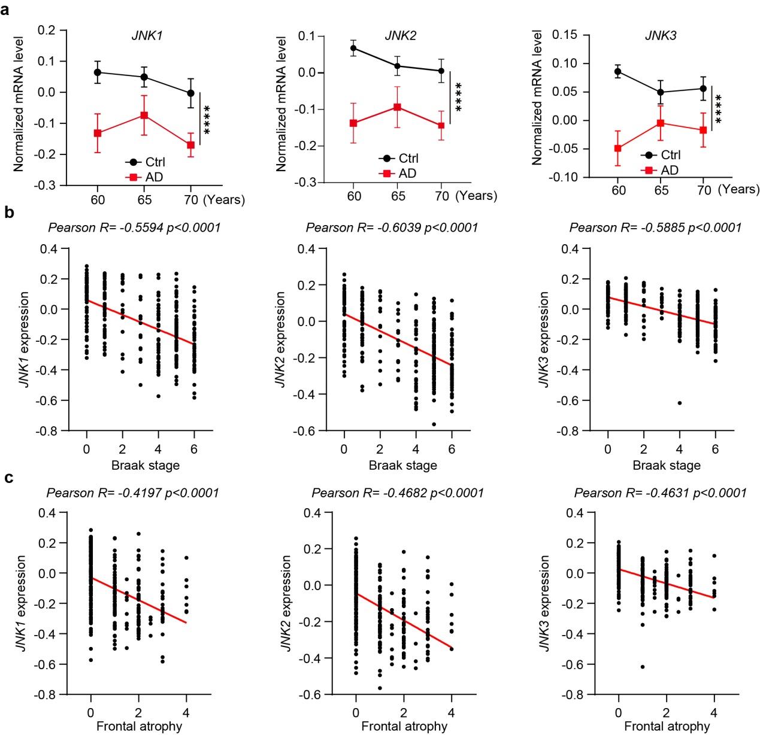
Fig.S1 The mRNA expression levels of JNK1/JNK2/JNK3 negatively correlate with the progression of Alzheimer’s disease (AD) in humans, related to Figure 1
a, Comparative analysis of JNK1 (left panel), JNK2 (middle panel), and JNK3 (right panel) mRNA expression levels in the prefrontal cortex between Alzheimer's disease patients (n=32) and age-matched healthy controls (n=50). b, Correlation analysis of JNK isoforms mRNA expression with neuropathological progression, showing JNK1 (left), JNK2 (middle), and JNK3 (right) expression patterns across different Braak stages in AD prefrontal cortex samples. c, Association between JNK isoforms mRNA expression and disease severity, demonstrating JNK1 (left), JNK2 (middle), and JNK3 (right) expression levels at varying stages of frontal atrophy in AD prefrontal cortex. For panels b and c, gene expression data (n = 360 samples) were obtained from the GEO dataset GSE44772. Statistical significance was determined using Pearson's correlation coefficient (r). All data are represented as mean ± SEM; ****p < 0.001.

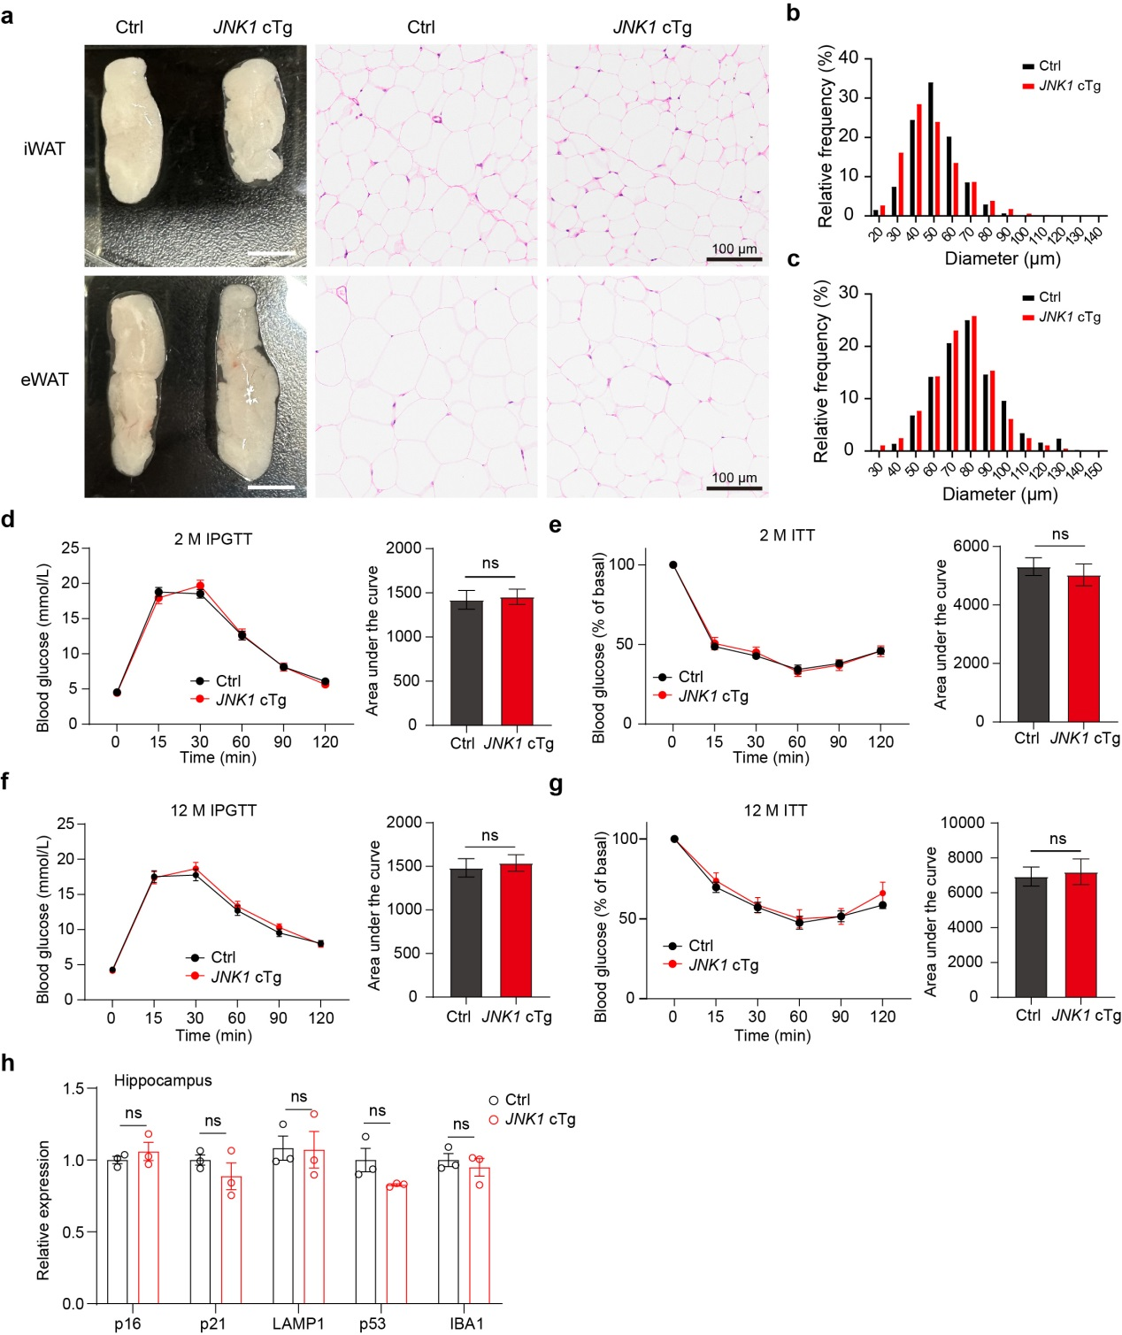
Fig.S2 JNK activation didn’t affect insulin sensitivity or glucose tolerance in JNK1 cTg mice, related to Figure 2
a, HE staining of inguinal white adipose tissue (iWAT) and epididymal white adipose (eWAT) tissue in 9-month-old JNK1 cTg and Ctrl mice, Scale bar, 100 μm. b, c, Frequency distribution histogram of iWAT and eWAT cell diameters. d, e, Intraperitoneal glucose tolerance test (IPGTT) and receiver operating characteristic curve (AUC) analysis for 2-month-old (c) and 12-month-old (e) JNK1 cTg and control mice (Ctrl: n = 17; JNK1 cTg: n = 17). f, g, Insulin tolerance test (ITT) and AUC analysis for 2-month-pld (d) and 12-month-old (f) JNK1 cTg and control mice (Ctrl: n = 17; JNK1 cTg: n = 12). (h) RT-qPCR analysis of mRNA expression of Lamp1, Trp53, Cdkn2a, Iba1, and Cdkn1a expression in the hippocampal tissues of the JNK1 cTg and Ctrl mice. All data are represented as mean ± SEM, n.s. p > 0.05.

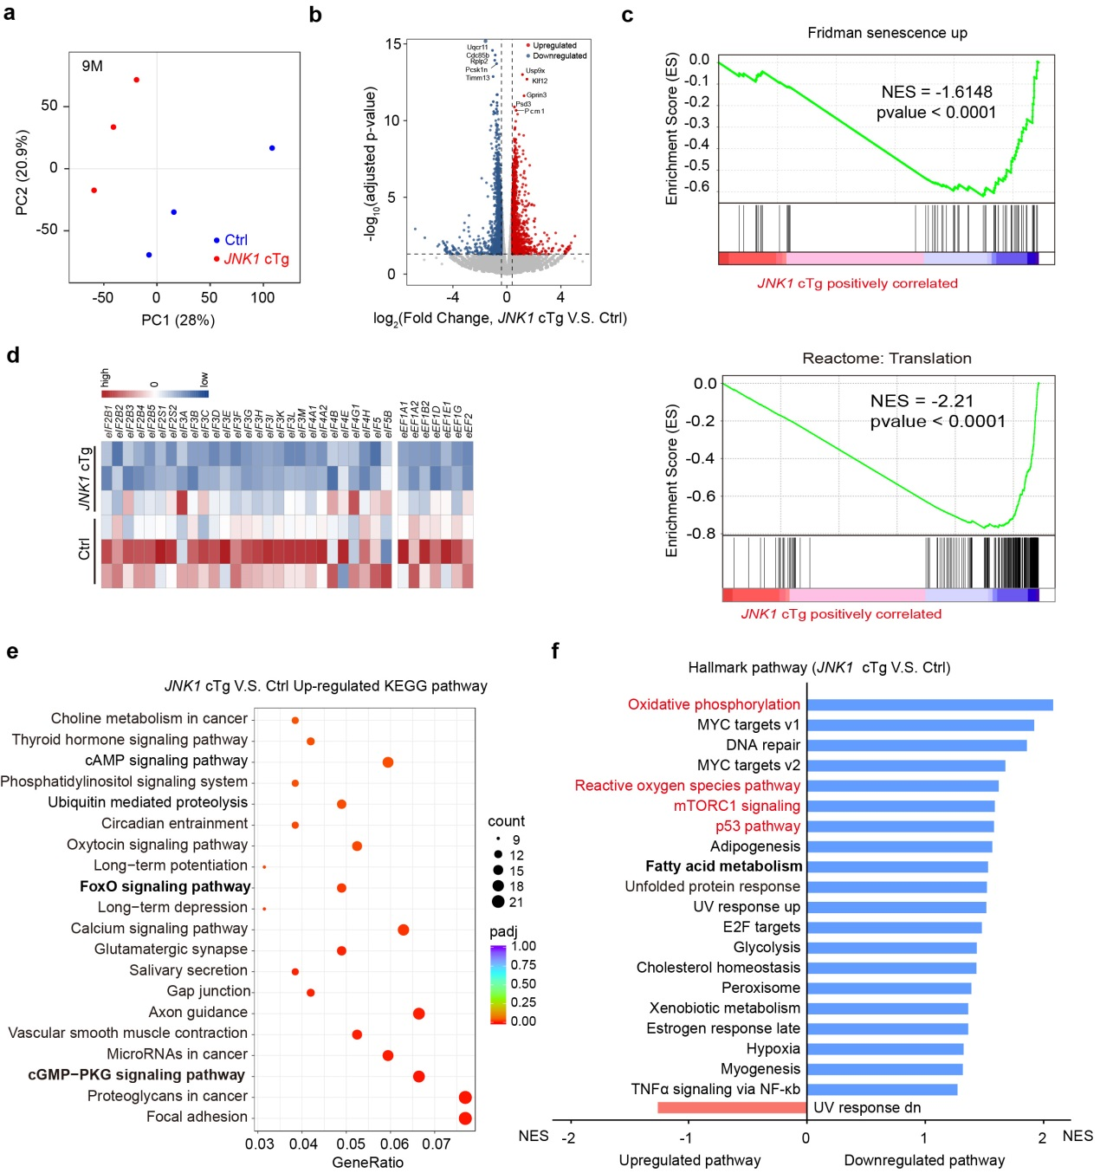
Fig.S3 Global transcriptomeanalysisusing bulkRNA-seq in 9-month-old JNK1 cTg and control mouse brains, related to Figure 4
a, Principal component analysis (PCA) of RNA-seq in 9-month-old JNK1 cTg and control mouse brains (each group n=3). b, Volcano plots of gene expression showing 860 upregulated and 1081 downregulated genes in RNA sequencing (RNA-seq) data from 9-month-old JNK1 cTg and control mice brains. c, GSEA revealed significant downregulation of both the 'Fridman senescence up' signature and translation-related pathways in 9-month-old JNK1 cTg mice compared to controls. d, Heatmap of genes associated with translation. e, KEGG enrichment analysis for the biological functions of upregulated genes in JNK1 cTg mouse brains (FDR < 0.05, log2FC > 0.4). f, GSEA analysis shown that hallmark pathways including oxidative phosphorylation, reactive oxygen species, mTOR1, and p53 are downregulated in JNK1 cTg mouse brains.

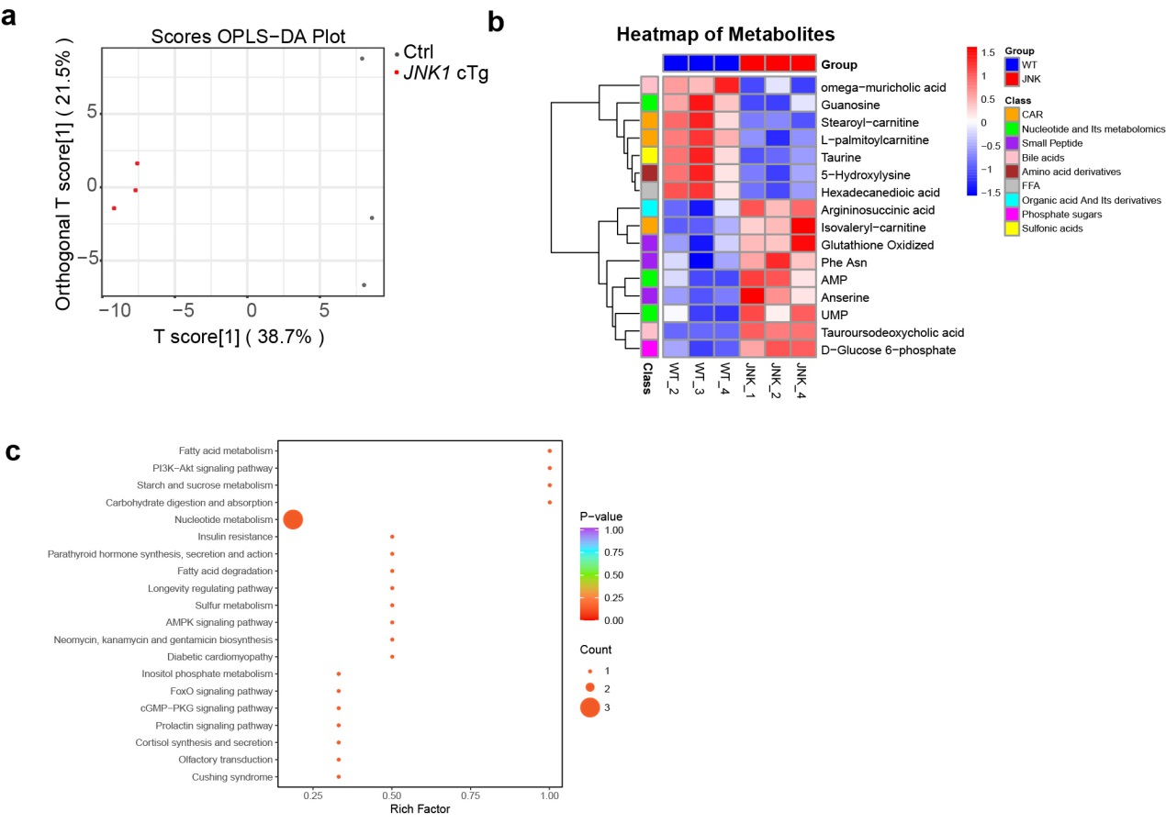Fig.S4 Targeted metabolomics analysis of brain tissues in JNK1 cTg and Ctrl mouse brains, related to Figure 5
(a) Orthogonal partial least squares-discriminant analysis (OPLS-DA) score plot showing the separation between Ctrl and JNK1 cTg mice. Each point represents an individual sample. (b) Heatmap of relative abundance of metabolites, grouped by class, in control (Ctrl) and JNK1 cTg mice. Rows represent individual metabolites, and columns represent samples. Color intensity indicates normalized metabolite levels. Group and class annotations are provided. (c) Dot plot of significantly enriched KEGG pathways based on differential metabolites

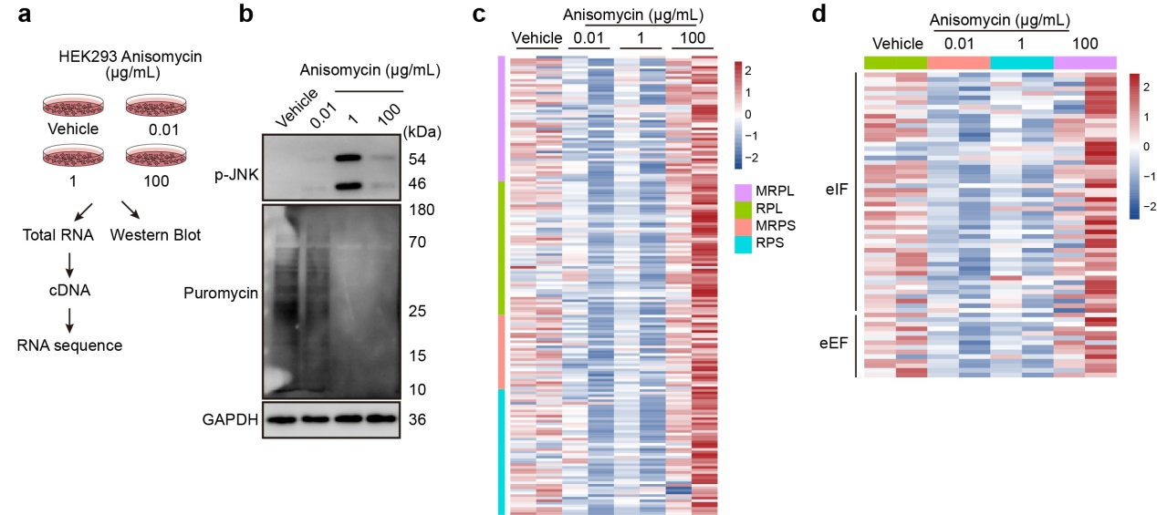
Fig.S5 Low dosage of anisomycin treatment causes down-regulation of ribosome-associated genes in HEK293 cells
a, Diagram of HEK293 cells were treated with different concentrations of anisomycin (ANS) and analyzed by bulk RNA-seq and Western blot. b, Immunoblots for phosphorylation of p-JNK and puromycin-based metabolic labeling of protein synthesis in HEK293 cells treated with ANS (0.001, 1, and 100 mg/L, 15 min) compared to vehicle. c, Heatmap of genes associated with ribosomal (RPL and RPS) and mitoribosmal (MRPL and MRPS) genes in HEK293 cells treated with different concentrations of ANS. d, Heatmap of genes associated with translation initiation factor (eIF) and (eEF).

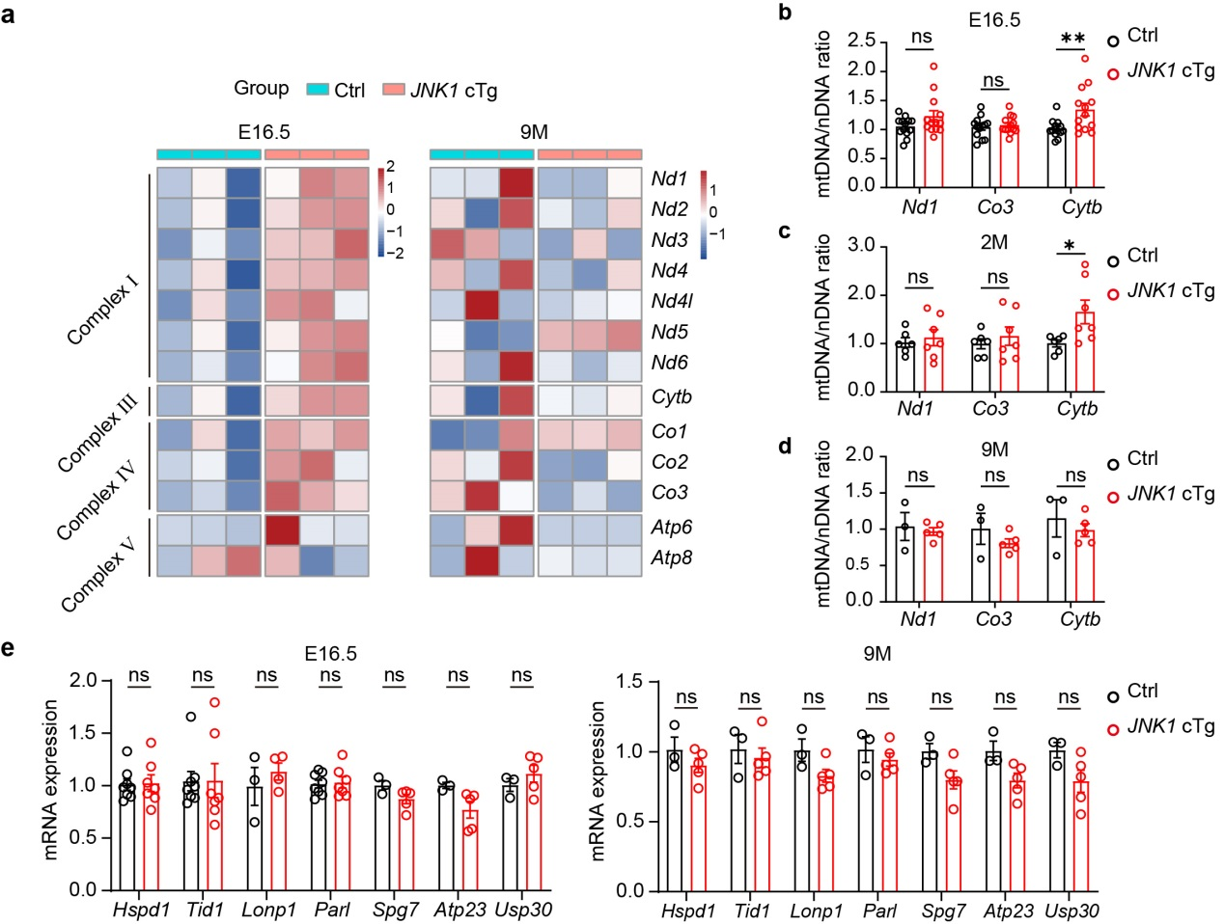
Fig.S6 JNK activation didn’t induce mitochondrial unfolded protein response mtUPR response in different stages of JNK1 cTg mouse brains
a, Heatmap of mitochondrial-encoded OXPHOS genes in E16.5 and 9-month-old JNK1 cTg and Ctrl mouse brains. b-d, RT-qPCR analysis of mtDNA/nDNA ratios by amplification DNA levels of Nd1, Co3, and Cytb normalized with the nuclear 18S gene in different stages of JNK1 cTg and Ctrl mouse brains. e, RT-qPCR analysis indicated no significant change in the mRNA level of mitochondrial chaperon (hspd1 and Tid1), and mitochondrial protease (Lonp1, Parl, Spg7, Atp23, and Usp30). All data are represented as mean ± SEM, n.s. p > 0.05, *p < 0.05, **p < 0.01.
.

Table S1 Comparative survival characteristics of JNK1^{CA} cTg and WT mice.

Genotype | Median | Mean s.e.m | Min-Max | Oldest 10% | Youngest 10% | N
Ctrl | 749 | 749±26 | 522-989 | 926±32 | 549±21 | 24
JNK1 cTg | 766 | 766±40 | 558-1079 | 1019±61 | 558±0 | 16
Lifespan is reported in days (±s.e.m, where appropriate) for Control and JNK1 cTg male mice. The oldest (youngest) 10% are the mean lifespan of the longest (or shortest) living 10% of animals within a genotype. N = Sample size.

Table S2 Primers for genotyping and QPCR analysis
Primer | Sequence (5’-3’)
Rosa 26 JNK1 P1 | AAAGTCGCTCTGAGTTGTTAT
Rosa 26 JNK1 P2  Rosa 26 JNK1 P3  Nestin Cre Forward  Nestin Cre Reverse  Mouse Gapdh QPCR-Forward  Mouse Gapdh QPCR-Reverse  Mouse Jnk1 QPCR-Forward  Mouse Jnk1 QPCR-Reverse  Mouse Jnk2 QPCR-Forward  Mouse Jnk2 QPCR-Reverse  Mouse Jnk3 QPCR-Forward  Mouse Jnk3 QPCR-Reverse  Mouse Cdkn2a QPCR-Forward  Mouse Cdkn2a QPCR-Reverse  Mouse Cdkn2b QPCR-Forward  Mouse Cdkn2b QPCR-Reverse  Mouse Cdkn1a QPCR-Forward  Mouse Cdkn1a QPCR-Reverse  Mouse Trp53 QPCR-Forward  Mouse Trp53 QPCR-Reverse  Mouse IL6-Forward  Mouse IL6-Reverse  Mouse IL1β-Forward  Mouse IL1β- Reverse  Mouse TNF-α-Forward  Mouse TNF-α-Reverse  Mouse Nd1-Forward  Mouse Nd1-Reverse  Mouse Co3-Forward  Mouse Co3-Reverse  Mouse Cytb-Forward  Mouse Cytb-Reverse  Mouse Hspd1-Forward  Mouse Hspd1-Reverse  Mouse Tid1-Forward  Mouse Tid1-Reverse  Mouse Lonp1-Forward  Mouse Lonp1-Reverse  Mouse Parl-Forward  Mouse Parl-Reverse  Mouse Spg7-Forward  Mouse Spg7-Reverse  Mouse Atp23-Forward  Mouse Atp23-Reverse  Mouse Usp30-Forward  Mouse Usp30-Reverse  Mouse Rpl6 QPCR-Forward  Mouse Rpl6 QPCR-Reverse  Mouse Rplp2 QPCR-Forward  Mouse Rplp2 QPCR-Reverse  Mouse Rpl38 QPCR-Forward  Mouse Rpl38 QPCR-Reverse  Mouse Rps15 QPCR-Forward  Mouse Rps15 QPCR-Reverse  Mouse Rps28 QPCR-Forward  Mouse Rps28 QPCR-Reverse  Mouse Rps29 QPCR-Forward  Mouse Rps29 QPCR-Reverse  Mouse Mrpl12 QPCR-Forward  Mouse Mrpl12 QPCR-Reverse  Mouse Mrpl14 QPCR-Forward  Mouse Mrpl14 QPCR-Reverse  Mouse Mrpl41 QPCR-Forward  Mouse Mrpl41 QPCR-Reverse  Mouse Mrps5 QPCR-Forward  Mouse Mrps5 QPCR-Reverse  Mouse Mrps11 QPCR-Forward  Mouse Mrps11 QPCR-Reverse  Mouse Mrps26 QPCR-Forward  Mouse Mrps26 QPCR-Reverse | GCGAAGAGTTTGTCCTCAACCGGAGCGGGAGAAATGGATATG  CGATGCAACGAGTGATGAGG  GCATTGCTGTCACTTGGTCGT  TGATGACATCAAGAAGGTGGTGAAG  TCCTTGGAGGCCATGTAGGCCAT  TCATTCTCGGCATGGGCTAC  AGCACATCGGGGAACAGTTT  CTGTTTGGTATGACCCCGCT  ACTGCTGCATCTGTGCTGAA  GGGAGCACACCATCGAAGAA  CGGTGGACATGGAGGAGATG  ACATCAAGACATCGTGCGATATT  CCAGCGGTACACAAAGACCA  GGCCTTGCAGGTCATGATGTT  GGAGCTAGGAAGCTGACCAC  TGTCCAATCCTGGTGATGTCC  CACGGGACCGAAGAGACAAC  TGAGGTTCGTGTTTGTGCCT  CTTCAGGTAGCTGGAGTGAGC  CCAAGAGGTGAGTGCTTCCC  CTGTTGTTCAGACTCTCTCCCT  GCAACTGTTCCTGAACTCAACT  ATCTTTTGGGGTCCGTCAACT  CCCTCACACTCAGATCATCTTCT  GCTACGACGTGGGCTACAG  TCCGAGCATCTTATCCACGC  GTATGGTGGTACTCCCGCTG  AAGGCCACCACACTCCTATT  ATCATGTGTTGGTACGAGGC  ACCTCAAAGCAACGAAGCCT  TGGGTGTTCTACTGGTTGGC  CACAGTCCTTCGCCAGATGAG  CTACACCTTGAAGCATTAAGGCT  GCTCGGGCATGGAAACTATCA  TCTGCACCCTGAATGTGACAA  CGGATGTGTTTCCTCACCTG  ACGCCAACATAGGGCTGTG  CCTATAAGAACACTCGTGAAGCC  ACCAGTCAGCTTTTATGCCATC  TTGCTATTGCGAATACTGACCC  CTGCTTCATCCTTGAGGTGTT  CTATGAAACACTCAGGTTGTGCT  GGTGAACCAGTGGACGTGA  CCTCCACTTTGCGAGCCTC  CAATCCCACCGATCACTCCC  AAGCCCAAGAAGGCGAAGC  GCAGCCGAGTATTTCCTTTTGTA  CGCTACGTCGCCTCTTACC  CTTGTTGAGCCGATCATCGTC  AGGATGCCAAGTCTGTCAAGA  TCCTTGTCTGTGATAACCAGGG  ACCTACCGTGGCGTAGACC  ATGTCCCTCAGGTGAGTCTTC  ATCAAGCTGGCTAGGGTAACC  GGCCTTTGACATTTCGGATGA  GTCTGATCCGCAAATACGGG  AGCCTATGTCCTTCGCGTACT  GCCACCGAAGGAGTGAAGC  GGAGCGTAAGGCTGGCAAT  CCATGTCAGCAGAGCATTCAG  GGGCGCTGTTGTCCACTAC  CTGACTGCCGTGACTCAAGG  GGACGACAAATTCTGGAACCA  AACCACTGTCTGACCAGCTTG  AGTCTCTGCTAATGCGCCTTT  CATGGAATGACCAGGTTTGTGG  AAAGGCTGAAGCGACTTGGAG  CATGACCCGCCTGCCAAAT  TCTCCCGGTACTGTCGGTAG

