Characteristics and Predictors of Post-Transplant Diabetes Mellitus: A Retrospective Analysis

Statistical Analysis

Table of Contents
Statistical analysis 3
Overall patients’ analysis 3
Baseline characteristics 3
Transplantation information 4
Laboratory biomarkers and viral status 5
PTDM patients’ findings 6
Determining age cutoff value 7
ACR cutoff point 7
Predictors of PTDM 8
Figures 9

Statistical analysis

The statistical analysis was performed using SPSS version 29. Continuous variables were presented as the mean ± SD or median and interquartile range (IQR), depending on the normality of their distribution. Categorical variables were presented as frequency and percentage. The t-test or Mann-Whitney U test was used to compare continuous variables between two independent groups, as appropriate. The Chi-squared test or Fisher's exact test was used to compare categorical variables, where applicable. The paired t-test was used to compare paired continuous variables. The Kaplan-Meier method was used to estimate survival free of PTDM. The ROC curve was used to determine cutoff values. Logistic regression analysis was employed for multivariate analysis to adjust for confounding and identify predictors of PTDM. All significant variables from the univariate analysis were included in the model. A two-sided p-value of less than 0.05 was considered statistically significant for all tests.

Overall patients’ analysis

The first table demonstrates the baseline characteristics of the total cohort and each group. You can observe that the PTDM group is significantly older with higher weight, height and BMI. Additionally, the distribution of the etiology of ESRD differs significantly between the two groups, primarily due to the higher prevalence of hypertension among PTDM patients. This aligns with the expected metabolic changes and the interrelationship between hypertension and diabetes. No significant differences were detected in terms of gender.

Baseline characteristics
 | Total | No PTDM | PTDM | P value
N | 228 | 174 (76.3%) | 54 (23.7%)
Age | 47.2±14.6 | 45.4±14.6 | 53.1±12.9 | <0.001
Gender
Female | 82 (36%) | 67 (38.5%) | 15 (27.8%) | 0.203
Male | 146 (64%) | 107 (61.5%) | 39 (72.2%) | 0.203
Weight | 68.3±16.4 | 66.5±16.3 | 75.5±15.1 | 0.002
Height | 162.9±9.5 | 161.9±9.7 | 165.6±8.6 | 0.026
BMI | 25.5±5.3 | 25.2±5.4 | 27±4.7 | 0.023
Etiology
Unknown | 167 (73.2%) | 133 (76.4%) | 34 (63%) | 0.006
HTN | 24 (10.5%) | 11 (6.3%) | 13 (24.1%) | 0.006
GN | 30 (13.2%) | 24 (13.8%) | 6 (11.1%) | 0.006
APKD | 3 (1.3%) | 2 (1.1%) | 1 (1.9%) | 0.006
Reflex | 4 (1.8%) | 4 (2.3%) | 0 (0%) | 0.006

Transplantation information

The second table presents data related to the transplantation. No significant differences between the groups were found except for a marginally higher incidence of PTDM in patients with elevated tacrolimus levels. It is important to note that missing data, particularly regarding tacrolimus levels, is a key limitation of the study and should be mentioned as such. (NA means Cyclosporine patients, Can we use it to compare between FK and CSA groups)

FK unit

 | Total | No PTDM | PTDM | P value
Tx Type
Deceased | 26 (11.4%) | 21 (12.1%) | 5 (9.3%) | 0.259
LR | 139 (61%) | 101 (58%) | 38 (70.4%) | 0.259
LNR | 63 (27.6%) | 52 (29.9%) | 11 (20.4%) | 0.259
Induction
Thymoglobulin | 69 (30.3%) | 53 (30.5%) | 16 (29.6%) | 0.923
Basilixmab | 76 (33.3%) | 59 (33.9%) | 17 (31.5%) | 0.923
Unknown | 83 (36.4%) | 62 (35.6%) | 21 (38.9%) | 0.923
Maintenance
Tacrolimus + MMF+ prednisolone | 187 (82%) | 140 (80.5%) | 47 (87%) | 0.330
Cyclosporine +MMF+ Prednisolone | 30 (13.2%) | 26 (14.9%) | 4 (7.4%) | 0.330
Tacrolimus+Azathiuoprine+prednisolone | 11 (4.8%) | 8 (4.6%) | 3 (5.6%) | 0.330
Tacrolimus | 198 (86.8%) | 148 (85.1%) | 50 (92.6%) | 0.174
Cyclosporine | 30 (13.2%) | 26 (14.9%) | 4 (7.4%) | 0.174
FK level
5-7 | 86 (43.4%) | 71 (48%) | 15 (30%) | 0.075
7-10 | 94 (47.5%) | 64 (43.2%) | 30 (60%) | 0.075
>10 | 18 (9.1%) | 13 (8.8%) | 5 (10%) | 0.075
Graft Outcome
None | 206 (90.4%) | 159 (91.4%) | 47 (87%) | 0.874
DGF | 4 (1.8%) | 3 (1.7%) | 1 (1.9%) | 0.874
TCMR | 15 (6.6%) | 10 (5.7%) | 5 (9.3%) | 0.874
ABMR | 3 (1.3%) | 2 (1.1%) | 1 (1.9%) | 0.874

Laboratory biomarkers and viral status
The third table shows the laboratory findings. It reveals that the CMV prevalence is significantly higher in the PTDM group. Additionally, the presence of low magnesium levels is significantly associated with PTDM. These important findings should be supported by suggested mechanisms and previous literature evidence. Kidney function as measured by creatinine and GFR, was comparable between the two groups. However, kidney damage measured by urine protein and the albumin to creatinine ratio was significantly higher in the PTDM group.

HCV

 | Total | No PTDM | PTDM | P value
HCV | 10 (4.4%) | 8 (4.6%) | 2 (3.7%) | 1
CMV | 9 (3.9%) | 4 (2.3%) | 5 (9.3%) | 0.036
Low Mg | 93 (40.8%) | 52 (29.9%) | 41 (75.9%) | <0.001
Last creatinine | 100 (81 to 125) | 100 (80 to 129) | 100 (81 to 114) | 0.540
Last eGFR | 75 (57 to 94) | 75 (55 to 94) | 75 (64 to 91) | 0.505
Urine PCr (mg/day) | 23 (11.5 to 71) | 21 (10 to 34) | 98.5 (29 to 160) | <0.001
ACR (mg/mmol) | 4 (1 to 21) | 4 (1 to 10) | 18.5 (4 to 44) | <0.001

PTDM patients’ findings
The 4th table presents the findings at the time of diabetes diagnosis. Nearly all patients had impaired fasting glucose and a quarter of them had severely uncontrolled diabetes. With HBA1C levels above 9, the mean survival free time for PTDM in the study sample was approximately 27 years. Patients who develop PTDM experienced an average weight gain of 7.1 kilograms. To maximize the clinical implications and applicability of the data, we conducted rock curve analysis to determine optimal cutoff points for age and ACR in predicting PTDM. You can see that an age greater than 36 years has an excellent sensitivity of 94.4% for predicting PTDM, which could be highly useful in practice in the sense that extra precautions should be considered in patients older than 36-years-old. Similarly, ACR more than 9 was found significant predictors. It is not mandatory to include these curves in your manuscript, but adding the written findings will be beneficial.

Total | 54
FBG
< 5.7 - 7 | 0
7 - 10 | 37 (68.5%)
> 10 | 17 (31.5%)
HBA1C
6.5-9 | 40 (74.1%)
> 9 | 14 (25.9%)
Survival without PTDM (years) ª | 27.7 (24.5 to 30.9)
Median time to devolve PTDM ^{b} | 2 (1 to 4.2)
Weight at DM diagnosis | 79.6±17
BMI at DM diagnosis | 28.9±5.3
Weight change | 7.1 (4.6 to 9.5) ^{c}
Medications
Metformin | 37 (68.5%)
Linagliptin (DPP-4) | 18 (33.3%)
Gliclazide (SUs) | 9 (16.7%)
Empagliflozin (SGLT2i) | 12 (22.2%)
Insulin | 26 (48.1%)
Semaglutide(GLP-1 agonists ) | 26 (48.1%)
ª estimated by Kaplan-Meir.
^{b} median (interquartile range)
^{c} mean change (95% confidence interval)

Determining age cutoff value
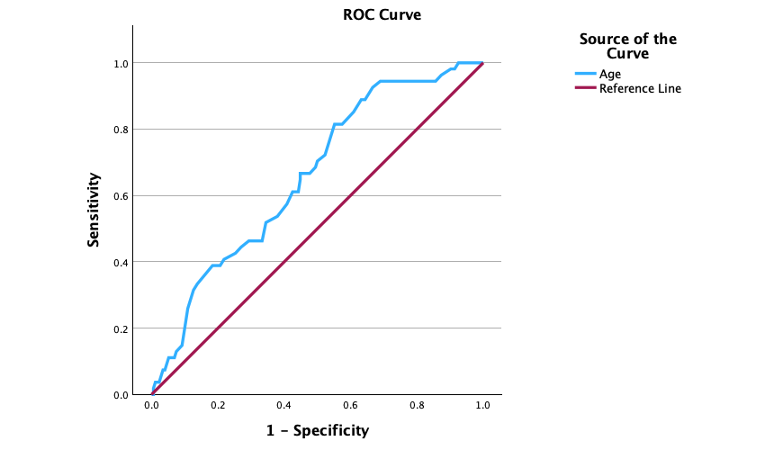

Area under the curve (AUC) = 0.658 (95% CI: 0.579 to 0.736), p-value <0.001. The 36-year-old cutoff point yielded sensitivity of 94.4% and specificity of 31%. While The 42-year-old cutoff point yielded sensitivity of 81.5% and specificity of 44.8%.

ACR cutoff point
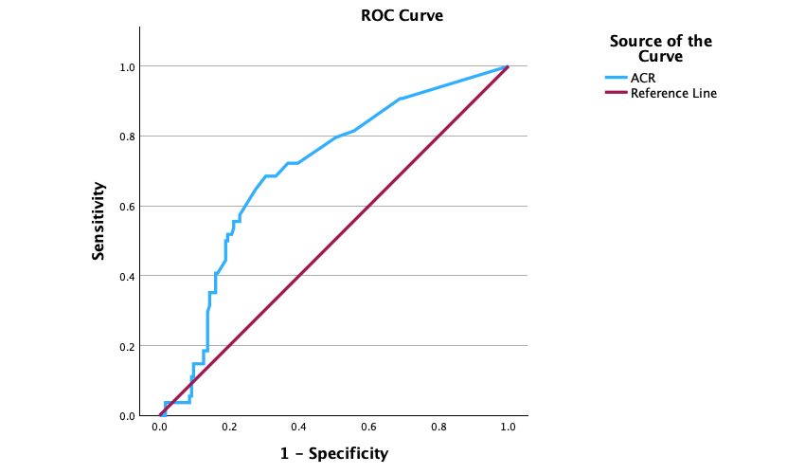

Area under the curve (AUC) = 0.697 (95% CI: 0.620 to 0.775), p-value <0.001. The 9 cutoff point yielded sensitivity of 68.5% and specificity of 69.5%.

Predictors of PTDM

Finally, we performed univariate and multivariate analysis. The univariate analysis shows the association between each variable and the outcome. PTDM, for example, age has an odds ratio of 1.039, meaning that for each additional year of age, the risk of PTDM increases by 1.39. Patients older than 36 have an 8.4 fold higher risk of developing PTDM. The multivariate analysis on the right shows all the significant variables after adjustment for other factors. The adjusted odds ratios provide valuable information after accounting for confounding effects, you can see that the effects of weight and CMV become non significant after adjustment, while age, hypertension, low magnesium FK levels, and ACR, remain significant predictors of PTDM. Some journals request to include both univariate and multivariate analysis, while others accept multivariate analysis only.
 | Univariate |  |  | Multivariate
 | OR | 95% CI | P value | aOR | 95% CI | P value
Age (years) | 1.039 | 1.016 to 1.063 | <0.001
≥36 vs. <36 | 8.412 | 2.497 to 28.343 | <0.001 | 13.862 | 2.293 to 83.788 | 0.004
Males vs. Females | 1.628 | 0.834 to 3.179 | 0.153
Bassline weight | 1.036 | 1.011 to 1.062 | 0.005 | 1.022 | 0.982 to 1.063 | 0.284
Baseline height | 1.044 | 1.005 to 1.085 | 0.028
Baseline BMI | 1.073 | 0.995 to 1.157 | 0.066
Tx Type
Deceased | Reference
LR | 1.58 | 0.556 to 4.49 | 0.39
LNR | 0.888 | 0.275 to 2.869 | 0.843
HTN | 4.698 | 1.963 to 11.248 | <0.001 | 7.925 | 1.828 to 34.352 | 0.006
Etiology
Unknown | Reference
HTN | 4.623 | 1.904 to 11.223 | <0.001
GN | 0.978 | 0.37 to 2.581 | 0.964
APKD | 1.956 | 0.172 to 22.213 | 0.588
Reflex | 0 |  | 0.999
Induction
ATG | Reference
SIMU | 0.954 | 0.439 to 2.076 | 0.906
Unknown | 1.122 | 0.532 to 2.367 | 0.763
Maintenance
FK+MMF+pr | Reference
CSA+MMF+Prd | 0.458 | 0.152 to 1.381 | 0.166
FK+AZA+pr | 1.117 | 0.285 to 4.385 | 0.874
FK level
5-7 | Reference |  |  | Reference
7-10 | 2.219 | 1.095 to 4.494 | 0.027 | 5.013 | 1.314 to 19.128 | 0.018
>10 | 1.821 | 0.564 to 5.878 | 0.316 | 4.703 | 0.723 to 30.575 | 0.105
Graft Outcome
None | Reference
DGF | 1.128 | 0.115 to 11.096 | 0.918
TCMR | 1.691 | 0.551 to 5.193 | 0.358
ABMR | 1.691 | 0.15 to 19.068 | 0.671
HCV | 0.798 | 0.164 to 3.877 | 0.78
CMV | 4.337 | 1.121 to 16.773 | 0.034 | 1.722 | 0.158 to 18.764 | 0.656
Low Mg | 7.399 | 3.663 to 14.949 | <0.001 | 8.303 | 2.484 to 27.755 | <0.001
Last creatinine | 0.997 | 0.993 to 1.002 | 0.268
Last eGFR | 1.004 | 0.992 to 1.016 | 0.511
Urine PCr (mg/day) | 1.002 | 1.001 to 1.004 | 0.009
ACR (mg/mmol) | 1.001 | 0.998 to 1.004 | 0.478
≥9 vs. <9 | 4.969 | 2.571 to 9.602 | <0.001 | 14.786 | 4.036 to 54.172 | <0.001
aOR: adjusted odds ratio; CI: confidence interval.

Figures

The first figure illustrates the association between age quartiles and the incidence of PTDM.

The incidence of PTDM by age quartile (p-value < 0.001)

The second figure shows the increased risk of PTDM with higher FK levels.

p-value = 0.075

The third figure displays a trend of increased PTDM incidents with higher BMI. Notably, this trend is broken in the category of obese individuals with a BMI of 30 to 35, which has a lower incidence. This deviation might explain why both BMI and weight were not significant predictors of PTDM.

p-value = 0.049

P = 0.877

The final figure shows the medications prescribed to treat PTDM patients. 2/3 of the patients received metformin, with half receiving insulin and GLP 1 agonist. Notably, the prescription of protective agents like SGLT2 inhibitors is low, with only 22% of patients receiving them.

