Supplementary Figure 1. Genetic correlations among 11 neuropsychiatric disorders in European ancestry. Genetic correlations corrected for sample overlap were estimated using GNOVA. The color intensity and size of the squares are proportional to the strength of the genetic correlations (violet = negative correlation, yellow = positive correlation). Asterisks indicate genetic correlations that are statistically significant at a false discovery rate level of 0.05. Red boxes highlight the correlations between MD and other traits. Abbreviations for disease names: AD - Alzheimer’s disease, ASD - Autism spectrum disorder, BD - Bipolar disorder, ICH - Intracerebral hemorrhage, MD - Major depression, Panic - Panic disorder, Parkinson - Parkinson's disease, SAH - Subarachnoid hemorrhage, SC - Schizophrenia.
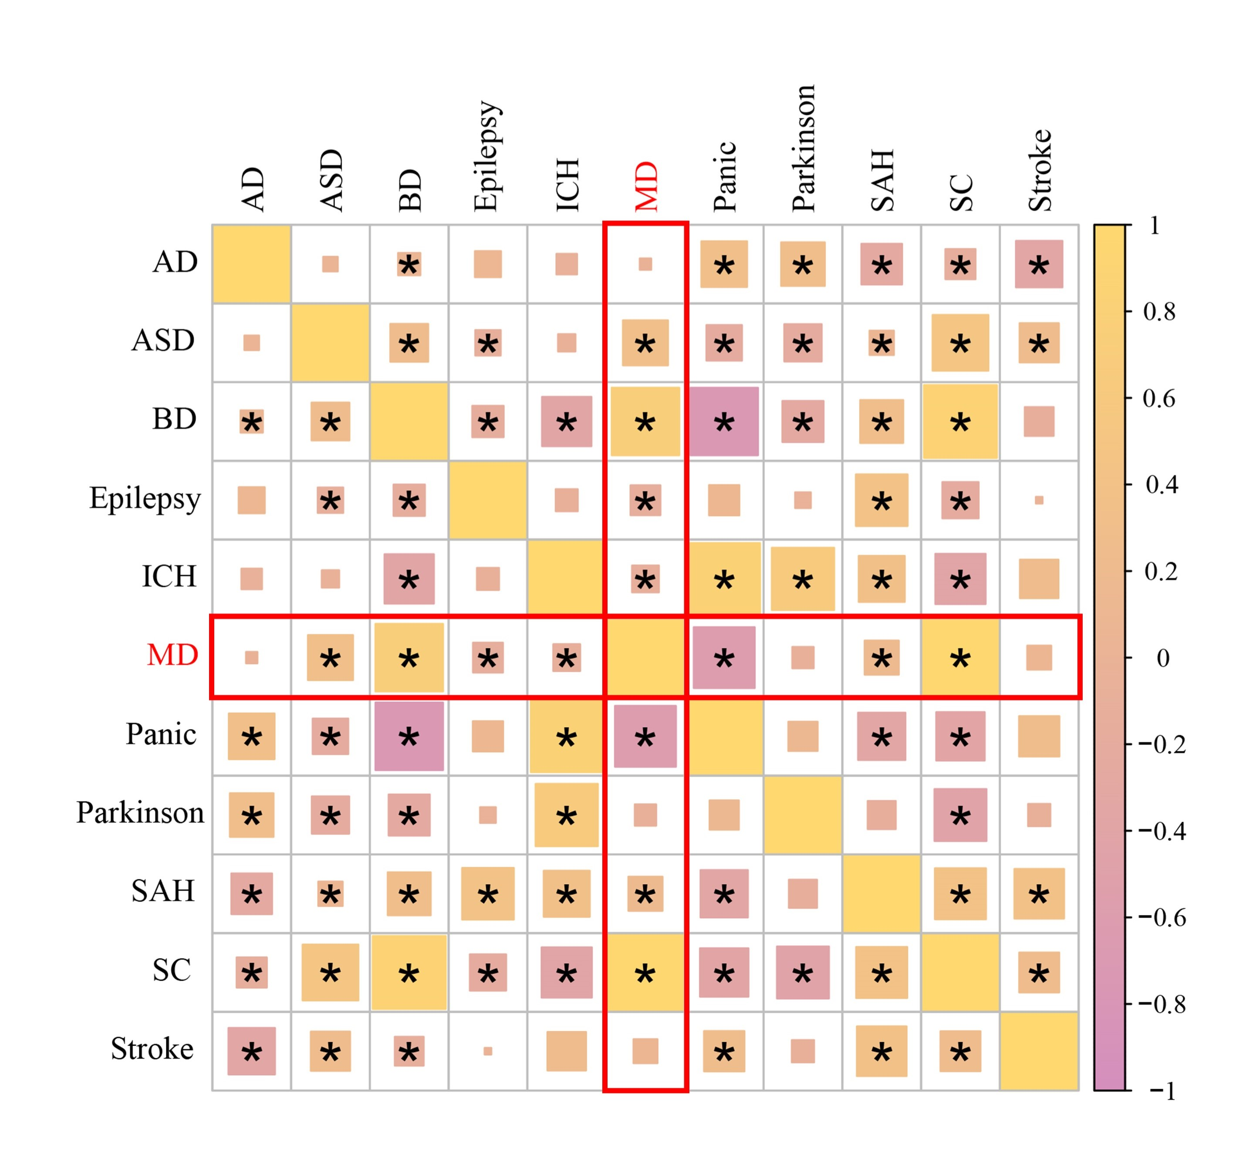
Supplementary Figure 2. QQ-plot. The x-axis of the QQ-plot represents the expected p-values under the null hypothesis, while the y-axis represents the observed p-values from the GWAS summary statistics data. There is a significant deviation from the diagonal line, which indicates potential variations from the null hypothesis that may result from true associations or LD. The genomic inflation factor (lambda) is labeled in the top left of the QQ-plot, and a lambda value of 1.195 indicating no strong population stratification.
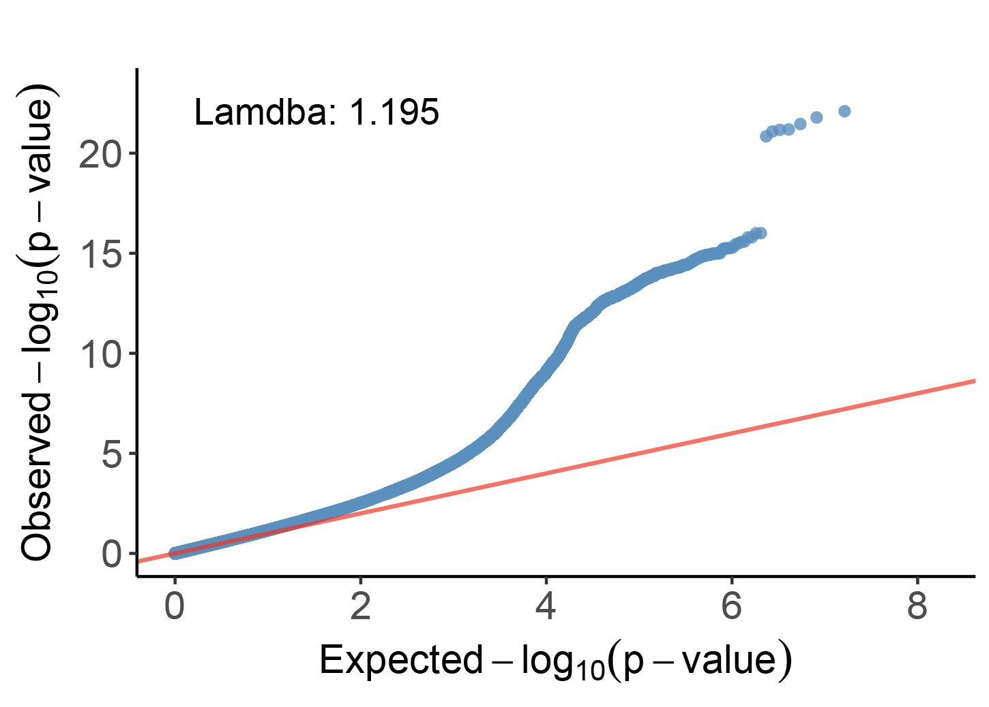

Supplementary Figure 3. 45 MD risk genes identified using five distinct methodologies, each gene recognized by four or more approaches. The left side represents the risk genes, while the right-side details the various methods employed.
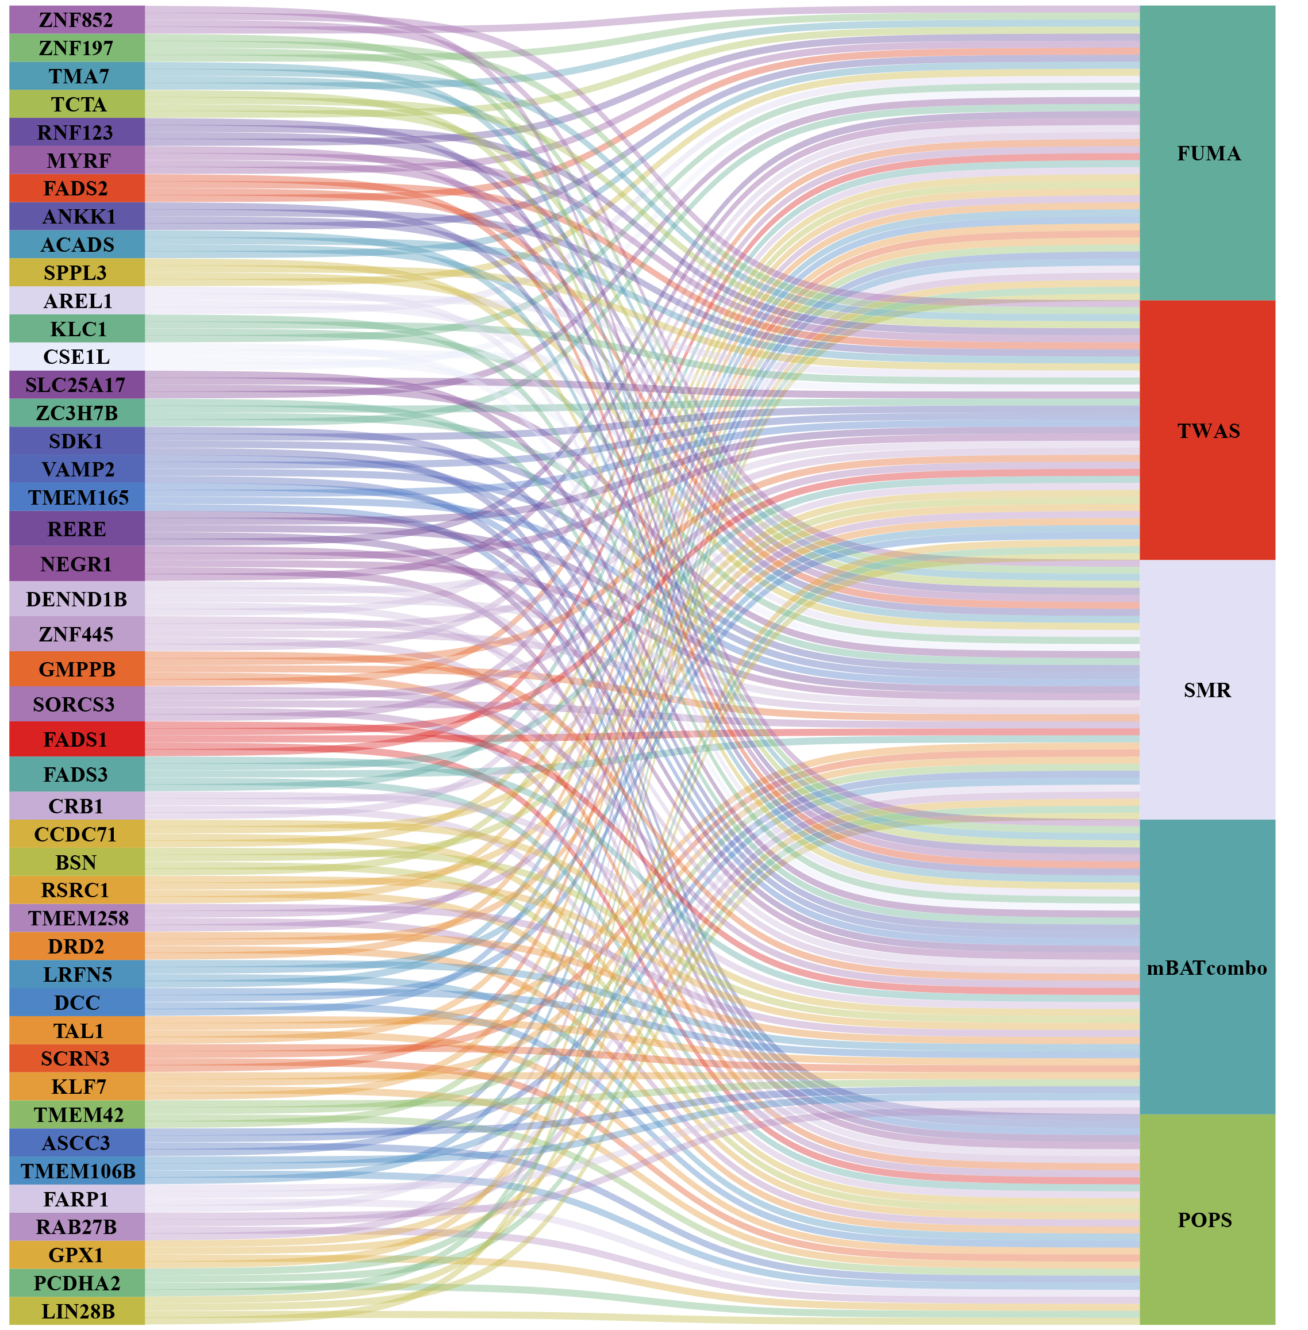

Supplementary Figure 4. Genomic enrichment analysis and parallel phenotypic analysis of risk genes.
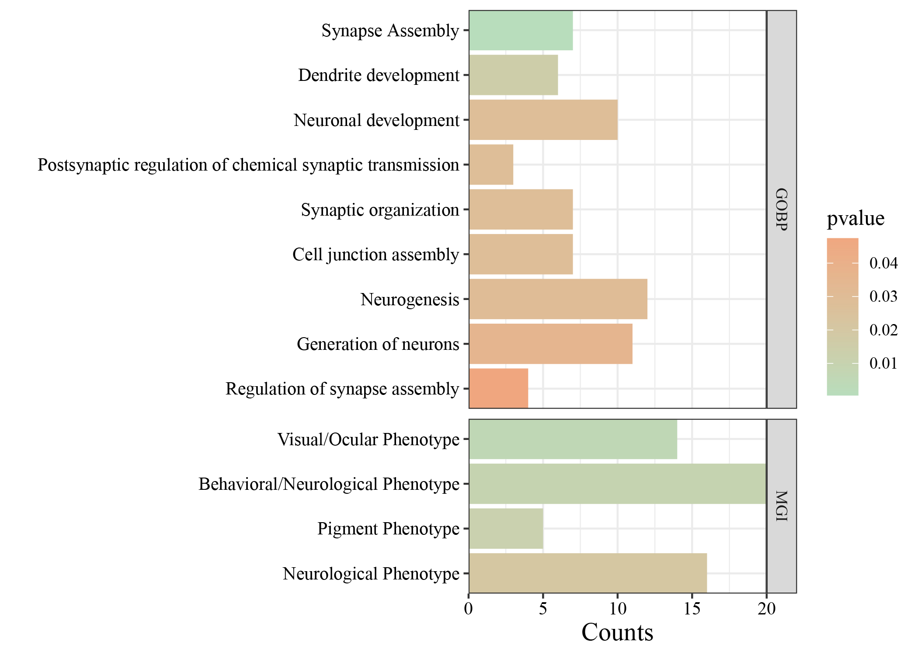

Supplementary Figure 5. Correlations of risk protein in each pQTL dataset derived through BLISS analysis, based on Beta and SE values.
