Supporting information
Safety of Sentinel Lymph Node Biopsy for Axillary Staging in Clinical T3-4c Breast Cancer

Fig. S1: Patient flowchart
Fig. S2: Sensitive analysis of overlap weighting. Recurrence free survival (a), loco-regional recurrence rate (b), overall survival (c)
Fig. S3: Kaplan–Meier curves of loco-regional recurrence after stabilized inverse probability of treatment weighting by cT3 (a) and T4a-c (b)
Fig. S4: Kaplan–Meier curves of overall survival. Unadjusted analysis (a), after stabilized inverse probability of treatment weighting (sIPTW) (b), by cT3 (c) and T4a-c (d)

Supplemental figure 1: Patient flowchart
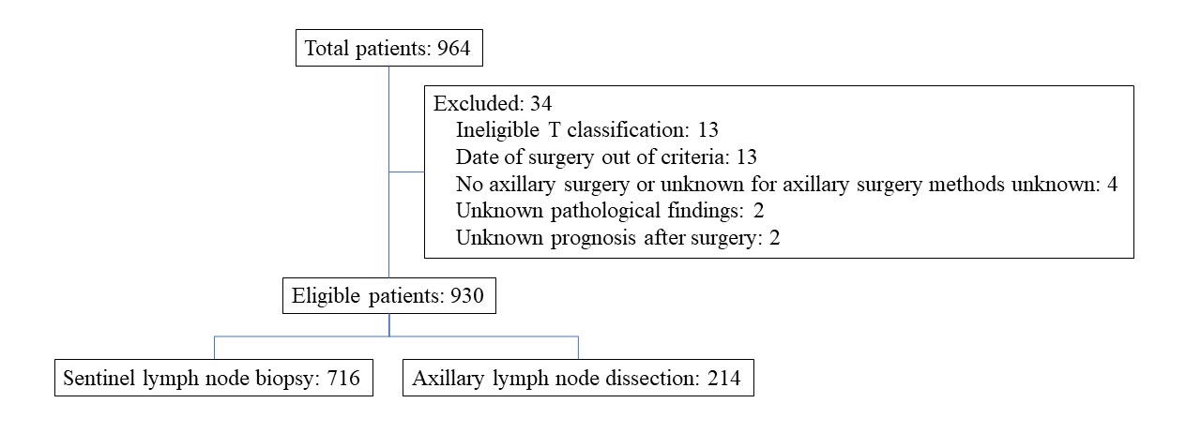

Supplemental figure 2: Sensitive analysis of overlap weighting. Recurrence free survival (a), loco-regional recurrence rate (b), overall survival (c). ALND, axillary lymph node dissection; CI, confidence interval; LRR, loco-regional recurrence; OS, odds ratio; SLNB, sentinel lymph node biopsy

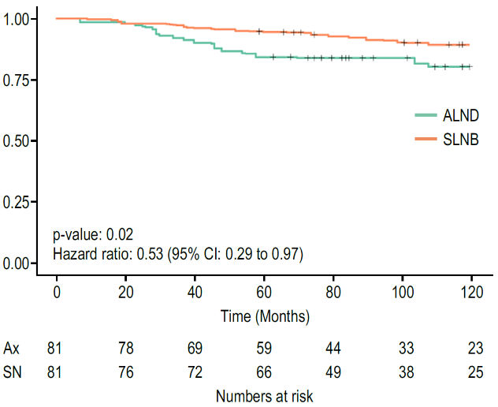
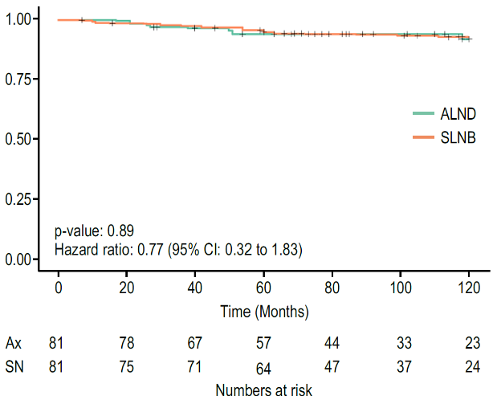
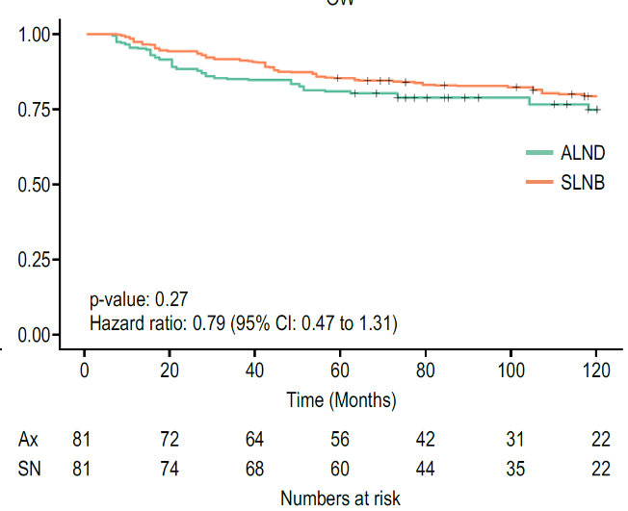
c. OS
a. RFS
b. LRR

Supplemental figure 3: Kaplan–Meier curves of loco-regional recurrence after stabilized inverse probability of treatment weighting by cT3 (a) and T4 (b). ALND, axillary lymph node dissection; CI, confidence interval; SLNB, sentinel lymph node biopsy

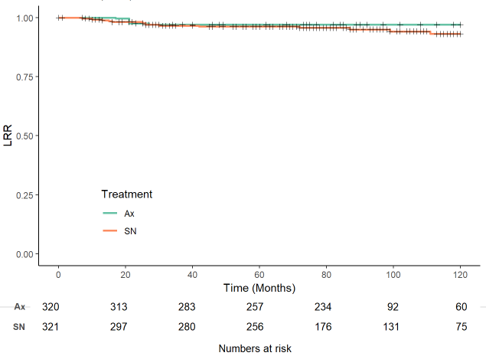
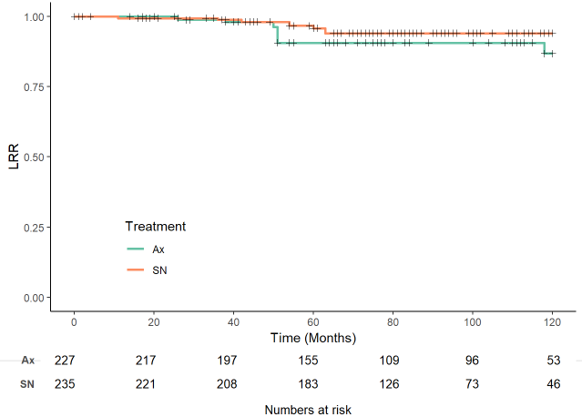

a. cT3
b. cT4a-c
ALND
SLNB
p-value: 0.25
Hazard ratio: 0.54 (95% CI: 0.14 to 2.1)

p-value: 0.67
Hazard ratio: 1.76 (95% CI: 0.38 to 8.21)

ALND
SLNB

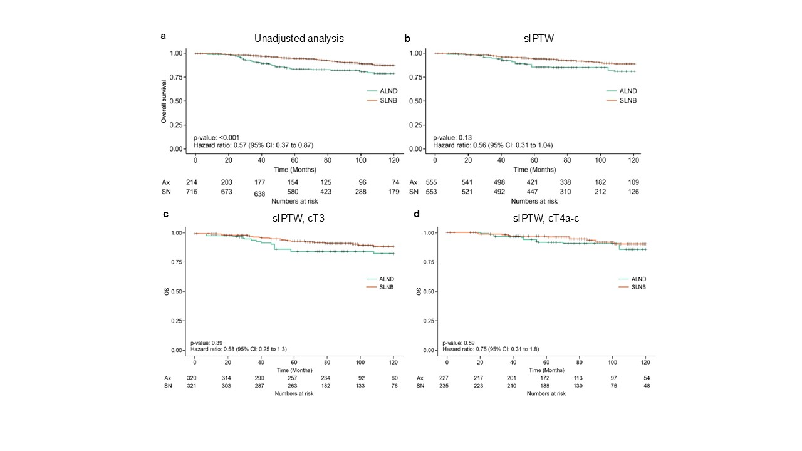
Supplemental figure 4: Kaplan–Meier curves of overall survival. Unadjusted analysis (a), after stabilized inverse probability of treatment weighting (b), by cT3 (c) and T4a-c (d)ALND, axillary lymph node dissection; CI, confidence interval; SLNB, sentinel lymph node biopsy

