Supplementary Tables

Supplementary Table 1; Antibodies used for TIL flow cytometry assays
Supplementary Table 2; Gene signatures for Immunophenotyping analysis
Supplementary Table 3; Differential upregulated and downregulated genes in the single cell RNA sequencing data from Tumor-Infiltrating Lymphocyte (TIL) + and – tumors
Supplementary Table 4; Supplementary Table 3; Differential upregulated and downregulated genes in the Xenium spatial transcriptomics data from Tumor-Infiltrating Lymphocyte (TIL) + and – tumors
Supplementary Table 5; Antibodies used for the Co-Detection by Indexing (CODEX) assays
Supplementary Table 6: Clinical and demographic data for 11 glioma patients (18 TIL expansion attempts). Each column represents a TIL product, identified by unique ID. Rows include patient age, sex, tumor type (glioblastoma or anaplastic astrocytoma), resection status (new or recurrent), IDH status, tumor location, and preREP adjunctive therapies. All samples underwent IL-2–based TIL expansion; select samples also received immune-modulating antibodies (atezolizumab, nivolumab, pembrolizumab, or urelumab).

Supplementary Figures
Supplementary Figure 1:
(A) Flow cytometry of TILs from 20 glioma patients.
(B–C) Comparison of preREP and REP TIL composition in two patients (23-0257, 23-0153).
(D) γδ T cell populations in expanded TILs.
Supplementary Figure 2:
Violin plots comparing TIL⁺ vs. TIL⁻ tumors across clonality metrics (Diversity Index, Entropy, Unique CDR3s, D50). No significant differences observed (p > 0.05), though trends in D50 and CDR3 counts suggest potential clonality differences.
Supplementary Figure 3:
UMAP plots of scRNA-seq and spatial data showing distinct cellular compositions between TIL⁺ and TIL⁻ tumors, with variable immune infiltration and TAM profiles across patients.
Supplementary Figure 4:
(A) UMAP shows enrichment of immune cells in TIL⁺ tumors and neuronal/OPC cells in TIL⁻ tumors (p < 0.03).
(B) Cell type proportions across groups.
(C) Sample-colored UMAPs highlight inter-patient heterogeneity and clustering biases due to sample variability.
Supplementary Figure 5:
Violin plots of immune and tumor cell populations:
(A) Immune cell distribution in TIL⁺/TIL⁻ tumors.
(B) Tumor cell subtypes (AC-, MES-, NPC-, OPC-like).
(C) TAM states (immunosuppressive vs. pro-inflammatory).
(D) Vascular gene expression in TIL⁺ tumors.
(E) Glial/neuronal cell proportions.
Supplementary Figure 6:
Violin plots from Xenium data show:
(A) Lymphoid gene expression,
(B) Tumor-intrinsic immune-regulatory genes,
(C) TAM variations,
(D) Endothelial, neuronal, and oligodendroglial markers. Plot width reflects intratumoral expression heterogeneity.
Supplementary Figure 7; Tumor-connected TAMs localize to necrotic, liquefied, or fibrotic regions in gliomas. H&E-stained sections from patient tumors aligned with Xenium spatial segmentation show that green-labeled tumor-connected TAMs are mostly in areas of necrosis (23-0227), liquefactive necrosis with viable tumor interfaces (23-0264, 23-0258), or fibrotic and calcified regions (22-0160), and are less abundant in viable tumor nests. These macrophages express stemness, neural, and glial markers (e.g., SOX2, NES, AQP4), suggesting phagocytosis of tumor cells, reprogramming, or mimicry. Their confinement to degenerating regions and enrichment in TIL⁻ tumors point to a potential role in immune exclusion and tumor-associated tissue remodeling. Abbreviations; F: Female, M: Male, R: Recurrent Disease, ND: Newly Diagnosed Disease. IDH: Isocitrate Dehydrogenase mutations: AA: Anaplastic Astrocytoma, yo: years old.

Supplementary material

Supplementary Table 1

color | marker | clone | catalog # | vendor
BUV395 | CD25 | BC96 | 567483 | BD
Live/Dead Blue | Live/dead |  |  | invitrogen
BUV496 | CD28 | CD28.2 | 741168 | BD
BUV563 | Lag3 | 3DS223H | 365-2239-42 | invitrogen
BUV615 | CD4 | SK3 | 612987 | BD
BUV661 | CD19 | HIB19 | 741604 | BD
BUV737 | CD69 | FN50 | 612818 | BD
BUV805 | CD3e | UCHT1 | 612896 | BD
BV421 | TCR γδ | 11F2 | 744870 | BD
BV480 | PD1 | EH12.1 | 566112 | BD
BV510 | HLA-DR | L243 | 307646 | biolegend
BV605 | CD57 | NK-1 | 567205 | BD
BV650 | CD56 | NCAM16.2 | 564057 | BD
BV711 | CD103 | Ber-ACT8 | 563162 | BD
BV750 | CD127 | HIL-7R-M21 | 747089 | BD
BV785 | TIM3 | F38-2E2 | 345032 | biolegend
FITC | TCR γδ2 | B6 | 331406 | biolegend
Spark Blue 574 | CD8 | sk1 | 344784 | biolegend
RB613 | PDL1 | MIH1 | 759043 | BD
PerCP | CD14 | M5e2 | 301848 | biolegend
BB700 | TIGIT | 741182 | 747846 | BD
RB744 | NKG2D | 1D11 | 758092 | BD
RB780 | CXCR6 | 13B1E5 | 755573 | BD
PE | Foxp3 | PCH101 | 12-4776-42 | invitrogen
PE-CF594 | CD45RA | HI100 | 562298 | BD
PE-Cy5 | CD39 | A1 | 328248 | biolegend
PE-Fire 700 | CD95 | DX2 | 305666 | biolegend
PE-Cy7 | TCR γδ1 | T28.2 | 25-5679-42 | invitrogen
PE-Fire 810 | CTLA4 | BNI3 | 369639 | biolegend
APC | CD137 | 4B4-1 | 550890 | BD
APC-R700 | CD45 | HI30 | 566041 | BD
APC-Cy7 | CCR7 | G043H7 | 353212 | biolegend

Supplementary Table 2

Term | Gene signature
Th1 | IFNG, TBX21, CCL5, CXCR3, TBX21, STAT11
Th2 | IL4, IL5, IL13, GATA3, STAT6, IL1RL1
Th9 | IL9, IL10, SPI1, STAT5A
Th17 | IL23R, RORC, STAT3
Tfh | BCL6, ICOS, CXCR5, IL21, CD38
Treg | FOXP3, IKZF2, IL10, LAG3, TGFB1, IL2RA, STAT5A
CD8Tn | CD8A, CD8B, LAG3, TCF7, SELL
TcmTn | CCR7, CD8A, SELL
Exhaustion | PDCD1, CTLA4, LAG3, HAVCR2, TIGIT, IDO1, PVR
Bcell | TNFRSF17, BTK, CD19, CD22, CD40, CD79A, CD79B, CXCR5, FCGR2B, BCL6, CD38, CD27, CD5
NKcell | KLRD1, KLRB1, KLRC1, NCR2, NCR3, KLRC1, SLAMF7, FCGR3A
Myeloid | MPO, CD14, CD68, ITGAM
Monocyte | ITGAM, CD14, FCGR3A, FCGR2A, FCGR1A, CD68, MRC1, FCGR2B, MPO, S100A8, PADI4
DC | ITGAX, CD40, CD83, IL3RA, HLA-DRA, ITGAE, S100A9
Eosinophils | EPX, IL5, IL4, IL13
Neutrophils | MPO, PADI4, CD14, FCGR3A
Pro-inflammatory | CCL5, IFNG, IL9, IL12B, IL13, IL21, TNF
Anti-inflammatory | IL10, IL4, IL1R1, IL5
Pleiotropic | IL5, IL21, IL23A, IL27
Activation | TNFRSF9, IL2RA, CD38, CD63, CD69, CD226, CXCR3, ICOS, KLRB1, KLRD1, TFRC
Cytotoxic | GZMB, PRF1, FAS, IFNG

Supplementary Table 3

Upregulated Genes in TIL+ group
Gene | log2FC | p-value | adj. p-value | Status
IL7R | 9.58 | 2.47E-08 | 1.13E-04 | upReg
ACSS3 | 2.83 | 2.88E-08 | 1.13E-04 | upReg
FOXD3 | 7.04 | 1.90E-05 | 1.90E-02 | upReg
ELOVL2 | 7.13 | 1.92E-05 | 1.90E-02 | upReg
PRLR | 6.96 | 3.89E-05 | 3.89E-02 | upReg
EHF | 6.94 | 3.98E-05 | 3.98E-02 | upReg
CD8A | 6.97 | 4.74E-05 | 4.74E-02 | upReg
IBSP | 1.56 | 4.74E-05 | 4.74E-02 | upReg
MRC2 | 1.56 | 4.74E-05 | 4.74E-02 | upReg
B3GNT3 | 1.69 | 4.74E-05 | 4.74E-02 | upReg
CIITA | 1.69 | 4.74E-05 | 4.74E-02 | upReg
HEXB | 1.69 | 4.74E-05 | 4.74E-02 | upReg
CD6 | 1.69 | 4.74E-05 | 4.74E-02 | upReg
HOXC13 | 5.62 | 9.33E-05 | 5.86E-02 | nonDE
IL18R1 | 6.11 | 9.35E-05 | 5.86E-02 | nonDE

Upregulated Genes in TIL- group
Gene | log2FC | p-value | adj. p-value | Status
SOX3 | 9.28 | 5.88E-14 | 1.13E-04 | upReg
LTBP4 | 2.15 | 1.96E-09 | 1.13E-04 | upReg
GSTM1 | 2.89 | 7.11E-08 | 4.96E-03 | upReg
GRID2 | 2.74 | 4.06E-06 | 8.40E-03 | upReg
FERMT1 | 2.68 | 1.33E-05 | 1.90E-02 | upReg
BMP2 | 2.65 | 1.19E-05 | 1.90E-02 | upReg
CLEC4F | 2.65 | 2.22E-05 | 3.89E-02 | upReg
NEU4 | 2.27 | 2.31E-05 | 4.35E-02 | upReg
HES6 | 1.77 | 4.64E-05 | 4.74E-02 | upReg
TOX | 1.74 | 5.90E-05 | 4.74E-02 | upReg
CD207 | 1.58 | 1.01E-04 | 5.86E-02 | nonDE
SOX8 | 1.52 | 1.01E-04 | 5.86E-02 | nonDE
ZFPM2 | 1.36 | 1.59E-04 | 7.24E-02 | nonDE
PTCH1 | 1.52 | 1.48E-04 | 7.24E-02 | nonDE
RTP5 | 1.32 | 1.69E-04 | 7.78E-02 | nonDE

Supplementary Table 4
logFC | FDR | gene | significant
6.8331692 | 0.0398152 | EGFR-exon1-exon8 | Upregulated
3.1837521 | 0.0398152 | DUSP4 | Upregulated
2.7139088 | 0.0435637 | MOXD1 | Upregulated
-2.00053 | 0.0483727 | ABCC9 | Downregulated
-2.217396 | 0.0398152 | SLC14A1 | Downregulated
-2.304604 | 0.0427589 | NDST4 | Downregulated
-2.875229 | 0.0483727 | CUX2 | Downregulated
-2.975365 | 0.0494847 | KLRK1 | Downregulated
-3.00894 | 0.0398152 | TOX | Downregulated
-3.138759 | 0.000029 | CD207 | Downregulated
-3.244759 | 0.0398152 | HPSE2 | Downregulated
-3.29303 | 0.0398152 | FERMT1 | Downregulated
-3.293543 | 0.0427589 | SPON1 | Downregulated
-3.711017 | 0.0398152 | SYN3 | Downregulated
-4.115114 | 0.0435637 | SFRP2 | Downregulated
3.7625388 | 0.2611661 | TRDC | Not significant
3.4810509 | 0.1393094 | CXCL8 | Not significant
2.7200506 | 0.1887431 | LHX6 | Not significant
2.6953447 | 0.0589641 | NPY | Not significant

Supplementary Table 5
Antibody | Clone | Company | Catalog Number | Oligo
Arg1 | Polyclonal |  |  | 43
aSMA | Polyclonal | abcam | AB5694 | 69
B-cat | 14 | CellMarque |  | 51
BCL2 | 124 | CellMarque |  | 41
CD11b | EPR1344 | abcam | ab209970 | 28
CD138 | DL-101 | Biolegend | 352302 | 76
CD163 | EDHu-1 | Novus | NB100-64980 | 45
CD20 | rlGEL/773 | Noovus | NBP2-54591 | 48
CD206 | E2L9N | CST | 49243SF | 55
CD25 | 4C9 | CellMarque | custom | 24
CD3 | MRQ-39 | CellMarque | MRQ-39 | 77
CD31 | C31.3+C31.7+C31.10 | Novus | NBP2-47785 | 68
CD34 | QBEnd/10 |  |  | 38
CD36 | D8L9T |  |  | 74
CD38 | E7Z8 | CST |  | 66
CD4 | EPR6855 | abcam | ab181724 | 20
CD45 | 2B11 + PD7/26 | Novus | NBP2-34287 | 56
CD56 | MRQ-42 | CellMarque | custom | 29
CD68
CD73 | Polyclonal | BD | AF5795 | 75
CD8 | C8/144B | Invitrogen | MA5-13473 | 8
CD90 | EPR3132 |  |  | 21
DCN | Polyclonal | Thermo |  | 63
FOXP3 | 236A/E7 | Invitrogen | 14-4777-82 | 61
HLADR | EPR3692 | abcam | ab209968 | 62
Ki67 | B56 | BD | 556003 | 6
MMP9 | L51/82 | Biolegend | 819701 | 80
p16 | G175-405 |  |  | 59
p53 | D07 |  |  | 52
pH2AX | EP854(2)Y |  |  | 57
Vimentin | RV202 | Novus | NBP1-97672 | 7

Supplementary Table 6
TIL | 1 | 2 | 3 | 4 | 5 | 6 | 7 | 8 | 9 | 10 | 11 | 12 | 13 | 14 | 15 | 16 | 17 | 18
Tumor
Age | 68 | 68 | 68 | 68 | 63 | 45 | 79 | 79 | 45 | 45 | 46 | 46 | 46 | 45 | 45 | 75 | 63 | 45
Sex
Histology
Resection
IDH
Location
Adjuncts
REP vs. pre-REP

Color Key

Tumor samples:
23-0257 | 23-0227 | 22-0189 | 23-0153 | 23-0059
23-0196 | 23-0217 | 21-0213 | 21-0221 | 21-0241 | 22-0155

Sex: Male Female

Histology: Glioblastoma Anaplastic Astrocytoma

Indication for tumor resection: Newly Diagnosed OR Recurrent Tumor

Isocitrate Dehydrogenase status: (IDH) Wild Type; IDH-Mutated

Tumor Anatomical Location: Frontal Temporal Parietal Midline Occipital

Expansion Protocol: preREP or REP

Adjuncts added to Pre-Rapid Expansion Culture:

IL2 alone Pembrolizumab Nivolumab Atezolizumab Urelumab

Supplementary Figures
Supplementary Figure 1

A
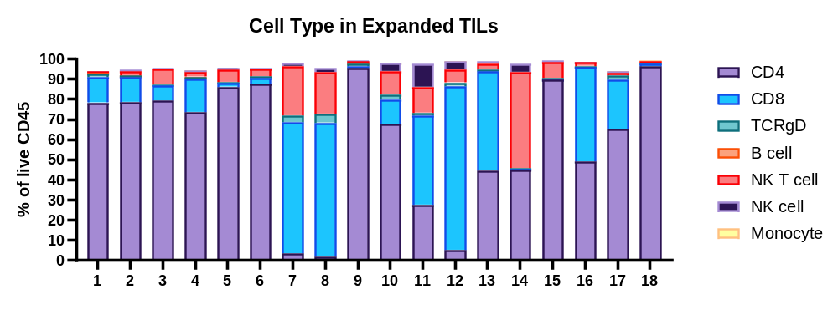
B | C
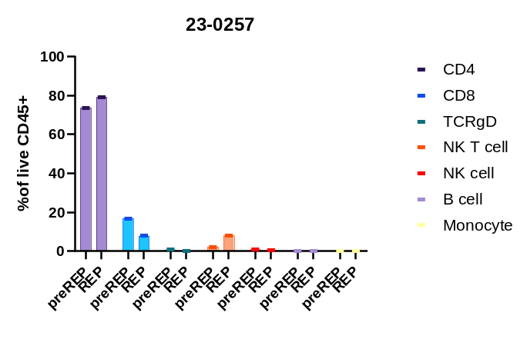 | 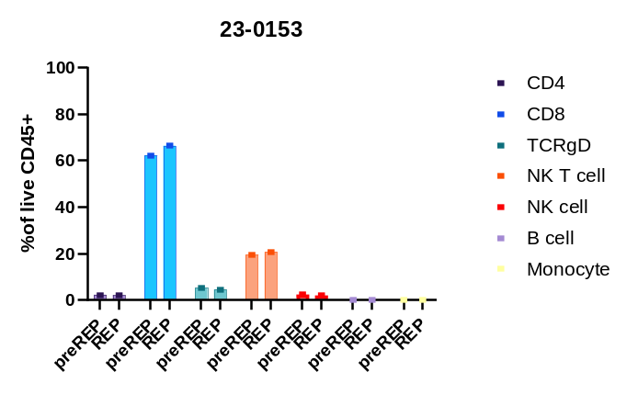
D
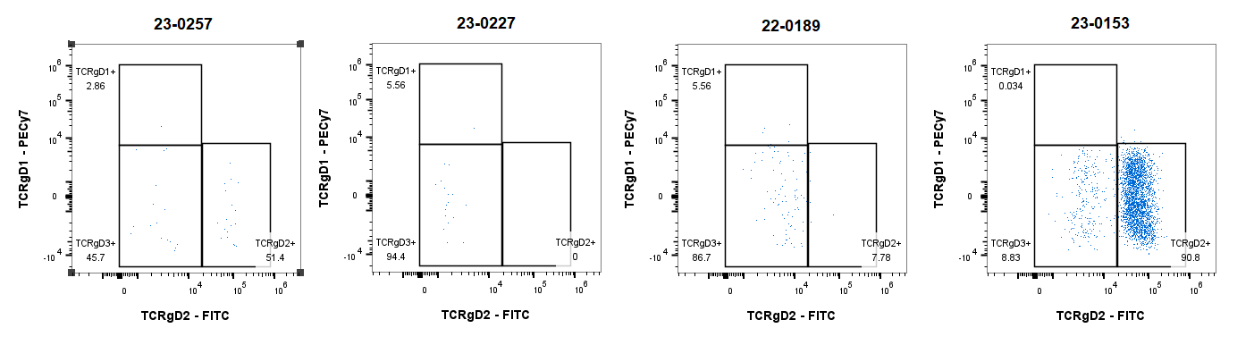

Supplementary Figure 2
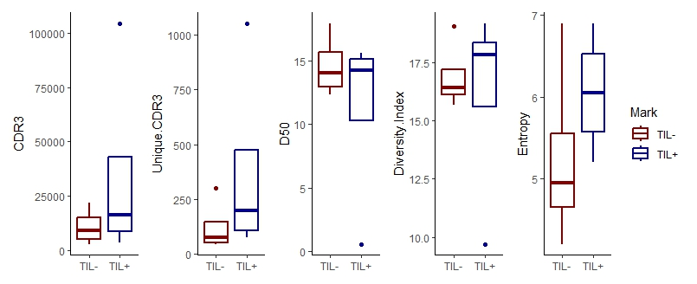

Supplementary Figure 3
(A)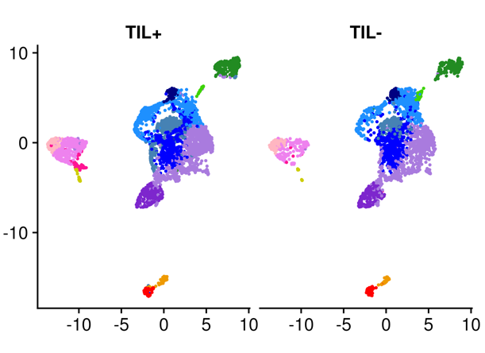 |  | 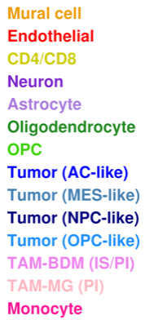 |  | (B)  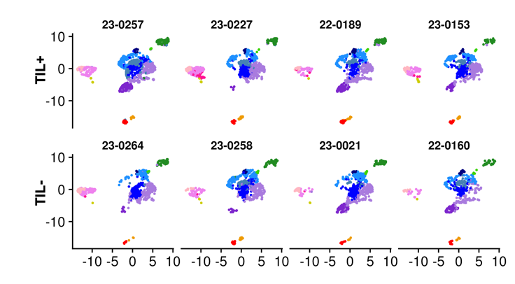
(C)  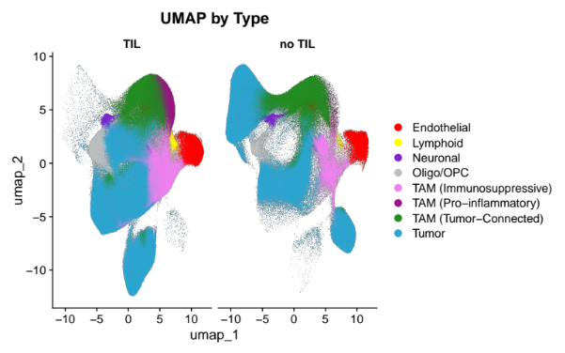 | 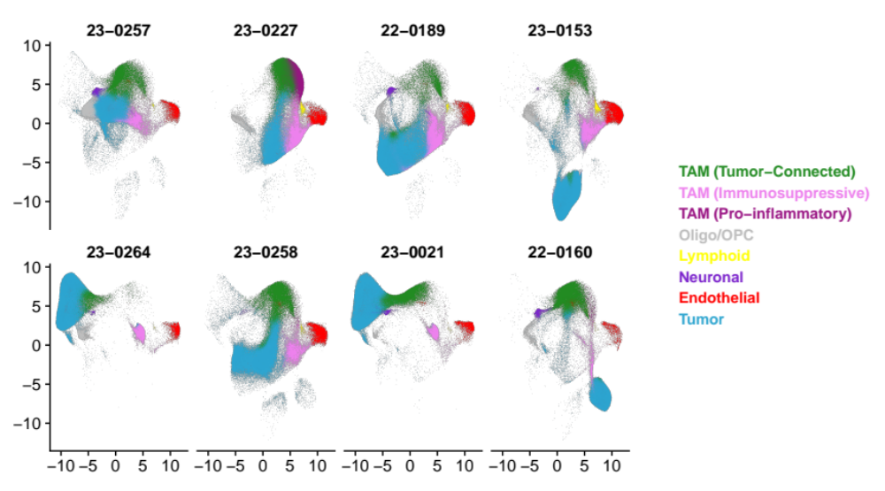 |  | D  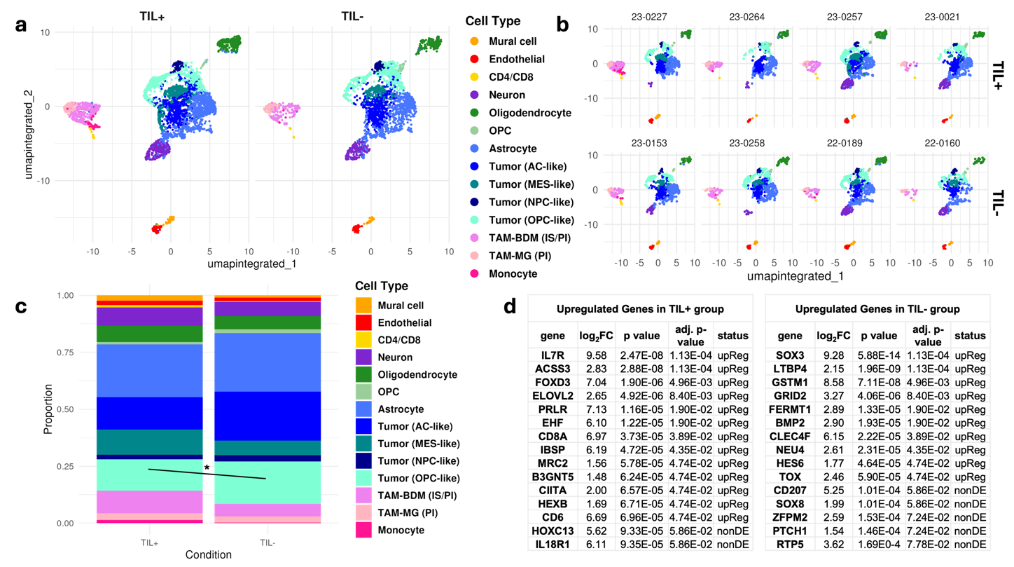 |  | 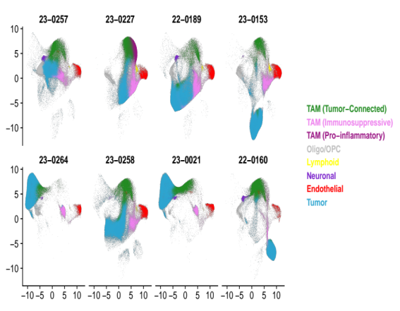

Supplementary Figure 4
A  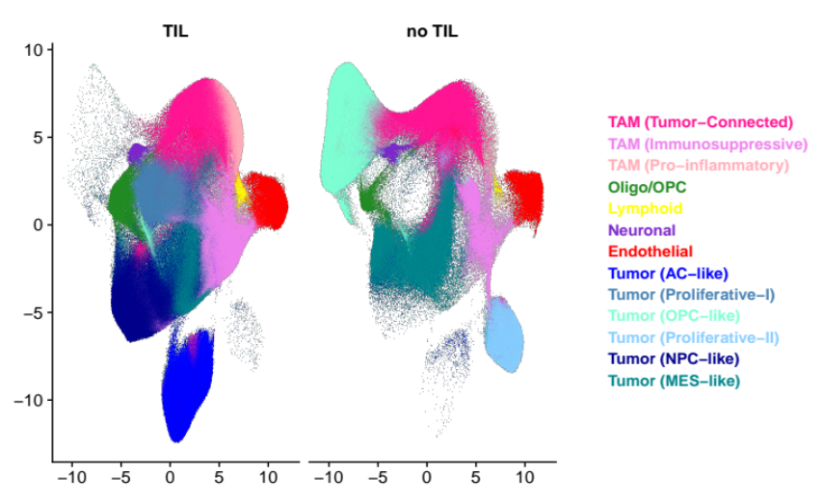 |  | B  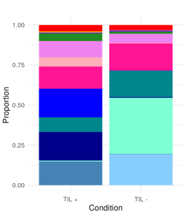
C | 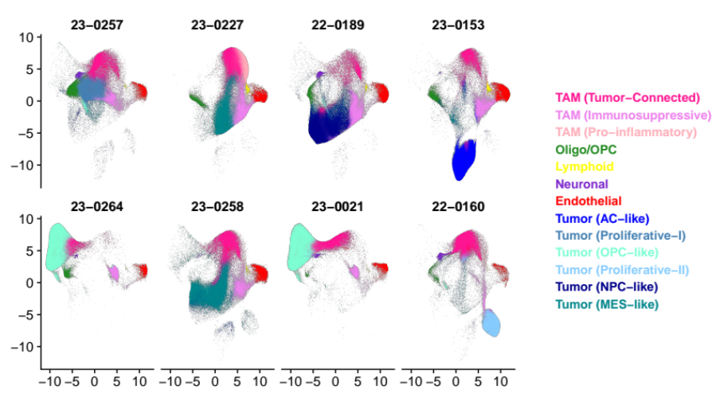 | 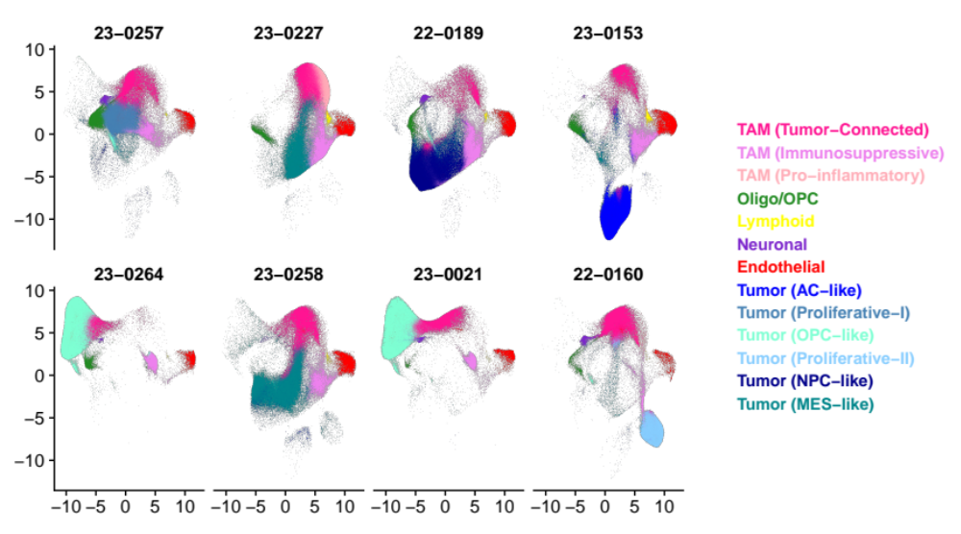

Supplementary Figure 5
(A)  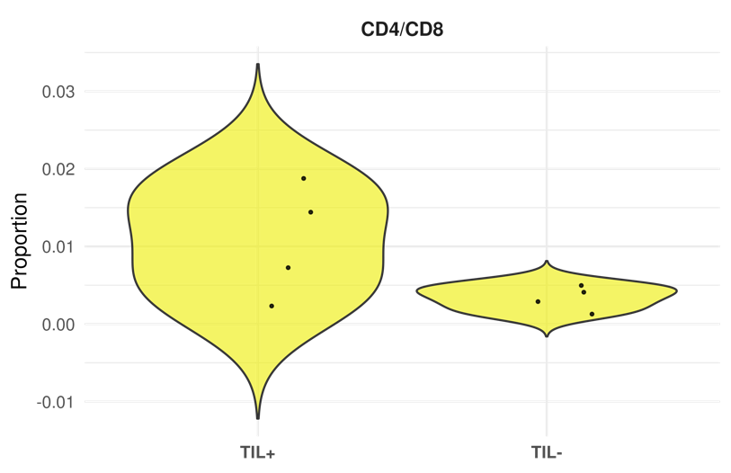 | (B)  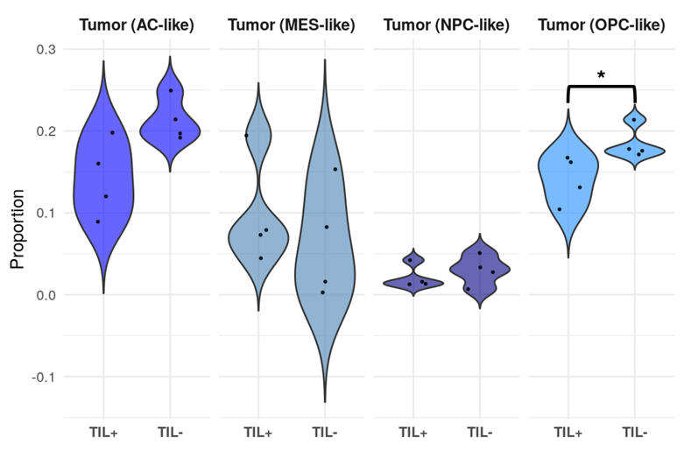
(C)  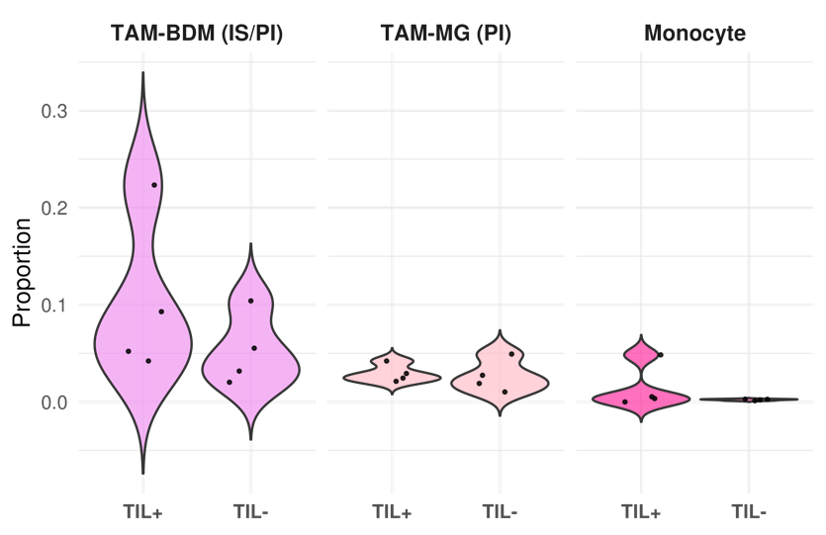 | (D)  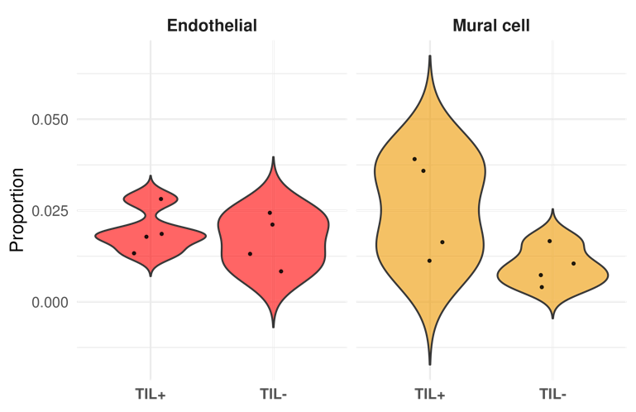
(E)
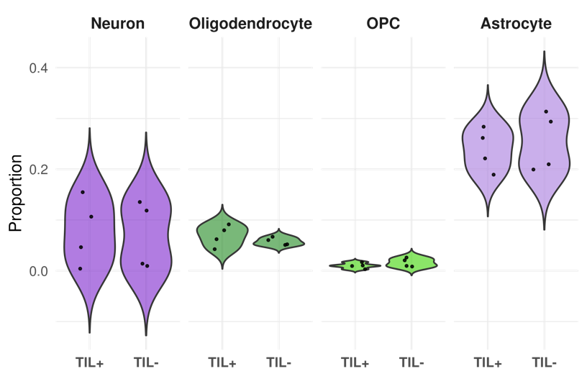

Supplementary Figure 6
(A)  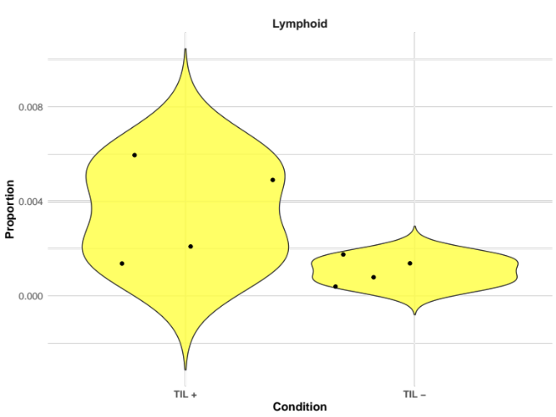  (C)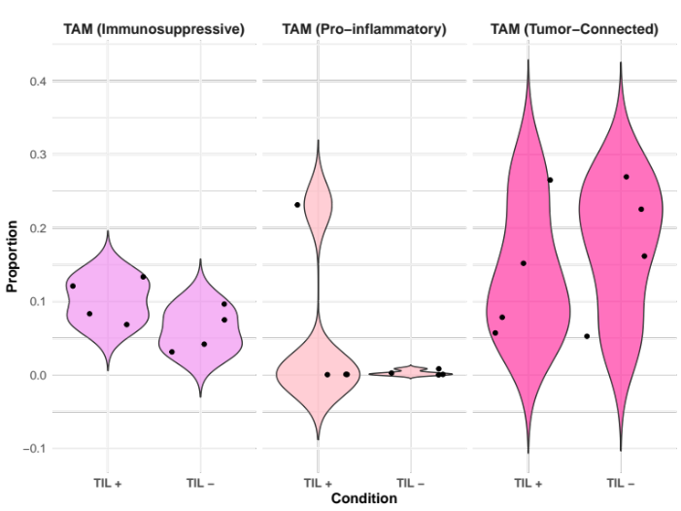 | (B)  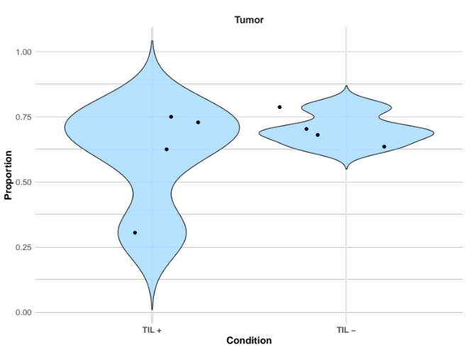  (D)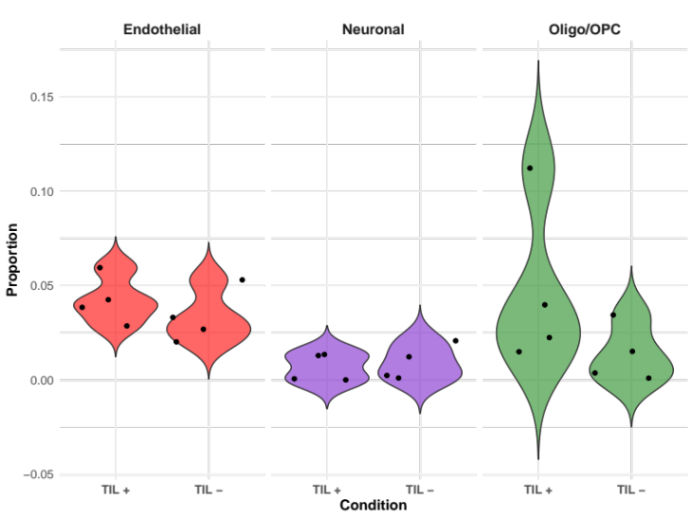

Supplementary Figure 7
23-0257: 68 yo, F, ND, right temporal glioblastoma |  |  | 23-0264: 32 yo, F, RD, right frontal (IDH R32H+) AA
Infiltrating tumor periphery exhibiting necrosis with a vacuolated appearance most obvious in upper left corner. Lower part of the box exhibit moderately hypercellular brain tissue with a mix of tumor cells and macrophages. |  |  | A pale, vacuolated area suggestive of edematous tumor, adjacent to eosinophilic and cellular tissue consistent with viable tumor.
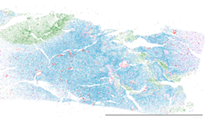 |  |  | 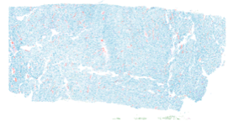 |  |  |  | 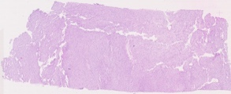 | 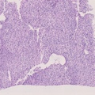
23-0227: 63 yo, M, RD, left temporal glioblastoma that recurred and resected from the frontal lobe. |  |  |  |  |  | 23-0258: 79 yo, M, ND left temporal glioblastoma
Necrosis with surrounding viable tumor. The upper half of the boxed region shows viable, densely cellular tumor, whereas the lower half consists of pale necrotic tissue, bordered by a dense cellular rim, indicating a transition to pseudopalisading necrosis. |  |  | The boxed region shows interface between pale, necrotic or edematous tissue, likely representing necrosis, and adjacent viable, more cellular tumor or stromal tissue in the right side of the box.
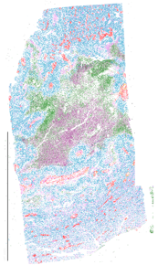 |  |  | 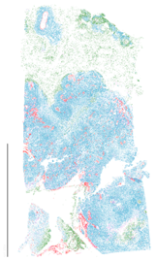
22-0189: 45 yo, ND, M, left parietal glioblastoma |  |  |  | 23-0021: 28 yo, F, ND, IDH (R143H) left frontal AA
A central zone of necrosis with eosinophilic cellular debris, surrounded by pseudopalisading hyperchromatic tumor cells and areas of microvascular proliferation and hemorrhage, characteristic of glioblastoma. |  |  | Infiltrating periphery, transition from viable tumor to a necrotic core, consistent with a pseudopalisading pattern characteristic of high-grade glioma.
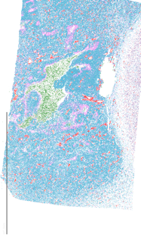 |  | 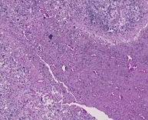 | 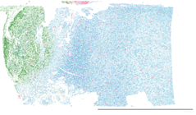 |  |  |  |  | 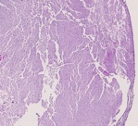
23-0153: 79 yo, F, ND, right temporopariental glioblastoma |  |  |  |  | 22-0160:54 yo, M, RD, right parietal glioblastoma
Transition from loosely structured, necrotic or edematous tissue on the left to more densely cellular, viable tumor tissue on the right, consistent with a necrosis-viable interface. |  |  | Fibrosis with calcification, which is an uncommon unspecific reaction after therapy including post-chemoradiation.
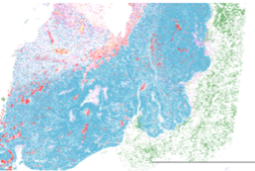 |  | 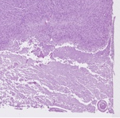 | 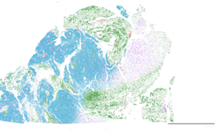 |  |  |  |  | 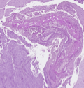

Cell Type
Endothelial
Lymphoid
Neuronal
Oligo/OPC
TAM (Immunosuppressive)
TAM (Pro-Inflammatory)
TAM (Tumor-Connected)
Tumor

