Supplementary Information
Together is better: How mixtures of organic filters mitigate the photocatalytic activity of TiO2 and ZnO

Mattia Battistin1,, Alessia Minisini2, Andrea Brunetta1, Fabio Brunetta1, Dario Voinovich2,Dritan Hasa2,*and Greta Camilla Magnano2,3,*
1Kalis Srl, Via Caodevilla 38, 31040 Pederobba, Italy
2Department of Chemical and Pharmaceutical Sciences, University of Trieste, Piazzale Europa 1, 34127 Trieste, Italy
3Clinical Unit of Occupational Medicine, University of Trieste, Via della Pietà 2/2, 34129 Trieste, Italy

*Corresponding authors: dhasa@units.it ; gmagnano@units.it

Photocatalytic Activity Analysis: Reaction Order and Degradation

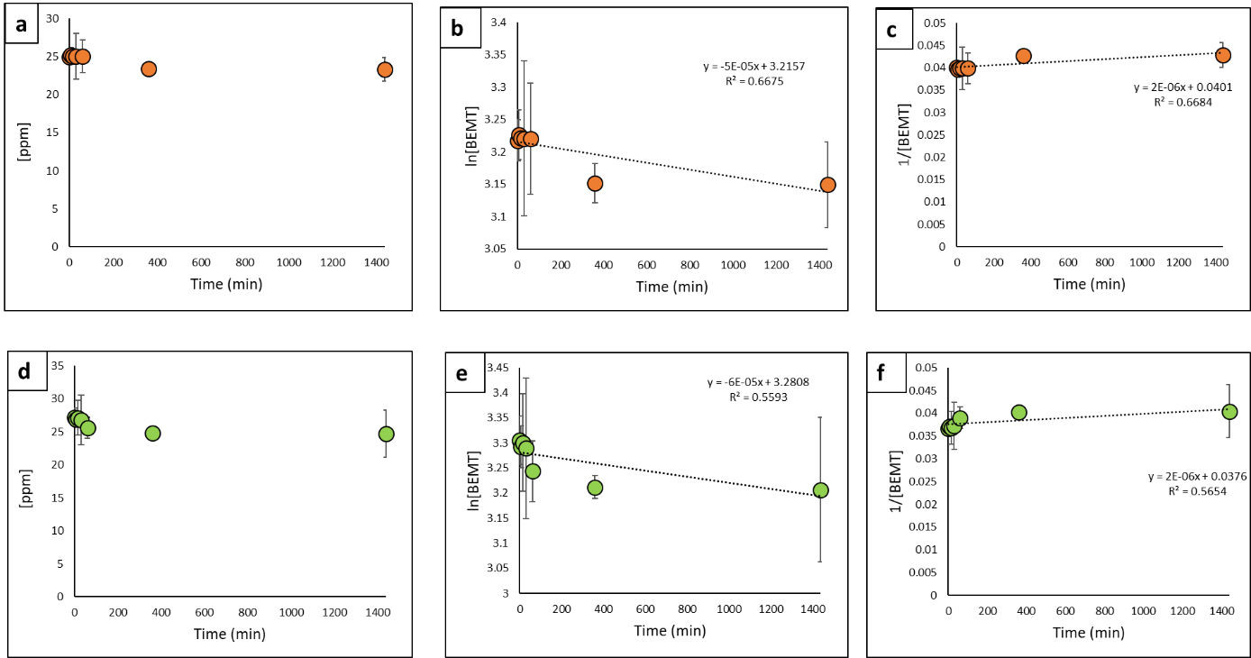
Figure S1: a) degradation of BEMT in 24h for ZnO; b) BEMT degradation by ZnO fitted with first order equation; c) data fitted with second order equation; d) degradation of BEMT in 24h for TiO₂; e) BEMT degradation by TiO₂ fitted with first order equation; f) data fitted with second order equation.
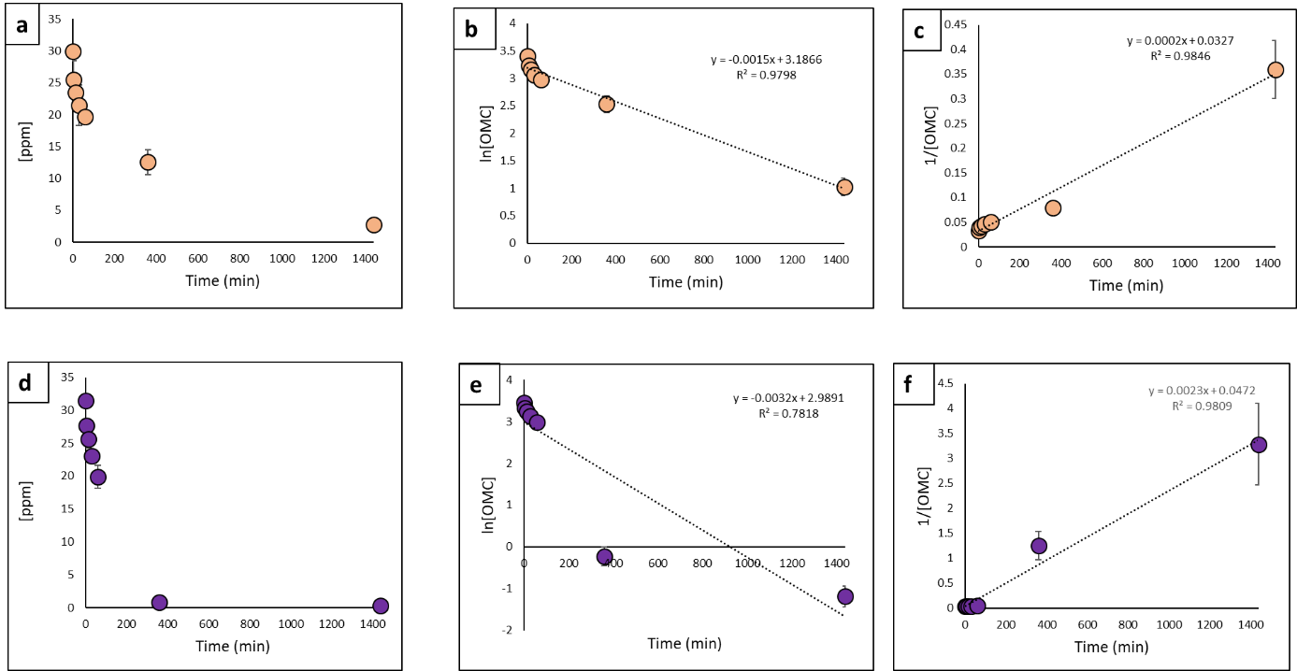
Figure S2: a) degradation of OMC in 24h for ZnO; b) OMC degradation by ZnO fitted with first order equation; c) data fitted with second order equation; d) degradation of OMC in 24h for TiO₂; e) OMC degradation by TiO₂ fitted with first order equation; f) data fitted with second order equation.
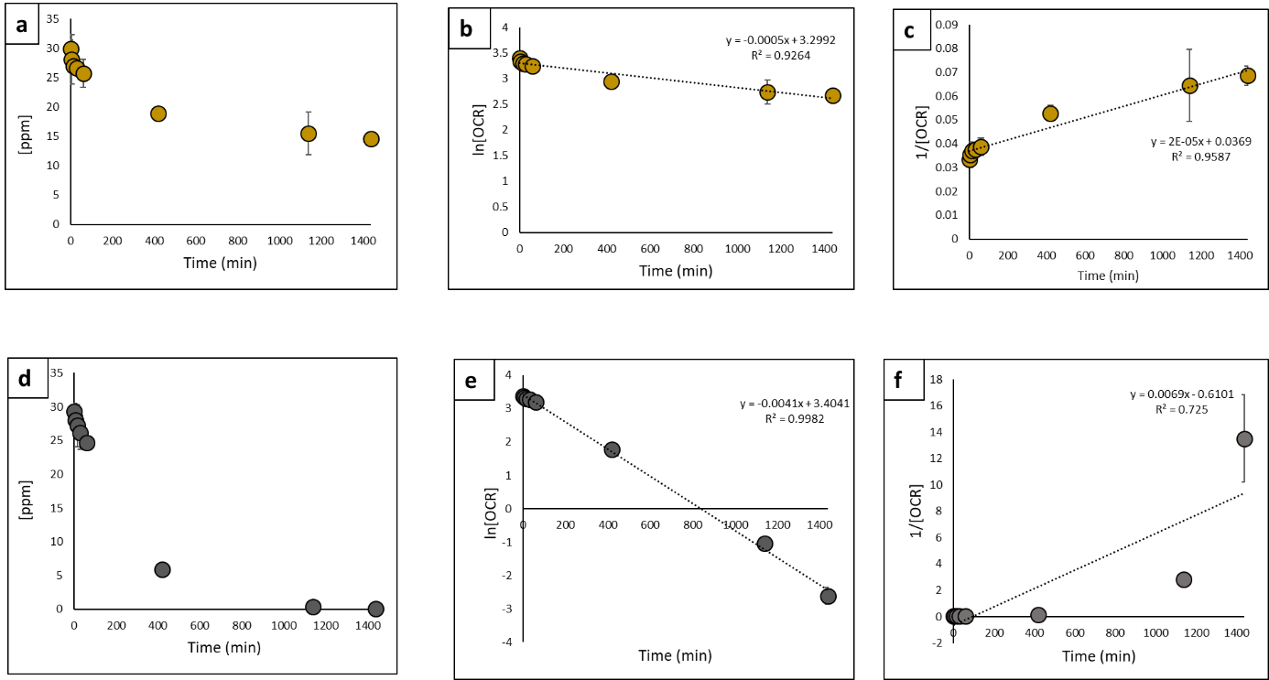
Figure S3: a) degradation of OCR in 24h for ZnO; b) OCR degradation by ZnO fitted with first order equation; c) data fitted with second order equation; d) degradation of OCR in 24h for TiO₂; e) OCR degradation by TiO₂ fitted with first order equation; f) data fitted with second order equation.
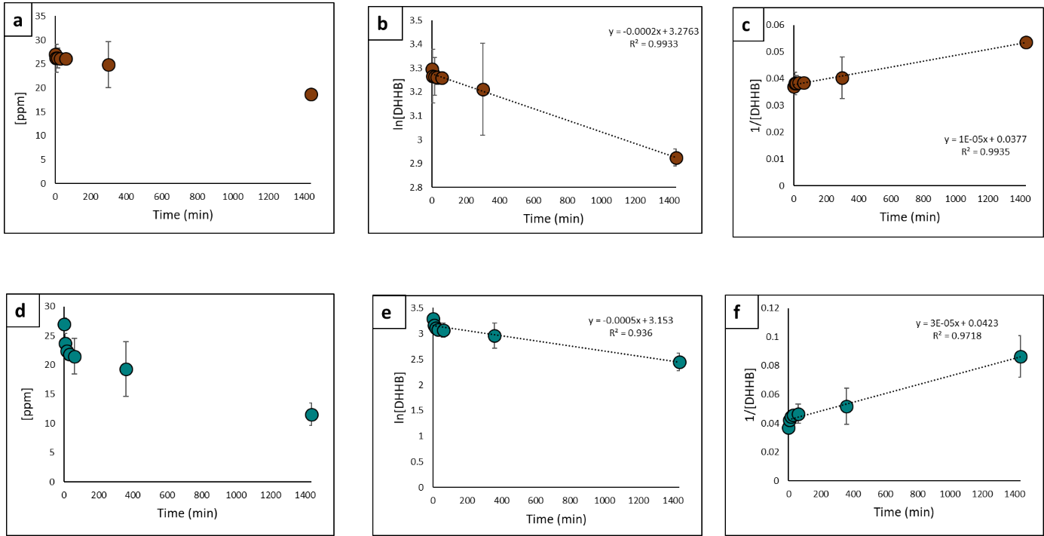
Figure S4: a) degradation of DHHB in 24h for ZnO; b) DHHB degradation by ZnO fitted with first order equation; c) data fitted with second order equation; d) degradation of DHHB in 24h for TiO₂; e) DHHB degradation by TiO₂ fitted with first order equation; f) data fitted with second order equation.

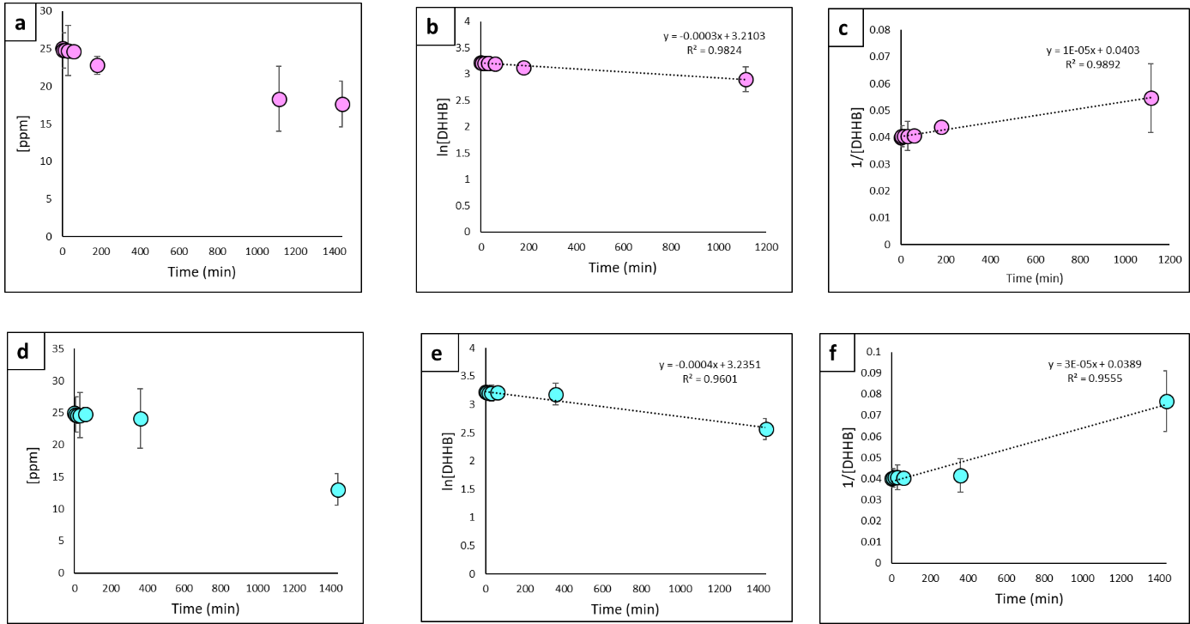
Figure S5: a) degradation of EHT in 24h for ZnO; b) EHT degradation by ZnO fitted with first order equation; c) data fitted with second order equation; d) degradation of EHT in 24h for TiO₂; e) EHT degradation by TiO₂ fitted with first order equation; f) data fitted with second order equation.

Degradation of PSA by ZnO
Degradation of PSA in 24 h |  |  | Degradation of PSA with first order equation |  |  | Degradation of PSA with second order equation
Time (min) | Conc.  [ppm] | SD | Time (min) | Conc.  ln[PBSA] | SD | Time  (min) | Conc.  1/[PBSA] | SD
0 | 91.045 | 3.043 | 0 | 4.511 | 0.03342 | 0 | 0.011 | 0.000
5 | 83.632 | 10.824 | 5 | 4.426 | 0.129 | 5 | 0.012 | 0.002
15 | 74.191 | 2.882 | 15 | 4.306 | 0.038 | 15 | 0.013 | 0.001
30 | 65.210 | 6.078 | 30 | 4.177 | 0.093 | 30 | 0.015 | 0.001
60 | 51.916 | 7.480 | 60 | 3.949 | 0.144 | 60 | 0.019 | 0.003
360 | 7.804 | 0.962 | 360 | 2.054 | 0.123 | 360 | 0.128 | 0.016
1440 | 0.140 | 0.011 | 1440 | -1.962 | 0.080 | 1440 | 7.115 | 0.575

Degradation of PSA by TiO₂
Degradation of PSA in 24 h |  |  | Degradation of PSA with first order equation |  |  | Degradation of PSA with second order equation
Time (min) | Conc.  [ppm] | SD | Time (min) | Conc.  ln[PBSA] | SD | Time  (min) | Conc.  1/[PBSA] | SD
0 | 80.8 | 3.68 | 0 | 4.39 | 0.05 | 0 | 0.01 | 0.00
5 | 75.5 | 8.85 | 5 | 4.32 | 0.12 | 5 | 0.01 | 0.00
15 | 70.1 | 8.59 | 15 | 4.25 | 0.12 | 15 | 0.01 | 0.00
30 | 64.3 | 8.77 | 30 | 4.16 | 0.14 | 30 | 0.02 | 0.00
60 | 53.8 | 3.15 | 60 | 3.98 | 0.06 | 60 | 0.02 | 0.00
360 | 0.89 | 0.16 | 360 | -0.11 | 0.17 | 360 | 1.12 | 0.19
1440 | 0.18 | 0.02 | 1440 | -1.72 | 0.13 | 1440 | 5.61 | 0.75

Degradation of BEMT by ZnO
Degradation of BEMT in 24 h |  |  | Degradation of BEMT with first order equation |  |  | Degradation of BEMT with second order equation
Time (min) | Conc.  [ppm] | SD | Time (min) | Conc.  ln[PBSA] | SD | Time  (min) | Conc.  1/[PBSA] | SD
0 | 24.97 | 0.80 | 0 | 3.22 | 0.03 | 0 | 0.040 | 0.001
5 | 25.19 | 0.96 | 5 | 3.23 | 0.04 | 5 | 0.040 | 0.002
15 | 25.05 | 0.32 | 15 | 3.22 | 0.01 | 15 | 0.040 | 0.001
30 | 25.05 | 3.00 | 30 | 3.22 | 0.12 | 30 | 0.040 | 0.005
60 | 25.05 | 2.16 | 60 | 3.22 | 0.09 | 60 | 0.040 | 0.003
360 | 23.37 | 0.71 | 360 | 3.15 | 0.03 | 360 | 0.043 | 0.001
1440 | 23.32 | 1.53 | 1440 | 3.15 | 0.07 | 1440 | 0.043 | 0.003

Degradation of BEMT by TiO₂
Degradation of BEMT in 24 h |  |  | Degradation of BEMT with first order equation |  |  | Degradation of BEMT with second order equation
Time (min) | Conc.  [ppm] | SD | Time (min) | Conc.  ln[PBSA] | SD | Time  (min) | Conc.  1/[PBSA] | SD
0 | 27.26 | 1.30 | 0 | 3.31 | 0.05 | 0 | 0.037 | 0.002
5 | 26.91 | 1.13 | 5 | 3.29 | 0.04 | 5 | 0.037 | 0.002
15 | 27.14 | 2.65 | 15 | 3.30 | 0.10 | 15 | 0.037 | 0.004
30 | 26.82 | 3.75 | 30 | 3.29 | 0.14 | 30 | 0.037 | 0.005
60 | 25.63 | 1.54 | 60 | 3.24 | 0.06 | 60 | 0.039 | 0.002
360 | 24.83 | 0.56 | 360 | 3.21 | 0.02 | 360 | 0.040 | 0.001
1440 | 24.71 | 3.56 | 1440 | 3.21 | 0.14 | 1440 | 0.040 | 0.006

Degradation of OMC by ZnO
Degradation of OMC in 24 h |  |  | Degradation of OMC with first order equation |  |  | Degradation of OMC with second order equation
Time (min) | Conc.  [ppm] | SD | Time (min) | Conc.  ln[PBSA] | SD | Time  (min) | Conc.  1/[PBSA] | SD
0 | 30.00 | 0.46 | 0 | 3.40 | 0.02 | 0 | 0.033 | 0.001
5 | 25.46 | 3.06 | 5 | 3.24 | 0.12 | 5 | 0.039 | 0.005
15 | 23.45 | 0.77 | 15 | 3.16 | 0.03 | 15 | 0.043 | 0.001
30 | 21.48 | 3.13 | 30 | 3.07 | 0.15 | 30 | 0.047 | 0.007
60 | 19.64 | 0.06 | 60 | 2.98 | 0.00 | 60 | 0.051 | 0.000
360 | 12.59 | 1.95 | 360 | 2.53 | 0.15 | 360 | 0.079 | 0.012
1440 | 2.79 | 0.46 | 1440 | 1.03 | 0.16 | 1440 | 0.359 | 0.059

Degradation of OMC by TiO₂
Degradation of OMC in 24 h |  |  | Degradation of OMC with first order equation |  |  | Degradation of OMC with second order equation
Time (min) | Conc.  [ppm] | SD | Time (min) | Conc.  ln[PBSA] | SD | Time  (min) | Conc.  1/[PBSA] | SD
0 | 31.45 | 0.95 | 0 | 3.45 | 0.03 | 0 | 0.03 | 0.00
5 | 27.72 | 0.34 | 5 | 3.32 | 0.01 | 5 | 0.04 | 0.00
15 | 25.61 | 1.28 | 15 | 3.24 | 0.05 | 15 | 0.04 | 0.00
30 | 23.07 | 0.31 | 30 | 3.14 | 0.01 | 30 | 0.04 | 0.00
60 | 19.88 | 1.78 | 60 | 2.99 | 0.09 | 60 | 0.05 | 0.00
360 | 0.80 | 0.18 | 360 | -0.23 | 0.23 | 360 | 1.25 | 0.28
1440 | 0.30 | 0.08 | 1440 | -1.19 | 0.25 | 1440 | 3.29 | 0.81

Degradation of OCR by ZnO
Degradation of OCR in 24 h |  |  | Degradation of OCR with first order equation |  |  | Degradation of OCR with second order equation
Time (min) | Conc.  [ppm] | SD | Time (min) | Conc.  ln[PBSA] | SD | Time  (min) | Conc.  1/[PBSA] | SD
0 | 29.91 | 1.44 | 0 | 3.40 | 0.05 | 0 | 0.033 | 0.002
5 | 28.14 | 4.20 | 5 | 3.34 | 0.15 | 5 | 0.036 | 0.005
15 | 27.01 | 0.71 | 15 | 3.30 | 0.03 | 15 | 0.037 | 0.001
30 | 26.60 | 1.03 | 30 | 3.28 | 0.04 | 30 | 0.038 | 0.001
60 | 25.74 | 2.40 | 60 | 3.25 | 0.09 | 60 | 0.039 | 0.004
360 | 18.92 | 1.15 | 360 | 2.94 | 0.06 | 360 | 0.053 | 0.003
1440 | 14.57 | 0.87 | 1440 | 2.68 | 0.06 | 1440 | 0.069 | 0.004

Degradation of OCR by TiO₂
Degradation of OCR in 24 h |  |  | Degradation of OCR with first order equation |  |  | Degradation of OCR with second order equation
Time (min) | Conc.  [ppm] | SD | Time (min) | Conc.  ln[PBSA] | SD | Time  (min) | Conc.  1/[PBSA] | SD
0 | 29.4 | 1.17 | 0 | 3.38 | 0.04 | 0 | 0.03 | 0.00
5 | 28.1 | 0.03 | 5 | 3.33 | 0.00 | 5 | 0.04 | 0.00
15 | 27.2 | 3.11 | 15 | 3.30 | 0.11 | 15 | 0.04 | 0.00
30 | 26.2 | 2.54 | 30 | 3.27 | 0.10 | 30 | 0.04 | 0.00
60 | 24.6 | 0.48 | 60 | 3.20 | 0.02 | 60 | 0.04 | 0.00
360 | 5.87 | 0.30 | 360 | 1.77 | 0.05 | 360 | 0.17 | 0.01
1440 | 0.07 | 0.02 | 1440 | -2.60 | 0.25 | 1440 | 13.5 | 3.32

Degradation of DHHB by ZnO
Degradation of OCR in 24 h |  |  | Degradation of OCR with first order equation |  |  | Degradation of OCR with second order equation
Time (min) | Conc.  [ppm] | SD | Time (min) | Conc.  ln[PBSA] | SD | Time  (min) | Conc.  1/[PBSA] | SD
0 | 27.0 | 0.28 | 0 | 3.30 | 0.01 | 0 | 0.037 | 0.000
5 | 26.2 | 2.93 | 5 | 3.27 | 0.11 | 5 | 0.038 | 0.004
15 | 26.é | 2.06 | 15 | 3.26 | 0.08 | 15 | 0.038 | 0.003
30 | 26.& | 0.74 | 30 | 3.26 | 0.03 | 30 | 0.038 | 0.001
60 | 26.1 | 0.29 | 60 | 3.26 | 0.01 | 60 | 0.038 | 0.000
360 | 24.8 | 4.78 | 360 | 3.21 | 0.19 | 360 | 0.040 | 0.008
1440 | 18.6 | 0.65 | 1440 | 2.93 | 0.04 | 1440 | 0.054 | 0.002

Degradation of DHHB by TiO₂
Degradation of OCR in 24 h |  |  | Degradation of OCR with first order equation |  |  | Degradation of OCR with second order equation
Time (min) | Conc.  [ppm] | SD | Time (min) | Conc.  ln[PBSA] | SD | Time  (min) | Conc.  1/[PBSA] | SD
0 | 27.00 | 0.99 | 0 | 3.30 | 0.04 | 0 | 0.04 | 0.00
5 | 23.65 | 1.72 | 5 | 3.16 | 0.07 | 5 | 0.04 | 0.00
15 | 22.43 | 1.53 | 15 | 3.11 | 0.07 | 15 | 0.04 | 0.00
30 | 21.80 | 0.85 | 30 | 3.08 | 0.04 | 30 | 0.05 | 0.00
60 | 21.49 | 3.04 | 60 | 3.07 | 0.14 | 60 | 0.05 | 0.01
360 | 19.26 | 4.67 | 360 | 2.96 | 0.24 | 360 | 0.05 | 0.01
1440 | 11.55 | 1.93 | 1440 | 2.45 | 0.17 | 1440 | 0.09 | 0.01

Physico-chemical properties of organic filters.

Trade Name | INCI name | Acronym | MW | log P | ε filters | Peak (nm)
Tinosorb® S | Bis-Ethylhexyloxyphenol Methoxyphenyl Triazine⁷ | BEMT | 627.8 | 10.4 | 405302 | 310
Uvinul® A plus Grasnular | Diethylamino Hydroxybenzoyl Hexyl Benzoate⁸ | DHHB | 397.51 | 6.5 | 39000 | 354
Uvin® T 150 | Ethylhexyl Triazone⁹ | EHT | 823.1 | 14.5 | 131497 | 314
Parsol® HS | Phenylbenzimidazole Sulfonic Acid¹⁰ | PSA | 274.3 | 2 | 24100 | 302
Uvin® MC 80 | Ethylhexyl Methoxycinnamate¹¹ | OMC | 290.4 | 5.3 | 26250 | 310
Parsol® 340 | Octocrylene¹² | OCR | 361.48 | 7.1 | 12308 | 307
Table S1: chemical-physical characteristic for analyzed organic filters.

