1 1.1 Study design

2 Participants were recruited through online and printed advertisements. The in-person

3 follow up period was approximately one year.

4 1.2 Decision tree

5 The decision tree is built using the rpart function in the “rpart” R package.

6 This study is intended to employ the decision tree learning algorithm, particularly the

7 classification and regression tree (CART), for the diagnosis of MASLD. Pruning of

8 the decision tree was performed with optimal complexity parameter (cp value) to

9 avoid overfitting. The tree was pruned with the cp function of the smallest tree within

10 one standard error of the best functioning tree—that is, the tree with the smallest

11 xerror, which was confirmed graphically (supplementary figure 1). Feature

12 importance for the decision tree was analysed using the Gini importance metric. In

13 this study, the trial-and-error procedure is employed to find the optimum maximum

14 depth of the tree. Internal validation of the decision tree was performed with the

15 whole data. Sensitivity, specificity, positive predictive value, negative predictive

16 value, positive likelihood ratio, negative likelihood ratio, and accuracy were

17 calculated.

18 1.3 linear mixed effect model

19 R package nlme was used to implement linear mixed effect model. Subject effect was

20 included in the mixed model as a random effect, and time (baseline or 1 year) was

21 reffered as fixed effect. LFC difference between baseline and 1 year was examined.

22 We further conducted a series of subgroup analyses according to the mixed-effects

1 model. We reported the estimated marginal means and standard error of the model in

2 the different subgroups.

3 1.4 Multivariable linear regression model

4 The ananlysis was conducted by the radiant.model package. Plot was generated using

5 the R package ggplot2. Linear regression intend s to predict a LFC using multiple

6 predictors. We used multiple linear regression to adjust for potential confounders (age,

7 sex, baseline weight, BMI and presence of Mets). Significant outliers were removed

8 from the analysis.

9 Supplementary Figure Legends
10 Supplementary Figure 1: visual representation between complexity parameter and the
11 mean error.
12 Supplementary Figure 2: The differences of histopathology results between Mets and no-
13 Mets.
14 Caption: Bar plot displayed the score of steatosis, inflammation, balloon, fibrosis and NAS
15 between Mets and no-Mets, * indicates P<0.05 between two comparisons.
16 Supplementary Figure 3 abc: The differences of MRI-PDFF results between Mets and
17 no-Mets.
18 Caption: Box plot displayed the liver fat content between Mets and no-Mets, * indicates
19 P<0.05 between two comparisons.
20 Supplementary Figure 4: Correlation matrix between the change of continuous variables.
21 Caption: The numbers above represent correlation coefficients, the diagonal displays a
22 histogram of frequency distributions, and below is a scatterplot (green highlighted the
23 significant correlations).
24 Supplementary Figure 5: The importance of Variables in the Decision tree 25
26
27
28
29

30

size of tree
Supplementary Figure 1
1 2 3 4 7 9 11 14 18 21 24
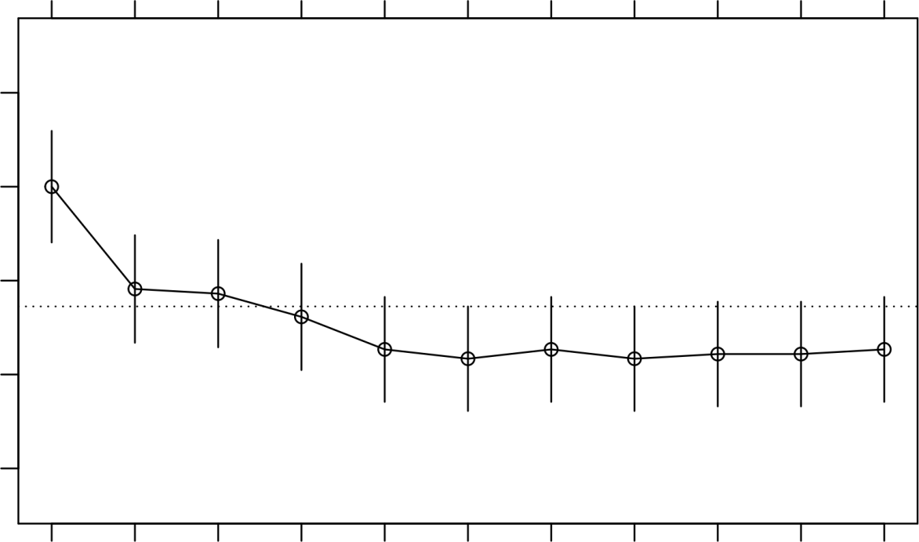
X−val Re lative Error
0 7 0 8 0 9 1 0 1.1
Inf 0.12 0.025 0.017 0.009 0.0029 0

cp

Supplementary Figure 2
Histopathology Differences between Mets and no-Mets

5
4
3
Score
2
1
0
Steatosis

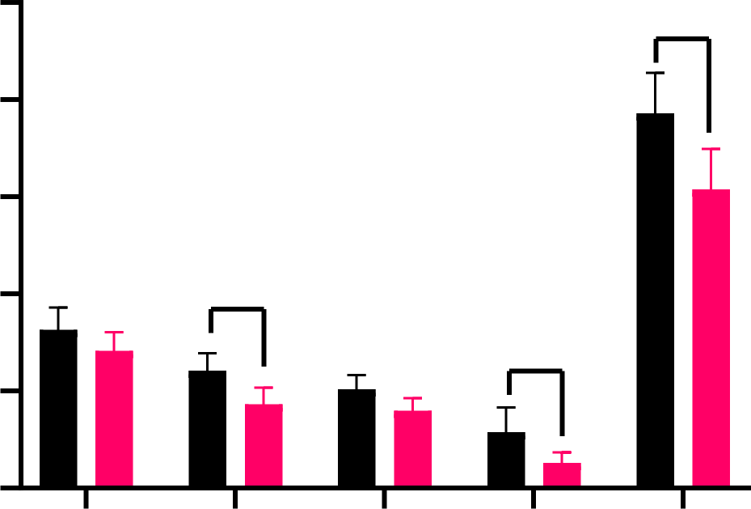
*

*
*
Inflammation
Balloon
Fibrosis

NAS

Mets
no-Mets

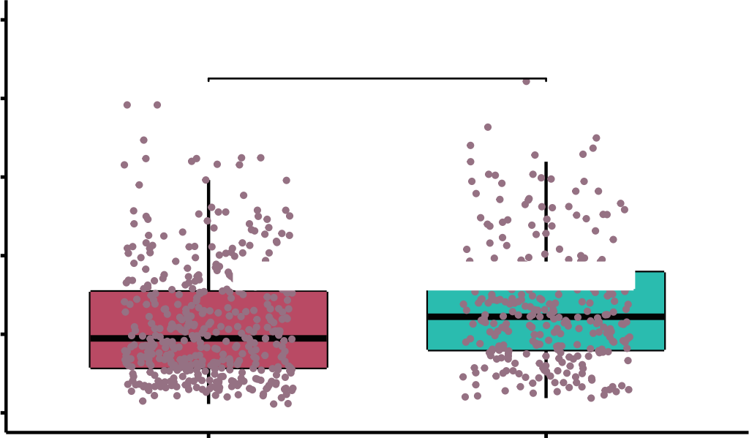
Supplementary Figure 3
Liver Fat Content

a | LFC in MASLD
a | 50  40  30  20  10  0 | *
a | 50  40  30  20  10  0 | no Mets Mets
a | Mets

b  Liver Fat Content | 50  40  30  20  10  0 | LFC in overweight MASLD  * |  | c  Liver Fat Content | LFC in obese MASLD
 |  |  |  |  | 50  40  30  20  10  0 |   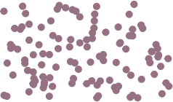    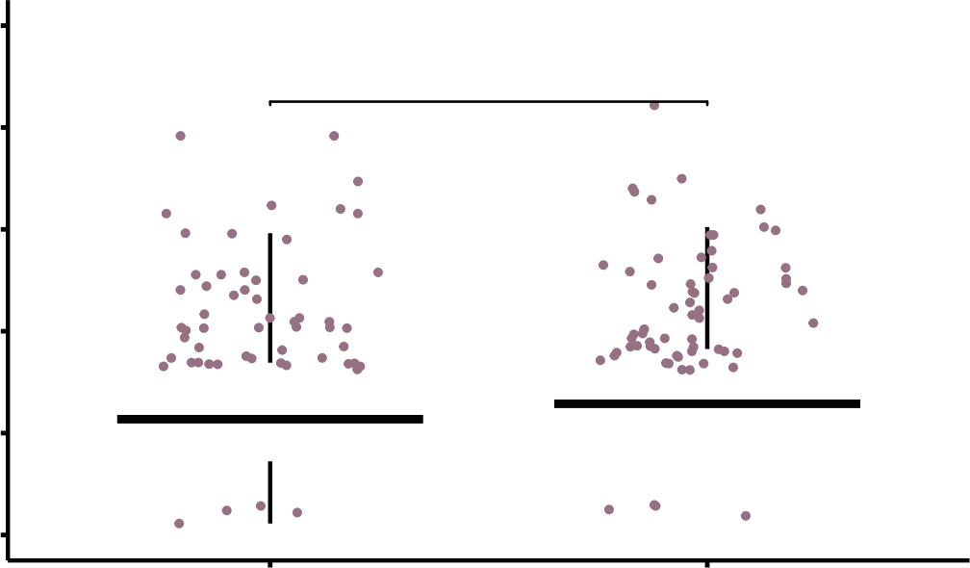  no Mets Mets  *
b  Liver Fat Content | 50  40  30  20  10  0 | 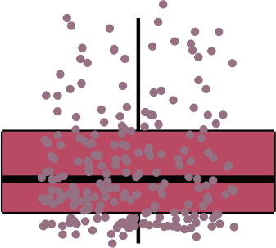 | 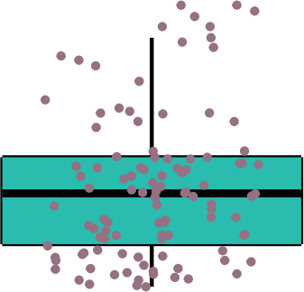 | c  Liver Fat Content | 50  40  30  20  10  0
no Mets Mets  Mets |  |  |  |  | 50  40  30  20  10  0
 |  |  |  |  | Mets

Supplementary Figure 4

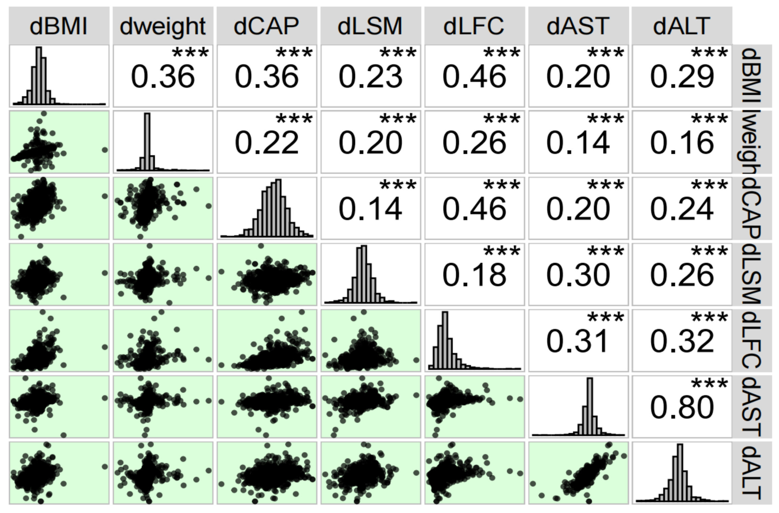

Importance of Variables in Decision Tree

Supplementary Figure 5

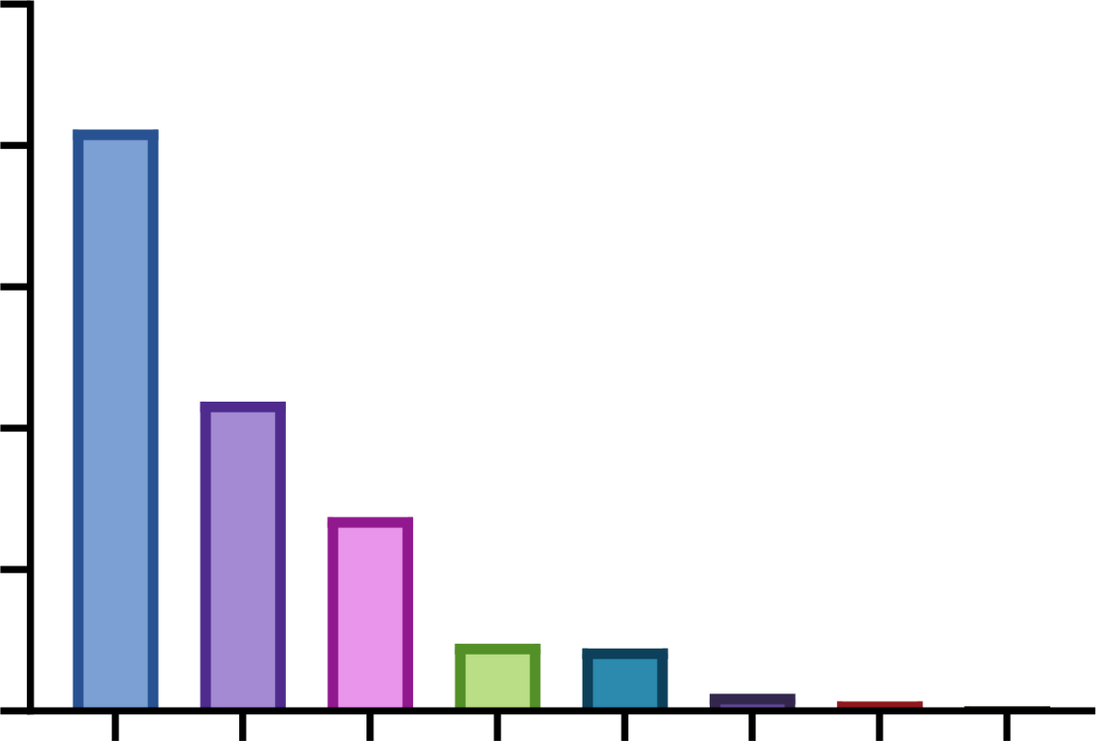
50

40
Importance
30

20

10

0
BMI
CAP
Weight
AST
ALT
LSM
LDL
GGT

Relative change from baseline

1 supplementary tables
Supplementary Table1 Baseline Characteristics by Histopathology Results

Variables | no-NASH (n = 65) NASH (n = 81) | P
Age,year | 46 (18) 39 (16) | 0.073
Male, N(%) | 31 (48%) 50 (62%) | 0.1264
Weight, kg | 80 (16.7) 81.4 (17.8) | 0.8873
BMI, kg/m2 | 29.4 (3.7) 29.5 (5.5) | 0.5184
Obesity, N(%) | 61 (94%) 74 (91%) | 0.8021
Diabetes, N(%) | 12 (18%) 27 (33%) | 0.0672
Mets, N(%)* | 19 (29%) 38 (47%) | 0.0449
AC,cm | 97.3 (11.3) 97.3 (10.6) | 0.967
WC,cm | 100.3 (9.5) 98.2 (8) | 0.1246
HC,cm | 103.5 (9.3) 101.7 (9.4) | 0.1295
SBP,mmHg | 130 (20) 129 (19) | 0.7571
DBP,mmHg | 81 (16) 83 (13) Hematology Test Results | 0.1406
AST, U/L* | 24.2 (12.5) 34.3 (24.9) | < 0.0001
ALT, U/L* | 25.6 (21) 53 (43.4) | < 0.0001
GGT, U/L* | 27.3 (31.5) 51.2 (52.9) | < 0.0001
TB, umol/L* | 13 (7.5) 14.5 (7.2) | 0.0169
TBA, umol/L | 2.6 (3.3) 2.8 (2.3) | 0.8316
UA,umol/L* | 377 (136) 428 (169) | 0.0048
TC, mmol/L | 5.16 (1.43) 5.3 (1.36) | 0.9247
TG, mmol/L* | 1.5 (0.87) 2.07 (2.11) | 0.0005
HDL, mmol/L* | 1.18 (0.32) 1.1 (0.2) | 0.004
LDL, mmol/L | 3.23 (1.44) 3.28 (1.08) | 0.4555
Glucose,mmol/L* | 5.26 (0.93) 5.8 (1.15) | 0.0002
Ferritin,ug/L* | 124.5 (176.9) 242 (203) | < 0.0001
Insulin,pmol/L* | 105.6 (110.83) 132.8 (96.8) | 0.0128
HOMA-IR* | 3.87 (3.88) 4.99 (4.48) Imaging Results | 0.0014
CAP, db/m* | 285 (50) 327 (49) | < 0.0001
LSM, kpa* | 5.6 (1.6) 6.7 (3.2) | 0.0007
LFC, %* | 5.85 (4.3) 15.72 (10.65) Biopsy Results | < 0.0001
steatosis* | 1 (0) 2 (2) | < 0.0001
inflammation* | 0 (1) 2 (1) | < 0.0001
balloon* | 0 (1) 1 (0) | < 0.0001
NAS* | 2 (2) 5 (1) | < 0.0001
fibrosis* | 0 (0) 1 (1) | < 0.0001
Note: continuous data were described as median(IQR) and compared using Wilcox method, categorical variables were presented as proportions and compared using χ2 analysis.

1 Supplementary table 2 Baseline Characteristics by Metabolic Syndrome Status

Variables | Non-Mets(n = 433) | Mets(n = 291) | p.value
Age, year* | 39 (14) | 42 (20) | 0.0019
Male, N(%) | 298 (69%) | 197 (68%) | 0.8122
BMI, kg/m2* | 27.4 (4.5) | 29 (4.35) | < 0.0001
Weight, kg* | 76.4 (15.9) | 81.4 (16.1) | < 0.0001
BMI categories - Lean*, N(%) | 45 (10%) | 2 (1%) | < 0.0001
- Overweight, N(%) | 218 (50%) | 110 (38%)
- Obese, N(%) | 170 (39%) | 179 (62%)
Diabetes, N(%)* | 43 (10%) | 123 (42%) | < 0.0001
AC,cm* | 94.8 (11.4) | 97.2 (10.8) | < 0.0001
WC,cm* | 97.2 (11) | 98.9 (11) | < 0.0001
HC,cm* | 101.3 (8.8) | 103.6 (9.7) | < 0.0001
SBP,mmHg* | 125 (14) | 140 (19.5) | < 0.0001
DBP,mmHg* | 80 (11)  Hematology Test Results | 91 (13.5) | < 0.0001
ALT, U/L* | 29.2 (16.3) | 34 (18.3) | 0.0003
AST, U/L* | 41.4 (37.5) | 49.3 (42.7) | 0.0118
GGT, U/L* | 42.5 (34) | 51 (45.7) | < 0.0001
TB, umol/L* | 14.1 (6.3) | 15 (6.4) | 0.0268
TBA, umol/L* | 2.6 (2.3) | 2.7 (2.6) | 0.0227
UA,umol/L* | 410 (138) | 428 (133) | 0.003
TG, mmol/L* | 5.1 (1.31) | 5.33 (1.34) | 0.0008
TC, mmol/L* | 1.69 (1.32) | 2.67 (1.83) | < 0.0001
HDL, mmol/L | 1.12 (0.26) | 1.09 (0.36) | 0.1091
LDL, mmol/L | 3.26 (1.19) | 3.26 (1.17) | 0.6309
Glucose,mmol/L* | 5.4 (0.72) | 6.2 (1.82) | < 0.0001
Ferritin,ug/L* | 201 (205.9) | 250.9 (249.95) | 0.002
Insulin,pmol/L* | 111.2 (72.11) | 136.1 (109.11) | < 0.0001
HOMA-IR* | 3.87 (2.81) Imaging Results | 5.46 (4.43) | < 0.0001
CAP, db/m* | 292 (64) | 314 (70.5) | < 0.0001
LSM, kpa* | 5.4 (2.2) | 6.4 (2.65) | < 0.0001
LFC, %* | 9.47 (9.65) | 12.22 (9.85) | < 0.0001
Steatotic degree -Health*, N(%) | 88 (20%) | 34 (12%) | 0.0021
- Mild steatosis, N(%) | 218 (50%) | 141 (48%)
'- Moderate steatosis, N(%) | 113 (26%) | 98 (34%)
- Severe steatosis, N(%) | 14 (3%) | 18 (6%)
2 Note: continuous data were described as median(IQR) and compared using Wilcox method, categorical

3 variables were presented as proportions and compared using χ2 analysis.

1

2 Supplementary table 3 Multivariate Linear Regression Analysis of Metabolic

3 Syndrome's Impact on Liver Fat in Different BMI Groups.

All participents(N=724) | coefficient | std.error | t.value | p.value
(Intercept) | 9.414 | 2.855 | 3.297 | 0.001
Mets* | 2.147 | 0.566 | 3.791 | <0.001
sex* | -3.189 | 0.769 | -4.146 | <0.001
age* | -0.162 | 0.028 | -5.756 | <0.001
weight | 0.05 | 0.041 | 1.214 | 0.225
BMI | 0.244 | 0.146 | 1.664 | 0.097
Obese(N=349) | coefficient | std.error | t.value | p.value
(Intercept) | 13.375 | 5.467 | 2.447 | 0.015
Mets* | 1.932 | 0.803 | 2.407 | 0.017
sex | -2.239 | 1.156 | -1.937 | 0.054
age* | -0.18 | 0.04 | -4.521 | <0.001
weight | 0.022 | 0.06 | 0.376 | 0.707
BMI | 0.206 | 0.259 | 0.794 | 0.428
Overweight(N=328) | coefficient | std.error | t.value | p.value
(Intercept) | 11.64 | 9.65 | 1.206 | 0.229
Mets* | 2.474 | 0.855 | 2.895 | 0.004
sex* | -3.979 | 1.17 | -3.402 | <0.001
age* | -0.16 | 0.043 | -3.696 | <0.001
weight | 0.108 | 0.067 | 1.619 | 0.106
BMI | 0.001 | 0.386 | 0.003 | 0.998
4

5 Supplementary Table 4 Weight Change Groups : Baseline Values and Changes in

6 Indicators

Variables | weight reduced >5% (n =  100) | weight witout great change (n  = 542) | weight increased >5% (n  = 82) | p.value

 |  | Baseline Characterics
Age,year | 39.5 (19.25) | 41 (15) | 37.5 (14.75) | 0.0911
Male, N(%) | 73 (73%) | 372 (69%) | 50 (61%) | 0.2142
Weight, kg | 85.2 (16.9) | 78.05 (15.9) | 73.9 (10.83) | <  0.0001
BMI, kg/m2 | 28.9 (4.15) | 27.8 (4.2) | 27.95 (4.32) | 0.0009
BMI categories - Lean,  N(%) | 3 (3%) | 38 (7%) | 6 (7%) | 0.1111
- Overweight, N(%) 37 (37%) 251 (46%) 40 (49%)

- Obese, N(%) | 60 (60%) | 253 (47%) | 36 (44%)
Mets, N(%)* | 42 (42%) | 220 (41%) | 29 (35%) | 0.6168
Diabetes, N(%)* | 30 (30%) | 122 (23%) | 14 (17%) | 0.1067
Steatotic degree -Health,  N(%)* | 13 (13%) | 89 (16%) | 20 (24%) | 0.2166
- Mild steatosis, N(%) | 46 (46%) | 279 (51%) | 34 (41%)
'- Moderate steatosis,  N(%) | 34 (34%) | 152 (28%) | 25 (30%)
- Severe steatosis, N(%) | 7 (7%) | 22 (4%) Changes From Baseline | 3 (4%)
dWeight, kg* | -8.03 (6.29) | 0.43 (3.48) | 9.16 (11.38) | <  0.0001
dBMI,kg/m2* | -1.7 (2.22) | 0 (1.07) | 1.2 (1.75) | <  0.0001
dAC,cm* | -5.4 (7.32) | -1.75 (6.4) | 0.7 (8.55) | <  0.0001
dWC,cm* | -1.6 (9.65) | -0.6 (7.12) | 2.75 (10.38) | <  0.0001
dHC,cm* | -4.3 (9.18) | -0.55 (6.3) | 1 (6.15) | <  0.0001
dSBP,mmHg* | -6.5 (20) | 0 (16) | 2 (19.75) | <  0.0001
dDBP,mmHg* | -3 (13) | -2 (13) | 1.5 (12.75) | 0.0006
dAST, U/L* | -7.8 (17.5) | -0.95 (12.77) | 0.9 (12) | <  0.0001
dALT, U/L* | -17.7 (34.7) | -2.75 (25.7) | 4.45 (33.33) | <  0.0001
dGGT, U/L* | -9.35 (19.27) | -1 (16.77) | 4.05 (16.58) | <  0.0001
dTBA, umol/L* | 0.1 (2.34) | 0.15 (2.3) | 0.75 (2.78) | 0.0029
dUA,umol/L* | -13 (89.5) | -4 (96.75) | 21 (85.5) | 0.0223
dTC, mmol/L* | -0.16 (1.08) | 0.06 (0.96) | 0.22 (1.14) | 0.0035
dTG, mmol/L* | -0.34 (1.09) | -0.12 (1.26) | 0.15 (1.14) | 0.0024
dHDL, mmol/L | 0.01 (0.26) | 0.02 (0.24) | 0.02 (0.32) | 0.5215
dLDL, mmol/L | -0.07 (0.86) | 0.06 (0.84) | 0.11 (0.84) | 0.1591
dGlucose,mmol/L* | -0.32 (0.73) | -0.04 (0.9) | -0.1 (0.92) | 0.0047
dFerritin,ug/L | -2.05 (99.77) | 2.1 (74.8) | 3.3 (86.57) | 0.5759
dInsulin,pmol/L* | -11.04 (75.45) | 5.3 (67.64) | 23.02 (74.72) | 0.0003
dHOMA-IR* | -0.67 (3.64) | 0.27 (2.79) | 0.9 (3.3) | 0.0003
dCAP, db/m* | -20 (62.25) | -1 (50) | 24 (50) | <  0.0001
dLSM, kpa* | -0.7 (2) | -0.1 (2) | 0.4 (1.9) | <  0.0001

1 Note: continuous data were described as median(IQR) and compared using Wilcox method, categorical

2 variables were presented as proportions and compared using χ2 analysis.
3 References 4
5 1 Wong VW, Adams LA, de Ledinghen V, et al. Noninvasive biomarkers in NAFLD and NASH -
6 current progress and future promise. Nat Rev Gastroenterol Hepatol 2018;15:461–78.
7 2 Kang GH, Cruite I, Shiehmorteza M, et al. Reproducibility of MRI-determined proton density fat
8 fraction across two different MR scanner platforms. J Magn Reson Imaging 2011;34:928–34.
9 3 Kuhn JP, Meffert P, Heske C, et al. Prevalence of fatty liver disease and hepatic iron overload in
10 a northeastern German population by using quantitative MR imaging. Radiology
11 2017;284:706–16.
12 4 Pavlou M, Ambler G, Seaman SR, et al. How to develop a more accurate risk prediction model
13 when there are few events. BMJ 2015;351:h3868.
14 5 Garcia-Carretero R, Vigil-Medina L, Barquero-Perez O, et al. Logistic LASSO and elastic net to
15 characterize vitamin D deficiency in a hypertensive obese population. Metab Syndr Relat Disord
16 2020;18:79-85.
17 6 McEligot AJ, Poynor V, Sharma R, et al. Logistic LASSO regression for dietary intakes and breast
18 cancer. Nutrients 2020;12:2652.
19

STROBE Statement—Checklist of items that should be included in reports of cohort studies
Item
Page

No Recommendation

Title and abstract | 1 | (a) Indicate the study’s design with a commonly used term in the title or the abstract | 1,3
Title and abstract | 1 | (b) Provide in the abstract an informative and balanced summary of what was 1 done and what was found
Introduction
Background/rationale | 2 | Explain the scientific background and rationale for the investigation being 4 reported
Objectives | 3 | State specific objectives, including any prespecified hypotheses 5
Methods
Study design | 4 | Present key elements of study design early in the paper 5
Setting | 5 | Describe the setting, locations, and relevant dates, including periods of 5  recruitment, exposure, follow-up, and data collection
Participants | 6 | (a) Give the eligibility criteria, and the sources and methods of selection of 6 participants. Describe methods of follow-up
Participants | 6 | (b) For matched studies, give matching criteria and number of exposed and 6 unexposed
Variables | 7 | Clearly define all outcomes, exposures, predictors, potential confounders, 6  and effect modifiers. Give diagnostic criteria, if applicable
Data sources/ | 8* | For each variable of interest, give sources of data and details of methods of 6
measurement |  | assessment (measurement). Describe comparability of assessment methods if there is more than one group
Bias | 9 | Describe any efforts to address potential sources of bias 6
Study size | 10 | Explain how the study size was arrived at 5
Quantitative variables | 11 | Explain how quantitative variables were handled in the analyses. If 6  applicable, describe which groupings were chosen and why
Statistical methods | 12 | (a) Describe all statistical methods, including those used to control for 6 confounding
Statistical methods | 12 | (b) Describe any methods used to examine subgroups and interactions 6
Statistical methods | 12 | (c) Explain how missing data were addressed 6
Statistical methods | 12 | (d) If applicable, explain how loss to follow-up was addressed 6
Statistical methods | 12 | (e) Describe any sensitivity analyses 6
Results
Participants | 13* | (a) Report numbers of individuals at each stage of study—eg numbers  potentially eligible, examined for eligibility, confirmed eligible, included in the study, completing follow-up, and analysed | 7
Participants | 13* | (b) Give reasons for non-participation at each stage 7
Participants | 13* | (c) Consider use of a flow diagram 7
Descriptive data | 14* | (a) Give characteristics of study participants (eg demographic, clinical, 7  social) and information on exposures and potential confounders
Descriptive data | 14* | (b) Indicate number of participants with missing data for each variable of 7 interest
Descriptive data | 14* | (c) Summarise follow-up time (eg, average and total amount) 7
Outcome data | 15* | Report numbers of outcome events or summary measures over time 9
Main results | 16 | (a) Give unadjusted estimates and, if applicable, confounder-adjusted 9  estimates and their precision (eg, 95% confidence interval). Make clear

 |  | which confounders were adjusted for and why they were included
 |  | (b) Report category boundaries when continuous variables were categorized | 9
 |  | (c) If relevant, consider translating estimates of relative risk into absolute risk for a meaningful time period | 9
Other analyses | 17 | Report other analyses done—eg analyses of subgroups and interactions, and sensitivity analyses | 9
Discussion
Key results | 18 | Summarise key results with reference to study objectives | 12
Limitations | 19 | Discuss limitations of the study, taking into account sources of potential bias or imprecision. Discuss both direction and magnitude of any potential bias | 14
Interpretation | 20 | Give a cautious overall interpretation of results considering objectives,  limitations, multiplicity of analyses, results from similar studies, and other relevant evidence | 13
Generalisability | 21 | Discuss the generalisability (external validity) of the study results | 13
Other information
Funding | 22 | Give the source of funding and the role of the funders for the present study and, if applicable, for the original study on which the present article is based | 2

*Give information separately for exposed and unexposed groups.

Note: An Explanation and Elaboration article discusses each checklist item and gives methodological background and published examples of transparent reporting. The STROBE checklist is best used in conjunction with this article (freely available on the Web sites of PLoS Medicine at http://www.plosmedicine.org/, Annals of Internal Medicine at
http://www.annals.org/, and Epidemiology at http://www.epidem.com/). Information on the STROBE Initiative is available at http://www.strobe-statement.org.

