Appendix
Figure 1A to E. Graphical representations of Y, Export G&S, Export High-Tech and FDI( Globalization factors)
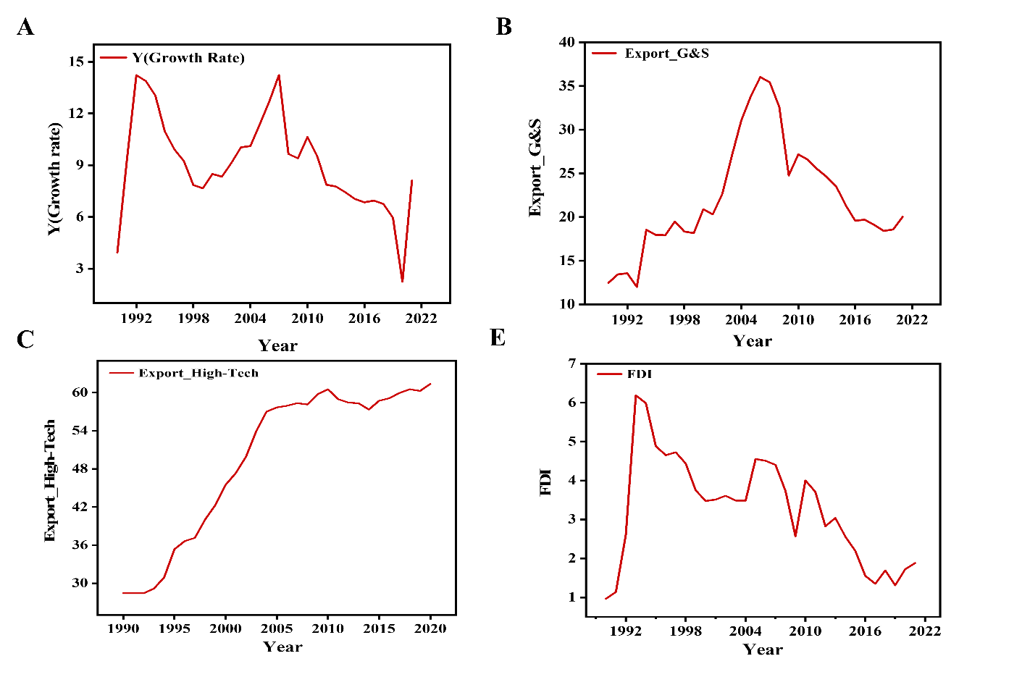
Source: Author’s Computation
Figure 2 A to F. Graphical representations of Governance, Rule of Law, and Corruption, HDI, R&D and Urban, ( Socio-Political)
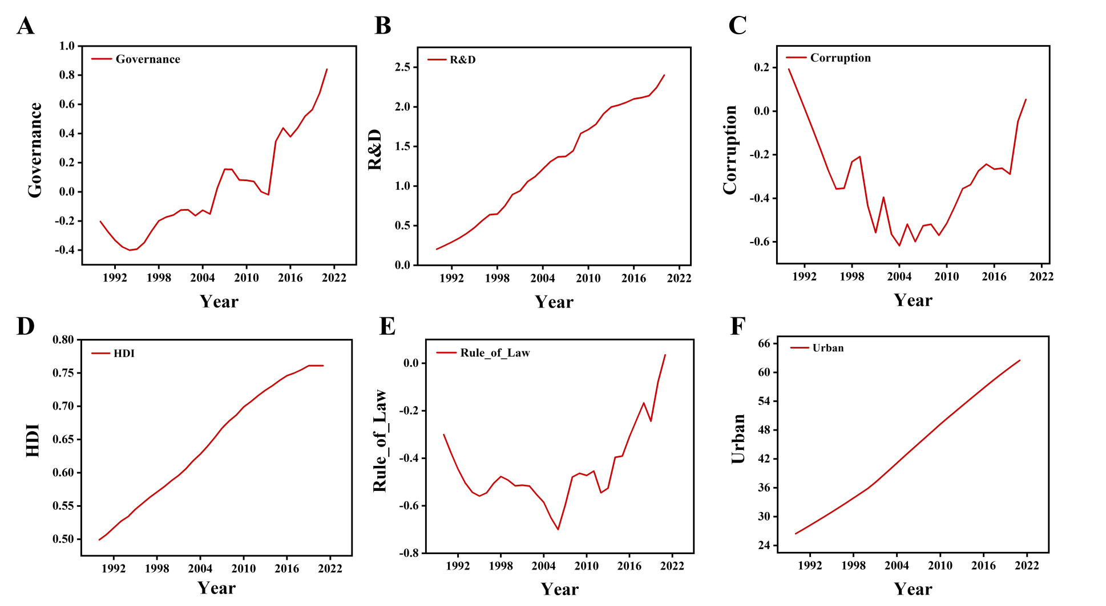
Source: Author’s Computation

Table A1: Augmented Dickey-Fuller (ADF) Unit Root Test
At Level
 |  | Y | EXPORT  G_S | EXPORT  HIGH_TECH |  | FDI | HDI
With Constant | t-Statistic | 1.0294 | -1.7285 | -2.0810 |  | -2.1430 | -2.0370
With Constant & Trend | t-Statistic | -0.2609  1.0884 | -1.1475  0.0667 | -1.0947  1.3462 |  | -3.5463***  -0.6057 | 0.9288  -2.2497**
Without Constant & Trend | t-Statistic
 |  | R_D | URBAN |  | GOVERNANCE | RULE OF  LAW | CORRUPTION
With Constant | t-Statistic | 0.2039 | -0.8636 |  | 1.2221 | 0.7218 | -1.9354
With Constant & Trend | t-Statistic | -2.4533 | -3.4318* |  | -1.9327 | -0.8069 | -1.0807
Without Constant & Trend | t-Statistic | 6.1903 | -0.6934 |  | 1.1809 | -0.6374 | -0.7962
At First Difference
 |  | ∆Y | ∆EXPORT  G_S | ∆EXPORT  HIGH_TECH | ∆FDI | ∆HDI
With Constant | t-Statistic | 0.0010 | -4.3995* | -3.0185** | -4.3777* | -1.0232
With Constant & Trend | t-Statistic | -2.7877 | -4.5901* | -3.5713*** | -4.5243* | -2.8927*
Without Constant & Trend | t-Statistic | 3.4862* | -4.4492* | -2.1950** | -4.4524* | -0.9447
 |  | ∆R_D | ∆URBAN | ∆GOVERNANCE | ∆RULE OF  LAW | ∆CORRUPTION
With Constant | t-Statistic | -4.6013* | -1.8331 | -4.2977* | -3.8562* | -4.5059*
With Constant & Trend | t-Statistic | -4.4461* | -0.9266 | -4.8409* | -4.8475* | -5.7865*
Without Constant & Trend | t-Statistic | -0.3755 | 0.0147 | -3.6321* | -3.7771* | -4.6014*
Source: Author’s Computation
Note that the asterisks *, **, and *** designate significance at the 1%, 5%, and 10% levels, respectively.
Table Ab: Phillips-Perron (PP) Unit Root Test
At Level
 |  | Y | EXPORT  G_S |  | EXPORT  HIGH_TECH | FDI | HDI
With Constant | t-Statistic | 4.7307 | -1.7679 |  | -1.7754 | -2.2919 | -1.8117
With Constant & Trend | t-Statistic | 0.1624  7.1000 | -1.2725  -0.0682 |  | -0.5052  1.9197 | -5.0205*  -0.6558 | 1.0315  6.4030
Without Constant & Trend | t-Statistic
 |  | R_D | URBAN | GOVERNANCE |  | RULE OF  LAW | CORRUPTION
With Constant | t-Statistic | 0.2394 | 1.7373 | 2.8214 |  | 0.3841 | -1.9654
With Constant & Trend | t-Statistic | -2.5819 | -2.9125 | -1.9486 |  | -0.7559 | -0.5435
Without Constant & Trend | t-Statistic | 4.1105 | 12.8860 | 0.8591 |  | -0.6701 | -0.8739
At First Difference
 |  | ∆Y | ∆EXPORT  G_S | ∆EXPORT  HIGH_TECH |  | ∆FDI | ∆HDI
With Constant | t-Statistic | -1.5705 | -4.4653* | -2.9484*** |  | -4.2765* | -0.6390
With Constant & Trend | t-Statistic | -3.7841** | -4.5928* | -3.5464*** |  | -4.4391* | -1.9585**
Without Constant & Trend | t-Statistic | 0.7081 | -4.5118* | -2.0185** |  | -4.3607* | -0.8834
 |  | ∆R_D | ∆URBAN | ∆GOVERNANCE | ∆RULE OF  LAW |  | ∆CORRUPTION
With Constant | t-Statistic | -4.4966* | -1.7288 | -3.9093* | -3.8562* |  | -4.4546*
With Constant & Trend | t-Statistic | -4.3978* | -0.3658 | -4.6143* | -5.0791* |  | -8.8743*
Without Constant & Trend | t-Statistic | -1.2121 | 2.3111** | -3.6321* | -3.7647* |  | -4.5586*
Source: Author’s Computation
Note that the asterisks *, **, and *** designate significance at the 1%, 5%, and 10% levels, respectively.

Table Ac: Kwiatkowski-Phillips-Schmidt-Shin (KPSS) Unit Root Test
At Level
 |  | Y | EXPORT  G_S |  | EXPORT  HIGH_TECH | FDI |  | HDI
With Constant | t-Statistic | 0.7709 | 0.2486 |  | 0.6442** | 0.3665*** |  | 0.7428*
With Constant & Trend | t-Statistic | 0.2780 | 0.1720** |  | 0.1784** | 0.1652** |  | 0.1345***
 |  | R_D | URBAN | GOVERNANCE |  |  | RULE OF  LAW | CORRUPTION
With Constant | t-Statistic | 0.7866 | 0.7489 | 0.6992** |  |  | 0.3852*** | 0.2321
With Constant & Trend | t-Statistic | 0.0975 | 0.1577 | 0.1646** |  |  | 0.1948** | 0.1999**
At First Difference
 |  | ∆Y | ∆EXPORT  G_S | ∆EXPORT  HIGH_TECH | ∆FDI | ∆HDI
With Constant | t-Statistic | 0.6634** | 0.2484* | 0.3170 | 0.2189** | 0.3627***
With Constant & Trend | t-Statistic | 0.0576 | 0.0758 | 0.1244*** | 0.1009 | 0.1781**
 |  | ∆R_D | URBAN | GOVERNANCE | RULE OF  LAW | CORRUPTION
With Constant | t-Statistic | 0.0881 | 0.3757*** | 0.3615*** | 0.6244** | 0.6585**
With Constant & Trend | t-Statistic | 0.0806* | 0.1791** | 0.1420*** | 0.0966 | 0.1631***
Source: Author’s Computation
Note that the asterisks *, **, and *** designate significance at the 1%, 5%, and 10% levels, respectively.

Figure 3A: CUSUM Test for Model 1 Figure 3B: CUSUMQ Test for Model 1
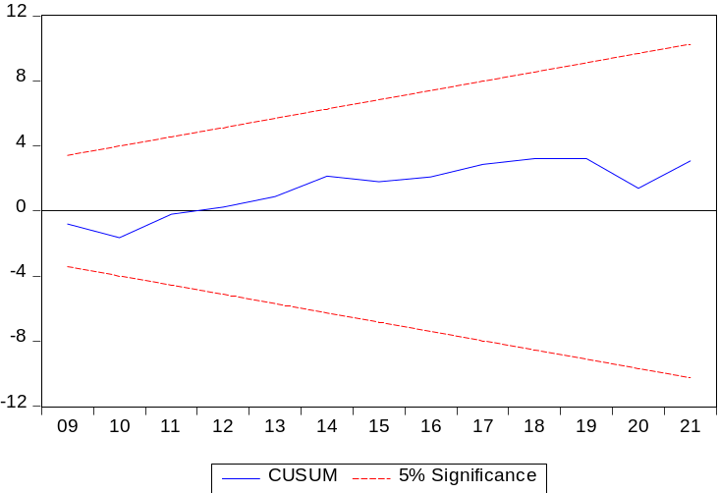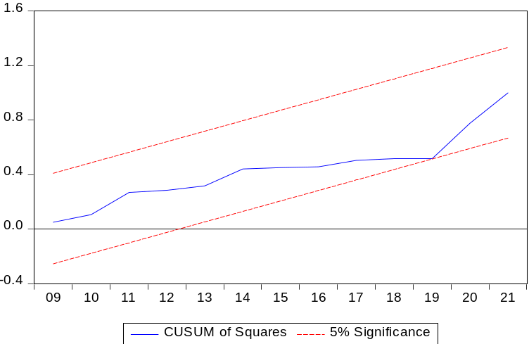
Figure 4A: CUSUM Test for Model 2 Figure 4B: CUSUMQ Test for Model 2
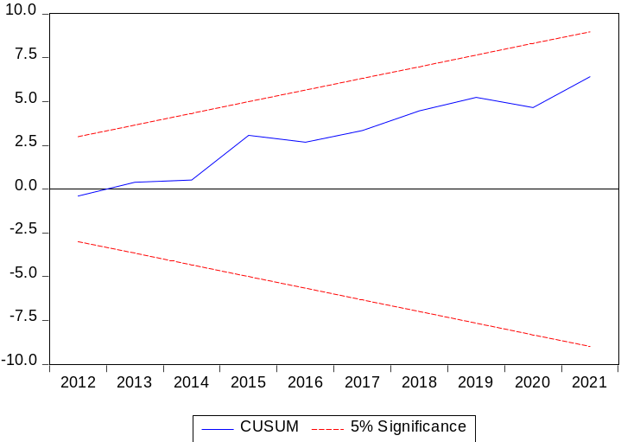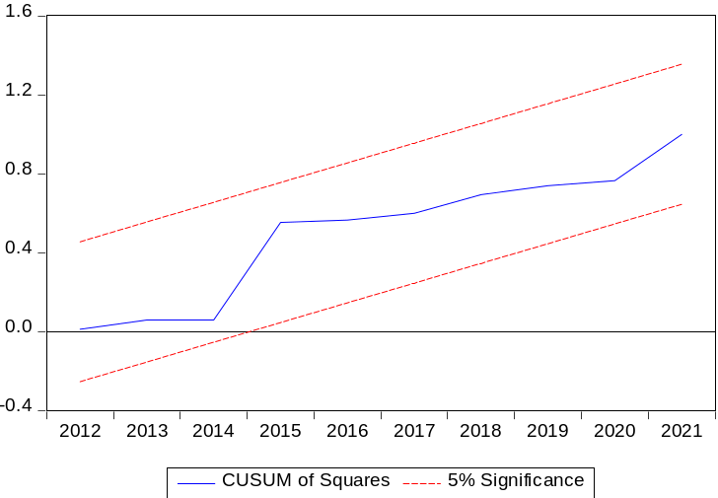
Figure 5A: CUSUM Test for Model 3 Figure 5B: CUSUMQ Test for Model 3
