Supporting Information

Biomimetic Self-Powered Smart Insole with AI-Enhanced Mechanodiagnosis for Continuous Gait Monitoring
Yingchun Li^{1,#}, Yarong Ding^{2,#}, Yuze Zhang^{3,#}, Xing Guo¹, Kaixin Lei³, Jiachun Sun¹, Xing Hu², Xinyue Li², Wenguang Yang², Rui Liu⁴, Zhenhua Lin², Wendong Zhang⁴, Shaozhe Tan², Xu Yang⁵, Yumeng Xu², Jin Tian^{6,7}, Yue Hao², Yannan Liu^{5,*}, Xiangning Li^{3,*} Feng Xu^{6,7*} and Jingjing Chang^{1,2*}
¹ Advanced Interdisciplinary Research Center for Flexible Electronics, Academy of Advanced Interdisciplinary Research, Xidian University, Xi’an 710071, P.R. China
² State Key Laboratory of Wide-Bandgap Semiconductor Devices and Integrated Technology, Faculty of Integrated Circuit, Xidian University, Xi’an 710071, P.R. China
³ Institute of Electromechanical Science and Technology, Xidian University, Xi’an 710071, P.R. China
⁴ Department of Rehabilitation Medicine, Tangdu Hospital, Air Force Military Medical University, Xi’an, 710032, P.R. China
⁵ Shaanxi Key Laboratory of Degradable Biomedical Materials, School of Chemical Engineering, Northwest University, Xi’an 710069, P.R. China
⁶ The Key Laboratory of Biomedical Information Engineering of Ministry of Education, School of Life Science and Technology, Xi’an Jiaotong University, Xi’an 710049, P.R. China
⁷Bioinspired Engineering and Biomechanics Center (BEBC), Xi’an Jiaotong University, Xi’an 710049, P.R. China
* Corresponding authors: jjingchang@xidian.edu.cn; fengxu@mail.xjtu.edu.cn; liuyannan@nwu.edu.cn; lixn@xidian.edu.cn

Table of Contents
Supplementary Legend for Videos.............................................................................1
Supplementary Notes..................................................................................................2
Supplementary Note 1: Preparation process and characterization principle of the pressure sensor ......................................................................................................2
Supplementary Note 2: Sensing performance and finite element simulation of the pressure sensor...................................................................................................... 5
Supplementary Note 3: Real-time monitoring application demo of the pressure sensor............................................................................................................................8
Supplementary Note 4: Characterizations of photorechargeable power system........................................................................................................................ 11
Supplementary Note 5: Integrated smart insole system for static and dynamic gait monitoring.......................................................................................................... 13
Supplementary Note 6: AI-assisted mechanodiagnosis using smart insole data............................................................................................................................ 15
Supplementary Table...............................................................................................18
Supplementary References......................................................................................21

Supplementary Legend for Videos:
Video S1. FEA simulation of the sensor with double-sided pyramid microstructure.
Video S2. The signal stability of the pressure sensor affixed to the tire tread of a running car.
Video S3. LEDs powered by PSC series, forming various lighting patterns.
Video S4. Smart insole powered by both Li-S batteries and PSCs.
Video S5. Real-time gait monitoring during walking up the stairs.
Video S6. Real-time gait monitoring during marching in place.
Supplementary Notes
Supplementary Note 1: Preparation process and characterization principle of the pressure sensor

TPU microporous foam was oxidized using FeCl₃ to introduce functional groups that facilitate the in-situ polymerization of PEDOT. The oxidized TPU foam was then immersed in an EDOT monomer solution, enabling uniform PEDOT deposition throughout the foam's porous architecture (Fig. S1). Energy-dispersive spectroscopy (EDS) confirmed the uniform incorporation of PEDOT into the TPU foam, as evidenced by the consistent distribution of carbon, nitrogen, oxygen, and sulfur elements across the foam's surface (Fig. S2). Fourier-transform infrared spectroscopy (FTIR) and Raman spectroscopy further validated the successful polymerization of PEDOT within the TPU matrix. FTIR spectra revealed characteristic peaks at 1360 cm⁻¹ (C=C stretching in the thiophene ring), 1058 cm⁻¹ (asymmetric C–O–C stretching), 899 cm⁻¹ (oxyethylene ring deformation), and 689 cm⁻¹ (C–S stretching) in the TPU/PEDOT foam, which were absent in pure TPU foam (Fig. S3a). Raman spectra exhibited distinctive PEDOT peaks at 2930 cm⁻¹ (C–H stretching), 1279 cm⁻¹ (C–N stretching), and 1442 cm⁻¹ (C=C stretching), confirming the presence and uniform distribution of PEDOT within the foam (Fig. S3b).

To examine the microstructure, we conducted scanning electron microscopy (SEM) imaging of the PEDOT/TPU foam. We observed that the microporous TPU foam exhibits evenly distributed pores with diameters of approximately 40 μm (Fig. S4a,b). Fig. S4c shows the SEM image of the foam with a single-sided micropyramid array, and Fig. S4d displays the top view under an optical microscope, further demonstrating the uniform distribution of the pyramid arrays. In addition, mechanical testing revealed that doping TPU foam with PEDOT significantly enhanced its mechanical properties. The Young's modulus increased from 0.62 MPa for pure TPU foam to 1.19 MPa for TPU/PEDOT foam, indicating improved mechanical strength. Concurrently, the dielectric constant rose from 3.38 to 5.08 after PEDOT incorporation, highlighting enhanced dielectric properties critical for capacitive sensing applications. To assess the mechanical properties of the double-sided pyramids sensor, we measured the stress-strain curves, as shown in Fig. S5. When external stresses of 100 kPa, 200 kPa, and 300 kPa were applied, the stress-strain curves remained largely consistent in shape and trend, with tensile length correlating well with the applied pressure. This result demonstrates that the sensor possesses good and stable mechanical properties, essential for reliable biomechanical sensing.
Fig. S1 Schematic illustration of the fabrication process and features of the dielectric layers.
Fig. S2 Mappings and energy dispersive spectroscopy (EDS) of C, N, O, S element on the surface of PEDOT/TPU foam.
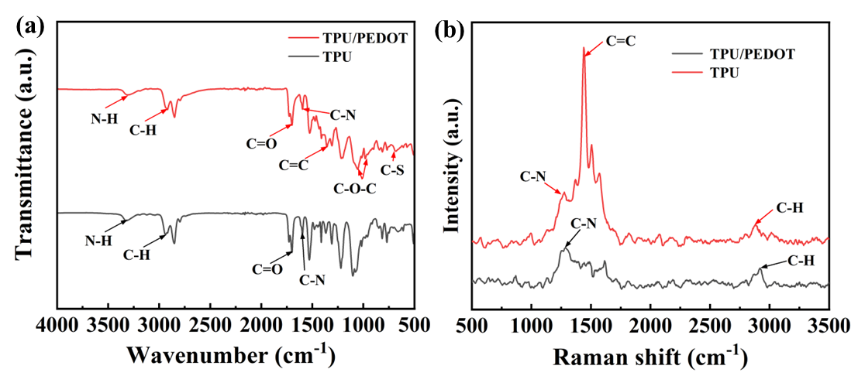
Fig. S3 (a) FTIR spectra of the TPU foam and PEDOT/TPU foam. (b) Raman patterns of the TPU foam and PEDOT/TPU foam.
Fig. S4 SEM photograph on the surface and the enlarged view of (a) TPU foam and (b) PEDOT/TPU foam. (c) SEM photographs on cross-section of PEDOT/TPU foam with single-sided micropyramid array. (d) Optical images of the micropyramid array of the dielectric layer.
Fig. S5 Young's modulus and dielectric constant of TPU and TPU/PEDOT foam. (b) Stress-strain curves of the sensor with high pressure loading.
Supplementary Note 2: Sensing performance and finite element simulation of the pressure sensor

To simulate the sensing mechanism during compression, we conducted finite element analysis using ABAQUS software (Video S1). The simulations confirmed that the dual microstructures enhance the air gap effect and dielectric properties, leading to improved sensitivity (Fig. S6a). Specifically, the pyramid microstructures facilitate greater deformation and contact area changes between the electrodes and the dielectric layer under pressure (Fig. S6b), while the microporous structure of the TPU/PEDOT foam contributes to dielectric constant variation (Fig. S6c).

Fig. S7 illustrates the force-electricity relationship of the sensors during pressure deformation ranging from 0 to 1.4 MPa. Notably, the single-sided pyramid array sensor demonstrated a maximum sensitivity of 0.318 kPa⁻¹ (Fig. S7b), which represents an improvement compared to sensors devoid of pyramid microstructures (Fig. S7c). The double-sided pyramid array sensor achieved an even higher maximum sensitivity of 0.602 kPa⁻¹ (Fig. S7a), which is 2.8 times greater than that of sensors without pyramid microstructures (Fig. S7c). It means that the incorporation of surface microstructures facilitates enhanced deformation and stress concentration, thereby significantly elevating the overall performance of the sensors. The experimental results align with simulation findings, consistently showing that the air gap effect and dielectric properties enhance the sensor's responsiveness to pressure changes. In a word, optimizing the dielectric layer parameters and introducing dual microstructures significantly enhanced the sensor's sensitivity and working range.

To validate the sensor's enhanced performance, we tested its electrical signal stability of double-sided pyramids sensor under different pressures by performing cyclic loading experiments. Under pressures of 100 kPa, 200 kPa, and 300 kPa, the sensor exhibited stable electrical signals with the relative capacitance change (ΔC/C₀) increasing proportionally with pressure (Fig. S8a). We also assessed the sensor's response at varying frequencies (0.5 Hz to 2 Hz) under a pressure of 200 kPa, observing rapid and stable signal outputs with minimal change in ΔC/C₀ (Fig. S8b). This demonstrates that the sensor exhibits good electrical stability under different magnitudes and frequencies of pressure, which is crucial for the plantar pressure signals during cyclic movements. Besides, we measured the response times of the optimized sensor under pressures of 0.5 kPa, 1.0 kPa, and 5.0 kPa, finding response times of 135 ms, 167 ms, and 192 ms, respectively, with corresponding recovery times after stress removal (Fig. S9).
Fig. S6 (a) The enlarged image of finite element simulation analysis of the pressure sensor with double-sided pyramid microstructures during the pressing process. (b) The simulation curves of the pyramid contact area during pressure loading. (c) The simulation curves of the pore area in the TPU foam during pressure loading. (d) Schematic illustration of the pressure sensor with double-sided pyramid microstructures during the pressing process.
Fig. S7 The sensitivity of the three types of sensors with (a) double-sided pyramid microstructures, (b) single-sided pyramid microstructures and (c) no pyramid microstructures.
Fig. S8 (a) Repeatability of the sensor with different loading pressure of 100, 200, 300 kPa at the frequency of 1 Hz for 10 cycles. (b) Repeatability of the sensor with pressure of 200 kPa at the frequency of 0.5 Hz, 1 Hz, 1.5 Hz and 2 Hz for 10 cycles.
Fig. S9 Response time of the sensor when (a, c, e) pressing and (b, d, f) releasing with three kinds of pressure levels (0.5, 1, and 5 kPa).
Supplementary Note 3: Real-time monitoring application demo of the pressure sensor

Biocompatibility is a critical requirement for wearable biomedical devices to prevent adverse skin reactions and ensure user safety during prolonged use. We conducted comprehensive biocompatibility assessments using L929 fibroblast cells cultured in sensor extraction solutions. Acridine orange/propidium iodide (AO/PI) staining after 1-3 days of culture exhibited strong green fluorescence signals, indicative of high cell viability and normal spindle-shaped morphology (Fig. S10a). The CCK-8 assay further confirmed that cell survival rates remained above 90% even at high extraction concentrations of 20 mg mL⁻¹ (Fig. S10b). To evaluate the sensor's safety on human skin, we conducted prolonged wear tests by applying the flexible sensor to a volunteer's arm for 8 hours daily over a week (Fig. S10c). No significant skin irritation, redness, or allergic reactions were observed, demonstrating the sensor's biocompatibility and suitability for long-term skin contact. These findings affirm that the materials and construction of our sensors are safe for continuous use in wearable biomedical applications.

We positioned the sensor on various body parts to detect multiple physiological signals. It performed exceptionally well in recognizing subtle activities and changes in facial expressions. On the neck and throat, it recorded nodding and cough capacitance variations (Fig. S11a,b). On the forehead, it captured expression changes from normal to frowning (Fig. S11c), aiding neurological assessments and human-machine interfaces. On the index finger, it distinguished tap counts (Fig. S11d), beneficial for gaming and dexterity exercises. Palm sensors distinguished clenching actions (Fig. S11e), aiding rehabilitation. The sensor also monitored handshake actions, tube grabbing, and beaker weight (Fig. S11f-h), suggesting its use in perceiving pressure changes in daily life. This also helps improve the perception capabilities of tactile robotic hands.

Owing to its excellent sensing performance, the sensor has potential applications in information encryption. Morse code represents letters of the English alphabet using arrangements of dots and dashes, which can be represented by short and long compression times of the pressure sensor, respectively (Fig. S11i). A short compression time generates a spike, and a long compression time generates a prolonged signal, corresponding to the dots and dashes in Morse code. We demonstrated that the pressure sensor could transmit specific words through information encryption, such as “SOS” and “CALL”, and “STOP” (Fig. S11j-l), indicating certain secret signals. These results indicate that wearable flexible sensors have promising applications in cryptography and secure communication.

Fig. S10 (a) Live/dead staining of L929 cells incubated with sensors extract for 1, 2 and 3 days. (b) Cell survival efficiencies of sensors extract for 1, 2 and 3 days. (c) Photographs of the sensors attached to human skin before and after 8 h.

Fig. S11 (a) Recognition of nodding frequency by a sensor attached to the neck. (b) Recognition of cough frequency by a sensor attached to the throat. (c) Recognition of facial expressions by a sensor attached to the forehead. (d) Recognition of the click frequency of the mouse via a sensor attached to the finger. (e) Recognition of clenching actions using a sensor attached to the palm. (f) Recognition of handshake actions using a sensor attached to the hand. (g) Recognition of grasping with a centrifuge tube using a sensor attached to the palm. (h) Recognition of grasping with different cup weights by a sensor stuck on the surface of objects. (i) Morse code table including 26 letters and the schematic diagram of the signal codes. (j-l) Morse code signal representing different English words: (j) “SOS”, (k) “CALL” and (l) “STOP”.
Supplementary Note 4: Characterizations of photorechargeable power system

Since the output voltage of a single PSC is lower than the charging voltage of a Li–S battery, we connected four PSCs in series to boost the output voltage. As shown in Fig. S12a, the four series-connected PSCs exhibit a PCE of 15.27%, with a J_{SC} of 6.14 mA cm⁻², a V_{OC} of 3.88 V, and an FF of 0.64. The decreased J_{SC} and FF are likely due to the increased series resistance of the connected PSCs. Although series connection slightly decreases JSC and FF due to increased series resistance, it still provides the necessary voltage for effective Li–S battery charging. To construct a closed-loop power supply system, we also fabricated the Li-S battery for energy storage with a laminated construction of lithium, electrolyte, separator, and hollow carbon spheres embracing sulfur (Fig. S12b).

The entire self-charging system is evaluated based on its overall photoelectric conversion efficiency (η_{overall}) and energy storage efficiency (η_{storage}). The overall photoelectric conversion efficiency of the self-charging system can be calculated as follows:
$$η_{\text{overall}}=\frac{E_{d}}{\left(P×S×t_{1}\right)}×100 \%$$
In the formula, E_{d}, P, S, and t₁ represent the discharge energy of the Li-S battery (mWh, measured using the Blue Energy Testing System), light power density (100 mW/cm²), effective area of the series-connected PSCs, and the light charging time (h), respectively. The energy storage efficiency of the self-charging system can be calculated as follows:
$$η_{\text{storage}}=\frac{η_{\text{overall}}}{\text{PCE}}×100 \%$$
In the formula, PCE refers to the power conversion efficiency (PCE) of the series-connected PSC module before the charging/discharging cycle.

To demonstrate the power supply capacity of the PSCs, we connected eight PSCs in series to power commercial LEDs. The PSC power supply lights up 14 LEDs to form different patterns (Fig. S12c and Video S3). According to the J-V curves of the series-connected PSCs after different photocharge/discharge cycles, the corresponding electrical parameters are shown in Fig. S12d,e. The PSCs exhibit good light stability with almost unchanged electrical properties after long-term illumination over multiple cycles. With 94% efficiency retention over 1000-hour aging, the PSCs enable reliable energy autonomy for wearable systems, achieving a key milestone toward clinical-grade health monitoring (Fig. S12f).
Fig. S12 (a) J-V curves of four PSCs connected in series. (b) Schematic illustration of the device structure of Li-S battery. (c) A group of patterned commercial LEDs lit up by eight single PSCs connected in series for displaying different letters. (d,e) Corresponding electrical parameters of (d) V_{OC}, J_{SC}, (e) FF, and PCE based on the J-V curves of four single PSCs connected in series for five charge-discharge cycles. (f) Normalized PCE of PSCs as a function of time.

Supplementary Note 5: Integrated smart insole system for static and dynamic gait monitoring.

To demonstrate the system's capability of dynamic activities, we further evaluated the smart insole's performance during stair climbing and marching in place. Video S5 and S6 illustrate the dynamic evolution of pressure distribution across 32 plantar regions on the left and right feet during stair climbing and marching in place, demonstrating the insole's ability to perceive plantar pressure in real-time. The insole consistently provided stable and accurate sensor signals, with heatmaps that closely matched the actual plantar pressure distribution. Furthermore, we assessed the smart insole's capability in walking posture correction and disease prediction. During walking, a volunteer with flat feet alternately performs heel strikes, full-foot landing, and toe-off actions, aligning well with the corresponding color changes in the sensor feedback. We recorded real-time capacitive signal variations from the 32 pressure sensors on both feet during motion (Fig. S13).

Fig. S13 The integrated smart insole for gait monitoring during walking. (a) Decomposition diagram of the walking process. (b) The image of plantar recognition using the integrated smart insole. (c) The collected 16-channel data curves of the left foot using the integrated smart insole during walking. (d) The collected 16-channel data curves of the right foot using the integrated smart insole during walking.

Supplementary Note 6: AI-assisted mechanodiagnosis using smart insole data
The Framework and parameters of one-dimensional Convolution Neural Network (1D-CNN) for gait recognition problem are shown in Fig. S14 and Table S2. Fig. S14 illustrates the overall architecture of the 1D-CNN model, comprising layers such as convolution and pooling. Table S2 provides detailed parameters for each layer, including padding type and output channels. Additionally, the number of kernels and kernel sizes can be inferred from the input and output dimensions of the convolutional layers. To further study the clustering patterns for 3 arch types and 12 gait types, T-distributed stochastic neighbor embedding (t-SNE) was applied to intuitively visualize signal differences among the types, reducing high-dimensional pressure data to a two-dimensional space through orthogonal transformation. In addition, the 1D-CNN framework for gait identification achieves stabilized training convergence within 40 epochs, as evidenced by the loss curves in Fig. S15b.

Compared to the algorithm used in the paper, other algorithms have critical limitations: (1) For static arch disease identification, 1D-CNN models (Fig. S16) show inadequate accuracy about 80% (Δ=16% vs. Random Forest models) and premature training saturation for arch classification; (2) Transformer architectures (Fig. S17a) demand longer training time per epoch and require more epochs to reach gait recognition accuracy about 97.6%, indicating that the Transformer model demands higher computational power and time requirements. Additionally, due to the Transformer model's lower efficiency in capturing local features, its stability is insufficient, as evidenced by Fig. S17b and S17c.
Fig. S14 Framework of 1D-CNN for gaits recognition

Fig. S15 (a) Confusion matrix result for the recognition of 12 gaits using the 1D-CNN framework. (b) Training and validation losses of 1D-CNN framework for the recognition of 12 gaits.

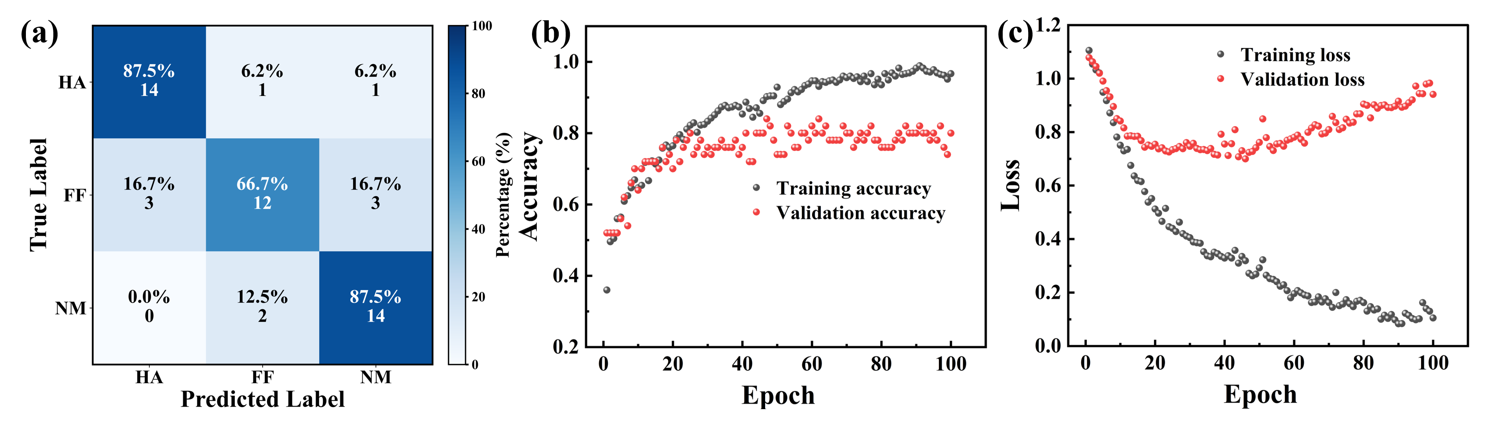
Fig. S16 (a) Confusion matrix results for static arch disease identification using the 1D-CNN framework. (b) Training and validation losses of 1D-CNN framework for static arch disease identification. (c) Training and validation accuracies of 1D-CNN framework for static arch disease identification.

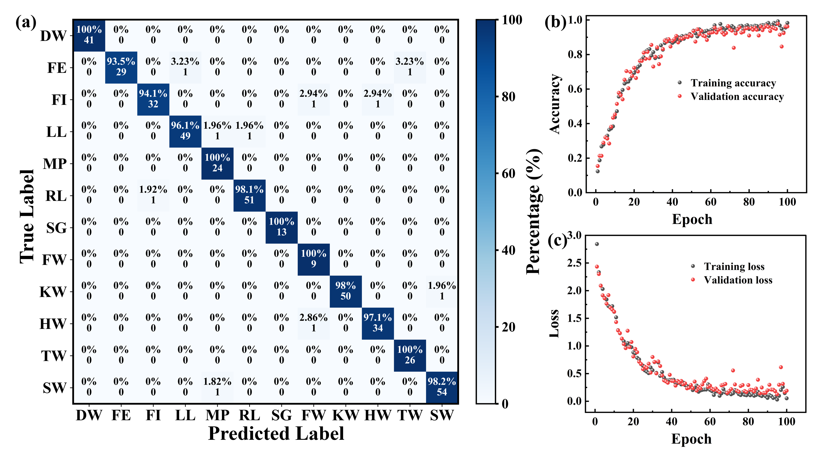
Fig. S17 (a) Confusion matrix results for the recognition of 12 gaits using the Transformer framework. (b) Training and validation losses of Transform framework for the recognition of 12 gaits. (c) Training and validation accuracies of Transform framework for the recognition of 12 gaits.

Supplementary Table:
Table S1 Comparison of sensing performance between various design of capacitive pressure sensors.
Dielectric material |  | Electrode material |  | Sensitivity |  | Detection range |  | Detection limit |  | Response time/ Recovery time |  | Stability |  | Ref.
PDMS/CNTs |  | PDMS/CNTs |  | 0.15 kPa⁻¹ |  | 450 kPa |  | 0.35 Pa |  | 6 ms/6 ms |  | 100000 cycles |  | ¹
PDMS/BaTiO₃ |  | AgNWS-LOOP@PET |  | 0.005 kPa⁻¹ |  | 100 kPa |  | - |  | 70 ms/- |  | 20000 cycles |  | ²
Poly (glycerol sebacate) |  | Mg/Polylactic acid |  | 0.13 kPa⁻¹ |  | 10 kPa |  | 12 Pa |  | 150 ms/150 ms |  | 30000 cycles |  | ³
Graphene nanosheets |  | Cu/Ni |  | 0.33 kPa⁻¹ |  | 110 kPa |  | 0.25 Pa |  | 50 ms/110 ms |  | 10000 cycles |  | ⁴
PDMS |  | PDMS/Cu |  | 0.22 kPa⁻¹ |  | 500 kPa |  | <1 Pa |  | 4.2 ms/5.3 ms |  | 10000 cycles |  | ⁵
PDMS |  | P(TFEA-co-AAm)-[EMIM][TFSI] ionogel |  | 0.51 kPa⁻¹ |  | 1000 kPa |  | 10 Pa |  | 100 ms/200 ms |  | 8000 cycles |  | ⁶
CIP/NdFeB/PDMS |  | CNT/PDMS |  | 0.314 kPa⁻¹ |  | 1000 kPa |  | 2 Pa |  | 200 ms/300 ms |  | 5000 cycles |  | ⁷
CB-PVDF-HFP/ [EMIM][TFSI] |  | ITO/PET |  | 0.35 kPa⁻¹ |  | 250 kPa |  | 22 Pa |  | 110 ms/220 ms |  | 7000 cycles |  | ⁸
PVDF/AgNWs/TiO₂ |  | Au |  | 0.0012 kPa⁻¹ |  | 1500 kPa |  | - |  | 166.9 ms/199 ms |  | 33000 cycles |  | ⁹
PDMS |  | Gallium/Liquid metal |  | 0.007 kPa⁻¹ |  | 100 kPa |  | 1.11 Pa |  | 80 ms/80 ms |  | 10000 cycles |  | ¹⁰
TPU/EMIS:TFSI |  | PEDOT:PSS |  | 0.5 kPa⁻¹ |  | 400 kPa |  | <100 Pa |  | - |  | 2500 cycles |  | ¹¹
Cotton fiber/PU |  | Cu |  | 0.0024 kPa⁻¹ |  | 500 kPa |  | - |  | - |  | 10000 cycles |  | ¹²
Ion-gel |  | AgNWs/PEDOT |  | 0.32 kPa⁻¹ |  | 50 kPa |  | - |  | 227 ms/232 ms |  | 5000 cycles |  | ¹³
Nanofiber/PDMS |  | CNT/PDMS/MXene |  | 0.091 kPa⁻¹ |  | 2000 kPa |  | 1 Pa |  | 71 ms/117 ms |  | 6000 cycles |  | ¹⁴
EPU |  | Cu |  | 0.0063 kPa⁻¹ |  | 400 kPa |  |  |  | 1.1 s/2.58 s |  | 850 cycles |  | ¹⁵
FEC/ACMO/ AM |  | ITO |  | - |  | 1080 kPa |  | 1 kPa |  | - |  | 500 cycles |  | ¹⁶
Pectin xerogel |  | Carbon paste coated cellulose film |  | 0.0294 kPa⁻¹ |  | 100 kPa |  | 100 Pa |  | 118 ms/130 ms |  | 10000 cycles |  | ¹⁷
MWNTs/PDMS |  | CNT-Ecoflex |  | 0.12 kPa⁻¹ |  | 130 kPa |  | 3 Pa |  | 46 ms/44 ms |  | 3000 cycles |  | ¹⁸
 | PVDF/HFP/μNi |  | Cu |  | 0.0982 kPa⁻¹ |  | 100 kPa |  |  |  | 24 ms/24 ms |  |  |  | ¹⁹
PVDF/rGO |  | Ag |  | 0.18 kPa⁻¹ |  | 360 kPa |  | 100 Pa |  | 56.3 ms/- |  | 3000 cycles |  | ²⁰
PHB/PHV |  | CNT/PU |  | 0.19 kPa⁻¹ |  | 680 kPa |  | <500 Pa |  | - |  | 30000 cycles |  | ²¹
Cotton fabric |  | Ag |  | 0.036 kPa⁻¹ |  | 110 kPa |  | - |  | 104 ms/96 ms |  | 10000 cycles |  | ²²
 | PDMS |  | Au/PET |  | 0.139 kPa⁻¹ |  | 45 kPa |  | - |  | - |  | - |  | ²³
 | PDMS/PVA |  | Cu |  | 0.43 kPa⁻¹ |  | 120 kPa |  | - |  | - |  | - |  | ²⁴
PDMS |  | AgNWs/MXene |  | 0.075 kPa⁻¹ |  | 30 kPa |  | - |  | 65 ms/- |  | 2000 cycles |  | ²⁵
TPU/PEDOT/PDMS |  | Cu |  | 0.602 kPa⁻¹ |  | 1400 kPa |  | 0.1 Pa |  | 135 ms/127 ms |  | 12000 cycles |  | Our work
ITO: Indium tin oxide
PET: Poly(ethylene terephthalate)
MWCNTs: Multi-walled carbon nanotubes
MTMPA: Magnetic tilted micropillar array
PEDOT:PSS: Poly(3,4-ethylenedioxythiophene)-poly(styrenesulfonate)
IG：Ionic gel
EPU: elastomeric polyurethane
FEC: fluorinated ethylene carbonate
ACMO: 4-acryloyl morpholine
AM: acrylamide
PHB: polyhydroxybutyrate
PHV: polyhydroxyvalerate
PVDF: poly(vinylidene fluoride)
HFP: hexafluoropropylene
Carbonyl iron powder/NdFeB/PDMS (CIP/NdFeB/PDMS)
Carbon black (CB)-embedded poly(vinylidene fluoride-co-hexafluoropropylene) (PVDF-HFP)/ [EMIM][TFSI]
Polyvinylidene fluoride (PVDF)@AgNWs@TiO₂

Table S2. The parameters for constructing 1D-CNN for gait recognition problem
Layer (type) | Padding | Output Shape | Param #
Input |  | (None, 16, 200) | 0
Conv_1 (Conv1d) | Same | (None, 32, 200) | 1568
ReLU_1 (Activation) |  | (None, 32, 200) | 0
Pool_1 (MaxPool1d) | Valid | (None, 32, 100) | 0
Conv_2 (Conv1d) | Same | (None, 64, 100) | 6208
ReLU_2 (Activation) |  | (None, 64, 100) | 0
Pool_2 (MaxPool1d) | Valid | (None, 64, 50) | 0
Flatten |  | (None, 3200) | 0
FC_1 (Linear) |  | (None, 128) | 409728
ReLU_fc1 (Activation) |  | (None, 128) | 0
FC_2 (Linear) |  | (None, 12) | 1548

References:
1 Zhang, Y. et al. Highly stable flexible pressure sensors with a quasi-homogeneous composition and interlinked interfaces. Nat. Commun. 13, 1317 (2022).
2 Luo, Y. et al. A flexible dual-function capacitive sensor enhanced by loop-patterned fibrous electrode and doped dielectric pillars for spatial perception. Nano. Res. 16, 7550-7558 (2023).
3 Boutry, C. M. et al. A stretchable and biodegradable strain and pressure sensor for orthopaedic application. Nat. Electron. 1, 314-321 (2018).
4 Ye, X. et al. All-textile sensors for boxing punch force and velocity detection. Nano. Energy. 97, 107114 (2022).
5 Ji, Y. et al. Splashing‐assisted femtosecond laser‐activated metal deposition for mold‐and mask‐free fabrication of robust microstructured electrodes for flexible pressure sensors. Small. 19, 2207362 (2023).
6 Huang, Z. et al. Highly stretchable ionotronic pressure sensors with broad response range enabled by microstructured ionogel electrodes. J. Mater. Chem. A. 11, 7201-7212 (2023).
7 Ji, B. et al. Bio‐inspired hybrid dielectric for capacitive and triboelectric tactile sensors with high sensitivity and ultrawide linearity range. Adv. Mater. 33, 2100859 (2021).
8 Keum, K. et al. Dual-stream deep learning integrated multimodal sensors for complex stimulus detection in intelligent sensory systems. Nano. Energy. 122, 109342 (2024).
9 Han, R. et al. High anti‐jamming flexible capacitive pressure sensors based on core–shell structured AgNWs@ TiO₂. Adv. Funct. Mater. 33, 2305531 (2023).
10 Zhang, C. et al. Wireless, smart hemostasis device with all-soft sensing system for quantitative and real-time pressure evaluation. Adv. Sci. 10, 2303418 (2023).
11 Qiu, J. et al. An efficiently doped pedot: pss ink formulation via metastable liquid− liquid contact for capillary flow‐driven, hierarchically and highly conductive films. Small. 19, 2205324 (2023).
12 Chen, M. et al. Imperceptible, designable, and scalable braided electronic cord. Nat. Commun. 13, 7097 (2022).
13 Keum, K. et al. Mechanically robust textile-based strain and pressure multimodal sensors using metal nanowire/polymer conducting fibers. Iscience. 25, 104032 (2022).
14 Li, X. et al. Capacitive pressure sensor combining dual dielectric layers with integrated composite electrode for wearable healthcare monitoring. ACS Appl. Mater. Interfaces. 16, 12974-12985 (2024).
15 Berman, A. et al. Additively manufactured micro-lattice dielectrics for multiaxial capacitive sensors. Sci. Adv. 10, eadq8866 (2024).
16 Zhang, C. et al. Dielectric gels with microphase separation for wide‐range and self‐damping pressure sensing. Adv. Mater. 36, 2308520 (2024).
17 Basarir, F. et al. Edible and biodegradable wearable capacitive pressure sensors: a paradigm shift toward sustainable electronics with bio‐based materials. Adv. Funct. Mater. 34, 2403268 (2024).
18 Wu, L. et al. Beetle‐inspired gradient slant structures for capacitive pressure sensor with a broad linear response range. Adv. Funct. Mater. 34, 2312370 (2024).
19 Guo, H. et al. Artificially innervated self-healing foams as synthetic piezo-impedance sensor skins. Nat. Commun. 11, 5747 (2020).
20 Huang, J. et al. Multi‐hierarchical microstructures boosted linearity of flexible capacitive pressure sensor. Adv. Eng. Mater. 24, 2101767 (2022).
21 Boutry, C. M. et al. A hierarchically patterned, bioinspired e-skin able to detect the direction of applied pressure for robotics. Sci. Robot. 3, eaau6914 (2018).
22 Su, Z. et al. All-fabric tactile sensors based on sandwich structure design with tunable responsiveness. ACS Appl. Mater. Interfaces. 15, 32002-32010 (2023).
23 Hu, H. et al. Bioinspired hierarchical structures for contact‐sensible adhesives. Adv. Funct. Mater. 32, 2109076 (2022).
24 Patil, D. et al. Versatile patterning of liquid metal via multiphase 3D printing. Small. 20, 2402432 (2024).
25 Fan, Q. et al. Biomimetic hierarchically silver nanowire interwoven MXene mesh for flexible transparent electrodes and invisible camouflage electronics. Nano. Lett. 22, 740-750 (2022).

