Table 1 Medicinal properties attributed to the three plants (bore, guasca, nopal)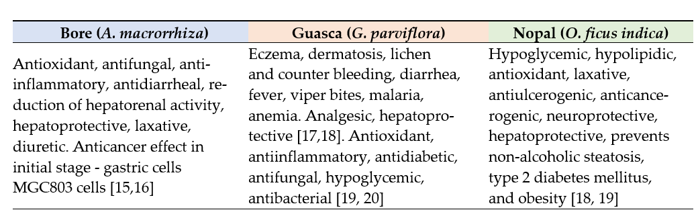
Table 2 Samples weight and water percentage for fresh and dehydration status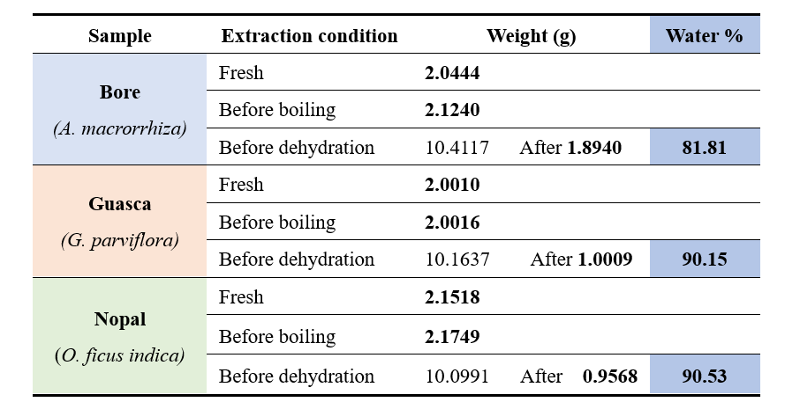

Table 3 Total phenolic and flavonoid content by proportionality. Treatment

corresponds to Fresh (F), Boiled (B), and Dehydrated (D) samples.