Supplementary Data
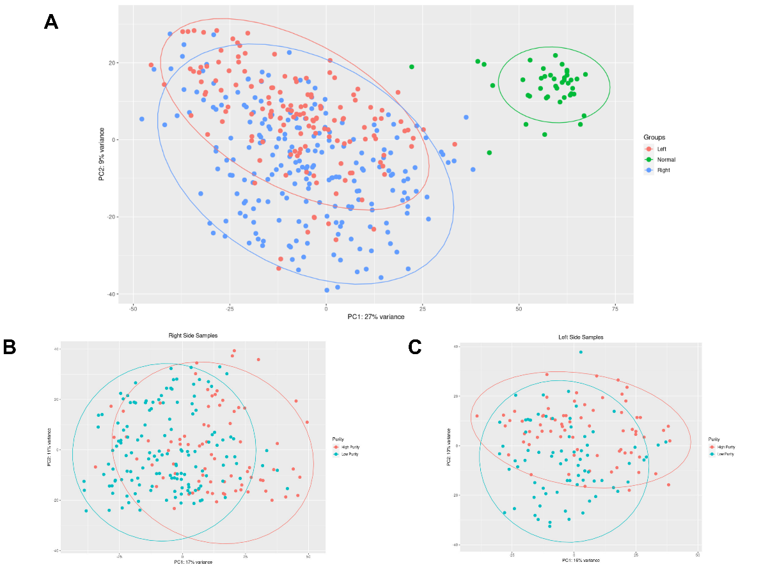
Supplementary Material 1: Supplementary Fig. 1: Principal Component Analysis (PCA) of COAD samples downloaded from the TCGA database. A PCA analysis of normal and tumor samples separated by region of the large intestine. Green represents the normal samples, red indicates tumor samples from the left region, and blue represents tumor samples from the right region. B PCA analysis of tumor samples from the right side of the large intestine, separated by purity. Red represents high-purity samples, and blue represents low-purity samples. C PCA analysis of tumor samples from the left side of the large intestine, separated by purity. Red represents high-purity samples, and blue represents low-purity samples.

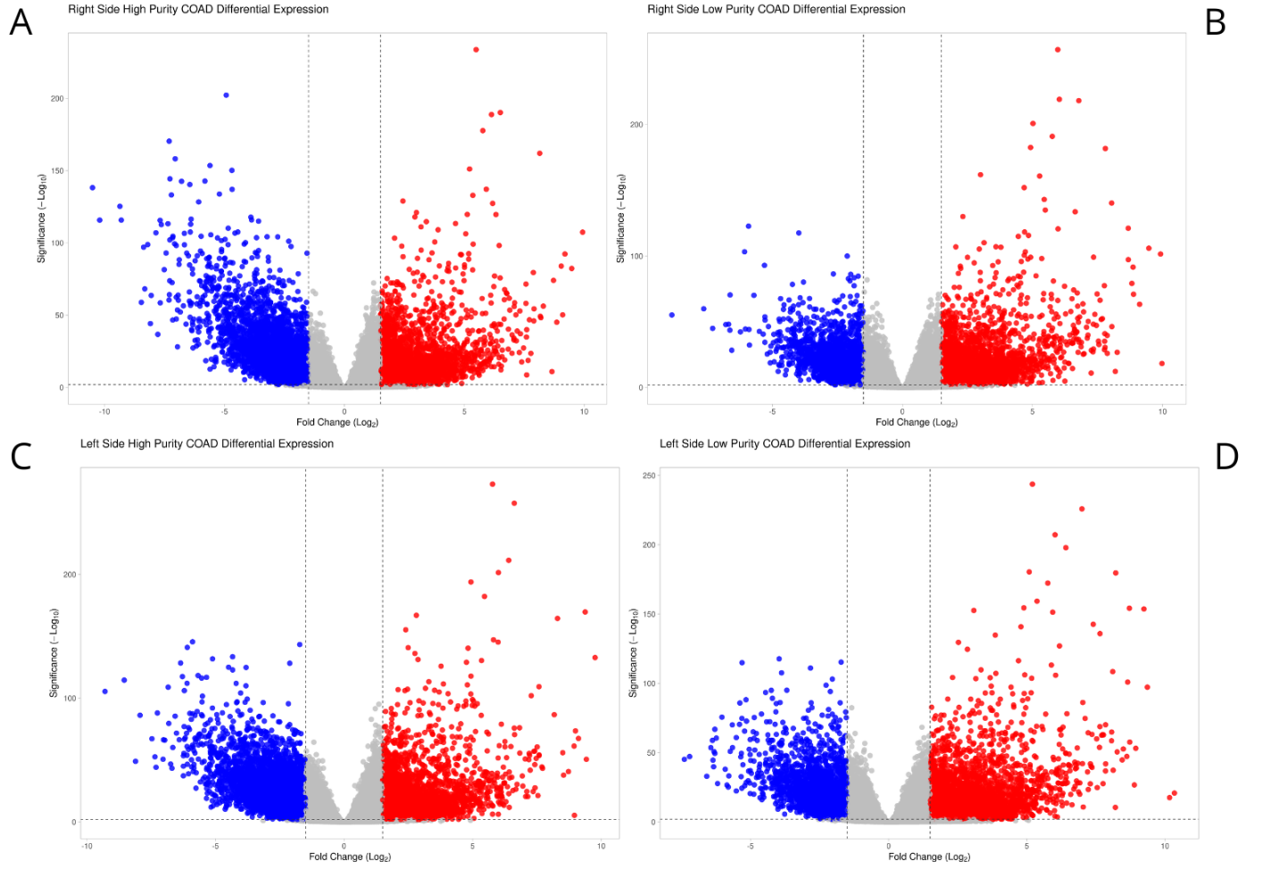
Supplementary Fig. 2: Volcano plots of differential expression analyses. Downregulated genes are shown in blue, and upregulated genes in red. A Volcano plot of the differential expression analysis comparing normal samples with high-purity large intestine tumor samples from the right region. B Volcano plot of the differential expression analysis comparing normal samples with low-purity large intestine tumor samples from the right region. C Volcano plot of the differential expression analysis comparing normal samples with high-purity large intestine tumor samples from the left region. D Volcano plot of the differential expression analysis comparing normal samples with low-purity large intestine tumor samples from the left region.

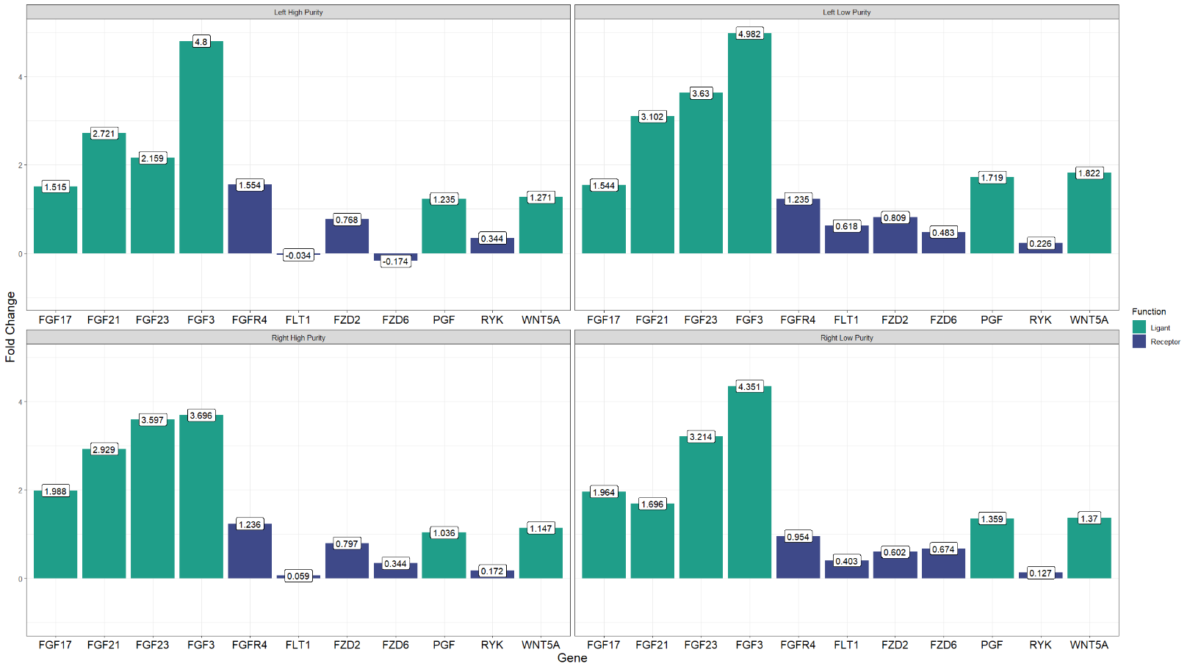
Supplementary Fig. 3: Fold change values for the genes detected in the significant pairs across different CRC sites.
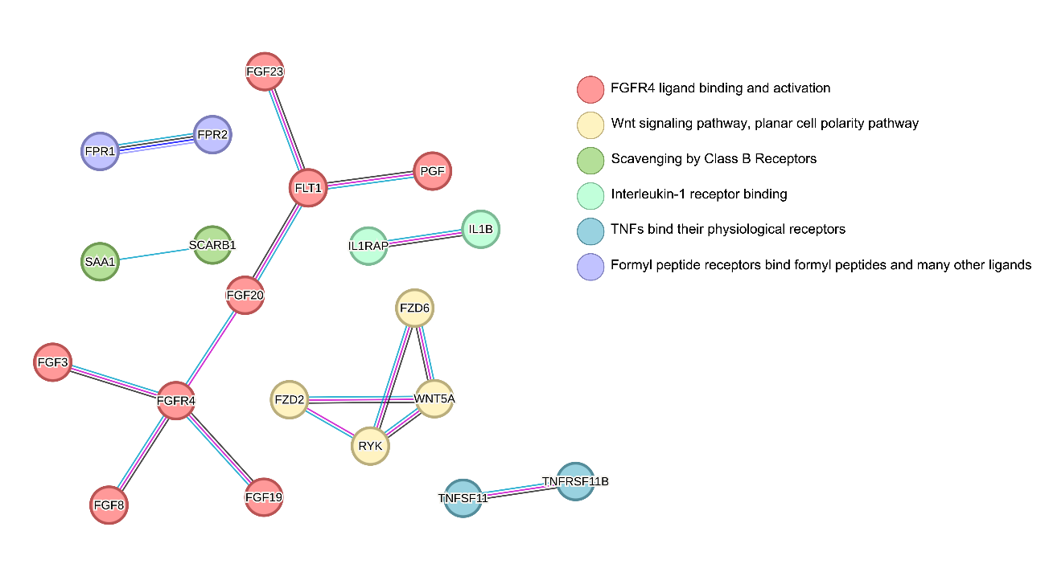
Supplementary Fig. 4: Protein-protein interaction network generated using the STRING tool, enriched and clustered by k-means. Six clusters related to distinct biological processes were identified: Red: FGFR4 ligand binding and activation. Yellow: Wnt signaling pathway, planar cell polarity pathway. Lime Green: Elimination by class B receptors. Green: Interleukin-1 receptor binding. Blue: TNF binding its physiological receptors. Purple: Formyl peptide receptors binding formyl peptides and various other ligands.

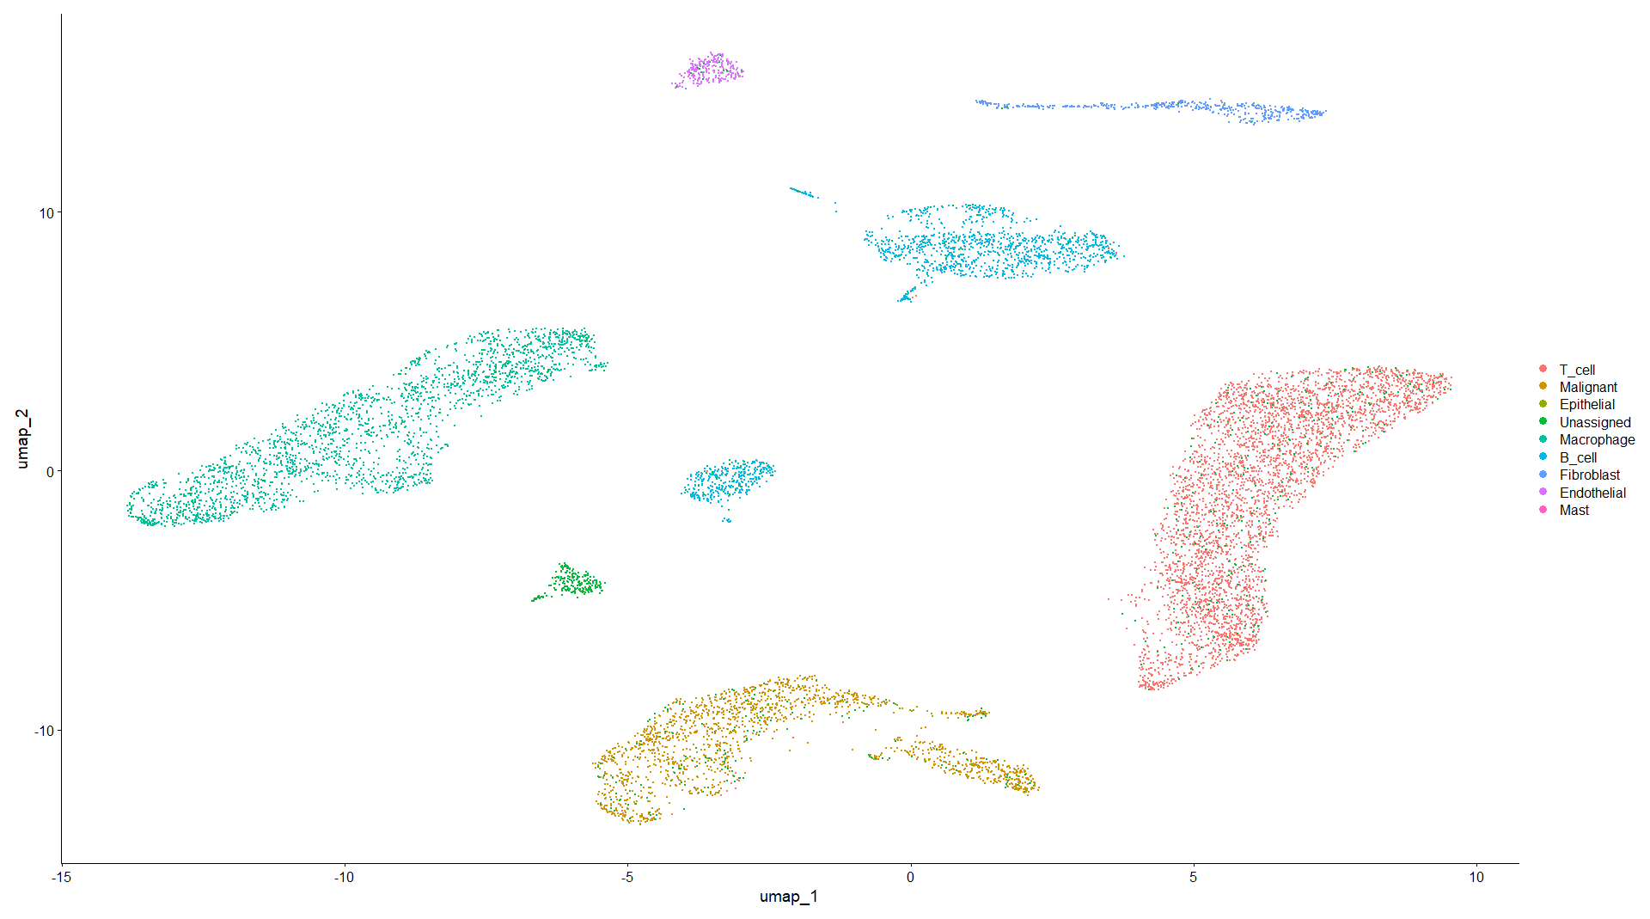
Supplementary Fig. 5: UMAP plot displaying the cell types identified from the data of Lee et al., 2020. Eight cell types were identified in the tumor microenvironment of samples extracted from the large intestine: T cells, malignant cells, epithelial cells, macrophages, B cells, fibroblasts, endothelial cells, and mast cells.
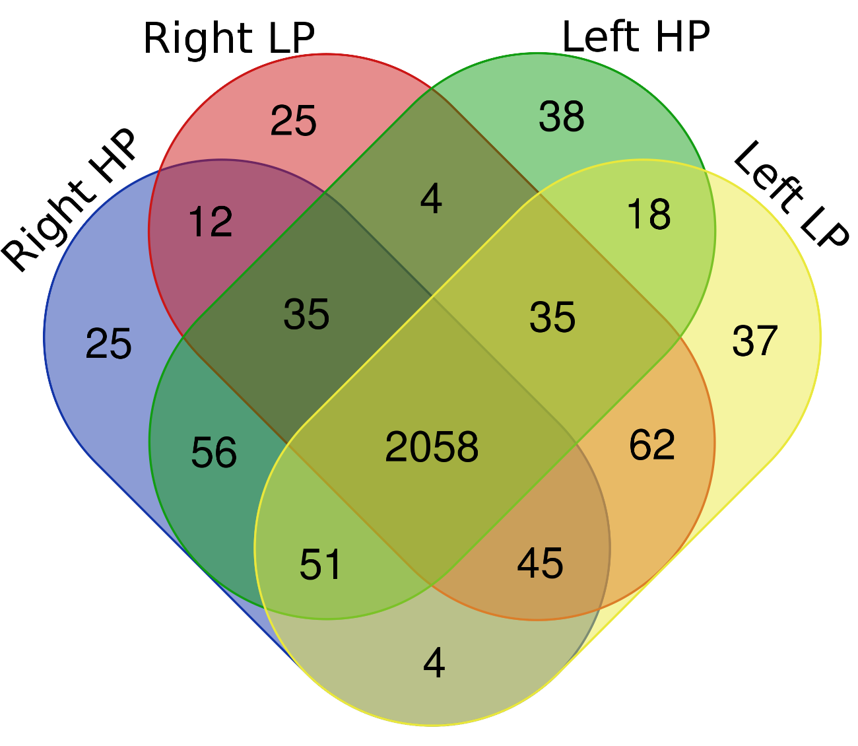
Supplementary Fig. 6: Venn diagram illustrating the drugs predicted to reverse the expression profile, based on the connectivity map obtained from the L1000FWD platform.

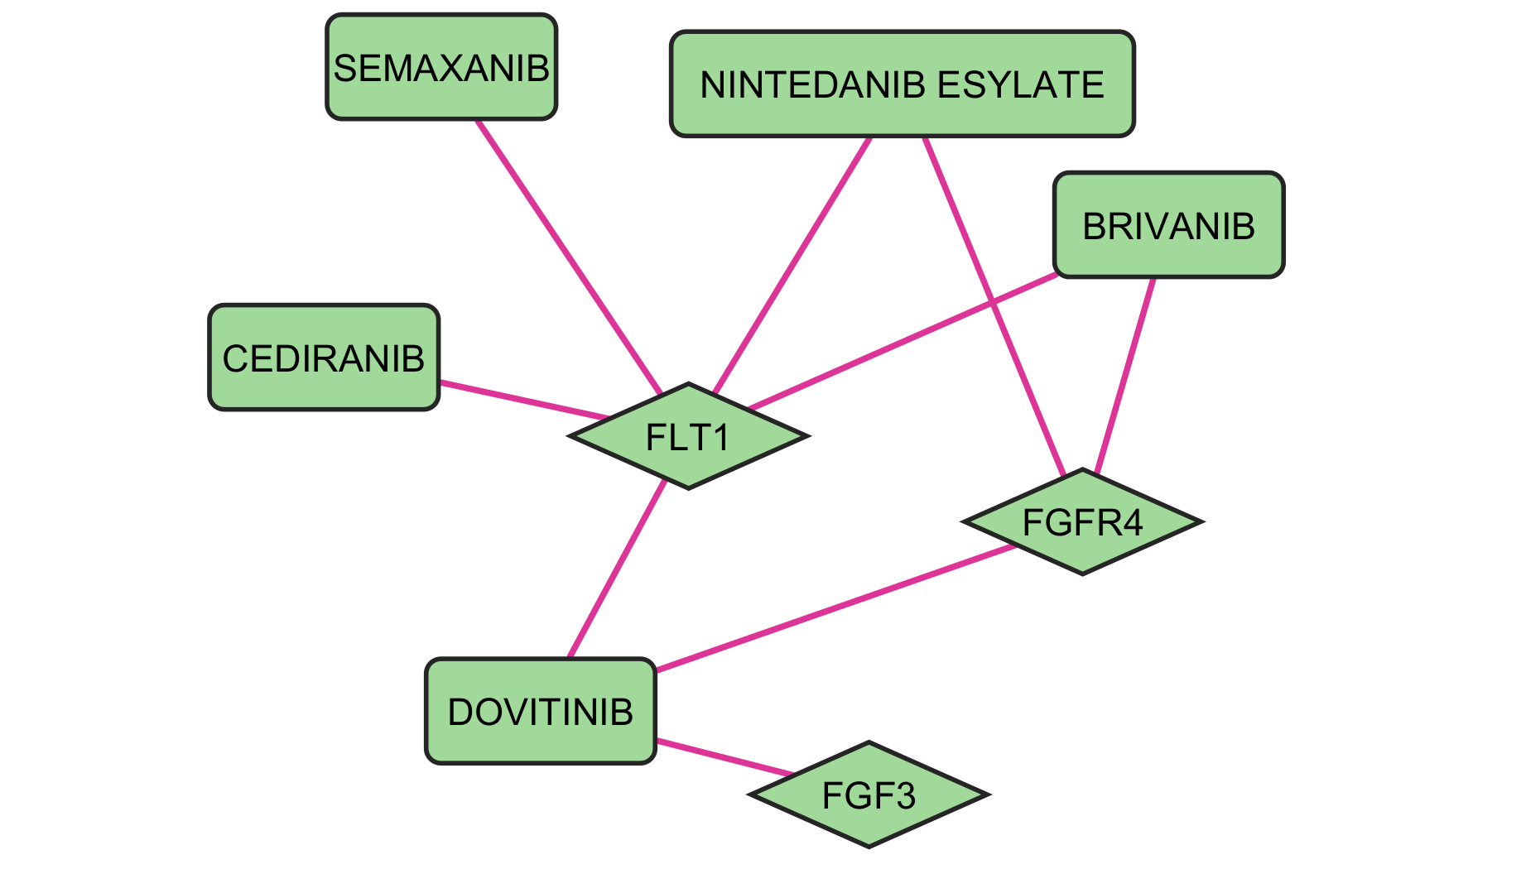
Supplementary Fig. 7: Interaction network of drugs identified in more than one tool and their respective targets predicted by the DGIDB tool.

