Supplementary material
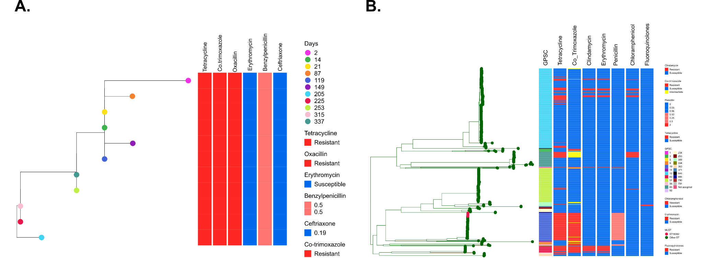
Supplementary Fig 1: ST18362 single colony phylogeny and global placement of ST18362 in a global serotype 3 phylogeny. A) Phylogeny of ST18362 overlaid by sampling day and phenotypic antimicrobial resistant profile. B) Phylogeny of circulating serotype 3 lineages from Global Pneumococcal Sequence database overlaid by pneumococcal lineage (GPSC) and in silico antimicrobial resistant profile. Highlighting strains defined by multilocus sequence typing scheme (MLST), namely novel ST18362 (persistently carried isolates) and other STs.

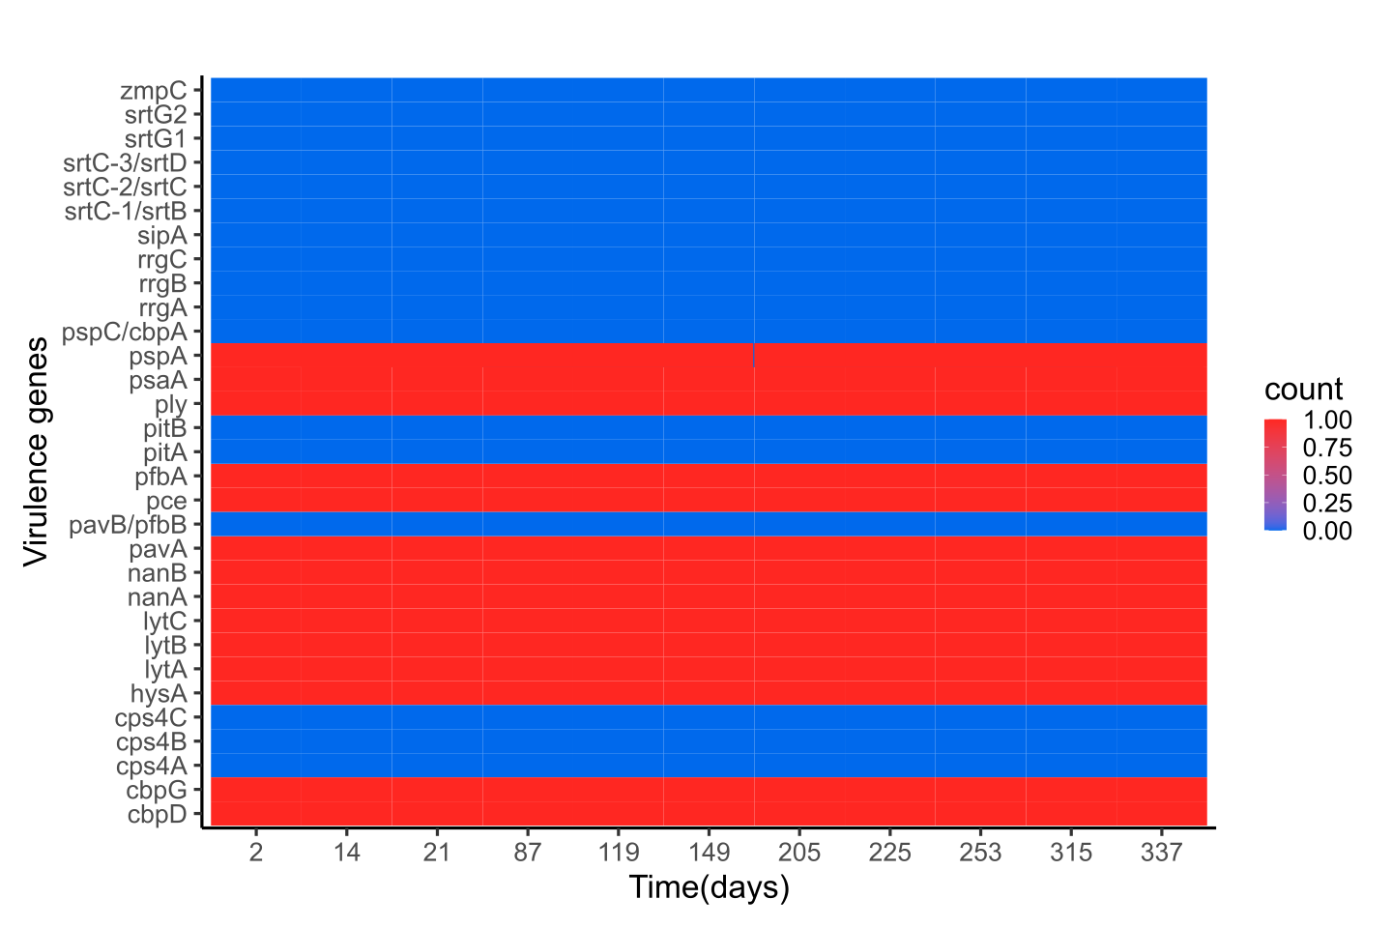

Supplementary Fig 2: A heatmap of virulence genes of the persistently carried pneumococcal serotype 3 (ST18362) stratified by the day of sample collection.
cbpD, choline binding protein D; cbpG, choline binding protein G; cps4A, capsular polysaccharide biosynthesis protein; cps4B, capsular polysaccharide biosynthesis protein; cps4C, capsular polysaccharide biosynthesis protein; hysA, hyaluronate lyase; lytA, autolysin; lytB, endo-beta-N-acetylglucosaminidase; lytC, 14-beta-N-acetylmuramidase; nanA, neuraminidase A; nanB neuraminidase B; pavA, Fibronectin-binding protein-like protein A; pavB/pfbB, cell wall surface anchor family protein Plasminogen- and Fibronectin-binding protein B; pce, choline binding protein E; pfbA,cell wall surface anchor family protein Plasminogen- and Fibronectin-binding protein A; pitA, minor pilin; pitB, major pilin; ply, pneumolysin; psaA, manganese ABC transporter manganese-binding adhesion liprotein; pspA, pneumococcal surface protein A; pspC/cbpA, Choline binding protein A; rrgA, cell wall surface anchor family protein pilus tip adhesin; rrgB, cell wall surface anchor family protein major pilin; rrgC, cell wall surface anchor family protein minor pili; sipA, signal peptidase I; srtC-1/srtB, sortase; srtC-2/srtC, sortase; srtC-3/srtD, sortase; srtG1, sortase SrtB family; srtG2, surface protein cell wall anchor sortase_B family; zmpC, immunoglobulin A1 protease.

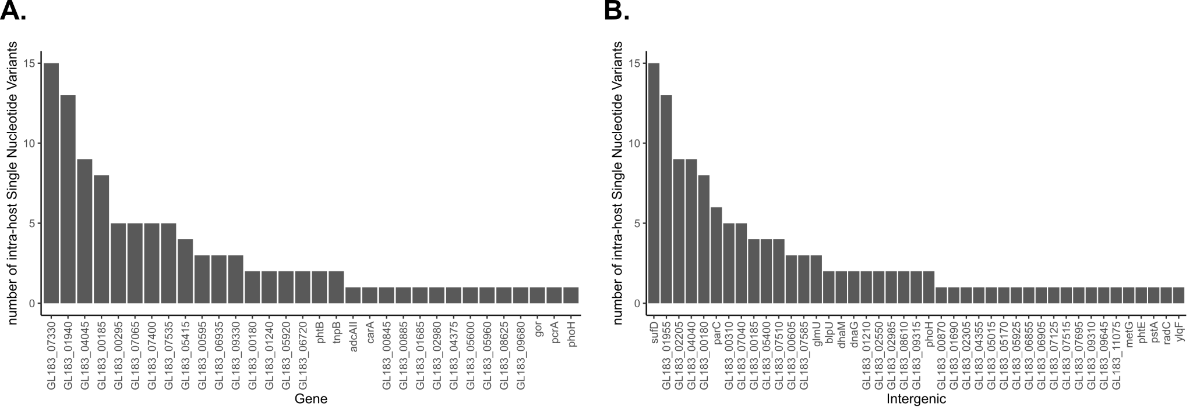
Supplementary Fig 3: Raw data or unnormalized data of genic and intergenic Intrahost single nucleotide variants of the novel ST18362. A) Number of genic intrahost single nucleotide substitutions per gene or locus tag (each mutation counted once per gene or locus tag position during the carriage episode). B) Number of intergenic intrahost single nucleotide substitutions per gene or locus tag (each mutation counted once per gene or locus tag position during the carriage episode).

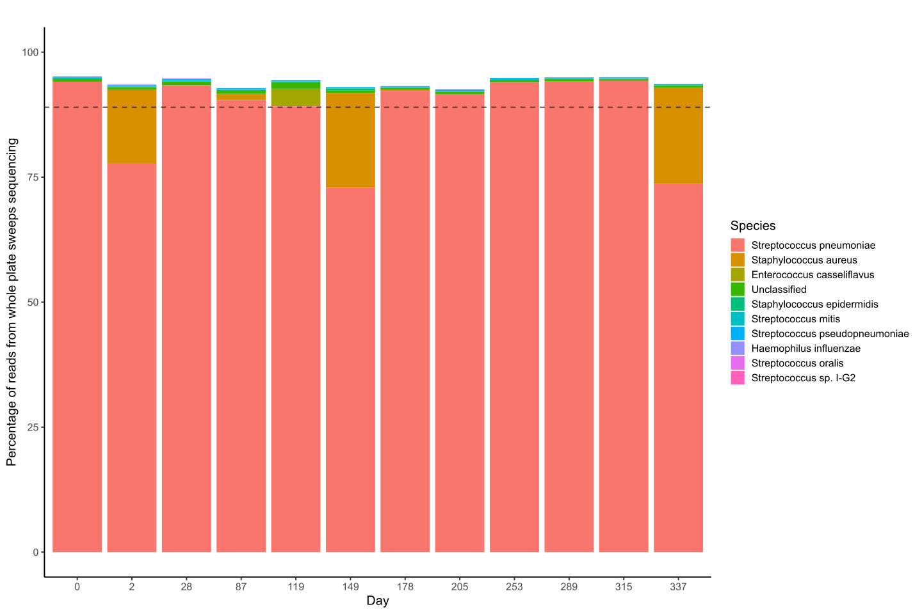
Supplementary Fig 4: Proportion of reads assigned to different species by Kraken stratified by sampling day and species. The black dotted line indicates the 89% threshold of reads mapping to S. pneumoniae, which were included in the minority variant calls. This Kraken report includes reads reported at >= 1% and excluded Homo sapiens reads.

Supplementary Table 1: Reported persistent pneumococcal carriage durations of pneumococcal serotypes from 1985 to 2016 among adults and children.
Study site | Data collection year | Sampling interval (follow-up period) | Serotype | Median Carriage duration (95% CI) | Number of episodes/carriers | Age | Reference
Papua New Guinea | 1985 - 1987 | Monthly (~18 months) | 2 | 31.3 days* | 2ª | Children | Smith et al. 1993⁹
Gambia | <2010 | Bi-weekly (~1 year) | 14 | ~258.3 days* | 11^{b} | <1 - >40 years | Hill et al.  2010¹²
Kenya | 2006 – 2008 | 1, 2, 4, 8, 16 and 32 days, and then monthly until clearance ((~≤486 days) | 6A | 50.8 (19.7 - 131) days* | 237ª | 3 - 59 months | Abdullahi et al.  2012¹⁰
Thailand | 2007~2010 | Monthly (~2 years) | 19F | 91.5 (62.0 - 120) days* | 146^{b} | Infants | Turner et al.  2012¹¹
South Africa | 2012 - 2014 | Bi-weekly (1 year) | 6B | 56.37 (41.02 - 71.73) days* | 4^{b} | infants | Dube et al.  2018¹⁷
Gambia | 2008 – 2009 | Bi-weekly (~6 months) | 6B | 85.85 (53.37 - 138.1) days | 17^{b} | infants | Chaguza et al.  2020¹³
Portugal | 2015 - 2016 | Monthly; weekly for carriers (6 months) | 19A | ~126 days# | 2^{b} | 25 – 50 years | Almeida et al.  2021¹⁸
#The estimates are in terms of the observed rather than median carriage duration
*Mean carriage duration (95% CI)
ª Carriage episodes were defined as the date on which the last swab positive was collected and the date on which the first swab with a negative or other result was collected. Those that did not clear were right censored at the date on which the last swab positive for that serotype was collected.
^{b}Carriage episodes were defined as the midpoint between the last negative swab and the first positive swab for the serotype. Clearance of the serotype from the nasopharynx was considered to have occurred when two consecutive swabs were culture-negative for that serotype. Termination of the carriage episode was defined as the midpoint between the last positive swab and the first negative swab for serotype.

Supplementary Table 2: Characteristics of the participants with persistent carriage.
Characteristic
Sex | Female
Age | 30
HIV status | HIV-uninfected
CD4 count (Cells/μl) median (IQR) | 670.5 (521.5-752)
Number of under 5 children | 1
Socioeconomic status* | 2 (Low)
Antibiotic intake (second week of follow-up only) | 1 (amoxicillin and metronidazole)
Period (Month, Year) | September 2020 – August 2021
*Possession index (socioeconomic status)¹⁹ was calculated as a sum of positive responses for household ownership of each of one of fifteen different functioning items: watch, radio, bank account, iron (charcoal), sewing machine(electric), mobile phone, CD player, fan (electric), bednet, mattress, bed, bicycle, motorcycle, car, and television.

Supplementary Table 3: Reported persistent pneumococcal carriage durations of pneumococcal serotype 3 from 1985 to 2016 among adults and children.
Study site | Year | Sampling interval (follow-up period) | Serotype | Median Carriage duration (95% CI) | Number of episodes/carriers | Age | Reference
Papua New Guinea | 1985–1987 | Monthly (~18 months) | 3 | 18.5 days* | 23ª | Children | Smith et al. 1993⁹
Gambia | <2010 | Bi-weekly (~1 year) | 3 | ~70 days and  ~99.4 days* | 24^{b} | <1 - >40 years | Hill et al.  2010¹²
Kenya | 2006 –2008 | 1, 2, 4, 8, 16 and 32 days and then monthly until clearance ((~≤486 days) | 3 | 10.5 (3.8–29.1) days* | 34ª | 3 - 59 months | Abdullahi et al.  2012¹⁰
Thailand | 2007~2010 | Monthly (~2 years) | 3 | 45.5 (30.5–90) days* | 23^{b} | Mothers | Turner et al.  2012¹¹
South Africa | 2012 -2014 | Bi-weekly (1 year) | 3 | 29.4 (23.31 -35.48) days* | 5^{b} | infants | Dube et al.  2018¹⁷
Gambia | 2008 – 2009 | Bi-weekly (~6 months) | 3 | 24.94 (12.47, 49.87) days | 8^{b} | infants | Chaguza et al.  2020¹³
Portugal | 2015 - 2016 | Monthly; weekly for carriers (6 months) | 3 | ~21 days# | 1^{b} | 25 – 50 years | Almeida et al.  2021¹⁸
#The estimates are in terms of the observed rather than median carriage duration
*Mean carriage duration (95% CI)
ªCarriage episodes were defined as the date on which the last swab positive was collected and the date on which the first swab with a negative or other result was collected. Those that did not clear were right censored at the date on which the last swab positive for that serotype was collected.
^{b}Carriage episodes were defined as the midpoint between the last negative swab and the first positive swab for the serotype. Clearance of the serotype from the nasopharynx was considered to have occurred when two consecutive swabs were culture-negative for that serotype. Termination of the carriage episode was defined as the midpoint between the last positive swab and the first negative swab for serotype.

