Supplementary Information

Figure S1
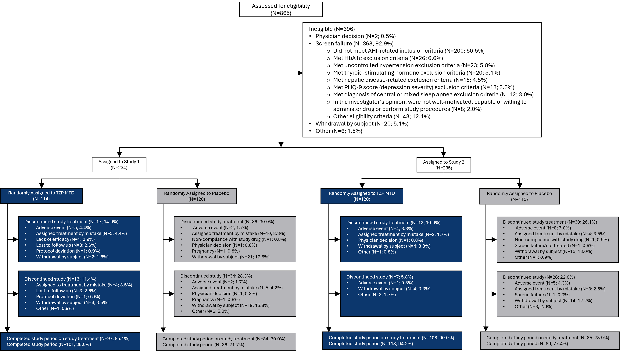

Adapted from previously published study protocol (1)

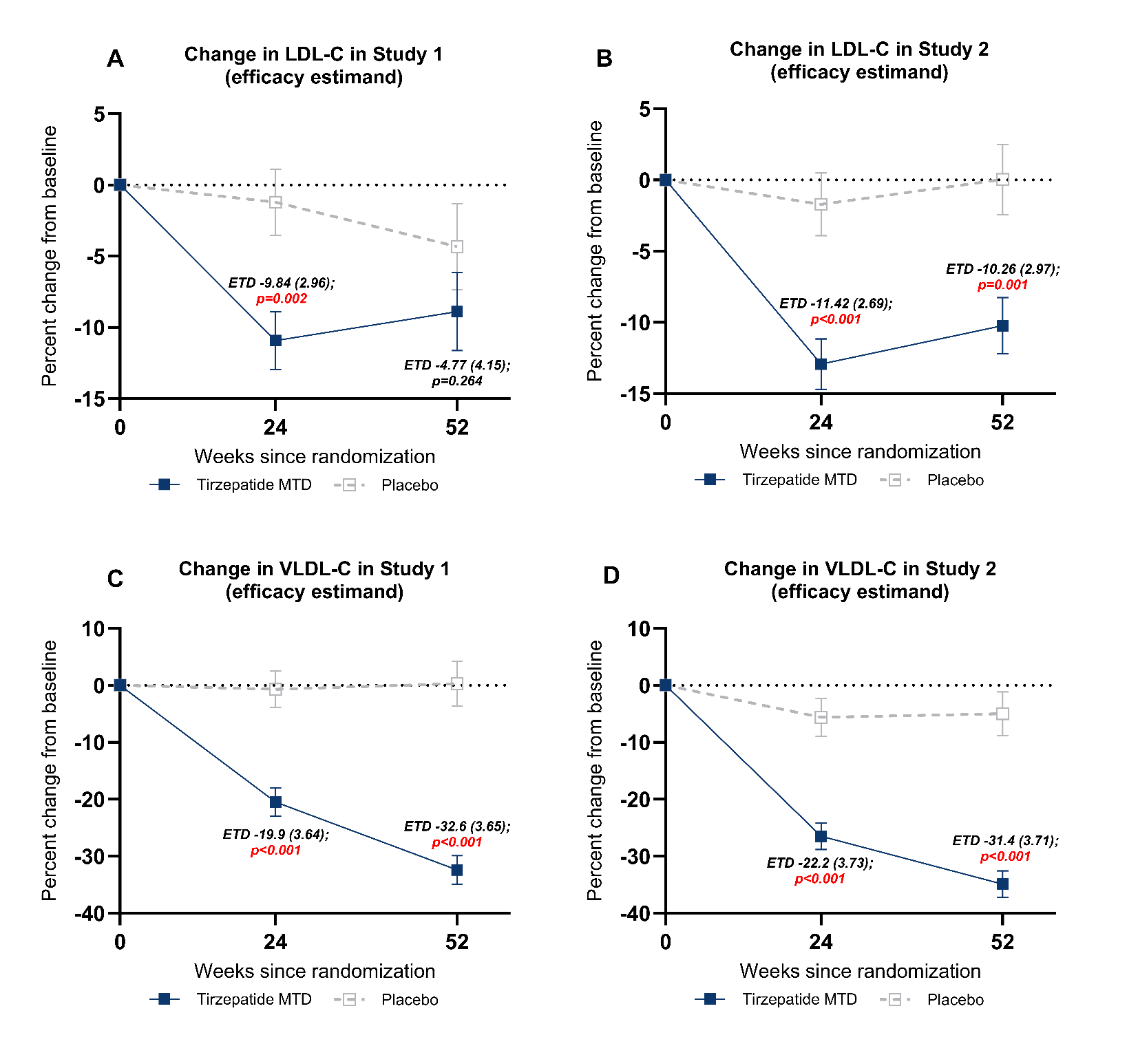
Figure S2: Change from baseline in LDL-C and VLDL-C

Data points are estimate ± SE
ETD = estimated treatment difference; LDL-C = low-density lipoprotein-cholesterol; MTD = maximum tolerated dose; SE = standard error; VLDL-C = very low-density lipoprotein-cholesterol

Table S1: Correlation between change in cardiometabolic parameters and change in body weight, AHI or SASHB
 | AHI | Body Weight | log(SASHB)
SBP | 0.11* | 0.29*** | 0.12*
DBP | 0.08 | 0.17** | 0.13*
hsCRP | 0.27*** | 0.37*** | 0.38***
HDL-C | -0.18*** | -0.29*** | -0.30***
Non-HDL-C | 0.25*** | 0.35*** | 0.28***
Triglycerides | 0.34*** | 0.47*** | 0.36***
HOMA-IR | 0.38*** | 0.53*** | 0.40***

**p-value <0.01, ***p-value <0.001 representing significant Pearson’s correlation coefficient.

Bibliography

1. Malhotra A, Grunstein RR, Fietze I, Weaver TE, Redline S, Azarbarzin A, et al. Tirzepatide for the Treatment of Obstructive Sleep Apnea and Obesity. N Engl J Med. 2024.

