Revealing Novel Protein Biomarkers for Female Infertility through an Integrated Analysis of Plasma Proteomics and Mendelian Randomization

Supplementary Figure 1 Protein-Protein Interaction (PPI) Network between Identified Causal Proteins and Implicated Protein Targets.
Supplementary Figure 2 Results of Drug-Gene Interaction Analysis.

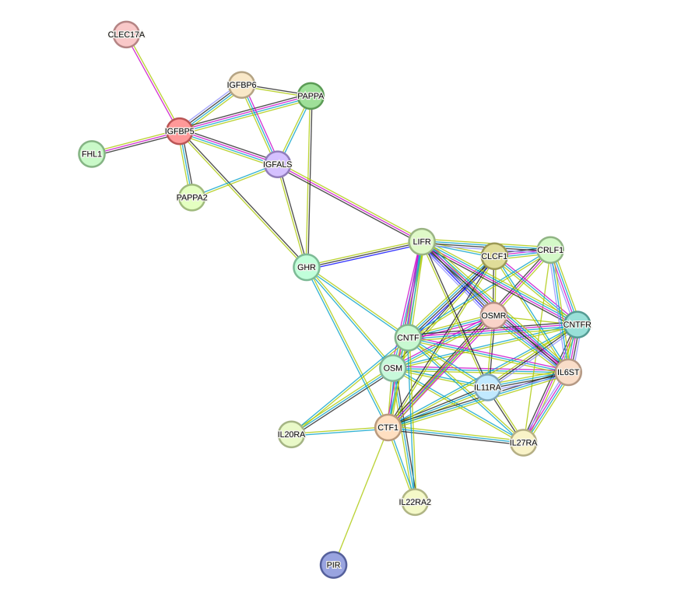
Supplementary Figure 1 Protein-Protein Interaction (PPI) Network between Identified Causal Proteins and Implicated Protein Targets.

- CTF1 (b) IGFBP5
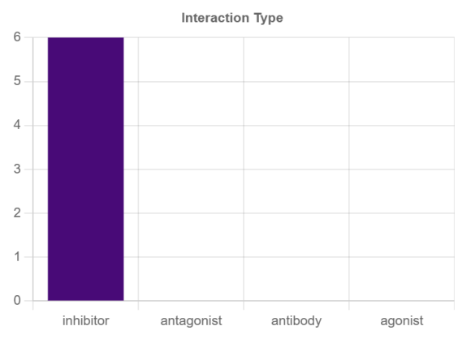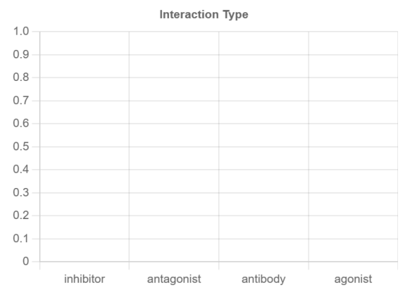

(c) CNTFR (d) IL11RA
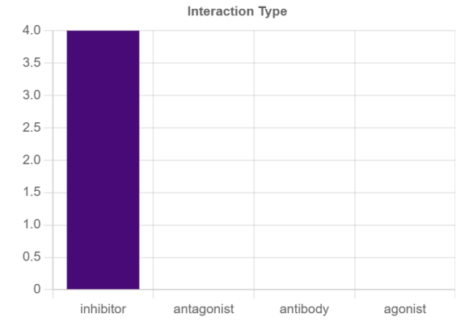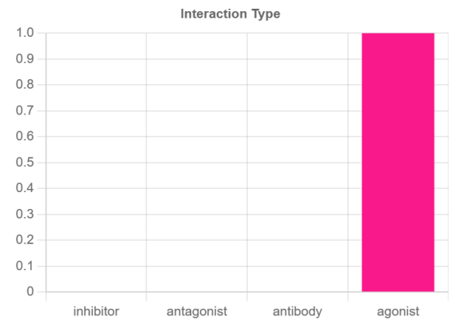

(e) OSMR (g) IL6ST
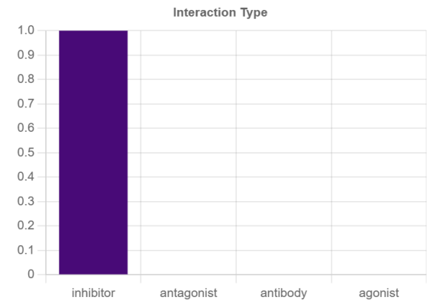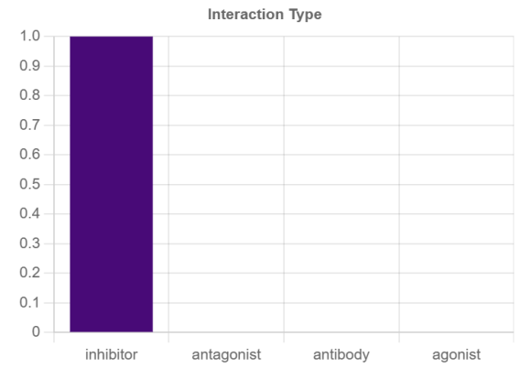

(g) LIFR (h) CNTF
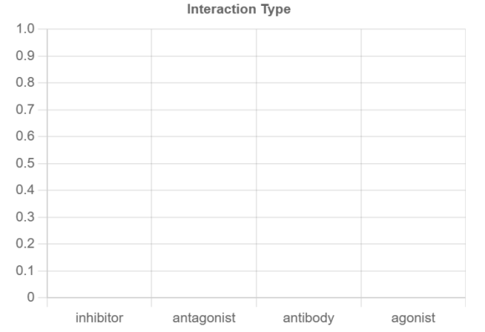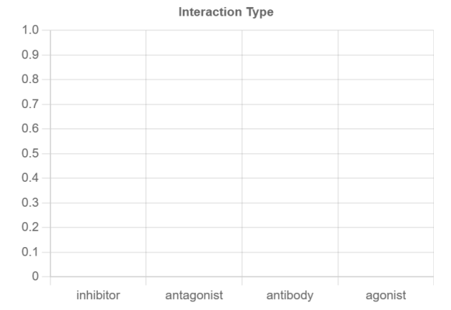

(i) OSM (j) FHL1
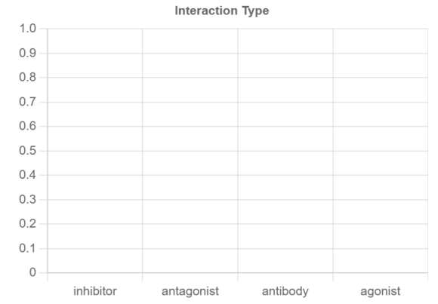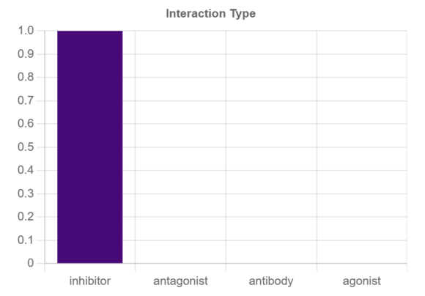

(k) IGFBP6 (l) PAPPA
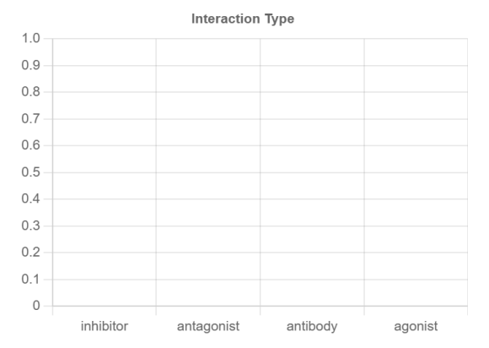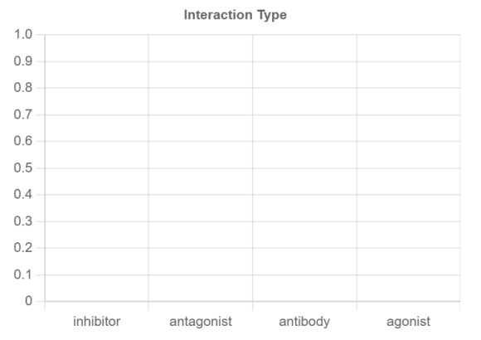

(m) PAPPA2 (n) GHR
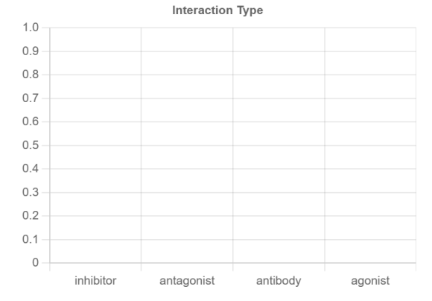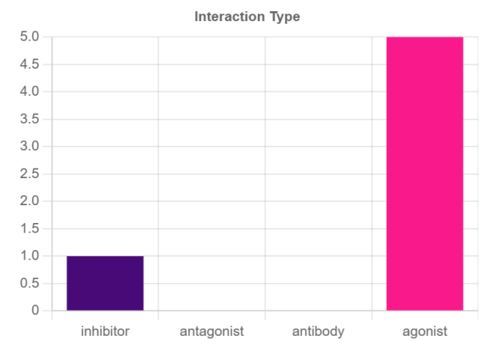
Supplementary Figure 2 Results of Drug-Gene Interaction Analysis. Plasma proteins: CTF1(a), IGFBP5(b), CNTFR(c), IL11RA(d), OSMR(e), IL6ST(g), LIFR(g), CNTF(h), OSM(i), FHL1(j), IGFBP6(k), PAPPA(l), PAPPA2(m), GHR(n). CTF1=Cardiotrophin-1, IGFBP5=Insulin-like growth factor-binding protein 5, CNTFR=Ciliary neurotrophic factor receptor subunit alpha, IL11RA=Interleukin-11 receptor subunit alpha, OSMR=Oncostatin-M-specific receptor subunit beta, IL6ST=Interleukin-6 receptor subunit beta, LIFR=Leukemia inhibitory factor receptor, CNTF=Ciliary neurotrophic factor, OSM=Oncostatin-M , FHL1=Four and a half LIM domains protein 1 , IGFBP6=Insulin-like growth factor-binding protein 6, PAPPA=Pappalysin-1 , PAPPA2=Pappalysin-2 , GHR=Growth hormone-binding protein.

