Supplemental materials
Spatiotemporal Dynamics of Human Ovarian Cortex Transcriptome Following Vitrification and Thawing: Insights into the FOS/AP-1 Pathway
Fanghao Guo*, Di Sun*, Haixia Ding*, Yanquan Li*, Mengxi Guo, Yongjian Ma, Rui Qiao, Songmao Li, Li Zhang, Qing Zhang#, Meiling Zhang#, Wen Li#
# Co-first authors: Fanghao Guo, Di Sun, Haixia Ding
* Corresponding authors: Wen Li, Meiling Zhang, Qing Zhang
E-mail: liwen@shsmu.edu.cn (Prof. Wen Li),
zhml1119@sina.com (Meiling Zhang), zhangqing08l@sina.com (Qing Zhang)
This PDF file includes:
Figs. S1 to S10
Major Resources Table
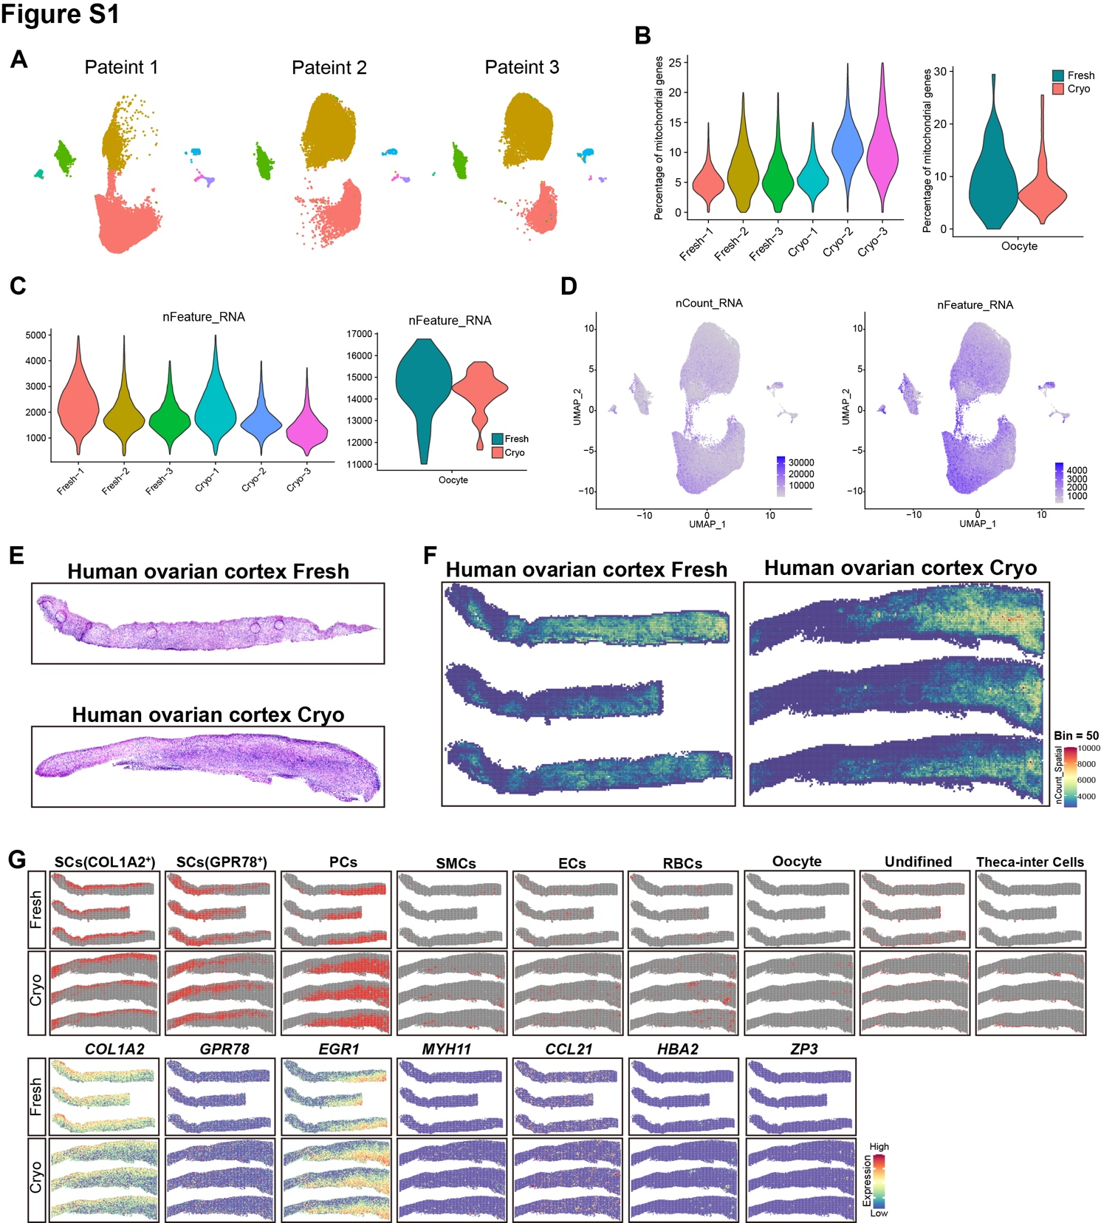
Figure S1. Information of human ovaries and quality control of scRNA-seq and Stereo-seq data.
A) UMAP showing seven cell types in each sample dependent on donor. B) Percentages of mitochondrial genes detected in each sample. Violin Plots (maximum, 25th percentile). C) Numbers of genes (nFeature_RNA) detected in each cell types shown by Violin Plots. D) The number of expressed UMIs (nUMI) and genes (nGene) in different cell types. E) Representative H&E staining of Fresh and Vitrification-Thawed human ovarian cortex sections for stereo-seq F) Spatial visualization of the distribution of captured transcripts on Fresh and Vitrification-Thawed human ovarian cortex sections (bin=50). G) All the cell type mapping resulted from Figure 1E were shown separately. In addition, the marker genes corresponding to each subgroup are displayed by SpatialFeaturePlot.
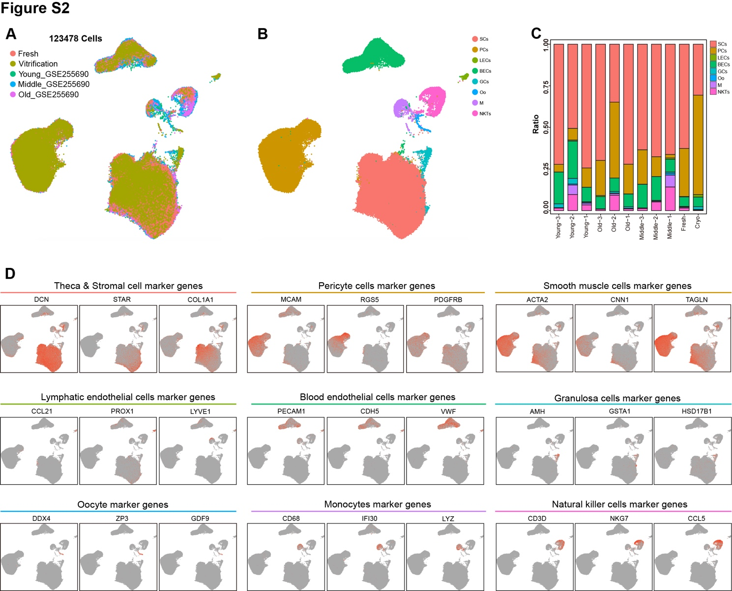
Figure S2. Integration of our ovarian sequencing data with additional data extracted from the published dataset GSE255690 helped identify the origins of subclusters.
A-B) UMAP showing the integration analysis of our single cell data with the published ovarian scRNA-seq data (GSE255690). C) Proportions of each subcluster for the fresh, vitrification-thawing and the GSE255690. D) Featureplots characterized representative marker genes for different cell types and were used to define clusters of integrated human ovarian single cell data.
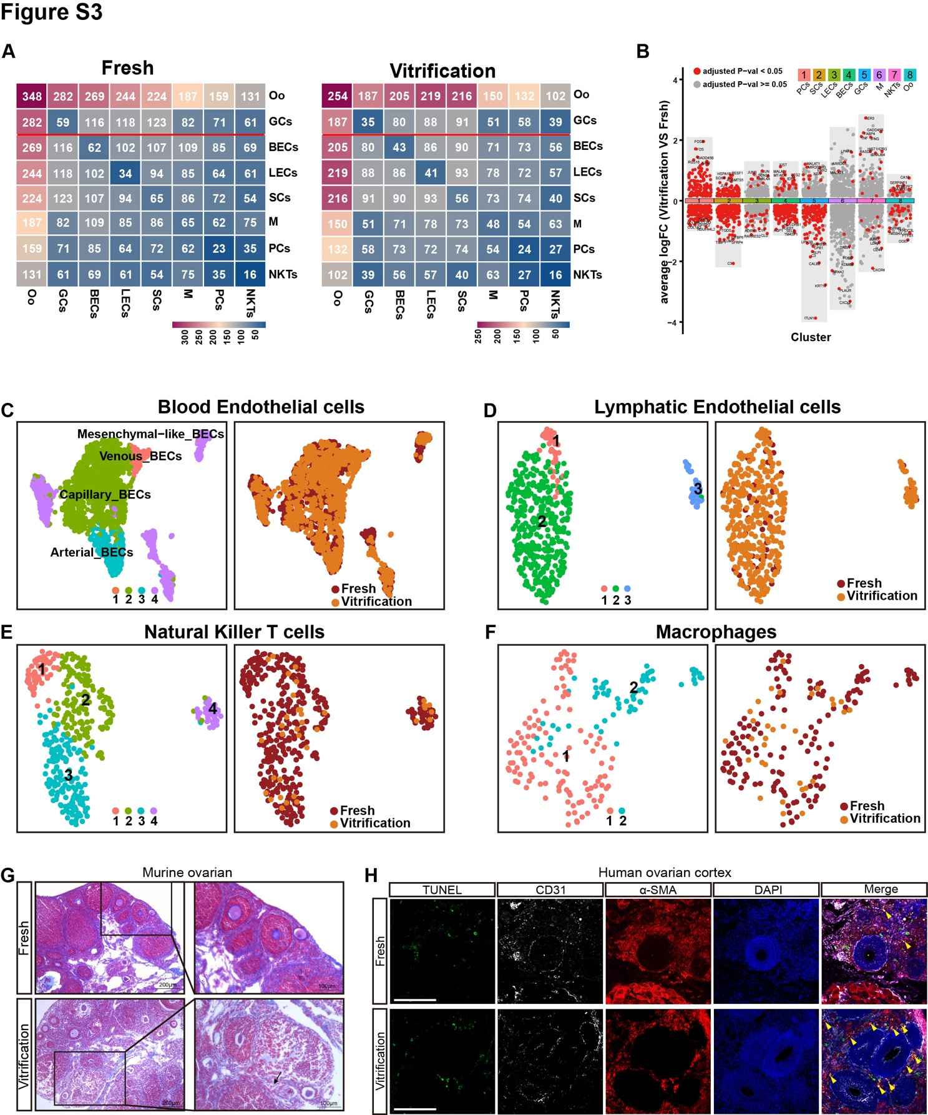
Figure S3. The expression changes of Blood Endothelial, Lymphatic Endothelial, Natural Killer T, and Macrophages cells differ after vitrification-thawing treatment.
A) Heatmap of molecular interaction levels between Seurat clusters (Left: Fresh, Right: Vitrification-Thawed processed), calculated using CellPhoneDB. B) Differential gene expression analysis showing up- and down-regulated genes across all ten clusters. An adjusted p value < 0.05 is indicated in red, while an adjusted p value >= 0.05 is indicated in black. C) 4 clusters subclustered from integrated Blood Endothelial cells subset and the fraction of each subcluster calculated separately from fresh and vitrification-thawing processed ovary. D) 3 clusters subclustered from integrated Lymphatic Endothelial cells subset and the fraction of each subcluster calculated separately from fresh and vitrification-thawing processed ovary. E) 4 clusters subclustered from integrated Natural Killer T cells subset and the fraction of each subcluster calculated separately from fresh and vitrification-thawing processed ovary. F) 2 clusters subclustered from integrated Macrophages subset and the fraction of each subcluster calculated separately from fresh and vitrification-thawing processed ovary. G) Masson staining evaluates ovarian tissue fibrosis after vitrification-thawing in murine ovary. H) Multiplex immunofluorescence staining for TUNEL, CD31 (Endothelial cells marker), α-SMA (Perivascular cells marker) of fresh and vitrification-thawed human ovarian cortex. The experiment was repeated three times. Scale bar = 100um
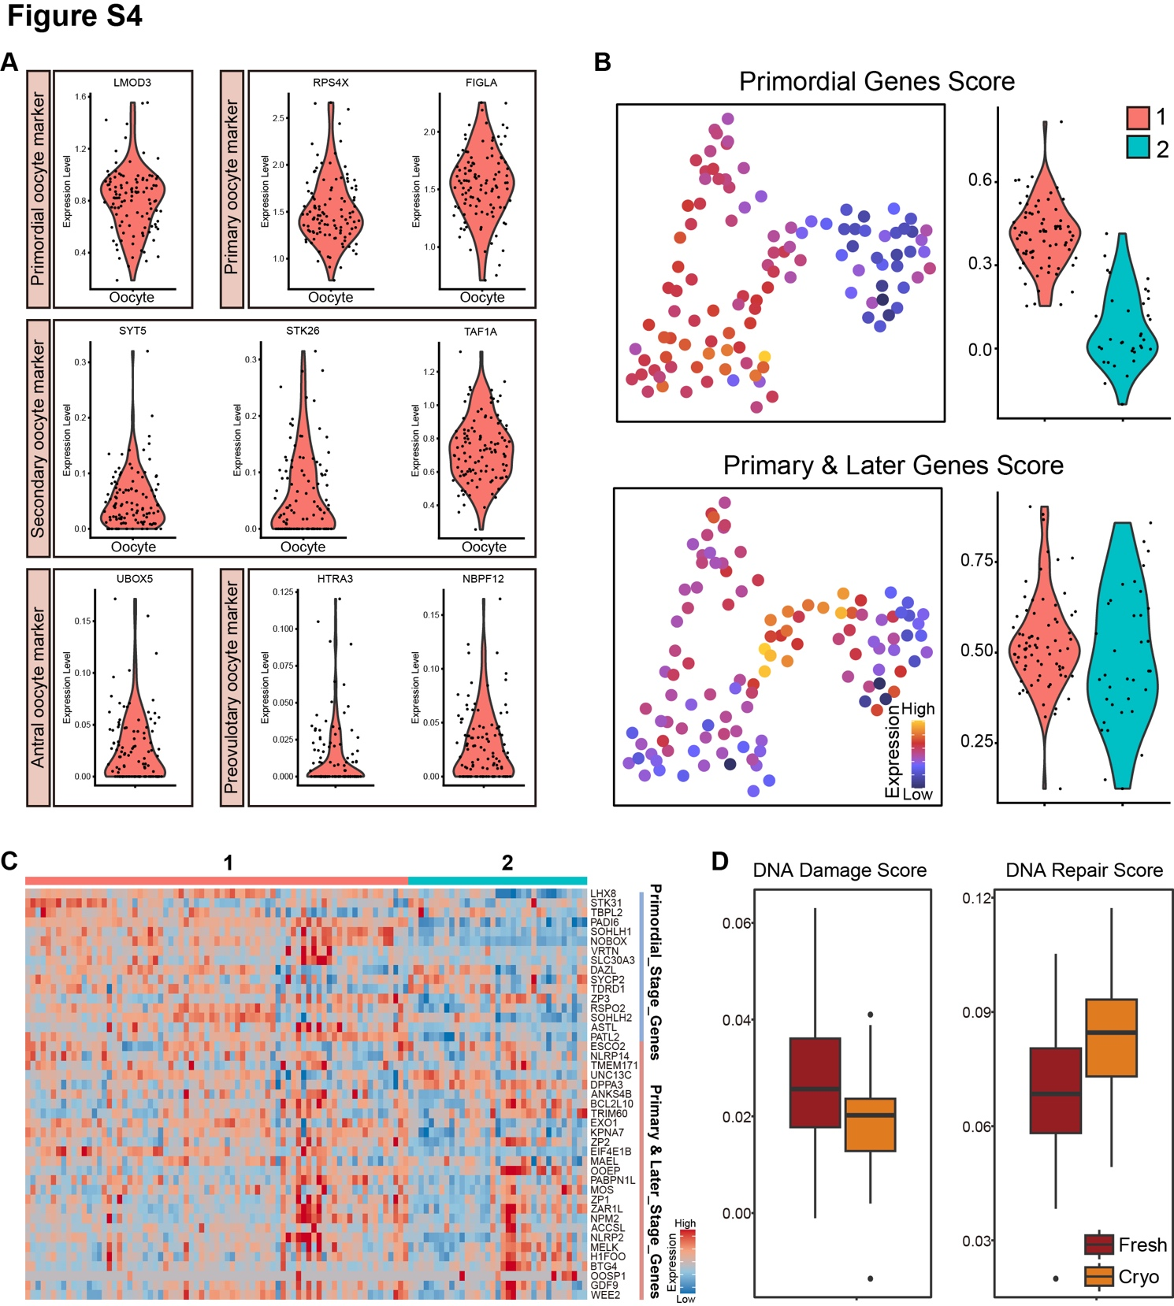
Figure S4. Supplement of gene expression in oocytes changed throughout human ovarian vitrification and thawing.
A) The expression level of stage-specific markers for oocytes. LMOD3 for primordial oocytes, RPS4X and FIGLA for primary oocytes, SYT5, STK26 and TAF1A for secondary oocytes, UBOX5 for antral oocytes, HTRA3 and NBPF12 for preovulatory oocytes. B) Gene set score analysis of primordial genes and primary/later genes in oocytes via FeaturePlot and VlnPlot strategy. C) Heatmap illustrating the DEGs of each oocyte stage in subcluster 1 and 2. D) Gene set score analysis of DNA damage and DNA repair pathways in oocytes post vitrification-thawing.
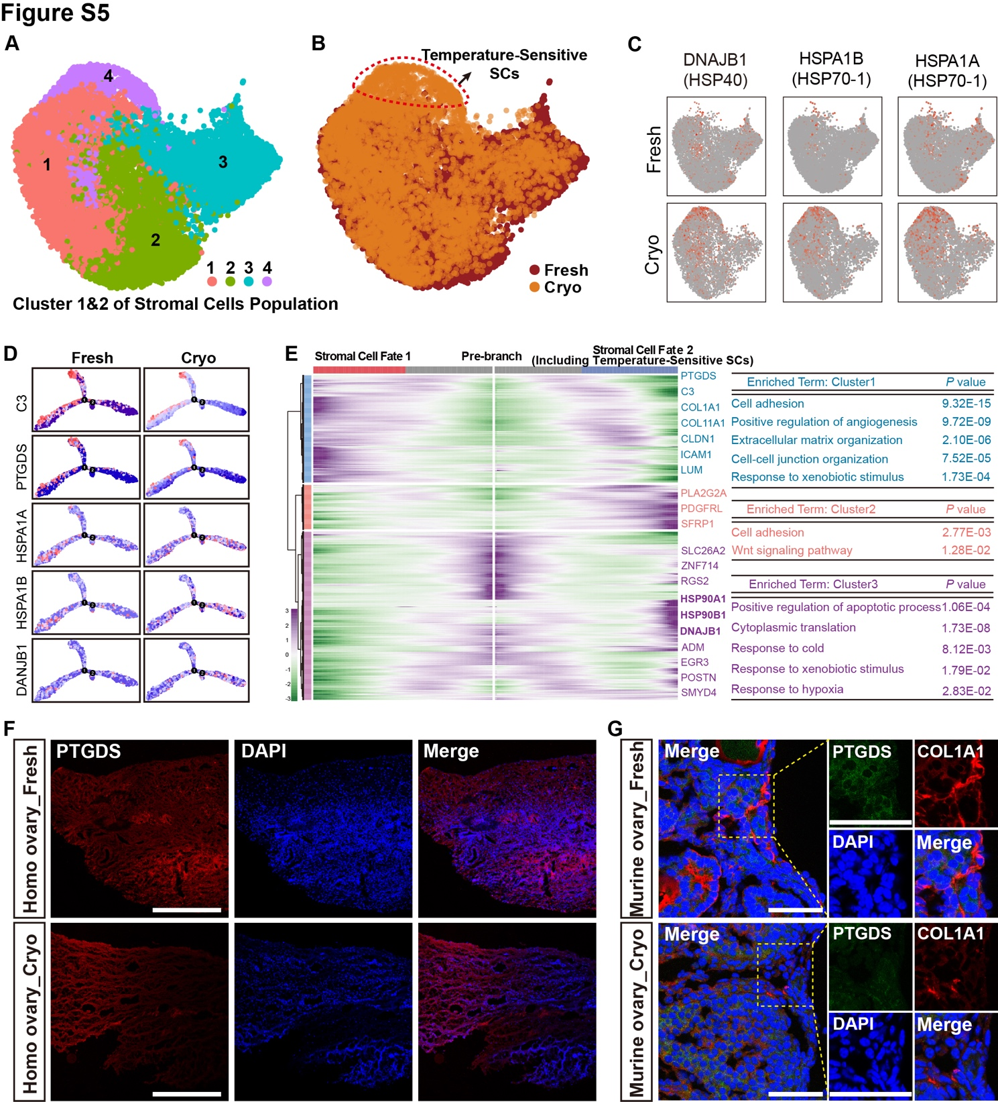
Figure S4. Supplement of SCs subclusters.
A) UMAP showing the 4 subpopulations which deriving from subcluster 1 and 2 in Figure 4A. B) Integration analysis displayed the different clustering between fresh and vitrification treatment, and the additional subgroup has been defined as “Temperature-sensitive Stromal cells”. C) Featureplot showing the expression profile of DNAJB1, HSPA1B and HSPA1A in fresh and vitrification-thawed stromal cells, respectively. D) The plot_cell_trajectory displays the dynamic expression trends of representative genes at different time points following the vitrification and thawing process. E) heatmap shows the differentially expressed genes (DEGs) across various blocks along the pseudotime trajectory. From stromal cell fate1 to stromal cell fate2 which includes the Temperature-Sensitive SCs. Right: Representative genes and GO (Gene Ontology) analysis reveal the primary cellular biological functions of each cluster. F) Immunofluorescent labeling of PTGDS protein expression was performed in both fresh and vitrification-thawed human ovarian cortex samples. scale bar=100μm. G) Co-immunofluorescent labeling of PTGDS and COL1A1 protein was performed in both fresh and vitrification-thawed murine ovary. scale bar=200μm.
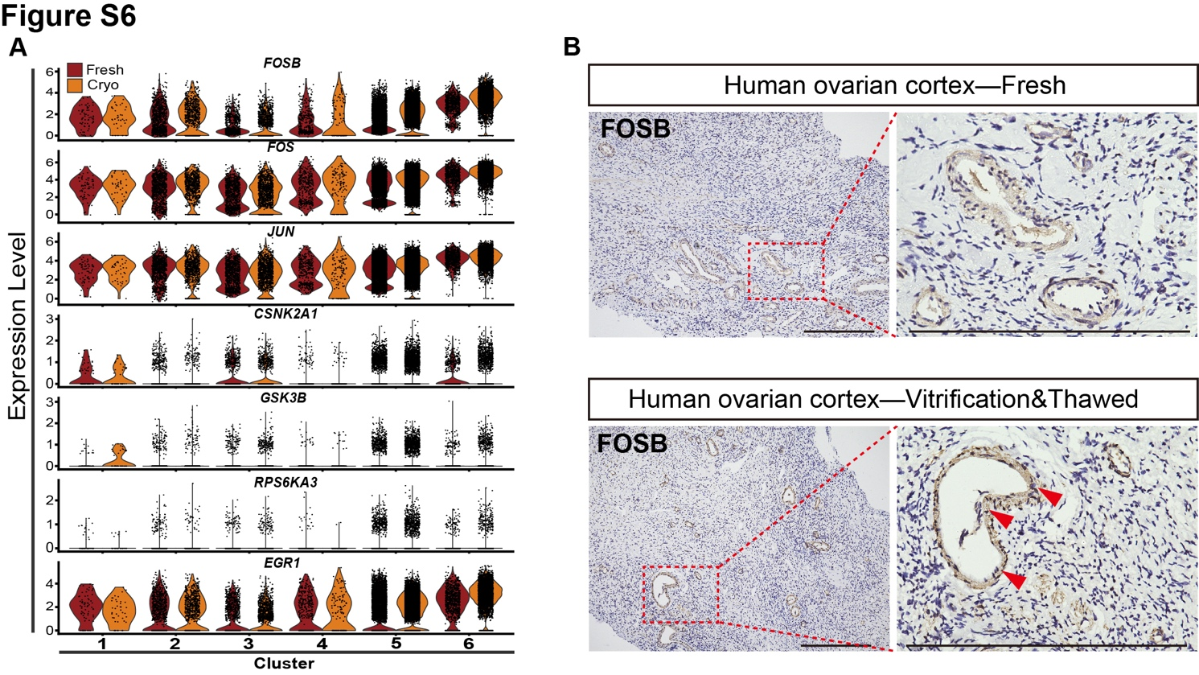
Figure S6. Supplement of PCs subclusters.
A) Vlnplot showing the expression profile of up and downstream genes in AP-1 pathway. B) Immunohistochemical staining of FOSB in both fresh and vitrification-thawed treated human ovarian cortex section, scale bar=200μm.
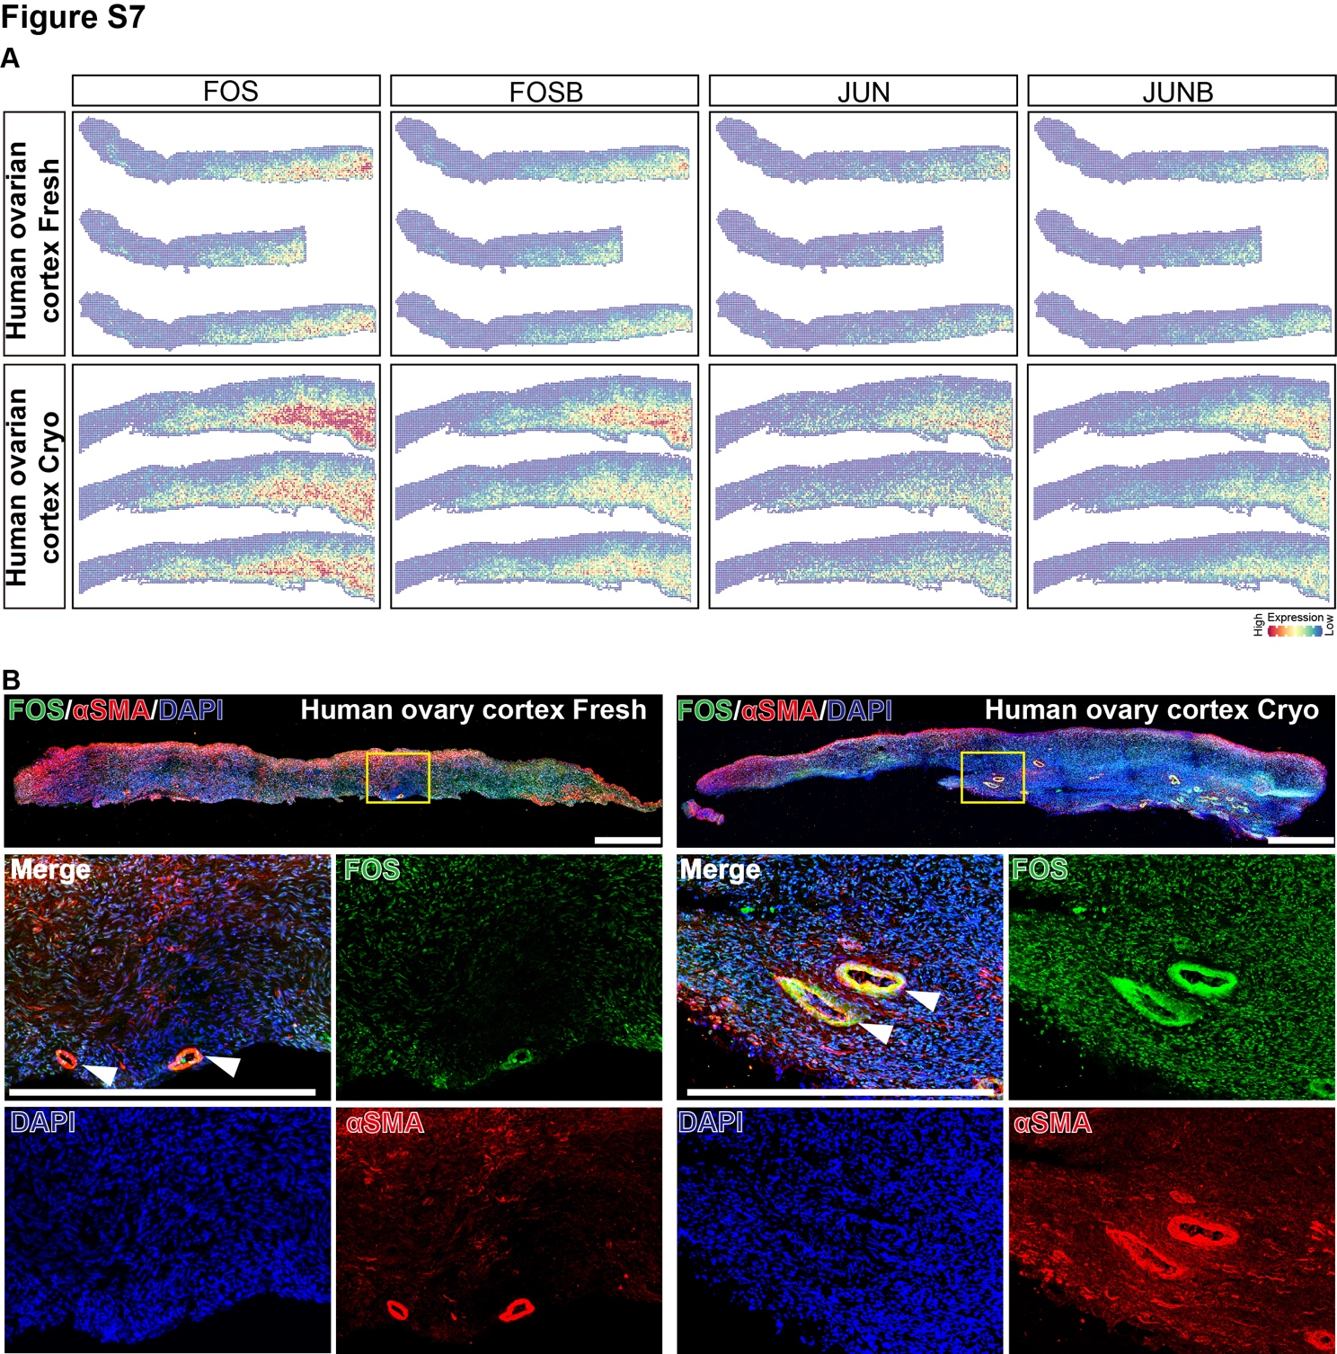
Figure S7. Validation of AP-1 Complex pathway being significantly activated after vitrification-thawed processed in ST-seq data.
A) SpatialFeatureplots show FOS, FOSB, JUN and JUNB (AP-1 complex) expression in fresh and vitrification-thawed ovarian cortex section in situ. Deeper color means higher expression score. B) Immunofluorescence staining was employed to detect the expression site of FOS in sections of human ovary tissue sextion used for stereo-seq, both fresh and following vitrification-thawing treatment.
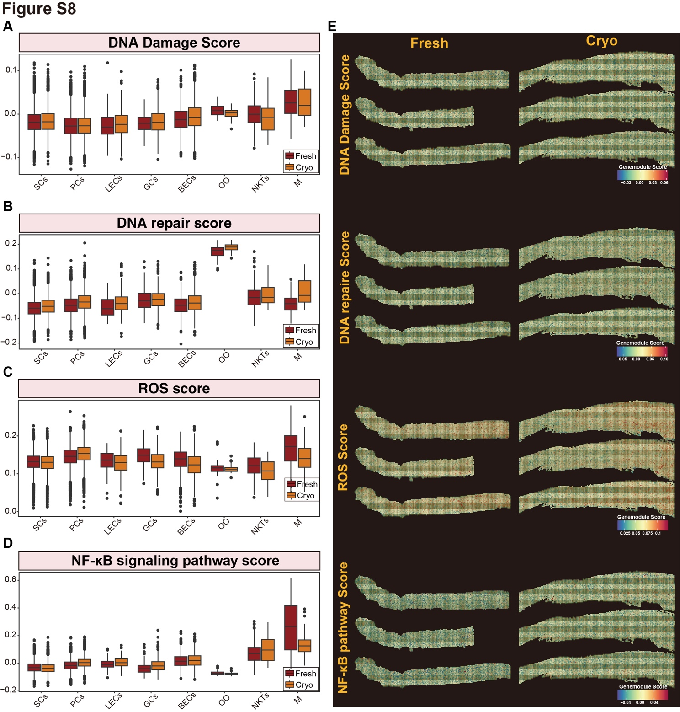
Figure S8. Gene set score analysis of representative signaling pathways in ovarian cell types between vitrification-thaw and fresh groups.
A) Gene set score analysis of DNA damage pathway in all ovarian cells with vitrification-thawed vs Fresh. B) Gene set score analysis of DNA repaire pathway in all ovarian cells with vitrification-thawed vs Fresh. C) Gene set score analysis of reactive oxygen species metabolic process (ROS) in all ovarian cells with vitrification-thawed vs Fresh. D) Gene set score analysis of NF-κB signaling pathway in all ovarian cells with vitrification-thawed vs Fresh.
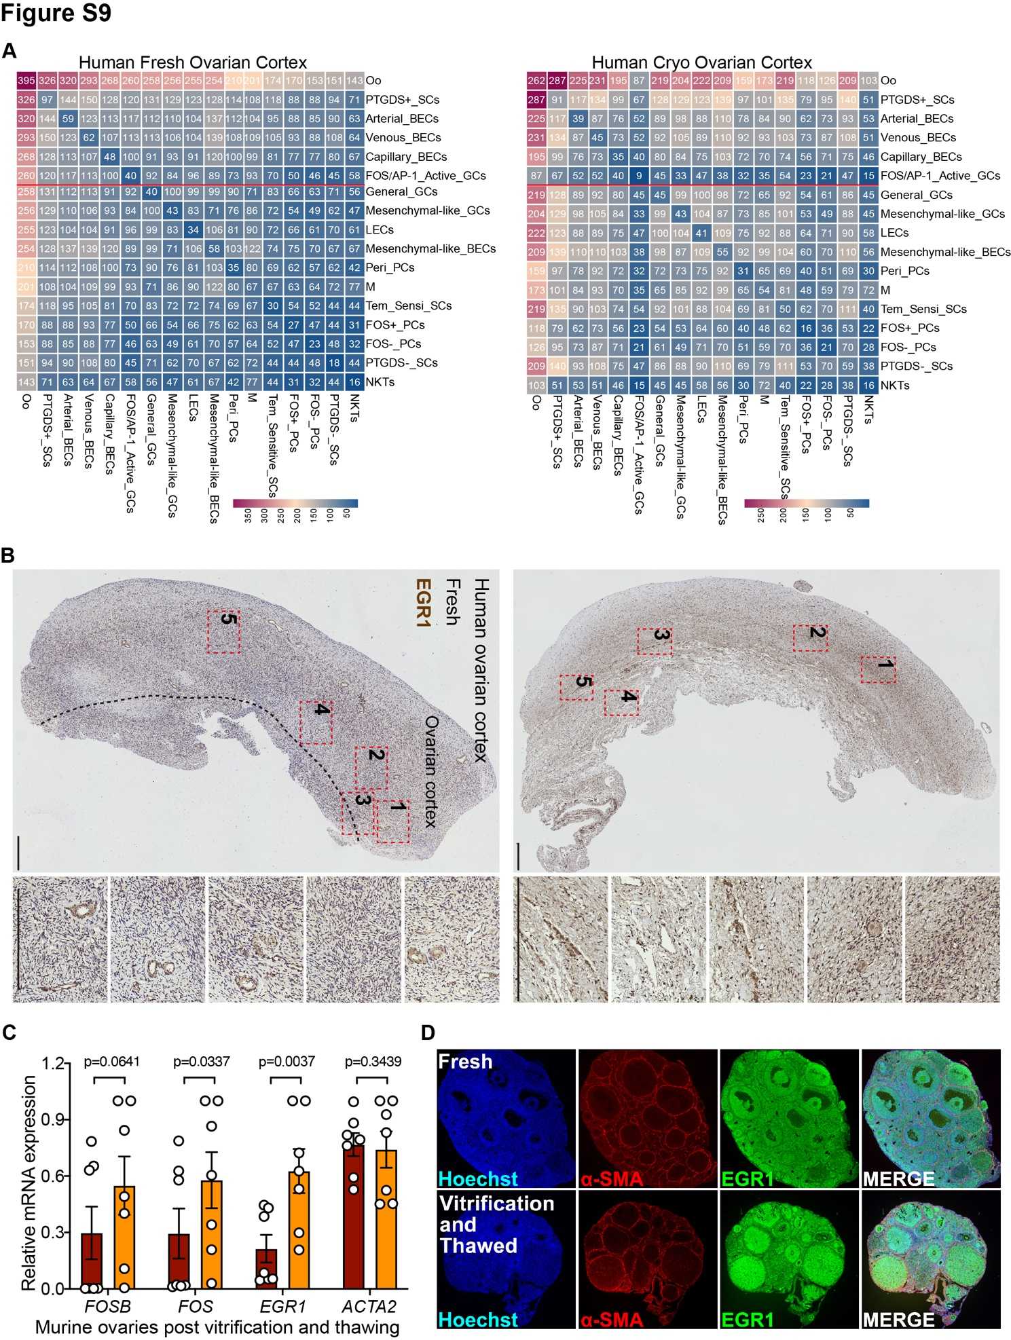
Figure S9. Quantification of ligand/receptor changes across specific cell types after vitrification-thawing, and preliminary downstream analysis of the FOS/AP-1 pathway.
A) Heatmap of molecular interaction levels between Seurat clusters (Left: Fresh, Right: Vitrification-Thawed processed), calculated using CellPhoneDB. B) Immunohistochemical staining of EGR1 in both fresh and vitrification-thawed treated human ovarian cortex section, scale bar=200μm. C) Quantitative RCR analysis on FOSB, FOS, EGR1 in murine ovaries post vitrification and thawing. D) Dual immunofluorescence of EGR1 and SMA in the fresh and vitrification-thawed murine ovaries. Scale bar = 500um.
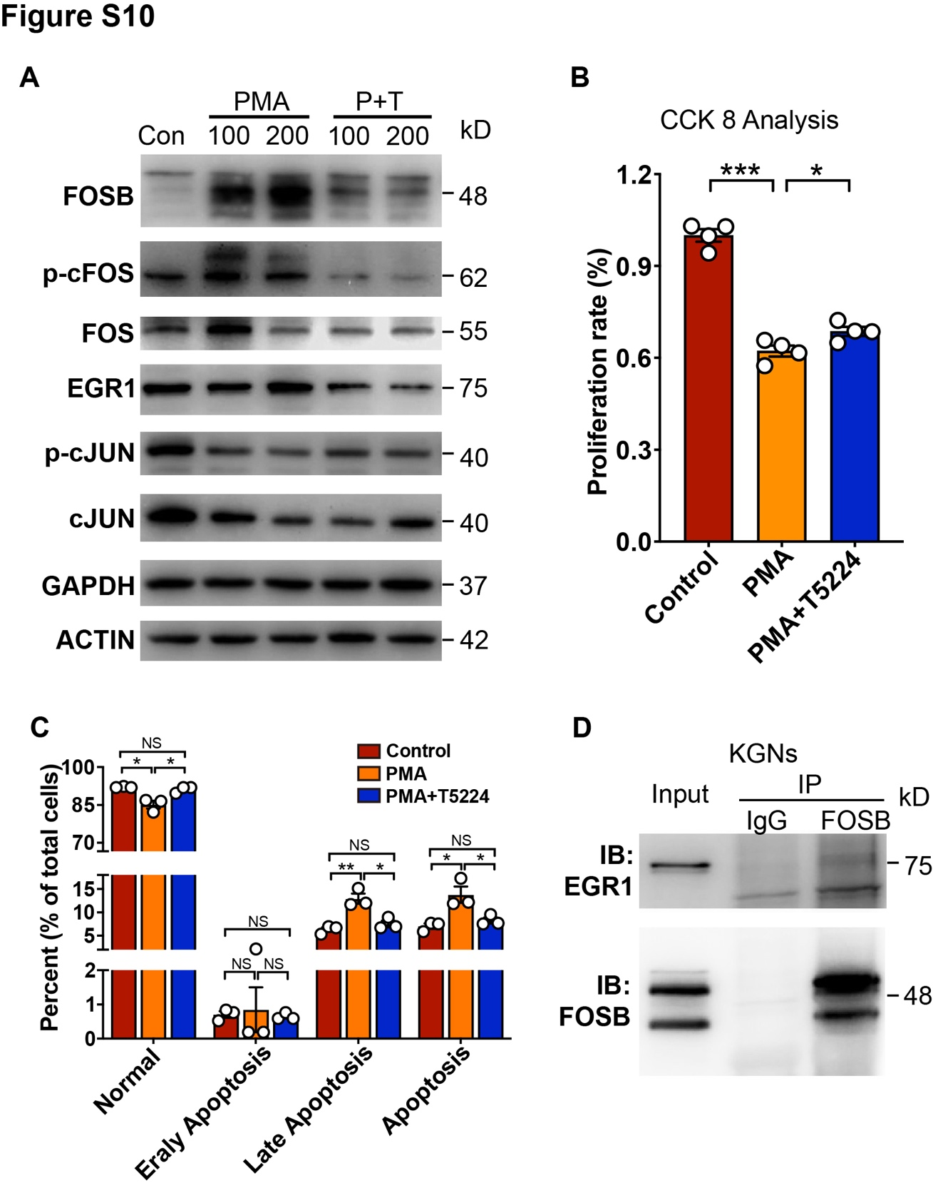
Figure S10. Activation of the FOS/AP-1 pathway in vitro results in decreased proliferation and increased apoptosis in granulosa cells.
A) Western blot analysis reveals the expression of the AP-1 complex family and downstream target EGR1 following treatment with phorbol 12-myristate 13-acetate (PMA) and co-treatment with PMA and T-5224 (P+T). B) CCK8 assays demonstrate the proliferative capacity of KGN cells under PMA treatment and co-treatment with PMA and T-5224. C) Apoptosis assays assess KGN cell apoptosis rates in response to PMA treatment and co-treatment with PMA and T-5224. D) Immunoprecipitation experiments confirm a direct interaction between FOS and EGR1 proteins.
Major Resources Table
Table 1: Patient detail information
Note: /, not applicable; BMI, body mass index; AFC, antral follicle account; AMH, Anti-Müllerian hormone; FSH, Follicle-stimulating hormone; LH, Luteinizing hormone; E2, Estradiol
animals (in vivo studies)
Species | Vendor or Source | Background Strain | Sex | Persistent ID / URL
Mouse | International Peace Maternity and Child Health Hospital, School of Medicine, Shanghai Jiao Tong University | C57BL/6J | Female | /
Others
Description | Source / Repository | Persistent ID / URL
Chromium Single Cell 3’ Library & Gel Bead Kit v2 | 10 X Genomics | https://www.10xgenomics.com/products/single-cell-gene-expression
KITAZATO Ovarian Tissue Vitrification Kit | KITAZATO | https://kitazato-ivf.com/vitrification/ovarian-tissue-vitrification/
Collagenase Type I | Sigma/flu/Ald | https://www.sigmaaldrich.com/HK/zh/product/sigma/c0130
STOmics Stereo-seq Kits | 211ST004, 211SP118, 211ST114, 301AUX001, 211SC114, 111KL114 | https://en.stomics.tech/products/stereo-seq-transcriptomics-solution/list.html
Oligos used in this study
Name | Sequence (5’-3’) | Description
homo_PTGDS_F1 | CCAGGGCTGAGTTAAAGGAGA | qPCR primer
homo_PTGDS_R1 | CCGTCATGCACTTATCGGTTTG | qPCR primer
homo_FOS-F | CCGGGGATAGCCTCTCTTACT | qPCR primer
homo_FOS-R | CCAGGTCCGTGCAGAAGTC | qPCR primer
homo_FOSB-F | GCTGCAAGATCCCCTACGAAG | qPCR primer
homo_FOSB-R | ACGAAGAAGTGTACGAAGGGTT | qPCR primer
homo_EGR1-F | GGTCAGTGGCCTAGTGAGC | qPCR primer
homo_EGR1-R | GTGCCGCTGAGTAAATGGGA | qPCR primer
homo_CDKN1A-1-F | GTCTTGTACCCTTGTGC | qPCR primer
homo_CDKN1A-1-R | GGCGTTTGGAGTGGTAGAAA | qPCR primer
homo_JUN-F | TGACTGCAAAGATGGAAACG | qPCR primer
homo_JUN-R | GGGTCATGCTCTGTTTCAGG | qPCR primer
homo_JUNB-F | AACAGCCCTTCTACCACGAC | qPCR primer
homo_JUNB-R | CAGGCTCGGTTTCAGGAGTT | qPCR primer
homo_RGS16-F | GAGGATCCGATGAGTTGCTGG | qPCR primer
homo_RGS16-R | TGAGTTCTTTGGCTCTCTCCA | qPCR primer
homo_BTG2 F | ACGGGAAGGGAACCGACAT | qPCR primer
homo_BTG2 R | CAGTGGTGTTTGTAGTGCTCTG | qPCR primer
homo_ACTA2-F | AAAAGACAGCTACGTGGGTGA | qPCR primer
homo_ACTA2-R | GCCATGTTCTATCGGGTACTTC | qPCR primer
mus_PTGDS_F1 | TTTCAACAAGACAAGTTCCTGGG | qPCR primer
mus_PTGDS_R1 | GGCTGCTGTAGGTGTAGTGT | qPCR primer
mus_Fos-F | CGGGTTTCAACGCCGACTA | qPCR primer
mus_Fos-R | TGGCACTAGAGACGGACAGAT | qPCR primer
mus_Fosb-F | CGAGAAGAGACACTTACCCCA | qPCR primer
mus_Fosb-R | GTTTCCGCCTGAAGTCGATCT | qPCR primer
mus_Egr1-F | TCGGCTCCTTTCCTCACTCA | qPCR primer
mus_Egr1-R | CTCATAGGGTTGTTCGCTCGG | qPCR primer
mus_Acat2-F | GGACGTACAACTGGTATTGTGC | qPCR primer
mus_Acat2-R | TCGGCAGTAGTCACGAAGGA | qPCR primer

