A Long-read based Haplotype Panel Enhances Imputation and Discovery of Functional Small and Structural Variants

Tingting Gong, Yulu Zhou, Yechao Huang, Junfan Zhao, Jiao Gong, Jinxi Li, Qianqian Peng, Huidan Chang, Liyun Yuan, Guoqing Zhang, Sijia Wang, Li Jin, Shaohua Fan

Supplementary Information
Supplementary Data
Supplementary Data 1: The benchmark and haplotype-resolved variant set of HG002 and LCL6.

Supplementary Data 2: The called and phased heterozygous variant counts per individual in a cohort with 945 Chinese samples.

Supplementary Data 3: Imputation quality on SNP array data from 9,909 individuals from three Han Chinese cohorts.

Supplementary Data 4: GWAS signals for ﬁngerprint pattern type in Han Chinese from this study and Li et al. 2022.

Supplementary Data 5: Imputation quality on a small variant set derived from SRS data of a cohort with 1,016 Chinese individuals.

Supplementary Data 6: Significant independent GWAS signals for skin trait in 1,016 Chinese individuals.

Supplementary Data 7: Suggestive significant independent GWAS SV signals for skin trait in 1,016 Chinese individuals.

Supplementary Data 8: 145 quantitative skin pigmentation related phenotypes used to run GWAS in 1,106 Chinese individuals.

Supplementary Data 9: Summary of previously reported genetic studies on skin related phenotypes.

Supplementary Figures

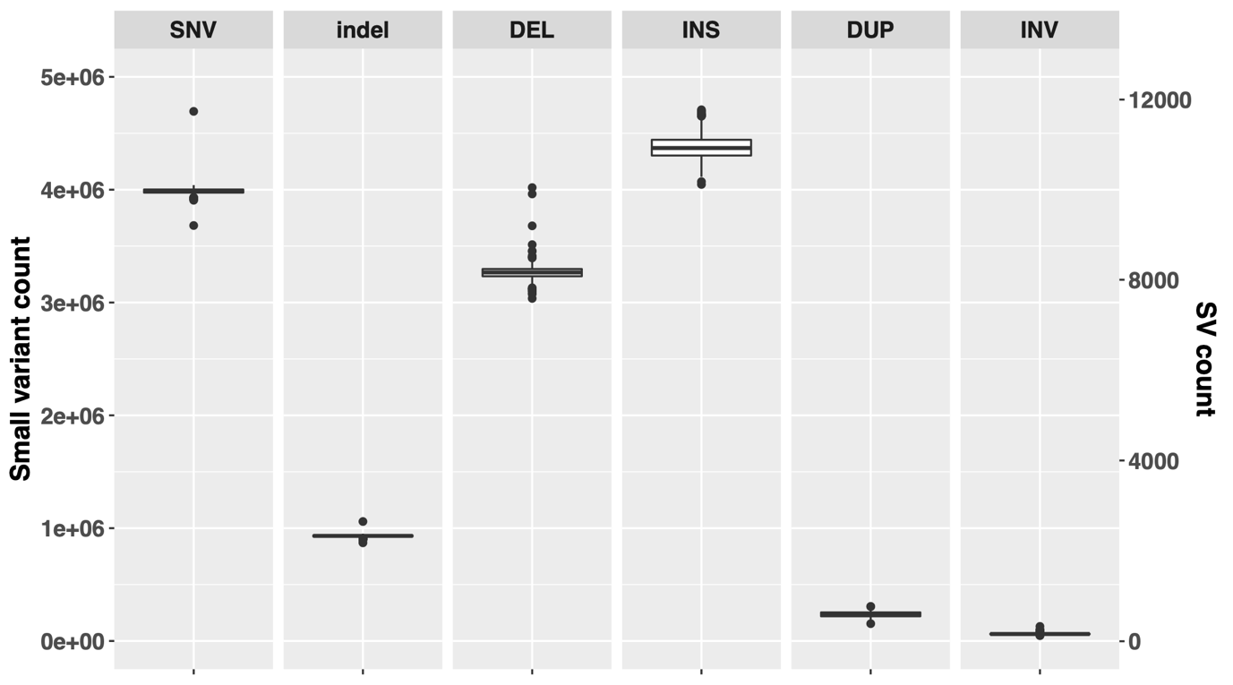
Figure S1. The number of high-quality variants per individual derived from 943 Chinese individuals. Small variants and SVs were called and genotyped from SRS data (~30X) and LRS data (100 with ~30X and 843 with ~15X depth of coverage), respectively. The count of small variants is labelled on the left vertical axis and SV count on right vertical axis. Each column represents different types of variants, including small variants (SNVs and indels) and SVs (DEL, INS, DUP and INV).

Figure S2. Comparison of different phased SV sets to benchmark haplotype-resolved SV set of HG002 and LCL6. The percentage of haplotype-resolved SV set being recovered by different phased sets (y-axis) was calculated based on breakpoint difference threshold from 10-500 bp (x-axis). Red line represents the phased SV set of HG002 and LCL6 from the individual-level LRS-based calling, genotyping and phasing. Individual-level phased SV sets of all samples in Han Chinese cohort, and HG002 and LCL6 were merged to generate multi-sample SV set as haplotype scaffold (Methods). Green line represents the phased SV set in haplotype scaffold, which may have genomic coordinates shifted compared to individual-level SV phased set due to SV merging across samples. Blue line represents the phased SV set of HG002 and LCL6 after statistically inferring the haplotypes for the unphased variants using the long-read phased variants as haplotype scaffold (Methods).
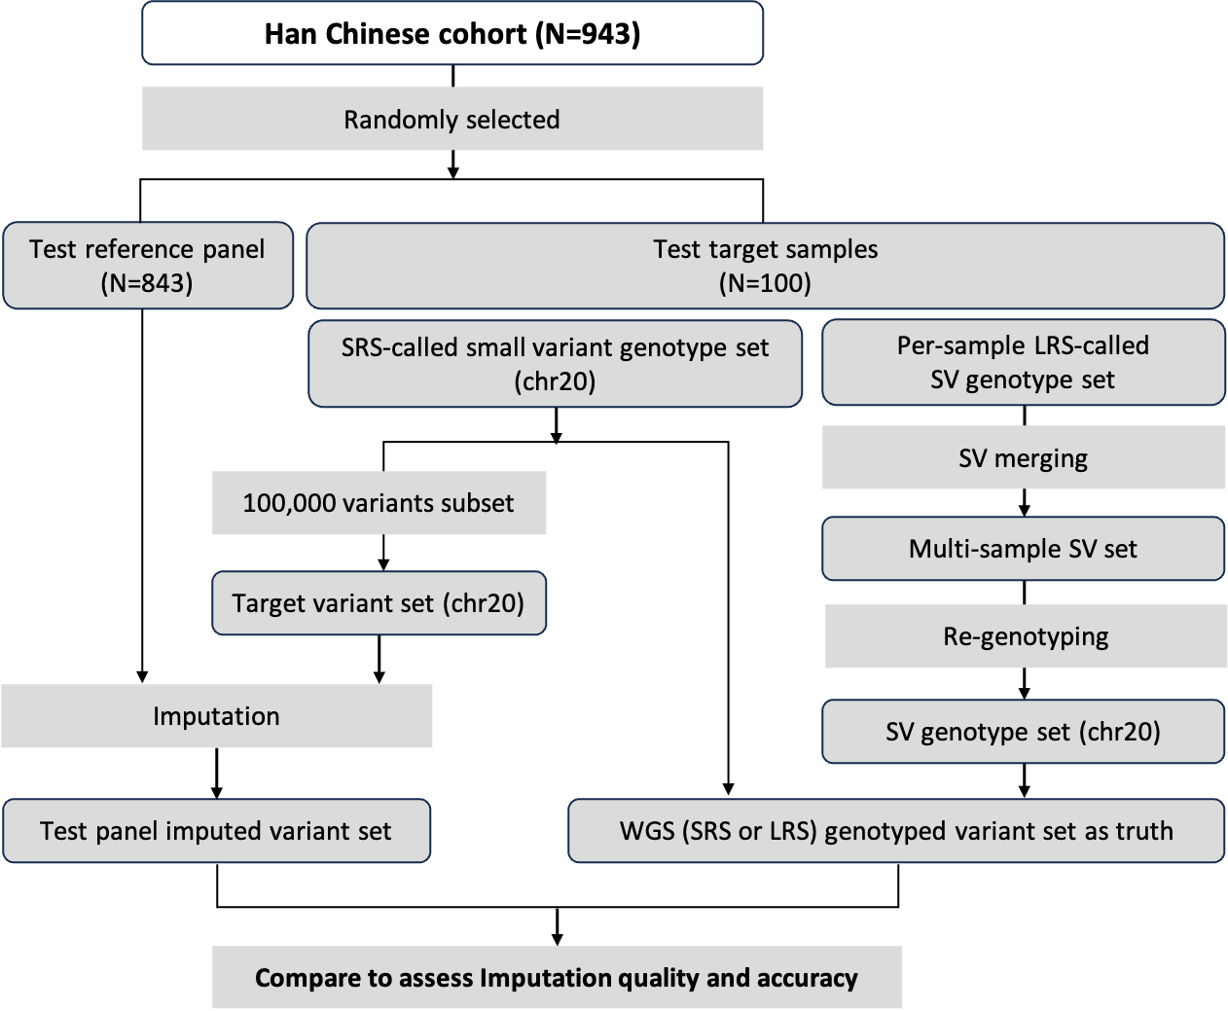
Figure S3. Imputation performance evaluation framework. In addition to the Test reference panel, the expanded-1KGP panel was also used to impute on the test target variant set and its imputation performance was also evaluated using this framework. Methods implemented in each step were shown in boxes without borders.
Figure S4. Imputation quality. Count of imputed variants on chromosome 20 of test 100 samples were shown versus different imputation dosage $r^{2}$ from 0 to 0.9. The percentage of variant among total imputed count is shown on top of each bar.
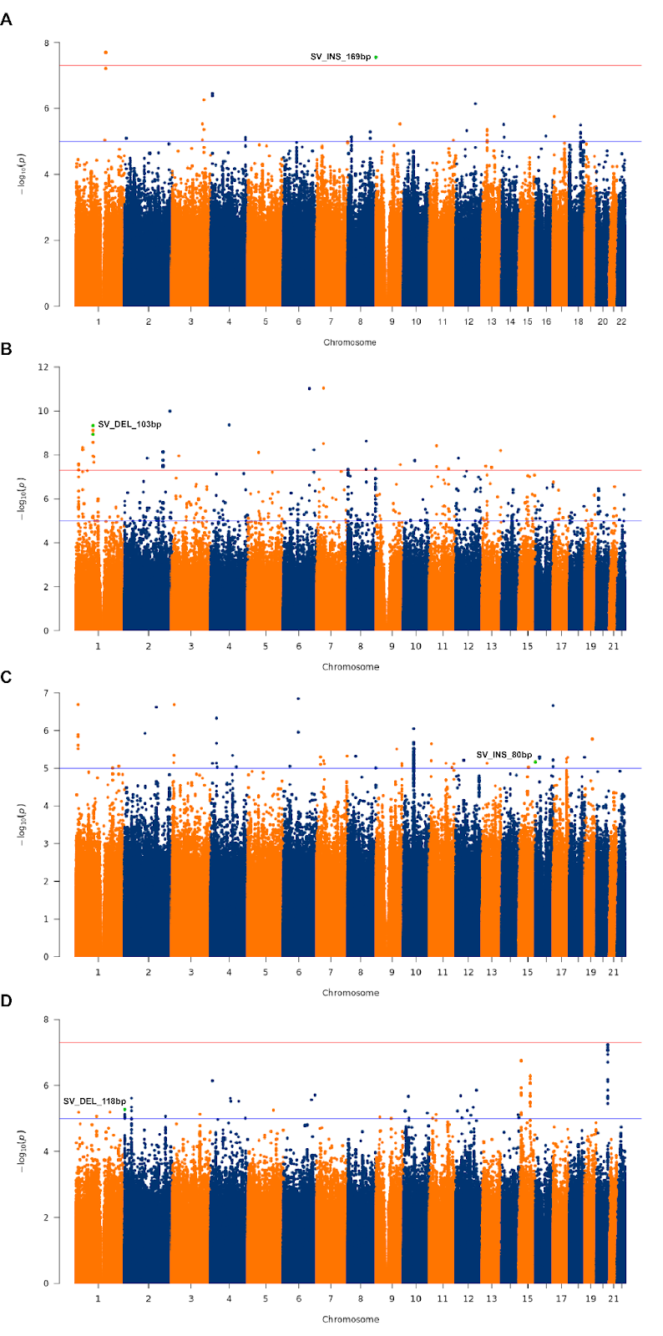
Figure S5. Manhattan plots of GWAS conducted for skin phenotypes. The red line indicates the threshold for genome-wide significance (p < 5 × 10⁻⁸), and the blue line indicates the threshold for suggestive associations (p < 1 × 10⁻⁵). Genome-wide scans of skin phenotype associated with moisture in the left cheek. Dot in green indicates the 169-base insertion as an independent SV signal in this region. (B) Genome-wide scans of skin phenotype associated with roughness (SELS-Roughness) in the flexor side of the left arm. Green dot indicates the 103-base DEL as an independent signal in this region. (C) Genome-wide scans of skin phenotype associated with smoothness (SELE-Smoothness) in the left check. Green dot indicates the 80-base insertion as an independent SV signal found in this region. (D) Genome-wide scans of skin phenotype associated with ITA° in the flexor side of the left arm. Green dot indicates the 118-base DEL as an independent variant in the region.

