Appendix/ Online Supplement

Resilience among parents whose child died of cancer – Investigating its role on psychological distress and prolonged grief: Results from a cross-sectional survey in Switzerland

Short title: Resilience of cancer bereaved parents

Peter Francis Raguindin 1, Eva De Clercq 1, Anna Katharina Vokinger 1, Eddy Carolina Pedraza 1, Céline Bolliger 1, Katrin Scheinemann 1,2, Eva Maria Tinner 3, Eva Bergstraesser 4, Andre Oscar von Bueren 5, Gisela Michel 1

1 Faculty of Health Sciences and Medicine, University of Lucerne, Lucerne, Switzerland
2 Division of Hematology-Oncology, Children’s Hospital of Eastern Switzerland, St Gallen, Switzerland
3 Division of Hematology/Oncology, Department of Pediatrics, Inselspital Bern, University of Bern, Bern, Switzerland
4 University Children’s Hospital Zurich, Zurich, Switzerland
5 CANSEARCH Research Platform for Pediatric Oncology and Hematology, Faculty of Medicine, Department of Pediatrics, Gynecology and Obstetrics, University of Geneva, Geneva, Switzerland

Corresponding author
Prof. Dr. Gisela Michel
Faculty of Health Sciences and Medicine
University of Lucerne
Alpenquai 4, 6005 Lucerne
Gisela.Michel@unilu.ch

STROBE Statement—checklist of items that should be included in reports of observational studies

 | Item No | Recommendation | Page/ Line no.
Title and abstract | 1 | (a) Indicate the study’s design with a commonly used term in the title or the abstract | P1 L3  P2 L37
Title and abstract | 1 | (b) Provide in the abstract an informative and balanced summary of what was done and what was found | P2 L2-3
Introduction
Background/rationale | 2 | Explain the scientific background and rationale for the investigation being reported | P4 L63-86
Objectives | 3 | State specific objectives, including any prespecified hypotheses | P5 L88-91
Methods
Study design | 4 | Present key elements of study design early in the paper | P5 l94-96
Setting | 5 | Describe the setting, locations, and relevant dates, including periods of recruitment, exposure, follow-up, and data collection | P5-6 L98-130
Participants | 6 | (a) Give the eligibility criteria, and the sources and methods of selection of participants | P5 L99-102  P6 L121-124
Variables | 7 | Clearly define all outcomes, exposures, predictors, potential confounders, and effect modifiers. Give diagnostic criteria, if applicable | P6 L132-171
Data sources/ measurement | 8* | For each variable of interest, give sources of data and details of methods of assessment (measurement). Describe comparability of assessment methods if there is more than one group | P6-7 L162-171
Bias | 9 | Describe any efforts to address potential sources of bias | P8 L182-183  P8 L187-188  P8 L195
Study size | 10 | Explain how the study size was arrived at | n.a.
Quantitative variables | 11 | Explain how quantitative variables were handled in the analyses. If applicable, describe which groupings were chosen and why | P8-7 L133-171
Statistical methods | 12 | (a) Describe all statistical methods, including those used to control for confounding | P8-9 L173-201
Statistical methods | 12 | (b) Describe any methods used to examine subgroups and interactions | n.a.
Statistical methods | 12 | (c) Explain how missing data were addressed | L137-138  L146-148  L160
Statistical methods | 12 | (d) If applicable, describe analytical methods taking account of sampling strategy | n.a.
Statistical methods | 12 | (e) Describe any sensitivity analyses | P9 L197-201
Results
Participants | 13* | (a) Report numbers of individuals at each stage of study—eg numbers potentially eligible, examined for eligibility, confirmed eligible, included in the study, completing follow-up, and analysed | P9 L213  Appendix Table S1
Participants | 13* | (b) Give reasons for non-participation at each stage | n.a.
Participants | 13* | (c) Consider use of a flow diagram | Appendix Table S1
Descriptive data | 14* | (a) Give characteristics of study participants (eg demographic, clinical, social) and information on exposures and potential confounders | Table 1
Descriptive data | 14* | (b) Indicate number of participants with missing data for each variable of interest
Outcome data | 15* | Report numbers of outcome events or summary measures | Table 2
Main results | 16 | (a) Give unadjusted estimates and, if applicable, confounder-adjusted estimates and their precision (eg, 95% confidence interval). Make clear which confounders were adjusted for and why they were included | Table 2-4  Figure 2
Main results | 16 | (b) Report category boundaries when continuous variables were categorized | n.a.
Main results | 16 | (c) If relevant, consider translating estimates of relative risk into absolute risk for a meaningful time period | n.a.
Other analyses | 17 | Report other analyses done—eg analyses of subgroups and interactions, and sensitivity analyses | Appendix Table S1-3  Appendix Figure S2-3
Discussion
Key results | 18 | Summarise key results with reference to study objectives | P12 L283
Limitations | 19 | Discuss limitations of the study, taking into account sources of potential bias or imprecision. Discuss both direction and magnitude of any potential bias | P14-15 L346-364
Interpretation | 20 | Give a cautious overall interpretation of results considering objectives, limitations, multiplicity of analyses, results from similar studies, and other relevant evidence | P14-15 L346-364
Generalisability | 21 | Discuss the generalisability (external validity) of the study results | P14-15 L346-364
Other information
Funding | 22 | Give the source of funding and the role of the funders for the present study and, if applicable, for the original study on which the present article is based | P17-18 L433-439

*Give information separately for exposed and unexposed groups.

Note: An Explanation and Elaboration article discusses each checklist item and gives methodological background and published examples of transparent reporting. The STROBE checklist is best used in conjunction with this article (freely available on the Web sites of PLoS Medicine at http://www.plosmedicine.org/, Annals of Internal Medicine at http://www.annals.org/, and Epidemiology at http://www.epidem.com/). Information on the STROBE Initiative is available at www.strobe-statement.org.

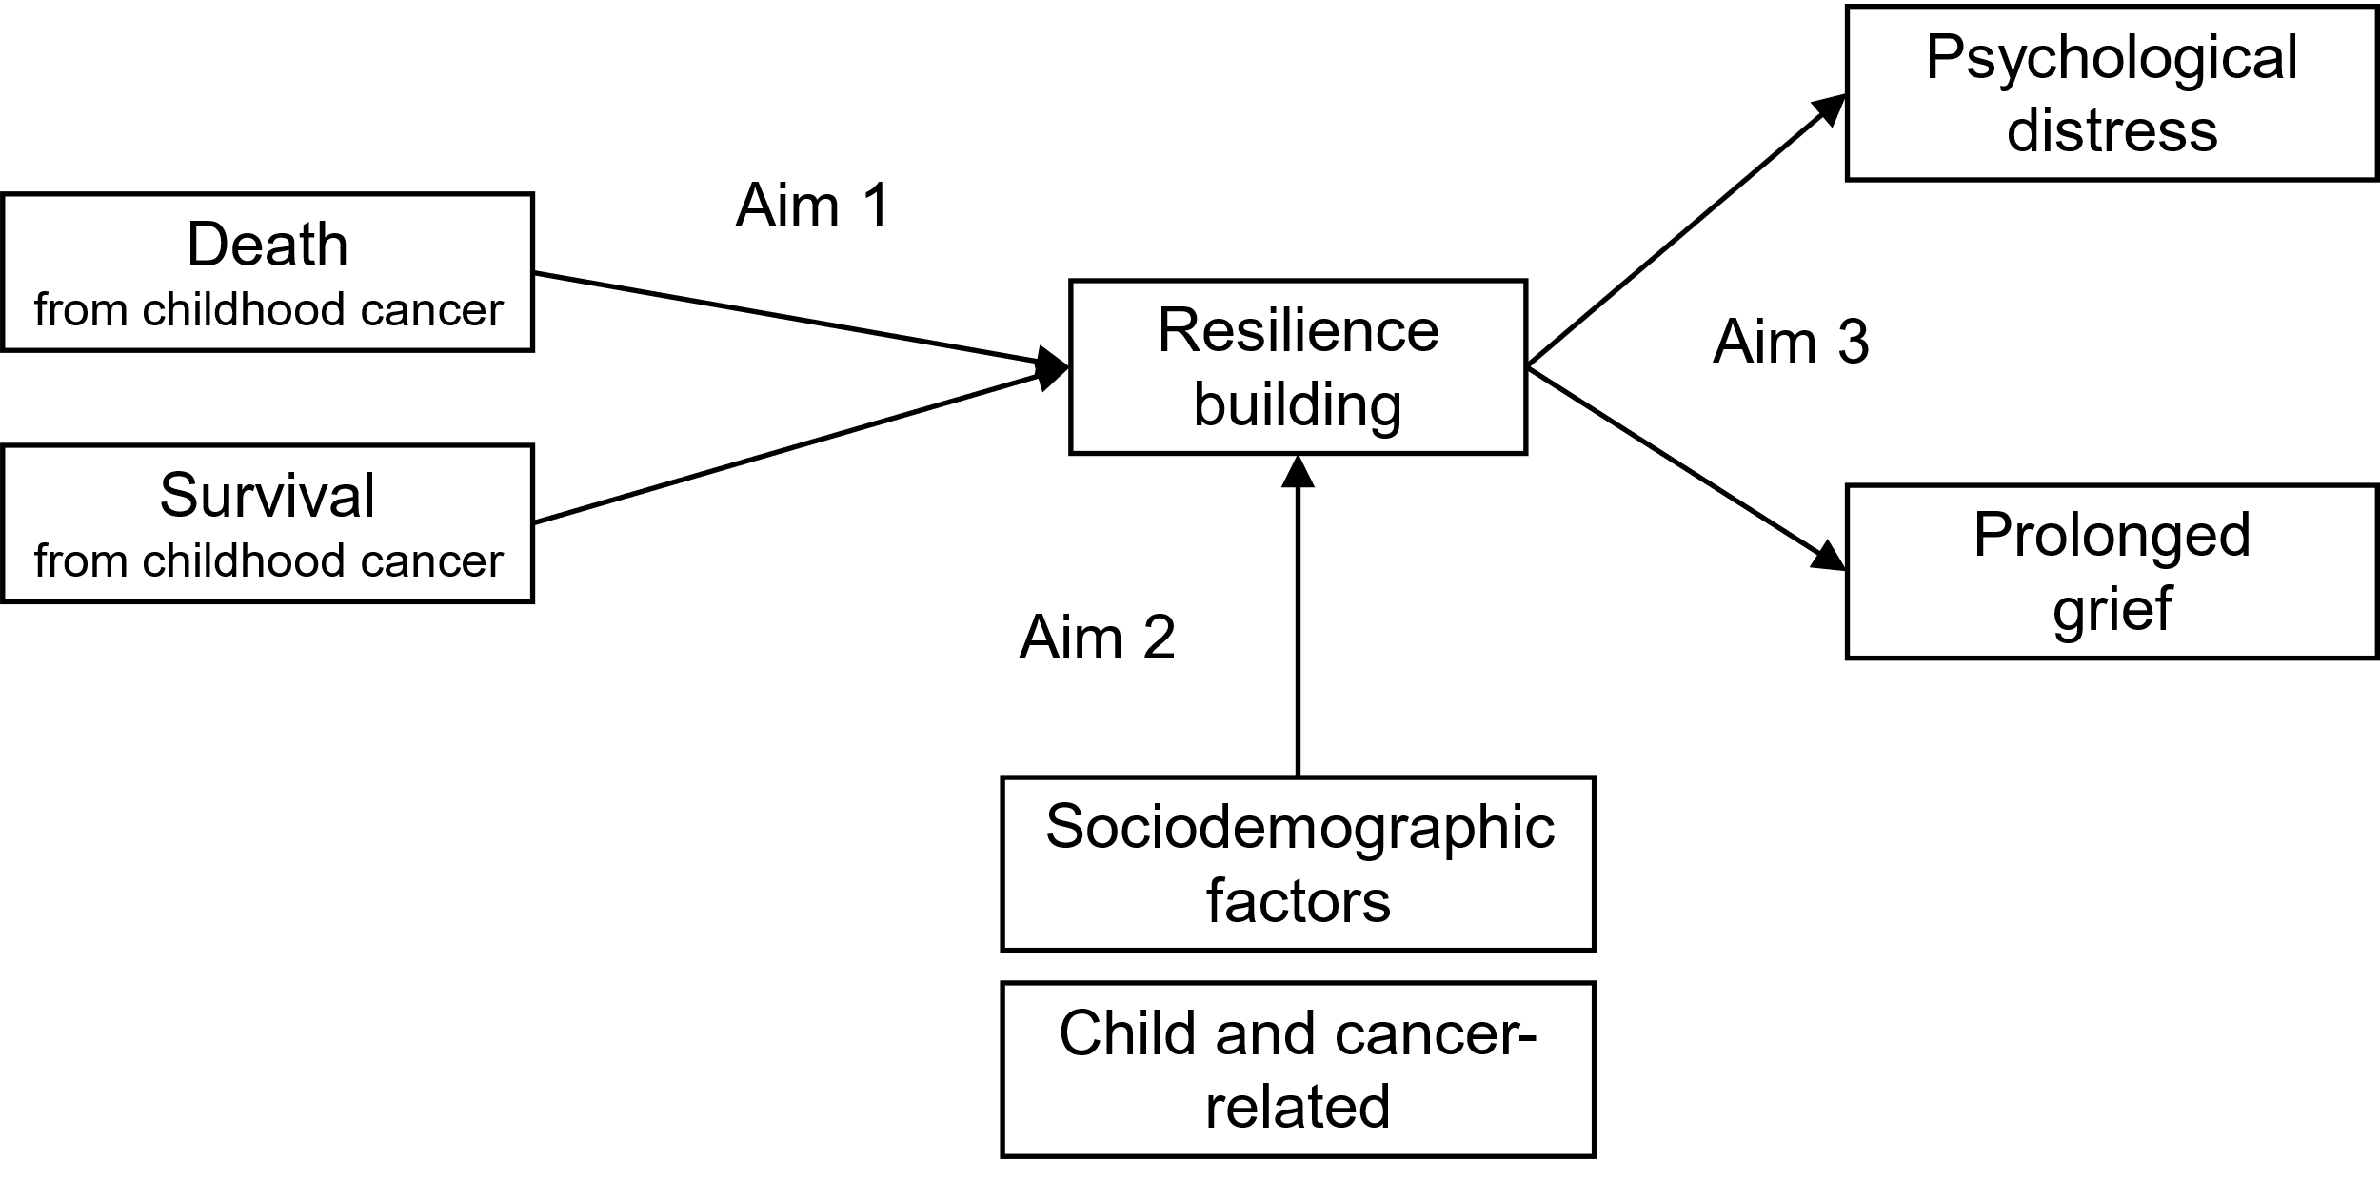

Appendix Figure S1. Analysis framework

Appendix Table S1. Item comparison to CDRISC-10 between bereaved parents and CCS parents
 | Bereaved parents | CCS parents | P value¹
Number of participants (N) | 103 | 345
I am able to adapt when changes occur. (Positivity)
Not at all | 1 (1.0%) | 3 (0.9%) | 0.011
Rarely true | 4 (3.9%) | 4 (1.2%) | 0.011
Sometime true | 12 (11.7%) | 58 (16.8%) | 0.011
Often true | 29 (28.2%) | 144 (41.7%) | 0.011
Always true | 57 (55.3%) | 136 (39.4%) | 0.011
Item mean, mean (SD)² | 3.3 (0.9) | 3.2 (0.8) | 0.102
I can deal with whatever comes my way. (Positivity)
Not at all | 3 (2.9%) | 10 (2.9%) | <0.001
Rarely true | 5 (4.9%) | 18 (5.2%) | <0.001
Sometime true | 18 (17.5%) | 101 (29.3%) | <0.001
Often true | 41 (39.8%) | 174 (50.4%) | <0.001
Always true | 36 (35.0%) | 42 (12.2%) | <0.001
Item mean, mean (SD)² | 3.0 (1.0) | 2.6 (0.9) | <0.001
I try to see the humorous side of things when I am faced with problems. (Resistance)
Not at all | 3 (2.9%) | 19 (5.5%) | 0.032
Rarely true | 9 (8.7%) | 54 (15.7%) | 0.032
Sometime true | 41 (39.8%) | 129 (37.4%) | 0.032
Often true | 28 (27.2%) | 105 (30.4%) | 0.032
Always true | 22 (21.4%) | 38 (11.0%) | 0.032
Item mean, mean (SD)² | 2.6 (1.0) | 2.3 (1.0) | 0.011
Having to cope with stress can make me stronger. (Resistance)
Not at all | 6 (5.8%) | 17 (4.9%) | 0.213
Rarely true | 12 (11.7%) | 50 (14.5%)
Sometime true | 33 (32.0%) | 133 (38.6%)
Often true | 37 (35.9%) | 119 (34.5%)
Always true | 15 (14.6%) | 26 (7.5%)
Item mean, mean (SD)² | 2.4 (1.1) | 2.3 (1.0) | 0.136
I tend to bounce back after illness, injury or other hardships. (Positivity)
Not at all | 0 (0.0%) | 1 (0.3%) | 0.123
Rarely true | 3 (2.9%) | 5 (1.4%) | 0.123
Sometime true | 15 (14.6%) | 24 (7.0%) | 0.123
Often true | 41 (39.8%) | 148 (42.9%) | 0.123
Always true | 44 (42.7%) | 167 (48.4%) | 0.123
Item mean, mean (SD)² | 3.2 (0.8) | 3.4 (0.7) | 0.061
I believe I can achieve my goals, even if there are obstacles. (Competence)
Not at all | 0 (0.0%) | 2 (0.6%) | 0.181
Rarely true | 1 (1.0%) | 7 (2.0%) | 0.181
Sometime true | 15 (14.6%) | 75 (21.7%) | 0.181
Often true | 50 (48.5%) | 173 (50.1%) | 0.181
Always true | 37 (35.9%) | 88 (25.5%) | 0.181
Item mean, mean (SD)² | 3.2 (0.7) | 3.0 (0.8) | 0.013
Under pressure, I stay focused and think clearly. (Resistance)
Rarely true | 3 (2.9%) | 12 (3.5%) | 0.019
Sometime true | 21 (20.4%) | 108 (31.3%) | 0.019
Often true | 40 (38.8%) | 145 (42.0%) | 0.019
Always true | 39 (37.9%) | 80 (23.2%) | 0.019
Item mean, mean (SD)² | 3.1 (0.8) | 2.8 (0.8) | 0.004
I am not easily discouraged by failure. (Competence)
Not at all | 2 (1.9%) | 8 (2.3%) | 0.415
Rarely true | 8 (7.8%) | 26 (7.5%) | 0.415
Sometime true | 23 (22.3%) | 103 (29.9%) | 0.415
Often true | 47 (45.6%) | 155 (44.9%) | 0.415
Always true | 23 (22.3%) | 53 (15.4%) | 0.415
Item mean, mean (SD)² | 2.8 (0.9) | 2.6 (0.9) | 0.143
I think of myself as a strong person when dealing with life’s challenges and difficulties. (Competence)
Not at all | 1 (1.0%) | 3 (0.9%) | 0.110
Rarely true | 3 (2.9%) | 13 (3.8%) | 0.110
Sometime true | 15 (14.6%) | 83 (24.1%) | 0.110
Often true | 45 (43.7%) | 157 (45.5%) | 0.110
Always true | 39 (37.9%) | 89 (25.8%) | 0.110
Item mean, mean (SD)² | 3.1 (0.8) | 2.9 (0.9) | 0.016
I am able to handle unpleasant or painful feelings like sadness, fear, and anger. (Resistance)
Not at all | 2 (1.9%) | 2 (0.6%) | 0.079
Rarely true | 1 (1.0%) | 17 (4.9%) | 0.079
Sometime true | 23 (22.3%) | 86 (24.9%) | 0.079
Often true | 44 (42.7%) | 163 (47.2%) | 0.079
Always true | 33 (32.0%) | 77 (22.3%) | 0.079
Item mean, mean (SD)² | 3.0 (0.9) | 2.9 (0.8) | 0.090
¹p value from chi-squared test, unless specified otherwise. CCS, childhood cancer survivor; SD, standard deviation
² p value from students t-test, comparing means of two groups (bereaved parents and CCS parents)

Appendix Table S2. Summary of items on religiosity and spirituality differences between parents of childhood cancer survivors and bereaved parents.

 | CCS parents  N= 345 | Bereaved parents  N=103 | P value¹
I have a strong sense of purpose in life.
Not at all | 7 (2.0%) | 16 (15.5%) | <0.001
Rarely true | 23 (6.7%) | 12 (11.7%) | <0.001
Sometime true | 61 (17.7%) | 23 (22.3%) | <0.001
Often true | 169 (49.0%) | 24 (23.3%) | <0.001
Always true | 85 (24.6%) | 28 (27.2%) | <0.001
Item mean, mean (SD) | 2.9 (0.9) | 2.3 (1.4) | <0.001
I have one close and secure relationship.
Not at all | 8 (2.3%) | 2 (1.9%) | 0.034
Rarely true | 10 (2.9%) | 2 (1.9%) | 0.034
Sometime true | 42 (12.2%) | 6 (5.8%) | 0.034
Often true | 94 (27.2%) | 18 (17.5%) | 0.034
Always true | 191 (55.4%) | 75 (72.8%) | 0.034
Item mean, mean (SD) | 3.3 (0.9) | 3.6 (0.8) | 0.010
Sometimes fate or God helps me
Not at all | 103 (29.9%) | 44 (42.7%) | 0.017
Rarely true | 70 (20.3%) | 15 (14.6%) | 0.017
Sometime true | 61 (17.7%) | 12 (11.7%) | 0.017
Often true | 63 (18.3%) | 11 (10.7%) | 0.017
Always true | 48 (13.9%) | 21 (20.4%) | 0.017
Item mean, mean (SD) | 1.7 (1.4) | 1.5 (1.4) | 0.374

¹p value from chi squared test
Abbreviation: CCS, childhood cancer survivor; SD. standard deviation

Appendix Table S3. Summary of psychological distress and prolonged grief in the study population
 | Bereaved parents
 | (N=103)
Psychological distress (BSI-18)
Global Severity Index | 50.3 (9.4)
Somatization | 49.7 (8.5)
Anxiety | 47.6 (9.4)
Depression | 52.1 (9.5)
Caseness
No | 92 (89.3%)
Yes | 11 (10.7%)
Prolonged grief disorder (PG-13)
Prolonged grief disorder
No | 98 (95.1%)
Yes | 5 (4.9%)
Separation distress
No | 79 (76.7%)
Yes | 24 (23.3%)
Duration criterion
No | 63 (61.2%)
Yes | 40 (38.8%)
Symptom criterion
No | 103 (94.2%)
Yes | 6 (5.8%)
Impairment criteria
No | 88 (85.4%)
Yes | 15 (14.6%)

20
25
30
35
40
Resilience sum score
0
5
10
15
20
25
Time since bereaved (years)

Appendix Figure S2. Spline model of resilience scores as a function of time since death for bereaved parents

