Supplemental material
Table S1: Sociodemographic characteristics at baseline of the eligible participants and those of the remaining cohort.
 | Eligible participants  (n = 5279) | Remaining cohort  (n = 3368) | p-value
Maternal age (years), mean (SD) | 29.8 (5.2) | 27.8 (5.9) | <0.001
Maternal education (years), mean (SD) | 11.2 (4.3) | 9.3 (4.0) | <0.001
Maternal smoking habits, n (%) |  |  | <0.001
Smokers | 1774 (33.8) | 1481 (44.3)
Non-smokers | 3475 (66.2) | 1864 (55.7)
Child sex, n (%) |  |  | 0.53
Female | 2572 (48.7) | 1665 (49.4)
Male | 2707 (51.3) | 1703 (50.6)
Childbirth weight (g), mean (SD) | 3146.3 (533.41) | 3152.3 (545.69) | 0.61
Childbirth length (cm), mean (SD) | 48.61 (2.54) | 48.6 (2.57) | 0.89
Abbreviations: n – sample size, % – percentage, SD – standard deviation.
Note: p-values from chi-square test or Student's t test, as appropriate.
Significant values are in bold.

Table S2: Reliability analysis of Tanner scale parameters.
 | α | med.r | r.drop | % miss
Girls
Pubic hair, 10 years | 0.72 | 0.38 | 0.48 | 40
Breast rating, 10 years | 0.70 | 0.39 | 0.53 | 39
Axillary hair, 13 years | 0.69 | 0.31 | 0.57 | 87
Pubic hair, 13 years | 0.70 | 0.36 | 0.56 | 55
Breast rating, 13 years | 0.73 | 0.36 | 0.46 | 47
Boys
Pubic hair, 10 years | 0.72 | 0.37 | 0.30 | 40
Genital rating, 10 years | 0.69 | 0.33 | 0.43 | 45
Axillary hair, 13 years | 0.58 | 0.30 | 0.63 | 50
Pubic hair, 13 years | 0.59 | 0.33 | 0.62 | 49
Genital rating, 13 years | 0.67 | 0.31 | 0.45 | 47

Abbreviations and notes
- α – raw alpha. Indicates the internal consistency to test if the items collectively measure a coherent construct.
- med.r – median of inter-item correlations. Represents the median of the correlation coefficients between a specific item and all the remaining items in the scale.
- r.drop – item-scale correlation after dropping the item. Measures the unique contribution of a specific item to the overall reliability of the scale
- % miss – miss rates, measured through percentage of missing reports.

Table S3: Graded response model item parameter estimates.
 | a | b1 | b2 | b3 | b4
Girls
Pubic hair, 10 years | 2.374 | -0.166 | 0.848 | 2.191 | 3.689
Breast rating, 10 years | 3.273 | -0.715 | 0.595 | 1.903 | 3.374
Pubic hair, 13 years | 1.039 | -5.380 | -3.144 | -0.630 | 2.436
Breast rating, 13 years | 0.961 | -4.999 | -2.510 | -0.151 | 2.845
Boys
Pubic hair, 10 years | 1.208 | 1.807 | 3.540 | 5.218 | 7.612
Genital rating, 10 years | 2.360 | 0.769 | 2.511 | 3.435 | 4.604
Pubic hair, 13 years | 1.246 | -1.885 | -0.478 | 0.815 | 2.785
Genital rating, 13 years | 1.745 | -3.316 | -1.499 | -0.397 | 0.892

Abbreviations and notes
- a – item’s discrimination (item slope).
- b – Item threshold (item difculty).

Figure S1: Item operation characteristic curves.
 | Girls | Boys
Pubic hair, 10 years | 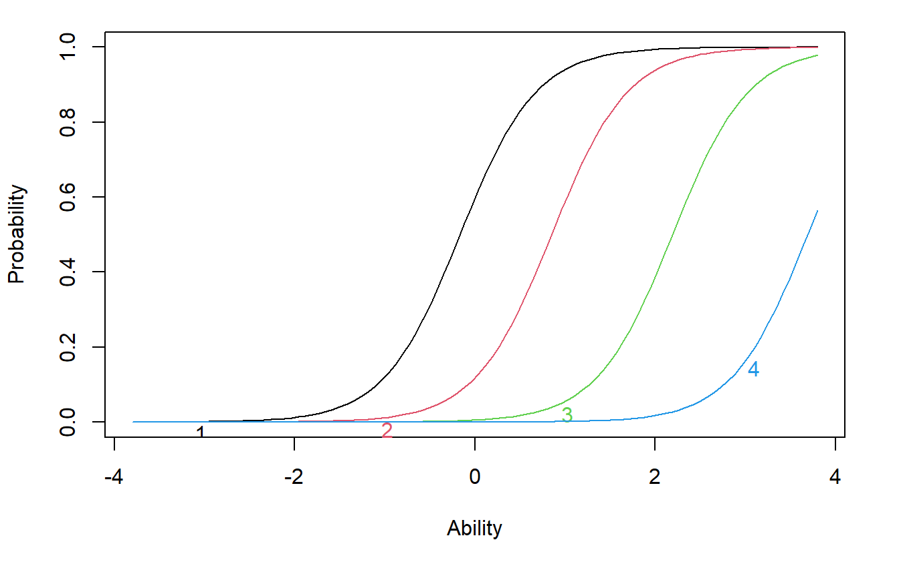 | 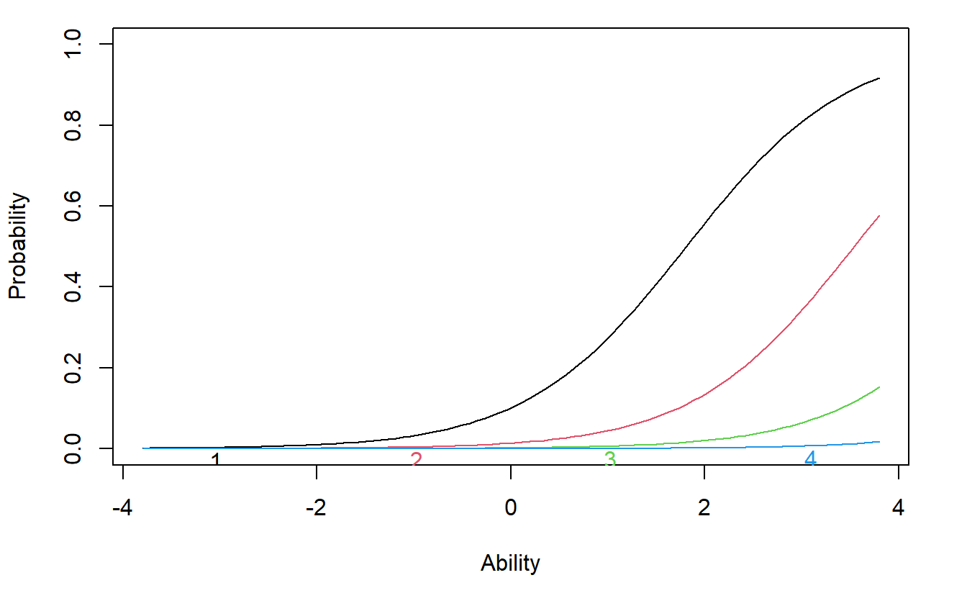
Breast or genital ratingª, 10 years | 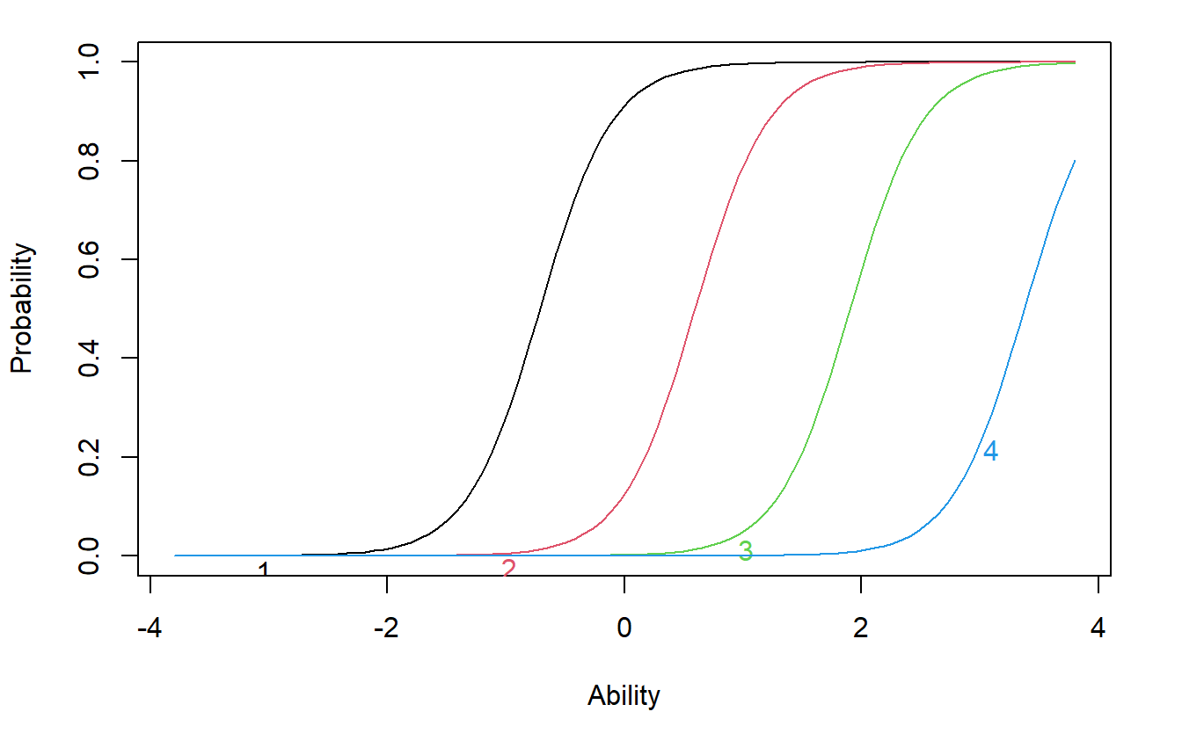 | 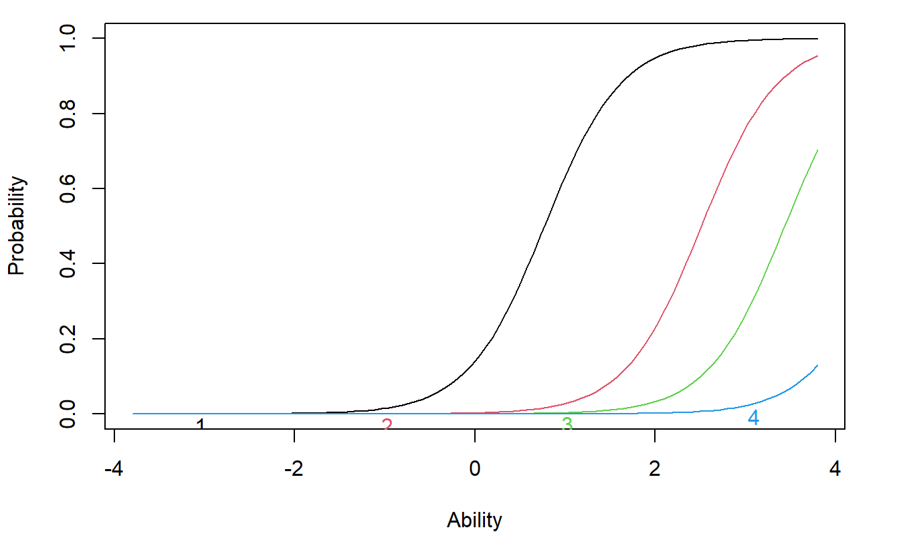
Pubic hair, 13 years | 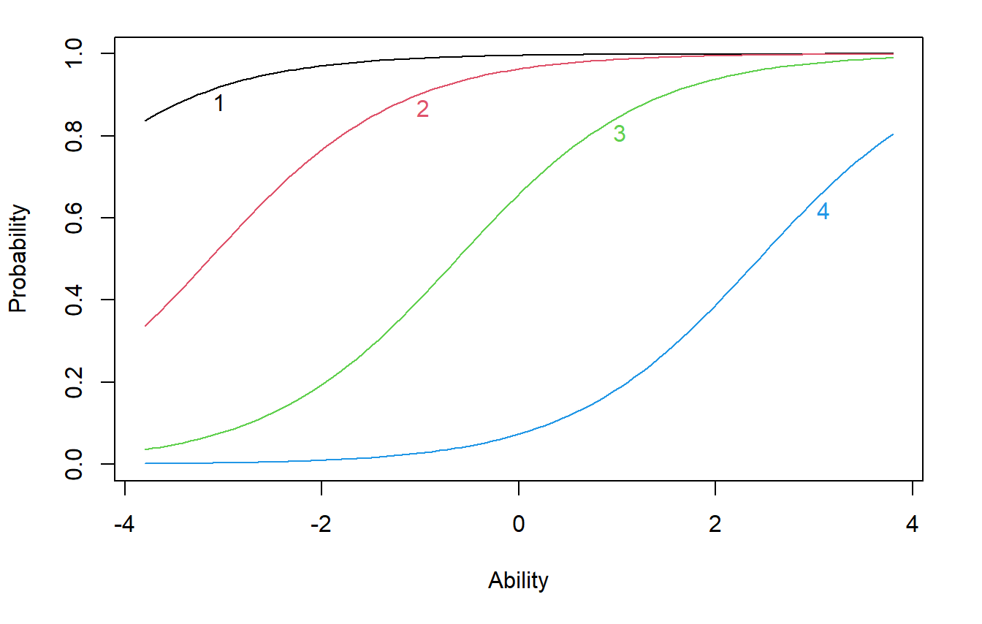 | 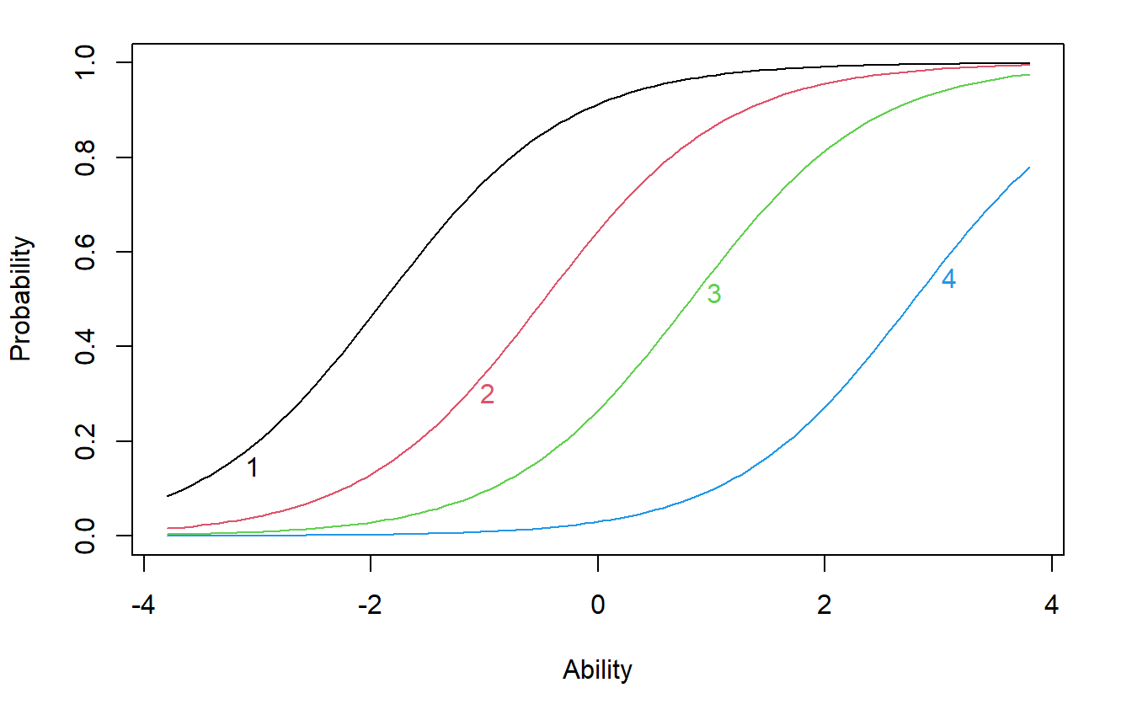
Breast or genital ratingª, 13 years | 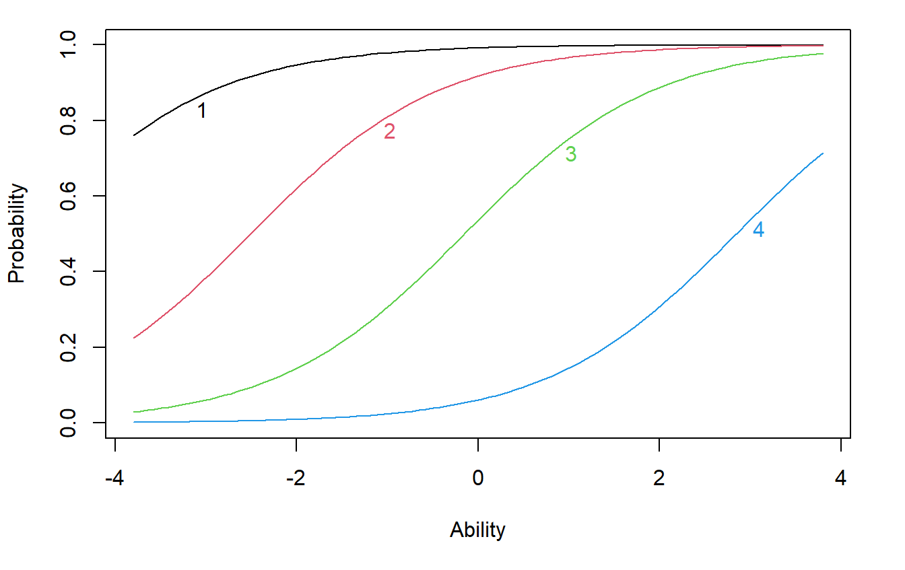 | 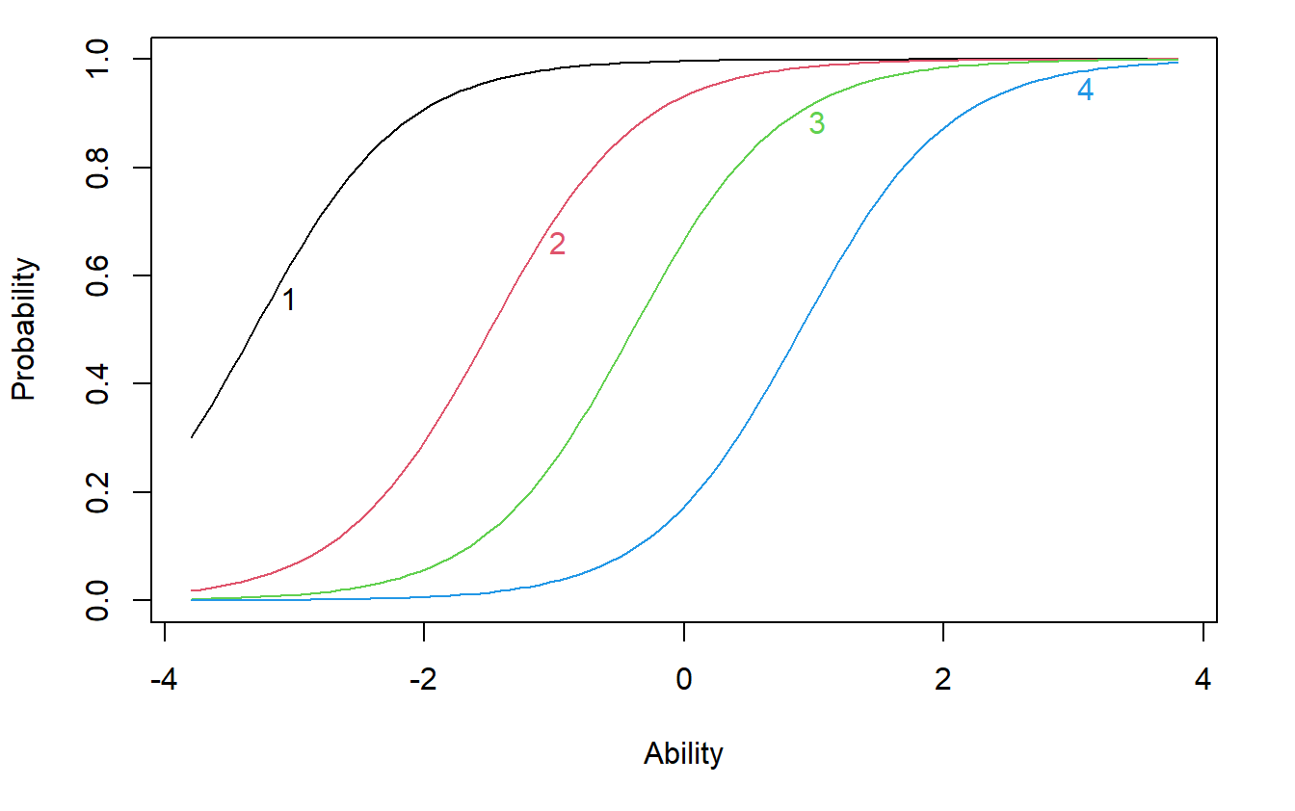

Notes: a) Breast rating for girls or genital rating for boys.

