Supplementary Table 1. The search terms for the search strategy in Scopus, Web of Science, PubMed, Science Direct, and SPORTDiscus
Concept A: Population | Concept B: Exposition | Concept C: Overall and Specific Injury Risk | Concept D: Study design
- Runner (MeSH)  - Jogger (MeSH)  - Running (MeSH)  - Jogging (MeSH)  - Track and Field (MeSH) | - Body mass index (MeSH)  - Risk factor (MeSH)  - Etiology (MeSH)  - Predictor (MeSH)  - Antecedent  - Body composition (MeSH)  - Overweight (MeSH)  - Obesity (MeSH) | - Injury (tx)  - Medial Tibial Stress Syndrome (MeSH)  - Shin splint (MeSH)  - Shin pain (MeSH)  - Lower leg pain (MeSH)  - Iliotibial band syndrome (MeSH)  - Patellofemoral pain (MeSH)  - Knee pain (MeSH)  - Tendinopathy (MeSH)  - Tendinitis (MeSH)  - Plantar fasciitis (MeSH)  - Stress fractures (MeSH) | - Prospective studies (MeSH); prospective (tx)  - Cohort studies (MeSH); cohort (tx)  - Longitudinal studies (MeSH); Longitudinal(tx)  - Follow-up studies (MeSH); follow-up (tx)  - Prospective

Supplementary Table 2. Risk of bias of included studies (ROBINS-E)
Studies | Bias due to confounding | Bias in the selection of participants for the study | Bias in the classification of exposures | Bias due to departures from intended exposures | Bias due to missing data | Outcome measurement | Reported results | Study-level RoB judgment
Naderi, Alizadeh, Calmeiro, Degens ¹ | Low | Low | Low | Low | Low | Low | Low | Low
Burke, Dillon, O’Connor, Whyte, Gore, Moran ² | Low | Low | Low | Low | Low | Low | Low | Low
Winter, Gordon, Brice, Lindsay, Barrs ³ | Moderate | Moderate | Low | Low | Low | Low | Low | Moderate
Hofstede, Franke, Van Eijk, Backx, Kemler, Huisstede ⁴ | Low | Low | Moderate | Low | Low | Low | Low | Moderate
Dallinga, Van Rijn, Stubbe, Deutekom ⁵ | Low | Low | Low | Low | Low | Low | Low | Low
Napier, MacLean, Maurer, Taunton, Hunt ⁶ | Low | Moderate | Low | Low | Moderate | Low | Low | Moderate
Messier, Martin, Mihalko, Ip, DeVita, Cannon, Love, Beringer, Saldana, Fellin ⁷ | Low | Low | Low | Low | Low | Low | Low | Low
Kluitenberg, van der Worp, Huisstede, Hartgens, Diercks, Verhagen, van Middelkoop ⁸ | Low | Low | Low | Low | Low | Moderate | Low | Modetate
van der Worp, de Wijer, van Cingel, Verbeek, Nijhuis-van der Sanden, Staal ⁹ | Low | Low | Moderate | Low | Low | Moderate | Low | Moderate
Hotta, Nishiguchi, Fukutani, Tashiro, Adachi, Morino, Shirooka, Nozaki, Hirata, Yamaguchi ¹⁰ | Low | Low | Low | Low | Low | Low | Low | Low
Nielsen, Parner, Nohr, Sørensen, Lind, Rasmussen ¹¹ | Low | Low | Low | Low | Low | Low | Low | Low
Bredeweg, Kluitenberg, Bessem, Buist ¹² | Low | Low | Low | Low | Low | Low | Low | Low
Nielsen, Cederholm, Buist, Sørensen, Lind, Rasmussen ¹³ | Moderate | Moderate | Low | Low | Low | Low | Low | Moderate
Junior, Costa, Lopes ¹⁴ | Low | Low | Low | Low | Low | Low | Low | Low
Buist, Bredeweg, Lemmink, Van Mechelen, Diercks ¹⁵ | Low | Low | Low | Low | Low | Low | Low | Low
Buist, Bredeweg, Bessem, Van Mechelen, Lemmink, Diercks ¹⁶ | Low | Low | Low | Low | Low | Low | Low | Low
Hesar, Van Ginckel, Cools, Peersman, Roosen, De Clercq, Witvrouw ¹⁷ | Moderate | Low | Low | Low | Moderate | Low | Low | Moderate
Naderi, Moen, Degens ¹⁸ | Low | Low | Low | Low | Low | Low | Low | Low
Becker, Nakajima, Wu ¹⁹ | Low | Low | Low | Low | Low | Low | Low | Low
Yagi, Muneta, Sekiya ²⁰ | Low | Low | Low | Low | Low | Low | Low | Low
Reinking, Austin, Hayes ²¹ | Moderate | Low | Moderate | Low | Moderate | Low | Low | Moderate
Skypala, Hamill, Sebera, Elavsky, Monte, Jandacka ²² | Moderate | Low | Low | Low | Low | Moderate | Low | Moderate
Lagas, Fokkema, Verhaar, Bierma-Zeinstra, van Middelkoop, de Vos ²³ | Low | Low | Low | Low | Low | Low | Low | Low
Wezenbeek, Willems, Mahieu, De Muynck, Vanden Bossche, Steyaert, De Clercq, Witvrouw ²⁴ | Low | Low | Low | Low | Low | Low | Low | Low
Hirschmüller, Frey, Konstantinidis, Baur, Dickhuth, Suedkamp, Helwig ²⁵ | Low | Low | Low | Low | Low | Low | Low | Low
Van Ginckel, Thijs, Hesar, Mahieu, De Clercq, Roosen, Witvrouw ²⁶ | Low | Low | Low | Low | Low | Low | Low | Low
Ramskov, Barton, Nielsen, Rasmussen ²⁷ | Low | Low | Low | Low | Moderate | Low | Low | Moderate
Thijs, Pattyn, Van Tiggelen, Rombaut, Witvrouw ²⁸ | Low | Low | Low | Low | Low | Low | Low | Low
Finnoff et al. (2011) | Low | Low | Low | Low | Moderate | Low | Low | Moderate
Thijs, De Clercq, Roosen, Witvrouw ²⁹ | Low | Low | Low | Low | Low | Low | Low | Low
Duffey, Martin, Cannon, Craven, Messier ³⁰ | Low | Low | Low | Low | Low | Low | Low | Low
Witvrouw, Lysens, Bellemans, Cambier, Vanderstraeten ³¹ | Low | Low | Low | Low | Low | Low | Low | Low
Carbuhn, Yu, Magee, McCulloch, Lambert ³² | Low | Low | Low | Low | Low | Low | Low | Low
Yagi, Muneta, Sekiya ²⁰ | Low | Low | Low | Low | Low | Low | Low | Low
Tenforde, Sayres, McCurdy, Sainani, Fredericson ³³ | Low | Low | Low | Low | Low | Low | Low | Low
Di Caprio, Buda, Mosca, Giannini ³⁴ | Low | Low | Low | Low | Low | Low | Low | Low
Item-level judgment | Low | Low | Low | Low | Low | Low | Low

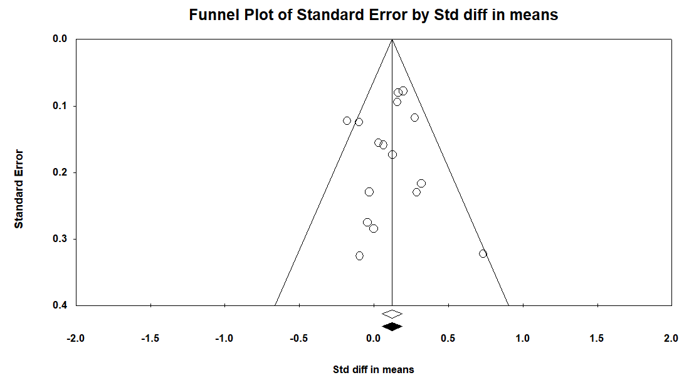
Supplementary figure 1. Funnel plot based on study standard error and standardized mean differences to assess publication bias for overall running injury.

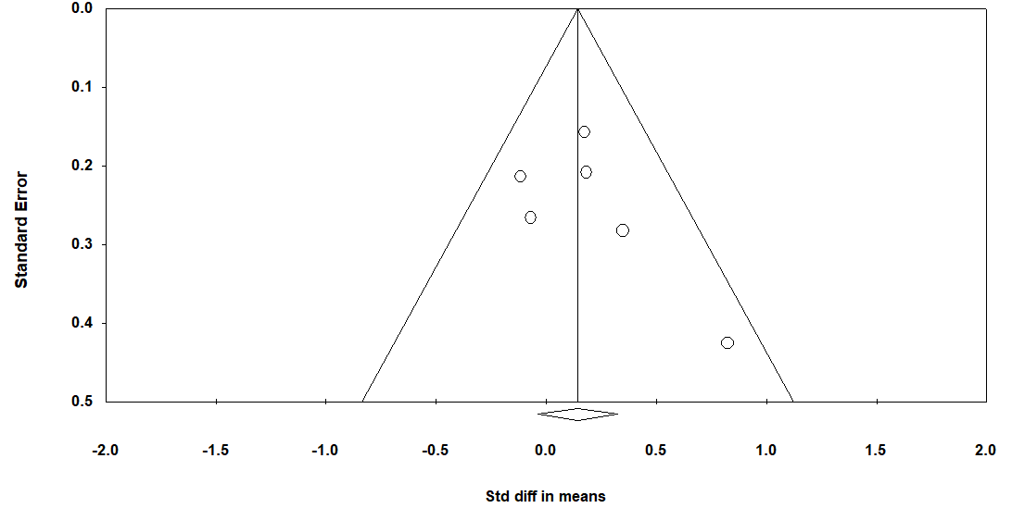
Supplementary figure 2. Funnel plot based on study standard error and standardized mean differences to assess publication bias for patellofemoral pain.
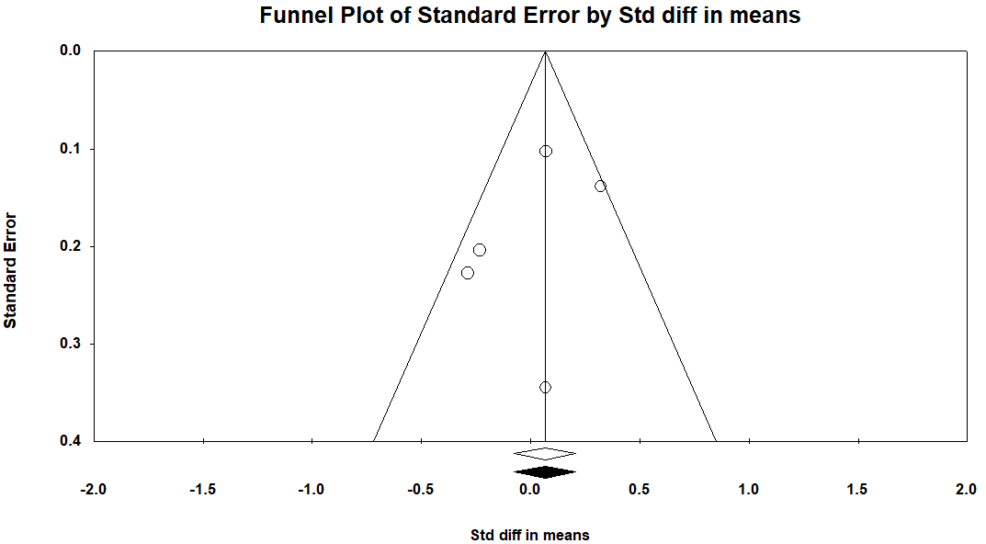
Supplementary figure 3. Funnel plot based on study standard error and standardized mean differences to assess publication bias for Achilles tendinopathy.

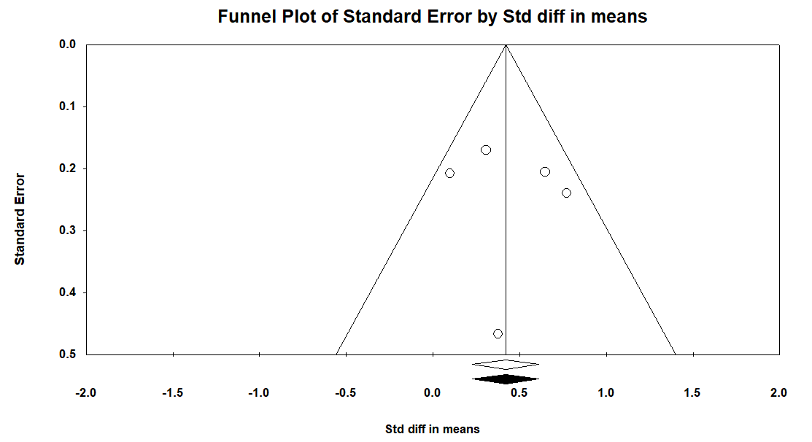
Supplementary figure 4. Funnel plot based on study standard error and standardized mean differences to assess publication bias for medial tibial stress syndrome.

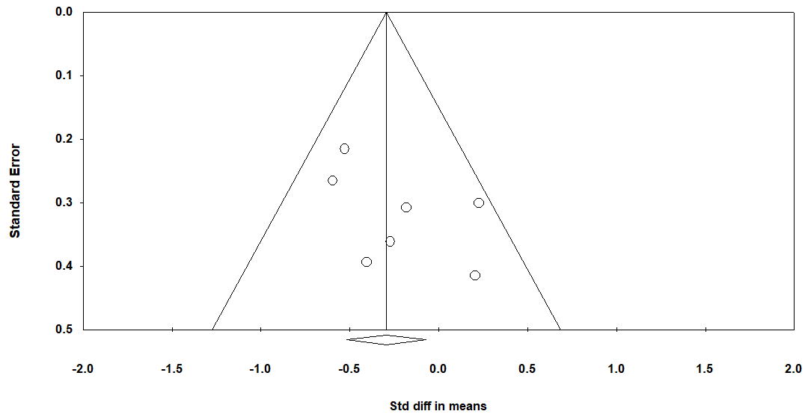
Supplementary figure 5. Funnel plot based on study standard error and standardized mean differences to assess publication bias for lower extremity stress fracture.

1. Naderi A, Alizadeh N, Calmeiro L, Degens H. Predictors of running-related injury among recreational runners: a prospective cohort study of the role of perfectionism, mental toughness and passion in running Sports Health. In press.
2. Burke A, Dillon S, O’Connor S, Whyte EF, Gore S, Moran KA. Aetiological Factors of Running-Related Injuries: A 12 Month Prospective “Running Injury Surveillance Centre”(RISC) Study. Sports Medicine-Open. 2023;9(1):46.
3. Winter SC, Gordon S, Brice SM, Lindsay D, Barrs S. Overuse injuries in runners of different abilities—a one-year prospective study. Research in Sports Medicine. 2021;29(2):196-212.
4. Hofstede H, Franke T, Van Eijk R, Backx F, Kemler E, Huisstede B. In training for a marathon: Runners and running-related injury prevention. Physical Therapy in Sport. 2020;41:80-86.
5. Dallinga J, Van Rijn R, Stubbe J, Deutekom M. Injury incidence and risk factors: a cohort study of 706 8-km or 16-km recreational runners. BMJ open sport & exercise medicine. 2019;5(1):e000489.
6. Napier C, MacLean C, Maurer J, Taunton J, Hunt M. Kinetic risk factors of running‐related injuries in female recreational runners. Scandinavian journal of medicine & science in sports. 2018;28(10):2164-2172.
7. Messier SP, Martin DF, Mihalko SL, et al. A 2-year prospective cohort study of overuse running injuries: the runners and injury longitudinal study (TRAILS). The American journal of sports medicine. 2018;46(9):2211-2221.
8. Kluitenberg B, van der Worp H, Huisstede BM, et al. The NLstart2run study: Training-related factors associated with running-related injuries in novice runners. Journal of Science and Medicine in Sport. 2016;19(8):642-646.
9. van der Worp MP, de Wijer A, van Cingel R, Verbeek AL, Nijhuis-van der Sanden MW, Staal JB. The 5-or 10-km Marikenloop Run: a prospective study of the etiology of running-related injuries in women. journal of orthopaedic & sports physical therapy. 2016;46(6):462-470.
10. Hotta T, Nishiguchi S, Fukutani N, et al. Functional movement screen for predicting running injuries in 18-to 24-year-old competitive male runners. The Journal of Strength & Conditioning Research. 2015;29(10):2808-2815.
11. Nielsen RØ, Parner ET, Nohr EA, Sørensen H, Lind M, Rasmussen S. Excessive progression in weekly running distance and risk of running-related injuries: an association which varies according to type of injury. journal of orthopaedic & sports physical therapy. 2014;44(10):739-747.
12. Bredeweg SW, Kluitenberg B, Bessem B, Buist I. Differences in kinetic variables between injured and noninjured novice runners: a prospective cohort study. Journal of Science and Medicine in Sport. 2013;16(3):205-210.
13. Nielsen RO, Cederholm P, Buist I, Sørensen H, Lind M, Rasmussen S. Can GPS be used to detect deleterious progression in training volume among runners? The Journal of Strength & Conditioning Research. 2013;27(6):1471-1478.
14. Junior LCH, Costa LOP, Lopes AD. Previous injuries and some training characteristics predict running-related injuries in recreational runners: a prospective cohort study. Journal of Physiotherapy. 2013;59(4):263-269.
15. Buist I, Bredeweg SW, Lemmink KA, Van Mechelen W, Diercks RL. Predictors of running-related injuries in novice runners enrolled in a systematic training program: a prospective cohort study. The American journal of sports medicine. 2010;38(2):273-280.
16. Buist I, Bredeweg SW, Bessem B, Van Mechelen W, Lemmink KA, Diercks RL. Incidence and risk factors of running-related injuries during preparation for a 4-mile recreational running event. British journal of sports medicine. 2010;44(8):598-604.
17. Hesar NGZ, Van Ginckel A, Cools A, et al. A prospective study on gait-related intrinsic risk factors for lower leg overuse injuries. British journal of sports medicine. 2009;43(13):1057-1061.
18. Naderi A, Moen MH, Degens H. Is high soleus muscle activity during the stance phase of the running cycle a potential risk factor for the development of medial tibial stress syndrome? A prospective study. Journal of sports sciences. 2020;38(20):2350-2358.
19. Becker J, Nakajima M, Wu WF. Factors Contributing to Medial Tibial Stress Syndrome in Runners: A Prospective Study. Medicine and science in sports and exercise. 2018;50(10):2092-2100.
20. Yagi S, Muneta T, Sekiya I. Incidence and risk factors for medial tibial stress syndrome and tibial stress fracture in high school runners. Knee Surgery, Sports Traumatology, Arthroscopy. 2013;21(3):556-563.
21. Reinking MF, Austin TM, Hayes AM. Risk factors for self-reported exercise-related leg pain in high school cross-country athletes. Journal of Athletic Training. 2010;45(1):51-57.
22. Skypala J, Hamill J, Sebera M, Elavsky S, Monte A, Jandacka D. Running-Related Achilles Tendon Injury: A Prospective Biomechanical Study in Recreational Runners. Journal of Applied Biomechanics. 2023;39(4):237-245.
23. Lagas IF, Fokkema T, Verhaar JA, Bierma-Zeinstra SM, van Middelkoop M, de Vos R-J. Incidence of Achilles tendinopathy and associated risk factors in recreational runners: a large prospective cohort study. Journal of Science and Medicine in Sport. 2020;23(5):448-452.
24. Wezenbeek E, Willems T, Mahieu N, et al. The role of the vascular and structural response to activity in the development of achilles tendinopathy: a prospective study. The American journal of sports medicine. 2018;46(4):947-954.
25. Hirschmüller A, Frey V, Konstantinidis L, et al. Prognostic value of Achilles tendon Doppler sonography in asymptomatic runners. Medicine and science in sports and exercise. 2012;44(2):199-205.
26. Van Ginckel A, Thijs Y, Hesar NGZ, et al. Intrinsic gait-related risk factors for Achilles tendinopathy in novice runners: a prospective study. Gait & posture. 2009;29(3):387-391.
27. Ramskov D, Barton C, Nielsen RO, Rasmussen S. High eccentric hip abduction strength reduces the risk of developing patellofemoral pain among novice runners initiating a self-structured running program: a 1-year observational study. Journal of Orthopaedic & Sports Physical Therapy. 2015;45(3):153-161.
28. Thijs Y, Pattyn E, Van Tiggelen D, Rombaut L, Witvrouw E. Is hip muscle weakness a predisposing factor for patellofemoral pain in female novice runners? A prospective study. The American journal of sports medicine. 2011;39(9):1877-1882.
29. Thijs Y, De Clercq D, Roosen P, Witvrouw E. Gait-related intrinsic risk factors for patellofemoral pain in novice recreational runners. British journal of sports medicine. 2008;42(6):466-471.
30. Duffey MJ, Martin DF, Cannon DW, Craven T, Messier SP. Etiologic factors associated with anterior knee pain in distance runners. Medicine and science in sports and exercise. 2000;32(11):1825-1832.
31. Witvrouw E, Lysens R, Bellemans J, Cambier D, Vanderstraeten G. Intrinsic risk factors for the development of anterior knee pain in an athletic population: a two-year prospective study. The American journal of sports medicine. 2000;28(4):480-489.
32. Carbuhn AF, Yu D, Magee LM, McCulloch PC, Lambert BS. Anthropometric factors associated with bone stress injuries in collegiate distance runners: new risk metrics and screening tools? Orthopaedic Journal of Sports Medicine. 2022;10(2):23259671211070308.
33. Tenforde AS, Sayres LC, McCurdy ML, Sainani KL, Fredericson M. Identifying sex-specific risk factors for stress fractures in adolescent runners. Med Sci Sports Exerc. 2013;45(10):1843-1851.
34. Di Caprio F, Buda R, Mosca M, Giannini S. Foot and lower limb diseases in runners: assessment of risk factors. Journal of sports science & medicine. 2010;9(4):587.

