Archives of Microbiology

Muricauda chongwuensis sp. nov., isolated from coastal seawater of China
Ming-Xia Chen^{1 *}, Xiao-Yu He¹, He-Yang Li^{2,3 *}
¹ College of Chemical Engineering, Huaqiao University, 668 Jimei Road, Fujian Xiamen 361021, PR China
²Third Institute of Oceanography, Ministry of Natural Resources, 178 Daxue Road, Fujian Xiamen 361005, PR China
³Fujian Provincial Key Laboratory of Marine Ecological Conservation and Restoration, Xiamen, Fujian 361005, PR China
*Correspondence: Ming-Xia Chen, chenmx1257@163.com and chenmx1257@hqu.
edu.cn, or He-Yang Li, heyang_li@tio.org.cn.

(b)
(a)
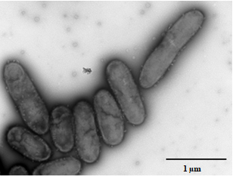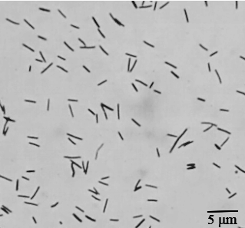

Fig. S1 Cell morphology of strain HICW^{T} after culturing on MA for 24 h at 28 ºC

(a). TEM micrograph; (b). optical micrograph.

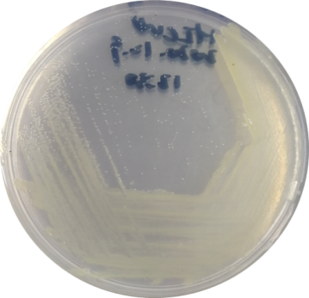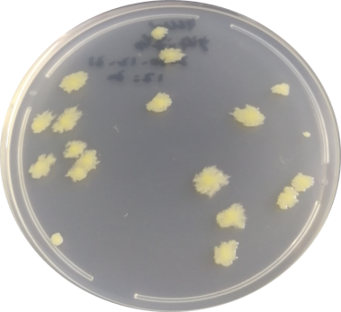
(a)
(b)

Fig. S2 Colony morphology of strain HICW^{T} on MA containing different concentrations of agar

(a). on MA containing 1.5% (w/v) agar for 72 h at 28 ºC; (b). on MA containing 1.0% (w/v) agar for 8 days at 28 ºC.

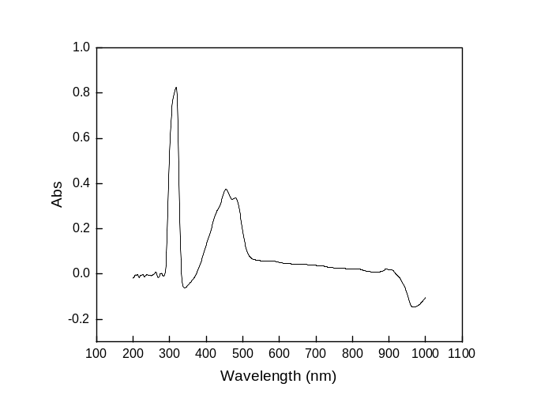

Fig. S3 Full-wavelength scanning pattern of pigment of strain HICW^{T}

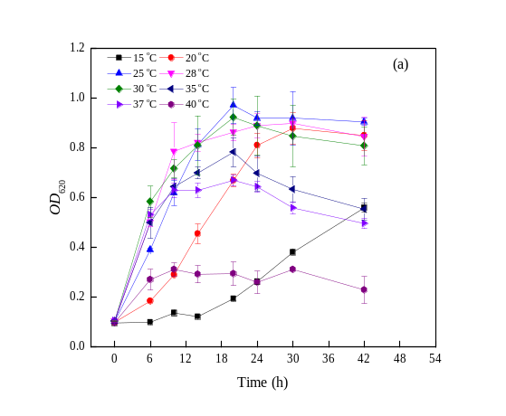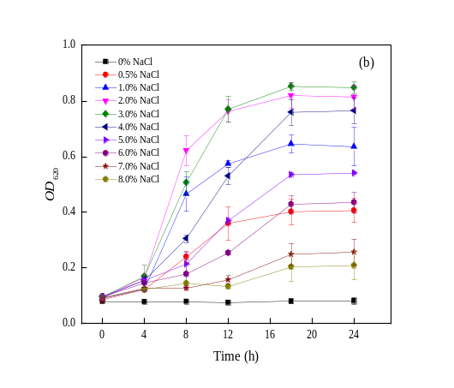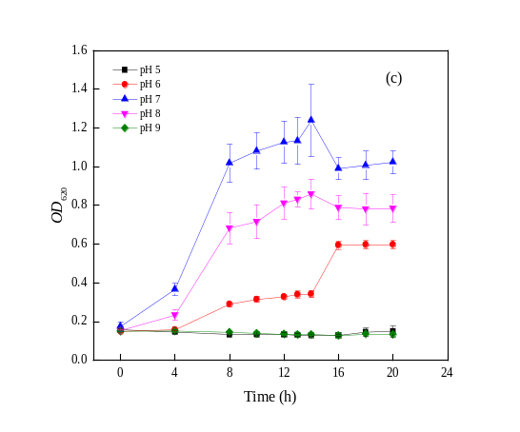

Fig. S4 Effect of different temperature (a), NaCl concentrations (b)

and pH (c) on the growth of strain HICW^{T}

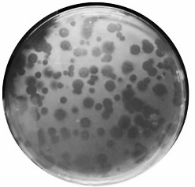
Fig. S5 Plaque morphology of strain HICW^{T} on Vibrio alginolyticus for 48 h at 28 ºC

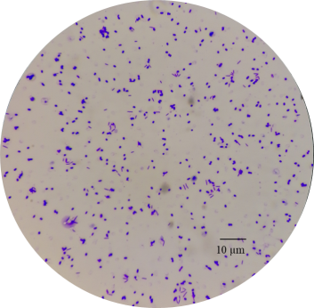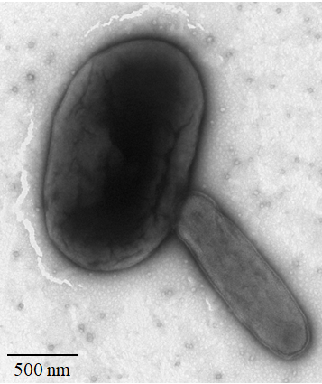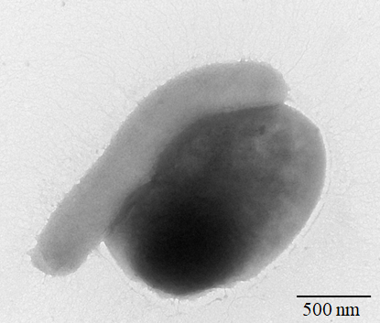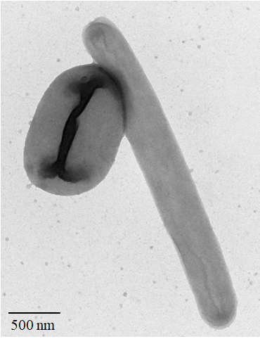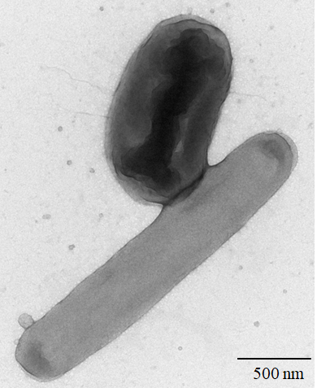
(e)
(d)
1
2
2
1
2
2
2
1
1
1
(c)
(b)
(a)

Fig. S6 The micrographs show strain HICW^{T} attaches to Vibrio alginolyticus LF TCBS15

(a). optical micrograph; (b-e). TEM micrograph; arrow 1, Vibrio alginolyticus LF TCBS15; arrow 2, strain HICW^{T}.

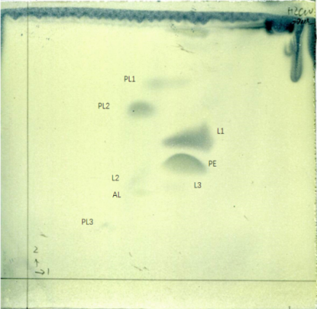
Fig. S7 Two-dimensional thin-layer chromatogram of the total polar lipid profile of strain HICW^{T}
Phosphatidylethanolamine (PE), three unknown phospholipids (PL1–PL3), one unknown aminolipids (AL) and three unknown polar lipids (L1–L3) are shown.

Muricauda taeanensis JCM 17757^{T} (QXFO01000026)

Muricauda Antarctica CGMCC 1.12174^{T} (jgi.1076178)

Muricauda amoyensis GCL-11^{T} (MH196532)

Muricauda flavescens SW-62^{T} (AY445073)

Muricauda beolgyonensis KCTC 23501^{T} (RZMY01000006)

Muricauda olearia CL-SS4^{T} (EU888117)

Muricauda alvinocaridis SCR12^{T} (MH997489)

Muricauda zhangzhouensis 12C25^{T} (JN426849)

Muricauda chongwuensis HICW^{T} (MK920190)

Muricauda aquimarina JCM 11811^{T} (RZMZ01000008)

Muricauda ruestringensis DSM 13258^{T} (CP002999)

Muricauda lutimaris KCTC 22173^{T} (QXFH01000077)

Muricauda iocasae L2^{T} (MG563767)

Muricauda marina H19-56^{T} (KU315479)

Muricauda indica 3PC125-7^{T} (KX874649)

Muricauda pacifica sw027^{T} (JN118551)

Muricauda hymeniacidonis 176CP4-71^{T} (SGIU01000004)

Muricauda nanhaiensis SM1704^{T} (MH492322)

Muricauda lutaonensis CC-HSB-11^{T} (CP011071)

Muricauda lutea CSW06^{T} (KU315485)

Croceitalea marina H01-35^{T} (KU315480)

Croceitalea eckloniae DOKDO 025^{T} (DQ191183)

Maribacter flavus KCTC 42508^{T} (KR058351)

Maribacter cobaltidurans B1^{T} (CP022957)

Zobellia galactanivorans DsiJ^{T} (FP476056)

Zobellia uliginosa DSM 2061^{T} (jgi.1096605)

78
74
99
52
57
99
63
77
71
50
67
78
51
99
99

Fig. S8 Maximum-parsimony tree showing phylogenetic positions of Muricauda chongwuensis HICW^{T} and its related species based on 16S rRNA gene sequences. Accession numbers for the type strains are shown in parenthesis. Only bootstrap values (expressed as percentages of 1000 replications) greater than 50 are shown at branching points.

Muricauda marina H19-56^{T} (KU315479)

Muricauda indica 3PC125-7^{T} (KX874649)

Muricauda iocasae L2^{T} (MG563767)

Muricauda amoyensis GCL-11^{T} (MH196532)

Muricauda flavescens SW-62^{T} (AY445073)

Muricauda taeanensis JCM 17757^{T} (QXFO01000026)

Muricauda Antarctica CGMCC 1.12174^{T} (jgi.1076178)

Muricauda beolgyonensis KCTC 23501^{T} (RZMY01000006)

Muricauda zhangzhouensis 12C25^{T} (JN426849)

Muricauda chongwuensis HICW^{T} (MK920190)

Muricauda aquimarina JCM 11811^{T} (RZMZ01000008)

Muricauda ruestringensis DSM 13258^{T} (CP002999)

Muricauda lutimaris KCTC 22173^{T} (QXFH01000077)

Muricauda olearia CL-SS4^{T} (EU888117)

Muricauda alvinocaridis SCR12^{T} (MH997489)

Muricauda pacifica sw027^{T} (JN118551)

Muricauda hymeniacidonis 176CP4-71^{T} (SGIU01000004)

Muricauda nanhaiensis SM1704^{T} (MH492322)

Muricauda lutaonensis CC-HSB-11^{T} (CP011071)

Muricauda lutea CSW06^{T} (KU315485)

Croceitalea marina H01-35^{T} (KU315480)

Croceitalea eckloniae DOKDO 025^{T} (DQ191183)

Maribacter flavus KCTC 42508^{T} (KR058351)

Maribacter cobaltidurans B1^{T} (CP022957)

Zobellia galactanivorans DsiJ^{T} (FP476056)

Zobellia uliginosa DSM 2061^{T} (jgi.1096605)

99
97
99
74
99
80
76
91
90
81
76
66
52
52
51
0.05

Fig. S9 Maximum-likelihood tree showing phylogenetic positions of Muricauda chongwuensis HICW^{T} and its related species based on 16S rRNA gene sequences. Accession numbers for the type strains are shown in parenthesis. Only bootstrap values (expressed as percentages of 1000 replications) greater than 50 are shown at branching points. Bar, 0.05 substitutions per nucleotide position.

Table S1 Cellular fatty acid composition of strain HICW^{T} and reference strains
Fatty acid | 1 | 2 | 3
Straight-chain Fatty acids
C_{16:0} | 1.2 | 0.4 | 0.4
Unsaturated Fatty acids
C_{15:1} ω6c | 0.4 | 0.9 | 0.9
C_{17:1} ω8c | 0.3 | ND | 0.7
C_{17:1} ω6c | 0.4 | 0.5 | 1.0
Branched Fatty acids
iso-C_{16:0} | 0.3 | 0.5 | ND
iso-C_{15:0} | 31.4 | 23.7 | 14.7
iso-C_{15:1} G★ | 23.5 | 21.6 | 20.5
anteiso-C_{15:0} | 1.1 | 2.0 | 1.1
Hydroxy Fatty acids
iso-C_{15:0} 3-OH | 4.4 | 5.2 | 4.6
C_{15:0} 3-OH | 0.8 | 1.4 | 1.8
C_{15:0} 2-OH | 0.2 | 0.2 | 0.5
C_{16:0} 3-OH | 0.7 | 0.6 | 0.4
iso-C_{16:0} 3-OH | 3.6 | 4.0 | 1.7
C_{17:0} 2-OH | 0.4 | 0.7 | 0.7
C_{17:0} 3-OH | 0.9 | 0.3 | 1.3
iso-C_{17:0} 3-OH | 22.5 | 17.3 | 20.9
Summed features†
3 | 1.7 | 2.3 | 4.2
Strains: 1, HICW^{T}; 2, M. aquimarina JCM 11811^{T}; 3, M. ruestringensis DSM 13258^{T}. Data for the reference strains were taken from previous reports (Yoon et al. 2005). ND, no data available.
★The double bond position indicated by a capital letter is unknown. †Summed feature 3 contains C_{16:1}ω6c, C_{16:1}ω7c or iso-_{15:0} 2-OH, which could not be separated by GLC with the MIDI system

Table S2 Antibiotic susceptibility profiles of strain HICW^{T} and reference strains
 | 1 | 2 | 3
Penicillin (10 U) | + | + | +
Erythromycin (15) | – | – | –
Neomycin (30) | + | – | +
Gentamicin (10) | + | + | +
Tetracycline (30) | + | + | +
Doxycycline (30) | + | + | –
Minocycline (30) | – | + | –
Kanamycin (30) | + | + | +
Amikacin (30) | – | + | +
Oxacillin (1) | + | + | +
Ampicillin (10) | + | – | +
Carbenicillin (100) | + | – | +
Piperacillin (100) | – | – | –
Cefradine (30) | + | – | +
Cephalexin (30) | + | – | +
Cefazoline (30) | + | – | +
Cefuroxime (30) | + | + | +
Ceftazidime (30) | + | + | +
Ceftriaxone (30) | + | + | +
Cefoperazone (75) | + | + | +
Strains: 1, HICW^{T}; 2, M. aquimarina JCM 11811^{T}; 3, M. ruestringensis DSM 13258^{T}.
+, resistant; –, sensitive. Antibiotic susceptibility tests were performed using 6 mm filter-paper discs with antibiotics (µg per disc unless stated otherwise)

