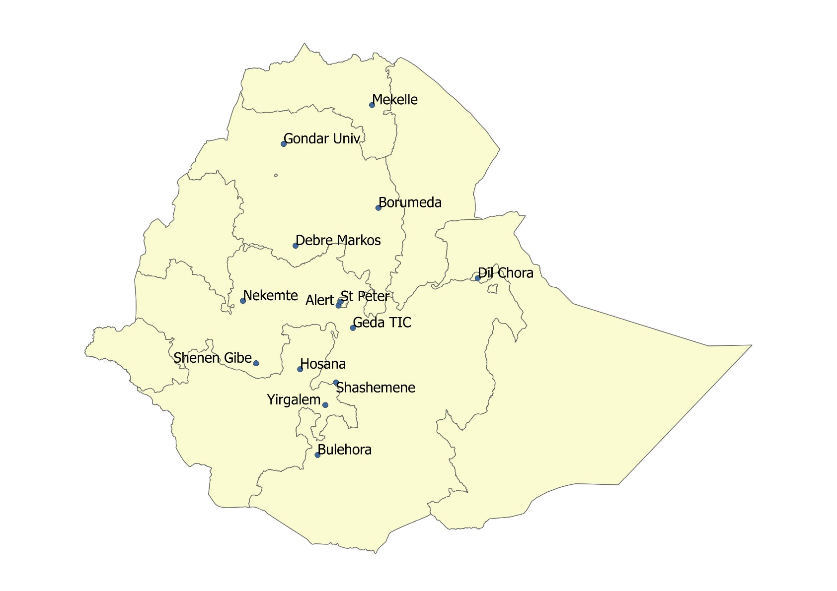
Figure 1. Map of Ethiopia with the location of MDRTB treatment initiation centres included in the study.

Source: Federal Democratic Republic of Ethiopia Population Census Commission Bureau

Ethiopia (14TICs, N=1559 patients)

Regions having treatment initiating centers (TICs=14, N=1559 patients)
Figure 3: Schematic diagram of sampling technique among patients treated for MDRTB in Ethiopia, 2009-2014.

All the regions having MDRTB service were included purposely

SNNPR (2TICs) N=66(4.2%)
Tigrai (1TIC) N=83(5.3%)
Addis Ababa (2TICs) N=942(60.5%)

Dire Dawa (1TIC) N =62(4%)
Amhara (3TIC), N=272(17.5%)
Oromia (5TICs), N =134(8.5%)

All the TICs from respective regional states were included purposely

K
J

M
L
I

H
C
D
E
F
a
B
N
A

Client load of each TIC from unit MDRTB register (N)

83
62
27
5
36
39
27
33
33
193
72
7
162
780

Simple random sampling from MDRTB unit registers after proportional assignment of the sample size (n).

376
78
40
34
4
93
16
16
2
13
13
17
19
30

454
40
30
64
32
131
n= 751

TICs: Treatment Initiating centers; N: Study population; n: Sample size.
A: Dilchora hospital TIC; B: Nekemte hospital TIC; C: Geda hospital TIC; D: Shashimene hospital TIC; E: Shenen Gibe hospital TIC;
F: Bulehora hospital TIC;G: Yirgalem hospital TIC;H:Hosana hospital TIC;I:Gondar univ. hospital TIC;J:Debre Marikos hospital TIC ;K:Borumeda hospital TIC ;L:St.Peter hospital TIC ;M:ALERT hospital TIC;N:Mekelle hospital TIC.

Figure2: Schematic diagram of sampling technique for MDRTB patients treated in Ethiopia, 2009-2014.

Table 1: Socio-demographic characteristics of Multi-drug resistant tuberculosis (MDR-TB) patients treated in Ethiopia, between 2009 and 2014 (N= 751).
Variables | Frequency | Percent (%)
Regions at which the patients treated:  Addis Ababa  Amhara  Oromia  Tigrai  SNNPR Dire Dawa | 454  131  64  40  32  30 | 60.5  17.4  8.5  5.3  4.3  4
Region from where the patients were come:  Addis Ababa  Amhara  Oromia  SNNPR  Tigrai  Dire Dawa  Afar  Somali  Harari  Gambela  Benishangul Gumuz  Unknown | 273  144  140  70  59  25  10  10  3  2  2  13 | 36.4  19.2  18.7  9.4  7.9  3.4  1.3  1.3  0.4  0.3  0.3  1.8
TIC at which the patients treated treatment  St.Peter hospital  Gondar university hospital  ALERT hospital  Mekele hospital  Borumeda hospital  Dilchora hospital  Shashamane hospital  Nekemte hospital  Adama hospital  Bulehora hospital  Shenengibe hospital  Yergalem hospital  Hosana hospital  Debre marikos hospital | 376  93  78  40  34  30  13  19  17  2  13  16  16  4 | 50  12.4  10.4  5.4  4.6  4  1.7  2.5  2.3  0.3  1.7  2  2  0.5
Sex:  Male  Female | 433  318 | 57.7  42.3
Residence:  Urban  Rural | 506  245 | 67.6  32.4

Table 2: Clinical and programmatic characteristics of the patients treated for multi-drug resistant tuberculosis in Ethiopia between 2009 and 2014(N=751).
Variables | Frequency | Percent (%)
Model of care  Ambulatory  Hospitalized | 178 573 | 23.7  76.3
TB treatment supporter  Yes  Missing/unknown  No | 399  43  309 | 53  6  41
Type of TB treatment supporter  HCW  Family  Other | 19  359  21 | 4.8  90  5.2
Co-morbidity (at least one)  Yes  Unknown  No | 293  65  393 | 39  8.7  52.3
HIV status  Reactive  Non-reactive | 164  587 | 21.8  78.2
Diabetes mellitus  Yes  No  Unknown | 26 361  364 | 3.5(*6.7)  48(*93.3)  48.5
Body mass index (in kg/m²)  <18.5 Unknown >=18.5 | 313  296  142 | 41.8  39.4  18.8
Treatment interruption  Yes  No  Missing | 28  669  54 | 3.7  89.1  7.2
Medication changed  No  Unknown  Yes | 248  432  71 | 33  57.5  9.5
Reason for medication changed  Side effect  National algorithm change  Others | 62  3  6 | 87.3  4.2  8.5
Pulmonary tuberculosis  Smear positive  Smear negative | 542  209 | 72  28

Bacilli load  Scanty  +  ++  +++  Unknown | 15  119  155  107  146 | 2.8  22  28.6  19.7  26.9
Previous history of susceptible TB treatment  Yes  No | 730  21 | 97.2  2.8
Frequency of susceptible TB treatment  One  Two  >=Three | 158  400  172 | 21.6  54.8  23.6
Resistance to  Four drugs (RHES)  Three drugs (RES/RHE)  Only two drugs (RH)  Only one drug (R) | 167  57  366  161 | 22.2  7.6  48.8  21.4
Category of the patient  Failure  Relapse  LTFU &Other  New | 555  70  105  21 | 73.9  9.3  14  2.8
History of hypokalemia  Yes  Missing/unknown  No | 341  90  320 | 45.4  12  42.6
Treatment outcome of FL treatment  Unsuccessful  Successful | 645  85 | 88.4  11.6
Base line x-rays done  Yes  No  Missing | 470  148  133 | 62.5  19.7  17.8
X-ray result/finding  Abnormal  Unknown  Normal | 426  30  14 | 90.6  6.4  3
History of second line drug  Yes  No | 15  736 | 2  98

* Percent from those with available information on history of DM
TB=Tuberculosis; HCW=Health Care Worker; HIV=Human Immuno Deficiency Virus; FL=First line, DM =Diabetes Mellitus.

Figure 4: Rate of sputum smear and culture conversion among patients treated for MDR-TB in Ethiopia, 2009 – 2014.
Table 3: The independent predictors of unknown intensive phase treatment outcome among patients treated for MDR-TB in Ethiopia, 2009-2014.
Variables | unknown outcome
Variables | CRRR 95% CI | ARRR 95% CI
Model of care  Ambulatory  Hospitalized | 2.107(1.386, 3.203) **  1 | 3.158(1.612, 6.185) **  1
Residence  Urban  Rural | 0.538(0.361,0.803) **  1 | 0.370(0.199, 0.66) **  1
TB Treatment supporter  Yes  Unknown  No | 0.964(0.634, 1.465)  3.383(1.632, 7.012) **  1 | 0.022(0.002, 0.231) **  0.332(0.083, 1.319)  1
Resistances to:  Four drugs (RHES)  Three drugs (RHE)  Two drugs (RH)  One drug(R) | 0.293(0.165,0.523) **  0.254(0.106,0.609) **  0.285(0.178,0.457) **  1 | 0.741(0.267, 2.059)  0.185(0.03, 0.9426) *  0.350(0.177, 0.693) **  1

CRRR=Crude Relative Risk Ratio; ARRR=Adjusted Relative Risk Ratio; * p value<0.05;
** P value<0.01

Table 4: The independent predictors of unfavorable intensive phase treatment outcome among patients treated for MDR-TB in Ethiopia, 2009-2014.
Variables | unfavorable outcome
Variables | CRRR 95% CI | ARRR 95%CI
Age | 1.039(1.022, 1.056) ** | 1.047(1.024, 1.072) **
History of hypokalemia  Yes  Unknown  No | 0.567(0.371, 0.867)**  1.548(0.857, 2.797)  1 | 0.512(0.280, 0.939) *  1.454(0.499, 4.242)  1

CRRR=crude relative risk ratio; ARRR=adjusted relative risk ratio; *p value<0.05;
** P value<0.01.

