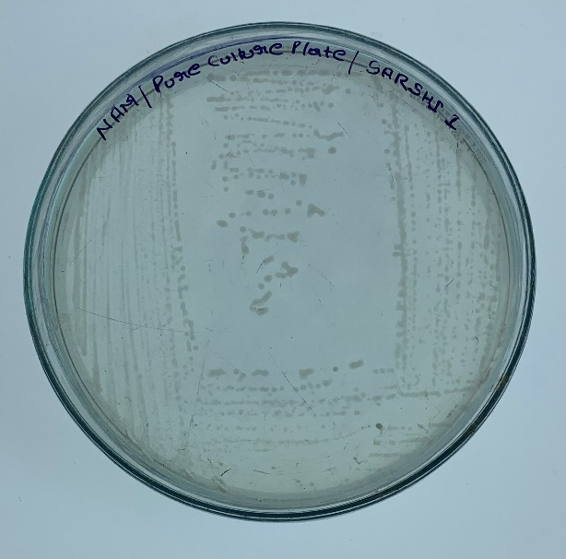
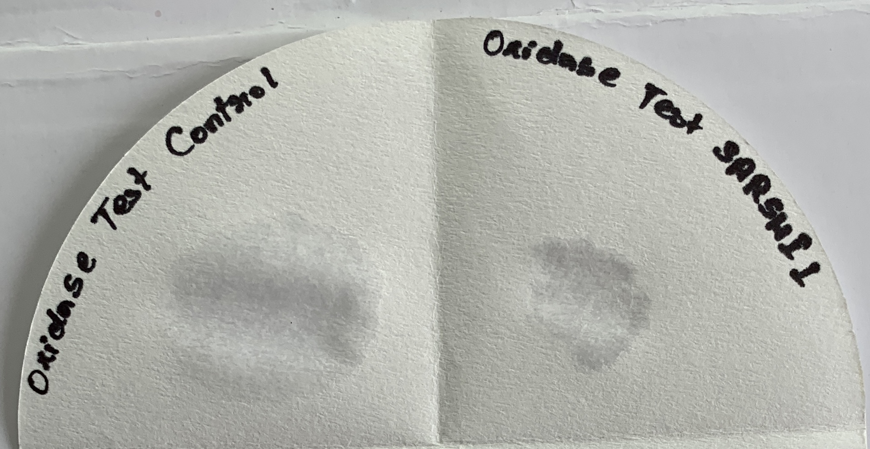
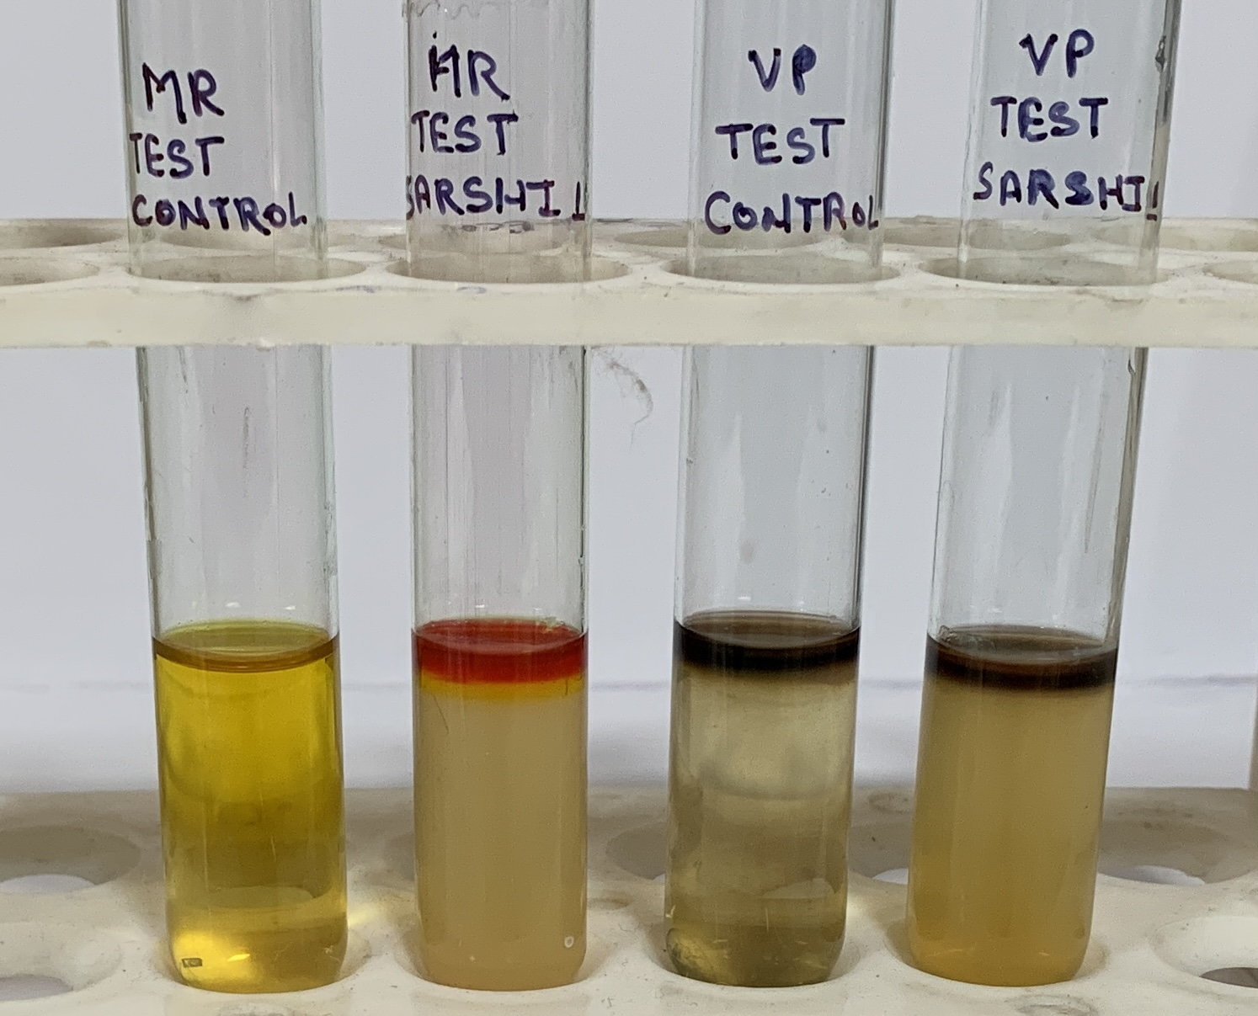
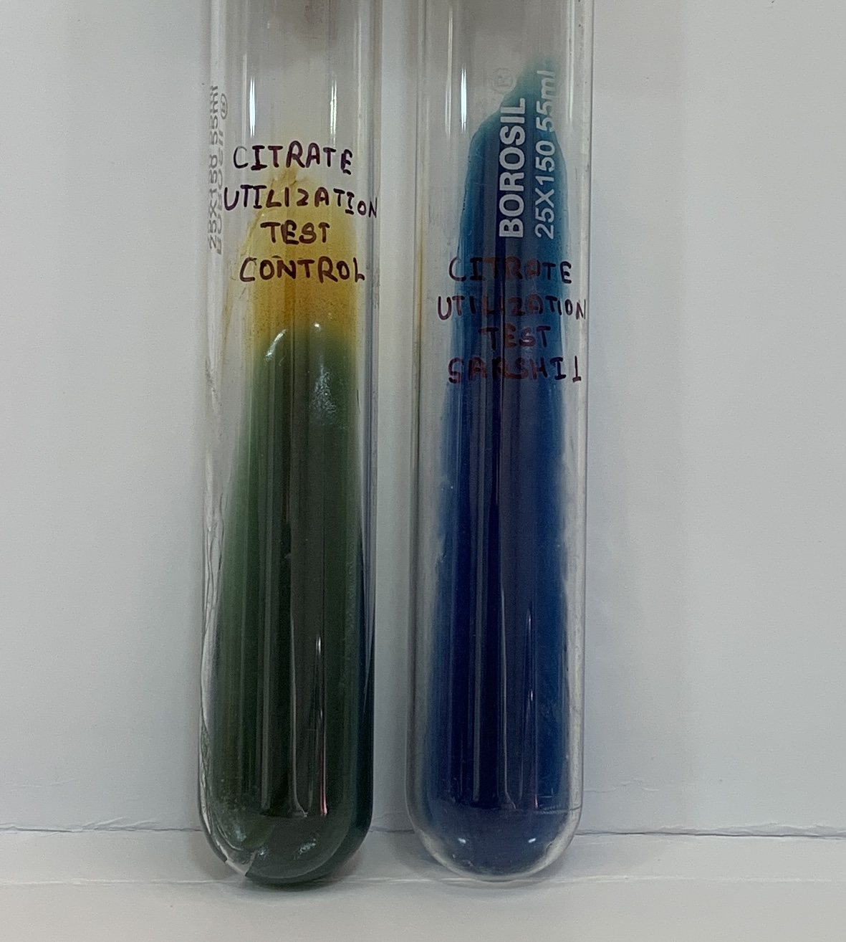
A
B
C
D

Fig. 1 Biochemical and Microbial Characterization of SARSHI1
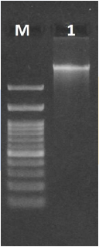
Fig. 2 DNA QC: Agarose Gel Electrophoresis

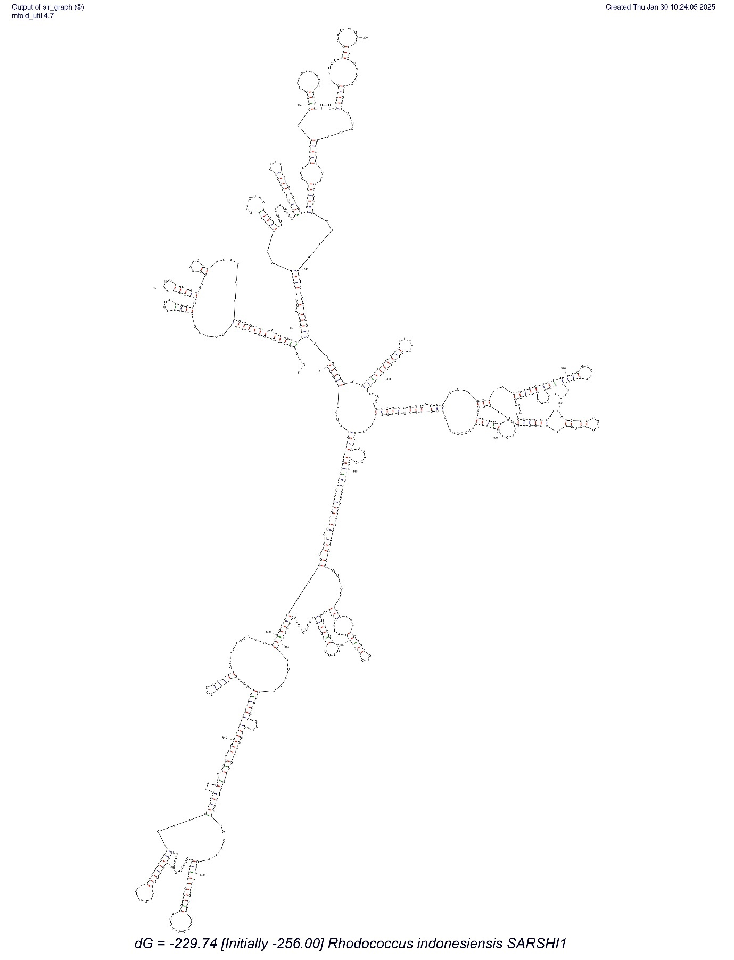
Fig. 3 rRNA Structure of Rhodococcus indonesiensis SARSHI1

Table:1 Maximum Likelihood Scores
 | Rate of Substitution | A | T/U | C | G | Nucleotide Frequencies
Maximum likelihood estimate of substitution matrix. | A | - | 5.44 | 7.38 | 11.78 | A = 21.74%, T/U = 18.35%, C = 24.89%, and G = 35.02%
Maximum likelihood estimate of substitution matrix. | T | 6.45 | - | 12.43 | 10.39 | A = 21.74%, T/U = 18.35%, C = 24.89%, and G = 35.02%
Maximum likelihood estimate of substitution matrix. | C | 6.45 | 9.17 | - | 10.39 | A = 21.74%, T/U = 18.35%, C = 24.89%, and G = 35.02%
Maximum likelihood estimate of substitution matrix. | G | 7.31 | 5.44 | 7.38 | - | A = 21.74%, T/U = 18.35%, C = 24.89%, and G = 35.02%
Maximum Composite likelihood estimate of the pattern of nucleotide substitution | A | - | 1.34 | 1.83 | 30.96 | A=22.38%, T/U=18.15%, C=24.80%, and G=34.66%.
 | T | 1.65 | - | 19.78 | 2.56 | A=22.38%, T/U=18.15%, C=24.80%, and G=34.66%.
 | C | 1.65 | 14.38 | - | 2.56 | A=22.38%, T/U=18.15%, C=24.80%, and G=34.66%.
 | G | 20 | 1.34 | 1.83 | - | A=22.38%, T/U=18.15%, C=24.80%, and G=34.66%.
Tajima’s neutrality test | m | s | Ps | Θ | π | D
 | 20 | ## | 0.9229390 | 0.260148476859608 | 0.416525183927561 | 2.51268132715715
m = number of sequences, n = total number of sites, S = Number of segregating sites, ps = S/n, Θ = ps/a1, π = nucleotide diversity, D - Tajima test statistic.

Table 2: Thermodynamic Properties of SARSHI1
Structural element | δG | Information
External loop | -0.20 | 5 ss bases & 3 closing helices.
Stack | -3.40 | External closing pair is G ²⁵⁴-C ⁷²⁰
Helix | -10.90 | 5 base pairs.
Multi-loop | 3.00 | External closing pair is G ²⁵⁸-C ⁷¹⁶  13 ss bases & 4 closing helices.
Helix | -6.40 | 4 base pairs.
Bulge loop | 4.00 | External closing pair is G ⁴³²-C ⁷⁰⁸
Stack | -3.30 | External closing pair is G ⁴³⁸-C ⁷⁰⁷
Helix | -8.70 | 6 base pairs.
Interior loop | 3.10 | External closing pair is A ⁴⁴³-U ⁷⁰²
Stack | -2.20 | External closing pair is A ⁴⁴⁶-U ⁶⁹⁹
Helix | -3.30 | 2 base pairs.
Multi-loop | 0.70 | External closing pair is C ⁴⁵⁶-G ⁶⁸⁷  18 ss bases & 4 closing helices.
Stack | -2.10 | External closing pair is C ⁵¹⁵-G ⁶⁸⁴
Helix | -7.50 | 5 base pairs.
Hairpin loop | 6.20 | Closing pair is A ⁶⁵⁷-U ⁶⁶¹
Stack | -2.50 | External closing pair is G ⁵²⁷-C ⁶⁴⁹
Helix | -1.50 | 2 base pairs.
Bulge loop | 3.30 | External closing pair is C ⁵⁴⁶-G ⁶³¹
Stack | -2.40 | External closing pair is U ⁵⁴⁷-A ⁶²⁸

