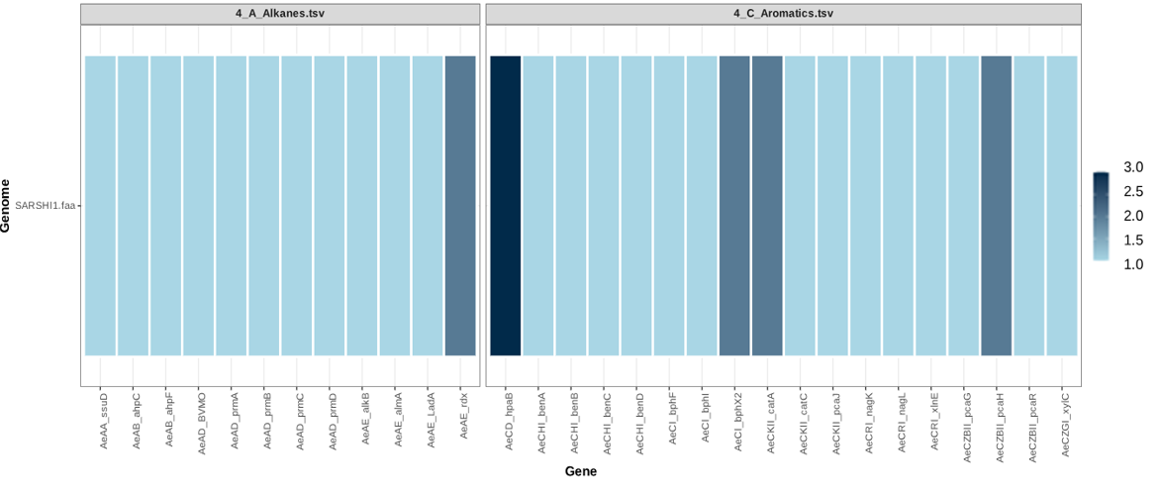
Fig.1 SARSHI1: Alkane and Aromatic Hydrocarbon Genes

