Statistics without reference | Assembly
# contigs | 2
# contigs (>= 0 bp) | 2
# contigs (>= 1000 bp) | 2
# contigs (>= 5000 bp) | 2
# contigs (>= 10000 bp) | 2
# contigs (>= 25000 bp) | 2
# contigs (>= 50000 bp) | 2
Largest contig | 5,536,171
Total length | 5,695,289
Total length (>= 0 bp) | 5,695,289
Total length (>= 1000 bp) | 5,695,289
Total length (>= 5000 bp) | 5,695,289
Total length (>= 10000 bp) | 5,695,289
Total length (>= 25000 bp) | 5,695,289
Total length (>= 50000 bp) | 5,695,289
N50 | 5,536,171
N90 | 5,536,171
auN | 5,385,944
L50 | 1
L90 | 1
GC (%) | 70.08
Per base quality | -
# N's per 100 kbp | 0
# N's | 0
Table: 1 QUAST Statistics of SARSHI1

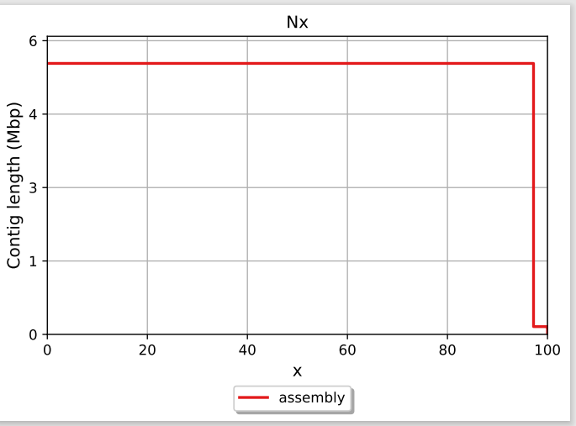
Fig. 1 Genome Assembly Nx Plot

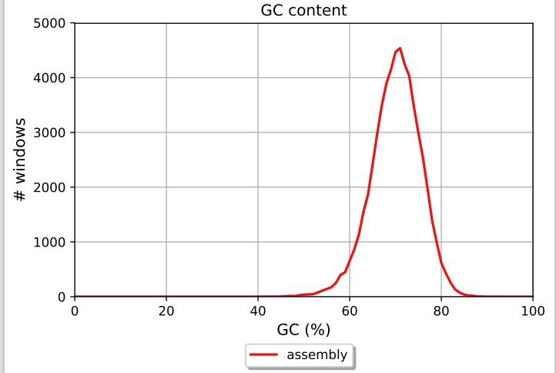
Fig. 2 Genome Assembly GC Content

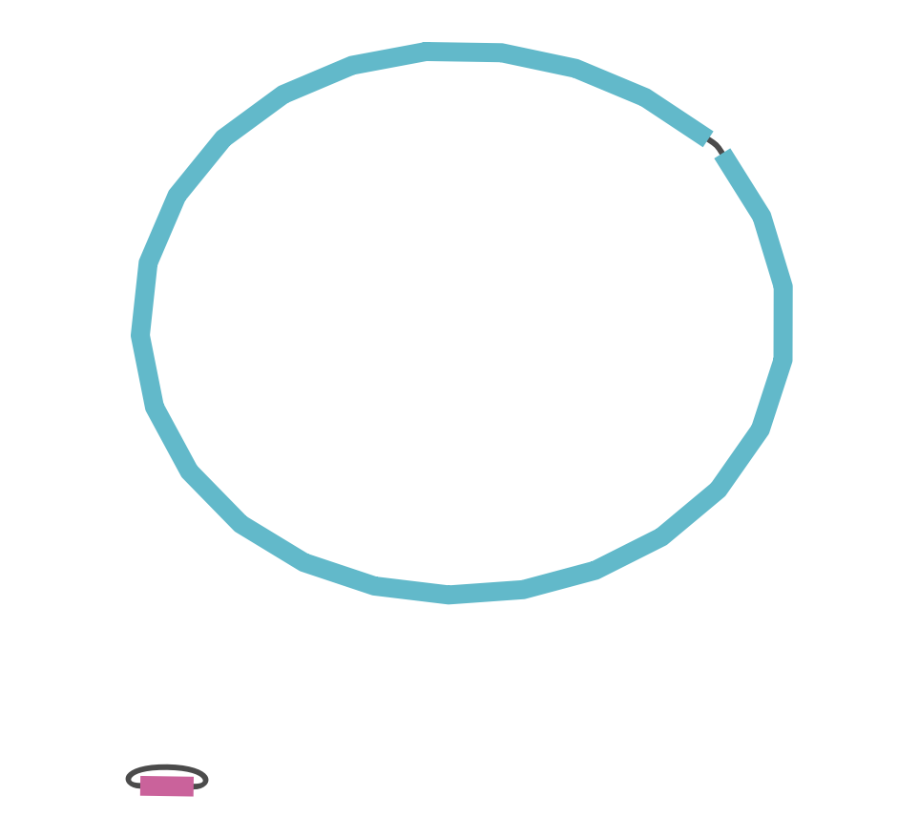
Fig. 3 Genome Assembly visualization using Bandage

