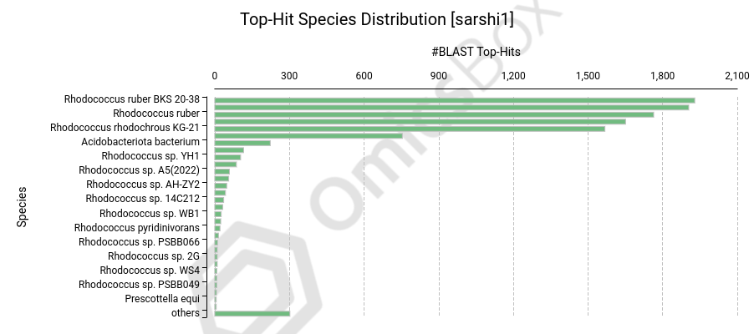
Fig. 1 Blast2go_ Species Distribution

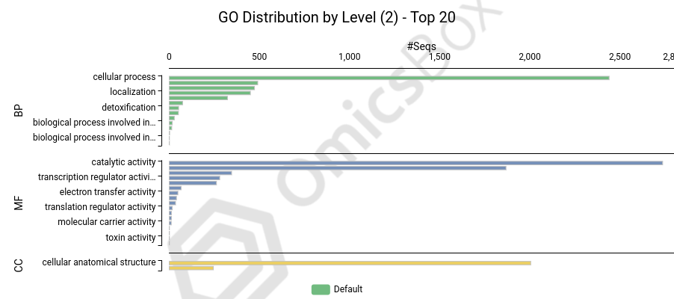
Fig. 2 GO distribution of SARSHI1
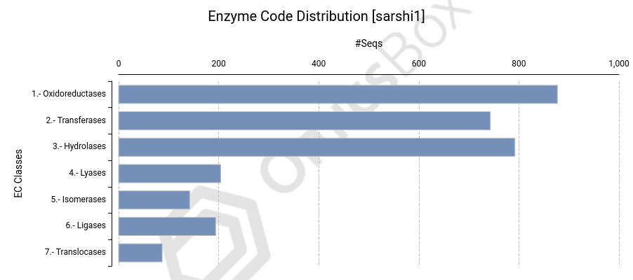
Fig. 3 Enzyme Distribution of SARSHI1

