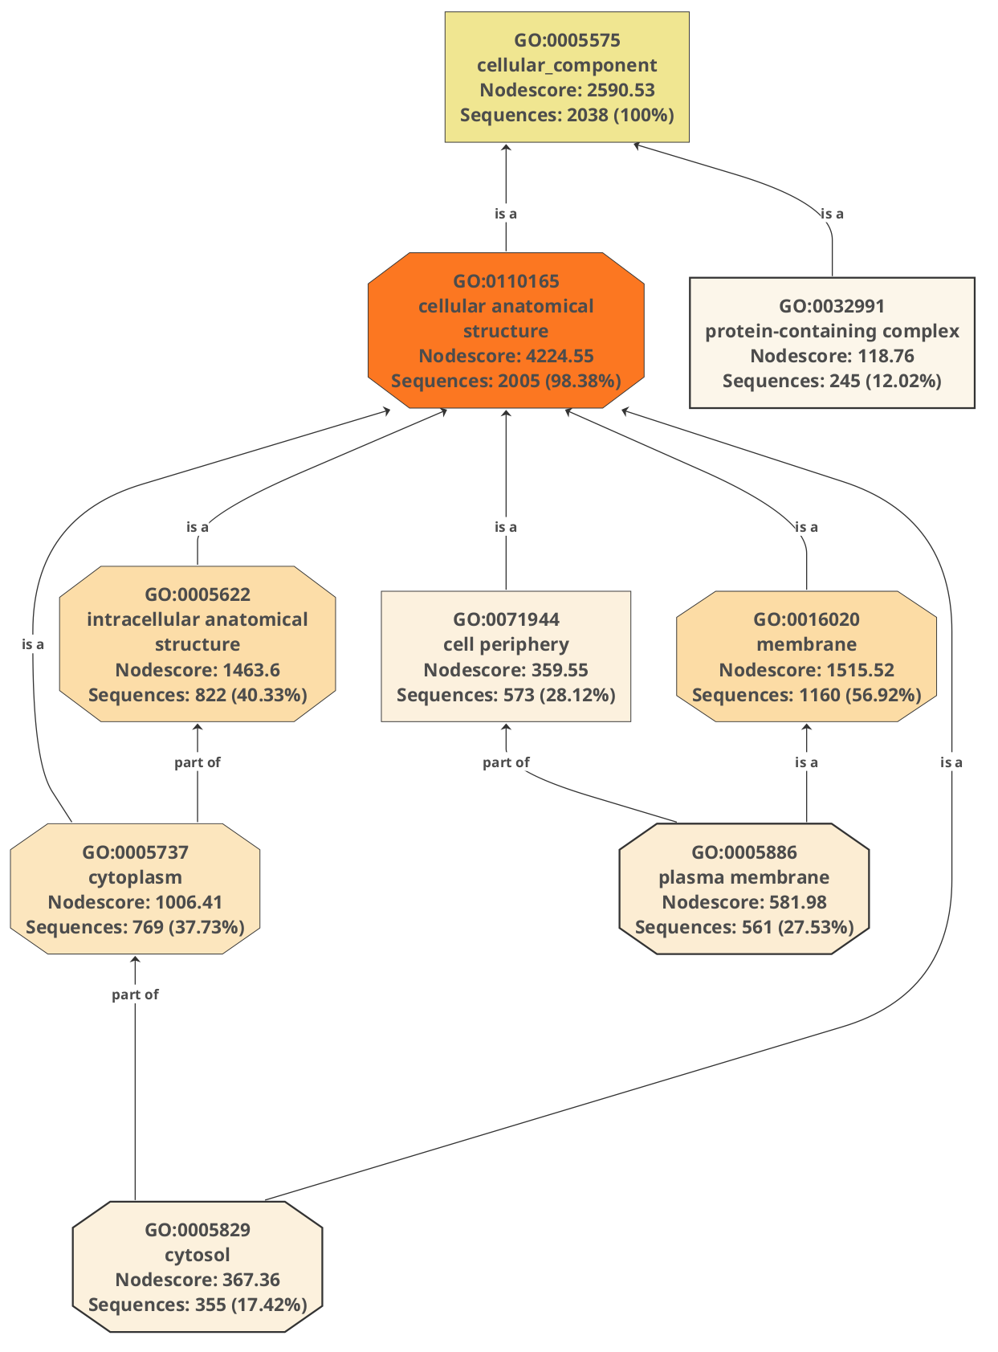
Fig. 1 Cellular Component Ontology Graph

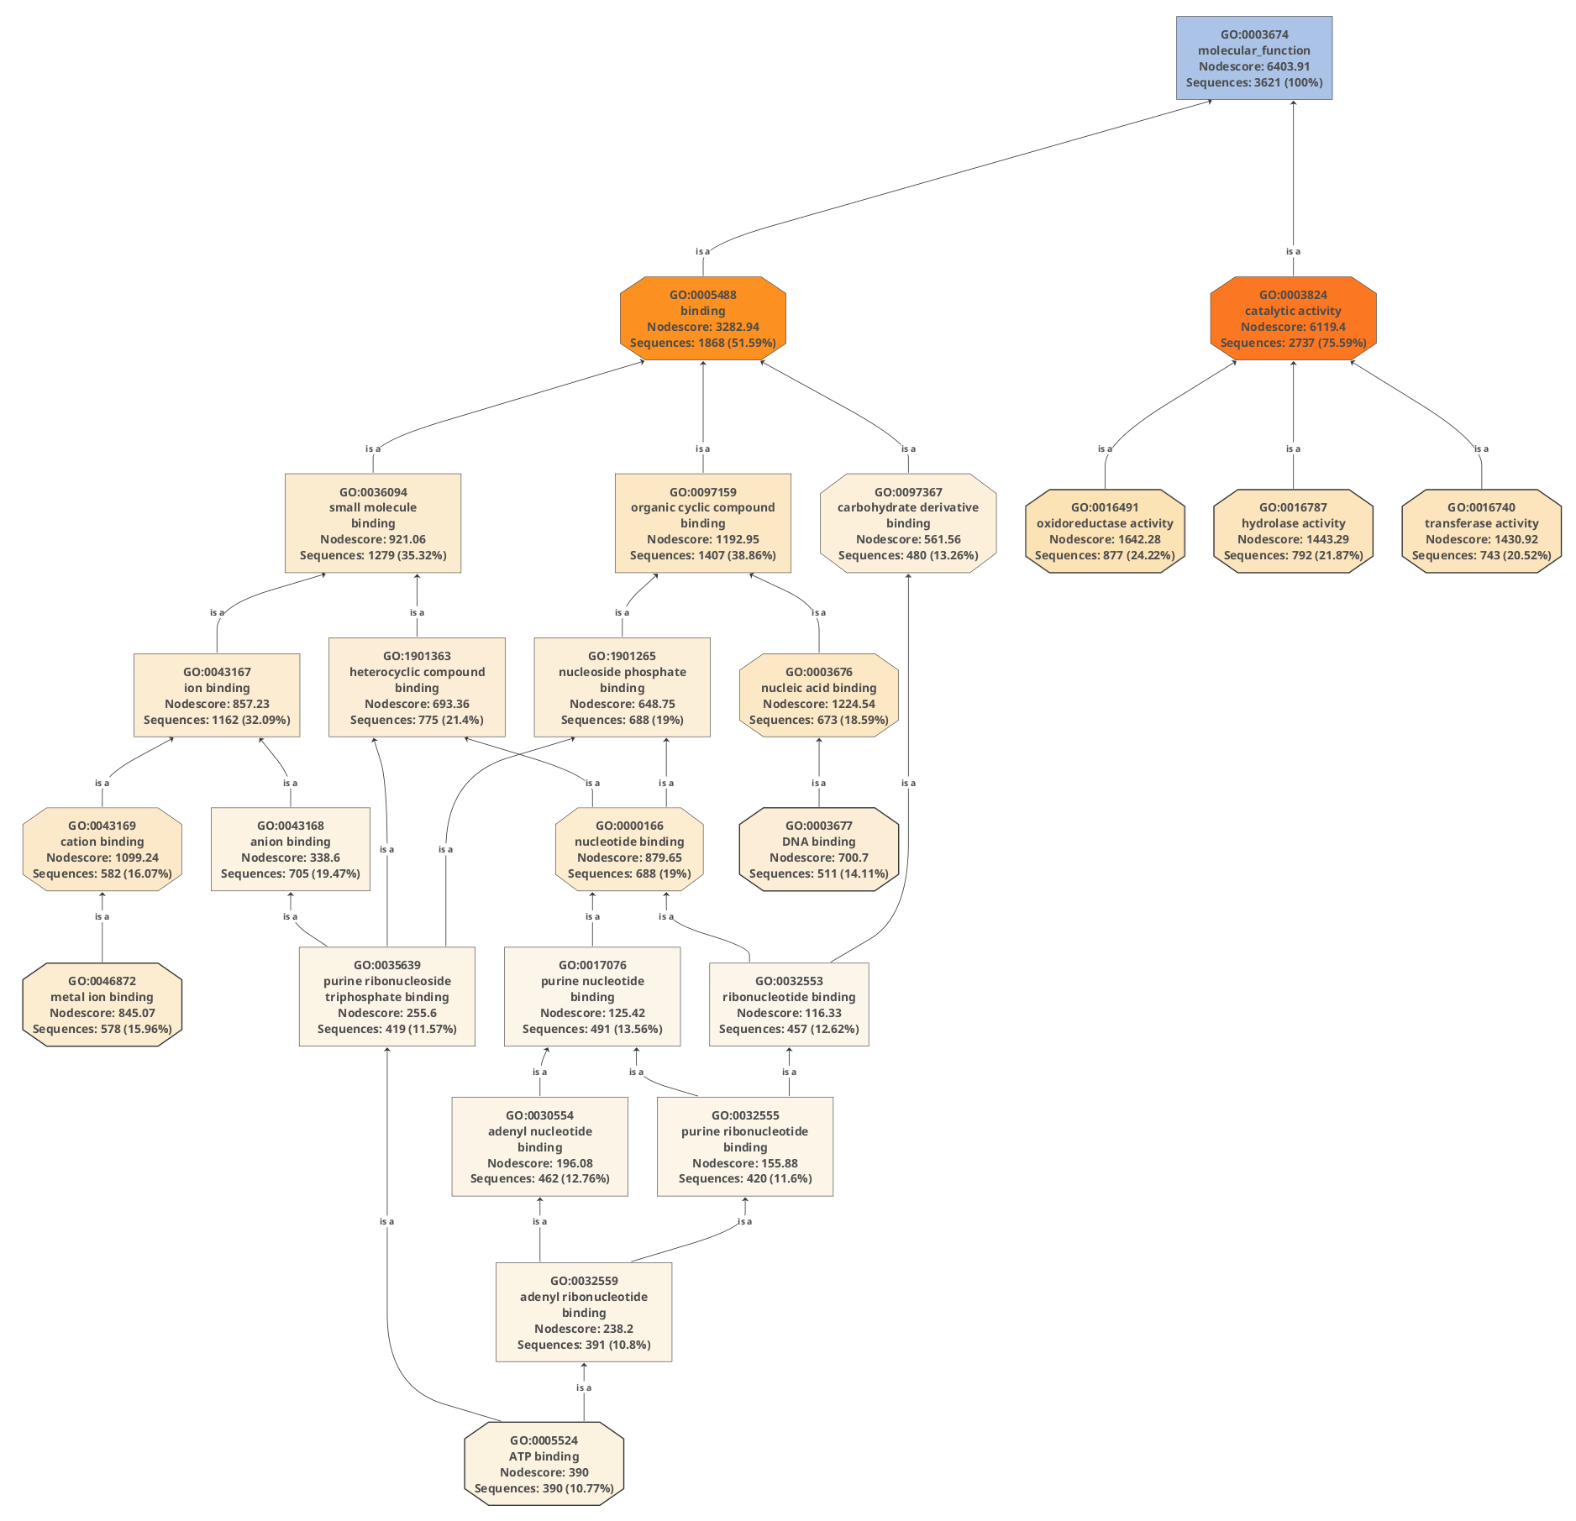
Fig. 2 Molecular Component Ontology Graph
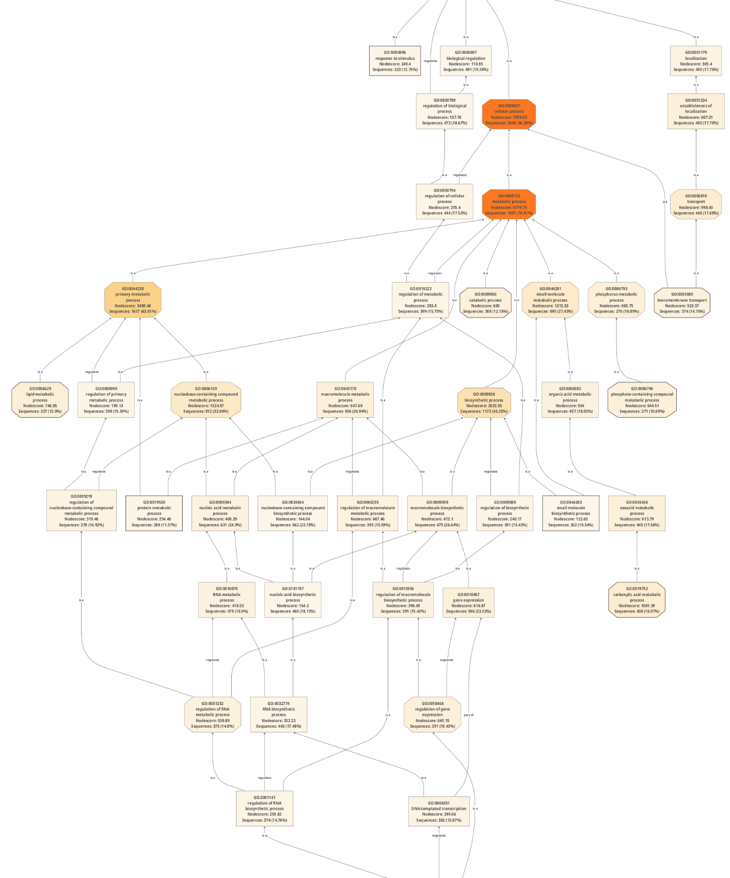
Fig. 3 Biological Process Ontology Graph

