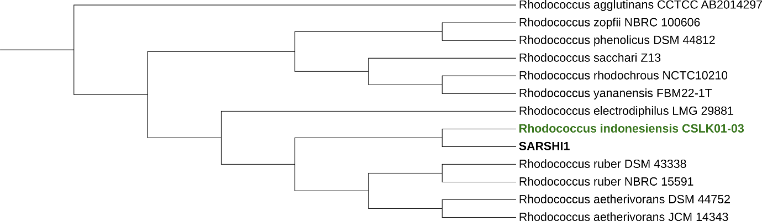
Fig. 1 SSU Tree of SARSHI1

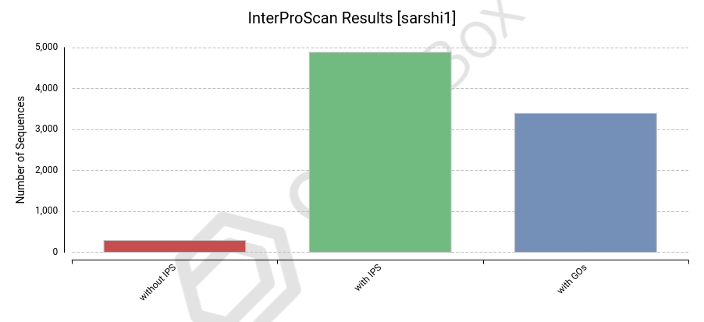
Fig. 2: InterProScan Hits for SARSHI1
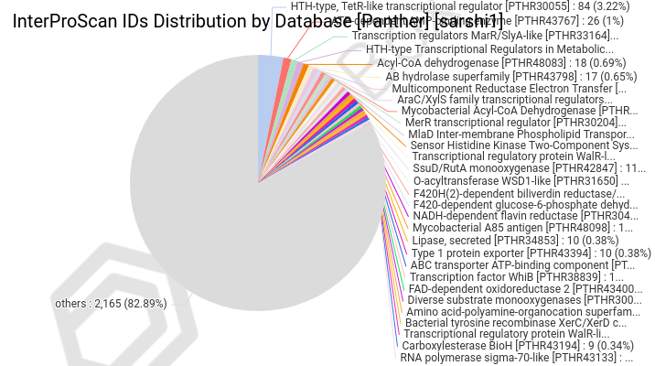
Fig. 3: Panther based functional annotation of the SARSHI1

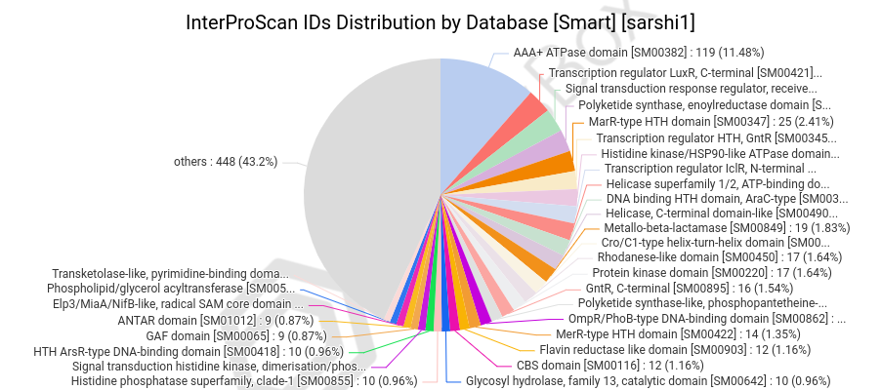
Fig. 4: SMART based functional annotation of the SARSHI1

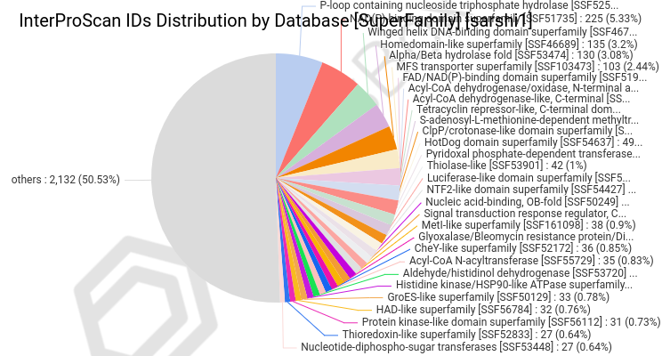
Fig. 5: SuperFamily-based functional annotation of the SARSHI1

Table 1: Pairwise comparisons of SARSHI1 genome vs. type-strain genomes
Query | Subject | d₀ | C.I. d₀ | d₄ | C.I. d₄ | d₆ | C.I. d₆ | Diff. G+C Percent
SARSHI1 | Rhodococcus indonesiensis CSLK01-03 | 89.2 | [85.9 - 91.9] | 88.2 | [85.7 - 90.3] | 91.7 | [89.2 - 93.7] | 0.09
SARSHI1 | Rhodococcus electrodiphilus LMG 29881 | 82.8 | [78.9 - 86.0] | 60.8 | [58.0 - 63.6] | 81.2 | [77.8 - 84.1] | 0.45
SARSHI1 | Rhodococcus ruber NBRC 15591 | 81.1 | [77.2 - 84.5] | 60.6 | [57.7 - 63.4] | 79.7 | [76.3 - 82.8] | 0.6
SARSHI1 | Rhodococcus ruber DSM 43338 | 80.2 | [76.3 - 83.6] | 60.6 | [57.8 - 63.4] | 79 | [75.6 - 82.1] | 0.59
SARSHI1 | Rhodococcus aetherivorans JCM 14343 | 69.7 | [65.8 - 73.4] | 43 | [40.5 - 45.5] | 64.6 | [61.3 - 67.9] | 0.2
SARSHI1 | Rhodococcus aetherivorans DSM 44752 | 69.7 | [65.8 - 73.3] | 43 | [40.5 - 45.6] | 64.6 | [61.2 - 67.8] | 0.18
SARSHI1 | Rhodococcus zopfii NBRC 100606 | 27.1 | [23.8 - 30.8] | 22.5 | [20.2 - 24.9] | 25.1 | [22.2 - 28.2] | 1.84
SARSHI1 | Rhodococcus phenolicus DSM 44812 | 25.9 | [22.6 - 29.5] | 22.2 | [20.0 - 24.7] | 24.1 | [21.2 - 27.2] | 1.72
SARSHI1 | Rhodococcus sacchari Z13 | 26.6 | [23.2 - 30.2] | 22.1 | [19.8 - 24.5] | 24.6 | [21.7 - 27.7] | 0.27
SARSHI1 | Rhodococcus rhodochrous NCTC10210 | 25.3 | [22.0 - 29.0] | 21.4 | [19.2 - 23.9] | 23.5 | [20.7 - 26.6] | 1.91
SARSHI1 | Rhodococcus yananensis FBM22-1T | 22.8 | [19.5 - 26.5] | 21.3 | [19.1 - 23.7] | 21.6 | [18.8 - 24.6] | 1.41
SARSHI1 | Rhodococcus agglutinans CCTCC AB2014297 | 19.8 | [16.6 - 23.4] | 20.6 | [18.3 - 23.0] | 19.1 | [16.4 - 22.1] | 0.82

Table 2: Type-based Species and Subspecies clustering
Species cluster | Subspecies cluster | Strain | Authority | Synonyms | Base pairs | Percent G+C | No. proteins | Bioproject accession | Biosample accession | Assembly accession
1 | 1 | Rhodococcus aetherivorans | DSM 44752 | Rhodococcus aetherivorans | 64,25,690 | 70.3 | 5,798 | PRJNA607633 | SAMN14142455 | GCA_011058165
1 | 1 | Rhodococcus aetherivorans | JCM 14343 | Rhodococcus aetherivorans | 63,81,318 | 70.3 | 5,988 | PRJDB8788 | SAMD00186790 | GCA_009176285
2 | 0 | Rhodococcus zopfii | NBRC 100606 | Rhodococcus zopfii | 62,97,215 | 68.2 | 5,885 | PRJDB309 | SAMD00046765 | GCA_001895025
3 | 2 | Rhodococcus rhodochrous | NCTC10210 | Rhodococcus rhodochrous; Staphylococcus rhodochrous | 52,74,756 | 68.2 | 4,815 | PRJEB6403 | SAMEA4535765 | GCA_900187265
4 | 3 | Rhodococcus agglutinans | CCTCC AB2014297 | Prescottella agglutinans; Rhodococcus agglutinans | 54,19,727 | 69.3 | 4,862 | PRJNA504549 | SAMN10395197 | GCA_004011865
5 | 4 | Rhodococcus sacchari | Z13 | Rhodococcus sacchari | 45,32,339 | 69.8 | 4,095 | PRJNA224116 | SAMN31157772 | GCF_025837095
6 | 5 | Rhodococcus phenolicus | DSM 44812 | Rhodococcus phenolicus | 62,83,557 | 68.4 | 5,932 | PRJNA224116 | SAMN04357313 | GCF_001646785
7 | 6 | Rhodococcus ruber | DSM 43338 | Rhodococcus ruber; Streptothrix rubra | 53,03,098 | 70.7 | 4,897 | PRJNA224116 | SAMN04357318 | GCF_001646835
7 | 6 | Rhodococcus electrodiphilus | LMG 29881 | Rhodococcus electrodiphilus | 54,78,764 | 70.5 | 5,064 | PRJNA610628 | SAMN35798641 | GCA_030509825
7 | 6 | Rhodococcus ruber | NBRC 15591 | Rhodococcus ruber; Streptothrix rubra | 53,27,597 | 70.7 | 4,891 | PRJDB304 | SAMD00046777 | GCA_001894945
8 | 7 | Rhodococcus yananensis | FBM22-1T | Rhodococcus yananensis | 42,32,636 | 68.7 | 3,839 | PRJNA224116 | SAMN21894551 | GCF_020515525
9 | 8 | Rhodococcus indonesiensis | CSLK01-03 | Rhodococcus indonesiensis | 54,79,544 | 70.2 | 5,096 | PRJNA610628 | SAMN35785859 | GCA_030360185
9 | 8 | SARSHI1 | — | — | 56,95,289 | 70.1 | 5,170 | — | — | —

