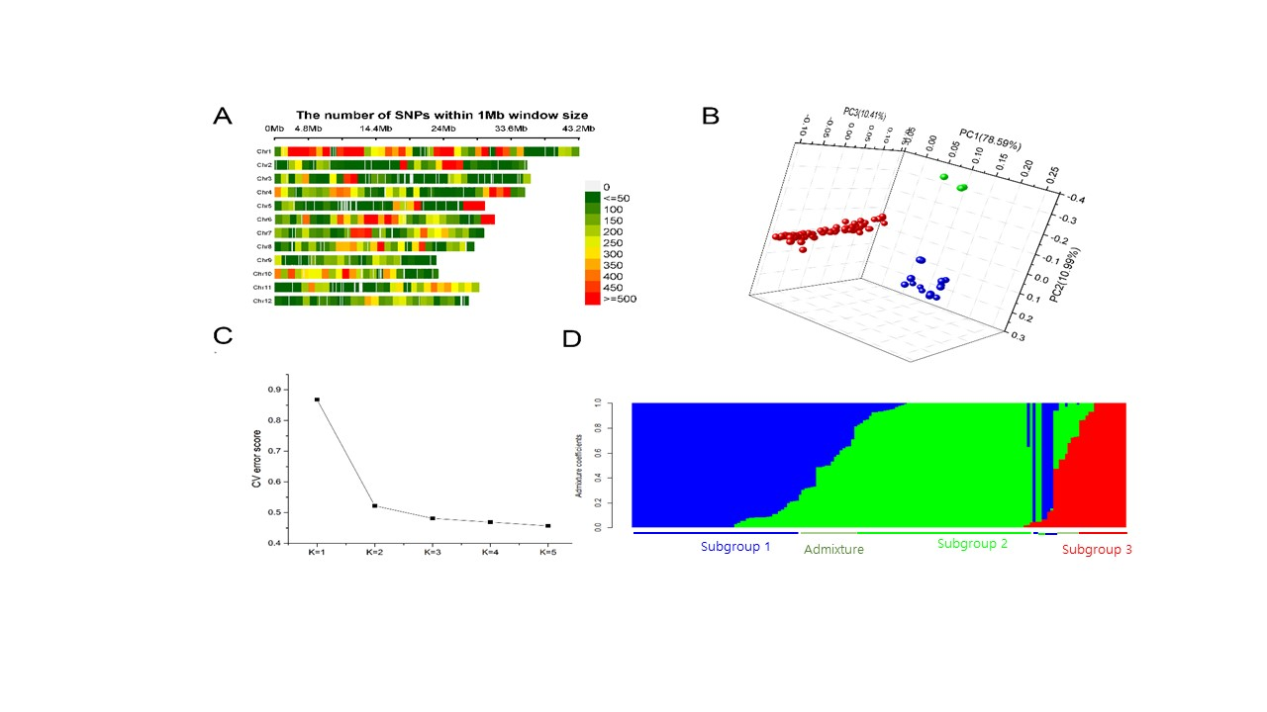
Fig S1. Population structure of 169 landraces. (A) Chromosome distribution of mapped SNPs across the whole genome of rice; (B) PCA of 169 rice varieties; (C) cross-validation (CV) error of diverse groups (K); (D) subgroups (K=3) inferred via structural software.

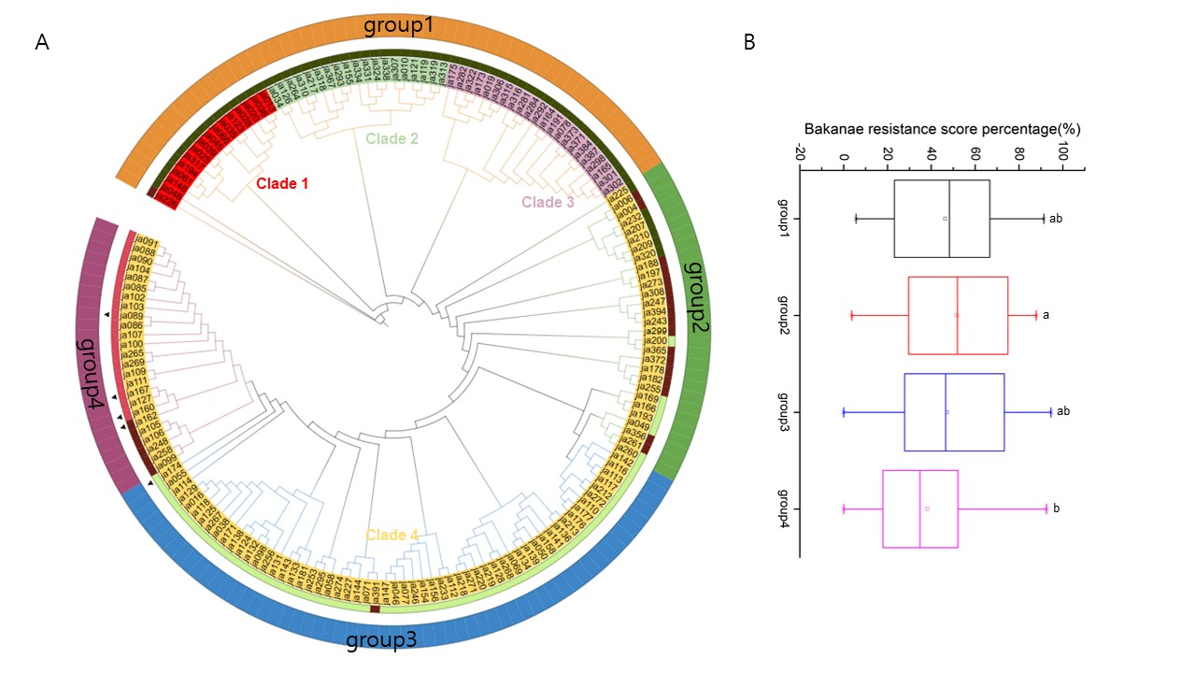
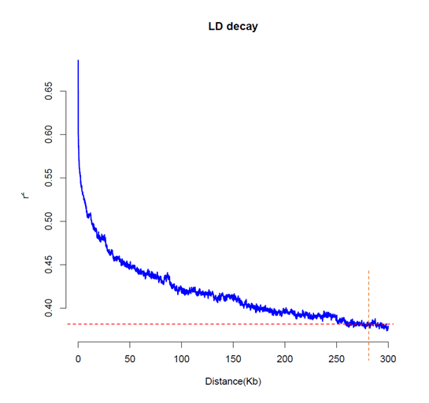
Fig S2. Population structure analysis and phenotype distribution in different groups. (A) Phylogenetic tree of 169 rice accessions based on genotype. First circle: phylogenetic tree analysis results; different clades are indicated by different colors; second circle: structural analysis results; green yellow: subgroup 1; dark olive green: subgroup 2; Indian Red: subgroup 3; dark red: subgroup 4; third circle: group information on the basis of structure and phylogenetic analysis; the triangle sign is indica. (B) Box plots of the percentages of bakanae resistance scores among the 169 accessions in the different groups. The different letters indicate significant differences according to one-way ANOVA followed by Tukey's test (P<0.05).
Fig S3 Linkage disequilibrium (LD)decay curve on chromosome 9.

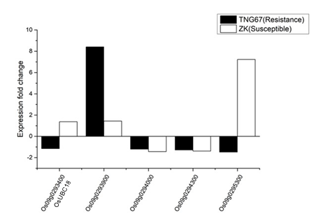
Fig S4. Expression analysis of candidate regions via public RNA-seq. data. TNG67 is a bakanae-resistant variety, and ZK is a susceptible variety.
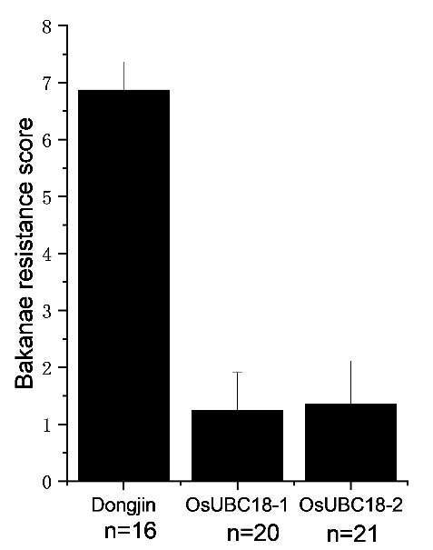
Fig S5 Bakanae resistance score of Dongjin and T-DNA mutant OsUBC18

Supplementary Table 1 Accessions information used in this study
No. | ID | Accession Name | Subspecies
1 | ja004 | Muyeopseoldo | Japonica
2 | ja006 | Musaekjojeokjo | Japonica
3 | ja010 | Chindadachigi | Japonica
4 | ja013 | Yoo | Japonica
5 | ja016 | Heuindadak | Japonica
6 | ja019 | Maekdo | Japonica
7 | ja020 | Dorae | Japonica
8 | ja025 | Mido | Japonica
9 | ja028 | Taegujo | Japonica
10 | ja034 | Waejo | Japonica
11 | ja035 | Sandudo | Japonica
12 | ja036 | Noinjo | Japonica
13 | ja038 | Baek Cheon | Japonica
14 | ja039 | Geum Jeom Do | Japonica
15 | ja045 | YEJO | Japonica
16 | ja046 | Jangsamdo | Japonica
17 | ja048 | Sandadagido | Japonica
18 | ja049 | Damagung | Japonica
19 | ja050 | Banchonjo | Japonica
20 | ja055 | Dongobyeo | Japonica
21 | ja058 | MIGWANG | Japonica
22 | ja061 | Daegwando | Japonica
23 | ja066 | Eunjo | Japonica
24 | ja069 | Haerim | Japonica
25 | ja071 | Chimabyeo | Japonica
26 | ja077 | Gaori | Japonica
27 | ja078 | Monajo | Japonica
28 | ja085 | Neulbyeo | Japonica
29 | ja086 | Gawichal | Japonica
30 | ja087 | Sanduchalbyeo | Japonica
31 | ja088 | NEULBYEO | Japonica
32 | ja089 | Icheon7ilchal | Indica
33 | ja090 | Bongok | Japonica
34 | ja091 | Joseon | Japonica
35 | ja098 | Nado | Japonica
36 | ja099 | Jodo | Japonica
37 | ja100 | Yukseongjaerae | Japonica
38 | ja102 | HEUKPI | Japonica
39 | ja103 | Heukpi | Japonica
40 | ja104 | Heukmok | Japonica
41 | ja105 | Sando | Japonica
42 | ja106 | Sando | Japonica
43 | ja107 | Hwaseongbatchal | Japonica
44 | ja109 | Sandudo | Japonica
45 | ja110 | Jwiipparibyeo | Japonica
46 | ja111 | JAERAEYUKDO | Japonica
47 | ja112 | Jeonggijosaeng | Japonica
48 | ja113 | Jaeraejongdo | Japonica
49 | ja114 | Nado | Japonica
50 | ja116 | Yongmyeonheuk | Japonica
51 | ja117 | Jeona | Japonica
52 | ja118 | Gasanbyeo | Japonica
53 | ja119 | Guando | Japonica
54 | ja121 | Jeongjonghwa | Japonica
55 | ja123 | SODUJO | Japonica
56 | ja124 | Ojeonggeun | Japonica
57 | ja125 | Dadajo | Japonica
58 | ja126 | Oigukbyeo | Japonica
59 | ja127 | Hongdo | Japonica
60 | ja128 | Pyeongyang | Japonica
61 | ja129 | Paldado | Japonica
62 | ja131 | Sandudo | Japonica
63 | ja132 | Chanseobyeo | Japonica
64 | ja133 | Dadujo | Japonica
65 | ja134 | Sinbaekseok | Japonica
66 | ja136 | Dangdo | Japonica
67 | ja138 | Orido | Japonica
68 | ja139 | Pungujo | Japonica
69 | ja141 | Obaekjo | Japonica
70 | ja142 | Bujari | Japonica
71 | ja143 | Noindo | Japonica
72 | ja144 | Guido | Japonica
73 | ja147 | NOINJO | Japonica
74 | ja148 | Seogandodo | Japonica
75 | ja154 | Joslbichal | Japonica
76 | ja155 | Ddangbyeo | Japonica
77 | ja156 | Daejichal | Japonica
78 | ja158 | Obaekjo | Japonica
79 | ja160 | Hongsado | Indica
80 | ja162 | Aengmi | Indica
81 | ja164 | Noindo | Japonica
82 | ja165 | Jagwangdo(Awn present) | Japonica
83 | ja166 | Guhwangdo | Japonica
84 | ja167 | Hyoseongjaeraejong | Indica
85 | ja169 | Chanseobyeo | Japonica
86 | ja171 | Soemeoribyeo | Japonica
87 | ja173 | Deokjeokjodo | Japonica
88 | ja174 | Weonjabyeo | Indica
89 | ja175 | Jangsamdo | Japonica
90 | ja176 | Gangweonna | Japonica
91 | ja177 | Gangweondo | Japonica
92 | ja178 | Ginggalagsyale | Japonica
93 | ja181 | Godudo | Japonica
94 | ja182 | Joseondo | Japonica
95 | ja188 | Dalgolmot | Japonica
96 | ja191 | Sangdo | Japonica
97 | ja193 | Daeguna | Japonica
98 | ja194 | Daigolna | Japonica
99 | ja197 | Inbujido | Japonica
100 | ja200 | Chanarak | Japonica
101 | ja207 | Mojo | Japonica
102 | ja209 | Olbyeo | Japonica
103 | ja210 | Daegudo | Japonica
104 | ja212 | Agabyeo | Japonica
105 | ja213 | Ssanmadeuragi | Japonica
106 | ja217 | DUCHUNGJONG | Japonica
107 | ja218 | Josaengjodo | Japonica
108 | ja219 | BEOBPANHWA | Japonica
109 | ja220 | Yonanco | Japonica
110 | ja225 | Buldo | Japonica
111 | ja226 | Cheonjeungdo | Japonica
112 | ja227 | Daegoldo | Japonica
113 | ja232 | Hwangdaiolbyeo | Japonica
114 | ja233 | Cheonpungdo | Japonica
115 | ja243 | Buljo | Japonica
116 | ja246 | Jjoljangbyeo | Japonica
117 | ja247 | Hansujindo | Japonica
118 | ja248 | Pocheonryukdo | Japonica
119 | ja253 | Annamjo | Japonica
120 | ja255 | Hongdodo | Japonica
121 | ja256 | Hongna | Japonica
122 | ja258 | Jodo | Japonica
123 | ja260 | Agukdo | Japonica
124 | ja261 | Hangibuji | Japonica
125 | ja264 | Hwangju | Japonica
126 | ja265 | Batnarak | Japonica
127 | ja267 | Hannaebyeo | Japonica
128 | ja268 | PYEONGBUK 4 | Japonica
129 | ja269 | Sando | Japonica
130 | ja271 | Soenbenchigi | Japonica
131 | ja272 | Boribyeo | Japonica
132 | ja273 | Olbyeo | Japonica
133 | ja274 | Hwangtojo | Japonica
134 | ja281 | Gangreungdo 106 | Japonica
135 | ja282 | CHIGYEONGDO | Japonica
136 | ja284 | JODO | Japonica
137 | ja292 | Geumdo | Japonica
138 | ja293 | Doaji | Japonica
139 | ja295 | Jinhwa | Japonica
140 | ja298 | Dongsanjo | Japonica
141 | ja299 | CHANARAK(B) | Japonica
142 | ja301 | Weoljo | Japonica
143 | ja302 | Jeokmosaek | Japonica
144 | ja306 | Deokjeokjodo | Japonica
145 | ja307 | Geum chang Do | Japonica
146 | ja308 | Chimabyeo | Japonica
147 | ja310 | Naengdo | Japonica
148 | ja313 | Cheongsongjo | Japonica
149 | ja315 | Ddangjo 131 | Japonica
150 | ja316 | MAEKJO | Japonica
151 | ja317 | Yeosubyeo | Japonica
152 | ja318 | SULLSULLDO | Japonica
153 | ja319 | Jandadagi | Japonica
154 | ja320 | HONGDODO | Japonica
155 | ja322 | Modo | Japonica
156 | ja324 | Ninado | Japonica
157 | ja331 | Dabaekjo | Japonica
158 | ja334 | SUJUNGJO | Japonica
159 | ja338 | Duchungjong | Japonica
160 | ja356 | Gujungdo | Japonica
161 | ja365 | Hongcheonchalbyeo | Japonica
162 | ja367 | Nokdudo | Japonica
163 | ja371 | Heukdo | Japonica
164 | ja372 | Arongbyeo | Japonica
165 | ja373 | Heukdaegu | Japonica
166 | ja384 | Seondal | Japonica
167 | ja387 | Sundal | Japonica
168 | ja391 | Ssubyeo | Japonica
169 | ja394 | Hwado | Japonica

Supplementary Table 2 Mapping results of RNA-seq reads of Zerawchanica karatals (ZK) and Tainung 67 (TNG67) under dH2O-treated or F. fujikuroi-inoculated conditions
Libraryª | SRR ID | Total paired-end raw reads | Total paired-end clean reads | Total mapped reads (%)^{b}
ZK_Mock_1 | SRR11002540 | 2 × 27,382,764 | 2 × 25,433,590 | 23,978,788 (94.28%)
ZK_Mock_2 | SRR11002536 | 2 × 23,683,715 | 2 × 21,706,443 | 20,067,606 (92.45%)
TNG67_Mock_1 | SRR11002538 | 2 × 22,656,070 | 2 × 20,799,037 | 19,474,138 (93.63%)
TNG67_Mock_2 | SRR11002534 | 2 × 20,354,874 | 2 × 18,750,132 | 17,184,495 (91.65%)
ZK_Ff_1 | SRR11002539 | 2 × 22,132,341 | 2 × 20,340,352 | 18,322,589 (90.08%)
ZK_Ff_2 | SRR11002535 | 2 × 26,386,770 | 2 × 24,193,434 | 22,352,313 (92.39%)
TNG67_Ff_1 | SRR11002537 | 2 × 30,997,323 | 2 × 28,723,020 | 25,893,802 (90.15%)
TNG67_Ff_2 | SRR11002533 | 2 × 23,573,542 | 2 × 21,658,414 | 20,122,832 (92.91%)
ª ZK: Zerawchanica karatals; TNG67: Tainung 67; Mock: dH2O-treated; Ff: F. fujikuroi-inoculated; 1: pooled sample from independent trial 1; 2: pooled sample from independent trial 2
^{b}The percentages were calculated based on the total number of clean reads.

Supplementary Table 3 Primers used in this study
Primer ID | Forward primer(5'-3') | Reverse primer(5'-3') | Annotation
900 | ACAAGAAAGGGAGGGTGGTT | CCCCATCATATCCTTGACCA | Pimer for expression analysis of Os09g0290900
1500 | AAGGAACCCAGCAACAACTG | GGATCGTTCCACCTCCTACA | Pimer for expression analysis of Os09g0291500
1700 | CCTGTAGGAGGAGGGAGGAG | CCACTGCTTGAGATCCCAGT | Pimer for expression analysis of Os09g0291700
2101 | CAACCGAACAAGGCCTAAGA | TCGAGTGCACCATATTCAGC | Pimer for expression analysis of Os09g0292101
2400 | CCGCATAGAAGGGTTGTTGT | TTGTGCAGCCTCATCTTCAG | Pimer for expression analysis of Os09g0292400
2900 | GAGTGAAGCATGCAGACAGC | GAACAGCCTCTCGGACATCT | Pimer for expression analysis of Os09g0292900
bk9-1 | AGCCCAGCATTGACCATATC | GTGGCCTCTGGCTCTTGTAG | Pimer for expression analysis of Os09g0293400(OsUBC18)
bk9-2 | AGGAGGACGATGAGGTTGTG | CTGTCGTCACTCGCGTTAAA | Pimer for expression analysis of Os09g0293900
bk9-3 | CTCGACAGCCTTGCATGTTA | AAGCCAACAGCAGCAAGAAT | Pimer for expression analysis of Os09g0294000
bk9-4 | CCCCACATGTCAGCTACTCC | GGCGACCTTGTTGTTCCTC | Pimer for expression analysis of Os09g0294300
bk9-5 | GAGGATTTGGTCCCTTTGCT | TTCCCTCGGTACCATAGCTG | Pimer for expression analysis of Os09g0295300
OsGID1 | CACGTCAAGGTTGTCCAATG | GGTTAGCGTTGAGGAAGTCG | Pimer for expression analysis of Os05g0407500
OsXTH8 | GCAAGAAGGAGCACCAGTTC | ATGATGTTTTGGGGATTCCA | Pimer for expression analysis of Os08g0237000
GA20OX2 | GTCGCCGACTACTTCTCCAG | AGCGACAGCTCCTTCATCTC | Pimer for expression analysis of Os01g0883800
GA3ox1 | CACACGGACTCAGGCTTCTT | TGAGCACATGGAAGAGATCG | Pimer for expression analysis of Os05g0178100
OsActin | CCTGGCAGTATGAAGGTAGTTG | GAAGCACTTCATGTGGACGAT | Internal control for expression analysis
bk9-1-T-DNA | CATTGAGGCCCTTGTTTAGG | TCTTCAGTAAAACGCCCACC | Pimer for positive verification of T-DNA mutants of OsUBC18
TDNA-LB | CTAGAGTCGAGAATTCAGTACA |  | Pimer for positive verification of T-DNA mutants of OsUBC18

Table S4 QTLs identified by GLM, MLM, CMLM and FarmCPU models
SNP | Chr | Pos | P.value | MAF | Effect | -log10p | Modle
S9_6944283 | 9 | 6944283 | 1.02E-08 | 0.147929 | 1.457598 | 7.992507 | FarmCPU
S6_29827809 | 6 | 29827809 | 6.09E-06 | 0.248521 | 1.025321 | 5.21507 | FarmCPU
S9_6944283 | 9 | 6944283 | 6.12E-06 | 0.147929 | 1.582168 | 5.213112 | CMLM
S9_6944283 | 9 | 6944283 | 9.07E-08 | 0.147929 | 1.69007 | 7.042299 | GLM
S9_6794608 | 9 | 6794608 | 1.22E-06 | 0.213018 | 1.642578 | 5.911968 | GLM
S9_6720080 | 9 | 6720080 | 6.10E-06 | 0.130178 | 1.510568 | 5.214605 | GLM
S9_6795259 | 9 | 6795259 | 7.98E-06 | 0.207101 | 1.462116 | 5.097777 | GLM
S9_6656685 | 9 | 6656685 | 1.35E-05 | 0.139053 | 1.391795 | 4.87033 | GLM
S9_6944283 | 9 | 6944283 | 6.12E-06 | 0.147929 | 1.582168 | 5.213112 | MLM

Table S5 Candidate genes in qBK9 region 1
Putative genes | Position start | Position end | stand | gene annotation
Os09g0290600 | 6646921 | 6650835 | + | Conserved hypothetical protein
Os09g0290700 | 6651255 | 6651710 | - | Conserved hypothetical protein
Os09g0290900 | 6673037 | 6678975 | + | Similar to H1005F08.16 protein
Os09g0291500 | 6745873 | 6746376 | + | Conserved hypothetical protein
Os09g0291700 | 6756705 | 6757136 | + | Conserved hypothetical protein
Os09g0292101 | 6798832 | 6803053 | - | Conserved hypothetical protein
Os09g0292300 | 6803261 | 6806757 | + | Myb/SANT-like domain domain containing protein
Os09g0292350 | 6805465 | 6810554 | - | Hypothetical protein
Os09g0292400 | 6810220 | 6810609 | + | Conserved hypothetical protein
Os09g0292900 | 6873236 | 6874612 | + | OsFBX310 - F-box domain containing protein expressed
Os09g0293400 | 6947883 | 6950902 | + | Ubiquitin-conjugating enzyme
Os09g0293450 | 6949087 | 6950619 | - | Non-protein coding transcript
Os09g0293500 | 6954967 | 6959667 | - | serine 2Fthreonine-protein kinase BRI1-like 1 precursor putative expressed
Os09g0293601 | 6973353 | 6974004 | + | Conserved hypothetical protein
Os09g0293900 | 6990927 | 6994473 | + | FKBP-type peptidyl-prolyl cis-trans isomerase
Os09g0294000 | 6995055 | 7009477 | - | Homoserine dehydrogenase
Os09g0294300 | 7017626 | 7020961 | - | Ubiquitin-conjugating enzyme
Os09g0294550 | 7038132 | 7038397 | + | Conserved hypothetical protein
Os09g0294800 | 7045390 | 7046136 | + | Conserved hypothetical protein
Os09g0294901 | 7052921 | 7054384 | + | Conserved hypothetical protein
Os09g0295000 | 7077214 | 7078851 | - | No apical meristem (NAM) protein
Os09g0295200 | 7083652 | 7086647 | + | Conserved hypothetical protein
Os09g0295300 | 7087266 | 7087829 | - | expressed protein
Os09g0295850 | 7162835 | 7163860 | + | Conserved hypothetical protein
Os09g0296400 | 7166573 | 7171386 | + | Similar to predicted protein.
Os09g0296450 | 7166594 | 7170669 | - | Hypothetical protein
Os09g0296500 | 7172525 | 7173592 | + | Conserved hypothetical protein
Os09g0296700 | 7179985 | 7181868 | + | Glycosyl transferase, group 1 domain containing protein.
Os09g0296800 | 7185218 | 7188139 | + | Light-harvesting chlorophyll a/b-binding (LHC) protein
Os09g0296900 | 7189541 | 7196703 | + | WD40 repeat-like domain containing protein
Os09g0297000 | 7198635 | 7204743 | + | Ferrochelatase I, Oxyfluorfen herbicide resistance
Os09g0297100 | 7205157 | 7208171 | - | Similar to CROC-1-like protein
Os09g0297200 | 7218928 | 7220483 | - | Hypothetical protein
Os09g0297300 | 7218944 | 7220635 | + | Similar to sugar carrier protein C
Os09g0297400 | 7222188 | 7225657 | - | Phosphoenolpyruvate/phosphate translocator 1
Os09g0297700 | 7229093 | 7229311 | + | Conserved hypothetical protein
Os09g0297800 | 7231651 | 7232571 | - | Similar to GPI-anchored protein
Os09g0297900 | 7233384 | 7234196 | - | Conserved hypothetical protein.

