Supplementary Information
Germanium-integrated exciplex host for high-performance narrowband OLEDs with mitigated efficiency roll-off
Xu Zhang^{1,2}, Zhanxiang Chen^{1,2}, Manli Huang¹, Jiahui Liu¹, Jingsheng Miao¹, Chuluo Yang¹*

¹Shenzhen Key Laboratory of New Display and Storage Materials, College of Materials Science and Engineering, Shenzhen University, Shenzhen, P. R. China
²These authors contributed equally: Xu Zhang, Zhanxiang Chen.

*Corresponding author. Email: Chuluo Yang (clyang@szu.edu.cn)

Table of Contents
Supplementary Notes
Supplementary Note 1. Materials synthesis and characterization
Supplementary Scheme 1. Synthesis procedure of GeTrzCz2
Supplementary Scheme 2. Synthesis procedure of GeCzCz
Supplementary Note 2. Calculation method of k_{r,S} and k_{RISC}.
Supplementary Figures
Supplementary Fig. 1. ¹H NMR spectrum of triphenyl(3-(4,4,5,5-tetramethyl-1,3,2-dioxaborolan-2-yl)phenyl)germane in CDCl₃ at room temperature
Supplementary Fig. 2. ¹³C NMR spectrum of triphenyl(3-(4,4,5,5-tetramethyl-1,3,2-dioxaborolan-2-yl)phenyl)germane in CDCl₃ at room temperature
Supplementary Fig. 3. ¹H NMR spectrum of GeTrzCz2 in CDCl₃ at room temperature
Supplementary Fig. 4. ¹³C NMR spectrum of GeTrzCz2 in CDCl₃ at room temperature
Supplementary Fig. 5. HRMS spectrum of GeTrzCz2
Supplementary Fig. 6. ¹H NMR spectrum of GeCzCz in CDCl₃ at room temperature
Supplementary Fig. 7. ¹³C NMR spectrum of GeCzCz in CDCl₃ at room temperature
Supplementary Fig. 8. HRMS spectrum of GeCzCz
Supplementary Fig. 9. Single crystal structures of HT hosts
Supplementary Fig. 10. Single crystal structures of ET hosts
Supplementary Fig. 11. Phosphorescence spectra of GeCzCz, GeTrzCz2, and GeCzCz:GeTrzCz2 in solid films at 77 K
Supplementary Fig. 12. Transient PL decay curve of the SiCzCz:SiTrzCz2 exciplex film
Supplementary Fig. 13. Spatial distributions of the highest occupied molecular orbital (HOMO) and lowest unoccupied molecular orbital (LUMO) in the optimized configuration between GeCzCz and GeTrzCz2
Supplementary Fig. 14. Calculated SOCME values between T₁ and S₁ for SiCzCz:SiTrzCz2 and GeCzCz:GeTrzCz2 in their optimized T₁ geometries
Supplementary Fig. 15. Normalized PL spectra of GeCzCz:GeTrzCz2 exciplex film and extinction spectrum of t-DABNA, υ-DABNA and ω-DABNA in toluene (10⁻⁵ mol.L⁻¹)
Supplementary Fig. 16. Chemical structures of the comprising materials in OLEDs
Supplementary Fig. 17. Current density and luminance versus driving voltage curves
Supplementary Tables
Supplementary Table 1. Physical data and kinetic parameters of GeCzCz:GeTrzCz2 and SiCzCz:SiTrzCz2 exciplex films
Supplementary Table 2. Physical data and kinetic parameters of MR-TADF emitters t-DABNA, υ-DABNA and ω-DABNA doped in exciplex hosts GeCzCz:GeTrzCz2 and SiCzCz:SiTrzCz2
Supplementary Table 3. Summary of recent advances in green-emitting OLEDs with CIE_{y} ≥ 0.71 (NTSC standard) and blue-emitting OLEDs with CIE_{y} ≤ 0.2
Supplementary Table 4. Summary of recently reported green OLEDs based on non-metallic heavy atoms with corresponding device half-lifetimes at 1,000 cd.m⁻²
Supplementary References

Supplementary Notes
Supplementary Note 1. Materials synthesis and characterization.
Synthesis of GeTrzCz2. GeTrzCz2 was synthesized via a two-step procedure starting with (3-bromophenyl)triphenylgermane and 4,4,4',4',5,5,5',5'-octamethyl-2,2'-bi(1,3,2-dioxaborolane). Stepwise synthetic routes are outlined in Supplementary Scheme 1, and full experimental details are provided below.
Supplementary Scheme 1. Synthesis procedure of GeTrzCz2.

Synthesis of triphenyl(3-(4,4,5,5-tetramethyl-1,3,2-dioxaborolan-2-yl)phenyl)germane. Under an argon atmosphere, (3-bromophenyl)triphenylgermane (6.90 g, 15.00 mmol), 4,4,4',4',5,5,5',5'-octamethyl-2,2'-bi(1,3,2-dioxaborolane) (7.60 g, 30.00 mmol), Pd(dppf)Cl₂ (0.22 g, 0.30 mmol), and potassium acetate (4.40 g, 45 mmol) were dissolved in dehydrated DMSO (50 mL) and stirred at 100 ºC for 12 h. Upon cooling to room temperature, the black mixture was diluted with water and extracted with ethyl acetate (3 × 30 mL). The organic phases were dried over anhydrous sodium sulfate and the solvent was removed under reduced pressure. The crude product was purified by column chromatography on silica gel using ethyl acetate/petroleum ether (v/v = 1/30) as eluent to afford a white solid (5.00 g, yield: 65%). ¹H NMR (CDCl₃, 400 MHz) δ (ppm): 1.31 (s, 12H), 7.34-7.40 (m, 10H), 7.52-7.54 (m, 6H), 7.59 (d, J = 8.0 Hz, 1H), 7.86 (d, J = 8.0 Hz, 1H), 8.05 (s, 1H). ¹³C NMR (CDCl₃, 100 MHz) δ (ppm): 24.8, 83.7, 127.6, 128.2, 129.0, 135.2, 135.4(2), 135.6, 136.2, 138.3, 141.4.
Synthesis of GeTrzCz2. Under an argon atmosphere, triphenyl(3-(4,4,5,5-tetramethyl-1,3,2-dioxaborolan-2-yl)phenyl)germane (1.80 g, 3.60 mmol), 9,9'-(6-chloro-1,3,5-triazine-2,4-diyl)bis(9H-carbazole) (1.30 g, 3.00 mmol), Pd(PPh₃)₄ (0.18 g, 0.16 mmol), and potassium carbonate (1.20 g, 9.00 mmol) were dissolved in THF/water (20 mL each) and stirred at 65 ºC for 12 h. Upon cooling to room temperature, the black mixture was diluted with water and extracted with dichloromethane (3 × 30 mL). The organic phases were dried over anhydrous sodium sulfate and the solvent was removed under reduced pressure. The crude product was purified by column chromatography on silica gel using dichloromethane/petroleum ether (v/v = 1/4) as eluent to afford a white solid (1.80 g, yield: 75%). ¹H NMR (CDCl₃, 500 MHz) δ (ppm): 7.36-7.44 (m, 17H), 7.64 (d, J = 7.5 Hz, 6H), 7.69 (t, J = 7.5 Hz, 1H), 7.85 (d, J = 7.0 Hz, 1H), 8.08 (d, J = 7.5 Hz, 4H), 8.78 (d, J = 7.5 Hz, 1H), 8.96 (d, J = 8.0 Hz, 4H), 9.04 (s, 1H). ¹³C NMR (CDCl₃, 125 MHz) δ (ppm): 117.6, 119.6, 123.3, 126.5, 127.0(2), 128.5(2), 128.9, 129.4(2), 130.1, 135.4(2), 135.7(2), 135.9, 136.1, 137.5, 138.9, 139.9, 164.7(2), 173.2(2). HRMS (ESI): m/z [M+H]⁺ calcd for C₅₁H₃₆GeN₅⁺: 792.2177; found: 792.2177.

Supplementary Scheme 2. Synthesis procedure of GeCzCz.

Synthesis of GeCzCz. Under an argon atmosphere, (3-bromophenyl)triphenylgermane (2.30 g, 5.00 mmol), 9H-3,9'-bicarbazole (2.00 g, 6.00 mmol), Pd₂(dba)₃ (0.18 g, 0.20 mmol), tri-tert-butylphosphine tetrafluoroborate (0.12 g, 0.41 mmol), sodium tert-butoxide (0.72 g, 7.5 mmol) were dissolved in toluene (30 mL) and stirred at 100 ºC for 12 h. Upon cooling to room temperature, the black mixture was diluted with water and extracted with dichloromethane (3 × 30 mL). The organic phases were dried over anhydrous sodium sulfate and the solvent was removed under reduced pressure. The crude product was purified by column chromatography on silica gel using dichloromethane/petroleum ether (v/v = 1/5) as eluent to afford a white solid (3.00 g, yield: 85%). ¹H NMR (CDCl₃, 400 MHz) δ (ppm): 7.29 (t, J = 8.0 Hz, 3H), 7.36-7.45 (m, 15H), 7.49 (d, J = 8.0 Hz, 1H), 7.55 (d, J = 8.0 Hz, 1H), 7.60-7.62 (m, 6H), 7.66-7.72 (m, 3H), 7.82 (s, 1H), 8.08 (d, J = 8.0 Hz, 1H), 8.18 (d, J = 8.0 Hz, 2H), 8.25 (s, 1H). ¹³C NMR (CDCl₃, 125 MHz) δ (ppm): 109.8, 110.1, 110.9, 119.4, 119.6, 120.3, 120.4, 120.5, 123.0, 123.1, 124.4, 125.4, 125.8, 126.6, 127.4, 128.5, 129.4, 129.8, 129.9, 133.5, 134.4, 135.4(2), 137.4, 139.2, 139.8, 141.3, 141.9. HRMS (ESI): m/z [M+H]⁺ calcd for C₄₈H₃₅GeN₂⁺: 713.2007; found: 713.2003.
Supplementary Note 2. Calculation method of k_{r,S} and k_{RISC}.
The respective rate constants of the prompt and delayed fluorescence components (k_{p} and k_{d}) occurring in the exciplex or terminal MR-TADF emitter, can be given by:
k_{p} and k_{d} could be experimentally determined from prompt and delayed fluorescence decay time constants τ_{p}, τ_{d} as follows:
Besides, the emission quantum yields Φ_{𝑝} and Φ_{𝑑} for the prompt and delayed fluorescence components have the following relationship with these rate constants:
From the equations above, one could obtain the following relationship between rate constants and k_{p}, k_{d}, Φ_{𝑝} and Φ_{𝑑} experimentally determined from typical PLQY and transient PL characteristics:

Supplementary Figures
Supplementary Fig. 1. ¹H NMR spectrum of triphenyl(3-(4,4,5,5-tetramethyl-1,3,2-dioxaborolan-2-yl)phenyl)germane in CDCl₃ at room temperature.

Supplementary Fig. 2. ¹³C NMR spectrum of triphenyl(3-(4,4,5,5-tetramethyl-1,3,2-dioxaborolan-2-yl)phenyl)germane in CDCl₃ at room temperature.

Supplementary Fig. 3. ¹H NMR spectrum of GeTrzCz2 in CDCl₃ at room temperature.

Supplementary Fig. 4. ¹³C NMR spectrum of GeTrzCz2 in CDCl₃ at room temperature.
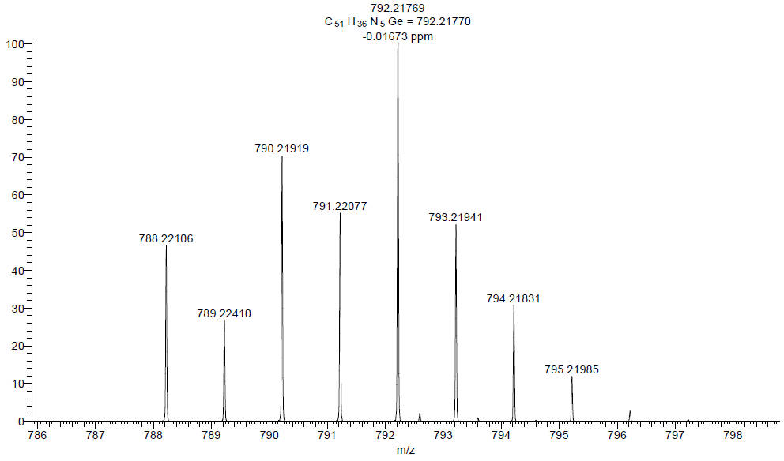
Supplementary Fig. 5. HRMS spectrum of GeTrzCz2.

Supplementary Fig. 6. ¹H NMR spectrum of GeCzCz in CDCl₃ at room temperature.

Supplementary Fig. 7. ¹³C NMR spectrum of GeCzCz in CDCl₃ at room temperature.

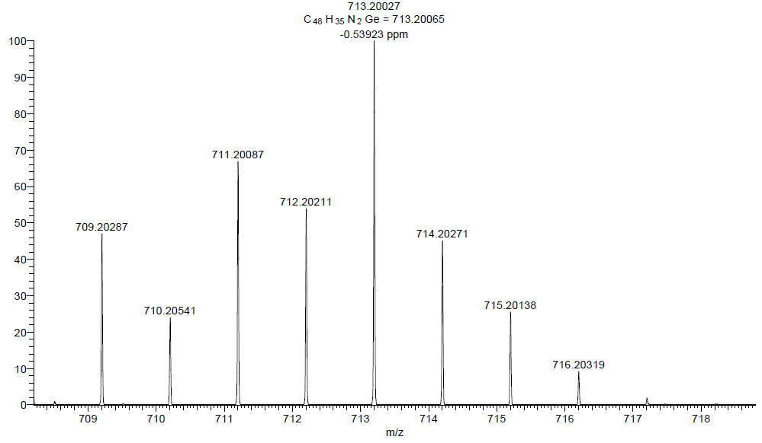
Supplementary Fig. 8. HRMS spectrum of GeCzCz.

Supplementary Fig. 9. Single crystal structures of HT hosts. (a) SiCzCz (CCDC: 2433937). (b) GeCzCz (CCDC: 2433938). The two crystals were grown by slow evaporating a solution in hexane at 25ºC. Selected bond length (Å) and angles (º) are annotated.

Supplementary Fig. 10. Single crystal structures of ET hosts. (a) SiTrzCz2 (CCDC: 2433936). (b) GeTrzCz2 (CCDC: 2433939). The two crystals were grown by slow evaporating a solution in CH₂Cl₂:methanol (5:2) at 25ºC. Selected bond length (Å) and angles (º) are annotated.

Supplementary Fig. 11. Phosphorescence spectra of GeCzCz, GeTrzCz2, and GeCzCz:GeTrzCz2 in solid films at 77 K.

Supplementary Fig. 12. Transient PL decay curve of the SiCzCz:SiTrzCz2 exciplex film.

Supplementary Fig. 13. Spatial distributions of the highest occupied molecular orbital (HOMO) and lowest unoccupied molecular orbital (LUMO) in the optimized configuration between GeCzCz and GeTrzCz2.

Supplementary Fig. 14. Calculated SOCME values between T₁ and S₁ for SiCzCz:SiTrzCz2 and GeCzCz:GeTrzCz2 in their optimized T₁ geometries.

Supplementary Fig. 15. Normalized PL spectra of GeCzCz:GeTrzCz2 exciplex film and extinction spectrum of t-DABNA, υ-DABNA and ω-DABNA in toluene (10⁻⁵ mol.L⁻¹).

Supplementary Fig. 16. Chemical structures of the comprising materials in OLEDs.

Supplementary Fig. 17. Current density and luminance versus driving voltage curves. (a) t-DABNA target device and control-A. (b) υ-DABNA target device and control-B. (b) ω-DABNA target device and control-C.

Supplementary Tables
Supplementary Table 1. Physical data and kinetic parameters of GeCzCz:GeTrzCz2 and SiCzCz:SiTrzCz2 exciplex films.
Film | λ_{PL}  / nm | PLQY  / % | τ_{p}  / ns | τ_{d}  / μs | k_{r,S}  / × 10⁶ s⁻¹ | k_{RISC}  / × 10⁵ s⁻¹
GeCzCz:GeTrzCz2 | 470 | 54 | 173.0 | 1.6 | 2.5 | 7.6
SiCzCz:SiTrzCz2 | 470 | 30 | 186.8 | 1.9 | 1.3 | 6.9
Supplementary Table 2. Physical data and kinetic parameters of MR-TADF emitters t-DABNA, υ-DABNA and ω-DABNA doped in exciplex hosts GeCzCz:GeTrzCz2 and SiCzCz:SiTrzCz2.
Film | τ_{p}  / ns | τ_{d}  / μs | k_{RISC}  / s⁻¹
GeCzCz:GeTrzCz2:t-DABNA | 10.7 | 112.3 | 2.2 × 10⁴
SiCzCz:SiTrzCz2:t-DABNA | 11.9 | 133.0 | 1.3 × 10⁴
GeCzCz:GeTrzCz2:υ-DABNA | 5.3 | 2.4 | 9.1 × 10⁵
SiCzCz:SiTrzCz2:υ-DABNA | 5.5 | 4.0 | 4.5 × 10⁵
GeCzCz:GeTrzCz2: ω-DABNA | 6.3 | 3.6 | 7.5 × 10⁵
SiCzCz:SiTrzCz2:ω-DABNA | 6.4 | 7.7 | 3.6 × 10⁵

Supplementary Table 3. Summary of recent advances in green-emitting OLEDs with CIE_{y} ≥ 0.71 (NTSC standard) and blue-emitting OLEDs with CIE_{y} ≤ 0.2.
Emitting materials | EQE / % |  | CIE_{y} | Ref.
Emitting materials | Max | 1,000 cd.m⁻² | CIE_{y} | Ref.
ω-DABNA | 40.4 | 33.4 | 0.74 | This work
MCNBN | 30.8 | 20.4 | 0.74 | 1
PMCNBN | 27.2 | 20.3 | 0.73 | 1
TCz-B | 29.2 | 9.4 | 0.71 | 2
TCz-VTCzBN | 32.2 | 16.0 | 0.71 | 3
BN-ICz-1 | 30.5 | 17.2 | 0.74 | 4
BN-ICz-2 | 29.8 | 26.1 | 0.73 | 4
tCzphB-Ph | 29.3 | ~10 | 0.75 | 5
tCzphB-Fl | 26.2 | ~9 | 0.72 | 5
ω-DABNA (single host) | 31.1 | 29.4 | 0.73 | 6
ω-DABNA-M | 32.7 | 27.4 | 0.74 | 7
ω-DABNA-PH | 31.8 | 27.4 | 0.74 | 7
DBNT-2 | 35.2 | 20.4 | 0.74 | 8
BN-TP-N3 | 37.3 | 19.8 | 0.71 | 9
QB-PXZ | 36.6 | 31.8 | 0.74 | 10
υ-DABNA | 40.1 | 32.8 | 0.12 | This work
υ-DABNA(single host) | 34.4 | 26.0 | 0.11 | 11
υ-DABNA(TSF) | 29.2 | 24.1 | 0.14 | 12
t-BuCz-DABNA(TSF) | 30.8 | 26.2 | 0.17 | 13
υ-DABNA(TSF) | 27 | 20 | 0.20 | 14
υ-DABNA(TSF) | 33.0 | 25.2 | 0.17 | 15
BD-02(phos.) | 25.4 | 23.4 | 0.197 | 16
TBE02(PSF) | 25.8 | ~22 | 0.165 | 17
PtON-TTBI (phos.) | 25.9 | 24.6 | 0.19 | 18
PtON7-dtb (phos.) | 24.8 | 11.0 | 0.079 | 19
PtON-CF₃-2 (phos.) | 33.8 | 31.6 | 0.15 | 20
f-cf6b (phos.) | 23.4 | 17.1 | 0.12 | 21
v-DABNA (PSF) | 26.2 | 18.4 | 0.13 | 21

Supplementary Table 4. Summary of recently reported green OLEDs based on non-metallic heavy atoms with corresponding device half-lifetimes at 1,000 cd m⁻².
Emitting materials | LT₅₀@1,000 cd m⁻²  / h | EQE / % |  | CIE_{y} | Ref.
Emitting materials | LT₅₀@1,000 cd m⁻²  / h | Max | 1,000 cd.m⁻² | CIE_{y} | Ref.
ω-DABNA | 241 | 40.4 | 33.4 | 0.74 | This work
PSeZBN2 | 41 | 29.5 | 29.0 | 0.65 | 22
2PTZBN | 5.6 | 34.6 | 29.5 | 0.67 | 23
BNSSe | 4.8 | 35.7 | 32.0 | 0.66 | 23
BNSeSe | 4.1 | 36.8 | 34.0 | 0.66 | 23
BN-STO | 35 | 40.1 | 28.1 | 0.70 | 24
BN-Se | 82.1 | 32.6 | 32.2 | 0.62 | 25

Supplementary References
1. Xue Z, Hu Y, Xiao S, Liu J, Miao J, Yang C. Cyano-Modified Multi-Resonance Thermally Activated Delayed Fluorescent Emitters Towards Pure-Green OLEDs with a CIE_{y} Value of 0.74. Angew. Chem. Int. Ed. e202500108 (2025).
2. Yang M, et al. Wide-Range Color Tuning of Narrowband Emission in Multi-resonance Organoboron Delayed Fluorescence Materials through Rational Imine/Amine Functionalization. Angew. Chem. Int. Ed. 60, 23142-23147 (2021).
3. Luo X-F, et al. Multiple-Resonance-Induced Thermally Activated Delayed Fluorescence Materials Based on Indolo[3,2,1-jk]carbazole with an Efficient Narrowband Pure-Green Electroluminescence. Angew. Chem. Int. Ed. 61, e202209984 (2022).
4. Zhang Y, et al. Fusion of Multi-Resonance Fragment with Conventional Polycyclic Aromatic Hydrocarbon for Nearly BT.2020 Green Emission. Angew. Chem. Int. Ed. 61, e202202380 (2022).
5. Liu J, et al. Toward a BT.2020 green emitter through a combined multiple resonance effect and multi-lock strategy. Nat. Commun. 13, 4876 (2022).
6. Uemura S, et al. Sequential Multiple Borylation Toward an Ultrapure Green Thermally Activated Delayed Fluorescence Material. J. Am. Chem. Soc. 145, 1505-1511 (2023).
7. Lee Y-T, et al. Bright, efficient, and stable pure-green hyperfluorescent organic light-emitting diodes by judicious molecular design. Nat. Commun. 15, 3174 (2024).
8. Fan X-C, et al. Ultrapure green organic light-emitting diodes based on highly distorted fused π-conjugated molecular design. Nat. Photon. 17, 280-285 (2023).
9. Wang Q, et al. Precise Regulation of Emission Maxima and Construction of Highly Efficient Electroluminescent Materials with High Color Purity. Angew. Chem. Int. Ed. 62, e202301930 (2023).
10. Xiao S, et al. Synergistic π-Extension and Peripheral-Locking of B/N-Based Multi-Resonance Framework Enables High-Performance Pure-Green Organic Light-Emitting Diodes. Angew. Chem. Int. Ed. 64, e202418348 (2025).
11. Kondo Y, et al. Narrowband deep-blue organic light-emitting diode featuring an organoboron-based emitter. Nat. Photon. 13, 678-682 (2019).
12. Huang T, et al. Enhancing the efficiency and stability of blue thermally activated delayed fluorescence emitters by perdeuteration. Nat. Photon. 18, 516-523 (2024).
13. Huang T, et al. Delocalizing electron distribution in thermally activated delayed fluorophors for high-efficiency and long-lifetime blue electroluminescence. Nat. Mater. 23, 1523-1530 (2024).
14. Chan C-Y, et al. Stable pure-blue hyperfluorescence organic light-emitting diodes with high-efficiency and narrow emission. Nat. Photon. 15, 203-207 (2021).
15. Jeon SO, et al. High-efficiency, long-lifetime deep-blue organic light-emitting diodes. Nat. Photon. 15, 208-215 (2021).
16. Sun J, et al. Exceptionally stable blue phosphorescent organic light-emitting diodes. Nat. Photon. 16, 212-218 (2022).
17. Kim E, et al. Highly efficient and stable deep-blue organic light-emitting diode using phosphor-sensitized thermally activated delayed fluorescence. Sci. Adv. 8, eabq1641 (2022).
18. Jung YH, et al. Modified t-butyl in tetradentate platinum (II) complexes enables exceptional lifetime for blue-phosphorescent organic light-emitting diodes. Nat. Commun. 15, 2977 (2024).
19. Fleetham T, Li G, Wen L, Li J. Efficient “Pure” Blue OLEDs Employing Tetradentate Pt Complexes with a Narrow Spectral Bandwidth. Adv. Mater. 26, 7116-7121 (2014).
20. Wu Y, et al. Iridium(III) Blue Phosphors with Heteroleptic Carbene Cyclometalates: Isomerization, Emission Tuning, and OLED Fabrications. Angew. Chem. Int. Ed. 64, e202421664 (2025).
21. Yan J, et al. Blue Electrophosphorescence from Iridium(III) Phosphors Bearing Asymmetric Di-N-aryl 6-(trifluoromethyl)-2H-imidazo[4,5-b]pyridin-2-ylidene Chelates. Adv. Mater. 36, 2305273 (2024).
22. Zou Y, et al. Acceleration of reverse intersystem crossing in multi-resonance TADF emitter. Chem 10, 1485-1501 (2024).
23. Hu YX, et al. Efficient selenium-integrated TADF OLEDs with reduced roll-off. Nat. Photon. 16, 803-810 (2022).
24. Hu Y, et al. Peripherally Heavy-Atom-Decorated Strategy Towards High-Performance Pure Green Electroluminescence with External Quantum Efficiency over 40 %. Angew. Chem. Int. Ed. 62, e202302478 (2023).
25. Cao X, et al. Manipulating Exciton Dynamics toward Simultaneous High-Efficiency Narrowband Electroluminescence and Photon Upconversion by a Selenium-Incorporated Multiresonance Delayed Fluorescence Emitter. J. Am. Chem. Soc. 144, 22976-22984 (2022).

