Title: Diagnostic performance of clinic and home blood pressure measurements compared with ambulatory blood pressure: a systematic review and meta-analysis
Auttakiat Karnjanapiboonwong, M.D.
Health Technology Assessment (HTA) Postgraduate Program, Mahidol University, Bangkok, Thailand, Email: auttakiat@yahoo.com
Thunyarat Anothaisintawee*, M.D., Ph.D.
Department of Family Medicine, Faculty of Medicine, Ramathibodi Hospital, Mahidol University, Bangkok, Thailand, Email: thunyarat.ano@mahidol.ac.th
Usa Chaikledkaew, B.Pharm, Ph.D.
Health Technology Assessment (HTA) Postgraduate Program, Mahidol University, Bangkok, Thailand, Email: usa.cha@mahidol.ac.th
Charungthai Dejthevaporn, M.D., Ph.D.
Division of Neurology, Department of Medicine, Faculty of Medicine, Ramathibodi Hospital, Mahidol University, Bangkok, Thailand, Email: charungthaid@gmail.com
John Attia, M.D., Ph.D.
School of Medicine and Public Health, University of Newcastle and Hunter Medical Research Institute, Newcastle, New Southwale, Australia, Email: john.attaia@newcastle.edu.au
Ammarin Thakkinstian, Ph.D.
Section for Clinical Epidemiology and Biostatistics, Faculty of medicine, Ramathibodi Hospital, Mahidol University, Bangkok Email: ammarin.tha@mahidol.ac.th

Additional Appendix
The search terms and search strategy used for Medline database
((((((((((("clinic blood pressure") OR "office blood pressure") OR "conventional blood pressure") OR "clinic BP measurement") OR CBPM) OR "conventional BP monitoring") OR "clinic BP monitoring")) OR ((((("home blood pressure") OR "home monitoring blood pressure") OR "home BP measurement") OR "HBPM") OR "home BP monitoring")))) AND (((((((((((((((((sensitivity) OR specificity) OR "false positive") OR "false negative") OR "true positive") OR "true negative") OR "diagnostic performance"))) OR ((((("white coat") OR "white-coat") OR isolate* AND clinic) OR isolate* AND office) OR "mask hypertension"))) OR "masked hypertension"))))))
The search term and search strategy used for Scopus database
( ( ( TITLE-ABS-KEY ( "Office blood pressure" ) ) OR ( TITLE-ABS-KEY ( "Clinic blood pressure" ) ) OR ( TITLE-ABS-KEY ( "Home blood pressure" ) ) OR ( TITLE-ABS-KEY ( "Home monitoring blood pressure" ) ) ) OR ( TITLE-ABS-KEY ( "conventional blood pressure" ) ) OR ( TITLE-ABS-KEY ( "clinic BP measurement" ) ) OR ( TITLE-ABS-KEY ( cbpm ) ) OR ( TITLE-ABS-KEY ( "conventional BP monitoring" ) ) OR ( TITLE-ABS-KEY ( "clinic BP monitoring" ) ) OR ( TITLE-ABS-KEY ( "home BP measurement" ) ) OR ( TITLE-ABS-KEY ( "home BP monitoring" ) ) OR ( TITLE-ABS-KEY ( hbpm ) ) ) AND ( ( ( TITLE-ABS-KEY ( "true positive" ) ) OR ( TITLE-ABS-KEY ( "true negative" ) ) OR ( TITLE-ABS-KEY ( "false negative" ) ) OR ( TITLE-ABS-KEY ( "false positive" ) ) OR ( TITLE-ABS-KEY ( sensitivity ) ) OR ( TITLE-ABS-KEY ( specificity ) ) OR ( TITLE-ABS-KEY ( "white coat hypertension" ) ) OR ( TITLE-ABS-KEY ( "mask* hypertension" ) ) OR ( TITLE-ABS-KEY ( "masked hypertension" ) ) OR ( TITLE-ABS-KEY ( "mask hypertension" ) ) OR ( TITLE-ABS-KEY ( "isolate* office" ) ) OR ( TITLE-ABS-KEY ( "isolate* clinic" ) ) ) OR ( TITLE-ABS-KEY ( "diagnostic performance" ) ) )

The search terms and search strategy for Cochrane Central Register of Controlled Trials
((((((((((("clinic blood pressure") OR "office blood pressure") OR "conventional blood pressure") OR "clinic BP measurement") OR CBPM) OR "conventional BP monitoring") OR "clinic BP monitoring")) OR ((((("home blood pressure") OR "home monitoring blood pressure") OR "home BP measurement") OR "HBPM") OR "home BP monitoring")))) AND (((((((((((((((((sensitivity) OR specificity) OR "false positive") OR "false negative") OR "true positive") OR "true negative") OR "diagnostic performance"))) OR ((((("white coat") OR "white-coat") OR isolate* AND clinic) OR isolate* AND office) OR "mask hypertension"))) OR "masked hypertension")))))) in Title Abstract Keyword

The search terms and search strategy used for WHO International Clinical Trials Registry Platform
((((((((((("clinic blood pressure") OR "office blood pressure") OR "conventional blood pressure") OR "clinic BP measurement") OR CBPM) OR "conventional BP monitoring") OR "clinic BP monitoring")) OR ((((("home blood pressure") OR "home monitoring blood pressure") OR "home BP measurement") OR "HBPM") OR "home BP monitoring")))) AND (((((((((((((((((sensitivity) OR specificity) OR "false positive") OR "false negative") OR "true positive") OR "true negative") OR "diagnostic performance"))) OR ((((("white coat") OR "white-coat") OR isolate* AND clinic) OR isolate* AND office) OR "mask hypertension"))) OR "masked hypertension"))))))

Additional Table 1: Risk of bias assessment based on QUADAS- 2 domains
Authors |  | Risk of bias |  |  |  |  | Applicability concerns
 |  | Subject selection | Index test |  | Reference standard | Flow and timing | Subject selection | Index test | Reference standard
CBPM studies
Brueren M. 1995¹ | Low |  | Low | ? |  | ? | Low | Low | Low
Hoegholm 1999² | Low |  | Low | ? |  | High | Low | Low | Low
Martinez M. 1999³ | Low |  | Low | ? |  | Low | Low | Low | Low
Stergiou G, 2000⁴ | Low |  | Low | ? |  | Low | Low | Low | Low
Gan S 2003⁵ | Low |  | Low | ? |  | High | Low | Low | Low
Calvo-Vargus C. 2003⁶ | Low |  | Low | ? |  | ? | Low | Low | Low
Botomino A. 2004⁷ | High |  | Low | ? |  | ? | Low | Low | Low
Ungar A. 2004⁸ | Low |  | Low | ? |  | Low | Low | Low | Low
Tunckale A. 2004⁹ | High |  | Low | ? |  | ? | Low | Low | Low
Ohkubo T. 2005¹⁰ | Low |  | Low | ? |  | High | Low | Low | Low
Fagard R. 2007¹¹ | Low |  | Low | ? |  | High | Low | Low | Low
Wang G. 2007¹² | Low |  | Low | ? |  | High | High | Low | Low
Trudel X. 2009¹³ | Low |  | Low | ? |  | Low | Low | Low | Low
Shimbo D. 2009¹⁴ | High |  | ? | Low |  | Low | Low | Low | Low
Schoenthaler A. 2010¹⁵ | Low |  | Low | ? |  | Low | Low | Low | Low
Viera A. 2010¹⁶ | High |  | Low | ? |  | High | Low | Low | Low
Hanninen M. 2010¹⁷ | Low |  | Low | ? |  | High | Low | Low | Low
Ishikawa J. 2010¹⁸ | Low |  | Low | ? |  | High | Low | Low | Low
Maseko M.2011¹⁹ | Low |  | Low | ? |  | Low | Low | Low | Low
Bacaksiz A. 2013²⁰ | Low |  | Low | ? |  | Low | Low | Low | Low
Sobrino J. 2013²¹ | ? |  | Low | ? |  | High | Low | Low | Low
Berge H. 2013 ²² | Low |  | Low | ? |  | Low | Low | Low | Low
Afsar B. 2013²³ | Low |  | Low | ? |  | ? | Low | Low | Low
Franklin S. 2013²⁴ | Low |  | Low | ? |  | High | Low | Low | Low
Alwan H. 2014²⁵ | Low |  | Low | ? |  | High | Low | Low | Low
Larsen T. 2014²⁶ | Low |  | Low | ? |  | High | Low | Low | Low
Viera A. 2014²⁷ | ? |  | Low | ? |  | ? | Low | Low | Low
Pengkeaw P. 2014²⁸ | ? |  | Low | ? |  | Low | Low | Low | Low
Conen D. 2014²⁹ | Low |  | Low | ? |  | High | Low | Low | Low
Trachsel L. 2015³⁰ | High |  | Low | ? |  | High | Low | Low | Low
Aihasmi K. 2015³¹ | ? |  | Low | ? |  | ? | Low | Low | Low
Zhang L. 2015³² | Low |  | Low | ? |  | ? | Low | Low | Low
Mutlu S. 2015 ³³ | High |  | Low | ? |  | ? | Low | Low | Low
Rhee M. 2015³⁴ | Low |  | Low | ? |  | High | Low | Low | Low
Mancia G. 2015³⁵ | Low |  | Low | ? |  | Low | Low | Low | Low
Redmond N. 2016³⁶ | Low |  | Low | ? |  | Low | Low | Low | Low
Piantanida E. 2016³⁷ | Low |  | Low | ? |  | ? | Low | Low | Low
Viera A. 2016³⁸ | High |  | Low | ? |  | Low | Low | Low | Low
Scuteri A. 2016³⁹ | Low |  | ? | ? |  | High | Low | Low | Low
Booth III J. 2017⁴⁰ | Low |  | Low | ? |  | ? | Low | Low | Low
Anstey D 2017⁴¹ | ? |  | Low | ? |  | High | Low | Low | Low
Fujita H. 2017⁴² | ? |  | Low | ? |  | ? | Low | Low | Low
Malgarejo J. 2017⁴³ | Low |  | Low | ? |  | Low | Low | Low | Low
Ozkan S. 2018⁴⁴ | Low |  | Low | ? |  | ? | Low | Low | Low
Gun T. 2018⁴⁵ | High |  | Low | ? |  | High | Low | Low | Low
Erdogmus S. 2018⁴⁶ | Low |  | Low | ? |  | ? | Low | Low | Low
Sheppard J.P. 2018⁴⁷ | Low |  | Low | ? |  | ? | Low | Low | Low
Bhattarai M. 2019⁴⁸ | ? |  | Low | ? |  | ? | ? | Low | Low
Cai P. 2019⁴⁹ | Low |  | Low | ? |  | ? | Low | Low | Low
Kaul U. 2019⁵⁰ | Low |  | Low | ? |  | ? | Low | Low | Low
Ntineri A. 2019⁵¹ | Low |  | Low | ? |  | ? | Low | Low | Low
Michaud A. 2019⁵² | Low |  | Low | ? |  | Low | High | Low | Low
Salazar M. R., 2019⁵³ | Low |  | Low | ? |  | Low | Low | Low | Low
Trudel X. 2020⁵⁴ | Low |  | Low | ? |  | ? | Low | Low | Low
HBPM studies
Stergiou G, 2000⁴ | Low |  | Low | ? |  | Low | Low | Low | Low
Hanninen M. 2010¹⁷ | Low |  | Low | ? |  | High | Low | Low | Low
de Almeida A., 2012⁵⁵ | High |  | ? | Low |  | Low | Low | Low | Low
de Almeida A, 2014⁵⁶ | Low |  | ? | Low |  | Low | Low | Low | Low
Zhang L. 2015³² | Low |  | Low | ? |  | High | Low | Low | Low
Park J. 2017⁵⁷ | Low |  | Low | ? |  | High | Low | Low | Low
Rhee M.Y., 2018⁵⁸ | Low |  | Low | ? |  | Low | Low | Low | Low
Ntineri A. 2019⁵¹ | Low |  | Low | ? |  | ? | Low | Low | Low

Additional Table 2. Data used of pooling diagnostic performance of clinic blood pressure measurement compared to ambulatory blood pressure measurement
Author year | No. of CBPM measures | Time ABPM measures | ABPM cut-off (mmHg) | Intervalª (day) | N | TP | TN | FP | FN
Brueren M.1995¹ | 3 | Daytime | ≥91 (DBP) | - | 94 | 32 | 24 | 22 | 16
Stergiou G.2000⁴ | 5 | Daytime | ≥135/85 | < 7 | 133 | 71 | 27 | 23 | 12
Botomino A. 2004⁷ | 1 | Daytime | ≥135/85 | - | 50 | 3 | 17 | 3 | 5
Calvo-Vargus C. 2003⁶ | 1 | Daytime | ≥135/85 | - | 90 | 41 | 21 | 19 | 9
Ungar A 2004⁸ | 1 | Daytime | ≥135/85 | 1 | 386 | 254 | 35 | 66 | 33
Ohkubo T. 2005 ¹⁰ | 1 | Daytime | ≥135/85 | - | 1332 | 202 | 739 | 170 | 221
Fagard R.2007¹¹ | 1 | Daytime | ≥135/85 | - | 1485 | 143 | 1020 | 146 | 176
Wang G. 2007¹² | 1 | Daytime | ≥135/85 | - | 694 | 243 | 322 | 54 | 75
Trudel X 2009¹³ | 1 | Daytime | ≥135/85 | - | 2370 | 221 | 1761 | 32 | 356
Hanninen M. 2010¹⁷ | 4 | Daytime | ≥140/85 | - | 254 | 27 | 191 | 7 | 29
Ishikawa J. 2010¹⁸ | 1 | 24-hour | ≥130/80 | - | 129 | 31 | 74 | 11 | 13
Maseko M. 2011¹⁹ | 1 | Daytime | ≥140/85 | < 1 | 689 | 132 | 390 | 124 | 43
Afsar B. 2013²³ | 1 | Daytime | ≥135/85 | - | 309 | 81 | 85 | 112 | 31
Berge H. 2013 ²² | 1 | Daytime | ≥135/85 | < 1 | 62 | 15 | 17 | 11 | 19
Alwan H. 2014²⁵ | 1 | Daytime | ≥135/85 | - | 652 | 146 | 386 | 17 | 103
Conen D. 2014²⁹ | 1 | 24-hour | ≥130/80 |  | 9550 | 1501 | 5926 | 753 | 1370
Aihasmi K.2015³¹ | - | Daytime | ≥135/85 | - | 150 | 49 | 68 | 21 | 12
Zhang L. 2015³² | 3 | Daytime | ≥135/85 | - | 831 | 197 | 287 | 26 | 321
Rhee M. 2015 ³⁴ | 1 | 24-hour | ≥130/80 | - | 462 | 100 | 271 | 8 | 83
Mutlu S. 2016 ³³ | - | 24-hour | ≥130/80 | - | 160 | 84 | 49 | 13 | 15
Scuteri A. 2016³⁹ | - | 24-hour | ≥130/80 | - | 2962 | 742 | 1871 | 279 | 63
Melgarejo J. 2017 ⁴³ | 1 | 24-hour | ≥130/80 | - | 4997 | 1079 | 2759 | 598 | 561
Fujita H. 2018 ⁴² | - | Daytime | ≥135/85 | - | 198 | 38 | 107 | 43 | 10
Erdogmus S. 2018⁴⁶ | 1 | 24-hour | ≥130/80 | - | 1053 | 394 | 394 | 147 | 118
Sheppard J.P. 2018⁴⁷ | 1 | Daytime | ≥135/85 | - | 268 | 156 | 88 | 16 | 8
Bhattarai M. 2019⁴⁸ | 1 | 24-hour | ≥130/80 | - | 140 | 98 | 10 | 20 | 12
Cai P. 2019⁴⁹ | 1 | 24-hour | ≥130/80 | - | 1056 | 257 | 422 | 132 | 245
Kaul U. 2019⁵⁰ | 1 | 24-hour | ≥130/80 | - | 27472 | 15246 | 3629 | 3304 | 5293
Ntineri A. 2019⁵¹ | 3 | 24-hour | ≥130/80 | 10-21 | 1971 | 805 | 663 | 185 | 318
Michaud A. 2019⁵² | 1 | 24-hour | ≥130/80 | - | 65 | 20 | 30 | 12 | 3
Trudel X. 2020⁵⁴ | 1 | Daytime | ≥135/85 | 0 | 6733 | 1262 | 4451 | 113 | 907
ªInterval between CBPM and ABPM
ABPM; ambulatory blood pressure monitoring, FP; false positive, FN; false negative, HT; hypertension, TP; true positive, TN; true negative,

Additional Table 3. Subgroup analysis of diagnostic performances of clinic blood pressure measurement comparing with any types of ambulatory blood pressure measurement
Subgroup | n | Sensitivity%  (95%CI) | Specificity%  (95%CI) | ROC area  (95%CI) | LR+ | DOR  (95%CI) | I² (%)  (95%CI)
Risk of bias
Low risk | 7 | 73 (60, 83) | 75 (51, 89) | 0.79 (0.72, 0.85) | 2.9 (1.5, 5.3) | 8 (5, 14) | 100
High and unclear risk | 24 | 69 (61, 76) | 82 (75, 88) | 0.82 (0.73, 0.88) | 3.9 (2.7, 5.5) | 10 (7, 16) | 100
Age (year)
<50 | 15 | 68 (59, 77) | 87 (76, 93) | 0.84 (0.80,0.87) | 5.1 (3.0, 8.7) | 14 (8, 24) | 100 (100, 100)
>50 | 16 | 71 (62, 79) | 74 (65, 81) | 0.79 (0.61, 0.90) | 2.8 (2.1, 3.6) | 7 (5, 11) | 100 (100, 100)
Male proportion
<50% | 14 | 61 (51, 70) | 89 (81, 94) | 0.81 (0.63, 0.91) | 5.8 (3.5, 9.8) | 13 (8, 23) | 100 (100, 100)
>50% | 15 | 77 (69, 83) | 71 (61, 79) | 0.80 (0.73, 0.86) | 2.6 (1.9, 3.6) | 8 (5, 13) | 100 (100, 100)
Setting
Community | 16 | 61 (53, 68) | 90 (84, 94) | 0.81 (0.63, 0.91) | 6.0 (3.9, 9.3) | 14 (8, 23) | 100 (100, 100)
Health care | 15 | 78 (70, 85) | 66 (56, 75) | 0.79 (0.71-0.85) | 2.3 (1.8, 3.0) | 7 (4, 12) | 100 (100, 100)
Number of visits of repeated CBPM
1 visit | 22 | 69 (61, 76) | 81 (71, 88) | 0.80 (0.62, 0.91) | 3.7 (2.5, 5.4) | 10 (6, 15) | 100 (100, 100)
2-5 visits | 9 | 71 (59, 81) | 81 (69, 89) | 0.82 (0.75, 0.88) | 3.7 (2.3, 5.9) | 10 (5, 20) | 99 (99, 100)
Included HT case in subjects
No | 6 | 70 (49, 85) | 79 (56, 92) | 0.81 (0.75, 0.86) | 3.3 (1.5, 7.3) | 9 (3, 27) | 100 (99, 100)
Yes | 25 | 70 (63, 76) | 81 (73, 88) | 0.81 (0.73, 0.87) | 3.8 (2.7, 5.3) | 10 (7, 15) | 100 (100, 100)
ABPM; ambulatory blood pressure measurement, CBPM; clinic blood pressure measurement, CI; confidence interval, DOR; diagnostic odds ratio, HT; hypertension, LR+; likelihood ratio positive, ROC; receive operating curve

Additional Table 4. Data used of pooling diagnostic performance of home blood pressure measurement compared to ambulatory blood pressure measurement
Authors, year | Measurement duration (day) | Type of ABPM | Cut-off of ABPM for HT diagnosis (mmHg) | n | TP | TN | FP | FN
Stergiou G. 2000⁴ | 6 | Daytime | 135/85 | 133 | 61 | 38 | 22 | 12
Hanninen M. 2010¹⁷ | 7 | Daytime | 140/85 | 258 | 44 | 186 | 12 | 12
Almeida A., 2012⁵⁵ | 5 | 24-hour | 130/80 | 158 | 31 | 79 | 19 | 29
de Almeida, 2014⁵⁶ | 3 | Daytime | 135/85 | 158 | 41 | 93 | 10 | 14
Zhang L, 2015³² | 7 | 24-hour | 130/80 | 1349 | 295 | 280 | 33 | 223
Park J. 2017⁵⁷ | 7 | 24-hour | 130/80 | 256 | 158 | 40 | 11 | 47
Rhee M.Y., 2018⁵⁸ | 7 | 24-hour | 130/80 | 157 | 94 | 24 | 8 | 31
Ntineri A., 2019⁵¹ | 3 | 24-hour | 130/80 | 1971 | 933 | 641 | 207 | 190
ABPM; ambulatory blood pressure measurement, FP; false positive, FN; false negative, HT; hypertension, TP; true positive, TN; true negative

Additional Table 5. Data used for pooling proportion of white coat hypertension among positive clinic blood pressure measurement compared with ambulatory blood pressure measurement

Authors Year | No. of CBPM measures | Time ABPM measuring | Cut-off of ABPM for diagnosis HT (mmHg) | No +ve CBPM | TP | FP
Brueren M.1995¹ | 3 | Daytime | ≥91 (DBP) | 54 | 32 | 22
Hoegholm A. 1999 ² | 3 | Daytime | ≥135/85 | 420 | 344 | 76
Martinez M.1999 ³ | 3 | Daytime | ≥135/85 | 345 | 209 | 136
Stergiou G.2000⁴ | 5 | Daytime | ≥135/85 | 94 | 71 | 23
Gan S. 2003 ⁵ | 2 | 24-hour | ≥135/85 | 118 | 52 | 66
Calvo-Vargus C. 2003⁶ | 1 | Daytime | ≥135/85 | 60 | 41 | 19
Botomino A. 2004⁷ | 1 | Daytime | ≥135/85 | 6 | 3 | 3
Tunckale A. 2004 ⁹ | 3 | Daytime | ≥135/85 | 290 | 167 | 123
Ungar A 2004⁸ | 1 | Daytime | ≥135/85 | 320 | 254 | 66
Ohkubo T. 2005 ¹⁰ | 1 | Daytime | ≥135/85 | 372 | 202 | 170
Fagard R.2007¹¹ | 1 | Daytime | ≥135/85 | 289 | 143 | 146
Wang G. 2007¹² | 1 | Daytime | ≥135/85 | 297 | 243 | 54
Trudel X 2009¹³ | 1 | Daytime | ≥135/85 | 253 | 221 | 32
Shimbo D. 2009 ¹⁴ | 2 | Daytime | ≥135/85 | 84 | 75 | 9
Hanninen M. 2010¹⁷ | 4 | Daytime | ≥140/85 | 34 | 27 | 7
Ishikawa J. 2010¹⁸ | 1 | 24-hour | ≥130/80 | 42 | 31 | 11
Maseko M. 2011¹⁹ | 1 | Daytime | ≥140/85 | 256 | 132 | 124
Afsar B. 2013²³ | 1 | Daytime | ≥135/85 | 193 | 71 | 112
Berge H. 2013 ²² | 1 | Daytime | ≥135/85 | 26 | 15 | 11
Alwan H. 2014²⁵ | 1 | Daytime | ≥135/85 | 163 | 146 | 17
Pengkeaw P. 2014 ²⁸ | 1 | Daytime | ≥135/85 | 31 | 17 | 14
Conen D. 2014²⁹ | 1 | 24-hour | ≥130/80 | 2254 | 1501 | 753
Aihasmi K.2015³¹ | - | Daytime | ≥135/85 | 70 | 49 | 21
Zhang L. 2015³² | 3 | Daytime | ≥135/85 | 223 | 197 | 26
Rhee M. 2015 ³⁴ | 1 | 24-hour | ≥130/80 | 108 | 100 | 8
Mancia G.2015 ³⁵ | 2 | 24-hour | ≥130/80 | 1168 | 795 | 373
Mutlu S. 2016 ³³ | - | 24-hour | ≥130/80 | 96 | 83 | 13
Scuteri A. 2016³⁹ | - | 24-hour | ≥130/80 | 805 | 742 | 63
Fujita H. 2018 ⁴² | - | Daytime | ≥135/85 | 81 | 38 | 43
Melgarejo J. 2017 ⁴³ | 1 | 24-hour | ≥130/80 | 1677 | 1079 | 598
Erdogmus S. 2018⁴⁶ | 1 | 24-hour | ≥130/80 | 541 | 394 | 147
Sheppard J.P. 2018⁴⁷ | 1 | Daytime | ≥135/85 | 172 | 156 | 16
Bhattarai M. 2019⁴⁸ | 1 | 24-hour | ≥130/80 | 118 | 98 | 20
Cai P. 2019⁴⁹ | 1 | 24-hour | ≥130/80 | 389 | 257 | 132
Kaul U. 2019⁵⁰ | 1 | 24-hour | ≥130/80 | 18550 | 15246 | 3304
Ntineri A. 2019⁵¹ | 3 | 24-hour | ≥130/80 | 990 | 805 | 185
Michaud A. 2019⁵² | 1 | 24-hour | ≥130/80 | 32 | 20 | 12
Trudel X. 2020⁵⁴ | 1 | Daytime | ≥135/85 | 1375 | 1262 | 113
ABPM; ambulatory blood pressure measurement; CBPM; clinic blood pressure measurement; DBP; diastolic blood pressure, FP; false positive, HT; hypertension, TP; true positive

Additional Table 6. Data used for pooling proportion of masked hypertension among negative clinic blood pressure measurement compared with ambulatory blood pressure measurement

Author Year | No. of visit | Type of ABPM | ABPM cut-off | No-negative CBPM | TN | FN
Brueren M.1995¹ | 3 | Daytime | ≥91 (DBP) | 40 | 24 | 16
Stergiou G.2000⁴ | 5 | Daytime | ≥135/85 | 39 | 27 | 12
Calvo-Vargus C. 2003⁶ | 1 | Daytime | ≥135 (SBP) | 30 | 21 | 9
Botomino A. 2004⁷ | 1 | Daytime | ≥135/85 | 22 | 17 | 5
Ungar A 2004⁸ | 1 | Daytime | ≥135/85 | 66 | 33 | 33
Ohkubo T. 2005 ¹⁰ | 1 | Daytime | ≥135/85 | 960 | 739 | 221
Wang G. 2007¹² | 1 | Daytime | ≥135/85 | 397 | 322 | 75
Fagard R.2007¹¹ | 1 | Daytime | ≥135/85 | 1096 | 1020 | 76
Trudel X 2009¹³ | 1 | Daytime | ≥135/85 | 2117 | 1761 | 356
Hanninen M. 2010¹⁷ | 4 | Daytime | ≥140/85 | 220 | 182 | 38
Schoenthaler A. 2010 ¹⁵ | 1 | Daytime | ≥135/85 | 240 | 190 | 50
Viera A. 2010¹⁶ | 1 | Daytime | ≥135/85 | 48 | 22 | 26
Ishikawa J. 2010¹⁸ | 1 | 24-hour | ≥130/80 | 87 | 74 | 13
Maseko M. 2011¹⁹ | 1 | Daytime | ≥140/85 | 433 | 390 | 43
Bacaksiz A. 2013²⁰ | 1 | Daytime | ≥135/85 | 110 | 92 | 18
Afsar B. 2013²³ | 1 | Daytime | ≥135/85 | 166 | 85 | 81
Sobrino J. 2013²¹ | - | Daytime | ≥135/85 | 485 | 374 | 111
Franklin S. 2013²⁴ | 1 | Daytime | ≥135/85 | 5486 | 4455 | 1031
Berge H.2013 ²² | 1 | Daytime | ≥135/85 | 26 | 17 | 9
Alwan H. 2014²⁵ | 1 | Daytime | ≥135/85 | 489 | 386 | 103
Larsen T. 2014²⁶ | 3 | 24-hour | ≥135/85 | 73 | 40 | 33
Viera A.J. 2014²⁷ | 1 | 24-hour | ≥130/80 | 294 | 90 | 204
Conen D. 2014²⁹ | 1 | 24-hour | ≥130/80 | 7296 | 5926 | 1370
Aihasmi K.2015³¹ | - | Daytime | ≥135/85 | 80 | 68 | 12
Zhang L. 2015³² | 3 | Daytime | ≥135/85 | 608 | 263 | 345
Rhee M. 2015 ³⁴ | 1 | 24-hour | ≥130/80 | 354 | 271 | 83
Trachsel L. 2015 ³⁰ | 1 | 24-hour | ≥130/80 | 87 | 54 | 33
Mutlu S. 2016 ³³ | - | 24-hour | ≥130/80 | 63 | 49 | 14
Redmond N. 2016³⁶ | 1 | Daytime | ≥135/85 | 680 | 493 | 187
Scuteri A. 2016³⁹ | - | 24-hour | ≥130/80 | 2150 | 1871 | 279
Piantanida E. 2016³⁷ | 1 | 24-hour | ≥130/80 | 50 | 37 | 13
Viera A. 2016³⁸ | 1 | 24-hour | ≥130/80 | 350 | 243 | 107
Booth III J. 2017⁴⁰ | 1 | Daytime | ≥135/85 | 695 | 561 | 134
Anstey D. 2017 ⁴¹ | 1 | Daytime | ≥135/85 | 305 | 221 | 84
Fujita H. 2018 ⁴² | - | Daytime | ≥135/85 | 117 | 107 | 10
Melgarejo J. 2017 ⁴³ | 1 | 24-hour | ≥130/80 | 3320 | 2759 | 561
Ozkan S. 2018⁴⁴ | - | 24-hour | ≥130/80 | 157 | 9 | 148
Gun T. 2018⁴⁵ | - | 24-hour | ≥130/80 | 85 | 82 | 3
Erdogmus S. 2018⁴⁶ | 1 | 24-hour | ≥130/80 | 512 | 394 | 118
Sheppard J.P. 2018⁴⁷ | 1 | Daytime | ≥135/85 | 96 | 88 | 8
Salazar M. R., 2019⁵³ | 1 | 24-hour | Day: ≥135/85  Night: ≥120/70 | 748 | 522 | 226
Bhattarai M. 2019⁴⁸ | 1 | 24-hour | ≥130/80 | 22 | 10 | 12
Cai P. 2019⁴⁹ | 1 | 24-hour | ≥130/80 | 667 | 422 | 245
Kaul U. 2019⁵⁰ | 1 | 24-hour | ≥130/80 | 8922 | 3629 | 5293
Ntineri A. 2019⁵¹ | 3 | 24-hour | ≥130/80 | 981 | 663 | 318
Michaud A. 2019⁵² | 1 | 24-hour | ≥130/80 | 33 | 30 | 3
Trudel X. 2020⁵⁴ | 1 | Daytime | ≥135/85 | 5358 | 4451 | 907
ABPM; ambulatory blood pressure measurement, CBPM clinic blood pressure measurement, DBP; diastolic blood pressure, FN; false negative, HT; hypertension, TN; true negative

Additional Table 7. Subgroup analysis of pooling proportion of white coat and masked hypertension among positive and negative clinic blood pressure measurement
Subgroup | %WCHT among positive CBPM |  |  | %MHT among negative CBPM
Subgroup | N | % (95% CI) | I² (%) | N | % (95% CI) | I² (%)
Age (year)
<50 | 18 | 27 (20, 33) | 97.79 | 24 | 25 (22, 29) | 97.11
>50 | 20 | 30 (25, 35) | 97.58 | 23 | 26 (18, 35) | 99.54
Male proportion
<50% | 17 | 26 (19, 32) | 98.22 | 23 | 26 (22, 30) | 98.39
>50% | 15 | 27 (21, 32) | 96.78 | 17 | 28 (17, 38) | 99.61
Setting
Community | 18 | 30 (23, 37) | 98.39 | 24 | 22 (19, 25) | 97.19
Health care | 20 | 27 (23, 32) | 96.08 | 23 | 31 (21, 40) | 99.19
Number of visit of repeated CBPM
1 visit | 23 | 28 (23, 33) | 98.20 | 34 | 28 (22, 33) | 99.45
2-3 visits | 11 | 29 (21, 37) | 96.65 | 5 | 38 (25, 51) | 96.38
4-5 visits | 2 | 23 (16, 31) | 99.58 | 2 | 15 (10, 19) | 99.09
Included HT case in subjects
No | 8 | 32 (21, 44) | 96.43 | 18 | 27 (22, 33) | 97.42
Yes | 29 | 27 (23, 31) | 97.75 | 29 | 26 (19, 33) | 99.57
ABPM; ambulatory blood pressure measurement, CI; confidence interval, CBPM; clinic blood pressure measurement; MHT; masked hypertension, WCHT; white coat hypertension

Additional Figure 1: Pooled diagnostic odds ratio, likelihood ratios positive and negative of clinic blood pressure measurement using 24-hour ABPM as the reference standard

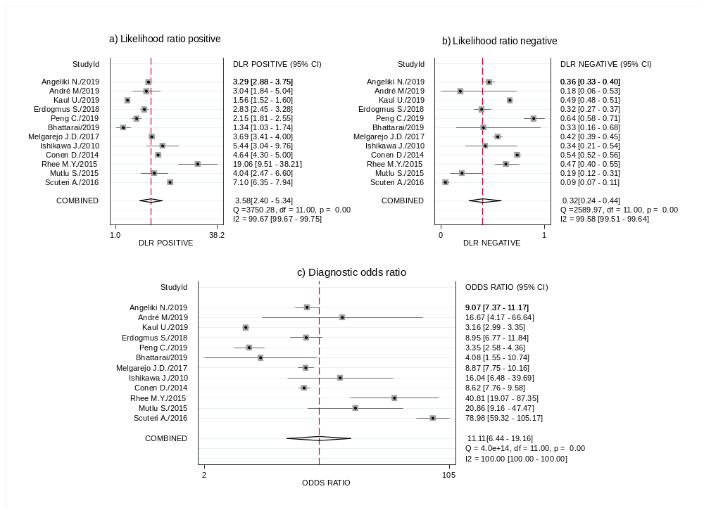

Additional Figure 2: The hierarchic summary receiver operating characteristic curves plotting the diagnostic performance of clinic blood pressure monitoring and home blood pressure monitoring, when using 24-hour ABPM as the reference standard

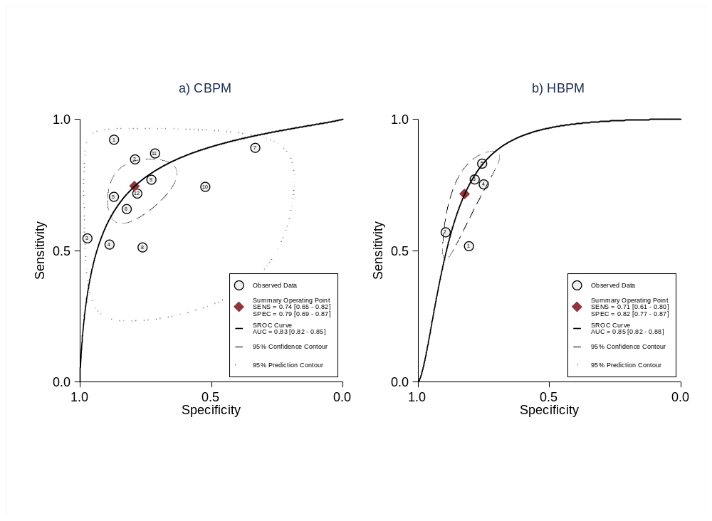
Additional Figure 3. Pooled diagnostic odds ratio, likelihood ratios positive and negative of clinic blood pressure measurement using daytime ABPM as the reference standard
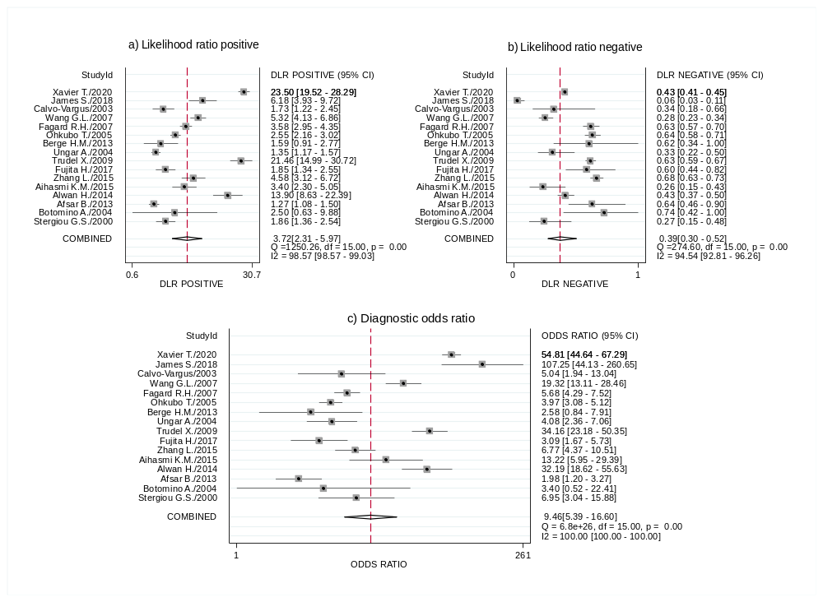

Additional Figure 4: Deeks’s funnel plot asymmetry test of clinic blood pressure monitoring and home blood pressure monitoring studies
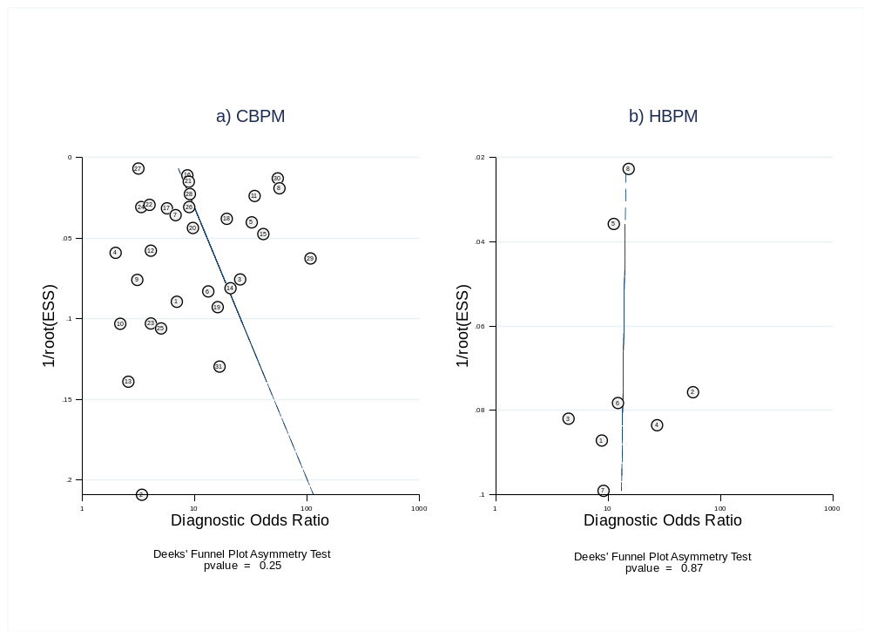

Additional Figure 5: Pooled diagnostic odds ratio, likelihood ratios positive and negative of home blood pressure measurement using 24-hour ABPM as the reference standard

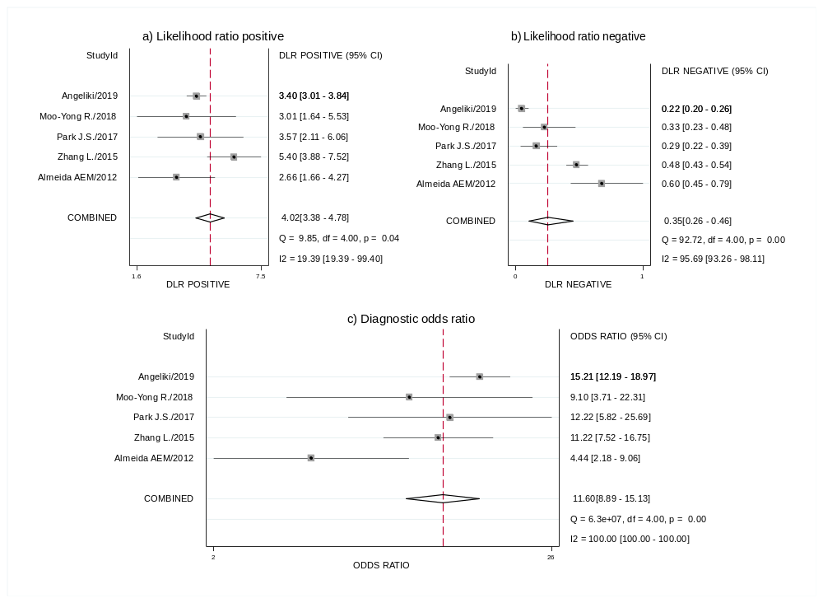

References

1. Brueren MM, Dinant GJ, Schouten BJ, et al. [Hypertension diagnosis by the family physician: measurements according to the NHG-standard (Dutch College of General Practitioners) compared with ambulatory blood pressure determination]. Nederlands tijdschrift voor geneeskunde 1995;139(6):278-82. [published Online First: 1995/02/11]
2. Hoegholm A, Kristensen KS, Bang LE, et al. White coat hypertension and blood pressure variability. American Journal of Hypertension 1999;12(10 I):966-72. doi: 10.1016/S0895-7061(99)00109-0
3. Martinez MA, Garcia-Puig J, Martin JC, et al. Frequency and determinants of white coat hypertension in mild to moderate hypertension: a primary care-based study. Monitorizacion Ambulatoria de la Presion Arterial (MAPA)-Area 5 Working Group. American journal of hypertension 1999;12(3):251-9. [published Online First: 1999/04/07]
4. Stergiou GS, Skeva, II, Baibas NM, et al. Diagnosis of hypertension using home or ambulatory blood pressure monitoring: comparison with the conventional strategy based on repeated clinic blood pressure measurements. J Hypertens 2000;18(12):1745-51. doi: 10.1097/00004872-200018120-00007 [published Online First: 2001/01/02]
5. Gan SK, Loh CY, Seet B. Hypertension in young adults--an under-estimated problem. Singapore Med J 2003;44(9):448-52. [published Online First: 2004/01/27]
6. Calvo-Vargas C, Padilla-Rios V, Troyo-Sanromán R. Loaned self-measurement equipment model compared with ambulatory blood pressure monitoring. Blood Pressure Monitoring 2003;8(2):63-70. doi: 10.1097/00126097-200304000-00002
7. Botomino A, Martina B, Ruf D, et al. White coat effect and white coat hypertension in community pharmacy practice. Blood Press Monit 2005;10(1):13-8. doi: 10.1097/00126097-200502000-00004 [published Online First: 2005/02/03]
8. Ungar A, Pepe G, Monami M, et al. Isolated ambulatory hypertension is common in outpatients referred to a hypertension centre. J Hum Hypertens 2004;18(12):897-903. doi: 10.1038/sj.jhh.1001756 [published Online First: 2004/07/09]
9. Tunçkale A, Aran SN, Karpuz H, et al. Relationship between insulin resistance and end-organ damage in white coat hypertension. American Journal of Hypertension 2004;17(11):1011-16. doi: 10.1016/j.amjhyper.2004.07.002
10. Ohkubo T, Kikuya M, Metoki H, et al. Prognosis of "masked" hypertension and "white-coat" hypertension detected by 24-h ambulatory blood pressure monitoring 10-year follow-up from the Ohasama study. Journal of the American College of Cardiology 2005;46(3):508-15. doi: 10.1016/j.jacc.2005.03.070 [published Online First: 2005/08/02]
11. Fagard RH, Van Den Broeke C, De Cort P. Prognostic significance of blood pressure measured in the office, at home and during ambulatory monitoring in older patients in general practice. Journal of Human Hypertension 2005;19(10):801-07. doi: 10.1038/sj.jhh.1001903
12. Wang GL, Li Y, Staessen JA, et al. Anthropometric and lifestyle factors associated with white-coat, masked and sustained hypertension in a Chinese population. J Hypertens 2007;25(12):2398-405. doi: 10.1097/HJH.0b013e3282efeee7 [published Online First: 2007/11/07]
13. Trudel X, Brisson C, Larocque B, et al. Masked hypertension: different blood pressure measurement methodology and risk factors in a working population. J Hypertens 2009;27(8):1560-7. doi: 10.1097/HJH.0b013e32832cb036 [published Online First: 2009/05/16]
14. Shimbo D, Kuruvilla S, Haas D, et al. Preventing misdiagnosis of ambulatory hypertension: algorithm using office and home blood pressures. J Hypertens 2009;27(9):1775-83. doi: 10.1097/HJH.0b013e32832db8b9 [published Online First: 2009/06/06]
15. Schoenthaler AM, Schwartz J, Cassells A, et al. Daily interpersonal conflict predicts masked hypertension in an urban sample. Am J Hypertens 2010;23(10):1082-8. doi: 10.1038/ajh.2010.141 [published Online First: 2010/07/10]
16. Viera AJ, Hinderliter AL, Kshirsagar AV, et al. Reproducibility of masked hypertension in adults with untreated borderline office blood pressure: comparison of ambulatory and home monitoring. Am J Hypertens 2010;23(11):1190-7. doi: 10.1038/ajh.2010.158 [published Online First: 2010/07/31]
17. Hanninen MR, Niiranen TJ, Puukka PJ, et al. Comparison of home and ambulatory blood pressure measurement in the diagnosis of masked hypertension. J Hypertens 2010;28(4):709-14. doi: 10.1097/HJH.0b013e3283369faa [published Online First: 2010/01/12]
18. Ishikawa J, Hoshide S, Eguchi K, et al. Masked hypertension defined by ambulatory blood pressure monitoring is associated with an increased serum glucose level and urinary albumin-creatinine ratio. J Clin Hypertens (Greenwich) 2010;12(8):578-87. doi: 10.1111/j.1751-7176.2010.00286.x [published Online First: 2010/08/11]
19. Maseko MJ, Woodiwiss AJ, Majane OH, et al. Marked underestimation of blood pressure control with conventional vs. ambulatory measurements in an urban, developing community of African ancestry. Am J Hypertens 2011;24(7):789-95. doi: 10.1038/ajh.2011.48 [published Online First: 2011/04/01]
20. Bacaksiz A, Erdogan E, Sonmez O, et al. Ambulatory blood pressure monitoring can unmask hypertension in patients with psoriasis vulgaris. Medical science monitor : international medical journal of experimental and clinical research 2013;19:501-9. doi: 10.12659/msm.889197 [published Online First: 2013/06/27]
21. Sobrino J, Domenech M, Camafort M, et al. Prevalence of masked hypertension and associated factors in normotensive healthcare workers. Blood Press Monit 2013;18(6):326-31. doi: 10.1097/mbp.0000000000000002 [published Online First: 2013/11/07]
22. Berge HM, Andersen TE, Solberg EE, et al. High ambulatory blood pressure in male professional football players. British journal of sports medicine 2013;47(8):521-5. doi: 10.1136/bjsports-2013-092354 [published Online First: 2013/03/19]
23. Afsar B. Comparison of demographic, clinical, and laboratory parameters between patients with sustained normotension, white coat hypertension, masked hypertension, and sustained hypertension. Journal of cardiology 2013;61(3):222-6. doi: 10.1016/j.jjcc.2012.11.003 [published Online First: 2013/01/09]
24. Franklin SS, Thijs L, Li Y, et al. Masked hypertension in diabetes mellitus: treatment implications for clinical practice. Hypertension 2013;61(5):964-71. doi: 10.1161/hypertensionaha.111.00289 [published Online First: 2013/03/13]
25. Alwan H, Pruijm M, Ponte B, et al. Epidemiology of masked and white-coat hypertension: the family-based SKIPOGH study. PloS one 2014;9(3):e92522. doi: 10.1371/journal.pone.0092522 [published Online First: 2014/03/26]
26. Larsen TR, Gelaye A, Waanbah B, et al. Prevalence of masked hypertension in African Americans. J Clin Hypertens (Greenwich) 2014;16(11):801-4. doi: 10.1111/jch.12418 [published Online First: 2014/10/21]
27. Viera AJ, Lin FC, Tuttle LA, et al. Levels of office blood pressure and their operating characteristics for detecting masked hypertension based on ambulatory blood pressure monitoring. Am J Hypertens 2015;28(1):42-9. doi: 10.1093/ajh/hpu099 [published Online First: 2014/06/06]
28. Pengkeaw P, Suwannakarn S. Prevalence of hypertension in suspected hypertensive patients in Rajavithi Hospital using ambulatory blood pressure monitoring. Journal of the Medical Association of Thailand = Chotmaihet thangphaet 2014;97 Suppl 11:S25-30. [published Online First: 2014/12/17]
29. Conen D, Aeschbacher S, Thijs L, et al. Age-specific differences between conventional and ambulatory daytime blood pressure values. Hypertension 2014;64(5):1073-9. doi: 10.1161/hypertensionaha.114.03957 [published Online First: 2014/09/04]
30. Trachsel LD, Carlen F, Brugger N, et al. Masked hypertension and cardiac remodeling in middle-aged endurance athletes. J Hypertens 2015;33(6):1276-83. doi: 10.1097/hjh.0000000000000558 [published Online First: 2015/02/11]
31. Al-Hashmi K, Al-Busaidi N, Amina B, et al. White coat hypertension and masked hypertension among omani patients attending a tertiary hospital for ambulatory blood pressure monitoring. Oman Med J 2015;30(2):90-4. doi: 10.5001/omj.2015.20
32. Zhang L, Li Y, Wei FF, et al. Strategies for classifying patients based on office, home, and ambulatory blood pressure measurement. Hypertension 2015;65(6):1258-65. doi: 10.1161/hypertensionaha.114.05038 [published Online First: 2015/04/15]
33. Mutlu S, Sari O, Arslan E, et al. Comparison of ambulatory blood pressure measurement with home, office and pharmacy measurements: is arterial blood pressure measured at pharmacy reliable? Journal of evaluation in clinical practice 2016;22(1):40-45. doi: 10.1111/jep.12424 [published Online First: 2015/08/26]
34. Rhee MY, Kim SW, Choi EH, et al. Prevalence of Masked Hypertension: a Population-Based Survey in a Large City by Using 24-Hour Ambulatory Blood Pressure Monitoring. Korean circulation journal 2016;46(5):681-87. doi: 10.4070/kcj.2016.46.5.681 [published Online First: 2016/10/11]
35. Mancia G, Facchetti R, Grassi G, et al. Adverse Prognostic Value of Persistent Office Blood Pressure Elevation in White Coat Hypertension. Hypertension 2015;66(2):437-44. doi: 10.1161/HYPERTENSIONAHA.115.05367
36. Redmond N, Booth JN, 3rd, Tanner RM, et al. Prevalence of Masked Hypertension and Its Association With Subclinical Cardiovascular Disease in African Americans: Results From the Jackson Heart Study. Journal of the American Heart Association 2016;5(3):e002284. doi: 10.1161/jaha.115.002284 [published Online First: 2016/03/31]
37. Piantanida E, Gallo D, Veronesi G, et al. Masked hypertension in newly diagnosed hypothyroidism: a pilot study. Journal of endocrinological investigation 2016;39(10):1131-8. doi: 10.1007/s40618-016-0488-7 [published Online First: 2016/05/20]
38. Viera AJ, Lin FC, Tuttle LA, et al. Examination of Several Physiological and Psychosocial Factors Potentially Associated With Masked Hypertension Among Low-Risk Adults. J Clin Hypertens (Greenwich) 2016;18(8):784-9. doi: 10.1111/jch.12761 [published Online First: 2015/12/29]
39. Scuteri A, Morrell CH, Orru M, et al. Gender specific profiles of white coat and masked hypertension impacts on arterial structure and function in the SardiNIA study. International journal of cardiology 2016;217:92-8. doi: 10.1016/j.ijcard.2016.04.172 [published Online First: 2016/05/15]
40. Booth JN, 3rd, Muntner P, Diaz KM, et al. Evaluation of Criteria to Detect Masked Hypertension. J Clin Hypertens (Greenwich) 2016;18(11):1086-94. doi: 10.1111/jch.12830 [published Online First: 2016/11/05]
41. Anstey DE, Booth JN, Abdalla M, et al. Predicted Atherosclerotic Cardiovascular Disease Risk and Masked Hypertension among Blacks in the Jackson Heart Study. Circulation: Cardiovascular Quality and Outcomes 2017;10(7) doi: 10.1161/CIRCOUTCOMES.116.003421
42. Fujita H, Matsuoka S, Awazu M. Masked Isolated Nocturnal Hypertension in Children and Young Adults. Pediatric cardiology 2018;39(1):66-70. doi: 10.1007/s00246-017-1728-0 [published Online First: 2017/09/28]
43. Melgarejo JD, Maestre GE, Thijs L, et al. Prevalence, Treatment, and Control Rates of Conventional and Ambulatory Hypertension Across 10 Populations in 3 Continents. Hypertension 2017;70(1):50-58. doi: 10.1161/hypertensionaha.117.09188 [published Online First: 2017/05/10]
44. Ozkan S, Ata N, Yavuz B. Increased masked hypertension prevalence in patients with obesity. Clinical and experimental hypertension (New York, NY : 1993) 2018:1-4. doi: 10.1080/10641963.2018.1431262 [published Online First: 2018/02/09]
45. Gun T, Ozkan S, Yavuz B. Is tinnitus an early voice of masked hypertension? High masked hypertension rate in patients with tinnitus. Clinical and experimental hypertension (New York, NY : 1993) 2018:1-4. doi: 10.1080/10641963.2018.1465077 [published Online First: 2018/04/24]
46. Erdogmus S, Kutlay S, Celebi ZK, et al. Clinical Correlates of Ambulatory Blood Pressure Phenotypes at a Tertiary Care Hospital in Turkey. Kidney & blood pressure research 2018;43(3):690-700. doi: 10.1159/000489742 [published Online First: 2018/05/16]
47. Sheppard JP, Martin U, Gill P, et al. Prospective external validation of the Predicting Out-of-OFfice Blood Pressure (PROOF-BP) strategy for triaging ambulatory monitoring in the diagnosis and management of hypertension: observational cohort study. Bmj 2018;361:k2478. doi: 10.1136/bmj.k2478 [published Online First: 2018/06/29]
48. Bhattarai M, Sainju NK, Bhandari B, et al. Prevalence of white coat hypertension among the patients visiting in a tertiary care center, Kathmandu, Nepal. Kathmandu University Medical Journal 2019;17(66):119-22.
49. Cai P, Peng Y, Chen Y, et al. Association of thyroid function with white coat hypertension and sustained hypertension. J Clin Hypertens (Greenwich) 2019;21(5):674-83. doi: 10.1111/jch.13536 [published Online First: 2019/04/12]
50. Kaul U, Arambam P, Rao S, et al. Usefulness of ambulatory blood pressure measurement for hypertension management in India: the India ABPM study. J Hum Hypertens 2019 doi: 10.1038/s41371-019-0243-6 [published Online First: 2019/09/06]
51. Ntineri A, Niiranen TJ, McManus RJ, et al. Ambulatory versus home blood pressure monitoring: Frequency and determinants of blood pressure difference and diagnostic disagreement. Journal of Hypertension 2019;37(10):1974-81. doi: 10.1097/HJH.0000000000002148
52. Michaud A, Lamarre-Cliche M, Cloutier L. Screening for hypertension: An elevated office blood pressure measurement is valuable, adding an automated one is even better. Blood Pressure Monitoring 2019;24(3):123-29. doi: 10.1097/MBP.0000000000000382
53. Salazar MR, Espeche WG, Balbin E, et al. Prevalence of isolated nocturnal hypertension according to 2018 European Society of Cardiology and European Society of Hypertension office blood pressure categories. J Hypertens 2019 doi: 10.1097/hjh.0000000000002278 [published Online First: 2019/10/05]
54. Trudel X, Brisson C, Gilbert-Ouimet M, et al. Long Working Hours and the Prevalence of Masked and Sustained Hypertension. Hypertension 2020;75(2):532-38. doi: 10.1161/hypertensionaha.119.12926 [published Online First: 2019/12/20]
55. Almeida AE, Stein R, Gus M, et al. Improved diagnostic accuracy of a 3-day protocol of home blood pressure monitoring for the diagnosis of arterial hypertension. Blood pressure monitoring 2013;18(2):119-26. doi: 10.1097/MBP.0b013e32835ebb18 [published Online First: 2013/02/15]
56. de Almeida AEM, Stein R, Gus M, et al. Relevance to home blood pressure monitoring protocol of blood pressure measurements taken before first-morning micturition and in the afternoon. Arquivos Brasileiros de Cardiologia 2014;103(4):338-47. doi: 10.5935/abc.20140139
57. Park JS, Rhee MY, Namgung J, et al. Comparison of Optimal Diagnostic Thresholds of Hypertension With Home Blood Pressure Monitoring and 24-Hour Ambulatory Blood Pressure Monitoring. Am J Hypertens 2017;30(12):1170-76. doi: 10.1093/ajh/hpx115 [published Online First: 2017/10/11]
58. Rhee MY, Kim JY, Kim JH, et al. Optimal schedule of home blood-pressure measurements for the diagnosis of hypertension. Hypertension research : official journal of the Japanese Society of Hypertension 2018;41(9):738-47. doi: 10.1038/s41440-018-0069-6 [published Online First: 2018/07/07]

