Table 1. Inhibitory Potency of Compounds Y1− Y15 on NLRP3-dependent IL-1β ª
Cmpds | R₁ | n | R₂ | IC₅₀ª (μM)
1 | 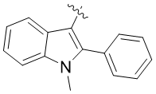 | 1 | 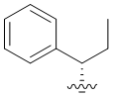 | 35.7±0.82
Y1 | 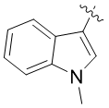 | 1 |  | 20.03±0.37
Y2 | 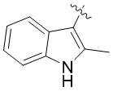 | 1 |  | 8.48±0.52
Y3 | 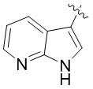 | 1 |  | 5.67±0.86
Y4 |  | 0 |  | >50
Y5 |  | 0 | 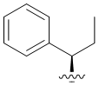 | >50
Y6 |  | 1 |  | >50
Y7 |  | 1 |  | >50
Y8 |  | 1 |  | 28.62±0.37
Y9 |  | 1 |  | 12.42±0.16
Y10 |  | 1 |  | >50
Y11 |  | 1 |  | >50
Y12 |  | 1 |  | >50
Y13 |  | 1 |  | >50
Y14 |  | 1 |  | 19.52±0.69
Y15 |  | 1 |  | >50
ª LPS-primed J774A.1 cells were treated with compounds for 1 h and stimulated with nigericin for 1 h, and then supernatants were analyzed by ELISA for IL-1β (three replicates in one separate determination).
Table 2. Inhibitory Potency of Compounds Y16− Y30 on NLRP3-dependent IL-1β ª
Cmpds | R₁ | n | R₂ | IC₅₀ª (μM)
Y16 |  | 1 |  | 3.02±0.56
Y17 |  | 1 |  | 16.14±0.73
Y18 |  | 1 |  | 4.80±0.69
Y19 |  | 1 |  | 1.26±0.37
Y20 |  | 1 |  | 15.11±0.26
Y21 |  | 1 |  | 11.14±0.33
Y22 |  | 1 |  | 8.79±0.78
Y23 |  | 1 |  | 12.27±0.36
Y24 |  | 1 |  | 5.24±0.48
Y25 |  | 1 |  | 5.83±0.68
Y26 |  | 1 |  | 15.70±0.72
Y27 |  | 1 |  | >50
Y28 |  | 1 |  | 10.60±0.78
Y29 |  | 0 |  | >50
Y30 |  | 1 |  | >50
ª LPS-primed J774A.1 cells were treated with compounds for 1 h and stimulated with nigericin for 1 h, and then supernatants were analyzed by ELISA for IL-1β (three replicates).

