Dietary exposure assessment of paralytic shellfish toxins through shellfish consumption in Shenzhen population, China
Yan Zhou^{a,1}, Shenpan Li^{a,1}, Jianying Zhang^{b}, Jinzhou Zhangª, Zhou Wangª, Liubo Panª, Baiqiang Huang^{a,c}, Ke Huang^{b}, Xiao Chenª, Qionghui Zhao^{b}, Tianjiu Jiang^{c}**, Jianjun Liuª*
a. Shenzhen Key Laboratory of Modern Toxicology, Shenzhen Medical Key Discipline of Health Toxicology (2020-2024), Shenzhen Center for Disease Control and Prevention，Shenzhen, Guangdong，518055，PR China
b. Food Inspection & Quarantine Center, Shenzhen Custom，Shenzhen, Guangdong，518045，PR China
c. Research Center of Harmful Algae & Marine Biology, Jinan University, No. 601 Shipai Street, Tianhe District, Guangzhou, 510632, PR China,
¹These authors contributed equally to this work.
* Corresponding author.
Prof. Jian-jun Liu, Shenzhen Key Laboratory of Modern Toxicology, Shenzhen Medical Key Discipline of Health Toxicology，Shenzhen Center for Disease Control and Prevention，No. 8 Longyuan Road, Nanshan District, Shenzhen, 518055, China. E-mail: junii8@126.com;
** Corresponding author:
Prof. Tian-jiu Jiang, Research Center of Harmful Algae & Marine Biology, Jinan University, No. 601 Shipai Street, Tianhe District, Guangzhou, 510632, China, E-mail: tjiangtj@jnu.edu.cn

Appendix: (Colors in figures showed below does not need to be used in print)

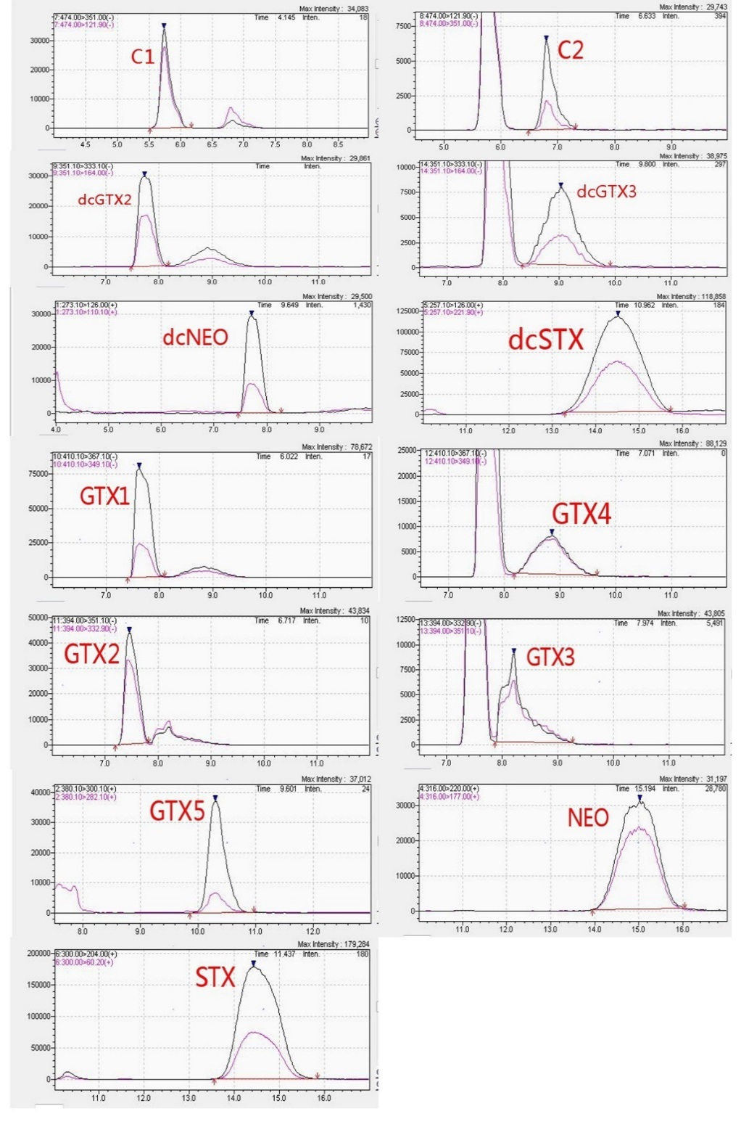
Appendix1 Chromatograms of mixed standard working solution for PSTs in blank matrix

Appendix2a Summary of shellfish samples collected at Buji wholesale market from March to August 2019
Sources | 30th Mar | 27th Apr | 27th May | 23rd Jun | 26th Jul | 28th Aug
Aotou | PU | PU | PU | PU | PU | PU
Aotou |  | CN | CN | CN | CN
Dianbai |  |  |  |  | MM | MM
Fukien | SC | SC | SC | SC | SC | SC
Fukien | SS | SG | CR |  | CN | CN
Guangxi |  |  |  |  | PU | PU
Guangxi |  | AP | AP | AP | AP
Hainan | BA |  | BA | BA | BA | BA
Huidong | PU | PU | PU | PU | PU
Huidong | SB | SB |  | SB
Huidong |  | CN | CN | CN |  | CN
Huidong | PV | PV | PV | PV | PV
Nan’ao | CN | CN | CN | CN | CN | PU
Nan’ao | SS |  |  |  |  | PV
Nan’ao |  |  |  |  |  | CN
Shantung |  |  |  |  |  | ME
Shantung | AP
Yangjiang | MM | MM | MM | MM | MM | MM
Yangjiang |  |  |  |  | CR
Zhanjiang | CN | CN | CN | CN | CN | AP
Zhanjiang | CR | CR |  | CR | CR | CR
Zhanjiang | PV | PV | PV |  | PV
Zhuhai | PU | PU | PU | PU | PU | PU
PV:Perna viridis; CN:Chamys nobilis; AP:Atrina pectinate; CR:Crassostrea rivularis;
PU:Paphia undulata; MM:Meretrix meretrix; SC:Sinonovacula constricta; SG:Solen gouldi; SB:Scapharca broughtoni; BA:Babylonia areolate; SS:Scapharca subcrenata; ME:Mytilus edulis

Appendix 2b Summary of shellfish samples collected at Buji wholesale market from March to August 2019
Sources | 26th Sep | 29th Oct | 26th Nov | 24th Dec | 17th Jan | 27th Feb
Aotou | PU | PU | PU | PU | PU | PU
Aotou | CN | CN | CN |  | CN | CN
Dianbai | MM | MM | MM |  |  | MM
Fukien | SC | SC | SC | SC | SC
Fukien |  |  |  |  | SG
Guangxi | PU | PU | PU |  |  | PU
Guangxi | AP | AP | AP | AP | AP | AP
Hainan | BA | BA |  | BA | BA | BA
Huidong | PU | PU | PU
Huidong |  | CR | CR | CR | CR | CR
Huidong | CN
Huidong | PV |  | PV | PV | PV | PV
Nan’ao | CN | CN | CN | CN | CN | CN
Nan’ao |  |  |  | PU |  | PV
Shantung |  |  |  | ME | RP
Shantung |  | PY | PY | PY | PY | PY
Yangjiang | MM | MM | MM | MM | MM | MM
Yangjiang | RP | RP | RP | RP |  | RP
Zhanjiang | CN | CN | CN | CN | CN | CN
Zhanjiang | CR | CR | CR | CR | CR | CR
Zhanjiang |  |  | PV | PV | PV | PV
Zhuhai | PU | PU | PU | PU | PU | PU
PV:Perna viridis; CN:Chamys nobilis; AP:Atrina pectinate; CR:Crassostrea rivularis;
RP:Ruditapes philippinara; PU:Paphia undulata; MM:Meretrix meretrix;
SC:Sinonovacula constricta; SG:Solen gouldi; SB:Scapharca broughtoni;
BA:Babylonia areolate; SS:Scapharca subcrenata; PY:Patinopecten yessoensis;
ME:Mytilus edulis

