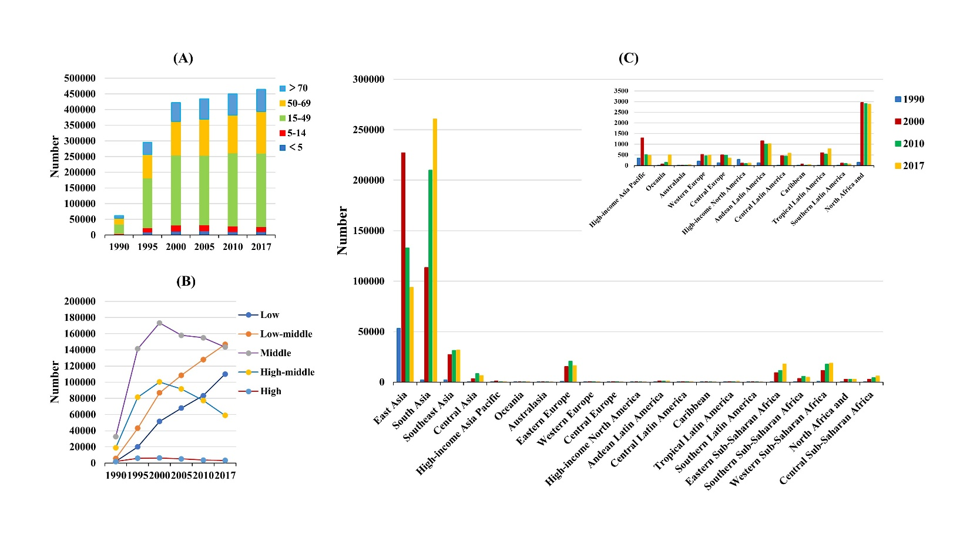
Supplementary figure 1. The distribution of the number of MDR-TB prevalence globally, and in SDI areas and geographic regions from1990 to 2017. (A) the number of MDR-TB prevalence in age groups; (B) the changing of number of MDR-TB prevalence in SDI areas; (C) the number of MDR-TB prevalence in geographical regions.
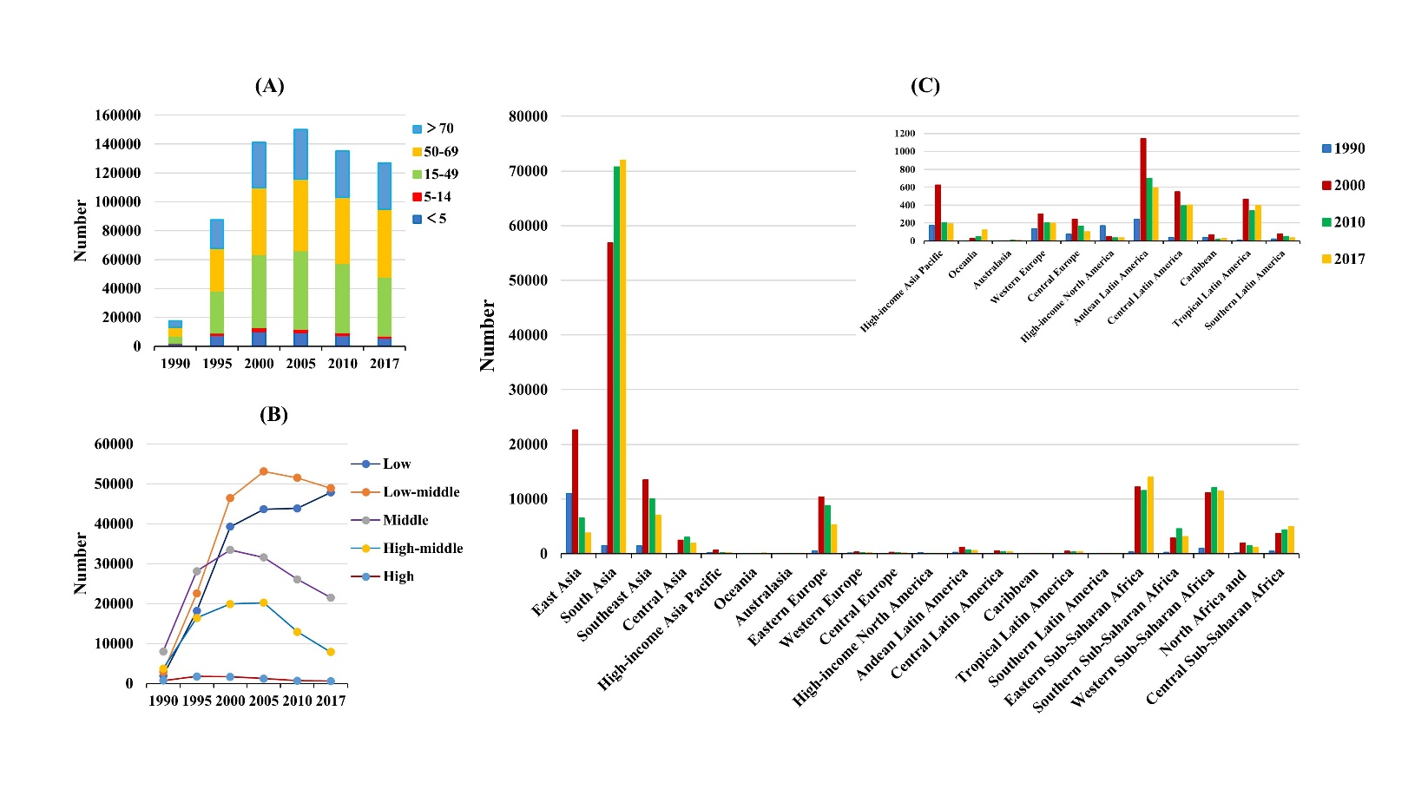
Supplementary figure 2. The distribution of the number of MDR-TB death globally, and in SDI areas and geographic regions from1990 to 2017. (A) the number of MDR-TB death in age groups; (B) the changing of number of MDR-TB death in SDI areas; (C) the number of MDR-TB death in geographical regions.
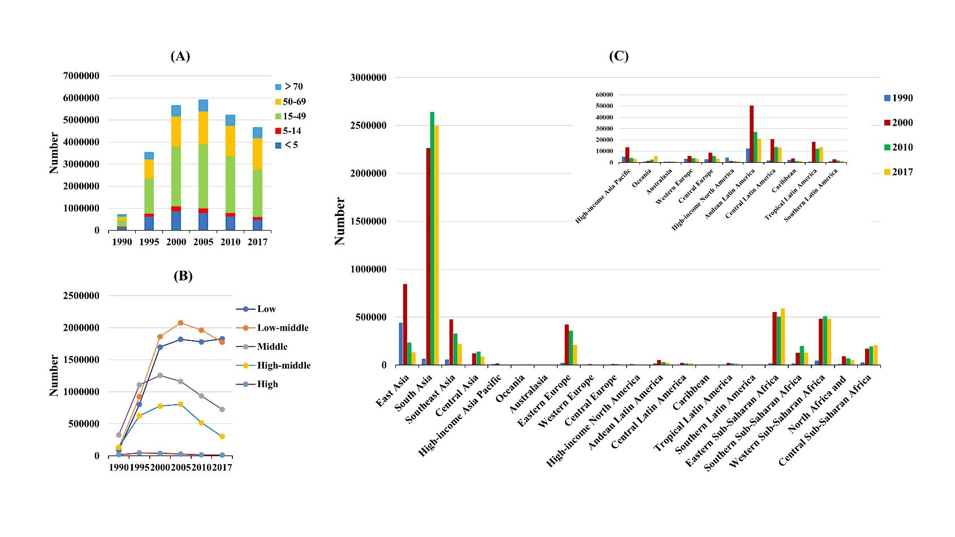
Supplementary figure 3. The distribution of the number of MDR-TB DALYs globally, and in SDI areas and geographic regions from1990 to 2017. (A) the number of MDR-TB DALYs in age groups; (B) the changing of number of MDR-TB DALYs in SDI areas; (C) the number of MDR-TB DALYs in geographical regions.
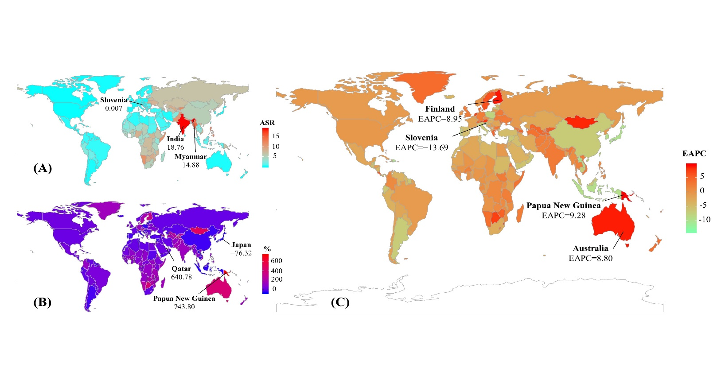
Supplementary figure 4. The distribution of ASR, percentage changes in absolute number, and EAPC of MDR-TB prevalence at a national level during 2000-2017. (A) the ASR of MDR-TB prevalence in 2017 in countries/territories; (B) the percentage changes in absolute number of MDR-TB prevalence between 2000 and 2017 in countries/territories; (C) the EAPCs of MDR-TB prevalence in countries/territories from 2000 to 2017. Countries/territories with an extreme value were annotated. ASR, age-standardized rate; EAPC, estimated annual percentage change.
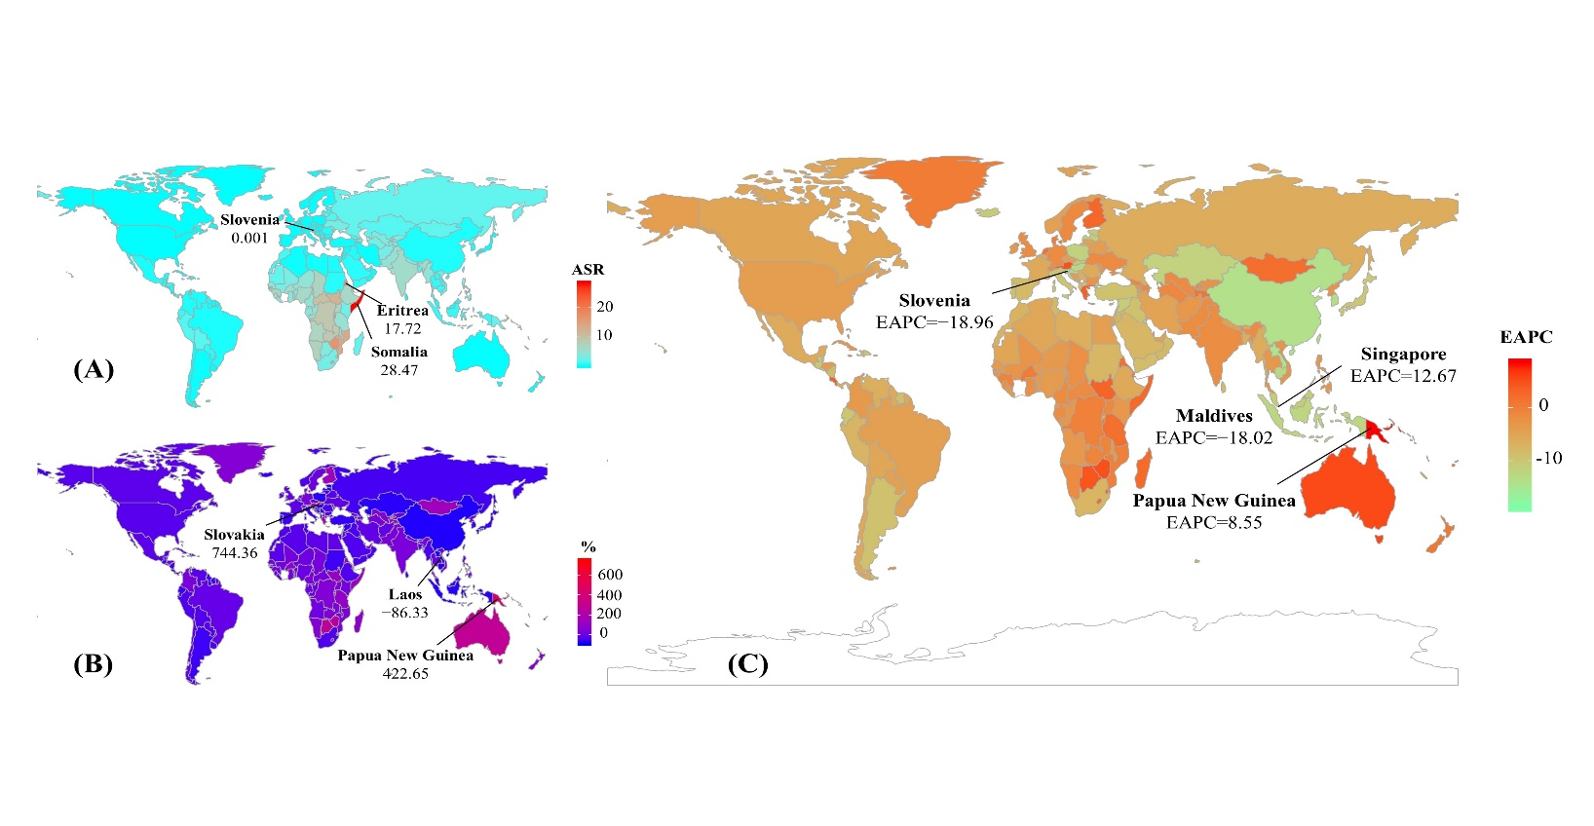
Supplementary figure 5. The distribution of ASR, percentage changes in absolute number, and EAPC of MDR-TB death at a national level during 2000-2017. (A) the ASR of MDR-TB death in 2017 in countries/territories; (B) the percentage changes in absolute number of MDR-TB death between 2000 and 2017 in countries/territories; (C) the EAPCs of MDR-TB death in countries/territories from 2000 to 2017. Countries/territories with an extreme value were annotated. ASR, age-standardized rate; EAPC, estimated annual percentage change.
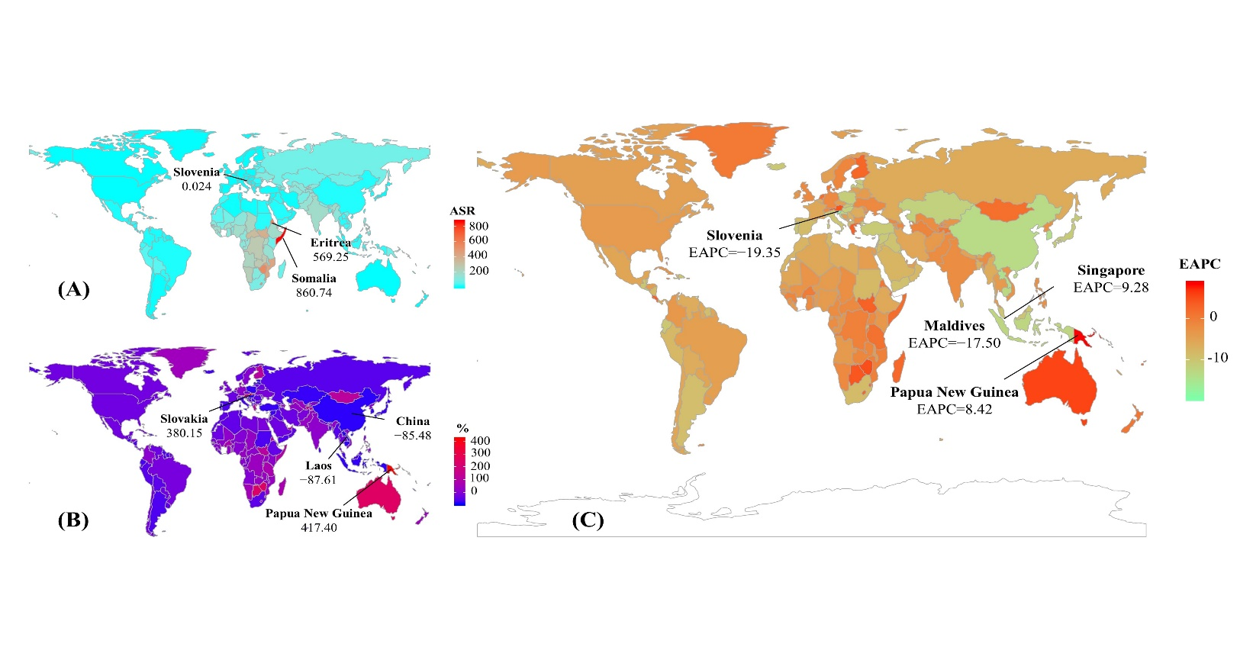
Supplementary figure 6. The distribution of ASR, percentage changes in absolute number, and EAPC of MDR-TB DALYs at a national level during 2000-2017. (A) the ASR of MDR-TB DALYs in 2017 in countries/territories; (B) the percentage changes in absolute number of MDR-TB DALYs between 2000 and 2017 in countries/territories; (C) the EAPCs of MDR-TB DALYs in countries/territories from 2000 to 2017. Countries/territories with an extreme value were annotated. DALYs, disability- adjusted life-years; ASR, age-standardized rate; EAPC, estimated annual percentage change.
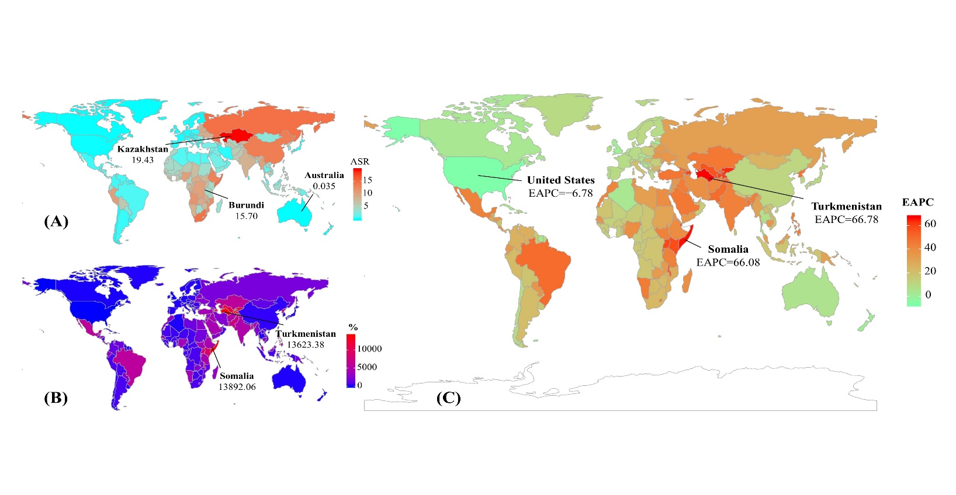
Supplementary figure 7. The distribution of ASR, percentage changes in absolute number, and EAPC of MDR-TB incidence at a national level during 1990-1999. (A) the ASR of MDR-TB incidence in 1999 in countries/territories; B. the percentage changes in absolute incident number of MDR-TB between 1990 and 1999 in countries/territories; C. the EAPCs of MDR-TB incidence in countries/territories from 1990 to 1999. Countries/territories with an extreme value were annotated. ASR, age-standardized rate; EAPC, estimated annual percentage change.
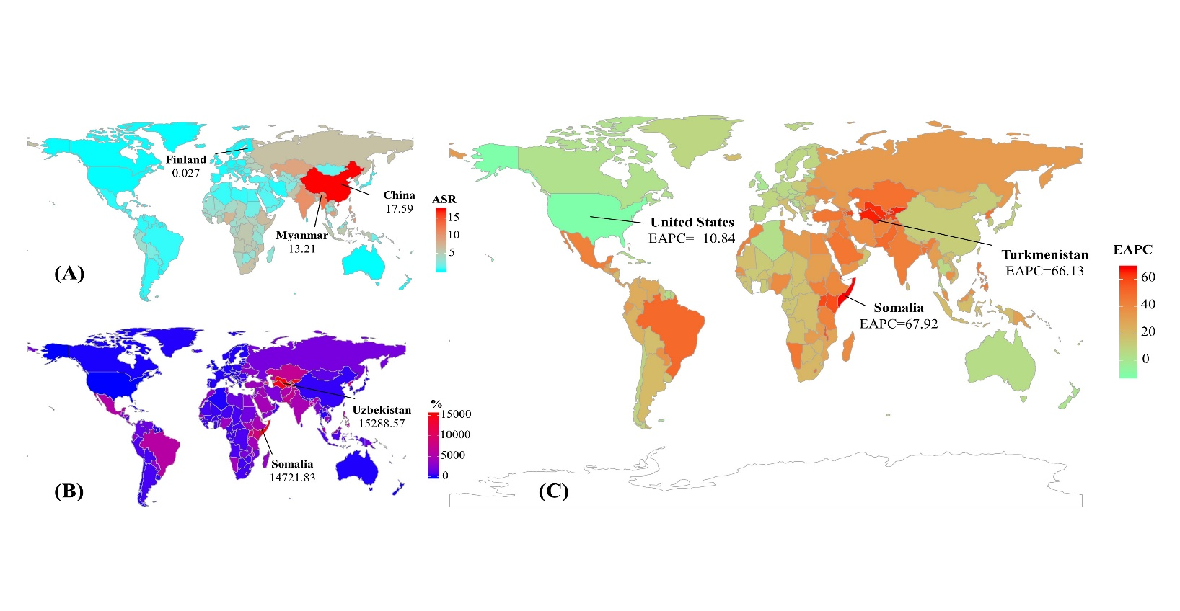
Supplementary figure 8. The distribution of ASR, percentage changes in absolute number, and EAPC of MDR-TB prevalence at a national level during 1990-1999. (A) the ASR of MDR-TB prevalence in 1999 in 195 countries/territories; B. the percentage changes in absolute number of MDR-TB prevalence between 1990 and 1999 in countries/territories; C. the EAPCs of MDR-TB prevalence in countries/territories from 1990 to 1999. Countries/territories with an extreme value were annotated. ASR, age-standardized rate; EAPC, estimated annual percentage change.
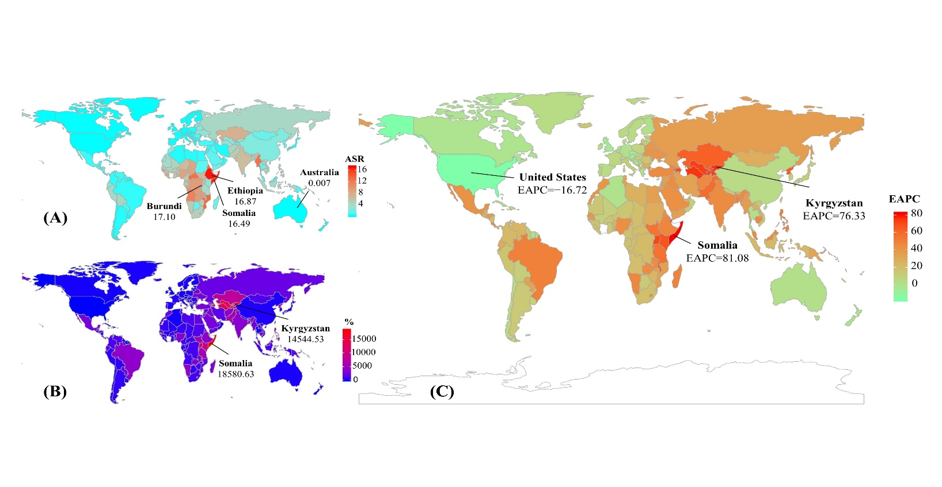
Supplementary figure 9. The distribution of ASR, percentage changes in absolute number, and EAPC of MDR-TB death at a national level during 1990-1999. (A) the ASR of MDR-TB death in 1999 in 195 countries/territories; B. the percentage changes in absolute number of MDR-TB death between 1990 and 1999 in countries/territories; C. the EAPCs of MDR-TB death in countries/territories from 1990 to 1999. Countries/territories with an extreme value were annotated. ASR, age-standardized rate; EAPC, estimated annual percentage change.
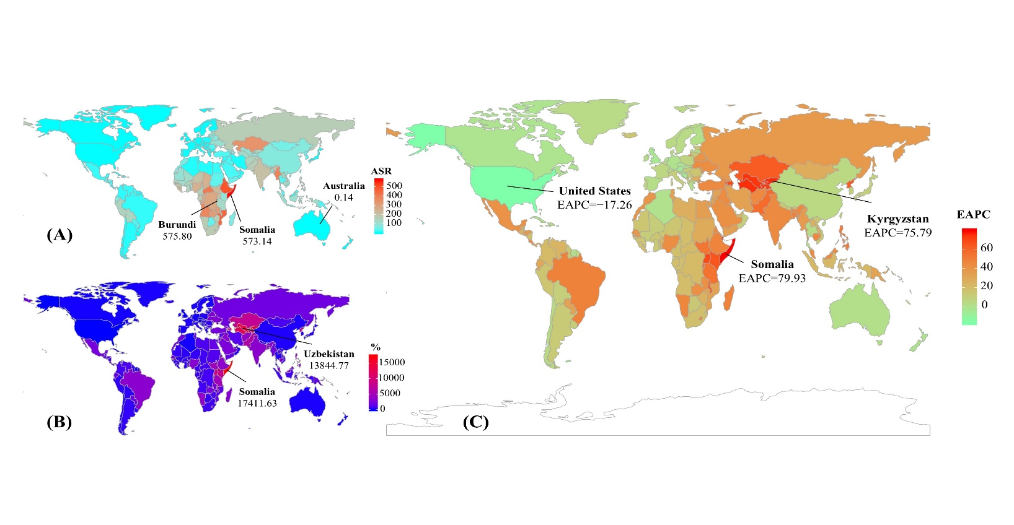
Supplementary figure 10. The distribution of ASR, percentage changes in absolute number, and EAPC of MDR-TB DALYs at a national level during 1990-1999. (A) the ASR of MDR-TB DALYs in 1999 in 195 countries/territories; B. the percentage changes in absolute number of MDR-TB DALYs between 1990 and 1999 in countries/territories; C. the EAPCs of MDR-TB DALYs in countries/territories from 1990 to 1999. Countries/territories with an extreme value were annotated. DALYs, disability- adjusted life-years; ASR, age-standardized rate; EAPC, estimated annual percentage change.
Supplementary table 1. the percentage changes in absolute number and EAPCs of MDR-TB prevalence from 1990 to 2017 in global, sexes, SDI areas and geographic regions
 | 1999 |  | 1990–1999 |  | 2017 |  | 2000–2017
Characteristics | Number  ×10³ (95% UI) | ASR per 100k  No. (95% UI) | Percentage Change in  absolute number (%) | EAPCs  (95%CI) | Number  ×10³ (95% UI) | ASR per 100k  No. (95% UI) | Percentage Change in  absolute number (%) | EAPCs  (95%CI)
Overall | 402.46  (291.50–565.66) | 7.03  (5.11–9.78) | 552.27 | 17.57  (11.51–23.95) | 464.12  (229.12–863.33) | 5.85  (2.90–10.83) | 9.92 | −1.32  (−1.38–−1.26)
Sex
Male | 253.14  (183.13–354.58) | 9.14  (6.64–12.75) | 551.31 | 17.89  (12.58–23.46) | 285.82  (136.55–544.61) | 7.32  (3.51–14.02) | 6.74 | −1.45(−1.58–−1.32)
Female | 149.33  (109.48–207.16) | 5.08  (3.74–7.03) | 553.90 | 17.01  (9.82–24.67) | 178.30  (91.88–317.29) | 4.48  (2.33–7.92) | 15.45 | −1.16  (−1.32–−0.99)
SDI
Low | 46.37  (21.6–103.01) | 7.58  (3.44–17) | 2389.96 | 35.01  (26.58–44.01) | 110.12  (43.45–254.99) | 11.67  (4.39–27.77) | 113.56 | 1.81  (1.62–2)
Low-middle | 79.55  (40.58–151.64) | 8.24  (4.23–15.65) | 1303.24 | 26.62  (19.35–34.32) | 146.75  (62.89–288.18) | 10.24  (4.28–20.33) | 68.84 | 0.77  (0.51–1.03)
Middle | 168.93  (105.46–246.31) | 11.09  (6.95–16.28) | 418.1 | 14.28  (8.33–20.56) | 143.47  (61.75–285.21) | 6.46  (2.79–12.90) | −17.23 | −3.13  (−3.26–−2.99)
High-middle | 97.56  (58.42–153.04) | 7.89  (4.72–12.41) | 419.02 | 15.03  (8.94–21.47) | 58.94  (27.01–140.61) | 3.65  (1.69–8.58) | −41.25 | −4.7  (−4.84–−4.55)
High | 6.28  (3.42–11.9) | 0.51  (0.28–0.96) | 235.42 | 10.87  (5.79–16.2) | 3.24  (1.52–7.65) | 0.23  (0.11–0.52) | −48.64 | −5.22  (−5.68–−4.75)
Regions
East Asia | 226.98  (156.62–320.61) | 17.18  (11.94–24.11) | 325.36 | 12.44  (6.43–18.79) | 93.95  (20.08–288.90) | 5.30  (1.14–16.37) | −58.67 | −6.74  (−6.91–−6.57)
South Asia | 99.71  (33.55–236.00) | 9.68  (3.28–23.01) | 4413.21 | 42.79  (32.29–54.12) | 260.63  (66.23–598.30) | 16.55  (4.17–37.91) | 129.76 | 2.34  (1.92–2.76)
Southeast Asia | 26.24  (12.90–61.71) | 6.03  (2.96–14.44) | 1073.87 | 22.65  (13.19–32.9) | 31.69  (18.50–50.16) | 4.90  (2.86–7.71) | 15.88 | −1.02  (−1.23–−0.8)
Central Asia | 2.75  (1.76–4.37) | 3.94  (2.54–6.24) | 8039.61 | 50.23  (34.78–67.46) | 6.59  (4.78–8.80) | 7.34  (5.33–9.80) | 99.59 | 1.97  (0.08–3.9)
High−income Asia Pacific | 1.28  (0.93–1.86) | 0.57  (0.42–0.84) | 265.61 | 11.3  (5.97–16.89) | 0.47  (0.11–1.33) | 0.17  (0.04–0.49) | −63.29 | −8.77  (−9.98–−7.55)
Oceania | 0.06  (0.01–0.19) | 0.97  (0.20–3.07) | 1465.33 | 28.34  (21.4–35.67) | 0.50  (0.25–0.87) | 4.82  (2.45–8.63) | 652.78 | 8.87  (7.41–10.36)
Australasia | 0.01  (0–0.02) | 0.03  (0.01–0.07) | 70.88 | 4.13  (1.32–7.02) | 0.03  (0.02–0.05) | 0.11  (0.06–0.17) | 332.75 | 7.58  (7.31–7.86)
Eastern Europe | 14.01  (9.80–19.41) | 5.71  (4.02–7.95) | 1780.53 | 31.72  (21.51–42.79) | 16.28  (11.00–22.26) | 6.91  (4.63–9.41) | 6.56 | 0.16  (−0.77–1.1)
Western Europe | 0.50  (0.421–0.584) | 0.12  (0.10–0.14) | 146.39 | 9.46  (7.77–11.18) | 0.48  (0.38–0.63) | 0.11  (0.08–0.14) | −6.45 | −1.63  (−2.15–−1.11)
Central Europe | 0.49  (0.34–0.79) | 0.36  (0.25–0.59) | 304.79 | 12.94  (5.64–20.74) | 0.34  (0.24–0.47) | 0.25  (0.17–0.34) | −29.80 | −2.69  (−3.53–−1.84)
High-income North America | 0.12  (0.10–0.14) | 0.03  (0.03–0.04) | −57.38 | −9.97  (−10.55–−9.39) | 0.11  (0.07–0.16) | 0.03  (0.02–0.04) | 3.17 | −0.53  (−1.09–0.03)
Andean Latin America | 1.08  (0.55–1.93) | 2.61  (1.32–4.62) | 832.53 | 23.43  (19–28.03) | 1.02  (0.74–1.52) | 1.70  (1.24–2.52) | −12.28 | −3.66  (−4.15–−3.16)
Central Latin America | 0.43  (0.25–0.80) | 0.26  (0.15–0.48) | 2350.01 | 31.95  (21–43.9) | 0.58  (0.27–1.23) | 0.23  (0.11–0.48) | 24.20 | −1.93  (−2.57–−1.29)
Caribbean | 0.06  (0.03–0.17) | 0.16  (0.07–0.43) | 170.59 | 8.67  (4.37–13.14) | 0.04  (0.02–0.09) | 0.08  (0.03–0.18) | −38.47 | −5.32  (−7.19–−3.41)
Tropical Latin America | 0.55  (0.15–1.36) | 0.33  (0.09–0.83) | 5402.06 | 49  (40.23–58.32) | 0.78  (0.18–2.12) | 0.33  (0.08–0.90) | 30.04 | −1.01  (−1.94–−0.08)
Southern Latin America | 0.11  (0.06–0.18) | 0.19  (0.11–0.33) | 477.23 | 18.54  (14.99–22.2) | 0.07  (0.02–0.19) | 0.10  (0.03–0.28) | −40.27 | −5.76  (−6.78–−4.74)
Eastern Sub-Saharan Africa | 8.65  (5.32–14.00) | 4.87  (3.00–8.09) | 4069.01 | 40.93  (30.36–52.36) | 18.14  (11.25–29.96) | 5.77  (3.60–9.97) | 91.60 | 0.3  (−0.21–0.81)
Southern Sub-Saharan Africa | 3.22  (1.69–7.06) | 5.50  (2.87–12.05) | 651.59 | 22.04  (20.98–23.1) | 4.79  (2.71–8.43) | 6.24  (3.57–10.79) | 29.98 | −0.8  (−2.04–0.45)
Western Sub-Saharan Africa | 10.65  (4.69–23.92) | 5.85  (2.56–13.13) | 1175.03 | 24.94  (17.44–32.92) | 18.77  (8.58–40.02) | 6.13  (2.77–13.12) | 61.50 | −0.44  (−1.04–0.15)
North Africa  and Middle East | 2.727  (1.696–4.051) | 0.71  (0.44–1.05) | 1811.55 | 33.7  (28.78–38.8) | 2.87  (1.89–4.74) | 0.49  (0.33–0.80) | −2.97 | −2.62  (−2.81–−2.44)
Central Sub-Saharan Africa | 2.831  (0.828–8.526) | 5.44  (1.63–16.56) | 686.24 | 18.15  (10.72–26.08) | 6.00  (1.43–16.40) | 6.66  (1.58–18.46) | 101.25 | 0.67  (0.45–0.89)
MDR-TB: multidrug resistant tuberculosis; EAPC: estimated annual percentage change; ASR, age-standardized rate; CI, confidence interval; UI: uncertainty interval; SDI: socio-demographic index.

Supplementary table 2. the percentage changes in absolute number and EAPCs of death due to MDR-TB from 1990 to 2017 in global, sexes, SDI areas and geographic regions
 | 1999 |  | 1990-1999 |  | 2017 |  | 2000-2017
Characteristics | Number  ×10³ (95% UI) | ASR per 100k  No. (95% UI) | Percentage Change in  absolute number (%) | EAPCs  (95%CI) | Number  ×10³ (95% UI) | ASR per 100k  No. (95% UI) | Percentage Change in  absolute number (%) | EAPCs  (95%CI)
Overall | 132.54  (89.22–205.25) | 1.60  (0.88–2.54) | 654.93 | 21.21  (15.96–26.69) | 126.89  (70.06–202.17) | 1.60  (0.88–2.54) | −10.17 | −3.30  (−3.56–−3.04)
Sex
Male | 85.15  (58.01–128.54) | 3.34  (2.29–5.01) | 690.65 | 21.52  (16.15–27.15) | 80.29  (45.46–127.64) | 2.10  (1.19–3.33) | −5.71 | −3.52  (−3.8–−3.23)
Female | 47.40  (30.69–74.57) | 1.68  (1.09–2.64) | 598.26 | 20.40  (15.42–25.6) | 46.60  (24.63–77.36) | 1.14  (0.61–1.89) | −1.68 | −3.01  (−3.27–−2.76)
SDI
Low | 36.44  (19.48–69.11) | 7.22  (3.83–13.8) | 1761.95 | 35.34  (28.34–42.72) | 47.85  (24.33–89.15) | 6.08  (3.03–11.61) | 21.77 | −1.74  (−1.95–−1.53)
Low-middle | 42.56  (23.20–77.57) | 5.26  (2.85–9.56) | 1372.7 | 31.39  (24.94–38.18) | 48.93  (24.59–83.67) | 3.90  (1.95–6.74) | 5.21 | −2.72  (−3.07–−2.36)
Middle | 32.44  (21.11–48.79) | 2.44  (1.6–3.67) | 304.11 | 12  (6.94–17.3) | 21.53  (11.29–35.34) | 0.99  (0.52–1.63) | −35.66 | −5.79  (−6.07–−5.51)
High-middle | 18.93  (14.3–24.36) | 1.57  (1.18–2.03) | 405.05 | 14.97  (8.97–21.3) | 7.89  (5.84–10.47) | 0.45  (0.33–0.60) | −60.4 | −8.14  (−8.79–−7.49)
High | 1.75  (1.29–2.40) | 0.12  (0.09–0.16) | 135.00 | 6.54  (2.54–10.7) | 0.60  (0.39–0.94) | 0.03  (0.02–0.04) | −63.98 | −9.19  (−9.98–−8.39)
Regions
East Asia | 24.00  (156.62–320.61) | 2.04  (1.33–2.88) | 117.01 | 4.43  (−1.06–10.24) | 3.81  (1.07–9.79) | 0.20  (0.06–0.51) | −83.17 | −13.57  (−14.21–−12.92)
South Asia | 50.72  (33.55–236) | 5.89  (1.98–13.57) | 3227.97 | 44.51  (35.74–53.85) | 71.98  (21.83–146.91) | 5.17  (1.55–10.55) | 26.67 | −1.95  (−2.34–−1.56)
Southeast Asia | 13.67  (12.90–61.71) | 3.89  (1.92–8.66) | 867.21 | 23.83  (15.94–32.25) | 7.03  (4.25–11.50) | 1.25  (0.77–2.04) | −47.89 | −6.35  (−6.83–−5.87)
Central Asia | 2.10  (1.76–4.37) | 3.24  (2.04–4.95) | 8156.05 | 62.35  (47.24–79.01) | 1.91  (1.43–2.36) | 2.14  (1.60–2.63) | −22.35 | −4.52  (−6.04–−2.98)
High-income Asia Pacific | 0.68  (0.93–1.86) | 0.26  (0.19–0.38) | 292.01 | 11.22  (6.95–15.67) | 0.19  (0.05–0.52) | 0.04  (0.01–0.10) | −69.35 | −11.65  (−12.9–−10.39)
Oceania | 0.02  (0.01–0.19) | 0.49(  0.09–1.61) | 1125.74 | 30.06  (23.96–36.47) | 0.12  (0.06–0.21) | 1.40  (0.71–2.43) | 377.19 | 8.14  (6.1–10.22)
Australasia | 0  (0–0.02) | 0.01  (0–0.02) | 54.70 | 0.97  (−2.07–4.1) | 0.01  (0–0.01) | 0.01  (0.01–0.02) | 219.36 | 4.51  (4.11–4.91)
Eastern Europe | 9.20  (9.80–19.41) | 3.41  (2.54–4.40) | 1651.72 | 35.61  (24.49–47.72) | 5.27  (3.96–6.51) | 1.88  (1.41–2.33) | −49.25 | −5.07  (−6.13–−3.99)
Western Europe | 0.29  (0.42–0.58) | 0.04  (0.03–0.05) | 113.03 | 5.49  (3.51–7.51) | 0.20  (0.15–0.26) | 0.02  (0.01–0.03) | −34.55 | −5.21  (−5.71–−4.71)
Central Europe | 0.25  (0.34–0.79) | 0.16  (0.10–0.28) | 227.03 | 12.43  (5.24–20.12) | 0.10  (0.07–0.14) | 0.06  (0.04–0.08) | −57.59 | −7.01  (−7.87–−6.13)
High-income North America | 0.05  (0.10–0.14) | 0.01  (0.01–0.02) | −68.42 | −15.91  (−18.52–−13.22) | 0.03  (0.02–0.05) | 0.01  (0–0.01) | −33.10 | −4.12  (−4.88–−3.36)
Andean Latin America | 1.18  (0.55–1.93) | 3.34  (1.72–5.63) | 390.27 | 16.64  (11.88–21.59) | 0.59  (0.39–0.88) | 1.05  (0.70–1.57) | −48.12 | −7.42  (−8.02–−6.81)
Central Latin America | 0.56  (0.25–0.80) | 0.41  (0.22–0.76) | 1345.62 | 30.59  (21.66–40.17) | 0.40  (0.20–0.76) | 0.17  (0.08–0.32) | −26.92 | −5.72  (−6.31–−5.13)
Caribbean | 0.08  (0.03–0.17) | 0.20  (0.07–0.55) | 91.26 | 4.1  (0.09–8.27) | 0.03  (0.01–0.07) | 0.05  (0.02–0.14) | −61.95 | −7.45  (−9.39–−5.47)
Tropical Latin America | 0.42  (0.15–1.35) | 0.30  (0.07–0.76) | 3685.82 | 48.38  (41.17–55.95) | 0.40  (0.09–1.00) | 0.17  (0.04–0.43) | −15.10 | −4.37  (−5.21–−3.53)
Southern Latin America | 0.08  (0.06–0.18) | 0.15  (0.08–0.25) | 292.64 | 11.96  (8.07–16) | 0.03  (0.01–0.09) | 0.04  (0.02–0.11) | −55.76 | −8.1  (−9.05–−7.13)
Eastern Sub-Saharan Africa | 11.61  (5.32–14.00) | 9.35  (5.30–16.25) | 3718.39 | 48.86  (39.59–58.73) | 14.03  (8.81–21.30) | 7.11  (4.42–10.83) | 14.88 | −1.81  (−2.3–−1.31)
Southern Sub-Saharan Africa | 2.10  (1.69–7.06) | 4.66  (2.35–9.59) | 730.78 | 21.24  (18.49–24.06) | 3.15  (1.52–5.80) | 4.94  (2.41–8.97) | 9.88 | −2.96  (−4.79–−1.1)
Western Sub-Saharan Africa | 10.06  (4.69–23.91) | 7.49  (3.42–16.16) | 1860.77 | 26.09  (19.28–33.29) | 11.45  (5.60–21.87) | 5.39  (2.65–10.26) | 2.62 | −3.24  (−3.73–−2.74)
North Africa  and Middle East | 1.88  (1.70–4.05) | 0.69  (0.38–1.18) | 1608.82 | 36.07  (30.69–41.67) | 1.18  (0.72–2.00) | 0.26  (0.16–0.42) | −39.55 | −6.53  (−6.88–−6.19)
Central Sub-Saharan Africa | 3.60  (0.83–8.53) | 9.74  (2.87–28.27) | 655.26 | 20.83  (14.32–27.72) | 4.98  (1.28–13.33) | 8.29  (2.06–22.15) | 34.32 | −1.03  (−1.18–−0.87)
MDR-TB: multidrug resistant tuberculosis; DALYs: disability-adjusted life-years; EAPC: estimated annual percentage change; ASR, age-standardized rate; CI, confidence interval; UI: uncertainty interval; SDI: socio-demographic index.

Supplementary table 3. the percentage changes in absolute number and EAPCs of DALYs due to MDR-TB from 1990 to 2017 in global, sexes, SDI areas and geographic regions
 | 1999 |  | 1990-1999 |  | 2017 |  | 2000-2017
Characteristics | Number  ×10³ (95% UI) | ASR per 100k  No. (95% UI) | Percentage Change in  absolute number (%) | EAPCs  (95%CI) | Number  ×10³ (95% UI) | ASR per 100k  No. (95% UI) | Percentage Change in  absolute number (%) | EAPCs  (95%CI)
Overall | 5316.10  (3629.10–8190.46) | 91.50  (62.35–140.86) | 659.48 | 21.90  (16.55–27.50) | 4647.99  (2663.04–7224.23) | 59.02  (33.99–91.37) | −17.71 | −3.32  (−3.59–−3.06)
Sex
Male | 3304.35  (2281.63–4971.77) | 115.93  (79.90–175.26) | 691.75 | 22.24  (16.76–27.97) | 2908.71  (1705.8–4532.12) | 74.01  (43.52–115.1) | −17.5 | −3.39  (−3.68–−3.1)
Female | 2011.75  (1306.89–3193.91) | 68.25  (44.27–108.37) | 611.83 | 21.25  (16.12–26.62) | 1739.28  (971.36–2783.97) | 44.63  (25.28–70.51) | −18.05 | −3.24  (−3.48–−2.99)
SDI
Low | 1583.62  (869.82–2958.63) | 235.92  (126.45–447.21) | 1685.9 | 35.29  (28.27–42.69) | 1828.11  (966.92–3315.25) | 187.57  (95.9–348.11) | 7.73 | −1.98  (−2.15–−1.82)
Low-middle | 1710.17  (952.93–3086.74) | 167.70  (92.24–305.94) | 1293.22 | 30.75  (24.36–37.47) | 1776.81  (937.92–2970.72) | 120.75  (61.88–205.40) | −4.58 | −2.83  (−3.19–−2.48)
Middle | 1228.33  (802.7–1849.21) | 78.94  (51.7–118.94) | 277.29 | 11.96  (6.85–17.31) | 725.94  (374.76–1187.1) | 32.39  (16.84–52.79) | −42.23 | −5.7  (−5.99–−5.4)
High-middle | 735.98  (559.92–942.02) | 59.15  (45.04–76.3) | 441.88 | 16.54  (10.36–23.06) | 302.43  (222.97–396.22) | 17.76  (13.05–23.42) | −61.12 | −7.84  (−8.54–−7.13)
High | 41.85  (30.3–57.99) | 3.17  (2.27–4.41) | 112.37 | 5.61  (1.39–10.02) | 11.56  (7.67–18.10) | 0.65  (0.44–1.01) | −70.79 | −9.56  (−10.27–−8.85)
Regions
East Asia | 910.89  (591.4–1295.6) | 72.32  (47.06–103.37) | 108.05 | 5.06  (−0.61–11.07) | 130.17  (33.96–351.32) | 7.19  (1.89–19.52) | −84.55 | −13.02  (−13.58–−12.46)
South Asia | 2027.32  (696.79–4674.64) | 188.14  (63.79–433.72) | 3136.15 | 44.18  (35.51–53.39) | 2495.54  (787.09–5092.26) | 157.24  (49.04–321.63) | 10.36 | −2.15  (−2.53–−1.76)
Southeast Asia | 483.98  (229.66–1086.61) | 110.25  (52.93–249.28) | 840.44 | 24.54  (16.38–33.26) | 217.81  (129.55–364.22) | 34.29  (20.53–57.28) | −54.02 | −6.55  (−6.96–−6.14)
Central Asia | 99.35  (62.77–151.56) | 144.33  (91.45–220.19) | 8030.83 | 62.87  (47.83–79.44) | 85.89  (65.06–105.22) | 91.64  (69.32–112.19) | −26.23 | −4.81  (−6.34–−3.25)
High-income Asia Pacific | 14.44  (10.37–21.62) | 5.98  (4.27–9.03) | 208.06 | 8.96  (4.86–13.24) | 2.84  (0.65–7.50) | 0.78  (0.18–2.15) | −78.56 | −12.62  (−13.85–−11.38)
Oceania | 1.09  (0.18–3.77) | 16.89  (2.92–57.28) | 1175.89 | 30.49  (24.51–36.76) | 5.53  (2.66–9.53) | 50.87  (24.87–87.99) | 376.81 | 8.32  (6.35–10.33)
Australasia | 0.05  (0.02–0.10) | 0.17  (0.08–0.38) | 38.21 | 0.39  (−2.44–3.3) | 0.13  (0.08–0.20) | 0.31  (0.18–0.48) | 185.44 | 4.49  (4.12–4.86)
Eastern Europe | 368.26  (274.92–472.87) | 143.54  (107.28–184.41) | 1807.91 | 36.88  (25.58–49.19) | 206.88  (154.87–257.02) | 79.59  (59.45–98.82) | −50.53 | −5.09  (−6.21–−3.95)
Western Europe | 5.42  (4.37–6.59) | 0.93  (0.75–1.12) | 90.16 | 4.65  (2.63–6.7) | 3.08  2.32–4.04) | 0.41  (0.31–0.54) | −44.61 | −5.44  (−5.93–−4.94)
Central Europe | 8.56  (5.14–15.21) | 6.16  (3.63–11.12) | 225.37 | 12.83  (5.18–21.04) | 3.27  (2.10–4.65) | 2.16  (1.37–3.10) | −60.68 | −7.16  (−8.06–−6.26)
High-income North America | 1.18  (0.92–1.48) | 0.31  (0.24–0.39) | −71.47 | −16.58  (−19.16–−13.92) | 0.72  (0.47–1.08) | 0.14  (0.09–0.22) | −33.16 | −3.87  (−4.59–−3.14)
Andean Latin America | 52.39  (26.31–88.8) | 124.44  (62.92–211.48) | 330.68 | 15.64  (11.09–20.37) | 20.68  (13.75–30.79) | 34.83  (23.12–51.86) | −58.86 | −8.08  (−8.69–−7.47)
Central Latin America | 20.92  (11.71–38.09) | 12.79  (7.03–23.45) | 1200.35 | 29.84  (20.82–39.54) | 13.04  (6.37–24.68) | 5.21  (2.54–9.83) | −35.66 | −5.71  (−6.28–−5.13)
Caribbean | 3.48  (0.99–9.83) | 8.92  (2.58–25.1) | 74.41 | 3.55  (−0.36–7.62) | 1.03  (0.32–2.85) | 2.22  (0.68–6.23) | −67.35 | −7.73  (−9.65–−5.78)
Tropical Latin America | 16.51  (4.09–41.9) | 10.44  (2.59–26.55) | 3210.22 | 47.41  (40.17–55.02) | 13.47  (3.17–33.66) | 5.70  (1.35–14.21) | −24.98 | −4.42  (−5.3–−3.54)
Southern Latin America | 2.55  (1.42–4.36) | 4.67  (2.59–7.98) | 254.86 | 11.21  (7.31–15.25) | 0.99  (0.33–2.65) | 1.35  (0.44–3.69) | −59.86 | −8.2  (−9.11–−7.29)
Eastern Sub-Saharan Africa | 527.41  (310.53–884.27) | 305.62  (175.1–522.12) | 3504.25 | 47.75  (38.48–57.65) | 588.37  (373.25–888.01) | 219.14  (137.5–332.37) | 6.75 | −2.03  (−2.53–−1.53)
Southern Sub-Saharan Africa | 90.00  (45.74–183.67) | 168.85  (85.68–340.88) | 648.65 | 19.64  (16.76–22.59) | 127.96  (61.63–245.11) | 177.79  (85.65–337.01) | 2.36 | −3.4  (−5.33–−1.44)
Western Sub-Saharan Africa | 433.95  (200.64–944.19) | 218.73  (102.49–474.07) | 926.07 | 25.15  (18.38–32.31) | 477.57  (231.46–943.68) | 149.98  (73.14–289.23) | −0.77 | −3.47  (−3.94–−3.01)
North Africa  and Middle East | 84.97  (45.48–147.39) | 22.93  (12.33–39.76) | 1542.92 | 36.41  (30.74–42.33) | 48.13  (27–88.54) | 8.71  (5.03–15.69) | −44.62 | −6.32  (−6.68–−5.96)
Central Sub-Saharan Africa | 163.37  (46.52–457.54) | 303.42  (88.59–869.75) | 643.87 | 20.63  (14.08–27.56) | 204.89  (53.23–549.80) | 243.74  (63.12–648.80) | 21.90 | −1.36  (−1.52–−1.2)
MDR-TB: multidrug resistant tuberculosis; DALYs: disability-adjusted life-years; EAPC: estimated annual percentage change; ASR, age-standardized rate; CI, confidence interval; UI: uncertainty interval; SDI: socio-demographic index.

Supplementary table 4. the percentage change in absolute number and EAPCs of MDR-TB at national level and both sexes from 1990 to 1999
Characteristics | Incidence |  |  | Prevalence |  |  |  | Death |  |  | DALYs
Characteristics | Percentage Change in  absolute number (%) | EAPCs  (95%CI) | Percentage Change in absolute number (%) |  | EAPCs  (95%CI) |  | Percentage Change in  absolute number (%) |  |  | EAPCs  (95%CI) |  | Percentage Change in  absolute number (%) |  | EAPCs  (95%CI)
Afghanistan | 5058.42 | 40.6  (30.66–51.28) |  | 5199.92 |  | 40.98  (31.06–51.66) |  | 3549.16 | 46.17  (37.59–55.28) |  | 3911.90 |  | 45.19  (36.97–53.89)
Albania | 413.67 | 14.35  (6.65–22.62) |  | 422.04 |  | 14.38  (6.72–22.59) |  | 168.53 | 8.15  (1.64–15.09) |  | 127.67 |  | 6.67  (0.13–13.63)
Algeria | 81.83 | 3.79  (1.98–5.63) |  | 82.78 |  | 3.91  (2.09–5.75) |  | 24.78 | 0.13  (−1.07–1.35) |  | 10.92 |  | 0.05  (−1.14–1.26)
American Samoa | 459.56 | 14.15  (6.25–22.64) |  | 442.88 |  | 13.5  (5.43–22.19) |  | 289.08 | 13.97  (6.04–22.5) |  | 299.42 |  | 14.07  (6.21–22.5)
Andorra | 55.96 | 2.37  (−1.15–6.02) |  | 80.16 |  | 3.46  (−0.32–7.38) |  | 67.08 | 0.82  (−3.74–5.59) |  | 52.42 |  | 0.87  (−3.56–5.51)
Angola | 698.08 | 17.91  (10.88–25.37) |  | 733.40 |  | 18.5  (11.53–25.91) |  | 636.57 | 19.74  (13.48–26.33) |  | 634.42 |  | 19.48  (13.15–26.17)
Antigua and Barbuda | 213.34 | 8.74  (4.08–13.61) |  | 214.01 |  | 8.92  (4.18–13.89) |  | 114.16 | 5.17  (1.04–9.46) |  | 111.85 |  | 4.62  (0.53–8.88)
Argentina | 610.83 | 21.29  (17.69–24.99) |  | 578.44 |  | 20.4  (16.25–24.7) |  | 365.12 | 13.64  (9–18.48) |  | 315.47 |  | 12.77  (8.2–17.53)
Armenia | 6764.20 | 52.6  (39.71–66.68) |  | 7253.84 |  | 50.92  (35.86–67.66) |  | 7165.75 | 61.38  (46.69–77.54) |  | 6228.22 |  | 59.67  (45.29–75.46)
Australia | 93.08 | 5.52  (2.26–8.89) |  | 93.13 |  | 5.26  (2.01–8.61) |  | 73.29 | 1.67  (−1.97–5.45) |  | 55.75 |  | 1.21  (−2.23–4.77)
Austria | 87.45 | 6.91  (6.27–7.55) |  | 65.88 |  | 5.29  (4.63–5.94) |  | −17.01 | −5.25  (−7.13–−3.33) |  | −17.43 |  | −5.24  (−7.12–−3.32)
Azerbaijan | 11125.57 | 59.74  (45.44–75.46) |  | 11351.30 |  | 59.84  (45.46–75.64) |  | 10098.86 | 69.59  (55.5–84.95) |  | 9638.74 |  | 69.29  (55.58–84.2)
Bahrain | 3736.16 | 41.48  (33.36–50.09) |  | 3720.77 |  | 41.31  (33.07–50.06) |  | 2862.73 | 41.85  (34.1–50.04) |  | 2974.58 |  | 41.87  (34.25–49.91)
Bangladesh | 5159.30 | 46.89  (36.79–57.73) |  | 5424.69 |  | 48.04  (37.85–58.98) |  | 3504.97 | 49.29  (40.47–58.66) |  | 3348.69 |  | 48.75  (40.01–58.03)
Barbados | 122.51 | 7.03  (1.08–13.33) |  | 127.88 |  | 7.17  (1.01–13.69) |  | 63.98 | 4.33  (−1.05–10.01) |  | 61.61 |  | 4.42  (−1.04–10.18)
Belarus | 2600.87 | 34.47  (21.19–49.2) |  | 2682.80 |  | 34.67  (21.2–49.64) |  | 2554.13 | 39.1  (27.14–52.2) |  | 2754.62 |  | 40.03  (28.02–53.16)
Belgium | 144.22 | 9.35  (7.24–11.51) |  | 144.19 |  | 8.87  (5.93–11.9) |  | 109.67 | 5.59  (2.4–8.88) |  | 98.65 |  | 5.19  (2.12–8.36)
Belize | 200.44 | 8.73  (3.73–13.96) |  | 210.08 |  | 9.07  (4.04–14.33) |  | 173.69 | 8.7  (4.54–13.02) |  | 148.57 |  | 8.19  (3.92–12.64)
Benin | 1158.56 | 29.69  (28.69–30.69) |  | 1157.09 |  | 29.77  (28.76–30.79) |  | 874.19 | 24.96  (23.32–26.62) |  | 833.45 |  | 24.42  (22.78–26.08)
Bermuda | 188.76 | 9.55  (4.19–15.18) |  | 207.08 |  | 10.13  (4.86–15.67) |  | 66.41 | 2.66  (−2.19–7.76) |  | 58.36 |  | 2.54  (−2.53–7.89)
Bhutan | 690.29 | 20.6  (13.38–28.29) |  | 705.34 |  | 20.44  (13.16–28.19) |  | 532.06 | 18.65  (11.92–25.78) |  | 476.13 |  | 18.25  (11.47–25.46)
Bolivia | 614.29 | 18.19  (12.72–23.93) |  | 620.62 |  | 18.62  (13.06–24.46) |  | 295.52 | 11.33  (6.03–16.89) |  | 258.58 |  | 10.62  (5.31–16.2)
Bosnia and Herzegovina | 38.01 | 3.26  (0.55–6.06) |  | 55.43 |  | 3.96  (0.85–7.16) |  | 4.43 | −3.49  (−8.5–1.81) |  | 2.07 |  | −3.31  (−8.45–2.11)
Botswana | 590.55 | 22.28  (19.6–25.02) |  | 535.28 |  | 20.72  (18.18–23.31) |  | 387.24 | 13.87  (11.38–16.41) |  | 377.84 |  | 13.76  (11.27–16.3)
Brazil | 5663.46 | 49.86  (41.1–59.16) |  | 5752.34 |  | 50.34  (41.51–59.73) |  | 3887.56 | 49.92  (42.62–57.59) |  | 3354.05 |  | 48.66  (41.38–56.32)
Brunei | 380.65 | 12.05  (5.34–19.18) |  | 380.62 |  | 12.09  (5.37–19.23) |  | 265.41 | 10.6  (4.53–17.03) |  | 264.25 |  | 10.44  (4.52–16.71)
Bulgaria | 853.84 | 25.49  (17.94–33.52) |  | 768.79 |  | 22.78  (14.32–31.86) |  | 854.64 | 27.7  (18.91–37.14) |  | 809.62 |  | 27.81  (19.13–37.14)
Burkina Faso | 540.71 | 16.68  (10.25–23.48) |  | 562.25 |  | 17.28  (10.82–24.13) |  | 396.94 | 15.4  (9.11–22.06) |  | 373.48 |  | 14.89  (8.62–21.53)
Burundi | 3135.20 | 38.87  (28.02–50.63) |  | 3265.19 |  | 39.51  (28.58–51.36) |  | 3566.73 | 50.2  (40.62–60.43) |  | 3321.74 |  | 48.81  (39.06–59.24)
Cambodia | 3202.28 | 35.7  (22.82–49.94) |  | 3638.68 |  | 37.59  (24.84–51.64) |  | 2966.12 | 46.41  (35.21–58.55) |  | 2697.80 |  | 45.55  (34.42–57.59)
Cameroon | 547.85 | 14.78  (7.6–22.45) |  | 535.59 |  | 14.7  (7.51–22.37) |  | 570.93 | 18.03  (11.21–25.27) |  | 566.33 |  | 17.85  (10.95–25.17)
Canada | 54.49 | 3.52  (0.96–6.15) |  | 51.56 |  | 2.95  (0.19–5.79) |  | 24.04 | −1.01  (−4.13–2.21) |  | 13.89 |  | −1.51  (−4.57–1.65)
Cape Verde | 648.05 | 18.68  (12.02–25.73) |  | 652.40 |  | 18.9  (12.75–25.39) |  | 576.28 | 19.61  (13.54–26.01) |  | 566.67 |  | 19.48  (13.33–25.96)
Central African Republic | 622.26 | 17.52  (10.36–25.14) |  | 608.33 |  | 17.06  (9.82–24.77) |  | 637.45 | 20.36  (13.63–27.49) |  | 655.04 |  | 20.44  (13.68–27.6)
Chad | 604.71 | 17.38  (11.03–24.09) |  | 597.03 |  | 17.39  (11–24.14) |  | 569.66 | 19.4  (13.77–25.3) |  | 589.14 |  | 19.27  (13.68–25.12)
Chile | 172.75 | 9.08  (6.3–11.93) |  | 186.96 |  | 9.83  (7.73–11.96) |  | 121.18 | 6.25  (4.23–8.3) |  | 84.33 |  | 4.47  (2.46–6.53)
China | 269.42 | 11.23  (3.94–19.02) |  | 322.14 |  | 12.36  (6.37–18.68) |  | 114.12 | 4.25  (−1.24–10.04) |  | 105.78 |  | 4.94  (−0.74–10.95)
Colombia | 1327.57 | 25.74  (17.29–34.81) |  | 1343.13 |  | 25.87  (17.21–35.18) |  | 821.26 | 22.31  (14.67–30.45) |  | 701.37 |  | 21.34  (13.74–29.45)
Comoros | 3338.10 | 39.07  (28.52–50.48) |  | 3397.49 |  | 39.02  (28.54–50.35) |  | 3645.78 | 48.42  (40.31–56.99) |  | 3202.96 |  | 46.64  (38.36–55.41)
Congo | 562.85 | 16.01  (8.87–23.63) |  | 539.02 |  | 15.5  (8.46–23.01) |  | 537.63 | 18.69  (12.22–25.54) |  | 554.52 |  | 18.71  (12.21–25.6)
Costa Rica | 4583.78 | 39  (26.15–53.17) |  | 4632.6 |  | 39.06  (25.84–53.67) |  | 3233.36 | 43.46  (32.79–55) |  | 3172.34 |  | 43.81  (33.25–55.22)
Cote d'Ivoire | 446.85 | 12.72  (4.67–21.39) |  | 439.31 |  | 12.53  (4.58–21.08) |  | 478.72 | 15.5  (7.89–23.66) |  | 453.76 |  | 15.41  (7.74–23.63)
Croatia | 49.58 | 4.35  (0.77–8.06) |  | 37.20 |  | 3.34  (0.81–5.93) |  | −3.03 | −2.22  (−4.06–−0.34) |  | −5.60 |  | −2.18  (−4.22–−0.1)
Cuba | 69.68 | 4.19  (0.68–7.83) |  | 68.13 |  | 4.08  (0.55–7.74) |  | 22.24 | −0.29  (−6.08–5.84) |  | 21.94 |  | −0.05  (−5.55–5.77)
Cyprus | 548.54 | 19.89  (16.6–23.27) |  | 530.72 |  | 19.3  (16.09–22.6) |  | 364.86 | 15.45  (12.93–18.04) |  | 343.16 |  | 15.2  (12.61–17.85)
Czech Republic | 91.45 | 6.12  (3.83–8.45) |  | 67.17 |  | 4.77  (3.02–6.56) |  | −9.56 | −3.85  (−5.63–−2.03) |  | −5.78 |  | −3.15  (−4.83–−1.44)
Democratic Republic  of Congo | 680.61 | 18.41  (10.89–26.43) |  | 692.22 |  | 18.35  (10.76–26.46) |  | 684.91 | 21.54  (14.94–28.52) |  | 662.92 |  | 21.35  (14.73–28.36)
Denmark | 124.12 | 9.25  (8.53–9.98) |  | 111.57 |  | 7.94  (6.26–9.66) |  | 59.23 | 4.01  (1.55–6.53) |  | 55.21 |  | 3.63  (1.38–5.92)
Djibouti | 9251.53 | 62.22  (56.24–68.42) |  | 9866.59 |  | 62.6  (56.13–69.33) |  | 13630.11 | 73.64  (67.41–80.1) |  | 12342.66 |  | 72.26  (65.64–79.14)
Dominica | 53.46 | 3.78  (−2.54–10.51) |  | 52.31 |  | 3.7  (−2.74–10.57) |  | 9.68 | −0.71  (−6.8–5.77) |  | 8.79 |  | −0.56  (−6.59–5.86)
Dominican Republic | 219.91 | 9.76  (5.18–14.53) |  | 231.02 |  | 10.31  (5.84–14.97) |  | 115.69 | 5.1  (1.87–8.44) |  | 82.27 |  | 4.03  (0.77–7.4)
Ecuador | 3126.76 | 34.56  (22.32–48.02) |  | 3011.87 |  | 33.9  (21.27–47.85) |  | 1734.09 | 30.51  (19.91–42.04) |  | 1644.93 |  | 30.31  (19.82–41.72)
Egypt | 2815.28 | 38.79  (31.27–46.74) |  | 2754.84 |  | 38.4  (30.81–46.44) |  | 1636.52 | 35.98  (29.13–43.19) |  | 1549.59 |  | 35.29  (28.54–42.39)
El Salvador | 1383.52 | 25.14  (14.07–37.29) |  | 1576.04 |  | 27.37  (16.62–39.1) |  | 686.47 | 22.38  (13.11–32.42) |  | 642.51 |  | 22.57  (13.39–32.5)
Equatorial Guinea | 491.88 | 13.17  (5.86–20.99) |  | 505.75 |  | 14.11  (7–21.69) |  | 254.87 | 11.49  (3.86–19.68) |  | 261.62 |  | 10.74  (3.02–19.04)
Eritrea | 3197.26 | 36.57  (24.38–49.96) |  | 3286.37 |  | 37.7  (25.91–50.59) |  | 3285.83 | 45.61  (36.73–55.07) |  | 3133.64 |  | 44.88  (35.68–54.7)
Estonia | 197.76 | 12.74  (9.98–15.58) |  | 217.30 |  | 12.95  (9.34–16.68) |  | 239.37 | 14.98  (9.67–20.55) |  | 245.43 |  | 15.44  (9.94–21.22)
Ethiopia | 4442.63 | 39.48  (27.04–53.15) |  | 4584.77 |  | 40.35  (27.82–54.11) |  | 3487.71 | 47.81  (37.17–59.28) |  | 3446.72 |  | 47.46  (36.79–58.96)
Federated States  of Micronesia | 417.40 | 14.92  (7.28–23.1) |  | 389.06 |  | 14.1  (6.37–22.39) |  | 250.23 | 14.13  (7.47–21.2) |  | 245.18 |  | 13.8  (7.13–20.88)
Fiji | 306.21 | 13.5  (8.93–18.26) |  | 309.31 |  | 13.24  (8.62–18.06) |  | 306.55 | 16.08  (12.04–20.26) |  | 294.66 |  | 15.77  (11.85–19.82)
Finland | 116.26 | 8.1  (7.38–8.83) |  | 120.40 |  | 8.27  (8.08–8.47) |  | 57.03 | 1.4  (−0.11–2.93) |  | 43.01 |  | 0.77  (−0.67–2.22)
France | 117.83 | 8.39  (7.48–9.3) |  | 123.41 |  | 8.61  (8.29–8.92) |  | 148.20 | 7.09  (5.62–8.57) |  | 124.25 |  | 6.08  (4.66–7.52)
Gabon | 583.81 | 16.95  (9.7–24.68) |  | 560.05 |  | 16.39  (9.05–24.21) |  | 502.80 | 18.91  (12.62–25.55) |  | 490.51 |  | 18.54  (12.22–25.23)
Georgia | 3937.53 | 48.44  (38.79–58.75) |  | 3870.85 |  | 43.29  (29.72–58.28) |  | 2833.76 | 45.82  (32.81–60.11) |  | 2659.61 |  | 45.11  (32.3–59.15)
Germany | 106.93 | 8.65  (8.31–9) |  | 81.65 |  | 6.55  (5.88–7.23) |  | 28.99 | 0.64  (−0.82–2.11) |  | 14.04 |  | −0.76  (−2.2–0.72)
Ghana | 452.73 | 13.9  (6.61–21.7) |  | 457.98 |  | 13.95  (6.65–21.75) |  | 378.82 | 13.59  (7.15–20.41) |  | 352.48 |  | 13.3  (6.88–20.11)
Greece | 185.52 | 10.12  (6.86–13.47) |  | 184.38 |  | 9.92  (6.76–13.17) |  | 66.25 | 0.91  (−2.21–4.12) |  | 65.94 |  | 1.49  (−1.57–4.65)
Greenland | −10.33 | −1.27  (−2.96–0.45) |  | −7.78 |  | −1.14  (−2.85–0.6) |  | −21.24 | −5.67  (−7.6–−3.69) |  | −29.63 |  | −6.18  (−8.08–−4.23)
Grenada | 158.75 | 7.19  (3.12–11.43) |  | 150.17 |  | 6.99  (2.89–11.24) |  | 33.11 | 0.27  (−3.82–4.53) |  | 41.37 |  | 0.27  (−3.74–4.45)
Guam | 722.94 | 21.3  (15.71–27.17) |  | 711.11 |  | 20.48  (15.06–26.16) |  | 544.46 | 18.03  (12.41–23.92) |  | 522.69 |  | 18.36  (12.84–24.14)
Guatemala | 2292.12 | 28.1  (14.35–43.5) |  | 2346.75 |  | 28.79  (14.45–44.92) |  | 1077.32 | 25.41  (12.9–39.31) |  | 1000.83 |  | 25.38  (13.03–39.07)
Guinea | 511.17 | 15.69  (9.01–22.79) |  | 538.31 |  | 16.24  (9.52–23.37) |  | 471.22 | 17.01  (10.77–23.6) |  | 408.79 |  | 16.02  (9.78–22.61)
Guinea−Bissau | 452.13 | 15.33  (9.23–21.76) |  | 470.07 |  | 15.98  (9.91–22.39) |  | 376.45 | 15.64  (9.71–21.89) |  | 364.51 |  | 15.06  (9.12–21.33)
Guyana | 290.70 | 16  (14.63–17.39) |  | 325.41 |  | 17.08  (15.22–18.98) |  | 270.55 | 13.44  (10.65–16.3) |  | 272.42 |  | 14.43  (11.75–17.17)
Haiti | 135.65 | 6  (2–10.15) |  | 146.65 |  | 6.69  (2.55–11) |  | 66.75 | 1.76  (−2.45–6.16) |  | 61.35 |  | 1.49  (−2.73–5.91)
Honduras | 3399.83 | 35.57  (22.86–49.59) |  | 3507.38 |  | 36.23  (23.18–50.66) |  | 2095.76 | 38.58  (28.32–49.67) |  | 1756.16 |  | 36.38  (26.29–47.26)
Hungary | 664.94 | 21.55  (14.89–28.6) |  | 513.26 |  | 17.92  (10.18–26.21) |  | 241.87 | 11.4  (4.19–19.1) |  | 245.04 |  | 11.62  (4.22–19.54)
Iceland | 483.28 | 19.82  (16.89–22.82) |  | 453.95 |  | 18.6  (15.33–21.95) |  | 335.31 | 15.43  (12.37–18.58) |  | 307.83 |  | 14.74  (11.91–17.64)
India | 4757.27 | 43.5  (32.37–55.57) |  | 4814.09 |  | 43.35  (32.09–55.56) |  | 3457.42 | 44.87  (35.52–54.87) |  | 3367.91 |  | 44.75  (35.46–54.69)
Indonesia | 666.35 | 17.83  (7.54–29.1) |  | 819.58 |  | 19.33  (8.59–31.13) |  | 731.32 | 23.06  (13.98–32.87) |  | 630.79 |  | 21.93  (12.92–31.65)
Iran | 2340.98 | 38.15  (31.87–44.73) |  | 2291.62 |  | 37.44  (31.21–43.98) |  | 1407.42 | 34.33  (29.21–39.65) |  | 1169.21 |  | 33.58  (28.33–39.04)
Iraq | 4173.71 | 44.78  (39.77–49.97) |  | 4234.95 |  | 45.06  (40.03–50.28) |  | 3107.88 | 43.9  (38.24–49.8) |  | 3209.61 |  | 44.03  (38.32–49.98)
Ireland | 130.53 | 7.6  (3.87–11.46) |  | 130.78 |  | 6.93  (1.63–12.51) |  | 58.25 | 3.07  (0.87–5.32) |  | 53.54 |  | 2.8  (0.61–5.04)
Israel | 377.08 | 13.55  (8.34–19.01) |  | 424.75 |  | 14.35  (8.61–20.4) |  | 403.14 | 14.76  (9.43–20.34) |  | 359.70 |  | 14.3  (9.08–19.78)
Italy | 365.01 | 19.35  (17.67–21.06) |  | 358.45 |  | 18.62  (18.15–19.1) |  | 307.05 | 11.86  (9.51–14.26) |  | 256.02 |  | 11.08  (8.84–13.36)
Jamaica | 216.04 | 9.67  (3.63–16.07) |  | 232.72 |  | 10.3  (4.26–16.69) |  | 189.34 | 10.04  (4.33–16.05) |  | 193.99 |  | 10.62  (5.01–16.53)
Japan | 266.15 | 10.4  (4.27–16.89) |  | 243.58 |  | 9.92  (4.08–16.1) |  | 309.29 | 11.66  (6.66–16.9) |  | 247.71 |  | 10.51  (5.48–15.77)
Jordan | 2755.30 | 34.42  (24.34–45.32) |  | 2761.35 |  | 34.49  (24.43–45.36) |  | 1901.15 | 36.37  (27.73–45.59) |  | 1828.57 |  | 35.66  (27.14–44.76)
Kazakhstan | 5737.25 | 46.41  (30.32–64.49) |  | 6829.97 |  | 48.11  (30.99–67.47) |  | 7719.93 | 62.58  (45.31–81.9) |  | 7830.73 |  | 63.48  (46.09–82.94)
Kenya | 8339.85 | 58.07  (50.79–65.71) |  | 8326.56 |  | 57.87  (50.27–65.86) |  | 9067.39 | 67.16  (60.73–73.85) |  | 7886.26 |  | 65.39  (58.81–72.24)
Kiribati | 480.50 | 15.44  (7.57–23.89) |  | 500.99 |  | 15.92  (8.11–24.31) |  | 442.23 | 18.55  (11.3–26.28) |  | 440.12 |  | 18.59  (11.41–26.24)
Kuwait | 1511.46 | 30.55  (23.1–38.44) |  | 1497.51 |  | 29.88  (22–38.26) |  | 1412.53 | 32.32  (26.18–38.76) |  | 1231.96 |  | 32.58  (26.15–39.35)
Kyrgyzstan | 12126.55 | 63.94  (51.99–76.84) |  | 14528.84 |  | 65.68  (52.13–80.44) |  | 14544.53 | 76.33  (62.45–91.39) |  | 13633.70 |  | 75.79  (62.66–89.98)
Laos | 1103.01 | 20.96  (9.28–33.88) |  | 1191.55 |  | 21.97  (10.15–35.07) |  | 917.70 | 26.14  (16.2–36.94) |  | 879.19 |  | 25.61  (15.71–36.35)
Latvia | 12.11 | 1.66  (−1.78–5.22) |  | 17.33 |  | 1.9  (−2.26–6.23) |  | 40.74 | 3.66  (−2.53–10.26) |  | 41.88 |  | 3.88  (−2.63–10.82)
Lebanon | 1636.50 | 28.07  (19.39–37.39) |  | 1587.94 |  | 27.62  (18.98–36.9) |  | 912.04 | 25.84  (18.73–33.39) |  | 895.70 |  | 25.67  (18.52–33.25)
Lesotho | 3751.26 | 46.48  (40.27–52.97) |  | 3938.92 |  | 46.99  (40.78–53.48) |  | 3952.72 | 48.54  (43–54.3) |  | 3829.86 |  | 48.49  (43.06–54.12)
Liberia | 536.31 | 14.08  (5.32–23.57) |  | 593.96 |  | 15.62  (7.34–24.54) |  | 478.34 | 19.9  (12.45–27.84) |  | 440.42 |  | 18.78  (11.42–26.61)
Libya | 1550.63 | 32.77  (29.01–36.63) |  | 1563.13 |  | 32.81  (29.11–36.61) |  | 952.77 | 26.62  (23.5–29.83) |  | 910.94 |  | 26.71  (23.6–29.91)
Lithuania | 203.05 | 11.98  (9.26–14.78) |  | 217.35 |  | 11.89  (8.08–15.85) |  | 223.73 | 11.54  (5.41–18.03) |  | 218.74 |  | 11.5  (5.12–18.27)
Luxembourg | 179.79 | 10.22  (7.08–13.44) |  | 173.15 |  | 9.56  (6.02–13.22) |  | 101.04 | 5.97  (3.06–8.96) |  | 90.79 |  | 5.49  (2.49–8.57)
Macedonia | 528.04 | 16.98  (9.52–24.95) |  | 501.60 |  | 16.24  (8.77–24.23) |  | 425.62 | 16.46  (9.31–24.08) |  | 370.37 |  | 15.24  (8.16–22.79)
Madagascar | 3424.80 | 38.08  (27.36–49.7) |  | 3521.86 |  | 38.74  (28.23–50.11) |  | 3283.04 | 48.96  (40.05–58.43) |  | 3199.19 |  | 47.94  (38.93–57.55)
Malawi | 6412.32 | 55.5  (47.71–63.71) |  | 6170.33 |  | 53.95  (46.17–62.13) |  | 6807.07 | 65.13  (57.46–73.18) |  | 5837.63 |  | 63.27  (55.22–71.74)
Malaysia | 3398.39 | 32.66  (18.06–49.06) |  | 4093.04 |  | 36.36  (22.69–51.55) |  | 3040.66 | 45.57  (33.66–58.54) |  | 2991.41 |  | 44.27  (32.66–56.9)
Maldives | 808.11 | 16.92  (5.35–29.75) |  | 856.44 |  | 17.46  (5.86–30.34) |  | 444.32 | 16.79  (6.95–27.53) |  | 362.24 |  | 15.51  (5.8–26.12)
Mali | 397.31 | 13.13  (6.42–20.27) |  | 410.40 |  | 13.92  (7.17–21.09) |  | 239.22 | 11.15(  4.91–17.77) |  | 241.64 |  | 10.66  (4.39–17.31)
Malta | 333.89 | 16.26  (13.84–18.74) |  | 345.75 |  | 16.2  (13.65–18.81) |  | 222.34 | 10.6  (8–13.26) |  | 212.63 |  | 10.81  (8.23–13.45)
Marshall Islands | 2025.74 | 31.95  (22.4–42.24) |  | 2032.75 |  | 31.91  (22.31–42.25) |  | 1702.90 | 36.63  (28.37–45.43) |  | 1786.93 |  | 36.6  (28.43–45.29)
Mauritania | 594.32 | 18.58  (13.2–24.21) |  | 587.48 |  | 18.5  (13.05–24.21) |  | 384.57 | 15.2  (9.49–21.22) |  | 397.96 |  | 14.82  (9.11–20.82)
Mauritius | 1332.75 | 26.09  (15.71–37.4) |  | 1604.36 |  | 27.48  (16.62–39.35) |  | 782.89 | 25.57  (16.72–35.1) |  | 823.25 |  | 25.43  (16.61–34.93)
Mexico | 5824.11 | 42.95  (29.29–58.05) |  | 5556.99 |  | 42.88  (28.71–58.61) |  | 2404.54 | 41.45  (32.38–51.13) |  | 2300.50 |  | 41.28  (32.13–51.06)
Moldova | 1544.44 | 27.74  (15.05–41.83) |  | 1935.16 |  | 30.14  (16.68–45.16) |  | 2358.78 | 38.49  (25.28–53.08) |  | 2227.91 |  | 37.73  (24.77–52.03)
Mongolia | 1200.08 | 25.25  (16.12–35.09) |  | 1194.28 |  | 25.32  (16.26–35.08) |  | 941.74 | 28.29  (19.96–37.2) |  | 830.03 |  | 27.7  (19.25–36.73)
Montenegro | 546.32 | 20.34  (15.84–25) |  | 523.36 |  | 19.52  (14.94–24.27) |  | 583.81 | 20.33  (16.01–24.82) |  | 555.73 |  | 20.18  (15.87–24.66)
Morocco | 2793.59 | 41.81  (36.59–47.21) |  | 2833.49 |  | 42.06  (36.83–47.5) |  | 2058.65 | 40.46  (35.62–45.48) |  | 1819.85 |  | 39.28  (34.46–44.26)
Mozambique | 1511.54 | 27.2  (17.3–37.93) |  | 1629.05 |  | 28.75  (18.67–39.68) |  | 1652.32 | 34.67  (25.51–44.5) |  | 1444.97 |  | 32.78  (23.53–42.71)
Myanmar | 2277.43 | 31.45  (18.91–45.32) |  | 2497.44 |  | 32.44  (19.77–46.45) |  | 2133.78 | 37.46  (26.26–49.65) |  | 2001.15 |  | 36.87  (25.73–49.01)
Namibia | 4028.72 | 44.99  (38.72–51.54) |  | 4203.20 |  | 45.76  (39.24–52.59) |  | 4049.31 | 46.72  (40.71–52.99) |  | 3853.46 |  | 46.47  (40.61–52.57)
Nepal | 507.56 | 19.62  (18.69–20.57) |  | 522.67 |  | 19.87  (18.81–20.94) |  | 347.38 | 14.34  (12.46–16.26) |  | 309.36 |  | 13.52  (11.67–15.4)
Netherlands | 49.13 | 3.95  (1.16–6.81) |  | 45.14 |  | 3.3  (0.64–6.02) |  | 34.90 | 0.3  (−2.63–3.32) |  | 25.74 |  | −0.16  (−2.87–2.61)
New Zealand | 22.62 | 1.35  (−0.21–2.94) |  | 28.61 |  | 1.57  (−0.36–3.53) |  | 21.97 | −0.34  (−2.45–1.81) |  | 12.16 |  | −0.92  (−2.96–1.17)
Nicaragua | 797.77 | 19.03  (10.61–28.1) |  | 844.32 |  | 19.99  (11.57–29.03) |  | 563.56 | 19.7  (12.34–27.54) |  | 467.30 |  | 18.72  (11.56–26.35)
Niger | 545.01 | 15.21  (7.99–22.91) |  | 561.84 |  | 15.62  (8.38–23.34) |  | 406.28 | 15.76  (9.12–22.82) |  | 369.65 |  | 14.55  (7.89–21.61)
Nigeria | 3900.83 | 38.93  (27.87–50.94) |  | 3802.81 |  | 39.04  (28.07–50.94) |  | 3129.47 | 43.55  (33.39–54.48) |  | 3151.28 |  | 42.97  (32.85–53.85)
North Korea | 7834.70 | 47.92  (31.24–66.72) |  | 8057.11 |  | 48.14  (32–66.26) |  | 8027.46 | 64.53  (50.92–79.36) |  | 7970.22 |  | 63.48  (50.11–78.03)
Northern Mariana Islands | 1140.89 | 23.86  (19.32–28.58) |  | 1007.39 |  | 21.84  (17.3–26.55) |  | 545.33 | 17.13  (13.31–21.08) |  | 580.19 |  | 17.3  (13.51–21.21)
Norway | 144.24 | 9.17  (5.37–13.11) |  | 117.51 |  | 7.38  (2.86–12.09) |  | 77.95 | 4.83  (1.09–8.71) |  | 60.73 |  | 4.12  (0.43–7.95)
Oman | 504.60 | 15.5  (7.86–23.67) |  | 514.00 |  | 15.66  (8–23.86) |  | 243.40 | 11.71  (5.64–18.13) |  | 204.95 |  | 10.76  (4.76–17.1)
Pakistan | 6838.15 | 49.71  (37.99–62.41) |  | 6843.18 |  | 50.06  (38.36–62.74) |  | 6091.48 | 57.78  (47.42–68.86) |  | 6166.06 |  | 57.44  (46.98–68.66)
Palestine | 1133.24 | 24.71  (19.52–30.11) |  | 1170.03 |  | 25.02  (19.76–30.52) |  | 659.94 | 22.74  (18.31–27.33) |  | 626.78 |  | 22.01  (17.64–26.53)
Panama | 1863.24 | 28.89  (18.41–40.29) |  | 1960.14 |  | 29.63  (18.89–41.34) |  | 1253.22 | 28.17  (18.65–38.45) |  | 1133.58 |  | 27.78  (18.32–37.99)
Papua New Guinea | 1865.96 | 31.14  (24.04–38.64) |  | 1803.28 |  | 31.03  (23.78–38.71) |  | 1356.31 | 33.27  (26.9–39.96) |  | 1400.85 |  | 33.14  (26.94–39.64)
Paraguay | 2776.29 | 36.11  (27.25–45.58) |  | 2919.42 |  | 37.02  (28.25–46.38) |  | 1893.09 | 33.08  (24.97–41.71) |  | 1782.08 |  | 33.1  (24.82–41.93)
Peru | 718.21 | 22.35  (18.89–25.91) |  | 752.53 |  | 23.22  (19.94–26.6) |  | 331.94 | 16.31  (12.22–20.56) |  | 279.99 |  | 15.35  (11.45–19.39)
Philippines | 5364.31 | 43.74  (31.41–57.22) |  | 5763.42 |  | 44.38  (31.51–58.52) |  | 4348.21 | 52.3  (41.58–63.84) |  | 4072.14 |  | 51.45  (41.02–62.66)
Poland | 327.20 | 14.07  (8.9–19.49) |  | 253.73 |  | 12.26  (7.93–16.77) |  | 147.68 | 7.37  (3.3–11.61) |  | 144.89 |  | 7.19  (3.03–11.51)
Portugal | 157.80 | 8.37  (3.8–13.14) |  | 160.51 |  | 8.52  (4.03–13.2) |  | 132.98 | 7.49  (4.13–10.97) |  | 120.86 |  | 7.34  (3.94–10.85)
Puerto Rico | 804.34 | 21.5  (13.75–29.77) |  | 844.79 |  | 21.24  (12.64–30.49) |  | 507.97 | 17.52  (9.37–26.28) |  | 479.32 |  | 17.59  (9.36–26.43)
Qatar | 396.44 | 12.61  (5.11–20.65) |  | 398.83 |  | 12.63  (5.14–20.66) |  | 231.24 | 11.4  (3.3–20.14) |  | 197.74 |  | 9.83  (1.76–18.54)
Romania | 378.21 | 14.29  (5.5–23.81) |  | 348.20 |  | 13.4  (4.46–23.12) |  | 306.41 | 15.74  (6.42–25.89) |  | 276.99 |  | 15.14  (5.86–25.22)
Russian Federation | 1926.75 | 32.39  (22.18–43.45) |  | 2038.25 |  | 32.94  (22.23–44.6) |  | 1838.12 | 37.01  (25.31–49.8) |  | 1976.96 |  | 38.04  (26.21–50.98)
Rwanda | 6267.77 | 55.16  (47.73–62.96) |  | 6310.95 |  | 55.76  (48.26–63.64) |  | 6051.23 | 62.08  (53.48–71.15) |  | 6580.92 |  | 62.79  (53.73–72.38)
Saint Lucia | 139.38 | 6.27  (0.44–12.44) |  | 127.45 |  | 5.83  (−0.15–12.18) |  | 53.58 | 1.73  (−3.72–7.49) |  | 51.85 |  | 1.98  (−3.49–7.76)
Saint Vincent and  the Grenadines | 44.70 | 2.57  (−3.37–8.86) |  | 41.81 |  | 2.37  (−3.73–8.86) |  | 0.49 | −2.61  (−8.16–3.27) |  | 1.11 |  | −2.32  (−7.91–3.6)
Samoa | 674.15 | 20.81  (13.96–28.07) |  | 703.93 |  | 21.06  (14.23–28.3) |  | 545.14 | 23.41  (17.31–29.84) |  | 504.50 |  | 22.59  (16.58–28.91)
Sao Tome and Principe | 592.96 | 19.32  (12.77–26.24) |  | 608.67 |  | 19.55  (13–26.49) |  | 566.09 | 21.6  (15.44–28.09) |  | 534.38 |  | 21.04  (14.77–27.66)
Saudi Arabia | 4309.80 | 46.41  (40.14–52.97) |  | 4474.39 |  | 46.71  (40.32–53.4) |  | 2536.62 | 42.69  (37–48.62) |  | 2562.67 |  | 42.12  (36.48–47.98)
Senegal | 3057.96 | 36.29  (25.94–47.48) |  | 3123.97 |  | 36.49  (26.19–47.63) |  | 2413.16 | 39.31  (29.94–49.36) |  | 2277.14 |  | 38.89  (29.53–48.92)
Serbia | 290.24 | 13.12  (6.97–19.62) |  | 289.85 |  | 12.75  (6.46–19.4) |  | 295.25 | 13.73  (7.44–20.39) |  | 270.25 |  | 13.47  (7.2–20.11)
Seychelles | 1618.95 | 27.54  (16.32–39.84) |  | 1857.21 |  | 28.66  (17.02–41.44) |  | 1382.76 | 36.2  (26.05–47.16) |  | 1425.34 |  | 35.6  (25.56–46.45)
Sierra Leone | 289.37 | 14.61  (11.46–17.86) |  | 332.52 |  | 16.13  (13.59–18.73) |  | 338.56 | 17.63  (15.19–20.11) |  | 291.60 |  | 16.68  (14.23–19.19)
Singapore | 81.33 | 3.79  (0.67–7) |  | 83.06 |  | 3.67  (1.03–6.38) |  | −14.08 | −7.26  (−10.13–−4.3) |  | 8.63 |  | −3.7  (−6.46–−0.86)
Slovakia | 106.82 | 6.99  (4.77–9.25) |  | 92.98 |  | 6.26  (4.49–8.06) |  | 36.45 | 0.63  (−1.41–2.72) |  | 36.61 |  | 0.67  (−1.26–2.64)
Slovenia | 152.49 | 8.27  (3.08–13.71) |  | 119.78 |  | 6.86  (2.47–11.45) |  | 43.44 | 1.65  (−2.08–5.53) |  | 39.56 |  | 1.6  (−2.28–5.64)
Solomon Islands | 506.45 | 14.35  (6.87–22.35) |  | 521.46 |  | 14.62  (7.11–22.65) |  | 360.68 | 14.11  (7.54–21.08) |  | 358.69 |  | 14.02  (7.53–20.9)
Somalia | 13892.06 | 66.08  (55.93–76.89) |  | 14721.83 |  | 67.92  (58.28–78.16) |  | 18580.63 | 81.08  (72.54–90.05) |  | 17411.63 |  | 79.93  (70.87–89.47)
South Africa | 684.32 | 23.11  (22.62–23.61) |  | 623.37 |  | 21.79  (21.08–22.49) |  | 666.18 | 19.76  (16.8–22.79) |  | 586.30 |  | 17.9  (14.79–21.09)
South Korea | 249.70 | 11.09  (5.52–16.94) |  | 278.93 |  | 11.87  (6.73–17.26) |  | 280.14 | 12.11  (8.36–16) |  | 191.36 |  | 8.8  (5.06–12.68)
South Sudan | 4089.65 | 42.53  (31.47–54.52) |  | 4294.68 |  | 43.1  (31.87–55.29) |  | 5051.68 | 55.24  (45.22–65.96) |  | 4637.46 |  | 53.39  (43.09–64.42)
Spain | 144.12 | 9.22  (6.85–11.64) |  | 113.82 |  | 7.17  (4.44–9.96) |  | 94.49 | 3.7  (1.07–6.4) |  | 61.85 |  | 2.21  (−0.45–4.94)
Sri Lanka | 881.12 | 19.33  (8.13–31.68) |  | 940.42 |  | 19.59  (8.2–32.19) |  | 654.52 | 24.91  (15.87–34.66) |  | 661.89 |  | 25.11  (16.03–34.91)
Sudan | 1740.92 | 30.96  (24.31–37.98) |  | 1765.14 |  | 31.34  (24.68–38.36) |  | 1047.86 | 29.46  (23.69–35.49) |  | 995.60 |  | 28.88  (23.08–34.96)
Suriname | 78.06 | 4  (−1.51–9.82) |  | 83.12 |  | 4.4  (−1.07–10.17) |  | 44.63 | 0.68  (−4.4–6.02) |  | 38.45 |  | 0.7  (−4.56–6.25)
Swaziland | 388.71 | 14.15  (13.31–14.99) |  | 367.28 |  | 13.72  (13.19–14.25) |  | 507.58 | 16.28  (14.33–18.26) |  | 489.82 |  | 16.53  (14.63–18.46)
Sweden | 137.65 | 9.93  (8.29–11.59) |  | 111.89 |  | 7.9  (5.4–10.45) |  | 96.67 | 4.45  (2.67–6.27) |  | 75.39 |  | 3.55  (1.83–5.3)
Switzerland | 206.41 | 13.19  (12.89–13.48) |  | 191.28 |  | 12.12  (11.39–12.86) |  | 134.34 | 6.93  (5.89–7.98) |  | 102.82 |  | 5.54  (4.33–6.77)
Syria | 3065.07 | 35.45  (24.39–47.49) |  | 3035.45 |  | 35.04  (23.91–47.17) |  | 1563.74 | 35.12  (25.41–45.57) |  | 1391.98 |  | 33.37  (23.88–43.59)
Taiwan  (Province of China) | 484.83 | 13.73  (2.73–25.91) |  | 554.65 |  | 14.53  (3.95–26.19) |  | 365.13 | 13.1  (3.87–23.14) |  | 306.80 |  | 11.89  (2.83–21.76)
Tajikistan | 12221.33 | 61.1  (46.44–77.23) |  | 12192.71 |  | 60.79  (46.19–76.85) |  | 11176.07 | 73.21  (59.34–88.29) |  | 10122.52 |  | 72.2  (58.48–87.11)
Tanzania | 4489.87 | 42.97  (33.02–53.67) |  | 4266.08 |  | 41.94  (31.86–52.79) |  | 5362.75 | 56.72  (48.09–65.86) |  | 4853.01 |  | 55.04  (46.15–64.47)
Thailand | 158.38 | 6.5  (−1.31–14.93) |  | 185.91 |  | 6.85  (−1.03–15.36) |  | 93.58 | 2.26  (−4.67–9.68) |  | 93.93 |  | 3.21  (−3.85–10.79)
The Bahamas | 786.89 | 20.87  (13.96–28.2) |  | 811.65 |  | 20.98  (13.52–28.93) |  | 560.87 | 18  (10.33–26.21) |  | 538.21 |  | 17.84  (10.44–25.74)
The Gambia | 484.83 | 14.43  (7.7–21.58) |  | 506.38 |  | 14.94  (8.35–21.93) |  | 445.11 | 15.65  (9.74–21.87) |  | 383.93 |  | 14.72  (8.81–20.96)
Timor-Lester | 969.85 | 20.84  (9.59–33.24) |  | 1092.08 |  | 21.97  (10.57–34.56) |  | 737.56 | 23.84  (14.27–34.21) |  | 624.54 |  | 22.47  (12.93–32.82)
Togo | 504.54 | 14.94  (7.96–22.37) |  | 512.96 |  | 15.03  (8.14–22.35) |  | 468.01 | 16.56  (10.15–23.34) |  | 438.05 |  | 16.07  (9.65–22.87)
Tonga | 404.39 | 14.53  (6.71–22.93) |  | 406.09 |  | 14.27  (6.3–22.83) |  | 339.29 | 15.56  (8.43–23.17) |  | 322.70 |  | 15.44  (8.39–22.94)
Trinidad and Tobago | 160.86 | 8.11  (3.33–13.1) |  | 180.31 |  | 8.57  (3.17–14.24) |  | 142.34 | 5.68  (−0.16–11.87) |  | 136.12 |  | 5.97  (0.18–12.1)
Tunisia | 2259.30 | 36.58  (30.2–43.28) |  | 2328.53 |  | 36.96  (30.58–43.64) |  | 1562.03 | 35.01  (29.73–40.49) |  | 1248.92 |  | 33.85  (28.51–39.41)
Turkey | 4087.30 | 47.01  (39.84–54.55) |  | 4011.33 |  | 46.23  (38.87–53.99) |  | 2588.42 | 45.24  (38.46–52.34) |  | 2260.48 |  | 44.79  (38.07–51.83)
Turkmenistan | 13623.38 | 66.78  (55.5–78.89) |  | 14456.67 |  | 66.13  (53.53–79.76) |  | 13477.71 | 75.07  (62.32–88.81) |  | 12613.14 |  | 75.4  (63–88.75)
Uganda | 8643.27 | 58.49  (49.84–67.63) |  | 8796.97 |  | 59.13  (50.86–67.84) |  | 10500.52 | 70.99  (63.45–78.88) |  | 9282.32 |  | 69.17  (61.42–77.29)
Ukraine | 2604.40 | 36.23  (24.14–49.48) |  | 3108.03 |  | 37.55  (23.58–53.09) |  | 2498.13 | 40.89  (27.36–55.87) |  | 2863.05 |  | 42.9  (29.16–58.11)
United Arab Emirates | 1649.72 | 26.18  (19.7–33.02) |  | 1677.50 |  | 26.68  (20.2–33.51) |  | 1032.69 | 25.16  (20.61–29.87) |  | 1005.58 |  | 24.54  (19.89–29.37)
United Kingdom | 9.95 | 1.13  (−1.81–4.15) |  | −0.96 |  | 0.04  (−3.27–3.46) |  | −18.46 | −4.11  (−7.46–−0.64) |  | −20.94 |  | −3.96  (−7.23–−0.58)
United States | −41.51 | −6.78  (−8.19–−5.36) |  | −61.00 |  | −10.84  (−11.4–−10.28) |  | −70.99 | −16.72  (−19.41–−13.94) |  | −73.45 |  | −17.26  (−19.91–−14.54)
Uruguay | 328.35 | 16.65  (15.16–18.15) |  | 321.67 |  | 16.2  (14.25–18.19) |  | 184.41 | 9.83  (7.73–11.96) |  | 188.70 |  | 11.01  (9.14–12.9)
Uzbekistan | 11081.21 | 56.4  (41.34–73.07) |  | 15288.57 |  | 64.11  (50.06–79.47) |  | 14297.73 | 73.14  (60.84–86.39) |  | 13844.77 |  | 73.89  (61.4–87.36)
Vanuatu | 325.68 | 12.28  (7.7–17.06) |  | 315.20 |  | 12.1  (7.63–16.77) |  | 278.75 | 13.83  (9.7–18.13) |  | 283.41 |  | 13.64  (9.57–17.85)
Venezuela | 1551.62 | 26.58  (17.11–36.82) |  | 1574.42 |  | 26.9  (17.21–37.39) |  | 937.23 | 24.23  (16.28–32.73) |  | 854.64 |  | 24.14  (16.33–32.48)
Vietnam | 600.45 | 18.05  (11.06–25.48) |  | 686.00 |  | 19  (11.95–26.49) |  | 427.71 | 15.09  (8.44–22.15) |  | 386.97 |  | 14.4  (7.76–21.45)
Virgin Islands, U.S. | 163.20 | 8.53  (3.46–13.84) |  | 170.09 |  | 8.61  (3.49–13.98) |  | 92.95 | 3.69  (−0.75–8.32) |  | 75.42 |  | 3.52  (−0.82–8.05)
Yemen | 2760.41 | 35.35  (26.19–45.18) |  | 2836.6 |  | 35.95  (26.71–45.86) |  | 1620.15 | 35.13  (27.57–43.14) |  | 1506.22 |  | 34.48  (26.88–42.53)
Zambia | 2298.64 | 34.39  (24.43–45.16) |  | 2157.87 |  | 32.55  (22.89–42.97) |  | 2922.13 | 44.44  (34.66–54.93) |  | 2501.84 |  | 42.32  (32.49–52.88)
Zimbabwe | 693.50 | 22.46  (18.51–26.53) |  | 678.89 |  | 21.45  (17.48–25.56) |  | 873.63 | 24.07  (21.93–26.24) |  | 834.30 |  | 24.67  (22.66–26.72)
MDR-TB: multidrug-resistant tuberculosis; DALYs: disability-adjusted life-years; EAPC: estimated annual percentage change; ASR, age-standardized rate; CI, confidence interval; UI: uncertainty interval. Percentage change in absolute number was calculated based on the crew data.

Supplementary table 5. the percentage change in absolute number and EAPCs of MDR-TB at national level and both sexes from 2000 to 2017
Characteristics | Incidence |  |  | Prevalence |  |  |  | Death |  |  | DALYs
Characteristics | Percentage Change in  absolute number (%) | EAPCs  (95%CI) | Percentage Change in absolute number (%) |  | EAPCs  (95%CI) |  | Percentage Change in  absolute number (%) |  |  | EAPCs  (95%CI) |  | Percentage Change in  absolute number (%) |  | EAPCs  (95%CI)
Afghanistan | 93.39 | 2  (0.5–3.53) |  | 98.67 |  | 2.3  (0.74–3.88) |  | −15.15 | −3.1  (−4.46–−1.72) |  | −17.78 |  | −3.55  (−4.92–−2.16)
Albania | −31.71 | −1.69  (−3.05–−0.31) |  | −19.71 |  | −1.03  (−2.42–0.37) |  | −60.78 | −8.53  (−9.34–−7.72) |  | −67.19 |  | −8.02  (−8.75–−7.3)
Algeria | −5.43 | −2.27  (−3–−1.53) |  | −5.34 |  | −2.31  (−3.02–−1.6) |  | −34.16 | −5.27  (−5.88–−4.66) |  | −47.68 |  | −5.77  (−6.45–−5.08)
American Samoa | −53.31 | −6.1  (−7.36–−4.83) |  | −28.21 |  | −3.4  (−4.3–−2.49) |  | −46.85 | −5.1  (−6.34–−3.85) |  | −49.89 |  | −4.98  (−6.19–−3.75)
Andorra | −18.58 | −2.64  (−3.59–−1.68) |  | −7.92 |  | −2.39  (−3.32–−1.46) |  | −24.37 | −5  (−5.79–−4.2) |  | −32.40 |  | −5.06  (−5.85–−4.26)
Angola | 92.08 | −0.55  (−1.06–−0.05) |  | 103.71 |  | −0.19  (−0.76–0.38) |  | 8.04 | −3.25  (−3.97–−2.51) |  | −6.63 |  | −3.7  (−4.44–−2.96)
Antigua and Barbuda | −61.08 | −8.37  (−10.71–−5.96) |  | −62.65 |  | −8.99  (−11.56–−6.35) |  | −80.71 | −11.64  (−14.25–−8.96) |  | −80.74 |  | −11.24  (−13.83–−8.57)
Argentina | −46.33 | −6.61  (−7.78–−5.43) |  | −48.16 |  | −6.74  (−7.9–−5.57) |  | −64.22 | −9.13  (−10.22–−8.02) |  | −65.59 |  | −9.01  (−10.03–−7.98)
Armenia | 60.89 | 2.93  (0.58–5.33) |  | 70.92 |  | 2.74  (0.87–4.65) |  | −16.96 | −2.78  (−5.35–−0.13) |  | −26.30 |  | −3.21  (−5.76–−0.6)
Australia | 411.40 | 9.15  (8.66–9.65) |  | 402.48 |  | 8.81  (8.5–9.11) |  | 277.08 | 5.57  (4.99–6.15) |  | 245.52 |  | 5.79  (5.23–6.35)
Austria | 240.38 | 7.15  (4.33–10.04) |  | 276.06 |  | 7.57  (4.69–10.53) |  | 188.02 | 4.82  (2.33–7.38) |  | 153.31 |  | 4.55  (2.06–7.1)
Azerbaijan | 331.53 | 5.36  (3.55–7.19) |  | 241.58 |  | 4.4  (2.84–5.99) |  | 34.28 | −1.38  (−2.83–0.1) |  | 24.93 |  | −1.55  (−2.95–−0.12)
Bahrain | 75.04 | −2.84  (−3.64–−2.02) |  | 70.62 |  | −2.81  (−3.66–−1.96) |  | −0.99 | −6.04  (−7.04–−5.02) |  | −5.78 |  | −6.03  (−7.08–−4.97)
Bangladesh | 31.21 | −1.42  (−2.34–−0.49) |  | 51.71 |  | −1.12  (−2.02–−0.2) |  | −37.28 | −6.36  (−7.49–−5.21) |  | −50.38 |  | −7.01  (−8.02–−5.98)
Barbados | −82.23 | −12.32  (−15.31–−9.23) |  | −81.78 |  | −12.51  (−15.49–−9.42) |  | −87.46 | −13.88  (−16.99–−10.66) |  | −88.24 |  | −13.86  (−16.91–−10.69)
Belarus | 26.77 | 1.69  (0.62–2.78) |  | 49.89 |  | 2.58  (1.18–4) |  | −35.81 | −4.05  (−5.85–−2.21) |  | −37.88 |  | −4.06  (−5.94–−2.14)
Belgium | −23.90 | −1.27  (−1.71–−0.83) |  | −23.54 |  | −1.37  (−1.74–−0.99) |  | −50.13 | −5.72  (−6.28–−5.15) |  | −56.63 |  | −5.81  (−6.35–−5.27)
Belize | −38.18 | −8.02  (−10.01–−5.98) |  | −42.88 |  | −8.58  (−10.63–−6.47) |  | −60.65 | −10.2  (−12.52–−7.81) |  | −63.02 |  | −10.12  (−12.4–−7.78)
Benin | 56.27 | −2.19  (−3–−1.37) |  | 66.17 |  | −1.89  (−2.73–−1.05) |  | 12.03 | −3.67  (−4.46–−2.86) |  | 4.18 |  | −3.88  (−4.69–−3.06)
Bermuda | −63.51 | −9.09  (−12–−6.08) |  | −58.97 |  | −9.06  (−11.94–−6.08) |  | −81.22 | −12.53  (−15.8–−9.13) |  | −81.31 |  | −11.8  (−14.9–−8.58)
Bhutan | 61.54 | −0.56  (−0.82–−0.31) |  | 75.67 |  | −0.23  (−0.51–0.04) |  | −31.19 | −5.43  (−5.78–−5.07) |  | −39.62 |  | −6.02  (−6.38–−5.66)
Bolivia | 3.91 | −2.93  (−4.43–−1.41) |  | 16.84 |  | −2.23  (−3.63–−0.81) |  | −39.88 | −5.33  (−6.76–−3.88) |  | −53.80 |  | −6.27  (−7.67–−4.84)
Bosnia and Herzegovina | −12.80 | −1.02  (−2.23–0.21) |  | −6.77 |  | −1.01  (−2.25–0.25) |  | −32.16 | −4.01  (−5.28–−2.73) |  | −43.12 |  | −4.41  (−5.71–−3.09)
Botswana | 421.01 | 8.12  (7.21–9.04) |  | 395.25 |  | 7.31  (6.36–8.27) |  | 255.98 | 4.57  (3.17–5.99) |  | 233.89 |  | 4.21  (2.92–5.51)
Brazil | 42.00 | −0.33  (−1.21–0.55) |  | 32.50 |  | −0.89  (−1.79–0.02) |  | −14.41 | −4.35  (−5.18–−3.52) |  | −24.39 |  | −4.39  (−5.26–−3.52)
Brunei | −18.65 | −5  (−7.03–−2.94) |  | −17.94 |  | −4.99  (−7.02–−2.92) |  | −26.27 | −4.61  (−7.39–−1.74) |  | −32.63 |  | −4.54  (−7.27–−1.74)
Bulgaria | −8.55 | 2.78  (0.32–5.29) |  | 2.62 |  | 2.97  (0.75–5.24) |  | −43.56 | −2.68  (−4.48–−0.84) |  | −45.17 |  | −2.69  (−4.48–−0.86)
Burkina Faso | 145.15 | 1.97  (0.51–3.46) |  | 148.08 |  | 1.87  (0.43–3.33) |  | 76.54 | 0.2  (−1.12–1.54) |  | 69.28 |  | 0.17  (−1.1–1.46)
Burundi | 143.7 | 2.04  (1.37–2.7) |  | 134.36 |  | 1.82  (1.29–2.35) |  | 52.44 | 0.14  (−0.74–1.03) |  | 45.32 |  | −0.34  (−1.3–0.62)
Cambodia | −56.91 | −7.38  (−7.9–−6.86) |  | −49.97 |  | −6.93  (−7.46–−6.39) |  | −79.54 | −12.61  (−13.67–−11.54) |  | −83.35 |  | −12.99  (−13.96–−12.01)
Cameroon | 102.41 | −0.03  (−0.95–0.91) |  | 107.71 |  | 0.07  (−0.87–1.02) |  | 34.93 | −1.88  (−2.96–−0.79) |  | 27.53 |  | −2.11  (−3.18–−1.03)
Canada | 1.91 | −1.29  (−1.48–−1.1) |  | 12.11 |  | −0.87  (−1.04–−0.69) |  | −27.51 | −4.96  (−5.58–−4.33) |  | −30.82 |  | −4.51  (−5.11–−3.9)
Cape Verde | 29.28 | −0.95  (−1.38–−0.51) |  | 41.21 |  | −0.72  (−1.25–−0.2) |  | −3.97 | −3.67  (−4.31–−3.02) |  | −15.82 |  | −4.13  (−4.75–−3.51)
Central African Republic | 30.96 | −0.79  (−1.15–−0.44) |  | 31.93 |  | −0.75  (−1.07–−0.44) |  | 15.95 | −1.63  (−2.11–−1.15) |  | 10.85 |  | −1.62  (−2.09–−1.14)
Chad | 81.61 | −0.26  (−0.97–0.46) |  | 88.64 |  | 0.07  (−0.67–0.82) |  | 21.89 | −2.08  (−2.86–−1.29) |  | 22.98 |  | −2.24  (−3.01–−1.47)
Chile | 10.91 | −1.47  (−2.08–−0.86) |  | 14.53 |  | −1.33  (−1.88–−0.79) |  | −15.87 | −5.42  (−6.16–−4.67) |  | −26.16 |  | −5.42  (−6.05–−4.79)
China | −79.59 | −11.26  (−11.94–−10.57) |  | −59.34 |  | −6.82  (−6.99–−6.66) |  | −84.23 | −13.93  (−14.57–−13.3) |  | −85.48 |  | −13.38  (−13.92–−12.83)
Colombia | 109.74 | 1.3  (0.86–1.75) |  | 108.09 |  | 0.98  (0.49–1.48) |  | 25.38 | −3.45  (−4.13–−2.77) |  | 4.93 |  | −3.39  (−4.04–−2.73)
Comoros | 363.84 | 7.36  (5.73–9.02) |  | 246.09 |  | 5.39  (4.2–6.59) |  | 190.35 | 4.12  (2.88–5.36) |  | 145.01 |  | 3.56  (2.33–4.8)
Congo | 40.53 | −1.16  (−1.81–−0.5) |  | 40.06 |  | −1.23  (−1.81–−0.65) |  | −4.80 | −3.04  (−3.73–−2.35) |  | −12.90 |  | −3.38  (−4.07–−2.68)
Costa Rica | −40.44 | −5.31  (−6.07–−4.54) |  | −27.52 |  | −4.39  (−5.13–−3.65) |  | −48.00 | −8.17  (−9.62–−6.69) |  | −50.94 |  | −7.84  (−9.24–−6.42)
Cote d'Ivoire | −8.38 | −2.8  (−3.22–−2.39) |  | −3.24 |  | −2.6  (−2.96–−2.23) |  | −27.93 | −4.37  (−4.68–−4.06) |  | −32.32 |  | −4.48  (−4.83–−4.13)
Croatia | −60.52 | −6.01  (−7.62–−4.37) |  | −56.35 |  | −5.37  (−6.75–−3.97) |  | −79.27 | −12.35  (−14–−10.67) |  | −82.49 |  | −12.42  (−13.95–−10.85)
Cuba | −17.61 | −1.45  (−2.91–0.03) |  | −3.23 |  | −0.87  (−2.13–0.4) |  | −20.40 | −3  (−4.84–−1.14) |  | −25.38 |  | −2.73  (−4.55–−0.88)
Cyprus | −21.16 | −2.62  (−5.26–0.09) |  | −19.09 |  | −2.6  (−5.3–0.17) |  | −56.46 | −8.98  (−10.93–−6.98) |  | −59.05 |  | −8.57  (−10.56–−6.54)
Czech Republic | 1.77 | −0.25  (−0.94–0.45) |  | 23.62 |  | 0.26  (−0.45–0.97) |  | −22.95 | −4.36  (−5.4–−3.31) |  | −29.74 |  | −4.08  (−5.05–−3.11)
Democratic Republic  of Congo | 109.34 | 1.15  (0.94–1.37) |  | 107.54 |  | 1.06  (0.82–1.31) |  | 48.13 | −0.21  (−0.38–−0.05) |  | 35.92 |  | −0.44  (−0.63–−0.26)
Denmark | 117.29 | 3.7  (3.26–4.14) |  | 135.46 |  | 4  (3.38–4.62) |  | 53.03 | 0.41  (−0.47–1.31) |  | 45.45 |  | 0.45  (−0.43–1.34)
Djibouti | 218.37 | 3.01  (2.76–3.26) |  | 231.26 |  | 2.86  (2.63–3.1) |  | 158.83 | 1.68  (1.16–2.19) |  | 111.35 |  | 0.89  (0.42–1.36)
Dominica | −64.51 | −7.66  (−9.72–−5.54) |  | −67.07 |  | −8.4  (−10.73–−6) |  | −72.98 | −8.31  (−10.86–−5.68) |  | −73.84 |  | −7.93  (−10.49–−5.29)
Dominican Republic | −66.05 | −9.79  (−12.55–−6.95) |  | −63.17 |  | −9.49  (−12.21–−6.68) |  | −71.33 | −9.77  (−12.58–−6.87) |  | −75.59 |  | −10.16  (−12.95–−7.28)
Ecuador | −38.85 | −6.05  (−6.63–−5.45) |  | −36.49 |  | −6.05  (−6.78–−5.31) |  | −63.28 | −9.92  (−10.78–−9.05) |  | −69.66 |  | −10.43  (−11.31–−9.54)
Egypt | 24.66 | −0.7  (−1.16–−0.24) |  | 23.31 |  | −0.76  (−1.27–−0.25) |  | −15.97 | −4.16  (−4.8–−3.51) |  | −20.29 |  | −4.22  (−4.87–−3.57)
El Salvador | −54.83 | −6.6  (−7.99–−5.19) |  | −47.80 |  | −5.89  (−7.12–−4.64) |  | −72.67 | −9.67  (−10.85–−8.47) |  | −77.28 |  | −10.03  (−11.3–−8.74)
Equatorial Guinea | 147.55 | 0.6  (−0.34–1.54) |  | 128.43 |  | 0.27  (−0.58–1.13) |  | −15.89 | −3.96  (−5.03–−2.88) |  | −23.64 |  | −4.28  (−5.4–−3.14)
Eritrea | 179.08 | 2.69  (2.4–2.98) |  | 178.70 |  | 2.53  (2.2–2.85) |  | 107.16 | 1.57  (1.26–1.88) |  | 87.90 |  | 0.96  (0.64–1.28)
Estonia | −63.66 | −3.8  (−4.74–−2.86) |  | −53.65 |  | −3.33  (−4.01–−2.65) |  | −81.54 | −10.51  (−10.89–−10.13) |  | −83.93 |  | −10.84  (−11.22–−10.46)
Ethiopia | −5.83 | −4.01  (−4.77–−3.24) |  | 40.92 |  | −1.14  (−1.94–−0.33) |  | −41.84 | −5.64  (−6.43–−4.84) |  | −46.05 |  | −5.84  (−6.6–−5.08)
Federated States  of Micronesia | −48.81 | −5.04  (−6.02–−4.06) |  | −29.69 |  | −3.66  (−4.45–−2.87) |  | −57.30 | -5.71  (-7.01–-4.39) |  | −59.15 |  | −5.77  (−7.04–−4.48)
Fiji | 96.99 | 3.97  (2.48–5.47) |  | 114.99 |  | 4.1  (2.64–5.58) |  | 64.17 | 2.28  (0.18–4.42) |  | 45.18 |  | 2.27  (0.23–4.35)
Finland | 284.78 | 8.68  (8.03–9.33) |  | 313.79 |  | 8.95  (8.38–9.53) |  | 138.15 | 2.69  (2.35–3.03) |  | 106.15 |  | 2.6  (2.3–2.9)
France | 11.85 | −0.4  (−1.08–0.28) |  | −4.66 |  | −1.67  (−2.49–−0.85) |  | −27.56 | −5.76  (−6.63–−4.88) |  | −39.40 |  | −5.77  (−6.66–−4.88)
Gabon | 88.22 | 1.4  (1.15–1.65) |  | 66.80 |  | 0.65  (0.42–0.88) |  | 5.62 | −2.06  (−2.26–−1.86) |  | 3.82 |  | −2.15  (−2.38–−1.92)
Georgia | 45.76 | 2.35  (0.86–3.86) |  | 59.94 |  | 3.19  (2.27–4.11) |  | −21.78 | −1.1  (−1.69–−0.5) |  | −28.78 |  | −1.63  (−2.26–−1)
Germany | 124.08 | 2.66  (0.56–4.81) |  | 116.00 |  | 2.34  (0.55–4.16) |  | 23.50 | −1.58  (−3.28–0.15) |  | 13.82 |  | −1.46  (−3.13–0.24)
Ghana | 76.55 | 0.25  (−0.42–0.93) |  | 67.56 |  | −0.02  (−0.73–0.7) |  | 25.31 | −2.07  (−2.83–−1.3) |  | 19.18 |  | −2.12  (−2.84–−1.38)
Greece | 68.26 | 3.98  (1.22–6.82) |  | 77.17 |  | 4.61  (1.98–7.29) |  | 162.35 | 3.42  (0.45–7.44) |  | 102.27 |  | 3.22  (−0.36–6.94)
Greenland | 31.06 | 1.21  (0.86–1.56) |  | 29.34 |  | 0.87  (0.6–1.15) |  | −6.73 | −2.84  (−3.34–−2.33) |  | −22.09 |  | −3.21  (−3.72–−2.69)
Grenada | −25.46 | −4.94  (−7.7–−2.11) |  | −22.75 |  | −5.03  (−7.87–−2.1) |  | −35.98 | −6.38  (−9.13–−3.54) |  | −49.47 |  | −6.51  (−9.25–−3.68)
Guam | −35.05 | −2.74  (−5.25–−0.16) |  | −25.74 |  | −2.53  (−5.07–0.08) |  | −41.63 | −5.81  (−8.16–−3.39) |  | −44.32 |  | −5.09  (−7.47–−2.66)
Guatemala | −18.09 | −5  (−5.71–−4.29) |  | −23.68 |  | −5.31  (−6.23–−4.38) |  | −63.97 | −9.78  (−10.86–−8.68) |  | −68.60 |  | −10.17  (−11.22–−9.11)
Guinea | 47.71 | 0.25  (−0.62–1.13) |  | 57.02 |  | 0.55  (−0.36–1.47) |  | 9.95 | −0.63  (−1.54–0.3) |  | 3.20 |  | −1.01  (−1.91–−0.1)
Guinea−Bissau | 46.15 | −1.03  (−2.32–0.27) |  | 55.45 |  | −0.59  (−1.95–0.78) |  | −1.69 | −3.2  (−4.65–−1.72) |  | −8.46 |  | −3.41  (−4.84–−1.95)
Guyana | −15.63 | −2.94  (−4.7–−1.16) |  | −30.37 |  | −4.39  (−6.41–−2.32) |  | −59.80 | −5.71  (−7.79–−3.58) |  | −63.72 |  | −5.62  (−7.62–−3.57)
Haiti | −23.03 | −5.39  (−7.18–−3.56) |  | −20.48 |  | −5.12  (−6.88–−3.32) |  | −59.45 | −7.58  (−9.18–−5.96) |  | −64.59 |  | −8.06  (−9.65–−6.45)
Honduras | 30.41 | −1.92  (−2.36–−1.47) |  | 42.25 |  | −1.41  (−1.81–−1) |  | 4.80 | −3.58  (−3.93–−3.22) |  | −13.87 |  | −4.24  (−4.64–−3.85)
Hungary | −67.35 | −4.06  (−6.37–−1.69) |  | −57.08 |  | −3.24  (−5.47–−0.96) |  | −82.79 | −12.28  (−14.25–−10.26) |  | −83.43 |  | −11.6  (−13.53–−9.64)
Iceland | −46.42 | −3.59  (−6.95–−0.12) |  | −48.06 |  | −4.11  (−7.24–−0.88) |  | −69.60 | −10.75  (−13.75–−7.64) |  | −72.36 |  | −10.53  (−13.46–−7.49)
India | 117.22 | 2.16  (1.52–2.8) |  | 132.99 |  | 2.55  (2.1–3) |  | 29.18 | −1.82  (−2.21–−1.42) |  | 11.79 |  | −2.01  (−2.41–−1.6)
Indonesia | −77.57 | −9.85  (−10.4–−9.3) |  | −74.37 |  | −9.27  (−9.89–−8.64) |  | −80.68 | −12.35  (−13.38–−11.3) |  | −83.02 |  | −12.54  (−13.55–−11.53)
Iran | −6.75 | −2.21  (−2.59–−1.82) |  | −5.79 |  | −2.51  (−2.91–−2.1) |  | −18.05 | −4.72  (−5.51–−3.93) |  | −39.08 |  | −5.45  (−6.13–−4.76)
Iraq | −2.20 | −4.85  (−5.75–−3.93) |  | −5.43 |  | −5.1  (−6–−4.19) |  | −49.33 | −9.34  (−10.27–−8.39) |  | −55.68 |  | −9.76  (−10.7–−8.81)
Ireland | 38.23 | −0.08  (−1.75–1.61) |  | 46.42 |  | 0.21  (−1.3–1.74) |  | −12.83 | −3.08  (−4.9–−1.23) |  | −17.96 |  | −3.23  (−5.04–−1.38)
Israel | −24.42 | −3.96  (−5.32–−2.59) |  | −28.57 |  | −4.64  (−6.25–−3.01) |  | −68.09 | −10.25  (−11.81–−8.66) |  | −70.57 |  | −10.12  (−11.73–−8.48)
Italy | −50.35 | −6.08  (−7.4–−4.75) |  | −53.12 |  | −6.34  (−7.43–−5.23) |  | −66.00 | −9.94  (−11.11–−8.76) |  | −70.94 |  | −9.86  (−11–−8.71)
Jamaica | 27.55 | 0.45  (−1.13–2.06) |  | 30.93 |  | 0.42  (−1.24–2.11) |  | −16.03 | −0.97  (−3.74–1.87) |  | −13.35 |  | −0.23  (−3.04–2.68)
Japan | −71.40 | −9.14  (−11.29–−6.94) |  | −76.32 |  | −9.68  (−11.82–−7.5) |  | −66.92 | −10.02  (−11.59–−8.41) |  | −77.34 |  | −11.01  (−12.67–−9.32)
Jordan | 49.94 | −3.23  (−4.36–−2.09) |  | 48.50 |  | −3.44  (−4.58–−2.28) |  | −12.98 | −7.65  (−9–−6.29) |  | −27.13 |  | −8.38  (−9.69–−7.05)
Kazakhstan | −25.30 | −2.61  (−5.65–0.52) |  | −23.59 |  | −2.43  (−4.85–0.05) |  | −79.22 | −11.71  (−13.77–−9.6) |  | −79.96 |  | −11.91  (−14.03–−9.74)
Kenya | 44.50 | −1.56  (−2.39–−0.72) |  | 40.49 |  | −2.1  (−2.82–−1.38) |  | 21.96 | −3.06  (−4.08–−2.03) |  | 9.48 |  | −3.42  (−4.44–−2.39)
Kiribati | 13.61 | −2.87  (−3.99–−1.73) |  | 11.68 |  | −2.94  (−3.96–−1.91) |  | −22.92 | −4.28  (−5.54–−3.01) |  | −25.56 |  | −4.4  (−5.63–−3.15)
Kuwait | 27.30 | −4.25  (−4.58–−3.92) |  | 17.72 |  | −4.76  (−5.25–−4.27) |  | −42.73 | −10.11  (−11.6–−8.59) |  | −48.95 |  | −10.53  (−12.01–−9.02)
Kyrgyzstan | 296.75 | 6.43  (4.77–8.11) |  | 220.39 |  | 5.39  (3.6–7.21) |  | −1.67 | −2.6  (−4.31–−0.86) |  | −8.38 |  | −3.11  (−4.78–−1.41)
Laos | −75.56 | −10.59  (−11.02–−10.16) |  | −71.93 |  | −9.79  (−10.25–−9.33) |  | −86.33 | −14.38  (−15.4–−13.34) |  | −87.61 |  | −14.63  (−15.65–−13.59)
Latvia | −71.12 | −5.9  (−6.3–−5.51) |  | −65.75 |  | −5.47  (−5.99–−4.95) |  | −82.19 | −10.62  (−11.16–−10.08) |  | −83.62 |  | −10.84  (−11.42–−10.26)
Lebanon | 30.06 | −2.31  (−3.11–−1.49) |  | 27.06 |  | −2.47  (−3.24–−1.7) |  | −28.62 | −6.41  (−7.34–−5.47) |  | −33.82 |  | −6.51  (−7.47–−5.55)
Lesotho | 127.62 | 3.53  (2.33–4.75) |  | 126.73 |  | 2.87  (1.61–4.14) |  | 104.87 | 2.58  (0.59–4.61) |  | 110.27 |  | 2.73  (0.7–4.81)
Liberia | 19.39 | −1.58  (−1.95–−1.2) |  | 25.14 |  | −1.38  (−1.88–−0.88) |  | −26.18 | −3.53  (−3.9–−3.17) |  | −31.69 |  | −3.89  (−4.2–−3.58)
Libya | −12.14 | −4.42  (−5.46–−3.36) |  | −10.51 |  | −4.16  (−5.12–−3.2) |  | −25.41 | −6.3  (−7.71–−4.87) |  | −28.47 |  | −6.37  (−7.76–−4.96)
Lithuania | −27.33 | −1.35  (−2.2–−0.49) |  | −16.42 |  | −0.72  (−1.48–0.04) |  | −47.70 | −4.54  (−5.54–−3.53) |  | −51.54 |  | −4.59  (−5.69–−3.47)
Luxembourg | 340.81 | 8.18  (5.55–10.87) |  | 368.07 |  | 8.51  (5.88–11.2) |  | 114.25 | 2.29  (0.2–4.43) |  | 99.80 |  | 2.36  (0.29–4.46)
Macedonia | −18.19 | −1.97  (−2.95–−0.98) |  | −16.06 |  | −2.04  (−2.87–−1.21) |  | −61.13 | −8.72  (−9.69–−7.73) |  | −62.99 |  | −8.33  (−9.23–−7.43)
Madagascar | 142.89 | 2.68  (0.89–4.51) |  | 138.15 |  | 2.42  (0.68–4.19) |  | 82.31 | 2.49  (0.29–4.74) |  | 72.34 |  | 2.35  (0.12–4.63)
Malawi | 69.92 | −2.05  (−3.79–−0.27) |  | 68.70 |  | −2.13  (−3.81–−0.42) |  | 6.29 | −3.75  (−5.44–−2.03) |  | −5.68 |  | −4.01  (−5.7–−2.28)
Malaysia | −41.80 | −6.18  (−6.68–−5.68) |  | −40.02 |  | −6.28  (−6.76–−5.79) |  | −64.7 | −10.93  (−11.59–−10.26) |  | −65.09 |  | −10.05  (−10.63–−9.47)
Maldives | −64.03 | −10.77  (−11.19–−10.35) |  | −58.49 |  | −10.58  (−10.96–−10.2) |  | −88.84 | −18.02  (−18.98–−17.05) |  | −88.22 |  | −17.5  (−18.33–−16.66)
Mali | 93.71 | −0.25  (−0.82–0.33) |  | 90.28 |  | −0.24  (−0.86–0.38) |  | 19.25 | −2.64  (−3.05–−2.23) |  | 14.18 |  | −2.88  (−3.29–−2.47)
Malta | −11.42 | −1.6  (−4.65–1.55) |  | −14.83 |  | −2  (−5.01–1.11) |  | −45.68 | −7.93  (−11.22–−4.52) |  | −49.68 |  | −6.99  (−10.21–−3.66)
Marshall Islands | −5.28 | 0.86  (−1.28–3.06) |  | 2.64 |  | 0.68  (−1.47–2.87) |  | −37.05 | −4.19  (−6.52–−1.81) |  | −41.72 |  | −4.04  (−6.36–−1.66)
Mauritania | 2.09 | −2.44  (−2.98–−1.89) |  | 12.71 |  | −1.96  (−2.65–−1.27) |  | −30.28 | −5.07  (−5.7–−4.45) |  | −38.02 |  | −5.49  (−6.09–−4.89)
Mauritius | −53.34 | −3.64  (−4.97–−2.29) |  | −45.22 |  | −3.46  (−4.7–−2.2) |  | −36.07 | −5.4  (−6.89–−3.9) |  | −42.57 |  | −4.91  (−6.29–−3.5)
Mexico | 32.51 | −1.85  (−2.54–−1.17) |  | 19.26 |  | −2.2  (−2.93–−1.46) |  | −27.50 | −5.79  (−6.45–−5.12) |  | −30.72 |  | −5.33  (−5.96–−4.69)
Moldova | 133.97 | 4.45  (2.7–6.23) |  | 103.48 |  | 3.89  (2.55–5.25) |  | −28.01 | −2.98  (−4.87–−1.05) |  | −31.98 |  | −3.13  (−4.97–−1.26)
Mongolia | 475.55 | 8.55  (7.76–9.36) |  | 481.25 |  | 8.56  (7.89–9.25) |  | 135.39 | 1.89  (1.41–2.37) |  | 116.05 |  | 1.76  (1.23–2.29)
Montenegro | 5.74 | −2.51  (−4.4–−0.57) |  | 13.58 |  | −2.19  (−4.02–−0.33) |  | −34.08 | −5.19  (−6.78–−3.56) |  | −42.31 |  | −5.64  (−7.23–−4.03)
Morocco | −26.61 | −4.09  (−4.91–−3.27) |  | −27.07 |  | −4.12  (−4.93–−3.31) |  | −41.94 | −7.08  (−7.94–−6.22) |  | −51.67 |  | −7.45  (−8.35–−6.55)
Mozambique | 142.98 | 0.99  (0.88–1.1) |  | 133.15 |  | 0.63  (0.45–0.81) |  | 40.77 | −0.26  (−0.55–0.04) |  | 30.69 |  | −0.43  (−0.67–−0.2)
Myanmar | 30.47 | 0.31  (−0.1–0.71) |  | 46.28 |  | 0.86  (0.58–1.14) |  | −52.66 | −6.14  (−6.53–−5.75) |  | −58.50 |  | −6.44  (−6.81–−6.06)
Namibia | 232.50 | 4.23  (2.68–5.82) |  | 225.86 |  | 3.76  (2.23–5.31) |  | 57.73 | −1.42  (−3.11–0.31) |  | 54.34 |  | −1.44  (−3.14–0.29)
Nepal | 29.16 | −1.22  (−1.7–−0.73) |  | 42.25 |  | −0.95  (−1.39–−0.5) |  | −21.29 | −4.41  (−4.88–−3.94) |  | −34.39 |  | −4.85  (−5.34–−4.36)
Netherlands | 126.21 | 6.79  (5.01–8.6) |  | 133.48 |  | 6.64  (5.05–8.25) |  | 47.76 | 1.31  (0.07–2.58) |  | 36.65 |  | 1.47  (0.23–2.72)
New Zealand | 153.83 | 4.16  (3.26–5.06) |  | 130.78 |  | 3.51  (2.57–4.45) |  | 54.63 | 0.8  (−0.39–2.01) |  | 44.57 |  | 0.8  (−0.32–1.92)
Nicaragua | −21.05 | −4.24  (−5.03–−3.44) |  | −15.32 |  | −3.83  (−4.67–−2.99) |  | −59.00 | −8.23  (−9.05–−7.39) |  | −65.00 |  | −8.42  (−9.23–−7.61)
Niger | 60.69 | −1.33  (−2.02–−0.64) |  | 64.50 |  | −1.06  (−1.76–−0.35) |  | 4.73 | −3.46  (−4.07–−2.85) |  | −8.07 |  | −3.95  (−4.54–−3.35)
Nigeria | 67.59 | −0.29  (−0.83–0.26) |  | 63.36 |  | −0.3  (−0.9–0.3) |  | −2.37 | −3.73  (−4.27–−3.18) |  | −3.04 |  | −4  (−4.53–−3.46)
North Korea | 21.06 | −0.62  (−1.06–−0.17) |  | 37.05 |  | −0.4  (−0.86–0.05) |  | 8.85 | −2.66  (−3.24–−2.08) |  | −2.70 |  | −2.53  (−3.12–−1.94)
Northern Mariana Islands | −65.79 | −10.44  (−14.06–−6.67) |  | −54.64 |  | −9.4  (−12.92–−5.74) |  | −50.40 | −9.17  (−12.19–−6.04) |  | −62.75 |  | −9.27  (−12.32–−6.11)
Norway | 18.18 | 1.3  (0.67–1.94) |  | 4.46 |  | 0.04  (−0.3–0.37) |  | −43.85 | −4.48  (−4.87–−4.09) |  | −46.62 |  | −4.6  (−4.98–−4.22)
Oman | −19.82 | −6.04  (−7.6–−4.45) |  | −16.16 |  | −5.87  (−7.4–−4.31) |  | −53.67 | −7.91  (−8.95–−6.85) |  | −51.70 |  | −8.11  (−9.17–−7.04)
Pakistan | 121.74 | 0.98  (0.34–1.62) |  | 151.44 |  | 1.79  (1.14–2.45) |  | 34.37 | −1.81  (−2.5–−1.12) |  | 27.16 |  | −2.08  (−2.76–−1.39)
Palestine | 8.02 | −3  (−3.49–−2.5) |  | 9.35 |  | −3  (−3.46–−2.54) |  | −9.39 | −4.43  (−4.96–−3.89) |  | −21.63 |  | −4.81  (−5.36–−4.26)
Panama | −11.37 | −4.71  (−5.84–−3.57) |  | −8.28 |  | −4.35  (−5.31–−3.38) |  | −32.91 | −6.43  (−7.13–−5.73) |  | −37.79 |  | −6.12  (−6.81–−5.42)
Papua New Guinea | 808.43 | 9.83  (8.23–11.45) |  | 743.80 |  | 9.28  (7.81–10.78) |  | 422.65 | 8.55  (6.51–10.62) |  | 417.40 |  | 8.42  (6.46–10.43)
Paraguay | −15.97 | −3.92  (−5.44–−2.38) |  | −4.36 |  | −3.32  (−4.63–−1.99) |  | −27.59 | −4.56  (−5.69–−3.43) |  | −35.72 |  | −5.08  (−6.21–−3.94)
Peru | −19.36 | −3.78  (−4.28–−3.28) |  | −12.15 |  | −3.39  (−3.91–−2.86) |  | −46.16 | −7.39  (−8.25–−6.53) |  | −57.49 |  | −8.04  (−8.89–−7.17)
Philippines | 100.67 | 1.99  (1.27–2.71) |  | 79.38 |  | 1.13  (0.75–1.52) |  | −4.41 | −3.02  (−3.5–−2.54) |  | −4.35 |  | −2.55  (−3.02–−2.09)
Poland | −67.94 | −8.02  (−8.79–−7.25) |  | −65.52 |  | −7.78  (−8.53–−7.02) |  | −80.54 | −11.59  (−12.33–−10.84) |  | −81.24 |  | −11.26  (−11.94–−10.56)
Portugal | −69.60 | −6.63  (−7.17–−6.1) |  | −71.11 |  | −7.17  (−7.91–−6.42) |  | −72.12 | −9.38  (−10.06–−8.69) |  | −78.68 |  | −10.17  (−10.82–−9.51)
Puerto Rico | −45.90 | −3.82  (−4.63–−3) |  | −42.84 |  | −4.25  (−4.98–−3.51) |  | −61.95 | −7.38  (−8.53–−6.22) |  | −66.17 |  | −7.17  (−8.34–−5.99)
Qatar | 620.24 | 1.94  (1.71–2.16) |  | 640.78 |  | 2.11  (1.9–2.32) |  | 121.3 | −2.6  (−4.16–−1.02) |  | 145.93 |  | −2.56  (−3.97–−1.13)
Romania | −16.44 | −1.4  (−2.53–−0.26) |  | −20.61 |  | −1.92  (−2.9–−0.93) |  | −49.15 | −5.91  (−6.96–−4.86) |  | −55.40 |  | −6.35  (−7.37–−5.31)
Russian Federation | 10.66 | 0.88  (−0.58–2.35) |  | −7.24 |  | −0.74  (−1.83–0.35) |  | −56.50 | −6.17  (−7.4–−4.93) |  | −57.57 |  | −6.15  (−7.44–−4.85)
Rwanda | 41.86 | −1.91  (−2.38–−1.44) |  | 30.54 |  | −2.53  (−3.01–−2.05) |  | −48.08 | −7.5  (−8.31–−6.67) |  | −55.89 |  | −7.97  (−8.81–−7.13)
Saint Lucia | −79.97 | −11.69  (−14.25–−9.05) |  | −79.13 |  | −11.68  (−14.23–−9.06) |  | −82.45 | −13.08  (−15.77–−10.29) |  | −84.54 |  | −13.09  (−15.77–−10.33)
Saint Vincent and  the Grenadines | −70.06 | −9.85  (−12.15–−7.5) |  | −71.12 |  | −10.03  (−12.45–−7.54) |  | −75.23 | −10.53  (−13.15–−7.84) |  | −78.40 |  | −10.65  (−13.24–−7.99)
Samoa | −76.24 | −10.81  (−11.91–−9.69) |  | −74.28 |  | −10.54  (−11.64–−9.43) |  | −80.59 | −12.32  (−13.62–−10.99) |  | −82.38 |  | −12.62  (−13.93–−11.29)
Sao Tome and Principe | 112.54 | 0.86  (−0.2–1.92) |  | 114.55 |  | 0.92  (−0.07–1.91) |  | 25.16 | −1.35  (−2.25–−0.43) |  | 13.67 |  | −1.73  (−2.6–−0.85)
Saudi Arabia | 7.99 | −3.52  (−3.95–−3.09) |  | 5.67 |  | −3.58  (−3.93–−3.23) |  | −43.96 | −7.61  (−8.17–−7.05) |  | −36.65 |  | −7.58  (−8.13–−7.04)
Senegal | 13.67 | −2.63  (−3.37–−1.88) |  | 21.33 |  | −2.35  (−3.14–−1.56) |  | 0.30 | −3.79  (−4.54–−3.04) |  | −14.39 |  | −4.29  (−5.07–−3.51)
Serbia | −19.64 | −0.93  (−1.94–0.08) |  | −14.59 |  | −0.81  (−1.72–0.11) |  | −58.10 | −6.65  (−7.89–−5.4) |  | −64.18 |  | −7.06  (−8.27–−5.84)
Seychelles | −70.43 | −9.16  (−9.61–−8.7) |  | −66.97 |  | −8.9  (−9.36–−8.43) |  | −81.70 | −12.44  (−12.92–−11.96) |  | −80.73 |  | −12.24  (−12.75–−11.73)
Sierra Leone | 52.65 | −0.9  (−1.42–−0.38) |  | 65.48 |  | −0.45  (−1.11–0.22) |  | 3.14 | −2.56  (−3.28–−1.84) |  | −0.53 |  | −2.89  (−3.58–−2.2)
Singapore | 243.61 | 5.24  (4.45–6.04) |  | 209.73 |  | 4.71  (3.73–5.7) |  | 744.36 | 12.67  (10.6–14.78) |  | 380.15 |  | 9.28  (7.78–10.79)
Slovakia | −47.15 | −5.33  (−6.59–−4.04) |  | −45.03 |  | −5.28  (−6.42–−4.13) |  | −71.61 | −10.26  (−11.88–−8.61) |  | −72.94 |  | −10.09  (−11.75–−8.4)
Slovenia | −91.00 | −14.11  (−15.36–−12.83) |  | −89.01 |  | −13.69  (−15.04–−12.31) |  | −92.79 | −18.96  (−20.82–−17.06) |  | −94.36 |  | −19.35  (−21.1–−17.55)
Solomon Islands | −21.81 | −4.81  (−5.72–−3.89) |  | −12.69 |  | −4.46  (−5.38–−3.53) |  | −36.36 | −5.94  (−7.01–−4.86) |  | −39.88 |  | −6.09  (−7.16–−5.01)
Somalia | 155.64 | 3.4  (2.6–4.2) |  | 161.76 |  | 3.25  (2.47–4.03) |  | 117.67 | 2.37  (1.45–3.3) |  | 90.41 |  | 1.81  (0.93–2.7)
South Africa | −25.06 | −2.95  (−4.59–−1.28) |  | −10.34 |  | −2.93  (−4.27–−1.58) |  | −43.09 | −7.43  (−9.34–−5.48) |  | −51.01 |  | −8.47  (−10.6–−6.28)
South Korea | −41.20 | −7.87  (−9.72–−5.99) |  | −58.37 |  | −9.42  (−10.81–−8.01) |  | −70.96 | −13.5  (−14.88–−12.11) |  | −79.23 |  | −14.02  (−15.33–−12.69)
South Sudan | 125.78 | 3.09  (3.02–3.15) |  | 110.99 |  | 2.43  (2.37–2.5) |  | 112.37 | 3.04  (2.85–3.23) |  | 108.02 |  | 3.06  (2.85–3.26)
Spain | −46.04 | −4.76  (−5.25–−4.26) |  | −46.96 |  | −5.15  (−5.47–−4.82) |  | −60.74 | −8.13  (−8.54–−7.72) |  | −67.04 |  | −8.49  (−8.89–−8.09)
Sri Lanka | −34.94 | −2.79  (−3.92–−1.64) |  | −20.41 |  | −2.04  (−3.21–−0.86) |  | −69.12 | −8.22  (−9.28–−7.14) |  | −70.42 |  | −7.95  (−9.03–−6.87)
Sudan | −25.56 | −4.6  (−5.53–−3.65) |  | −23.46 |  | −4.52  (−5.49–−3.54) |  | −62.51 | −7.58  (−8.45–−6.71) |  | −67.15 |  | −8.18  (−9.01–−7.34)
Suriname | −34.52 | −5.82  (−7.52–−4.09) |  | −35.88 |  | −6.13  (−7.88–−4.34) |  | −59.45 | −8.83  (−10.62–−6.99) |  | −64.29 |  | −9  (−10.71–−7.26)
Swaziland | 330.37 | 7.41  (4.71–10.17) |  | 311.14 |  | 6.38  (3.62–9.22) |  | 175.43 | 2.75  (−0.85–6.48) |  | 167.01 |  | 2.78  (−0.88–6.57)
Sweden | 192.11 | 7.33  (5.97–8.71) |  | 170.23 |  | 6.31  (5.1–7.53) |  | 1.37 | −1.36  (−2.55–−0.15) |  | −2.63 |  | −1.03  (−2.11–0.06)
Switzerland | 150.85 | 4.53  (3.27–5.82) |  | 149.38 |  | 4.15  (2.85–5.47) |  | 9.33 | −1.76  (−3.24–−0.27) |  | 4.10 |  | −1.53  (−2.98–−0.06)
Syria | −56.87 | −6.75  (−7.62–−5.88) |  | −54.62 |  | −6.48  (−7.32–−5.63) |  | −71.83 | −10.61  (−11.81–−9.39) |  | −77.41 |  | −10.73  (−11.91–−9.52)
Taiwan  (Province of China) | −59.78 | −8.27  (−9.28–−7.26) |  | −57.79 |  | −7.87  (−9.04–−6.69) |  | −77.91 | −13.32  (−14.71–−11.91) |  | −80.47 |  | −12.86  (−14.27–−11.43)
Tajikistan | 274.95 | 3.28  (1.4–5.2) |  | 298.44 |  | 4.17  (2.51–5.85) |  | 125.42 | 1  (−0.55–2.56) |  | 112.09 |  | 0.72  (−0.81–2.27)
Tanzania | 158.57 | 2.69  (1.49–3.92) |  | 150.98 |  | 2.16  (0.95–3.39) |  | 89.77 | 1.79  (0.6–2.99) |  | 69.53 |  | 1.39  (0.17–2.64)
Thailand | 59.36 | 1.9  (1.21–2.61) |  | 71.69 |  | 1.73  (0.96–2.51) |  | −3.45 | −3.17  (−4.14–−2.2) |  | −28.96 |  | −3.85  (−4.62–−3.07)
The Bahamas | 171.82 | 3.5  (2.59–4.42) |  | 174.36 |  | 3.52  (2.64–4.4) |  | 113.64 | 3.39  (1.83–4.97) |  | 94.37 |  | 3.36  (1.8–4.95)
The Gambia | 62.30 | −0.41  (−1.23–0.43) |  | 75.22 |  | −0.05  (−0.91–0.82) |  | 53.46 | −1.05  (−1.93–−0.16) |  | 37.98 |  | −1.22  (−2.09–−0.34)
Timor−Lester | −54.65 | −8.81  (−10.02–−7.57) |  | −54.46 |  | −8.44  (−9.4–−7.48) |  | −76.44 | −12.69  (−13.53–−11.85) |  | −82.23 |  | −13.05  (−13.9–−12.19)
Togo | 72.96 | 0.26  (−0.53–1.06) |  | 83.24 |  | 0.42  (−0.43–1.28) |  | 31.39 | −1.81  (−2.69–−0.92) |  | 14.88 |  | −2.05  (−2.91–−1.18)
Tonga | −40.70 | −4.7  (−5.74–−3.64) |  | −30.73 |  | −4.07  (−5.03–−3.09) |  | −55.14 | −6.21  (−7.6–−4.79) |  | −55.32 |  | −5.96  (−7.31–−4.59)
Trinidad and Tobago | −53.29 | −7.4  (−9.12–−5.64) |  | −53.73 |  | −7.88  (−9.82–−5.89) |  | −67.29 | −9.89  (−11.96–−7.76) |  | −68.67 |  | −9.68  (−11.69–−7.64)
Tunisia | −38.69 | −4.89  (−5.94–−3.83) |  | −38.02 |  | −4.82  (−5.85–−3.79) |  | −48.92 | −7.77  (−8.7–−6.82) |  | −57.61 |  | −8.11  (−9.02–−7.2)
Turkey | −36.51 | −4.9  (−5.67–−4.12) |  | −36.31 |  | −4.9  (−5.72–−4.07) |  | −71.57 | −9.27  (−10.42–−8.11) |  | −80.42 |  | −10.79  (−12.26–−9.29)
Turkmenistan | 134.62 | 3.49  (3.4–3.59) |  | 148.48 |  | 3.44  (2.77–4.12) |  | 25.64 | −0.99  (−1.8–−0.17) |  | 18.49 |  | −0.9  (−1.63–−0.17)
Uganda | 111.25 | 0.57  (−0.13–1.28) |  | 115.36 |  | 0.3  (−0.27–0.86) |  | 39.72 | −1.23  (−1.79–−0.66) |  | 27.55 |  | −1.67  (−2.29–−1.05)
Ukraine | 71.89 | 3.41  (3.08–3.74) |  | 49.11 |  | 2.44  (2.1–2.78) |  | −18.99 | −1.48  (−2.31–−0.64) |  | −18.96 |  | −1.47  (−2.37–−0.56)
United Arab Emirates | 105.06 | −3.46  (−4.44–−2.46) |  | 105.95 |  | −3.44  (−4.38–−2.49) |  | 98.06 | −4.43  (−5.52–−3.32) |  | 96.34 |  | −4.18  (−5.23–−3.12)
United Kingdom | 33.98 | 2.46  (1.21–3.72) |  | 31.18 |  | 2.22  (1.08–3.37) |  | −13.06 | −1.63  (−2.05–−1.2) |  | −17.86 |  | −1.59  (−2.08–−1.1)
United States | −45.43 | −3.21  (−3.64–−2.77) |  | 1.89 |  | −0.49  (−1.13–0.15) |  | −33.88 | −4.04  (−4.84–−3.24) |  | −33.44 |  | −3.81  (−4.56–−3.06)
Uruguay | −11.16 | −0.64  (−2.31–1.06) |  | −22.37 |  | −1.83  (−3.35–−0.29) |  | −50.51 | −4.52  (−6.12–−2.89) |  | −51.25 |  | −4.22  (−5.78–−2.64)
Uzbekistan | 287.25 | 4.48  (1.73–7.3) |  | 235.89 |  | 4.46  (2.13–6.84) |  | 48.44 | −1.44  (−3.42–0.59) |  | 34.39 |  | −2  (−3.95–−0.01)
Vanuatu | 111.26 | 2.57  (0.98–4.18) |  | 129.67 |  | 2.86  (1.3–4.44) |  | 82.51 | 1.66  (−0.57–3.93) |  | 66.35 |  | 1.56  (−0.64–3.81)
Venezuela | −1.05 | −3.58  (−4.3–−2.85) |  | −1.77 |  | −3.68  (−4.45–−2.92) |  | −31.08 | −6.43  (−7.28–−5.58) |  | −36.86 |  | −6.41  (−7.19–−5.63)
Vietnam | 77.51 | 2.37  (1.36–3.38) |  | 97.32 |  | 2.46  (1.44–3.5) |  | −3.49 | −2.61  (−3.7–−1.52) |  | −9.70 |  | −2.57  (−3.68–−1.44)
Virgin Islands, U.S. | −63.09 | −7.55  (−9.74–−5.31) |  | −60.32 |  | −7.69  (−9.91–−5.43) |  | −66.24 | −8.71  (−11.55–−5.78) |  | −71.62 |  | −8.8  (−11.63–−5.88)
Yemen | −23.64 | −5.71  (−6.44–−4.98) |  | −21.95 |  | −5.61  (−6.34–−4.87) |  | −52.03 | −8.52  (−9.48–−7.56) |  | −61.00 |  | −9.22  (−10.19–−8.24)
Zambia | 162.66 | 0.91  (−1.12–2.98) |  | 159.26 |  | 0.93  (−1.05–2.96) |  | 41.96 | −0.76  (−2.75–1.28) |  | 28.94 |  | −1.14  (−3.17–0.94)
Zimbabwe | 216.16 | 5.34  (3.89–6.81) |  | 210.45 |  | 4.87  (3.43–6.32) |  | 236.41 | 5  (2.23–7.86) |  | 244.66 |  | 4.96  (2.13–7.86)
MDR-TB: multidrug-resistant tuberculosis; DALYs: disability-adjusted life-years; EAPC: estimated annual percentage change; ASR, age-standardized rate; CI, confidence interval; UI: uncertainty interval. Percentage change in absolute number was calculated based on the crew data.

