Figure S1:

A. B.
PBS
Flu
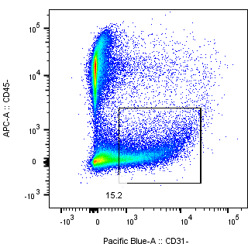
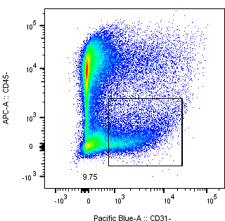
CD45
CD45

CD31
CD31

Figure S1: Endothelial cell numbers decrease in the heart with influenza infection. Hearts were collected six days after influenza infection vs PBS vehicle injection and subjected to enzymatic digestion and flow cytometry (n=3/group). A) Representative gating strategy used to identify CD31+CD45- endothelial cells. B) Quantification of the percentage of CD31+CD45- cells in the heart. Bar graph displayed as mean ± SEM with individual data points shown. Student’s t-test. P<0.05 considered significant.
Figure S2:

Figure S2: Circulating levels of activin A increase with influenza infection. Comparison of plasma activin A concentrations three days after influenza infection or PBS injection. N=5-6/group. Bar graph displayed as mean ± SEM with individual data points shown. Student’s t-test. P<0.05 considered significant.

Figure S3:

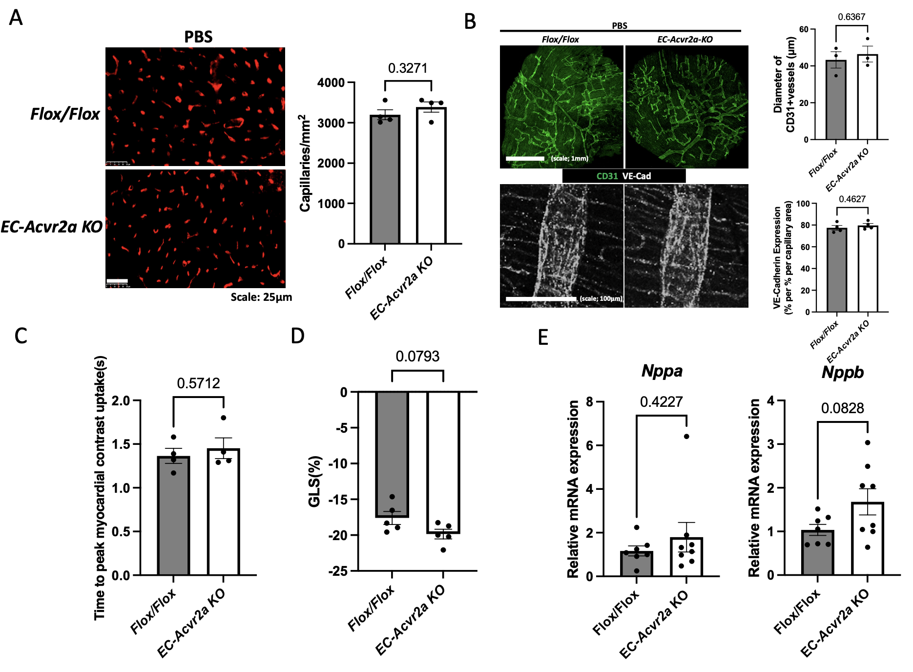

Figure S3: Baseline cardiac phenotyping of EC Acvr2a-KO mice. EC-Acvr2a-KO mice were generated by crossing Acvr2a flox/flox with Tie2-Cre mice. (A) Representative images and quantification of myocardial capillary density (CD31= red). N=4/group. (B) Representative images of 3D reconstruction of cardiac microvascular network with tissue clearing and CD31 and VE-cadherin staining. Quantification of vessel diameter and VE-Cadherin expression. N=3-4/group. (C) Myocardial perfusion by contrast echocardiography. N=4/group. (D LV GLS. See Table S1 for complete echocardiography data. N=5/group. (E) Relative cardiac mRNA expression of Nppa and Nppb. N=6-7/group. All bar graphs displayed as mean ± SEM with individual data points shown. Student’s t-test used. P <0.05 considered significant.

Figure S4:

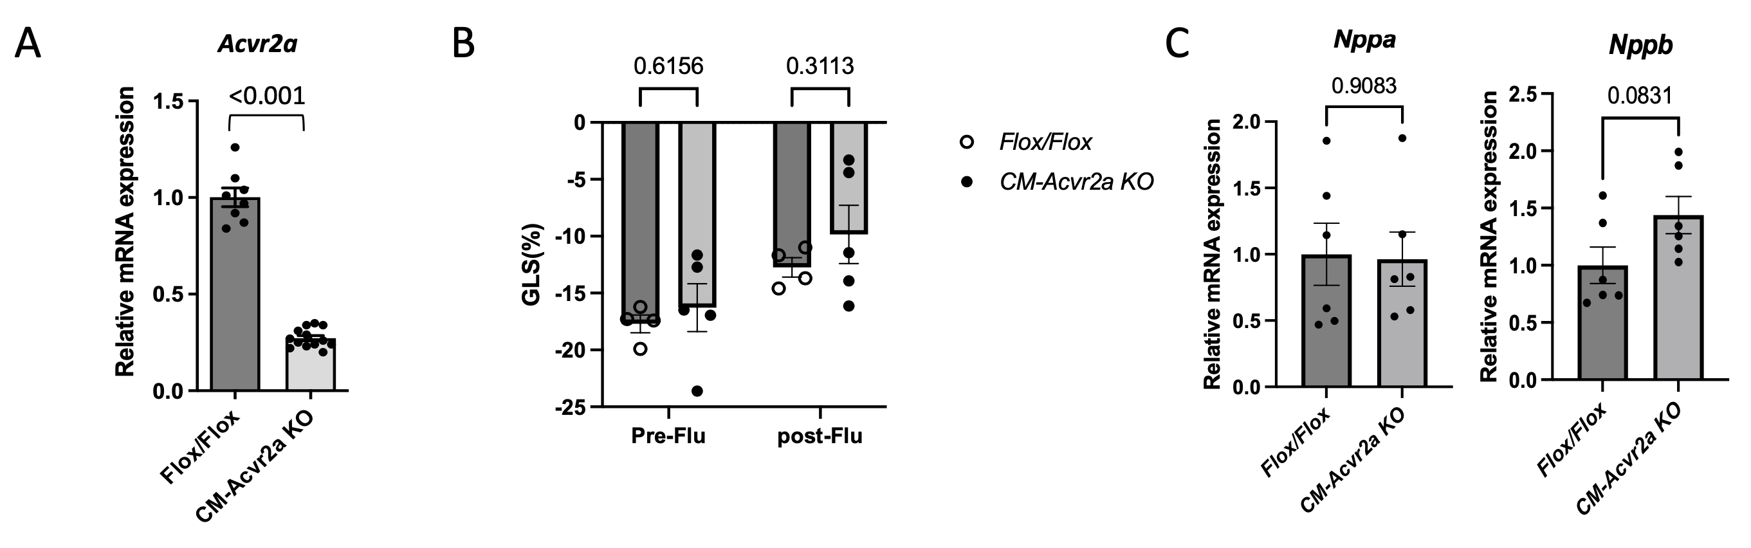
Figure S4: Cardiomyocyte-specific Acvr2a deletion does not protect from influenza-induced cardiac dysfunction. (A) Relative Acvr2a mRNA expression in LV from non-infected CM-Acvr2A KO vs flox/flox littermate controls. N=8-13/group (includes both males and females). (B) LV GLS before and five days after influenza infection. See Table S1 for complete echocardiography data. N=4-5/group. One-way ANOVA with post-hoc Tukey test. (C) Relative cardiac mRNA expression of Nppa and Nppb. N=6/group. Student’s t-test. All bar graphs displayed as mean ± SEM with individual data points shown. P <0.05 considered significant.

