SUPPLEMENTARY

Improving tolerance to fluctuating light through adaptive laboratory evolution in the cyanobacterium Synechocystis

Theo Figueroa-Gonzalez, Weiyang Chen, Eslam M. Abdel-Salam, Daniel Štipl, Josef Komenda, Milena Zhivkovikj, Marcel Dann & Dario Leister

Supplementary Figures

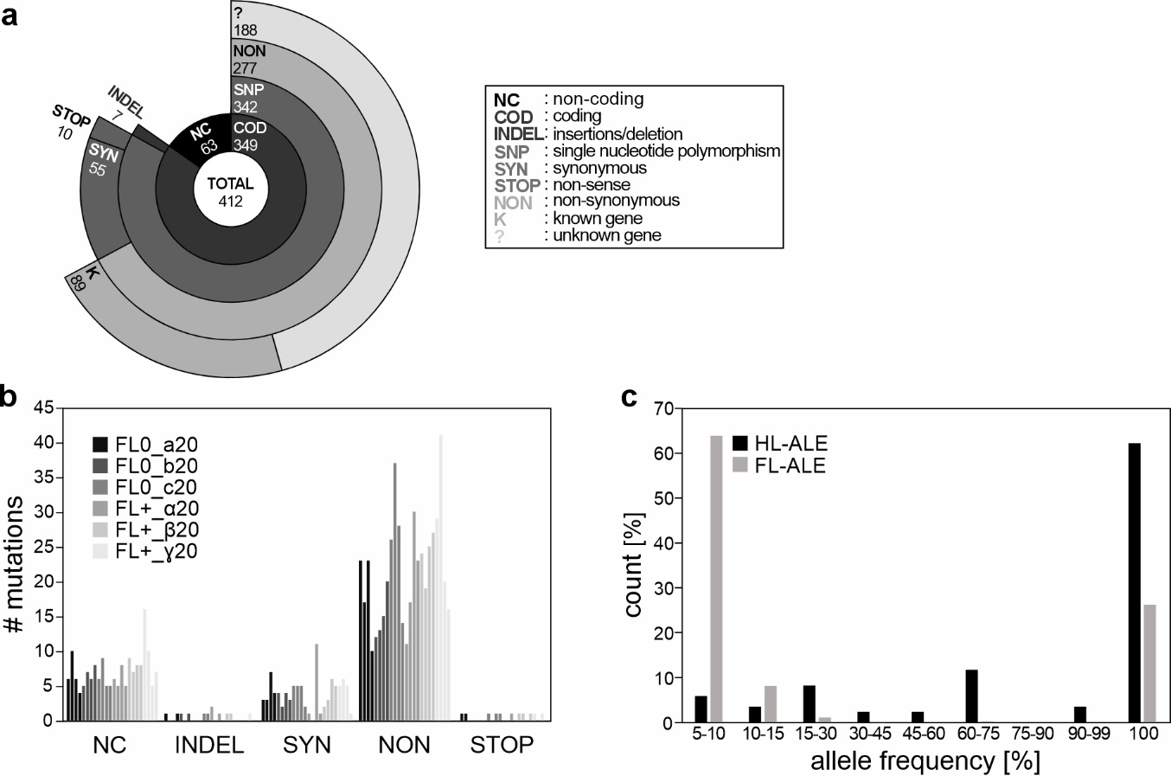

Supplementary Fig. 1 l Analysis of the mutational landscape observed in FL-adapted strains.
a, A hierarchical sunburst plot illustrates the distribution of novel alleles (absent in LT and WT strains) across four levels of classification: 1. Genomic context: Coding (COD) vs. Non-coding (NC) regions. 2. Mutation type in coding regions: Single-nucleotide polymorphisms (SNP) vs. Insertion/Deletions (INDELs). 3. SNP effect: Non-synonymous (NON), Synonymous (SYN) or Premature stop codon (STOP). 4. Functional annotation of non-synonymous mutations: Known/characterised (K) vs. Unknown/uncharacterised (?) genes.
b, Bar chart quantifying the relative abundance of mutations across five categories: NC, INDEL, NON, SYN, and STOP. Underlying data is provided in Source Data 2.
c, The frequency distribution of the total mutations observed in the two ALE experiments is presented, categorized into nine bins. This distribution is compared to previously reported data from high light (HL) ALE experiments conducted without external mutagens (see main text). Underlying data is provided in Source Data 3.

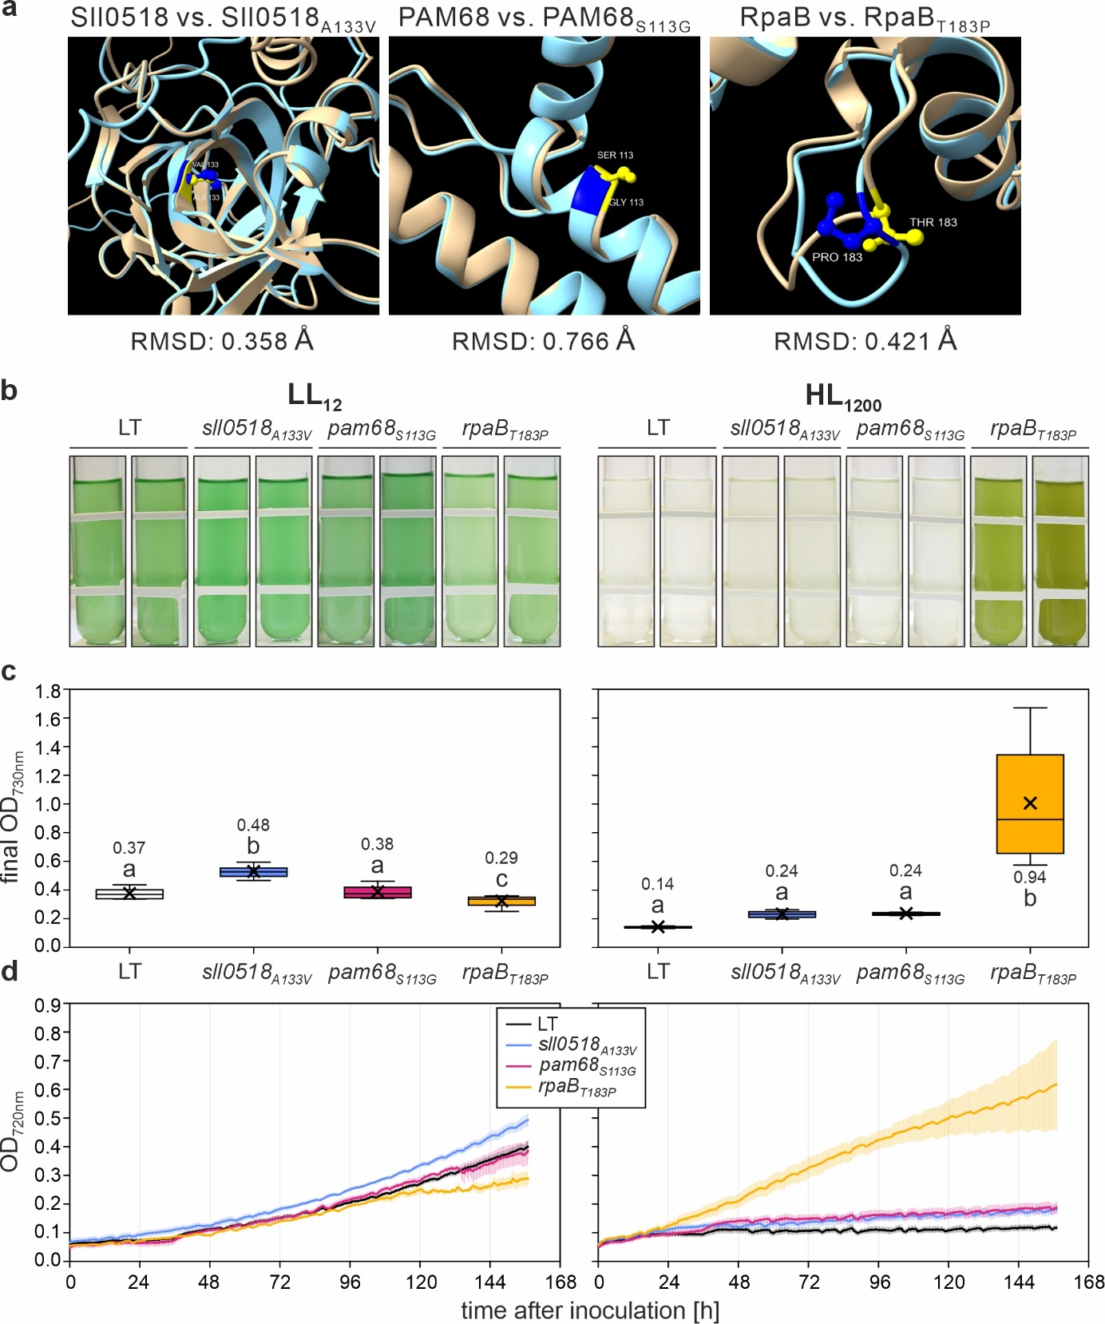
Supplementary Fig. 2 l Structural predictions of Sll0518_{A133V}, Pam68_{S113G}, and RpaB_{T183P}, and growth characteristics of their mutants and the LT strain under continuous LL₁₂ and HL₁₂₀₀ conditions.
a, Close-up of the structural alignments of Sll0518/Sll0518A133V, Pam68/Pam68_{S113G}, and RpaB /RpaB_{T183P}, as predicted by AlphaFold3. The full predicted structures are provided in Source Data 4. RMSD (root mean square deviation) values below 1.0 Å indicate no significant changes in the 3D structure compared to the wild-type protein reference.
b, Visual representation of liquid cultures for the four strains cultivated under LL (left) or HL (right) conditions at 23 °C with 100 mL min⁻¹ aeration, photographed seven days after post-inoculation. Data were collected from cultures grown in multi-cultivators.
c, Quantitative analysis of cell density (OD_{730nm}) for the four strains grown under conditions described in A. Box plots are presented, with lowercase letters denoting statistically significant differences (p ≤ 0.05) as determined by post-hoc Bonferroni-Holm simultaneous comparison of all measurements (n = 8) following significant between-group differences detected by one-factorial ANOVA.
d, Growth kinetics of the four strains under LL and HL conditions, monitored automatically by the multi-cultivators measuring OD_{720nm}. Error bars represent the standard deviation (n = 4).
Statistical data in panel b are presented as box plots, showing individual data points, median (horizontal lines), mean (crosses), interquartile range (box), and 1.5× interquartile range (whiskers). Raw data are provided in Source Data 4.

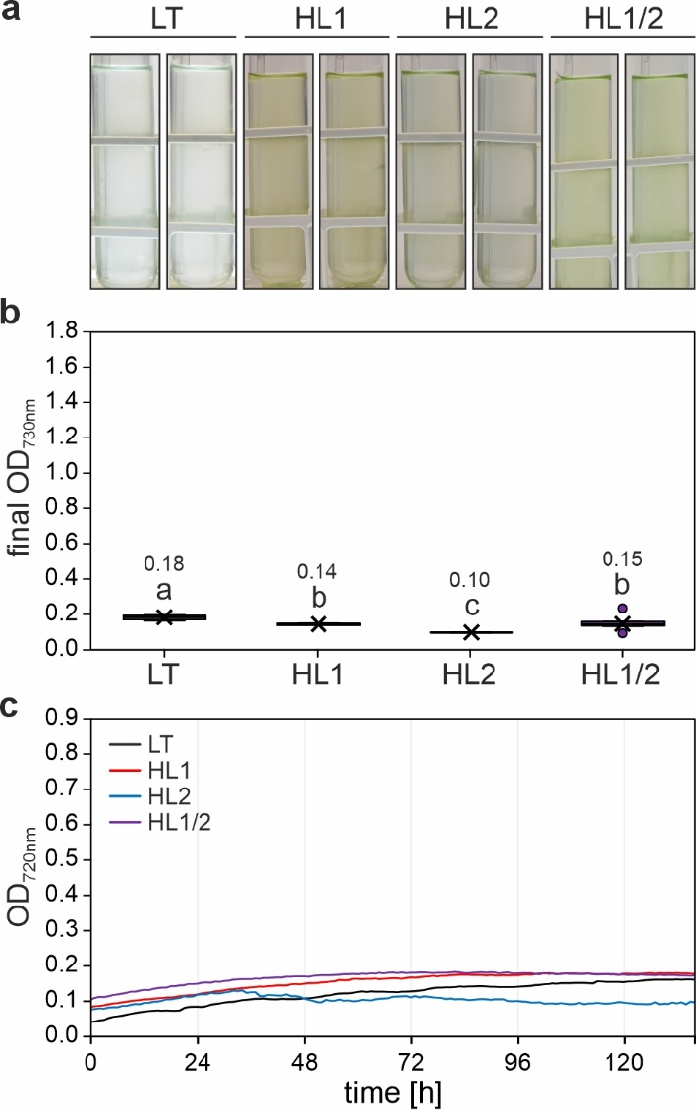
Supplementary Fig. 3 l Growth characteristics of HL-tolerant strains HL1, HL2, HL1/2 and the LT strain under FL+_{final} conditions.
a, Visual representation of liquid cultures for the four strains cultivated in multi-cultivators under FL+_{final} conditions at 23 °C with 100 mL min⁻¹ aeration, photographed seven days post-inoculation.
b, Quantitative analysis of cell density (OD_{730nm}) for the four strains grown under conditions as in A. Box plots are presented, with lowercase letters denoting statistically significant differences (p ≤ 0.05) as determined by post-hoc Bonferroni-Holm simultaneous comparison of all measurements (n = 8) following significant between-group differences detected by one-factorial ANOVA.
c, Growth kinetics of the four strains under final FL+ conditions, monitored automatically by multi-cultivators measuring OD_{720nm}. Error bars represent the standard deviation (n = 4).
Statistical data in panel b are presented as box plots, showing individual data points, median (horizontal lines), mean (crosses), interquartile range (box), and 1.5× interquartile range (whiskers). Raw data are provided in Source Data 4.

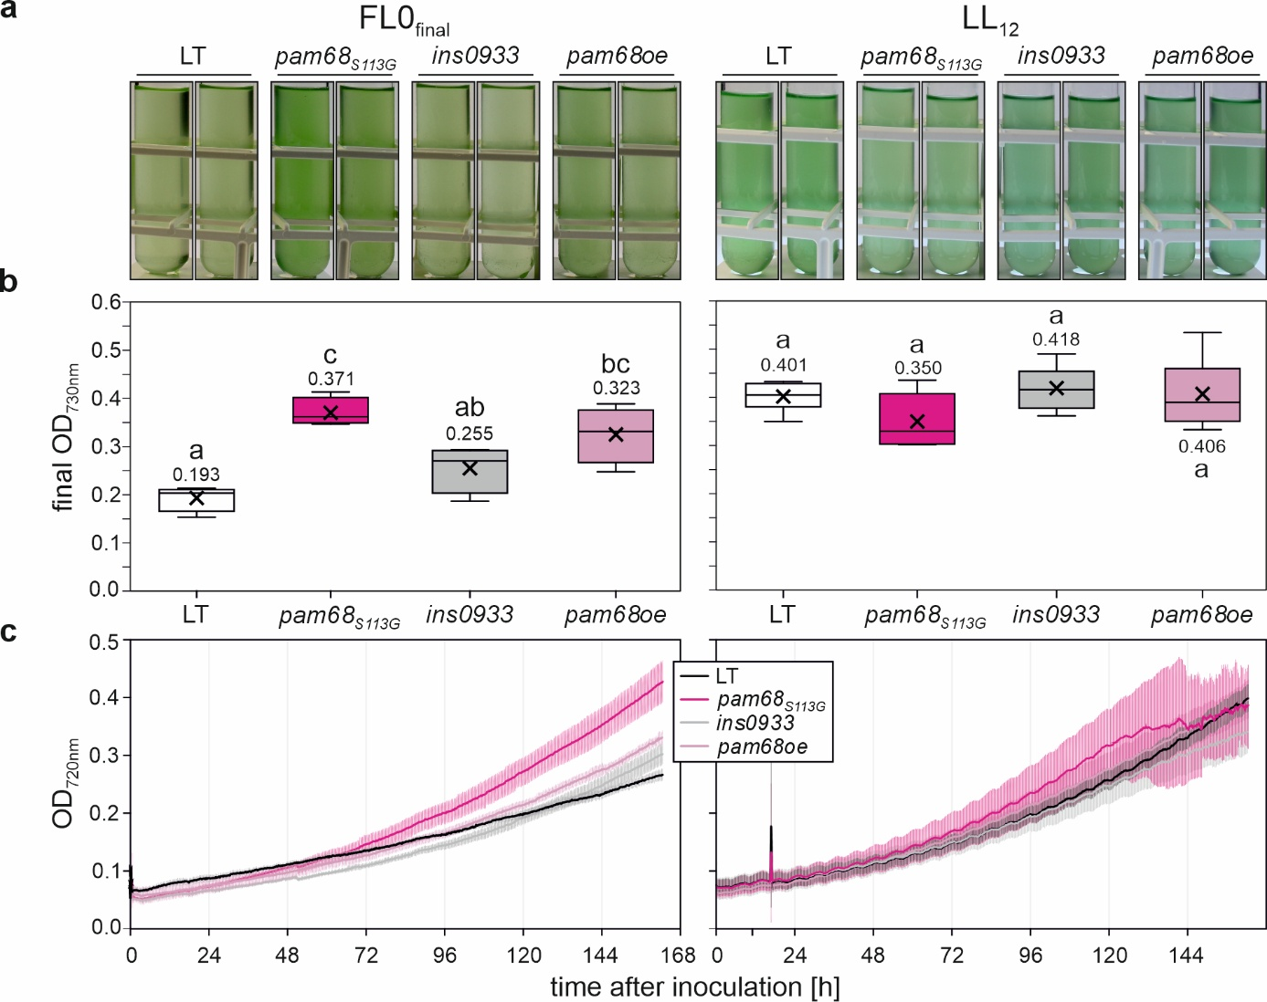Supplementary Fig. 4 l Growth characteristics of the pam68_{S113G}, ins0933, pam68oe and the LT strain under two different light conditions.
a, Visual representation of liquid cultures of the LT, ins0933, pam68oe and pam68_{S113G} strains cultivated in multi-cultivators under FL0_{final} and constant LL₁₂ conditions at 23 °C with 100 mL min⁻¹ aeration, photographed seven days post-inoculation.
b, Quantitative analysis of cell density (OD_{730nm}) for the four strains grown under the conditions as in a. Box plots are presented, with lowercase letters denoting statistically significant differences (p ≤ 0.05) as determined by post-hoc Bonferroni-Holm simultaneous comparison of all measurements (n = 4 for FL0 condition and n = 6 for LL₁₂ condition, respectively) following significant between-group differences detected by one-factorial ANOVA.
c, Growth kinetics of the four strains, monitored automatically by multi-cultivators measuring OD_{720nm}. Error bars represent the standard deviation (n = 4 for FL0_{final} condition and n = 6 for LL₁₂ condition, respectively).
Statistical data in panel b are presented as box plots, showing individual data points, median (horizontal lines), mean (crosses), interquartile range (box), and 1.5× interquartile range (whiskers). Raw data are provided in Source Data 5.

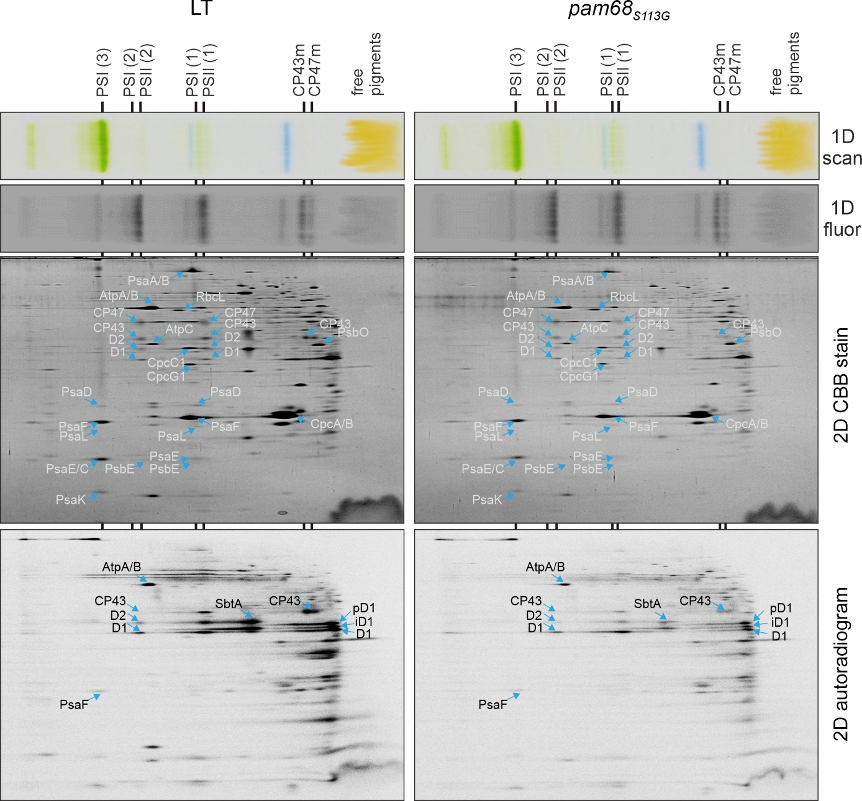Supplementary Fig. 5 l De-novo synthesis of PSII proteins in the pam68_{S113G} mutant.
Cells were radiolabelled with a mixture of [³⁵S]Met/Cys for 20 min at 500 μmol photons m⁻² s⁻¹. Membrane proteins isolated from the labelled cells were separated by 2D-CN/SDS-PAGE. The 1D native gels were photographed (1D scan) and examined for Chl fluorescence (1D fluor). After 2D SDS-PAGE, the gels were stained with Coomassie Brilliant Blue (2D CBB stain), dried, and imaged by a phosphoimager to detect the labelled proteins (2D autoradiogram). PSI (3): PSI trimer; PSI (2): PSI dimer; PSII (2): PSII dimer; PSI (1): PSI monomer; PSII (1): PSII monomer; CP43m: CP43 module; CP47m: CP47 module; pD1: D1 precursor; iD1: incompletely processed form of the D1 precursor.
Raw data are provided in Source Data 5.

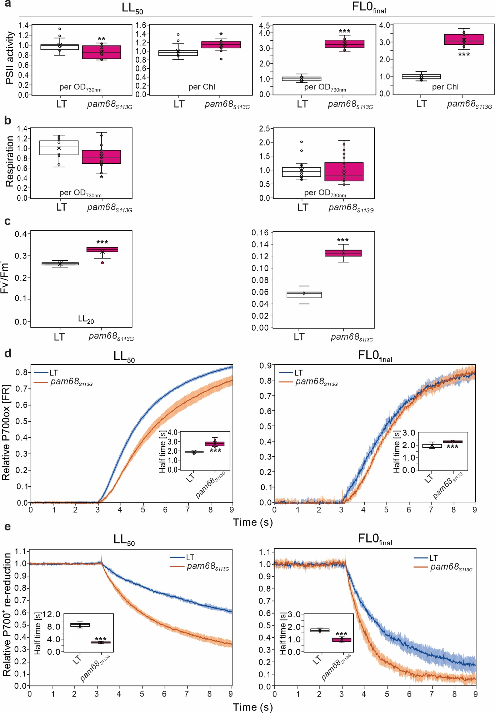Supplementary Fig. 6 l Physiological measurements of pam68_{S113G}.
a, PSII activity of the cells was obtained by measuring the steady-state rate of oxygen evolution in the presence of 0.5 mM DCBQ (1,4-benzoquinone) and 1 mM K₃Fe (CN)₆ under saturating light conditions. Measurements were performed on undiluted samples that had been grown for 7 days at LL₅₀ and FL0_{final} (n = 16 biological replicates for LL₅₀, and n =17 for FL0_{final}). The data were normalized to OD_{730nm} =1 and the Chl a content of the cultures. The mean activities taken for LT and pam68_{S113G} cells were 0.90 ± 0.14 and 0.78 ± 0.19 μmol O₂/mL/h under LL₅₀, and 0.16 ± 0.02 and 0.52 ± 0.05 μmol O₂/mL/h under FL0_{final}, respectively. With respect to Chl content: the values were 176 ± 26, and 199 ± 21 μmol O₂/mg Chl/h under LL₅₀, and 47 ± 7, and 145 ± 14 μmol O₂/mg Chl/h under FL0_{final}, respectively. Relative PSII activity was obtained by normalizing to the average LT rate for each independent experiment, and is represented as a box plot.
b, Cellular respiration rates were defined as the oxygen consumption in the dark. The cultures, as in (a), were analysed by determining the steady-state O₂ consumption rate over 5 min in the dark (n = 17 biological replicates for LL₅₀, and n = 22 for FL0_{final}). The mean activities taken for LT and pam68_{S113G} cells were 0.074 ± 0.024 and 0.064 ± 0.030 μmol O₂/mL/h under LL₅₀, and 0.143 ± 0.052, and 0.097 ± 0.018 μmol O₂/mL/h under FL0_{final}, respectively.
c, Fluorescence at room temperature was measured from dark-acclimated, OD_{730nm}-normalised LT and pam68_{S113G} droplets under incremental red-orange illumination (n = 25). The apparent quantum yield of PSII (F_{v}⁻/F_{m}⁻) was calculated after determining the “quenched” maximum fluorescence (F_{m}⁻) using saturating pulses (cold-white 6500 K LEDs providing ~1200 µmol photons m⁻² s⁻¹).
d and e, P700 oxidation (d) and re-reduction (e) kinetics. Cultures were grown for 7 days at LL₅₀ and FL0_{final}, incubated in the dark, exposed to FR light to follow P700 oxidation and then again to dark to follow re-reduction (see Methods). The data represent P700 oxidation traces as 820 –870 nm ΔI/I × 10³. The plots illustrate the average from 12 biological replicates for cells at LL₅₀ and 8 for cells at FL0_{final}. Error bars represent the standard deviation. The insets show the half-times of P700 oxidation (d) and re-reduction (e).
Statistical significance was determined using Student's t-Test, with the following thresholds: p ≤ 0.05 (*), p ≤ 0.01 (**), and p ≤ 0.001 (***).
Raw data are provided in Source Data 5.

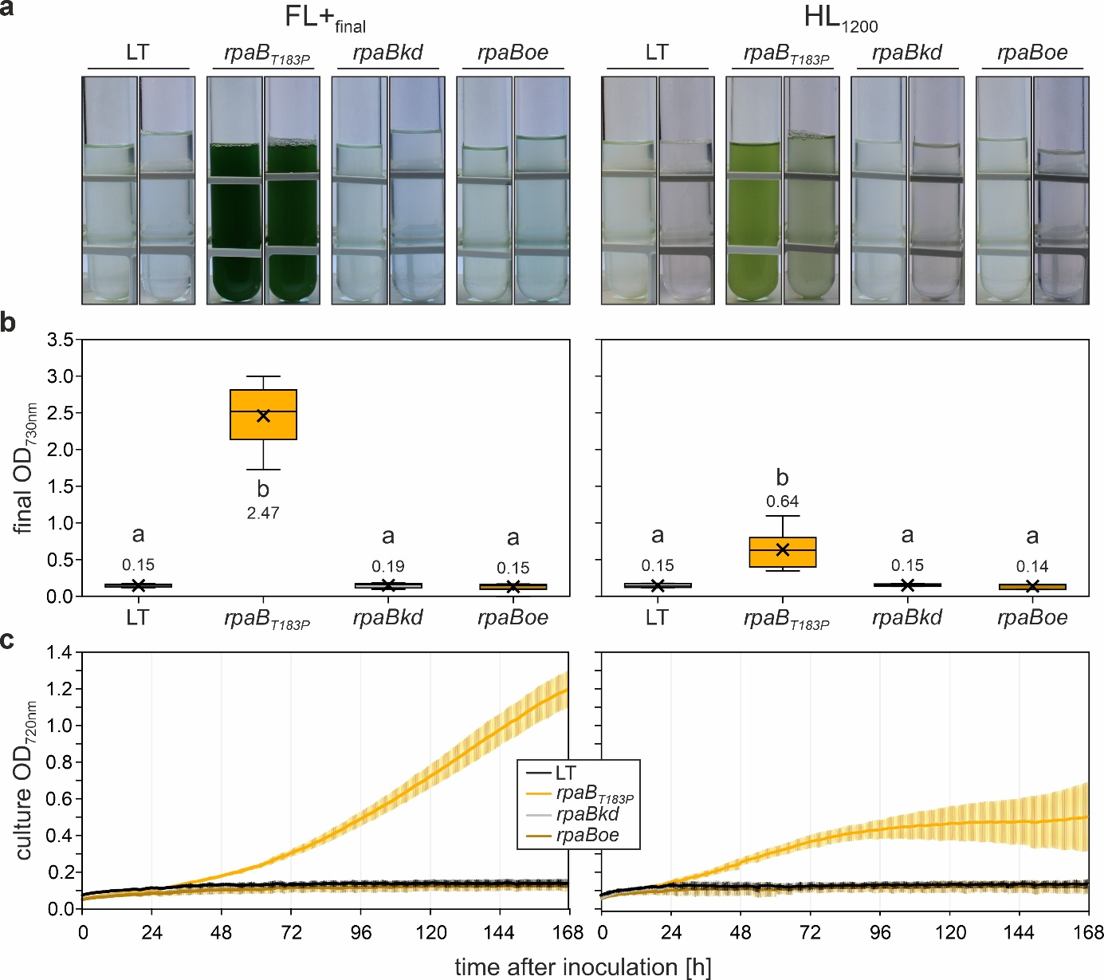
Supplementary Fig. 7 l Growth characteristics of the rpaBkd, rpaBoe, rpaB_{T183P}, and the LT strain under FL+_{final} and constant HL₁₂₀₀ conditions.
a, Visual representation of liquid cultures of the four strains cultivated in multi-cultivators under FL+_{final} and constant HL₁₂₀₀ conditions at 23 °C with 100 mL min⁻¹ aeration, photographed seven days post-inoculation.
b, Quantitative analysis of cell density (OD_{730nm}) for the four strains grown under conditions as in A. Box plots are presented, with lowercase letters denoting statistically significant differences (p ≤ 0.05) as determined by post-hoc Bonferroni-Holm simultaneous comparison of all measurements following significant between-group differences detected by one-factorial ANOVA.
c, Growth kinetics of the four strains under final FL+_{final} conditions, monitored automatically by multi-cultivators measuring OD_{720nm}. Error bars represent the standard deviations. Data shown in panels b and c represents n = 5/8/5/4 biological replicates of LT/rpaB_{T183P}/rpaB_{kd}/rpaB_{oe}, respectively. HL₁₂₀₀ data shown in panels B and C represents n = 4/6/4/3 biological replicates of LT/rpaB_{T183P}/rpaB_{kd}/rpaB_{oe}, respectively.
Statistical data in panel B are presented as box plots, showing individual data points, median (horizontal lines), mean (crosses), interquartile range (box), and 1.5× interquartile range (whiskers). Raw data are provided in Source Data 6.

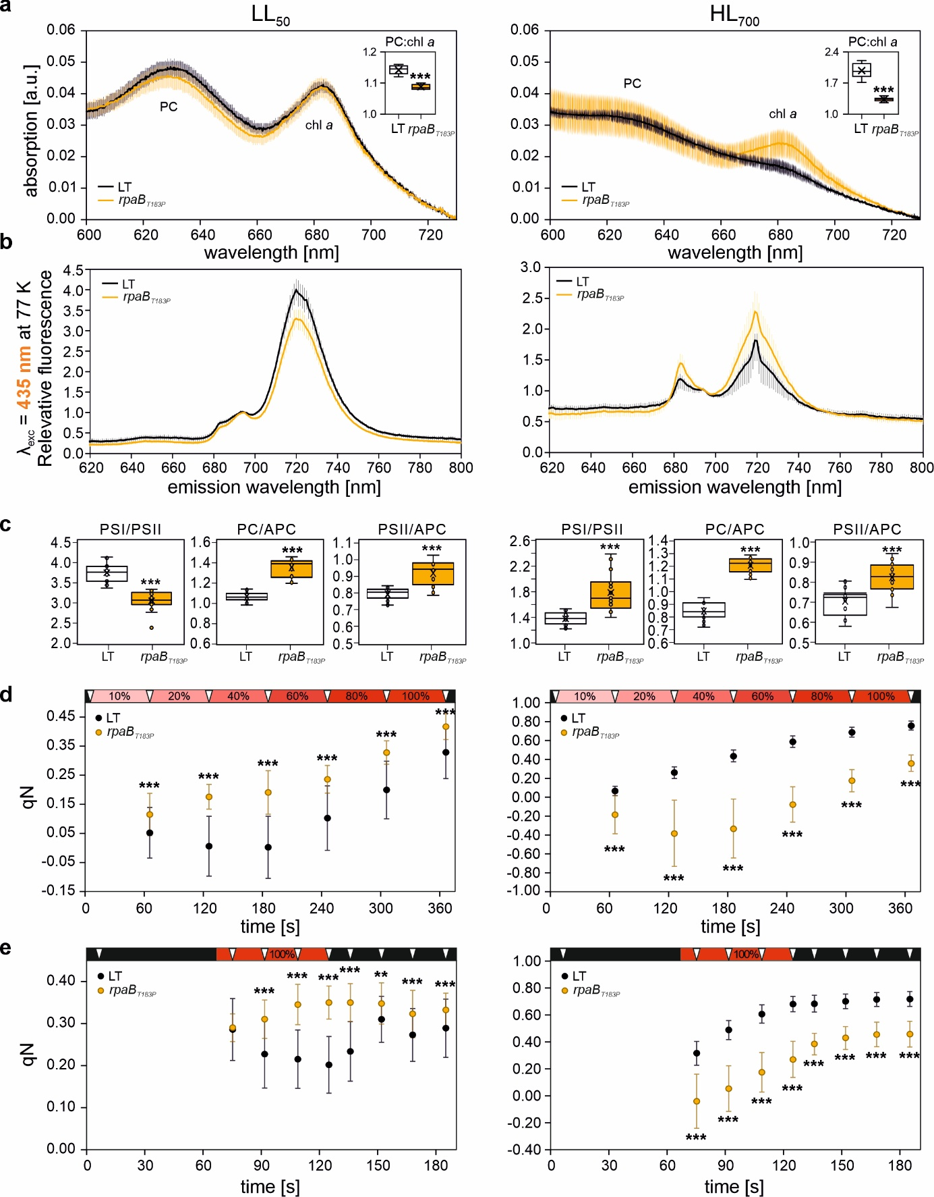
Supplementary Fig. 8 l Spectroscopic characterization of rpaB_{T183P}.
a, The absorption spectra of cultures grown under constant LL₅₀ and HL₇₀₀ in multi-cultivators, diluted to an optical density at 730 nm (OD_{730nm}) of 0.1, were recorded at intervals of 0.2 nm. The absorption shoulders corresponding to phycocyanin (PC) and chlorophyll a (Chl a) are indicated. The inset box plot shows the distribution of PC:Chl a ratios, calculated from the corresponding absorption maxima as Abs_{630nm}:Abs_{684nm} (LT and rpaB_{T183P} under LL₅₀, n = 4; LT and rpaB_{T183P} under HL₇₀₀, n = 12 and 24, respectively).
b, Fluorescence emission spectra were obtained by exciting undiluted samples (n = 15 biological replicates for LL₅₀, and n = 16 for HL₇₀₀) with deep blue light (λ_{exc} = 435 nm, targeting Chl a) at 77 K. The spectra were recorded at 1.0 nm intervals, normalized at the PSII peak (F695 nm), and presented as average +/- SD.
c, The box plots show the PSI:PSII ratio estimated from non-normalized F725:F695 from panel b. The PC:APC and PSII:APC ratios, estimated from non-normalized F645:F662 and F695:F662, respectively, are derived from 77 K measurements, as in panel b, but with a 600 nm excitation wavelength (see Source Data 6).
d, e, Room temperature fluorescence was measured from dark-acclimated, OD_{730nm}-normalised LT and rpaB_{T183P} droplets under incremental red-orange illumination (c) and an induction-relaxation regime (d). Dark periods are indicated in black, actinic red-orange light (100% ~ 215 µmol photons m⁻² s⁻¹; λ_{max} = 625 nm) in red, and saturating pulses (cold-white 6500 K LEDs providing ~1200 µmol photons m⁻² s⁻¹) as downward triangles in white. The coefficient of non-photochemical quenching of fluorescence (qN) was automatically calculated mid- and post-illumination after each saturating pulse (LT and rpaB_{T183P} under LL₅₀, n = 40; LT and rpaB_{T183P} under HL₇₀₀, n = 12 and 24, respectively).
Statistical significance was determined using Student's t-Test, with p ≤ 0.05 (*), p ≤ 0.01 (**), and p ≤ 0.001 (***).
Raw data are provided in Source Data 6.

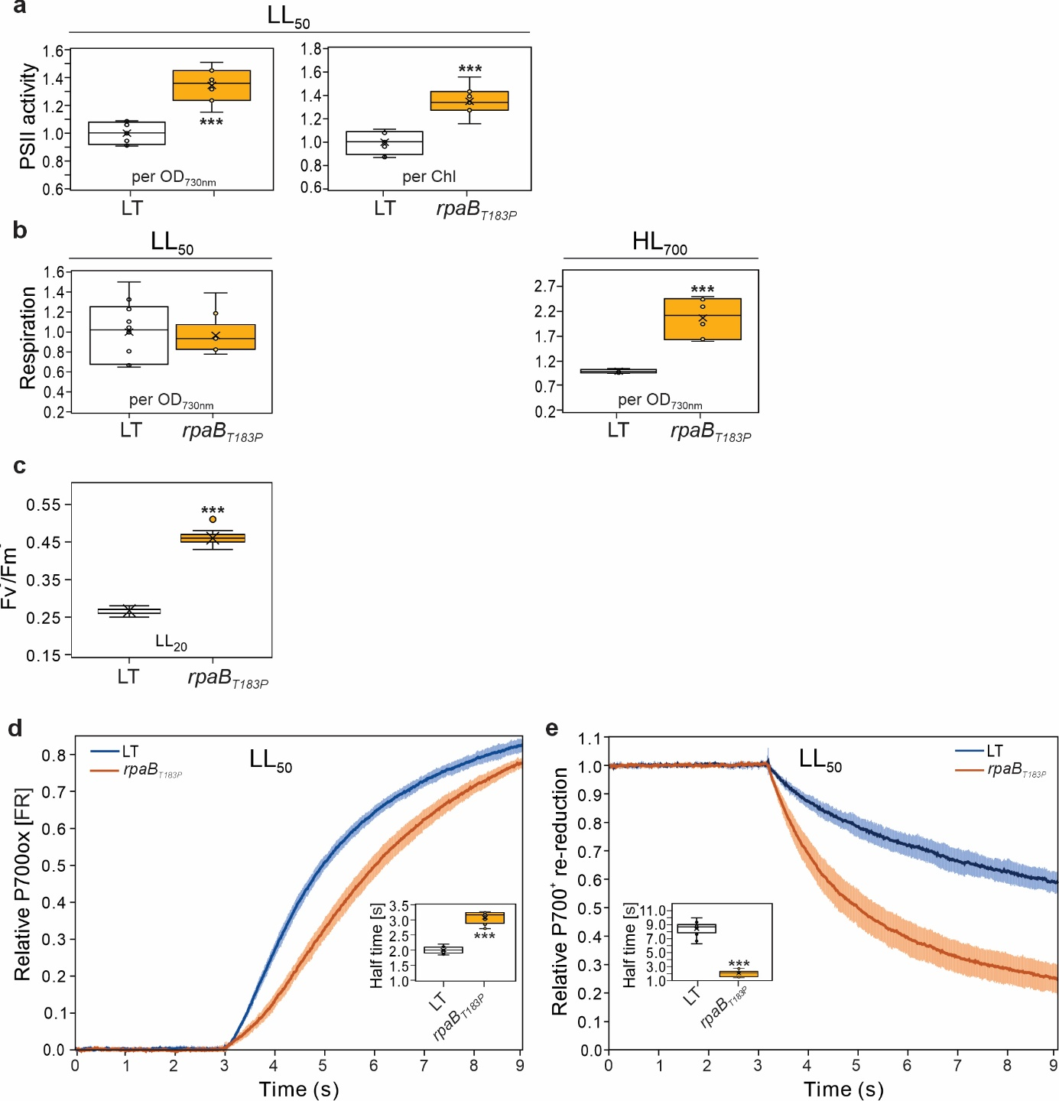
Supplementary Fig. 9 l Physiological measurements of rpaB_{T183P}.
a, PSII activity of the cells was obtained as described in Supplementary Fig. 6a. Measurements were performed on undiluted samples grown for 7 days at LL₅₀ (n = 8 biological replicates for LT, and n = 7 for rpaB_{T183P}). The data were normalized to OD_{730nm} =1 and Chl a content of the cultures. The mean activities taken for LT and rpaB_{T183P} cells were 0.961 ± 0.071, and 1.290 ± 0.116 μmol O₂/mL/h, and 205 ± 21, and 278 ± 31 μmol O₂/mg Chl/h, respectively.
b, Cellular respiration rates were obtained as described in Supplementary Fig. 6b (n = 10 biological replicates for LL₅₀, and n = 6 for HL₇₀₀). The mean activities taken for LT and rpaB_{T183P} cells were 0.084 ± 0.034, and 0.076 ± 0.016 μmol O₂/mL/h under LL₅₀, and 0.141 ± 0.032 and 0.264 ± 0.023 μmol O₂/mL/h under HL₇₀₀, respectively.
c, Room temperature fluorescence was measured as described in Supplementary Fig. 6c (n = 25).
d and e, P700 oxidation (d) and re-reduction (e) kinetics were determined as described in Supplementary Fig. 6d and e. Twelve biological replicates were used for LT, and 7 for rpaB_{T183P}.
Statistical significance was determined using Student's t-Test, with p ≤ 0.05 (*), p ≤ 0.01 (**), and p ≤ 0.001 (***).
Raw data are provided in Source Data 6.

